|  |
| --- |
|  |
| Roguelike Design |
| Technical Papers |
|  |
| **Jdc1197** |
| **5/25/2013** |

|  |
| --- |
| This document describes and documents the technical aspects and designs used in the Roguelike. |

The screen is split into 3 sub screens:

**ScreenGame**

The screen which the player, map, and items are drawn.

**ScreenMessages**

The screen which displays the messages send by the game.

**ScreenStatus**

The screen which displays the status and stats of the player.

**Default screen layout**

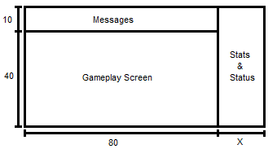

**ScreenGame**

* Fixed size (80 x 40)

**ScreenMessages**

* Variable Size (default 80x10)

**ScreenStatus**

* Variable Size (Θ x 50)

The size and positions of the subscreens will be set in the options, defined using two variables:

* Relative position of the top left corner
* Relative position of the bottom right corner

Example:

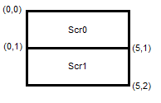

Save files will consist of: a small file header, followed by the data in Java Script Object Notation (JSON) compressed using gzip or an alternative. Although they can be named anything, the conventional file name will be:

**roguelike-<character_name>.json.gz**

**Save File Header**

The file header will be small binary string which details that begins the file. It will detail:

* A string to identify that it is a save file
* The file's compression method (or lack thereof)

**File Data**

The file data will begin with a JSON object. The object will contain all of the maps, objects, items, and beings throughout the dungeon.

**Saving Method**

The save file will be saved in such a way that, if the program exits unexpectedly, no data will be lost.

The method will execute as such:

1. Rename the current savefile (if any)
2. Save the new savefile in the place of the old one
3. After saving, delete the renamed savefile

If the program exits unexpectedly, the old save file will be preserved under a different file name.