LogReg2.R

JOsDP23

2020-11-30

#MJ Logistic Regression  
library(MASS)

## Warning: package 'MASS' was built under R version 3.6.3

library(ISLR)

## Warning: package 'ISLR' was built under R version 3.6.3

library(popbio)

## Warning: package 'popbio' was built under R version 3.6.2

#Creates dataset from the MJ stats csv  
dataset <- read.csv("C:\\Users\\JOsDP23\\OneDrive\\Documents\\GitHub\\Math4322\\MJDataSci\\michael-jordan-nba-career-regular-season-stats-by-game.csv", header = TRUE)  
#Creates the subset for the variable we will be using  
dataset = subset(dataset,select = -c(EndYear,Rk,G,Date,Years,Days,Tm,Home,Opp))  
#Array to hold our seed values  
i <- c(1,2,3,4,5,6,7,8,9,10)  
#Sets Win as a catagorical variable  
dataset$Win <- factor(dataset$Win)  
#Sets GS as catagorical  
#dataset$GS <- factor(dataset$GS)  
#Fills any NA values as Zeroes  
dataset[is.na(dataset)]<-0  
attach(dataset)  
avg = 0  
#For loop used to generate 10 different tests  
for (val in i)  
{  
 set.seed(val)  
 #Used to train model on the 80% training data and 20% testing data  
 MJ.sample.train <- sample(1:dim(dataset)[1],dim(dataset)[1]*.8,rep=FALSE)  
 MJ.train <- dataset[MJ.sample.train, ]  
 MJ.test <- dataset[-MJ.sample.train, ]  
 #generates our logistic regression  
 MJ.log <- glm(Win ~ Age + GS + MP + FG_PCT + TP_PCT + FT_PCT + ORB + DRB + AST + STL + BLK + TOV + PF + PTS + GmSc, data = MJ.train, family = "binomial")  
 #Preforms our prediction to see the variables most associated if MJ stats are the reason they win games  
 MJ.train.predict<-predict(MJ.log,MJ.test,type="response")  
 MJ.log.predict<-rep(0,length(MJ.train.predict))  
 #prints iteration of for loop  
 print(val)  
 #prints summary of logistic model  
 print(summary(MJ.log))  
 #prints The test prediction error  
 print(mean(MJ.log.predict != MJ.test$Win))  
 avg = avg + mean(MJ.log.predict != MJ.test$Win)  
 logi.hist.plot(Age,Win,boxp=FALSE,type="hist",col="gray", xlabel = "Age")  
 logi.hist.plot(GS,Win,boxp=FALSE,type="hist",col="gray", xlabel = "Started Game")  
 logi.hist.plot(MP,Win,boxp=FALSE,type="hist",col="gray", xlabel = "Minutes Played")  
 logi.hist.plot(PTS,Win,boxp=FALSE,type="hist",col="gray", xlabel = "Points Scored")  
 logi.hist.plot(GmSc,Win,boxp=FALSE,type="hist",col="gray", xlabel = "Game Score")  
}

## [1] 1  
##   
## Call:  
## glm(formula = Win ~ Age + GS + MP + FG_PCT + TP_PCT + FT_PCT +   
## ORB + DRB + AST + STL + BLK + TOV + PF + PTS + GmSc, family = "binomial",   
## data = MJ.train)  
##   
## Deviance Residuals:   
## Min 1Q Median 3Q Max   
## -2.4329 -1.0671 0.5577 0.8309 1.9306   
##   
## Coefficients:  
## Estimate Std. Error z value Pr(>|z|)   
## (Intercept) -3.20032 1.22699 -2.608 0.00910 **   
## Age 0.07773 0.01845 4.214 2.51e-05 ***  
## GS 2.19614 0.54483 4.031 5.56e-05 ***  
## MP -0.05345 0.02156 -2.479 0.01316 *   
## FG_PCT 2.50780 1.59670 1.571 0.11627   
## TP_PCT 0.12347 0.28456 0.434 0.66436   
## FT_PCT 0.07267 0.44260 0.164 0.86959   
## ORB -0.07092 0.06716 -1.056 0.29093   
## DRB 0.03450 0.03803 0.907 0.36428   
## AST -0.08766 0.05357 -1.636 0.10176   
## STL -0.06317 0.07530 -0.839 0.40150   
## BLK 0.08899 0.09472 0.940 0.34743   
## TOV 0.03746 0.06907 0.542 0.58764   
## PF 0.04374 0.06742 0.649 0.51645   
## PTS -0.11982 0.04042 -2.964 0.00303 **   
## GmSc 0.17995 0.05614 3.205 0.00135 **   
## ---  
## Signif. codes: 0 '***' 0.001 '**' 0.01 '*' 0.05 '.' 0.1 ' ' 1  
##   
## (Dispersion parameter for binomial family taken to be 1)  
##   
## Null deviance: 1081.51 on 856 degrees of freedom  
## Residual deviance: 933.63 on 841 degrees of freedom  
## AIC: 965.63  
##   
## Number of Fisher Scoring iterations: 4  
##   
## [1] 0.5953488

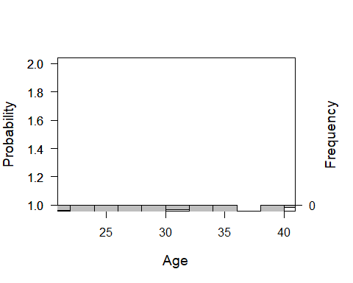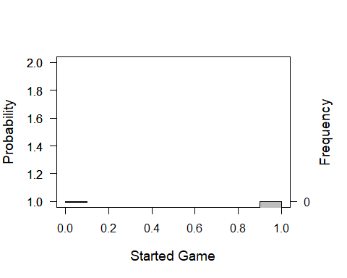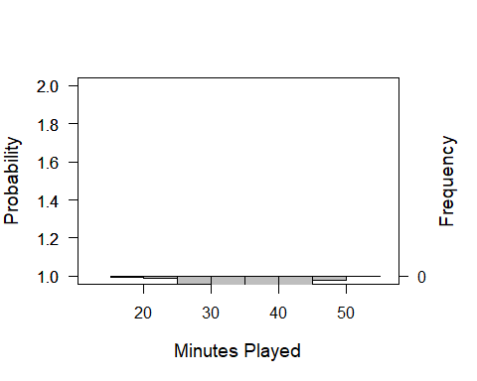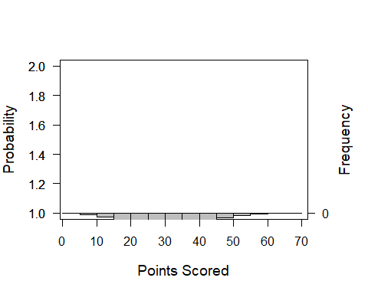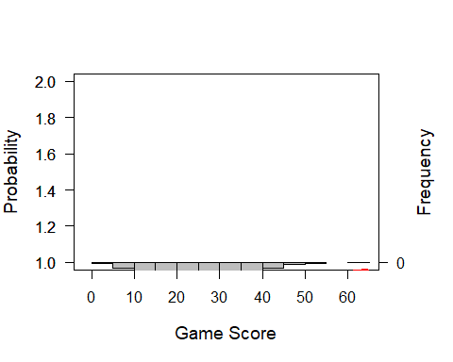

## [1] 2  
##   
## Call:  
## glm(formula = Win ~ Age + GS + MP + FG_PCT + TP_PCT + FT_PCT +   
## ORB + DRB + AST + STL + BLK + TOV + PF + PTS + GmSc, family = "binomial",   
## data = MJ.train)  
##   
## Deviance Residuals:   
## Min 1Q Median 3Q Max   
## -2.4839 -1.0469 0.5600 0.8618 2.0829   
##   
## Coefficients:  
## Estimate Std. Error z value Pr(>|z|)   
## (Intercept) -2.39000 1.20033 -1.991 0.046469 *   
## Age 0.08057 0.01849 4.357 1.32e-05 ***  
## GS 2.16867 0.50568 4.289 1.80e-05 ***  
## MP -0.07155 0.02214 -3.231 0.001232 **   
## FG_PCT 1.85961 1.52908 1.216 0.223921   
## TP_PCT 0.10804 0.28500 0.379 0.704608   
## FT_PCT -0.29885 0.43957 -0.680 0.496584   
## ORB -0.08278 0.06720 -1.232 0.217984   
## DRB 0.04775 0.03695 1.292 0.196247   
## AST -0.05840 0.05320 -1.098 0.272274   
## STL -0.06218 0.07478 -0.832 0.405651   
## BLK 0.08563 0.09173 0.934 0.350543   
## TOV 0.07622 0.07017 1.086 0.277347   
## PF 0.02437 0.06481 0.376 0.706946   
## PTS -0.13264 0.03976 -3.336 0.000848 ***  
## GmSc 0.20106 0.05487 3.664 0.000248 ***  
## ---  
## Signif. codes: 0 '***' 0.001 '**' 0.01 '*' 0.05 '.' 0.1 ' ' 1  
##   
## (Dispersion parameter for binomial family taken to be 1)  
##   
## Null deviance: 1104.75 on 856 degrees of freedom  
## Residual deviance: 944.84 on 841 degrees of freedom  
## AIC: 976.84  
##   
## Number of Fisher Scoring iterations: 4  
##   
## [1] 0.6744186



## [1] 3  
##   
## Call:  
## glm(formula = Win ~ Age + GS + MP + FG_PCT + TP_PCT + FT_PCT +   
## ORB + DRB + AST + STL + BLK + TOV + PF + PTS + GmSc, family = "binomial",   
## data = MJ.train)  
##   
## Deviance Residuals:   
## Min 1Q Median 3Q Max   
## -2.5910 -1.0496 0.5526 0.8505 2.0845   
##   
## Coefficients:  
## Estimate Std. Error z value Pr(>|z|)   
## (Intercept) -3.01596 1.19008 -2.534 0.01127 *   
## Age 0.07618 0.01817 4.193 2.75e-05 ***  
## GS 1.90987 0.47376 4.031 5.55e-05 ***  
## MP -0.06228 0.02149 -2.898 0.00376 **   
## FG_PCT 2.90641 1.53006 1.900 0.05749 .   
## TP_PCT 0.30832 0.28277 1.090 0.27555   
## FT_PCT -0.11192 0.43254 -0.259 0.79583   
## ORB 0.05963 0.06881 0.867 0.38617   
## DRB 0.05671 0.03822 1.484 0.13783   
## AST -0.08298 0.05421 -1.531 0.12588   
## STL -0.07598 0.07585 -1.002 0.31648   
## BLK 0.15062 0.09479 1.589 0.11205   
## TOV 0.06071 0.07043 0.862 0.38868   
## PF 0.01340 0.06616 0.203 0.83952   
## PTS -0.12244 0.04039 -3.032 0.00243 **   
## GmSc 0.18308 0.05594 3.273 0.00106 **   
## ---  
## Signif. codes: 0 '***' 0.001 '**' 0.01 '*' 0.05 '.' 0.1 ' ' 1  
##   
## (Dispersion parameter for binomial family taken to be 1)  
##   
## Null deviance: 1106.0 on 856 degrees of freedom  
## Residual deviance: 947.1 on 841 degrees of freedom  
## AIC: 979.1  
##   
## Number of Fisher Scoring iterations: 4  
##   
## [1] 0.6790698



## [1] 4  
##   
## Call:  
## glm(formula = Win ~ Age + GS + MP + FG_PCT + TP_PCT + FT_PCT +   
## ORB + DRB + AST + STL + BLK + TOV + PF + PTS + GmSc, family = "binomial",   
## data = MJ.train)  
##   
## Deviance Residuals:   
## Min 1Q Median 3Q Max   
## -2.4654 -1.0866 0.5524 0.8610 2.0323   
##   
## Coefficients:  
## Estimate Std. Error z value Pr(>|z|)   
## (Intercept) -1.97977 1.19368 -1.659 0.097209 .   
## Age 0.06836 0.01838 3.720 0.000199 ***  
## GS 1.26833 0.51635 2.456 0.014036 *   
## MP -0.05888 0.02149 -2.740 0.006135 **   
## FG_PCT 1.90660 1.52228 1.252 0.210399   
## TP_PCT 0.34668 0.27671 1.253 0.210265   
## FT_PCT 0.46696 0.42581 1.097 0.272791   
## ORB -0.04964 0.06748 -0.736 0.461956   
## DRB 0.05017 0.03815 1.315 0.188509   
## AST -0.10057 0.05472 -1.838 0.066105 .   
## STL -0.07471 0.07679 -0.973 0.330618   
## BLK 0.16058 0.09160 1.753 0.079592 .   
## TOV 0.02620 0.07084 0.370 0.711442   
## PF -0.01502 0.06549 -0.229 0.818655   
## PTS -0.11993 0.04098 -2.926 0.003430 **   
## GmSc 0.18313 0.05651 3.241 0.001193 **   
## ---  
## Signif. codes: 0 '***' 0.001 '**' 0.01 '*' 0.05 '.' 0.1 ' ' 1  
##   
## (Dispersion parameter for binomial family taken to be 1)  
##   
## Null deviance: 1112.24 on 856 degrees of freedom  
## Residual deviance: 954.35 on 841 degrees of freedom  
## AIC: 986.35  
##   
## Number of Fisher Scoring iterations: 4  
##   
## [1] 0.7023256



## [1] 5  
##   
## Call:  
## glm(formula = Win ~ Age + GS + MP + FG_PCT + TP_PCT + FT_PCT +   
## ORB + DRB + AST + STL + BLK + TOV + PF + PTS + GmSc, family = "binomial",   
## data = MJ.train)  
##   
## Deviance Residuals:   
## Min 1Q Median 3Q Max   
## -2.4047 -1.0289 0.5427 0.8604 2.1010   
##   
## Coefficients:  
## Estimate Std. Error z value Pr(>|z|)   
## (Intercept) -2.02372 1.22609 -1.651 0.098831 .   
## Age 0.06474 0.01827 3.543 0.000395 ***  
## GS 1.52572 0.51614 2.956 0.003116 **   
## MP -0.05991 0.02180 -2.748 0.005990 **   
## FG_PCT 1.72034 1.56069 1.102 0.270332   
## TP_PCT 0.41923 0.28796 1.456 0.145437   
## FT_PCT 0.31204 0.44682 0.698 0.484961   
## ORB -0.03921 0.06848 -0.572 0.566989   
## DRB 0.04984 0.03832 1.301 0.193374   
## AST -0.04218 0.05447 -0.774 0.438766   
## STL -0.04988 0.07623 -0.654 0.512852   
## BLK 0.07708 0.09534 0.808 0.418828   
## TOV 0.00629 0.07170 0.088 0.930093   
## PF -0.01880 0.06525 -0.288 0.773267   
## PTS -0.12801 0.04145 -3.088 0.002016 **   
## GmSc 0.19200 0.05768 3.329 0.000872 ***  
## ---  
## Signif. codes: 0 '***' 0.001 '**' 0.01 '*' 0.05 '.' 0.1 ' ' 1  
##   
## (Dispersion parameter for binomial family taken to be 1)  
##   
## Null deviance: 1106.03 on 856 degrees of freedom  
## Residual deviance: 942.44 on 841 degrees of freedom  
## AIC: 974.44  
##   
## Number of Fisher Scoring iterations: 4  
##   
## [1] 0.6790698



## [1] 6  
##   
## Call:  
## glm(formula = Win ~ Age + GS + MP + FG_PCT + TP_PCT + FT_PCT +   
## ORB + DRB + AST + STL + BLK + TOV + PF + PTS + GmSc, family = "binomial",   
## data = MJ.train)  
##   
## Deviance Residuals:   
## Min 1Q Median 3Q Max   
## -2.4384 -1.0296 0.5461 0.8568 1.7855   
##   
## Coefficients:  
## Estimate Std. Error z value Pr(>|z|)   
## (Intercept) -3.299279 1.228059 -2.687 0.007219 **   
## Age 0.089459 0.019014 4.705 2.54e-06 ***  
## GS 1.874804 0.520844 3.600 0.000319 ***  
## MP -0.081271 0.021756 -3.736 0.000187 ***  
## FG_PCT 2.667694 1.533225 1.740 0.081872 .   
## TP_PCT 0.439496 0.288121 1.525 0.127163   
## FT_PCT 0.406436 0.414188 0.981 0.326453   
## ORB 0.008476 0.067245 0.126 0.899693   
## DRB 0.041031 0.038016 1.079 0.280455   
## AST -0.032627 0.054002 -0.604 0.545729   
## STL -0.009941 0.075722 -0.131 0.895553   
## BLK 0.178326 0.096337 1.851 0.064160 .   
## TOV 0.018453 0.069569 0.265 0.790813   
## PF -0.013948 0.064949 -0.215 0.829964   
## PTS -0.090207 0.039709 -2.272 0.023105 *   
## GmSc 0.150752 0.054817 2.750 0.005958 **   
## ---  
## Signif. codes: 0 '***' 0.001 '**' 0.01 '*' 0.05 '.' 0.1 ' ' 1  
##   
## (Dispersion parameter for binomial family taken to be 1)  
##   
## Null deviance: 1102.17 on 856 degrees of freedom  
## Residual deviance: 936.49 on 841 degrees of freedom  
## AIC: 968.49  
##   
## Number of Fisher Scoring iterations: 4  
##   
## [1] 0.6651163



## [1] 7  
##   
## Call:  
## glm(formula = Win ~ Age + GS + MP + FG_PCT + TP_PCT + FT_PCT +   
## ORB + DRB + AST + STL + BLK + TOV + PF + PTS + GmSc, family = "binomial",   
## data = MJ.train)  
##   
## Deviance Residuals:   
## Min 1Q Median 3Q Max   
## -2.3876 -1.0987 0.5838 0.8620 2.0522   
##   
## Coefficients:  
## Estimate Std. Error z value Pr(>|z|)   
## (Intercept) -2.67171 1.18560 -2.253 0.024230 *   
## Age 0.06489 0.01845 3.517 0.000437 ***  
## GS 1.72125 0.50007 3.442 0.000577 ***  
## MP -0.04825 0.02131 -2.263 0.023607 *   
## FG_PCT 1.98550 1.49526 1.328 0.184223   
## TP_PCT 0.34117 0.27368 1.247 0.212554   
## FT_PCT 0.33203 0.42041 0.790 0.429662   
## ORB -0.04234 0.06542 -0.647 0.517525   
## DRB 0.05490 0.03771 1.456 0.145476   
## AST -0.03435 0.05255 -0.654 0.513380   
## STL -0.09000 0.07414 -1.214 0.224830   
## BLK 0.06988 0.09370 0.746 0.455812   
## TOV 0.04036 0.07067 0.571 0.567961   
## PF -0.03035 0.06481 -0.468 0.639523   
## PTS -0.11529 0.03942 -2.925 0.003445 **   
## GmSc 0.16942 0.05404 3.135 0.001719 **   
## ---  
## Signif. codes: 0 '***' 0.001 '**' 0.01 '*' 0.05 '.' 0.1 ' ' 1  
##   
## (Dispersion parameter for binomial family taken to be 1)  
##   
## Null deviance: 1098.23 on 856 degrees of freedom  
## Residual deviance: 961.49 on 841 degrees of freedom  
## AIC: 993.49  
##   
## Number of Fisher Scoring iterations: 4  
##   
## [1] 0.6511628



## [1] 8  
##   
## Call:  
## glm(formula = Win ~ Age + GS + MP + FG_PCT + TP_PCT + FT_PCT +   
## ORB + DRB + AST + STL + BLK + TOV + PF + PTS + GmSc, family = "binomial",   
## data = MJ.train)  
##   
## Deviance Residuals:   
## Min 1Q Median 3Q Max   
## -2.5698 -1.0464 0.5527 0.8418 1.9604   
##   
## Coefficients:  
## Estimate Std. Error z value Pr(>|z|)   
## (Intercept) -2.38896 1.17588 -2.032 0.042190 *   
## Age 0.07673 0.01839 4.172 3.02e-05 ***  
## GS 1.52636 0.51542 2.961 0.003063 **   
## MP -0.06102 0.02175 -2.806 0.005023 **   
## FG_PCT 2.07837 1.54672 1.344 0.179037   
## TP_PCT 0.18793 0.28386 0.662 0.507930   
## FT_PCT 0.01341 0.41471 0.032 0.974213   
## ORB -0.03658 0.06670 -0.548 0.583419   
## DRB 0.03680 0.03849 0.956 0.339027   
## AST -0.09385 0.05342 -1.757 0.078955 .   
## STL -0.05689 0.07612 -0.747 0.454801   
## BLK 0.06776 0.09491 0.714 0.475264   
## TOV 0.04691 0.07062 0.664 0.506483   
## PF 0.01711 0.06634 0.258 0.796525   
## PTS -0.11040 0.03989 -2.768 0.005644 **   
## GmSc 0.18570 0.05522 3.363 0.000771 ***  
## ---  
## Signif. codes: 0 '***' 0.001 '**' 0.01 '*' 0.05 '.' 0.1 ' ' 1  
##   
## (Dispersion parameter for binomial family taken to be 1)  
##   
## Null deviance: 1084.40 on 856 degrees of freedom  
## Residual deviance: 930.69 on 841 degrees of freedom  
## AIC: 962.69  
##   
## Number of Fisher Scoring iterations: 4  
##   
## [1] 0.6046512



## [1] 9  
##   
## Call:  
## glm(formula = Win ~ Age + GS + MP + FG_PCT + TP_PCT + FT_PCT +   
## ORB + DRB + AST + STL + BLK + TOV + PF + PTS + GmSc, family = "binomial",   
## data = MJ.train)  
##   
## Deviance Residuals:   
## Min 1Q Median 3Q Max   
## -2.3631 -1.0831 0.5702 0.8641 1.9543   
##   
## Coefficients:  
## Estimate Std. Error z value Pr(>|z|)   
## (Intercept) -2.28525 1.18289 -1.932 0.053369 .   
## Age 0.07414 0.01826 4.060 4.91e-05 ***  
## GS 1.99288 0.52532 3.794 0.000148 ***  
## MP -0.06882 0.02188 -3.145 0.001660 **   
## FG_PCT 1.45698 1.52564 0.955 0.339580   
## TP_PCT 0.20556 0.28138 0.731 0.465061   
## FT_PCT 0.32104 0.44838 0.716 0.473998   
## ORB -0.01571 0.06738 -0.233 0.815604   
## DRB 0.04951 0.03673 1.348 0.177673   
## AST -0.07323 0.05251 -1.395 0.163163   
## STL -0.07213 0.07360 -0.980 0.327138   
## BLK 0.17139 0.09229 1.857 0.063313 .   
## TOV 0.04862 0.06965 0.698 0.485100   
## PF -0.02413 0.06410 -0.376 0.706548   
## PTS -0.10965 0.03989 -2.749 0.005976 **   
## GmSc 0.16899 0.05520 3.061 0.002204 **   
## ---  
## Signif. codes: 0 '***' 0.001 '**' 0.01 '*' 0.05 '.' 0.1 ' ' 1  
##   
## (Dispersion parameter for binomial family taken to be 1)  
##   
## Null deviance: 1098.23 on 856 degrees of freedom  
## Residual deviance: 956.06 on 841 degrees of freedom  
## AIC: 988.06  
##   
## Number of Fisher Scoring iterations: 4  
##   
## [1] 0.6511628



## [1] 10  
##   
## Call:  
## glm(formula = Win ~ Age + GS + MP + FG_PCT + TP_PCT + FT_PCT +   
## ORB + DRB + AST + STL + BLK + TOV + PF + PTS + GmSc, family = "binomial",   
## data = MJ.train)  
##   
## Deviance Residuals:   
## Min 1Q Median 3Q Max   
## -2.4131 -1.0466 0.5550 0.8455 2.0626   
##   
## Coefficients:  
## Estimate Std. Error z value Pr(>|z|)   
## (Intercept) -3.080253 1.215035 -2.535 0.011241 *   
## Age 0.081544 0.018566 4.392 1.12e-05 ***  
## GS 1.853674 0.511649 3.623 0.000291 ***  
## MP -0.058504 0.021669 -2.700 0.006936 **   
## FG_PCT 2.550758 1.538474 1.658 0.097322 .   
## TP_PCT 0.098716 0.278671 0.354 0.723161   
## FT_PCT 0.179879 0.424985 0.423 0.672106   
## ORB -0.042942 0.067588 -0.635 0.525203   
## DRB 0.042830 0.037548 1.141 0.254015   
## AST -0.051720 0.053640 -0.964 0.334944   
## STL -0.119849 0.074942 -1.599 0.109772   
## BLK 0.159105 0.093699 1.698 0.089499 .   
## TOV 0.013360 0.071866 0.186 0.852524   
## PF -0.002598 0.066609 -0.039 0.968885   
## PTS -0.111371 0.040434 -2.754 0.005881 **   
## GmSc 0.172777 0.056032 3.084 0.002045 **   
## ---  
## Signif. codes: 0 '***' 0.001 '**' 0.01 '*' 0.05 '.' 0.1 ' ' 1  
##   
## (Dispersion parameter for binomial family taken to be 1)  
##   
## Null deviance: 1103.47 on 856 degrees of freedom  
## Residual deviance: 942.94 on 841 degrees of freedom  
## AIC: 974.94  
##   
## Number of Fisher Scoring iterations: 4  
##   
## [1] 0.6697674



#prints average error across all runs  
print(avg/10)

## [1] 0.6572093