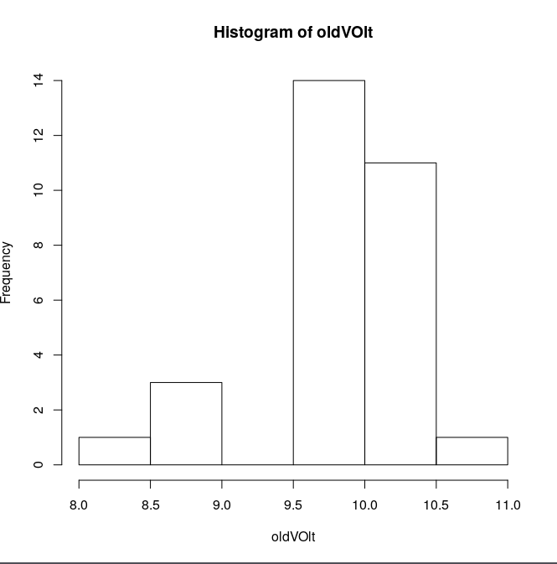
22) a. Relative Frequency Table:

44

b. Stem Table

The Stem graph is more informative, but less presentable than the Frequency Table.
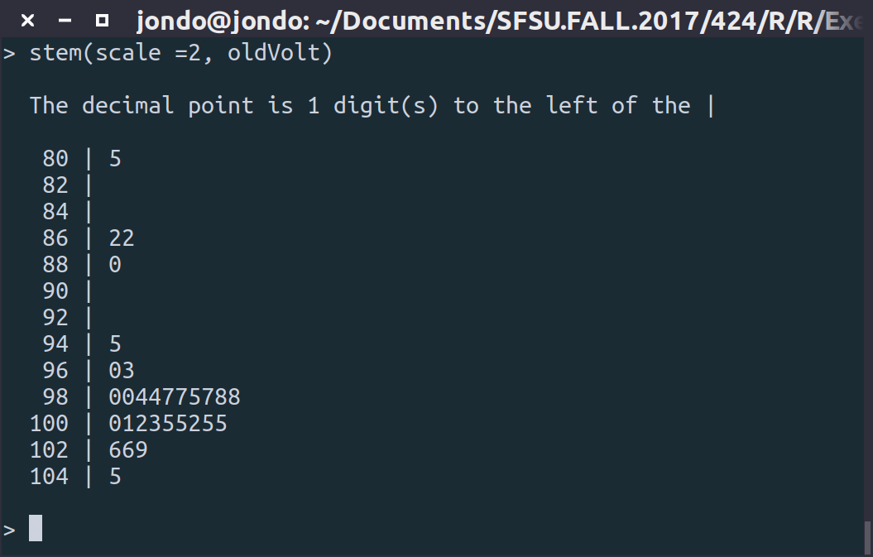

c. Frequency Table for new Voltages
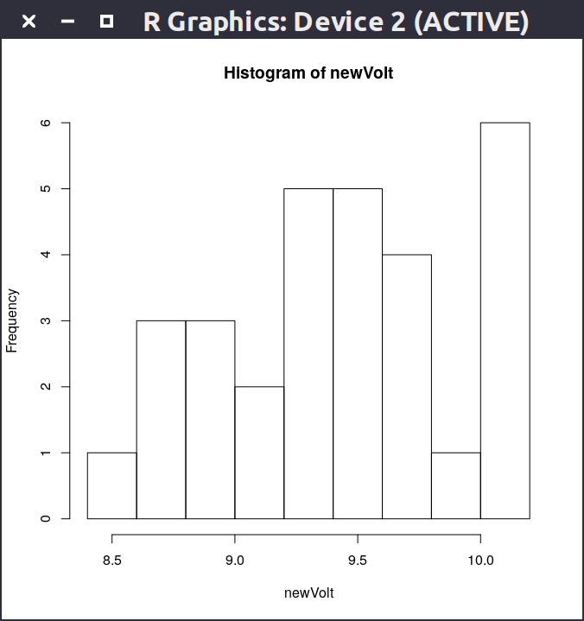

d. With an acceptable range of x>9.2V, the old method appears to be more successful in production, therefore the production is less effective when completed locally.

1.26)
a. The relative frequency table for nicotine content appears to trend towards a normal distribution, with a slight skew near 0.075 on the left hand side.
b. (0.15395, 1.53605)
c. This appears to encompass at least 95% of the graph.
d. Given the data from the SAS histogram, the interval of (0.15395, 1.53605) contained 95.44998% of the values, confirming the esimation of at encompassing at least 95% of the values. The value agrees with the estimate in part c.
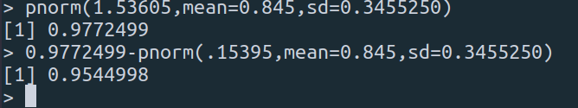

1.44)
a. The parameter of interest in this study is the difference between scores on the personality test and the scores on the aggression tests, which is labeled EFFSIZE, or effect size. They are interested in whether or not that one influences the other.
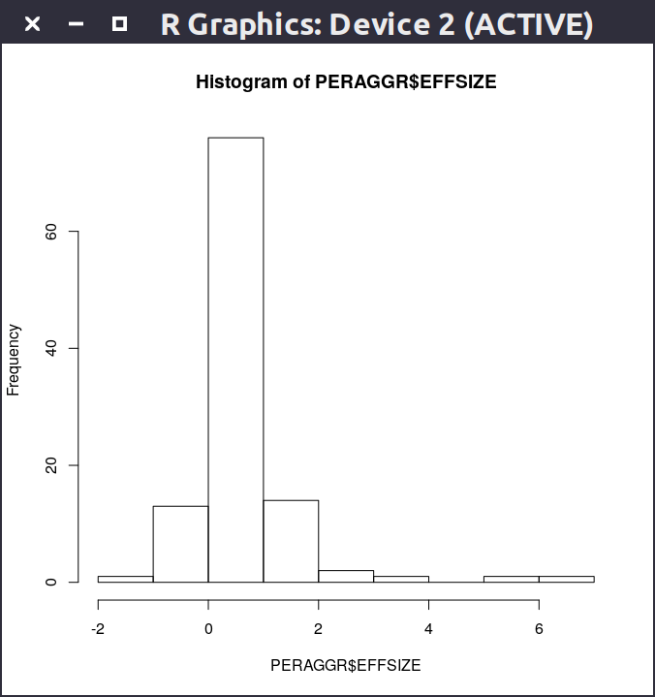
b. Looking at the given dot plot, the data appears to have a closely normal distribution with the exception of a few very high outliers. The answer is irrelevant because we expect the difference to be normal due to the central limit theorem.
c. The 95% CI stated is (0.4786, 0.8167), which when applied to the miniTab output, does not seem accurate in the slightest; However, doing my own histogram for the dataset reveals that this seems to be a much more accurate and believable CI.

d. Reasonably, the researchers can conclude that within the confidence level, the

1.55)
a. H_0 : μ = 15ppm
H_a : μ < 15ppm
b. A type 1 error would be in this case concluding that the level of mercury uptake is below 15ppm when the actual value is NOT below 15ppm.
c. A type 2 error would be in this case concluding that the level of mercury uptake is equal to 15ppm when the actual value is below 15ppm.

1.67)

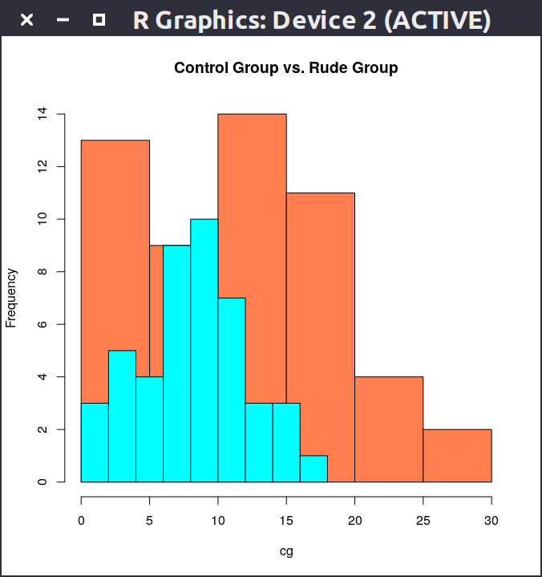

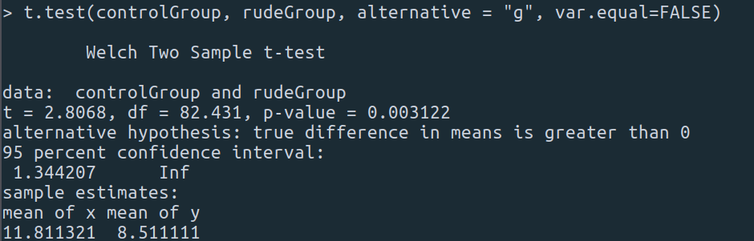
According to the 2-sample test, the p value calculated is 0.003312 which is very small, in which we must reject the null hypothesis and instead support the alternative. The group with the rude condition placed on them performed worse than the control group without the condition.

1.70)

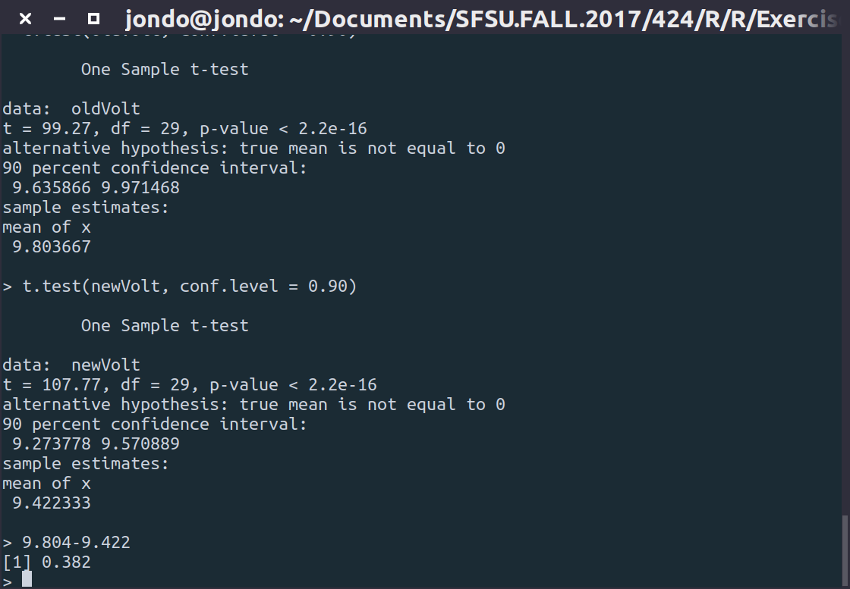

With the new Voltages having an estimated mean of 9.422 and CI (9.274 , 9.570)
and the old Voltages having an estimated mean of 9.804 and CI (9.646 , 9.971), the estimated difference between the means is 0.382. From this we can form the conclusion that the old location was on average more effective at a 90% confidence.

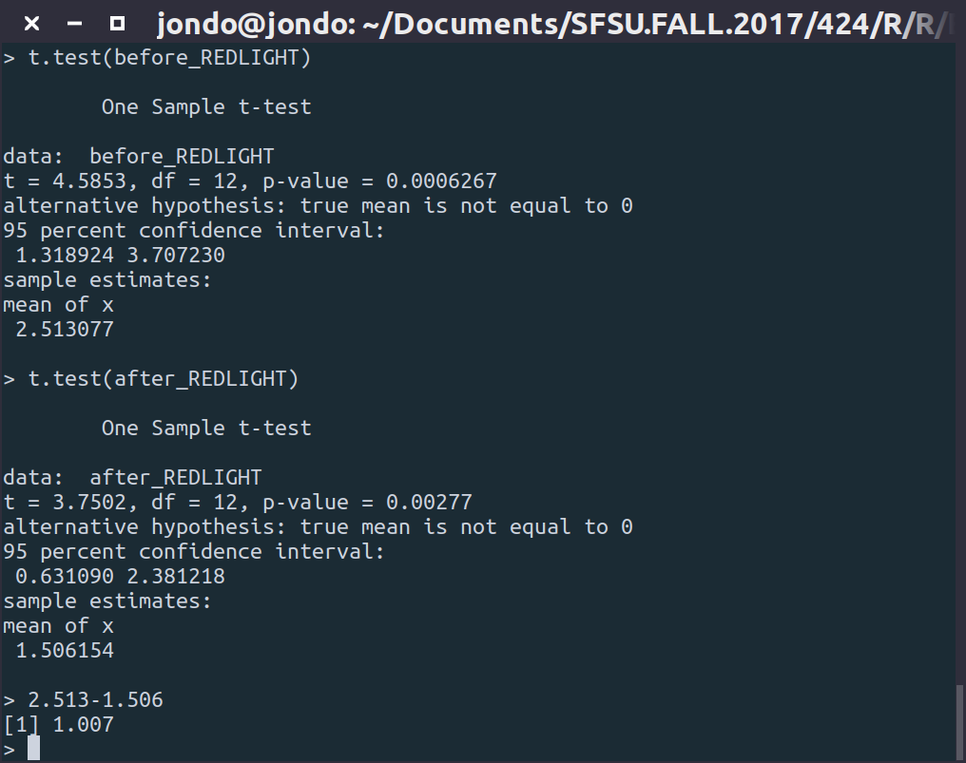
1.72)

Before the installation of the redlight system, the average of collisions with a 95% confidence was 2.513, after the installation of the system the average changed to 1.506 with a 1.007 difference in the collisions.

1.75)
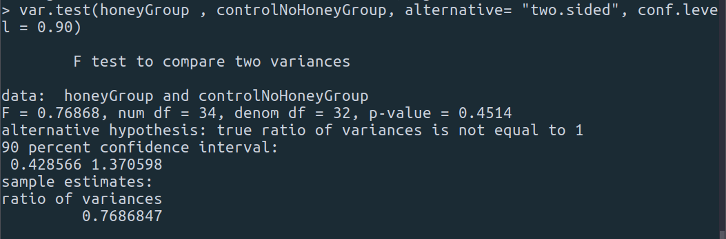
a) With a calculated p-value of 0.4514, p is considered large so we must accept the null hypothesis and conclude that the variances are reasonably the same.

Conclusion: The score variability in the two improvement scores do not differ between groups.

