INSY 3304/5335 Project

FINAL

Maximilian Lam

Gerardo Calvillo

Drew Atkison

Bobby Henson

Jeffrey Linnear

Defined Entities

Customer - Individuals that purchase furniture through orders

Furniture- Large movable equipment suitable for living or working.

Orders - an authoritative command, direction, or instruction.

Truck - a large, heavy motor vehicle used for transporting goods, materials, or troops

Shipment - the action of shipping goods.

Employee - The employees of the company.

Sales Rep- the employee who takes orders from customers.

Driver - the employee who delivers the shipments to customers.

Relationship Matrix

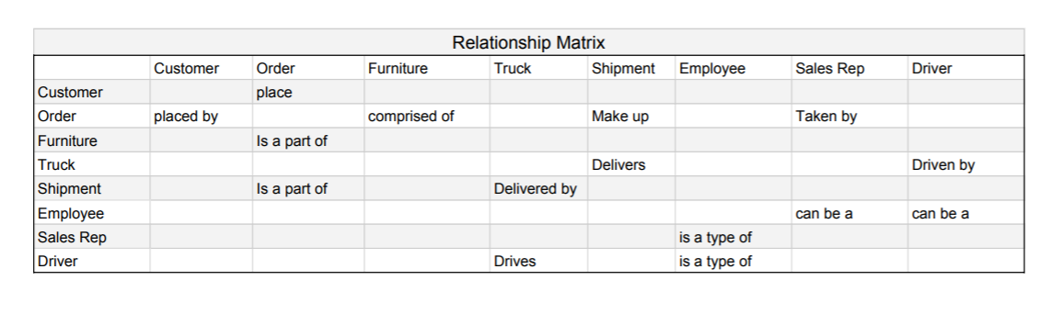

Business Rules

Each Customer sometimes places one or more order.

Each Order is always placed by one Customer.

Each Order is always comprised of one or more Furniture.

Each Furniture is sometimes part of one or more Orders.

Each Order always makes up one or more Shipments.

Each Shipment is always part of one Order.

Each Truck sometimes delivers one or more Shipments.

Each Shipment is always delivered by one Truck.

Each Sales Rep sometimes takes one or more Orders.

Each Order is always taken by one Sales Rep.

Each Driver always drives one truck.

Each Truck is always driven by one Driver.

An Employee can be a driver.

A Driver is a type of Employee.

An Employee can be a Sales Rep.

A Sales Rep is a type of Employee.

Conceptual Model

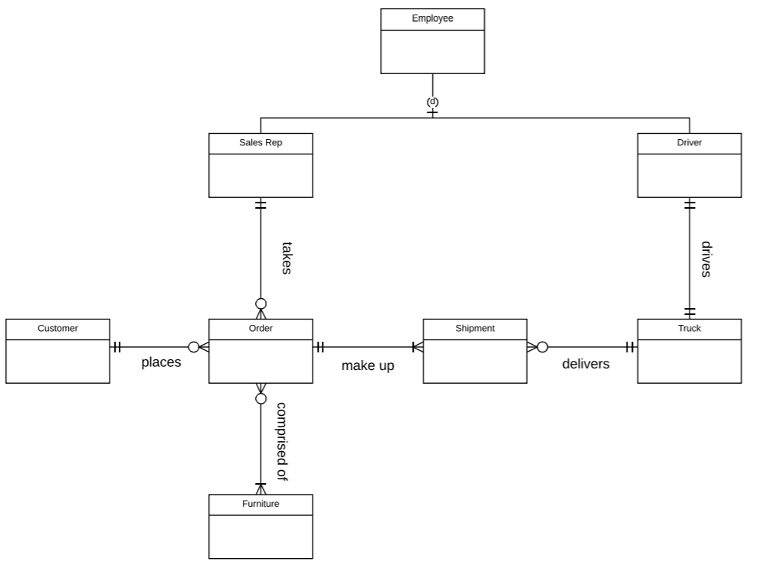

Internal Model

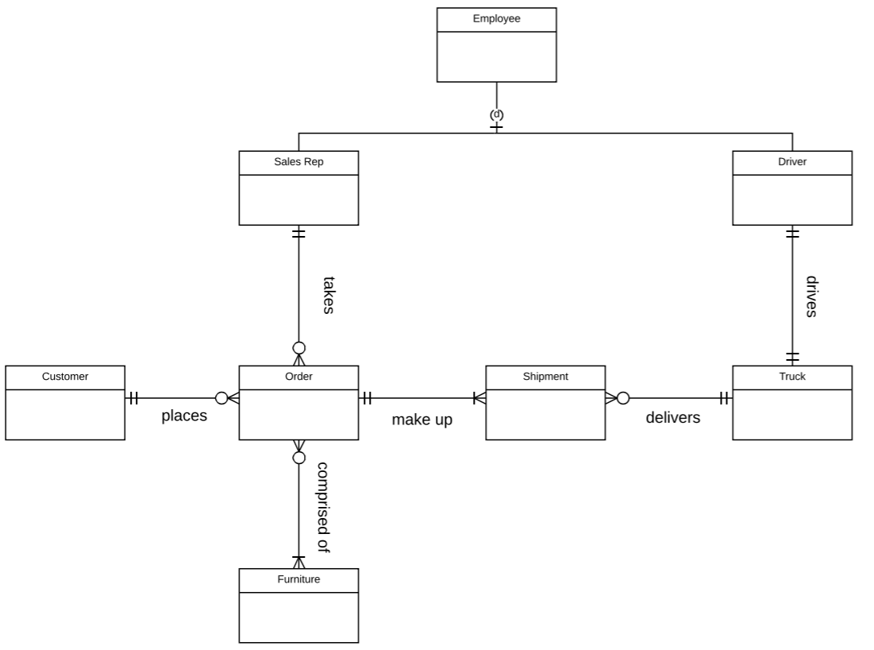

Database Schema

Customer(accountNum, firstName, lastName, phoneNum, billingAddress)

Orders(orderNum, shippingAddress, orderDate, empid, accountNum)

Purchase(orderNum, itemCode, extendedPrice, quantitySold)

Furniture(itemCode, fdescription, unitPrice, quantity)

Shipment(shipmentId, shippingDate, orderNum)

Sales Rep(empId, commission, profitGenerated)

Driver(empId, licenseNum, licenseExp, vehicleNum)

Truck(vehicleNum, licenseExpDate, inspectionExpDate, shipmentId)

Employee(empId, ssn, firstName, lastName, eAddress, phone, salary)

