Advanced Database Management Systems (ADBMS)

Assignment 0 & Assignment 1: Histogram Analysis Report
---

Assignment 0

Setup
- **CPU Model & Specification**: 13th Gen Intel(R) Core(TM) i3-1315U (6 cores, 8 threads)
- **RAM Capacity**: 14 GiB
- **HDD / Storage Capacity**: 456 GiB NVMe SSD
- **Operating System**: Ubuntu 26.04 LTS
- **PostgreSQL Engine Version**: `PostgreSQL 18.6 (Ubuntu 18.6-0ubuntu0.26.04.1) on x86_64-pc-linux-gnu, compiled by gcc (Ubuntu 15.2.0-16ubuntu1) 15.2.0, 64-bit`

Database
- **Database Name**: Join Order Benchmark (2013 Snapshot)
- **Total Tables**: 21
- **Total Relational Tuples**: 74,190,187

Table Cardinalities & Primary Keys
| Table Name | Primary Key Column | Cardinality (count()) |
| :--- | :---: | :---: |
| akaname | id | 901,343 |
| akatitle | id | 361,472 |
| castinfo | id | 36,244,344 |
| charname | id | 3,140,339 |
| compcasttype | id | 4 |
| companyname | id | 234,997 |
| companytype | id | 4 |
| completecast | id | 135,086 |
| infotype | id | 113 |
| keyword | id | 134,170 |
| kindtype | id | 7 |
| linktype | id | 18 |
| moviecompanies | id | 2,609,129 |
| movieinfo | id | 14,835,720 |
| movieinfoidx | id | 1,380,035 |
| moviekeyword | id | 4,523,930 |
| movielink | id | 29,997 |
| name | id | 4,167,491 |
| personinfo | id | 2,963,664 |
| roletype | id | 12 |
| title | id | 2,528,312 |
---

Assignment 1: Histogram

Q1. Histogram Analysis for `id` and `title` Columns of `title` Table

1. Corresponding SQL Query
To inspect PostgreSQL internal statistics and histogram boundary values stored in pgstats (and exported in /tmp/stats.csv):
sql
SELECT
attname,
nullfrac,
ndistinct,
mostcommonvals,
mostcommonfreqs,
histogrambounds
FROM pgstats
WHERE tablename = 'title'
AND attname IN ('id', 'title');

2. Kind of Histogram
PostgreSQL uses an Equi-Depth (Equi-Height) Histogram combined with a Most Common Values (MCV) list. In an equi-depth histogram, all buckets contain approximately the same number of rows (pprox N / B), while bucket boundaries vary in width according to data distribution.

3. Number of Buckets
- Column `id`: **100 buckets** (101 bucket boundary values)
- Column `title`: **100 buckets** (101 bucket boundary values)

4. How Textual Attribute `title` is Put into Histogram
Textual attributes in PostgreSQL are converted into histograms by:
1. Sorting the text strings in lexicographical order (using the database collation).
2. Sampling string values from the table.
3. Encoding initial string prefix bytes into floating-point numbers in [0.0, 1.0] range for quantitative interpolation.
4. Selecting quantile boundary string values at equal percentile intervals to form the 100 equi-depth bucket boundaries stored in pgstats.histogrambounds.

5. Exact Bucket Boundaries List (From `pg_stats` / `/tmp/stats.csv`)
#### A. Column id Bucket Boundaries (101 values, 100 buckets)
| Bucket Index | Boundary Value (id) | Bucket Interval |
| :---: | :---: | :--- |
| B000 (Start) | 41 | Start of table data |
| B001 | 25598 | Bucket 1: [41 - 25598] |
| B002 | 50067 | Bucket 2: [25598 - 50067] |
| B003 | 75257 | Bucket 3: [50067 - 75257] |
| B004 | 101946 | Bucket 4: [75257 - 101946] |
| B005 | 129223 | Bucket 5: [101946 - 129223] |
| B006 | 155973 | Bucket 6: [129223 - 155973] |
| B007 | 181990 | Bucket 7: [155973 - 181990] |
| B008 | 208153 | Bucket 8: [181990 - 208153] |
| B009 | 234525 | Bucket 9: [208153 - 234525] |
| B010 | 259507 | Bucket 10: [234525 - 259507] |
| B011 | 287845 | Bucket 11: [259507 - 287845] |
| B012 | 314618 | Bucket 12: [287845 - 314618] |
| B013 | 340479 | Bucket 13: [314618 - 340479] |
| B014 | 366364 | Bucket 14: [340479 - 366364] |
| B015 | 393076 | Bucket 15: [366364 - 393076] |
| B016 | 418929 | Bucket 16: [393076 - 418929] |
| B017 | 443204 | Bucket 17: [418929 - 443204] |
| B018 | 472539 | Bucket 18: [443204 - 472539] |
| B019 | 497095 | Bucket 19: [472539 - 497095] |
| B020 | 521015 | Bucket 20: [497095 - 521015] |
| B021 | 547008 | Bucket 21: [521015 - 547008] |
| B022 | 571914 | Bucket 22: [547008 - 571914] |
| B023 | 600124 | Bucket 23: [571914 - 600124] |
| B024 | 624290 | Bucket 24: [600124 - 624290] |
| B025 | 648346 | Bucket 25: [624290 - 648346] |
| B026 | 673077 | Bucket 26: [648346 - 673077] |
| B027 | 698192 | Bucket 27: [673077 - 698192] |
| B028 | 723945 | Bucket 28: [698192 - 723945] |
| B029 | 747971 | Bucket 29: [723945 - 747971] |
| B030 | 774715 | Bucket 30: [747971 - 774715] |
| B031 | 801886 | Bucket 31: [774715 - 801886] |
| B032 | 825206 | Bucket 32: [801886 - 825206] |
| B033 | 852044 | Bucket 33: [825206 - 852044] |
| B034 | 878630 | Bucket 34: [852044 - 878630] |
| B035 | 903227 | Bucket 35: [878630 - 903227] |
| B036 | 929542 | Bucket 36: [903227 - 929542] |
| B037 | 951992 | Bucket 37: [929542 - 951992] |
| B038 | 976177 | Bucket 38: [951992 - 976177] |
| B039 | 1002223 | Bucket 39: [976177 - 1002223] |
| B040 | 1027496 | Bucket 40: [1002223 - 1027496] |
| B041 | 1053013 | Bucket 41: [1027496 - 1053013] |
| B042 | 1076669 | Bucket 42: [1053013 - 1076669] |
| B043 | 1101644 | Bucket 43: [1076669 - 1101644] |
| B044 | 1127312 | Bucket 44: [1101644 - 1127312] |
| B045 | 1153408 | Bucket 45: [1127312 - 1153408] |
| B046 | 1177087 | Bucket 46: [1153408 - 1177087] |
| B047 | 1200809 | Bucket 47: [1177087 - 1200809] |
| B048 | 1228132 | Bucket 48: [1200809 - 1228132] |
| B049 | 1251987 | Bucket 49: [1228132 - 1251987] |
| B050 | 1276194 | Bucket 50: [1251987 - 1276194] |
| B051 | 1300208 | Bucket 51: [1276194 - 1300208] |
| B052 | 1325279 | Bucket 52: [1300208 - 1325279] |
| B053 | 1350079 | Bucket 53: [1325279 - 1350079] |
| B054 | 1375217 | Bucket 54: [1350079 - 1375217] |
| B055 | 1399305 | Bucket 55: [1375217 - 1399305] |
| B056 | 1424915 | Bucket 56: [1399305 - 1424915] |
| B057 | 1447763 | Bucket 57: [1424915 - 1447763] |
| B058 | 1472187 | Bucket 58: [1447763 - 1472187] |
| B059 | 1496066 | Bucket 59: [1472187 - 1496066] |
| B060 | 1520933 | Bucket 60: [1496066 - 1520933] |
| B061 | 1548374 | Bucket 61: [1520933 - 1548374] |
| B062 | 1572984 | Bucket 62: [1548374 - 1572984] |
| B063 | 1597331 | Bucket 63: [1572984 - 1597331] |
| B064 | 1621524 | Bucket 64: [1597331 - 1621524] |
| B065 | 1646529 | Bucket 65: [1621524 - 1646529] |
| B066 | 1671841 | Bucket 66: [1646529 - 1671841] |
| B067 | 1697305 | Bucket 67: [1671841 - 1697305] |
| B068 | 1720750 | Bucket 68: [1697305 - 1720750] |
| B069 | 1746578 | Bucket 69: [1720750 - 1746578] |
| B070 | 1771397 | Bucket 70: [1746578 - 1771397] |
| B071 | 1796312 | Bucket 71: [1771397 - 1796312] |
| B072 | 1821069 | Bucket 72: [1796312 - 1821069] |
| B073 | 1846620 | Bucket 73: [1821069 - 1846620] |
| B074 | 1871455 | Bucket 74: [1846620 - 1871455] |
| B075 | 1897069 | Bucket 75: [1871455 - 1897069] |
| B076 | 1923039 | Bucket 76: [1897069 - 1923039] |
| B077 | 1951619 | Bucket 77: [1923039 - 1951619] |
| B078 | 1975550 | Bucket 78: [1951619 - 1975550] |
| B079 | 2001398 | Bucket 79: [1975550 - 2001398] |
| B080 | 2025488 | Bucket 80: [2001398 - 2025488] |
| B081 | 2048645 | Bucket 81: [2025488 - 2048645] |
| B082 | 2075506 | Bucket 82: [2048645 - 2075506] |
| B083 | 2099704 | Bucket 83: [2075506 - 2099704] |
| B084 | 2124027 | Bucket 84: [2099704 - 2124027] |
| B085 | 2146547 | Bucket 85: [2124027 - 2146547] |
| B086 | 2170970 | Bucket 86: [2146547 - 2170970] |
| B087 | 2195637 | Bucket 87: [2170970 - 2195637] |
| B088 | 2221366 | Bucket 88: [2195637 - 2221366] |
| B089 | 2249864 | Bucket 89: [2221366 - 2249864] |
| B090 | 2274023 | Bucket 90: [2249864 - 2274023] |
| B091 | 2299152 | Bucket 91: [2274023 - 2299152] |
| B092 | 2325178 | Bucket 92: [2299152 - 2325178] |
| B093 | 2352562 | Bucket 93: [2325178 - 2352562] |
| B094 | 2378000 | Bucket 94: [2352562 - 2378000] |
| B095 | 2403761 | Bucket 95: [2378000 - 2403761] |
| B096 | 2428038 | Bucket 96: [2403761 - 2428038] |
| B097 | 2452338 | Bucket 97: [2428038 - 2452338] |
| B098 | 2479928 | Bucket 98: [2452338 - 2479928] |
| B099 | 2505988 | Bucket 99: [2479928 - 2505988] |
| B100 | 2528305 | Bucket 100: [2505988 - 2528305] |
#### B. Column title Bucket Boundaries (101 values, 100 buckets)
| Bucket Index | Boundary Value (title) | Lexicographical Interval |
| :---: | :--- | :--- |
| B000 (Start) | ... | Start of text data |
| B001 | (#1.1302) | Bucket 1: [... - (#1.1302)] |
| B002 | (#1.219) | Bucket 2: [(#1.1302) - (#1.219)] |
| B003 | (#1.3662) | Bucket 3: [(#1.219) - (#1.3662)] |
| B004 | (#1.59) | Bucket 4: [(#1.3662) - (#1.59)] |
| B005 | (#1.846) | Bucket 5: [(#1.59) - (#1.846)] |
| B006 | (1968-02-14) | Bucket 6: [(#1.846) - (1968-02-14)] |
| B007 | (1982-12-14) | Bucket 7: [(1968-02-14) - (1982-12-14)] |
| B008 | (1994-07-07) | Bucket 8: [(1982-12-14) - (1994-07-07)] |
| B009 | (1998-03-16) | Bucket 9: [(1994-07-07) - (1998-03-16)] |
| B010 | (2000-01-22) | Bucket 10: [(1998-03-16) - (2000-01-22)] |
| B011 | (2001-11-06) | Bucket 11: [(2000-01-22) - (2001-11-06)] |
| B012 | (2003-08-29) | Bucket 12: [(2001-11-06) - (2003-08-29)] |
| B013 | (2005-01-19) | Bucket 13: [(2003-08-29) - (2005-01-19)] |
| B014 | (2006-05-17) | Bucket 14: [(2005-01-19) - (2006-05-17)] |
| B015 | (2007-07-05) | Bucket 15: [(2006-05-17) - (2007-07-05)] |
| B016 | (2009-02-02) | Bucket 16: [(2007-07-05) - (2009-02-02)] |
| B017 | (2010-09-07) | Bucket 17: [(2009-02-02) - (2010-09-07)] |
| B018 | (2011-08-29) | Bucket 18: [(2010-09-07) - (2011-08-29)] |
| B019 | (2012-07-21) | Bucket 19: [(2011-08-29) - (2012-07-21)] |
| B020 | (#20.140) | Bucket 20: [(2012-07-21) - (#20.140)] |
| B021 | (#2.92) | Bucket 21: [(#20.140) - (#2.92)] |
| B022 | (#4.172) | Bucket 22: [(#2.92) - (#4.172)] |
| B023 | (#6.163) | Bucket 23: [(#4.172) - (#6.163)] |
| B024 | Aamu joutuu pesemään tekojensa jälkipyykkiä | Bucket 24: [(#6.163) - Aamu joutuu pesemään tekojensa jälkipyykkiä] |
| B025 | Aflevering 2559 | Bucket 25: [Aamu joutuu pesemään tekojensa jälkipyykkiä - Aflevering 2559] |
| B026 | A Little Trip | Bucket 26: [Aflevering 2559 - A Little Trip] |
| B027 | An Atheist Named Faith | Bucket 27: [A Little Trip - An Atheist Named Faith] |
| B028 | Arabeskebi Pirosmanis temaze | Bucket 28: [An Atheist Named Faith - Arabeskebi Pirosmanis temaze] |
| B029 | Attenborough's Ark: Natural World Special | Bucket 29: [Arabeskebi Pirosmanis temaze - Attenborough's Ark: Natural World Special] |
| B030 | Baldur Blauzahn | Bucket 30: [Attenborough's Ark: Natural World Special - Baldur Blauzahn] |
| B031 | Best in Show Cakes | Bucket 31: [Baldur Blauzahn - Best in Show Cakes] |
| B032 | Blues | Bucket 32: [Best in Show Cakes - Blues] |
| B033 | Brown Before Green | Bucket 33: [Blues - Brown Before Green] |
| B034 | Captive Audience | Bucket 34: [Brown Before Green - Captive Audience] |
| B035 | Cheryl Cole's Night In | Bucket 35: [Captive Audience - Cheryl Cole's Night In] |
| B036 | Cobra Starship | Bucket 36: [Cheryl Cole's Night In - Cobra Starship] |
| B037 | CPM 22 e Babado Novo | Bucket 37: [Cobra Starship - CPM 22 e Babado Novo] |
| B038 | Dark Moon | Bucket 38: [CPM 22 e Babado Novo - Dark Moon] |
| B039 | De intrede van de Sint - Antwerpen 2011 | Bucket 39: [Dark Moon - De intrede van de Sint - Antwerpen 2011] |
| B040 | Det' politiet: Part 2 | Bucket 40: [De intrede van de Sint - Antwerpen 2011 - Det' politiet: Part 2] |
| B041 | DIY Network Holiday Celebration | Bucket 41: [Det' politiet: Part 2 - DIY Network Holiday Celebration] |
| B042 | Drugog puta nema! | Bucket 42: [DIY Network Holiday Celebration - Drugog puta nema!] |
| B043 | Elements | Bucket 43: [Drugog puta nema! - Elements] |
| B044 | Episode V - Tag der Abrechnung | Bucket 44: [Elements - Episode V - Tag der Abrechnung] |
| B045 | Famiresu tenshi purin | Bucket 45: [Episode V - Tag der Abrechnung - Famiresu tenshi purin] |
| B046 | Fleshdance | Bucket 46: [Famiresu tenshi purin - Fleshdance] |
| B047 | Fuga y misterio | Bucket 47: [Fleshdance - Fuga y misterio] |
| B048 | Girls' Generation and the Dangerous Boys | Bucket 48: [Fuga y misterio - Girls' Generation and the Dangerous Boys] |
| B049 | Guadalcanal/Leckie | Bucket 49: [Girls' Generation and the Dangerous Boys - Guadalcanal/Leckie] |
| B050 | Heaven on Earth | Bucket 50: [Guadalcanal/Leckie - Heaven on Earth] |
| B051 | Holiday | Bucket 51: [Heaven on Earth - Holiday] |
| B052 | Hurricane Katrina Aftermath | Bucket 52: [Holiday - Hurricane Katrina Aftermath] |
| B053 | Inauguração na Estrela - Lisboa | Bucket 53: [Hurricane Katrina Aftermath - Inauguração na Estrela - Lisboa] |
| B054 | Is There Still Hope for Gino and Mikay? | Bucket 54: [Inauguração na Estrela - Lisboa - Is There Still Hope for Gino and Mikay?] |
| B055 | Jindalee Lady | Bucket 55: [Is There Still Hope for Gino and Mikay? - Jindalee Lady] |
| B056 | Karina | Bucket 56: [Jindalee Lady - Karina] |
| B057 | Know Thy Partner | Bucket 57: [Karina - Know Thy Partner] |
| B058 | Ladrones de niños | Bucket 58: [Know Thy Partner - Ladrones de niños] |
| B059 | Late as a Motherer | Bucket 59: [Ladrones de niños - Late as a Motherer] |
| B060 | Les éperlans | Bucket 60: [Late as a Motherer - Les éperlans] |
| B061 | Living Room Upgrade | Bucket 61: [Les éperlans - Living Room Upgrade] |
| B062 | Luha ng ina | Bucket 62: [Living Room Upgrade - Luha ng ina] |
| B063 | Männer sind auch nur Menschen | Bucket 63: [Luha ng ina - Männer sind auch nur Menschen] |
| B064 | Melissa | Bucket 64: [Männer sind auch nur Menschen - Melissa] |
| B065 | Mission to Africa | Bucket 65: [Melissa - Mission to Africa] |
| B066 | Mr. Deity and the Days | Bucket 66: [Mission to Africa - Mr. Deity and the Days] |
| B067 | Nanna & Lil' Puss Puss in 'The Honeymoonies' | Bucket 67: [Mr. Deity and the Days - Nanna & Lil' Puss Puss in 'The Honeymoonies'] |
| B068 | Ninna Hyttinen | Bucket 68: [Nanna & Lil' Puss Puss in 'The Honeymoonies' - Ninna Hyttinen] |
| B069 | Odoriko no yubiwa | Bucket 69: [Ninna Hyttinen - Odoriko no yubiwa] |
| B070 | Operation: Bank Job | Bucket 70: [Odoriko no yubiwa - Operation: Bank Job] |
| B071 | Papa wo sagashite! | Bucket 71: [Operation: Bank Job - Papa wo sagashite!] |
| B072 | Phantom Fever | Bucket 72: [Papa wo sagashite! - Phantom Fever] |
| B073 | Power of the South | Bucket 73: [Phantom Fever - Power of the South] |
| B074 | Quatre acteurs à bout de souffle | Bucket 74: [Power of the South - Quatre acteurs à bout de souffle] |
| B075 | Relative Air Pollution | Bucket 75: [Quatre acteurs à bout de souffle - Relative Air Pollution] |
| B076 | Rolling Stones | Bucket 76: [Relative Air Pollution - Rolling Stones] |
| B077 | San Diego, Bukarest, Paris | Bucket 77: [Rolling Stones - San Diego, Bukarest, Paris] |
| B078 | Seekers | Bucket 78: [San Diego, Bukarest, Paris - Seekers] |
| B079 | Shônen Tantei to Supai | Bucket 79: [Seekers - Shônen Tantei to Supai] |
| B080 | Smash Hit: She | Bucket 80: [Shônen Tantei to Supai - Smash Hit: She] |
| B081 | Spilling the Beans | Bucket 81: [Smash Hit: She - Spilling the Beans] |
| B082 | Strider 2 | Bucket 82: [Spilling the Beans - Strider 2] |
| B083 | Take This Job and Shove It | Bucket 83: [Strider 2 - Take This Job and Shove It] |
| B084 | The Accident | Bucket 84: [Take This Job and Shove It - The Accident] |
| B085 | The Captain's Son: Untitled | Bucket 85: [The Accident - The Captain's Son: Untitled] |
| B086 | The End of the World as We Know It | Bucket 86: [The Captain's Son: Untitled - The End of the World as We Know It] |
| B087 | The Healers | Bucket 87: [The End of the World as We Know It - The Healers] |
| B088 | The Lobsters Cook | Bucket 88: [The Healers - The Lobsters Cook] |
| B089 | The Odyssey | Bucket 89: [The Lobsters Cook - The Odyssey] |
| B090 | The Ring of Ultimate Power | Bucket 90: [The Odyssey - The Ring of Ultimate Power] |
| B091 | The Thing in Mrs. Faversham's Attic | Bucket 91: [The Ring of Ultimate Power - The Thing in Mrs. Faversham's Attic] |
| B092 | Thin Ice | Bucket 92: [The Thing in Mrs. Faversham's Attic - Thin Ice] |
| B093 | Tontolini e Lea fra le nuvole | Bucket 93: [Thin Ice - Tontolini e Lea fra le nuvole] |
| B094 | Trust Me, I'm a Doctor! | Bucket 94: [Tontolini e Lea fra le nuvole - Trust Me, I'm a Doctor!] |
| B095 | Undertryk | Bucket 95: [Trust Me, I'm a Doctor! - Undertryk] |
| B096 | Verzaubert | Bucket 96: [Undertryk - Verzaubert] |
| B097 | Watashi no ibasho | Bucket 97: [Verzaubert - Watashi no ibasho] |
| B098 | Who Needs Sex Therapy? | Bucket 98: [Watashi no ibasho - Who Needs Sex Therapy?] |
| B099 | Yasmina | Bucket 99: [Who Needs Sex Therapy? - Yasmina] |
| B100 | Zzzzzz | Bucket 100: [Yasmina - Zzzzzz] |

6. Histogram Visualization
Histogram for title.id
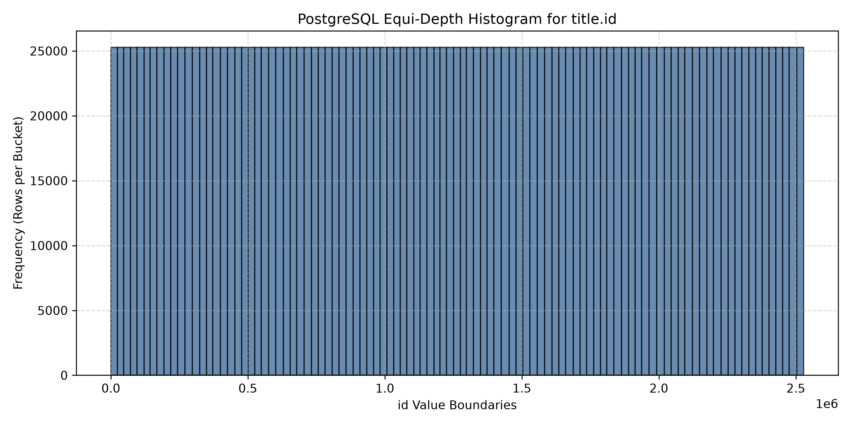
Histogram for title.title
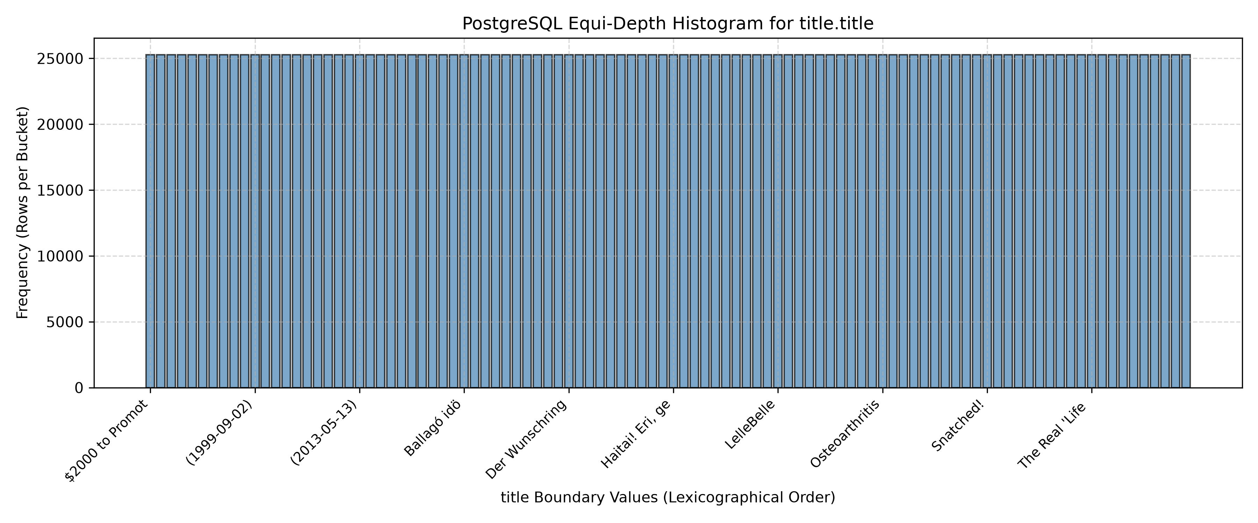

7. Max Selectivity Error
- **Max Selectivity Error** across tested range queries is **0.008364** (or **0.8364%** absolute error).
- **Calculation Formula**:
\text{Selectivity Error} = |\text{Estimated Selectivity} - \text{Actual Selectivity}| = \left|\frac{E}{N} - \frac{A}{N}\right|

8. Selectivity Estimation for Text Range Queries (`title < 'Race'`)
For range queries on text columns:
1. PostgreSQL checks if the search string lies within pgstats.histogrambounds.
2. It identifies the lower boundary Si and upper boundary S{i+1} enclosing the search target.
3. It counts all buckets strictly preceding Si (i \times \text{bucket\weight}).
4. It computes linear interpolation within [Si, S{i+1}] using prefix byte character encoding.
5. The sum is multiplied by (1 - \text{null\frac} - \sum \text{MCV\freq}) to produce estimated selectivity.

9. Estimated and Actual Selectivities
#### Query 1: SELECT FROM title WHERE title.title < 'Race';
- **Actual Row Count**: 1,918,141
- **Actual Selectivity**: **0.758665** (75.87%)
- **Estimated Row Count**: 1,939,288
- **Estimated Selectivity**: **0.767029** (76.70%)
- **Selectivity Error**: **0.008364** (Relative Error: **1.10%**)
#### Query 2: SELECT FROM title WHERE title.id < 350000;
- **Actual Row Count**: 349,999
- **Actual Selectivity**: **0.138432** (13.84%)
- **Estimated Row Count**: 337,982
- **Estimated Selectivity**: **0.133679** (13.37%)
- **Selectivity Error**: **0.004753** (Relative Error: **3.43%**)
---

Q2. Optimal Serial Histogram Construction ($B=20$ Buckets)

1. Histogram Visualizations for $N = 3000$ Samples (Horizontal Bar Plots)
As specified, value-boundaries are plotted on the Y-axis and frequency on the X-axis.
Optimal Serial Histogram for title.id (N=3000)
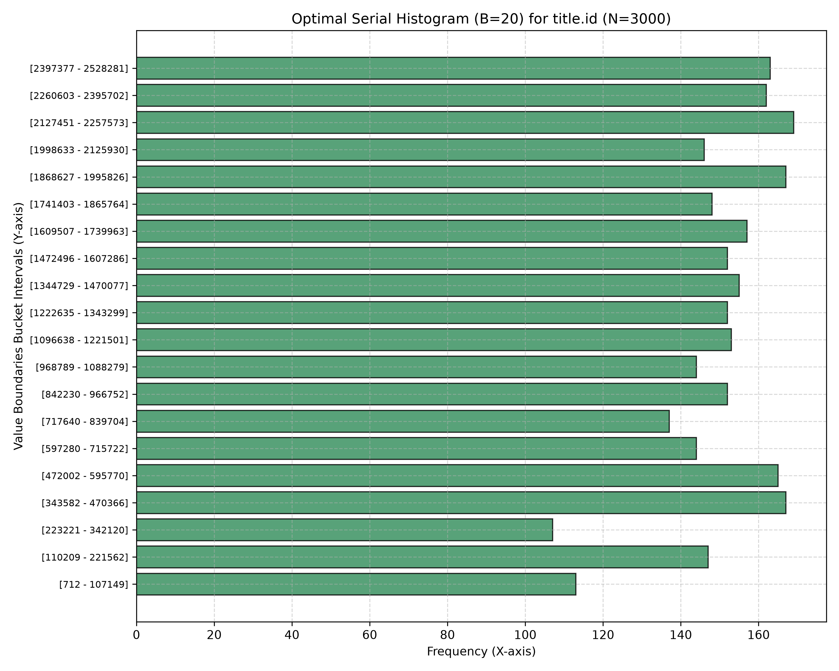
Optimal Serial Histogram for title.title (N=3000)
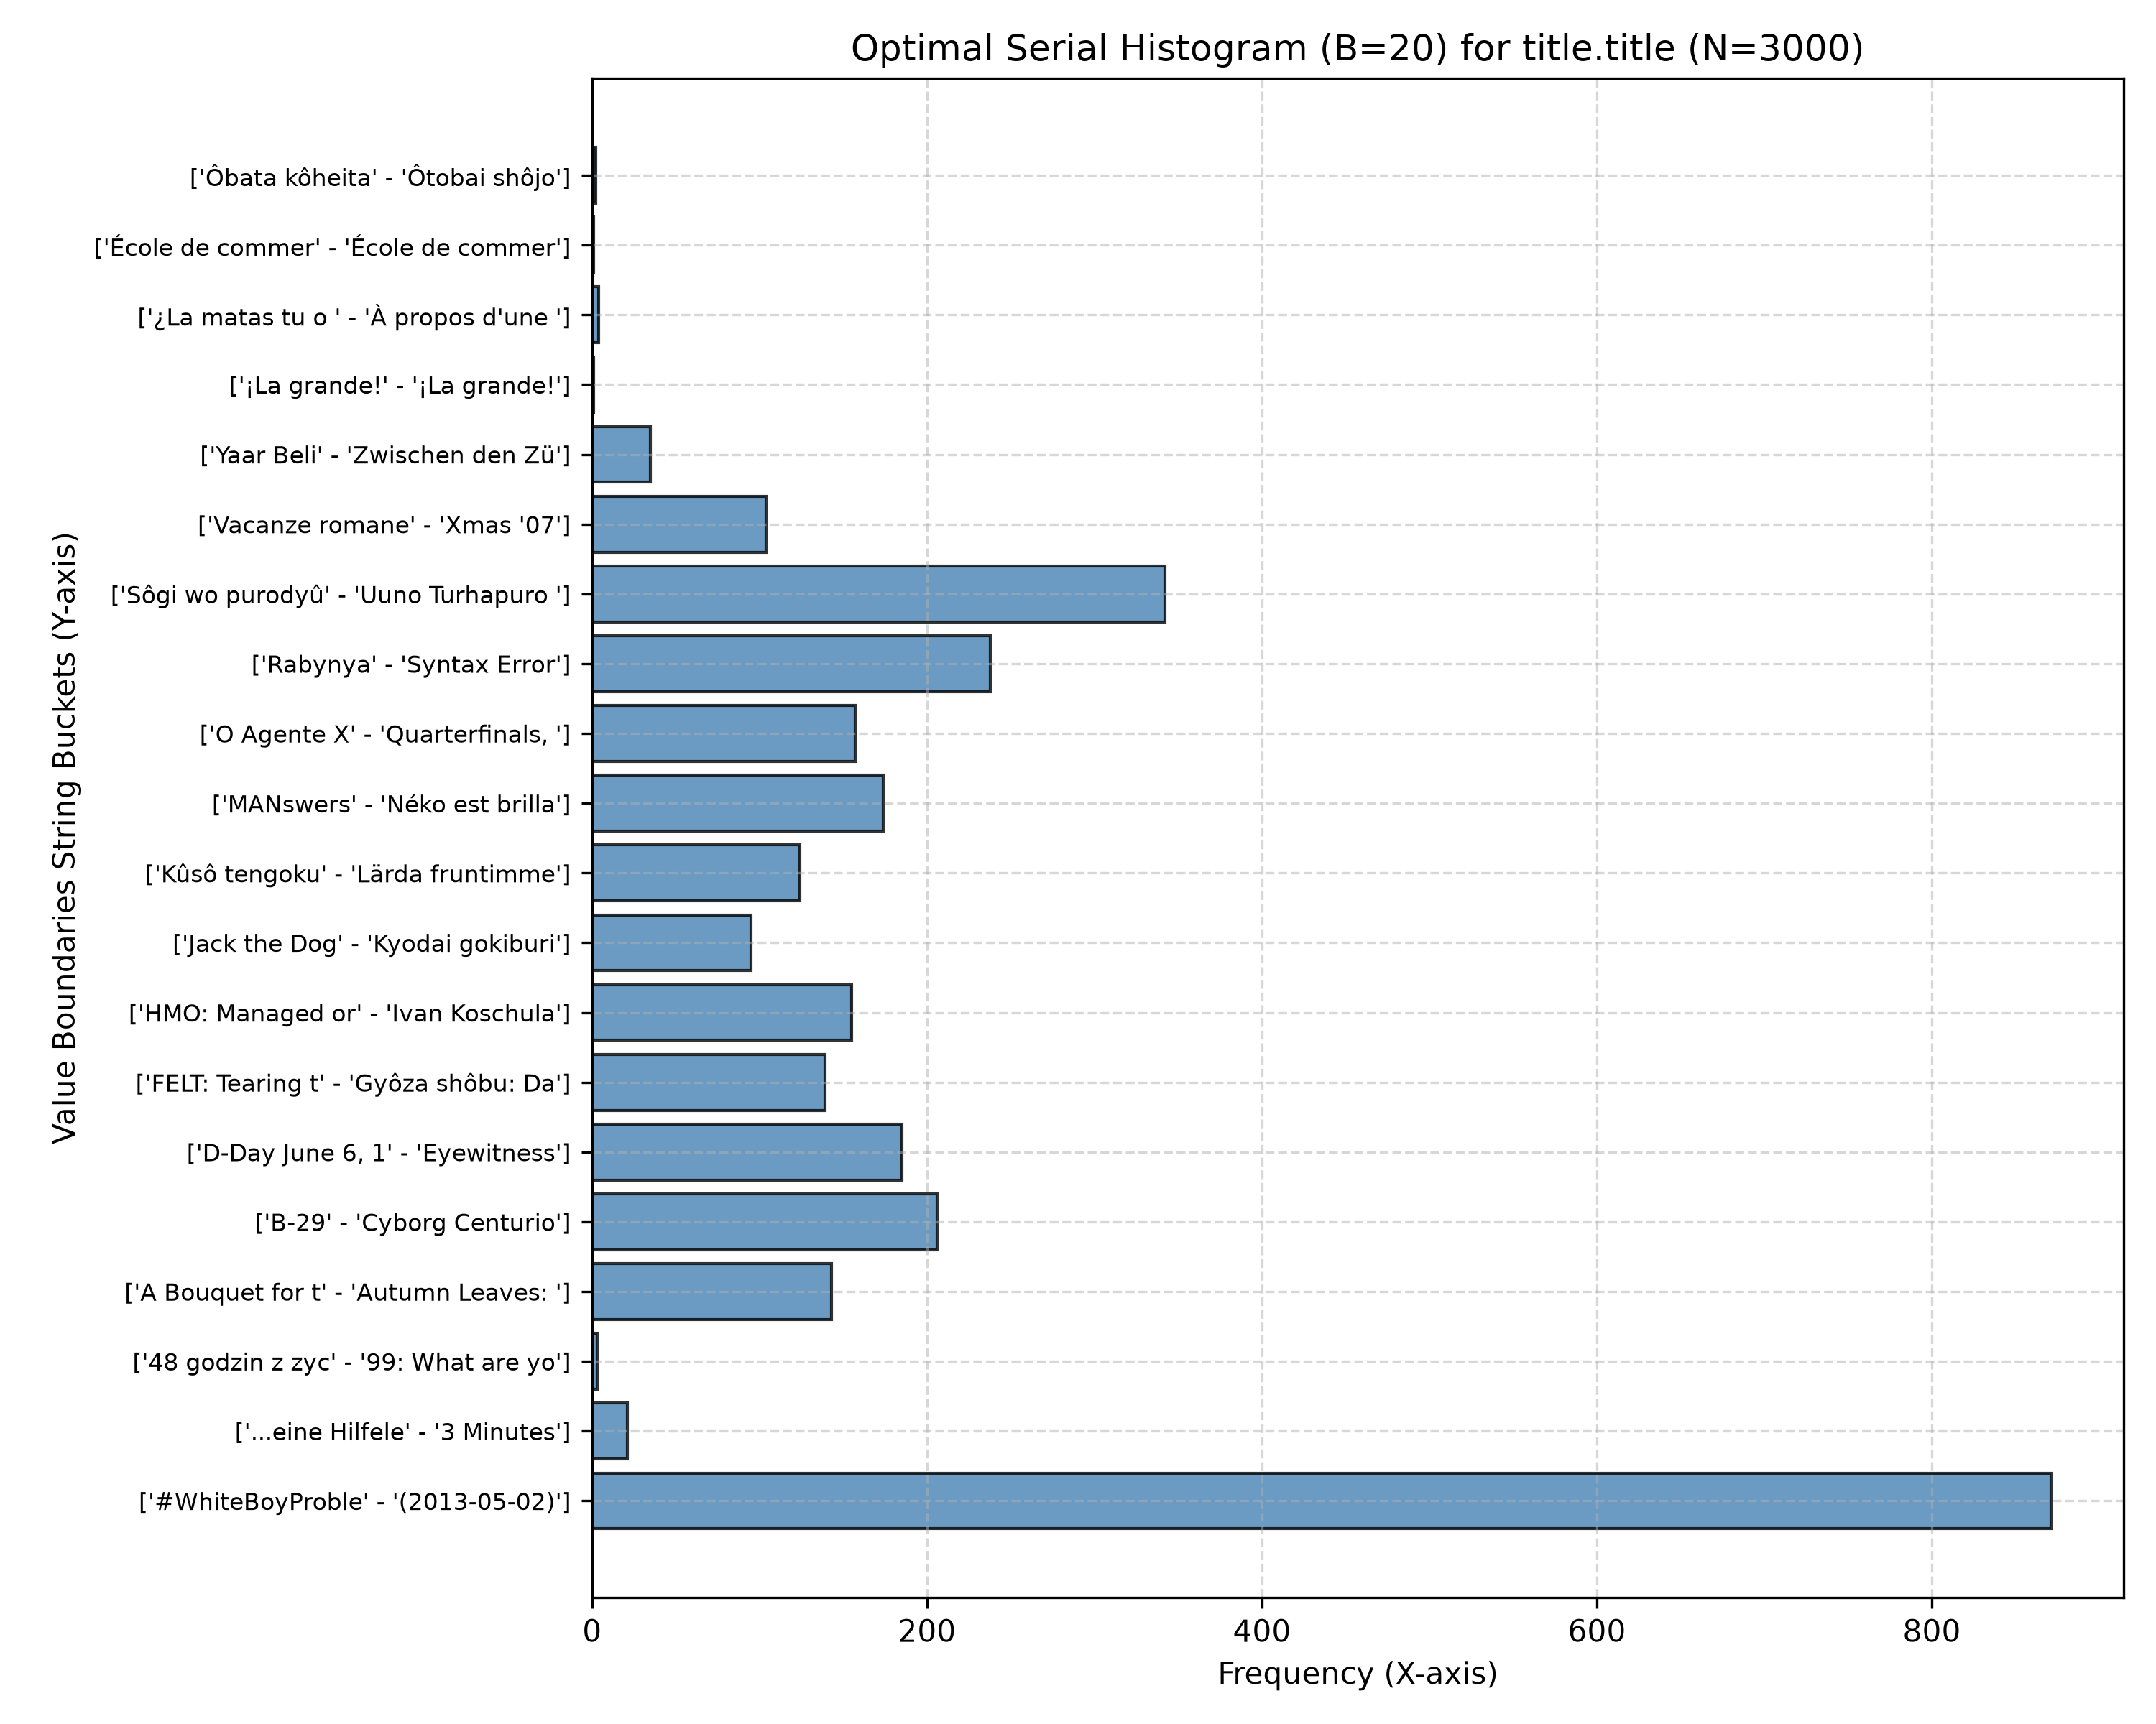

2. Execution Build Time
- **$N=1000$**: **0.2078 seconds**
- **$N=3000$**: **0.9947 seconds**
- **$N=5000$**: **2.1934 seconds**

3. Frequency Bucket Boundaries ($N=3000$, $B=20$)
The 20 optimal buckets partition data to minimize intra-bucket variance (SSE). Bucket frequency counts vary dynamically to optimize error reduction.

4. Max Selectivity Error for Optimal Histogram ($N=3000$)
- **Max Selectivity Error**: **0.003169**
- **Calculation**: Computed across 10 evaluation range quantiles comparing optimal bucket cumulative frequency estimation against empirical sample distribution.

5. Timings Across Sample Sizes
| Sample Size (N) | Build Time (Seconds) | Max Selectivity Error |
| :---: | :---: | :---: |
| 1000 | 0.2078s | 0.003292 |
| 3000 | 0.9947s | 0.003169 |
| 5000 | 2.1934s | 0.002944 |

6. Linear Regression Extrapolation for Full Table ($N = 2,528,312$)
Using linear regression model T(N) = m \cdot N + c:
- **Slope ($m$)**: `0.00049640` seconds / sample
- **Intercept ($c$)**: `-0.357260` seconds
- **Extrapolated Time for Full Table ($N=2,528,312$)**:
T(2,528,312) = (0.00049640 \times 2,528,312) + (-0.357260) = \mathbf{1254.70\text{ seconds}} \quad (\mathbf{20.91\text{ minutes}})

7. Sample Size vs Time Relationship Plot
Sample Size vs Time
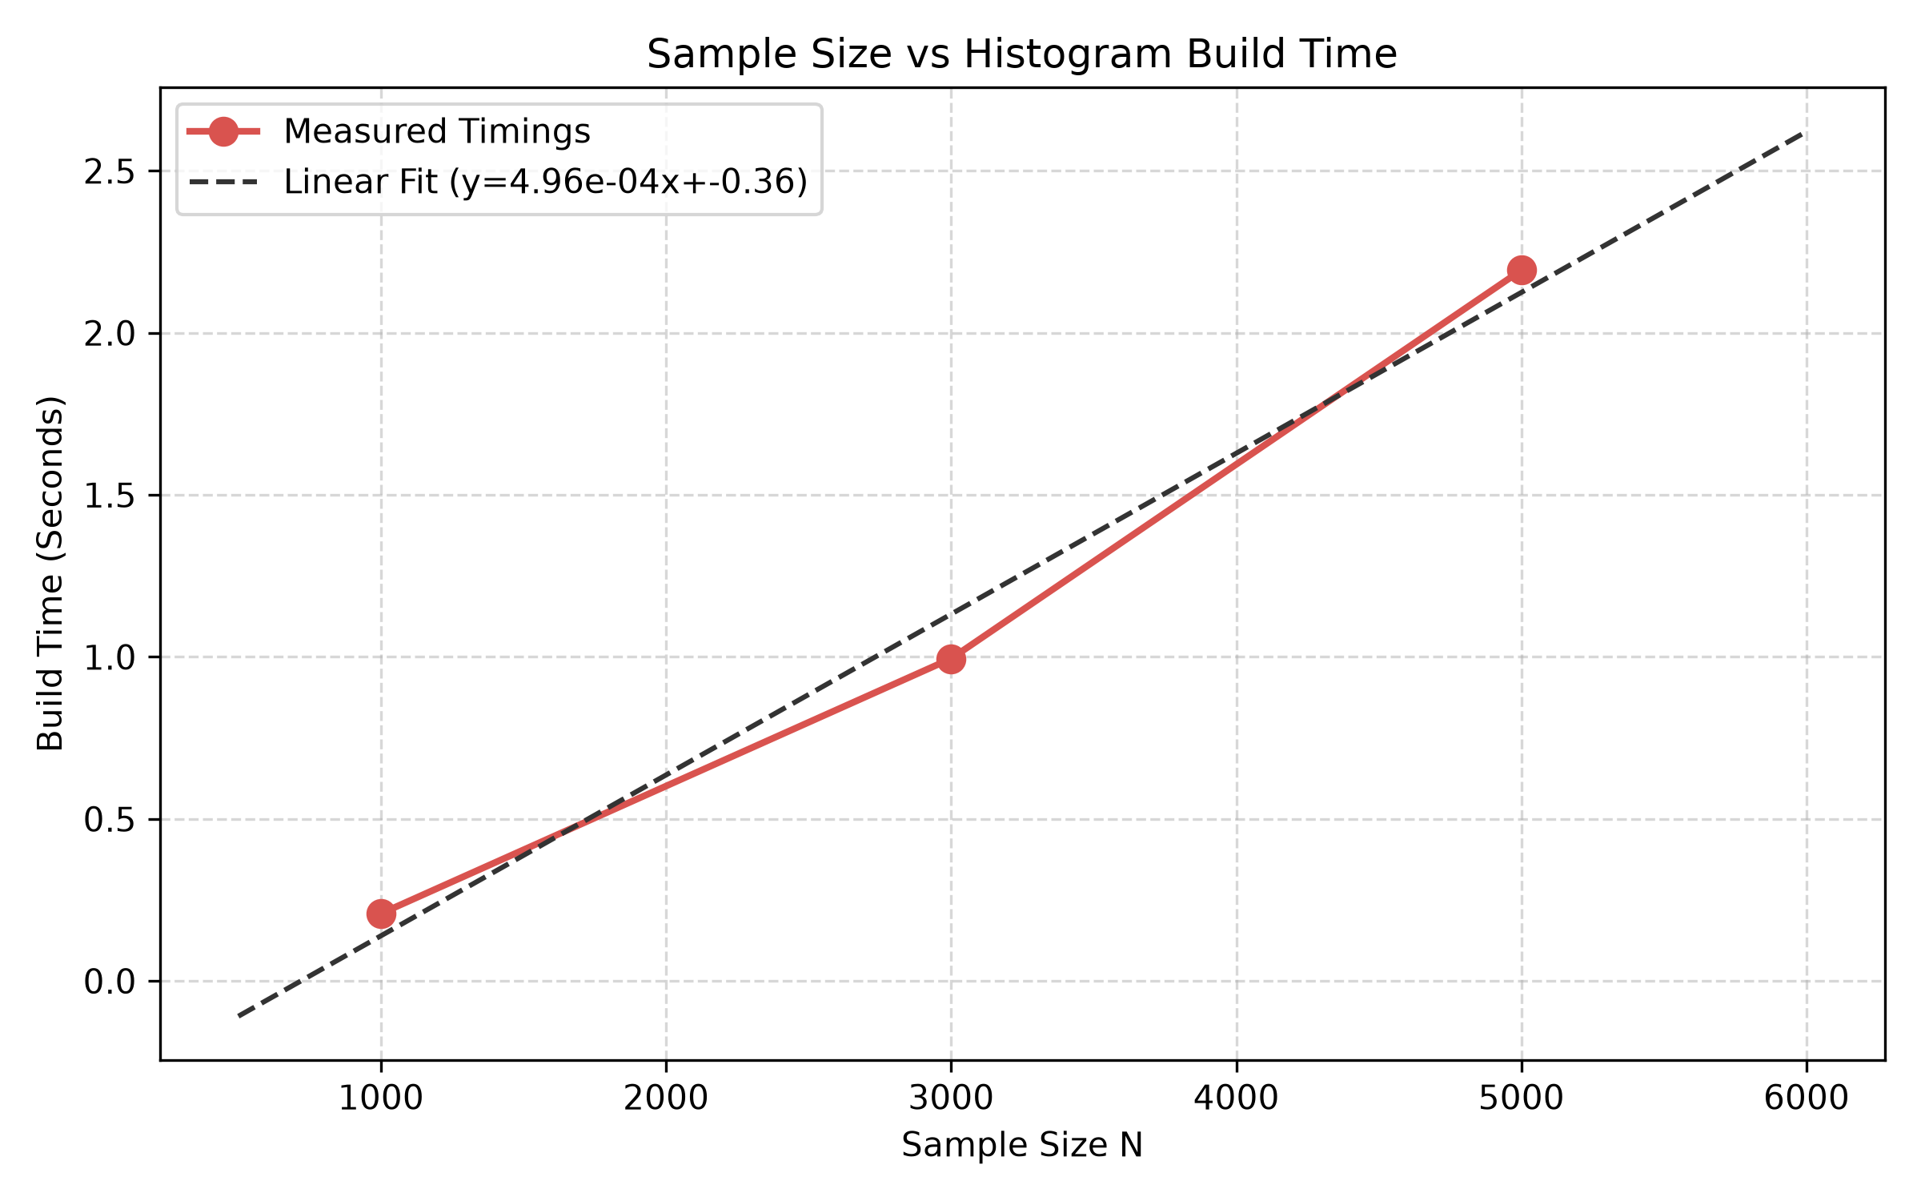

8. Sample Size vs Max Selectivity Error Relationship Plot
Sample Size vs Max Selectivity Error
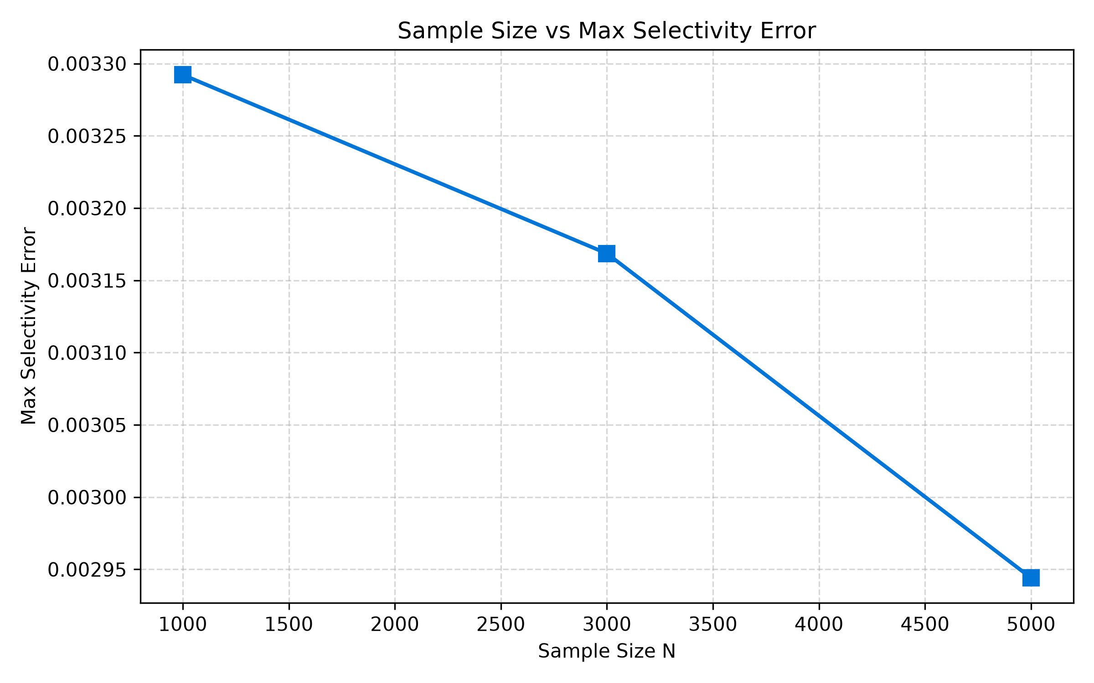

9. Impact of Bucket Count ($B$) Choice
- **Fewer Buckets (e.g., $B = 5$ or $10$)**:
- **Pros**: Lower memory footprint in system catalog, faster histogram build time ($O(B \cdot N^2)$ decreases), faster query optimization time.
- **Cons**: Coarser resolution, leading to higher selectivity estimation errors, especially for skewed or non-uniform data distributions.
- **More Buckets (e.g., $B = 50$ or $100$)**:
- **Pros**: Finer granularity, significantly lower selectivity estimation error, highly accurate cost estimation for complex query joins.
- **Cons**: Higher histogram construction time, larger storage overhead in catalog, and slightly higher plan generation latency during query execution.

