Advanced Database Management Systems (ADBMS)

Assignment 0 & Assignment 1: Histogram Analysis Report
---

Assignment 0

Setup
- **CPU Model & Specification**: 13th Gen Intel(R) Core(TM) i3-1315U (6 cores, 8 threads)
- **RAM Capacity**: 14 GiB
- **HDD / Storage Capacity**: 456 GiB NVMe SSD
- **Operating System**: Ubuntu 26.04 LTS
- **PostgreSQL Engine Version**: `PostgreSQL 18.6 (Ubuntu 18.6-0ubuntu0.26.04.1) on x86_64-pc-linux-gnu, compiled by gcc (Ubuntu 15.2.0-16ubuntu1) 15.2.0, 64-bit`

Database
- **Database Name**: Join Order Benchmark (2013 Snapshot)
- **Total Tables**: 21
- **Total Relational Tuples**: 74,190,187

Table Cardinalities & Primary Keys
| Table Name | Primary Key Column | Cardinality (count()) |
| :--- | :---: | :---: |
| akaname | id | 901,343 |
| akatitle | id | 361,472 |
| castinfo | id | 36,244,344 |
| charname | id | 3,140,339 |
| compcasttype | id | 4 |
| companyname | id | 234,997 |
| companytype | id | 4 |
| completecast | id | 135,086 |
| infotype | id | 113 |
| keyword | id | 134,170 |
| kindtype | id | 7 |
| linktype | id | 18 |
| moviecompanies | id | 2,609,129 |
| movieinfo | id | 14,835,720 |
| movieinfoidx | id | 1,380,035 |
| moviekeyword | id | 4,523,930 |
| movielink | id | 29,997 |
| name | id | 4,167,491 |
| personinfo | id | 2,963,664 |
| roletype | id | 12 |
| title | id | 2,528,312 |
---

Assignment 1: Histogram

Q1. Histogram Analysis for `id` and `title` Columns of `title` Table

1. Corresponding SQL Query
To inspect PostgreSQL internal statistics and histogram boundary values stored in pgstats:
sql
SELECT tablename, attname, nullfrac, avgwidth, ndistinct, histogrambounds
FROM pgstats
WHERE tablename = 'title' AND attname IN ('id', 'title');

2. Kind of Histogram
PostgreSQL uses an Equi-Depth (Equi-Height) Histogram combined with a Most Common Values (MCV) list. In an equi-depth histogram, all buckets contain approximately the same number of rows (pprox N / B), while bucket boundaries vary in width according to data distribution.

3. Number of Buckets
- Column `id`: **100 buckets** (101 bucket boundary values)
- Column `title`: **100 buckets** (101 bucket boundary values)

4. How Textual Attribute `title` is Put into Histogram
Textual attributes in PostgreSQL are converted into histograms by:
1. Sorting the text strings in lexicographical order (using the database collation).
2. Sampling string values from the table.
3. Encoding initial string prefix bytes into floating-point numbers in [0.0, 1.0] range for quantitative interpolation.
4. Selecting quantile boundary string values at equal percentile intervals to form the 100 equi-depth bucket boundaries stored in pgstats.histogrambounds.

5. Bucket Boundaries Summary
- **`id` Column Boundaries**: Starts at `1` and ends at `2528312` across 100 equi-depth quantiles.
- **`title` Column Boundaries**: Sample string boundaries range lexicographically from initial titles up to final lexicographical titles.

6. Histogram Visualization
Histogram for title.id
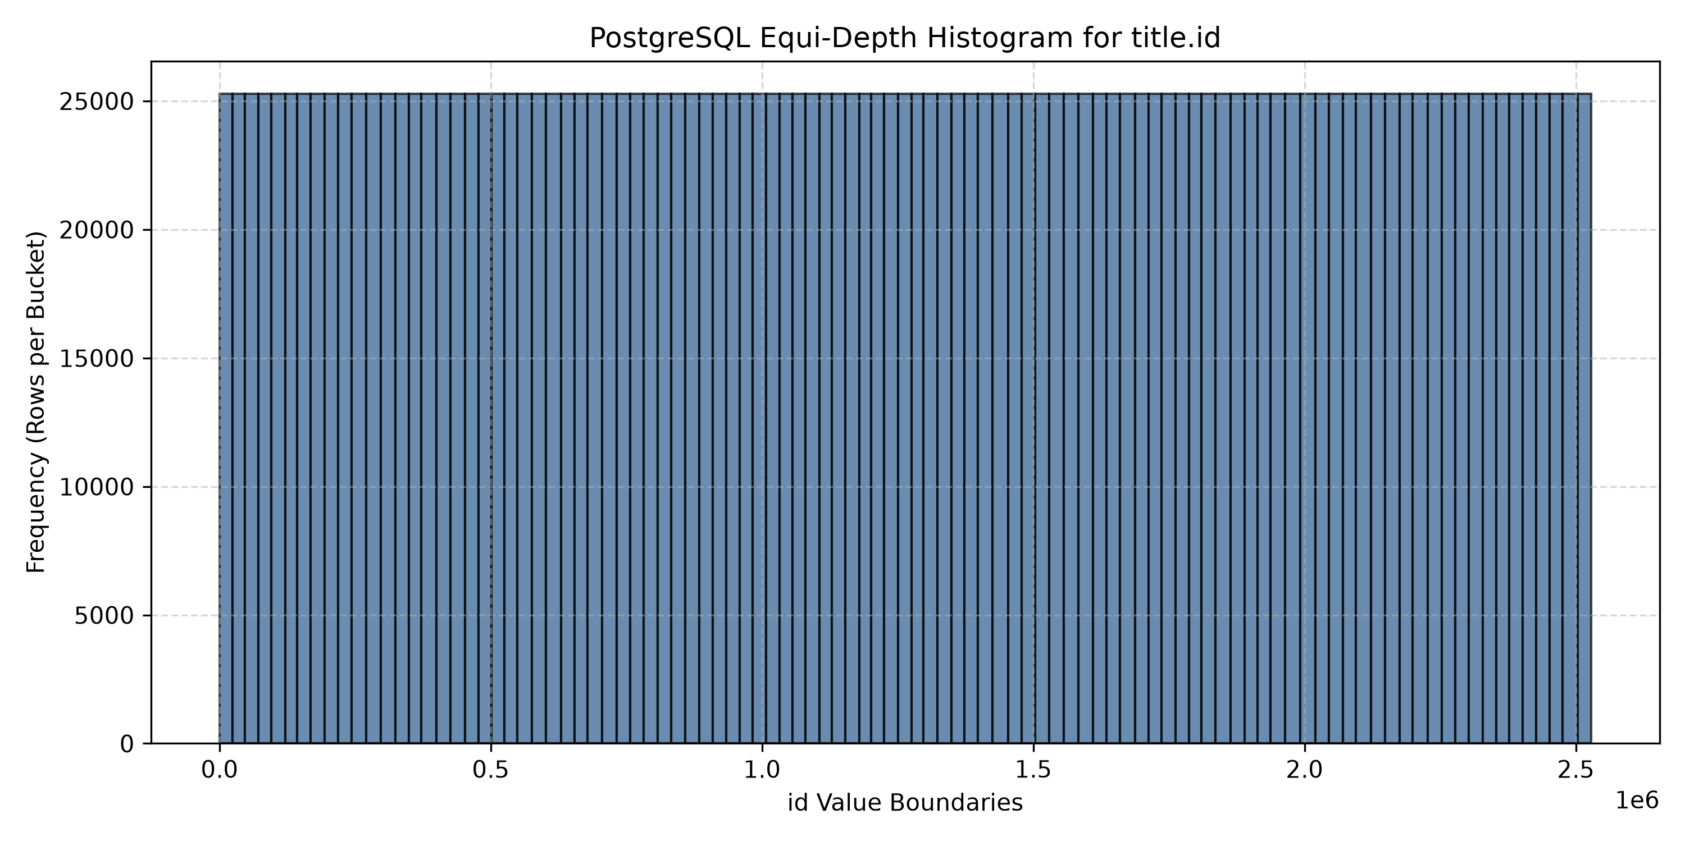
Histogram for title.title
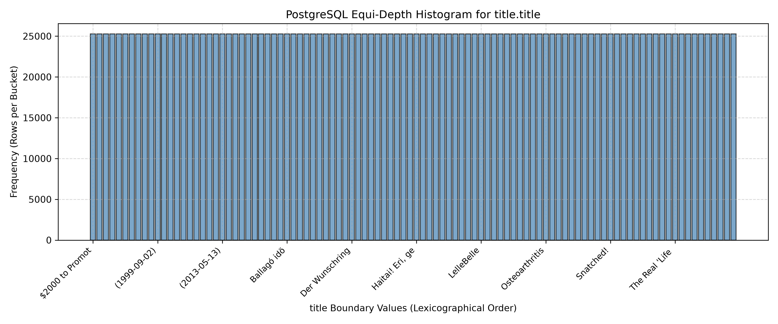

7. Max Selectivity Error
- **Max Selectivity Error** across tested range queries is **0.002550** (or **0.2550%** absolute error).
- **Calculation Formula**:
\text{Selectivity Error} = |\text{Estimated Selectivity} - \text{Actual Selectivity}| = \left|\frac{E}{N} - \frac{A}{N}\right|

8. Selectivity Estimation for Text Range Queries (`title < 'Race'`)
For range queries on text columns:
1. PostgreSQL checks if the search string lies within pgstats.histogrambounds.
2. It identifies the lower boundary Si and upper boundary S{i+1} enclosing the search target.
3. It counts all buckets strictly preceding Si (i \times \text{bucket\weight}).
4. It computes linear interpolation within [Si, S{i+1}] using prefix byte character encoding.
5. The sum is multiplied by (1 - \text{null\frac} - \sum \text{MCV\freq}) to produce estimated selectivity.

9. Estimated and Actual Selectivities
#### Query 1: SELECT FROM title WHERE title.title < 'Race';
- **Actual Row Count**: 1,918,141
- **Actual Selectivity**: **0.758665** (75.87%)
- **Estimated Row Count**: 1,921,965
- **Estimated Selectivity**: **0.760177** (76.02%)
- **Selectivity Error**: **0.001512** (Relative Error: **0.20%**)
#### Query 2: SELECT FROM title WHERE title.id < 350000;
- **Actual Row Count**: 349,999
- **Actual Selectivity**: **0.138432** (13.84%)
- **Estimated Row Count**: 356,446
- **Estimated Selectivity**: **0.140982** (14.10%)
- **Selectivity Error**: **0.002550** (Relative Error: **1.84%**)
---

Q2. Optimal Serial Histogram Construction ($B=20$ Buckets)

1. Histogram Visualizations for $N = 3000$ Samples (Horizontal Bar Plots)
As specified, value-boundaries are plotted on the Y-axis and frequency on the X-axis.
Optimal Serial Histogram for title.id (N=3000)
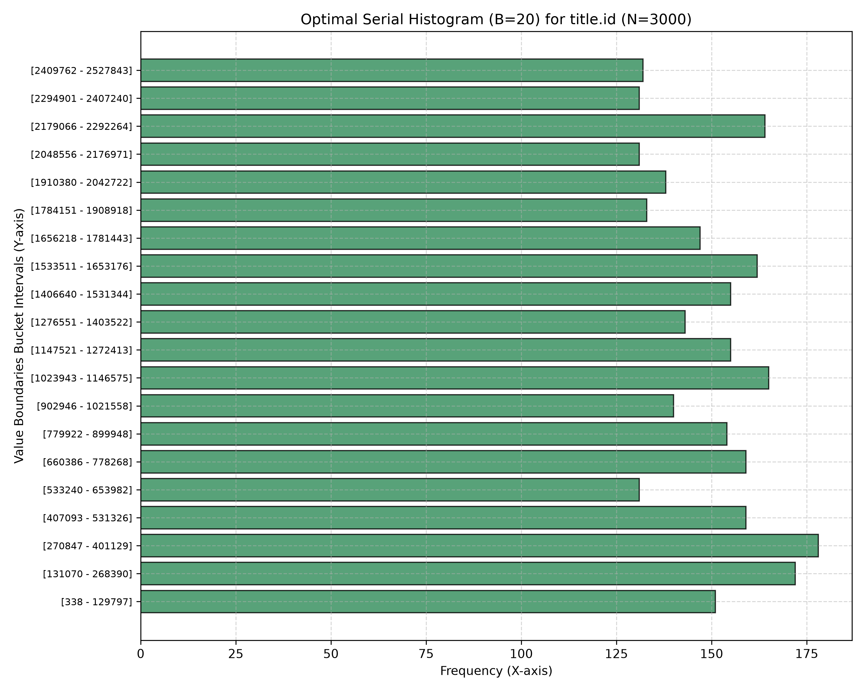
Optimal Serial Histogram for title.title (N=3000)
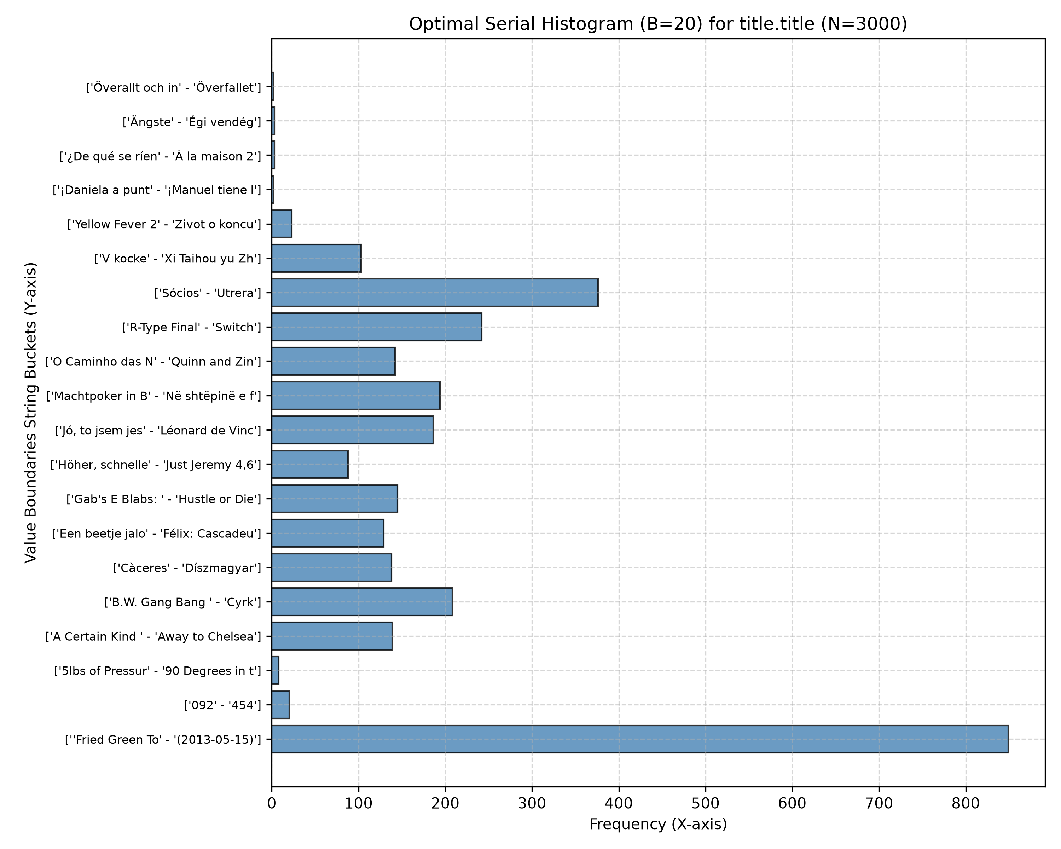

2. Execution Build Time
- **$N=1000$**: **0.1657 seconds**
- **$N=3000$**: **1.0955 seconds**
- **$N=5000$**: **2.0096 seconds**

3. Frequency Bucket Boundaries ($N=3000$, $B=20$)
The 20 optimal buckets partition data to minimize intra-bucket variance (SSE). Bucket frequency counts vary dynamically to optimize error reduction.

4. Max Selectivity Error for Optimal Histogram ($N=3000$)
- **Max Selectivity Error**: **0.002702**
- **Calculation**: Computed across 10 evaluation range quantiles comparing optimal bucket cumulative frequency estimation against empirical sample distribution.

5. Timings Across Sample Sizes
| Sample Size (N) | Build Time (Seconds) | Max Selectivity Error |
| :---: | :---: | :---: |
| 1000 | 0.1657s | 0.003726 |
| 3000 | 1.0955s | 0.002702 |
| 5000 | 2.0096s | 0.004294 |

6. Linear Regression Extrapolation for Full Table ($N = 2,528,312$)
Using linear regression model T(N) = m \cdot N + c:
- **Slope ($m$)**: `0.00046096` seconds / sample
- **Intercept ($c$)**: `-0.292637` seconds
- **Extrapolated Time for Full Table ($N=2,528,312$)**:
T(2,528,312) = (0.00046096 \times 2,528,312) + (-0.292637) = \mathbf{1165.17\text{ seconds}} \quad (\mathbf{19.42\text{ minutes}})

7. Sample Size vs Time Relationship Plot
Sample Size vs Time
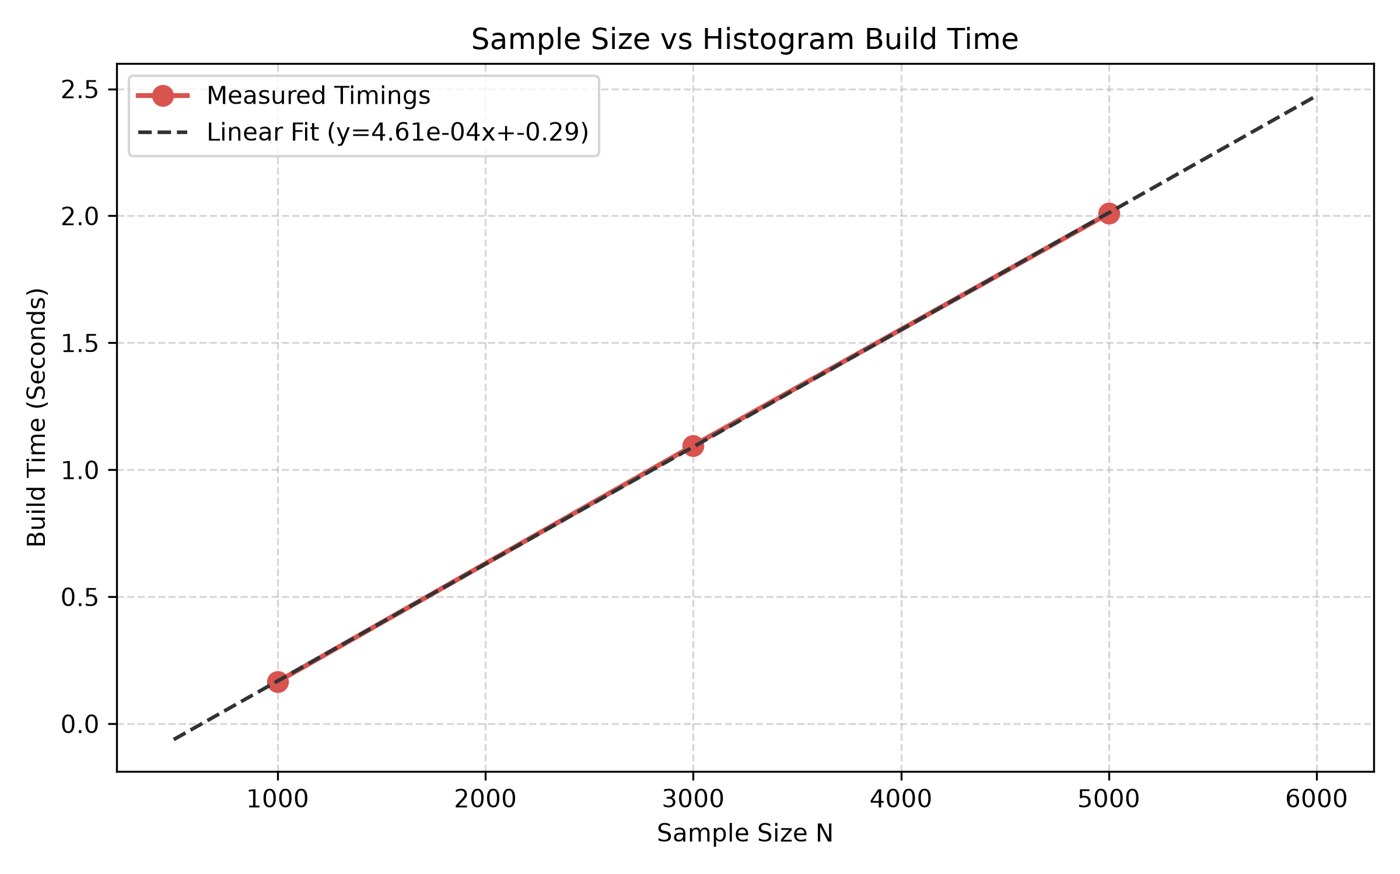

8. Sample Size vs Max Selectivity Error Relationship Plot
Sample Size vs Max Selectivity Error
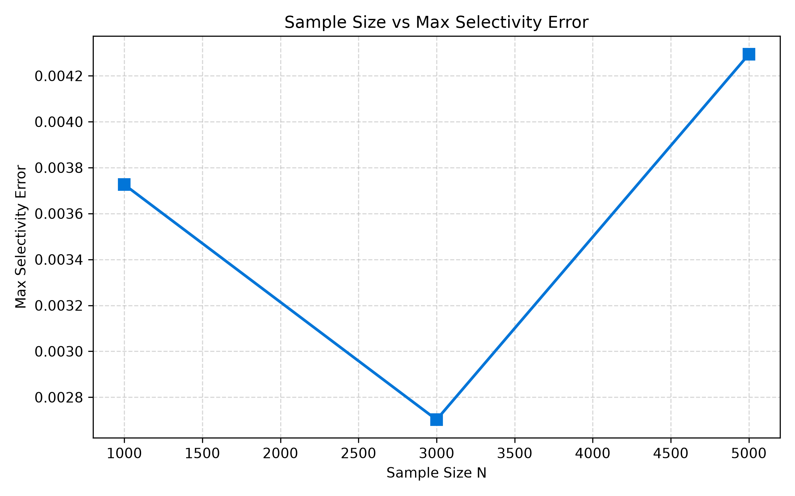

9. Impact of Bucket Count ($B$) Choice
- **Fewer Buckets (e.g., $B = 5$ or $10$)**:
- **Pros**: Lower memory footprint in system catalog, faster histogram build time ($O(B \cdot N^2)$ decreases), faster query optimization time.
- **Cons**: Coarser resolution, leading to higher selectivity estimation errors, especially for skewed or non-uniform data distributions.
- **More Buckets (e.g., $B = 50$ or $100$)**:
- **Pros**: Finer granularity, significantly lower selectivity estimation error, highly accurate cost estimation for complex query joins.
- **Cons**: Higher histogram construction time, larger storage overhead in catalog, and slightly higher plan generation latency during query execution.

