Jay Darshan Vakil

February 19, 2019

CSS142

Task 1: SE ethics

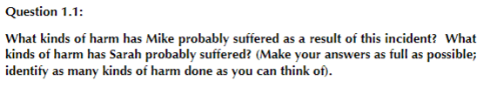

**Answer:** Due to the software glitch, Mike temporarily lost the funds which were supposed to be fees for her daughter in her college to reserve her seat. Mike also lost the trust her daughter had in him because he promised that he would pay the fees for her college. Sarah lost her seat her in the ivy-league college and she might never get the opportunity again thus, taking a hit in her future. Harms include: mental, monetary, career, relationship.

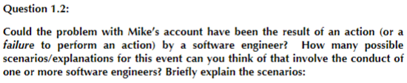

**Answer:** Perhaps, I mean in the backend many teams work simultaneously and software team might be behind this glitch. Maybe one engineer used sloppy programming to write the program that caused this glitch. Maybe the engineer did not practice proper coding standards that caused the bug. Bugs might have caused this glitch too, the bug was not completely debugged.

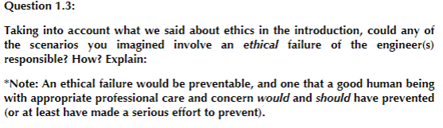

**Answer:** By not writing code according to coding standards the engineer has caused distress to the bank clients thus, that is unethical programming.

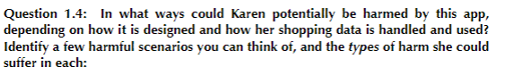

**Answer:** As karen is a lawyer at a prestigious firm, the important information that she communicates through her phone could be sold to third-party buyers which may include a rival firm. This leakage of vital data could cost her company money and lawsuits.



**Answer:** If the people from Errand Whiz are not careful or do not practice safe coding all the personal data of the users would get into the wrong hands of hackers and bad things would happen.



**Answer:** If the people from Errand Whiz are willing to limit the amount of data they collect from the user and openly tell the users what they are collecting would be ethical. Yes, errand whiz are ethically obligated to prevent them as a company and as humans.



**Answer:** Software engineers can use their skills and knowledge to prevent cyber crimes and not commit those crimes such as hacking, identity theft, spreading of viruses, malware, trojans, worms, and ransomware. Excellent software engineers can also build productive apps/softwares that can help the society.



**Answer:** I believe people who are more generous, patient, kind, caring etc are the ones that give back more.



**Answer:** The stakeholder are the common people who are going to use the software. If they activists are caught then their lives would be at stake.

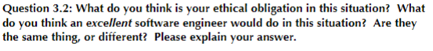

**Answer:** The ethical obligation for the company is to reject the offer. A software engineer at the company would have no say because he/she only work there, so an excellent software engineer should focus on their work. 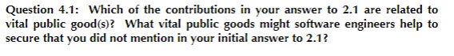

**Answer:** I feel that software engineers building apps/softwares have a higher relation to vital public goods because it is about giving something back to the society.Without software engineers, there would be no google, amazon, microsoft and all the luxuries we are having at the tip of our fingers.



**Answer:** The more conscious you get about being a better human being the more it forms onto you because then it becomes a form of living over time.



**Answer:** Yes.

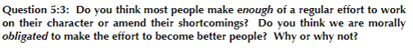

**Answer:** I do not think that people make effort to change themselves for others until they themselves find it uncomfortable. I think being a better person makes you feel better and everyone around you feel better.

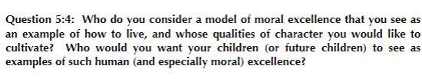

**Answer:** I would consider army men to be a great example for model of moral excellence, they have the discipline, the energy and motivation to do the right thing, they care for everyone.

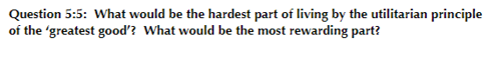

**Answer:** The hardest part is that, it is not comfortable, to live such a life you have to get out of your comfort zone. But the reward is living a life doing good things.

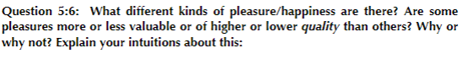

**Answer:** Anything could be pleasure, for some sports is pleasure, for some programming is, when one does something they love, it is pleasure for them. All pleasures are the same regardless of type.

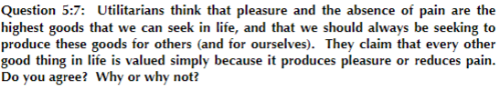

**Answer:** I feel that's true because everything in life should be valued, and everything gives pain or pleasure.

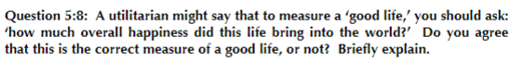

**Answer:** Yes, it is a good question because anything you do should make you happy. If it made you happy then it was worth it.

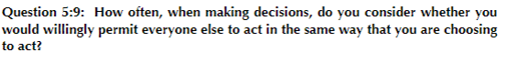

**Answer:** I would not think that way because if I feel what I am doing is right then I would still do it no matter what everyone else does.



**Answer:** Blaming on coworkers for a mistake made by you. Taking a medical certificate for silly excuses like oversleeping and laziness.

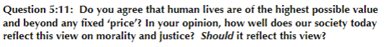

**Answer:** Yes I do feel that humans are of the highest possible value because what humans can do, no one else can. But not many humans, who can, try to be moral.

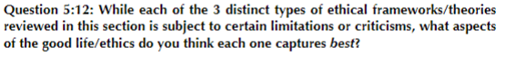

**Answer:** Deontological Ethics does this the best because humans need principles in life to achieve something and be a good moral human.