**FALA WEWE**

CLIENTS

Manish Mrembo

DEVELOPERS

HARIN RAMJI

JEET KHODA

Table Of Contents

Title Page------------------------------------------------------------------------------------------------------------Page 1

Table of Contents------------------------------------------------------------------------------------------------- Page 2

Brief Description-------------------------------------------------------------------------------------------------- Page 3

Landing Page------------------------------------------------------------------------------------------------------- Page 4

Checkout Page----------------------------------------------------------------------------------------------------- Page 5

Terms and conditions and size chart------------------------------------------------------------------------Page 6

Privacy Policy------------------------------------------------------------------------------------------------------Page 7

GitHub and Hosting----------------------------------------------------------------------------------------------Page 8

Client Sign Off----------------------------------------------------------------------------------------------------Page 9

Brief Description

After finalising the wireframes and mock-ups with the client we began creating the final html documents. The client provided us with pictures of some of the apparel some of their documents including their privacy policy and terms and conditions. After a few weeks of back and forth and very many iterations of the website we finally created the final version.

On 13th May 2024 we met with the client and showed him the website all the elements of it and the many features integrated into it. The client was ecstatic. The client also gave us some feedback and suggested some changes we make to the website. He also needed us to add a few more features which we then did. One of them included the addition of scroll to top button which was fairly simple to add on. The different patterns in the main page differentiate between different pages and are distinctively coloured to capture the beauty of African scenes.

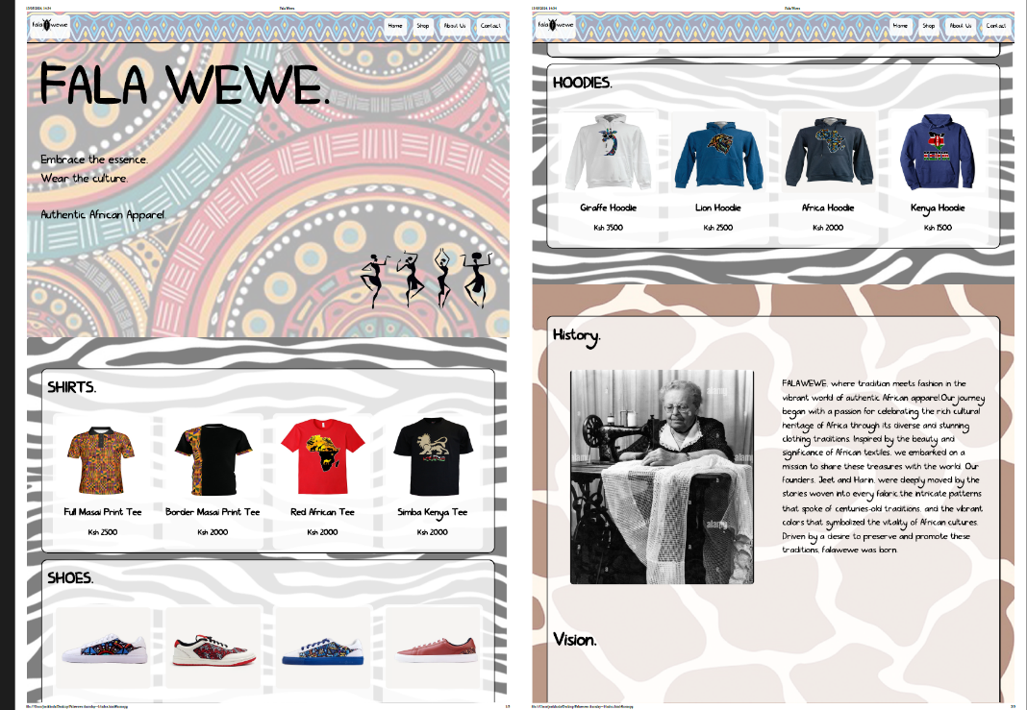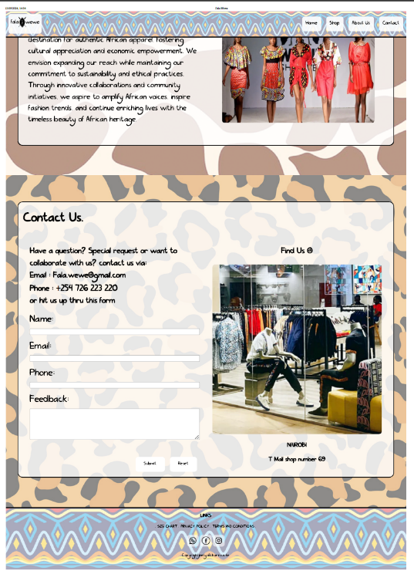Landing Page

This is the landing page. It is in a singular format. Pressing the home button takes you to the home page shown on the top left. The shop button takes user down to the shirts/shoes/hoodie tab. Clicking on any card will take you to the product page shown below. There is an about us page that shows our history and the vision of the company. The contact us page includes a form that is validated via JavaScript that allows users to ask us question or post some of their feedback.

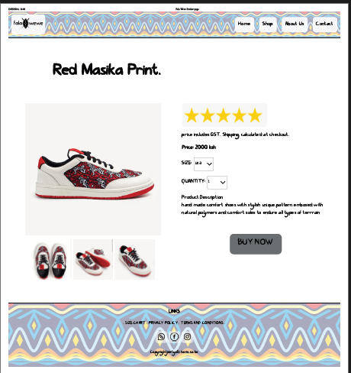Product Page

This page is our product page. Gives out some key information about our unique product. The size and quantity are dropdown boxes that allow users to select their size or quantity.

Clicking on the BUY NOW button takes the user to the checkout page. This page is integrated with bootstrap shown below.

Checkout Page

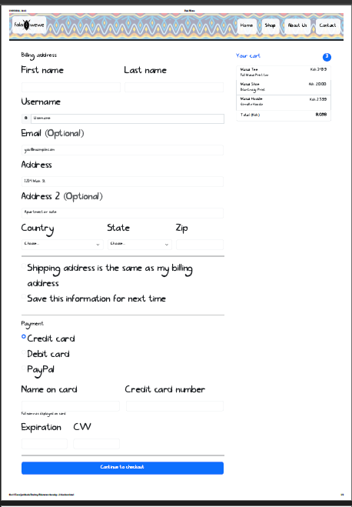

This page has been created with bootstrap. ( <https://getbootstrap.com/>).

Other Pages.

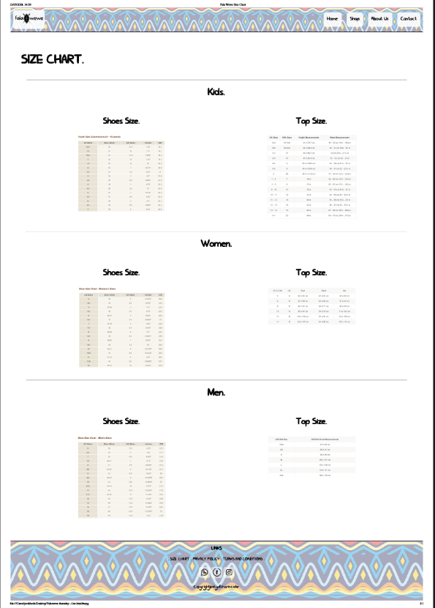

This page can be reached via a link in the footer. As every human has different sizes and every store has different ways of measuring things, we have provided a size chart in which the users can find out their sizes.

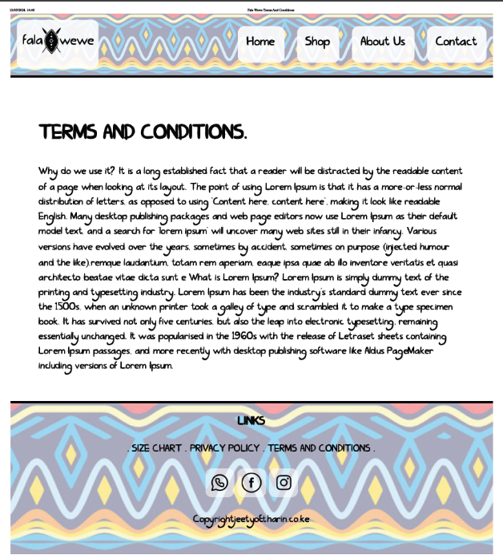

This page shows the company’s terms and conditions that the user agrees to upon interacting with our website.

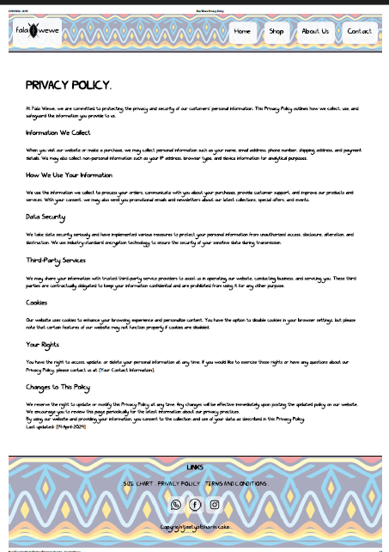

This is the privacy policy page that conveys information on what data we collect and all our policies.

GITHUB

These documents have also been added to Harin’s GitHub with a link and picture below

<https://github.com/raghwaniharin/FALAWEWE>

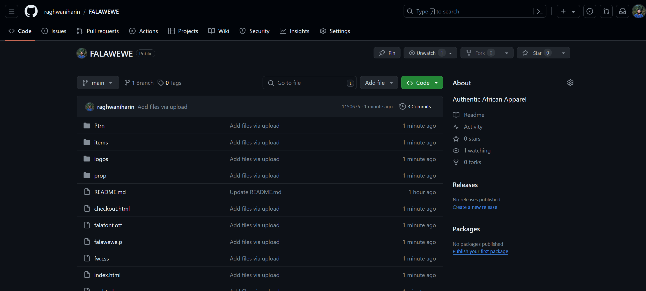

HOSTING

This site has been hosted and clicking on the link below takes the user directly to the landing page.

<https://falawewebyjeetyoandharin.on.drv.tw/www.falawewe.blog/>

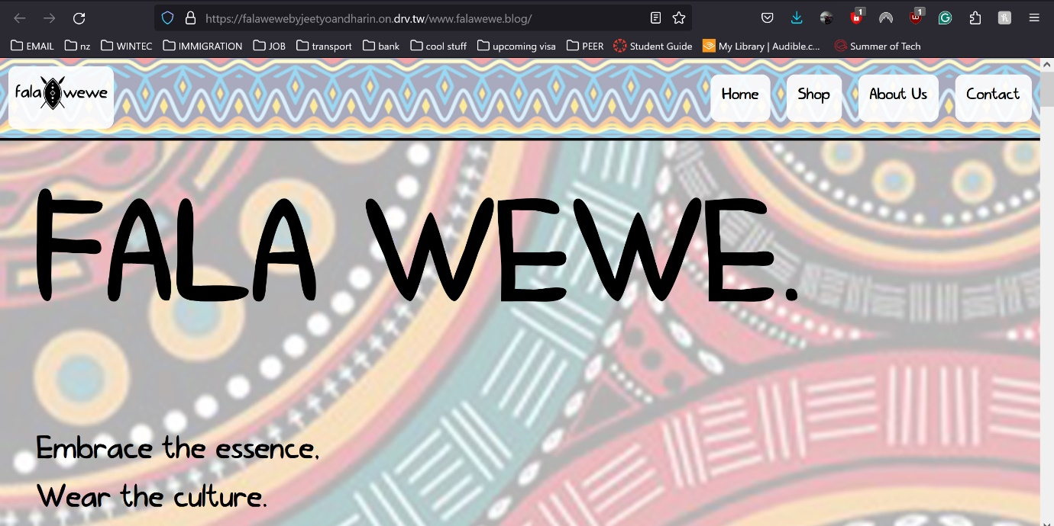

CLIENT SIGN OFF

I, Manish Mrembo approve of this design and would be willing to begin the actual creation of

the website

MANISH MREMBO



We, Harin and Jeet approve of this document and sign off that this document is our own creation.

HARIN



JEET

