Practical Coursework 3: Programming Challenges and Questions

Jessica Clara Fealy

- What are the four principles of object-oriented programming? Explain each with an example. [4 marks]
  - Encapsulation
    - This is accessibility privileges inside class, specifically keeping values kept private and using getters and setters to manipulate the data. In this example no instance can access A directly and must use getters and setters to change or access the value
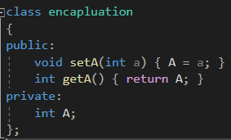
  - Abstraction
This is only showing relevant data and information to an outside class without disclosing how the data is created. In this example main does not need to know how these numbers are added, just that they have been.
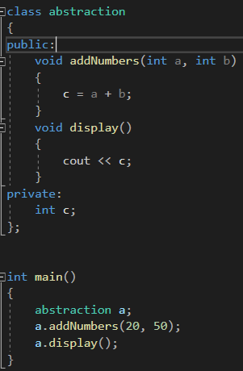
  - Inheritance
    - This is a relationship between two classes which can be a ‘has a‘ or an ‘is a’. In this example Child is a Parent.
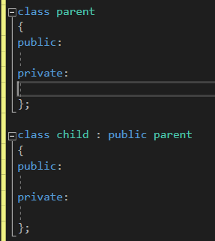
  - Polymorphism
    - Polymorphism is either static or dynamic, with static being overloading functions and dynamic being overriding functions. This is an example of overloading. With add having two ways of being completed, either taking 2 int arguments or 3.
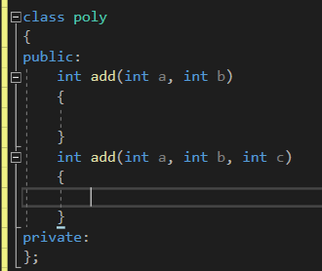
- What is a class? How does it differ from a struct? [2 marks]
  - A class is a data structure which can handle different members with varying types and can hold functions which manipulate these members. The primary difference between both classes and structs is the accessibility to the data contained. With structs being default public and classes being default private.
- What is an object? [2 marks]
  - An object is an instance of a class
- Explain the term "constructor", what does a constructor do? Give an example. [2 marks]
  - A constructor is a member function of a class which role is to initialise an object when created. This function is named the same as the class.
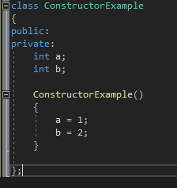
- What is Overloading? What is Overriding? Explain the difference. [2 marks]
  - Overloading is the act of having a function with the same name but takes different arguments. Such as having an addNumber(int a, int b) and addNumber(int a, int b, int c). Whereas overriding allows a child class as in the parent class.
- What is an Abstract Data Type? [2 marks]
  - An abstract data type is a class which has several operations and values. The class can internally use various data types or even additional abstract class types.
- In what situation would you choose a while loop over a for loop. Explain the difference and give an example [2 marks]
  - You would primarily use a FOR loop is you know the amount of iterations needed. This can be counting to 100, as you know the end condition you would use a for loop. Whereas a WHILE loop is when you do not know how many times the loop will be ran. For example, when validating user input you would use a WHILE loop as the user could input the correct data on loop 1 or loop 200. But you would use a FOR loop when your are going though an array with a clear known end point.
- What is the difference between inheritance and composition? Give an example. [2 marks]
  - Composition references one or more classes in each instance. Where inheritance allows a derived class from a parent class, this derived class holds all the data and functions from the parent. Composition ‘ has a ‘ class reference, where inheritance ‘ is a ‘ class reference. For example a car has a MOT, where a car is a vehicle. MOT is a composite of car, and car inherits from vehicle.
- Why is UML used to design software? [2 marks]
  - A UML is used to show relationships between classes, and what functions and variables each class will be responsible for. A UML gives a logical map of how classes will interact.
- What is a pointer? [2 marks]
  - A pointer is a variable that stores the memory address as its value
- What does it mean to "pass by reference" or "pass by value"? Explain the difference using an example. [2 marks]
  - Pass by reference is passing the exact data into a function call, this allows the data to be directly allowing the original data to be modified. Whereas pass by value only passes a copy of the data is sent and any changes to this data will not affect the values outside the function call. In this example in passByReference the value of a will be set to 10 outside of the function, but in passByValue setting a to 10 will only change that inside the function, outside the function a will remain as its previous value.
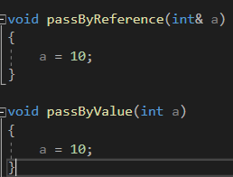
- Describe the process of writing software, from the clients request to delivery. Think about use cases, requirements, test cases etc. Talk about why each step is important, and the benefit it provides to both client and developer. (1000-word limit) [10 marks]
  - Stage 1: Consulting with the client to develop an idea of what they want from the program, during this stage it is key to create a clear detailed brief of what the client wants. The brief needs to clearly outline the requirements and end goal of the program.
  - Stage 2: Creating use cases. Use cases are used to design task in the program. These can include tasks which were not specified on the brief but are required for the program to function to tasks which are specified in the brief. Ideal use cases should include a situation where a function is needed and how the program intends to solve this. The use cases should be written in clear language utilising easy to understand diagrams. Doing such can help a potential nontechnology savvy client understand what the programming team intends to do. At this stage it is clear the client and programmer understand the full extent of the project.
  - Stage 3: Creating an UML diagram. Creating an UML creates a logical path on how all classes interact, the function they contain, and variables they include. Doing this means the classes on the program can be built using a premade guide which resolves the use cases and the requirements of the program.
  - Stage 4: Creating test conditions. Meeting with the client to discuss tests which must be passed for the software to be completed. These tests will be used once the software has been written to ensure that the software has no fatal flaws.
  - Stage 5: Prototyping. This is the stage where the bulk of the programming work is performed. Once a large section of code has been written e.g. Menu system, has been written it is vital that the development team consult with their progress and allow for the client to give feedback, and then changing anything the client was not happy with. The development team must keep doing this until the program has been completed to ensure the client has been keep in the loop and their feedback has been heard and acted upon.
  - Stage 6: Testing. Using the test conditions created earlier in the development cycle to fully ensure there are no faults with the software. If a test condition fails, then this must be fixed and then all test conditions must be tried again to ensure that changes made did not break other test results.
  - Stage 7: Release: This is the final stage for any software, the client should be given appropriate time to ensure the software includes all conditions discusses in the brief stage. If parts of the software are missing, then project must go back into stage 5 to add the missed features. If no parts of the software is missing then the software is signed off and handed to the client.
- Which repetition approach is less efficient: a loop or a recursive function? Why? [2 marks]
  - Loops are more efficient than recursive functions. With loops the operating systems only deals with the instructions inside the loop, yet with recursion the operating system must deal with stack call backs and the instructions in the recursions. With each recursion adding a new item to the stack, unmanaged this can cause stack overflow issue. Loops are generally faster and more memory efficient than recursion.
- Explain the keyword static and how it can be used for variables and function. Use examples [2 marks]
  - A static keyword means that any variable or function modified with static exists for the lifetime of the program and be accessed without functions or classes been initialised.
  - A static function can be called even if no objects of that class exist, static functions can be accessed by using the class name and the function name. A static function can only access variables for other static variables when the no class objects have been initialised.
  - A static variable gets space in memory allocated at the beginning of the program and remains the same for the lifetime of the program and be accessed at any time.
- What is a pure virtual function, why would you use one? [2 marks]
  - A pure virtual function is a virtual function which doesn’t have implementation in the parent class and is only declared but the implementation happens in the derived class. A pure virtual function can be used when many derived classes uses the same parent function, but each derived class needs different instructions to be performed.

