Software Development Fundamentals
Assessment A
18024092 – Fealy

Software Development Assessment A

Introduction
The game that has been produced for this project follows a similar simplified rule set from the original Hamurabi. The game has been altered changing the context of the game called ‘Survivors’ where the goal of the game is to manage a population of survivors during a nuclear incident.
The player must survive for 10 weeks, where each round is a week. To stay true to the original, the player must spend resources each round to keep the population alive. However, rather than spending resources on planting crops in Hamurabi to gain additional resources, the user can choose to spend people and resources in raiding missions where they have the potential to find additional resources and other people; however, they also have the potential to find nothing, and even lose people. In the original game the player may experience rat infestations that cause them to lose a random amount of their resources, to incorporate this mechanic into Survivors, the player may experience a random event that also means they lose a random quantity of resources, the game will supply a predefined reason for this. The original game included a random event which simulates the Black Death, the incorporation of this in Survivors is where a radiation storm will cause a random percentage of the population to become sick, and the user must treat their individuals in that round else they will be killed, lowering the population.

Rules
1. Each games last for 10 weeks, or until everyone dies. Each round is 1 week.
2. Each person requires 100 resources to survive the week.
3. You will be able to send out scavenging missions.
3a. Each scavenging mission requires 2 people.
3b. Each 2 team will require 50 resources.
3c. If nobody is left at base then game is over
4. Scavenging missions has the potential to find resources and people.
5. Anti radiation kits can be used to cure your population from radiation sickness
5a. 1 kit cures 1 person.

Testing

Rules
Condition | Expected | Evidence
Entering Y | To be told the rules | 1.1
Entering N | To begin the game | 1.2
Invalid input | To be asked the question again | 1.3

How much to feed population
Condition | Outcome | Evidence
A valid input value of multiples 100 | X amount of resource are taken away | 2.1
An invalid input of below 100 | Game over, no one is fed | 2.2
Between values of multiples of 100 | Resources are taken, but people who survived is rounded down | 2.3
Feeding minus numbers | Makes you repeat question | 2.4
Feeding more resources than you have | Makes you repeat question | 2.5
Inputting a sting | Makes you repeat question | 2.6

How many people to send on raiding missions
Condition | Outcome | Evidence
Valid input | For x amount of teams to be sent | 3.1
Not enough resources | Question to be repeated | 3.2
Non int number | Question to be repeated | 3.3
Not enough people | Question to be repeated | 3.4
Negative number | Question to be repeated | 3.5
When you send all survivors | Game over | 3.6

How many anti-radiation kits to build
Condition | Outcome | Evidence
A valid input | For x amount of AR kits to be made, then game will continue to play | 4.1
Entering 0 | No kits to be made, game will continue | 4.2
Negative value | Repeat question | 4.3
String input | Repeat question | 4.4
Not enough resources | Repeat question | 4.5

How many people do you wish to save?
Condition | Outcome | Evidence
Entering a value of which you have enough AR kits | For x amount of people to live | 5.1
Entering 0 | No one to be saved | 5.2
Entering minus value | Question to be asked again | 5.3
Entering a string | Question to be entered again | 5.4

Evidence

1

1.1
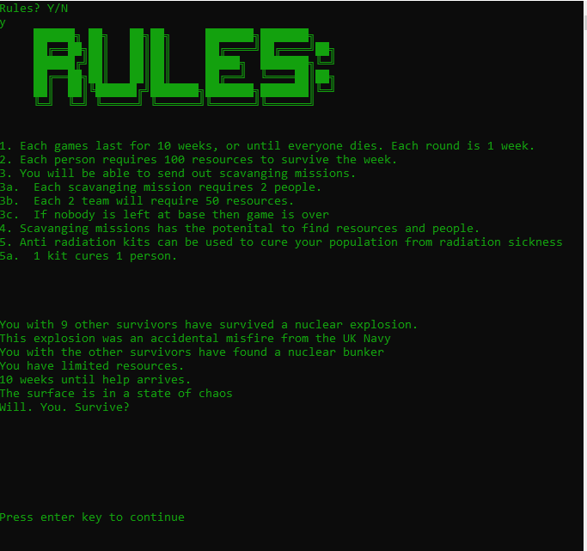

1.2
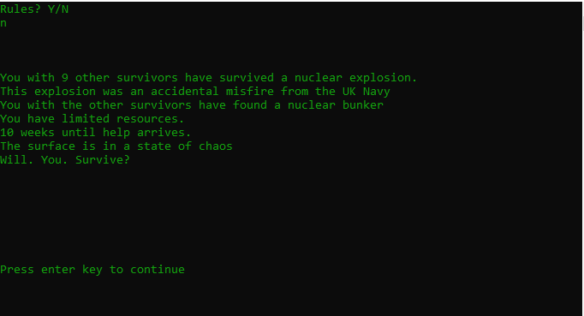

1.3
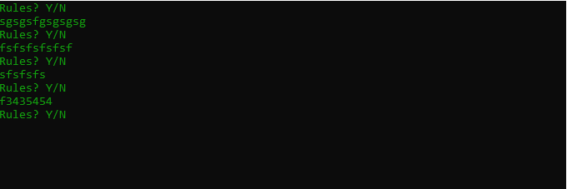

2

2.1
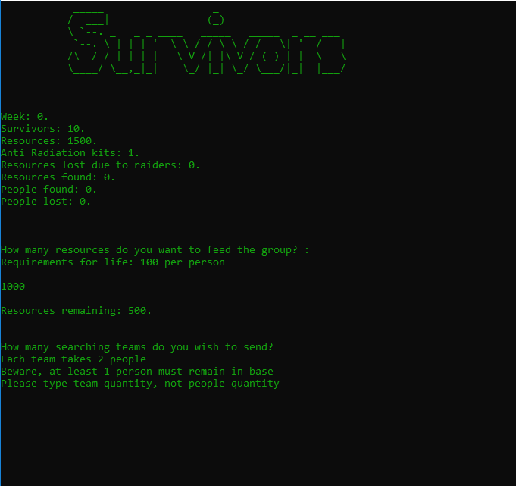

2.2
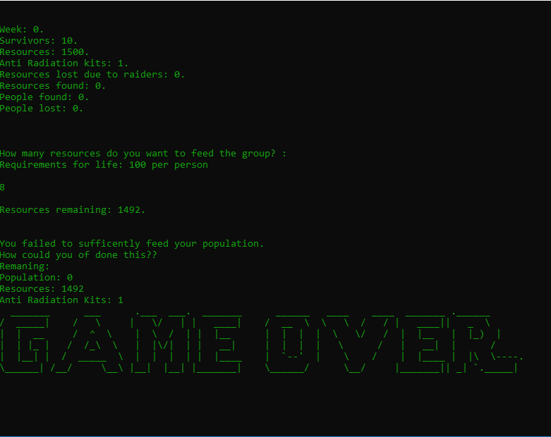

2.3
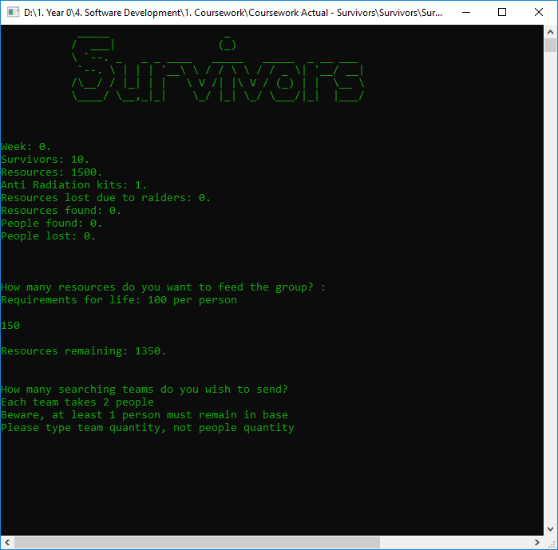

2.4

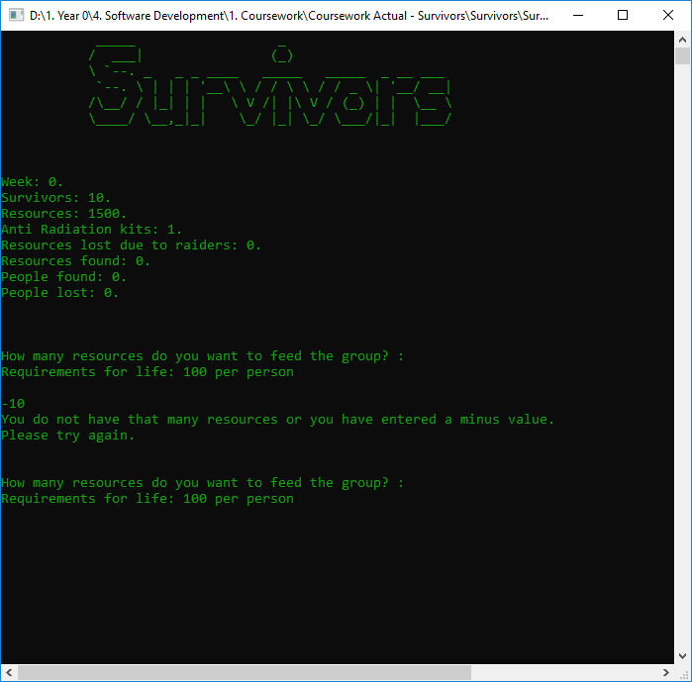2.5
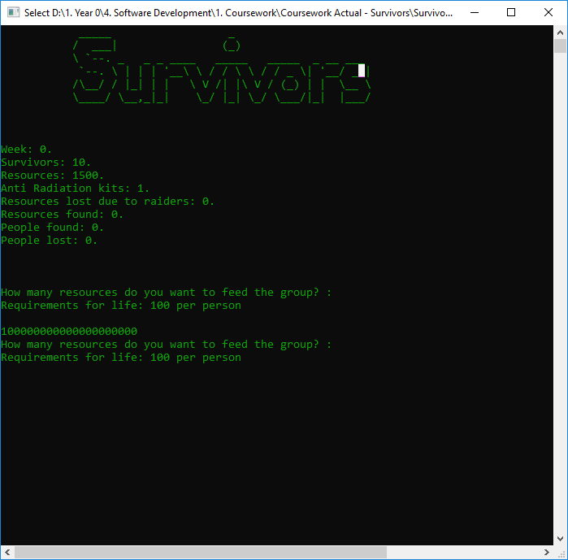

2.6
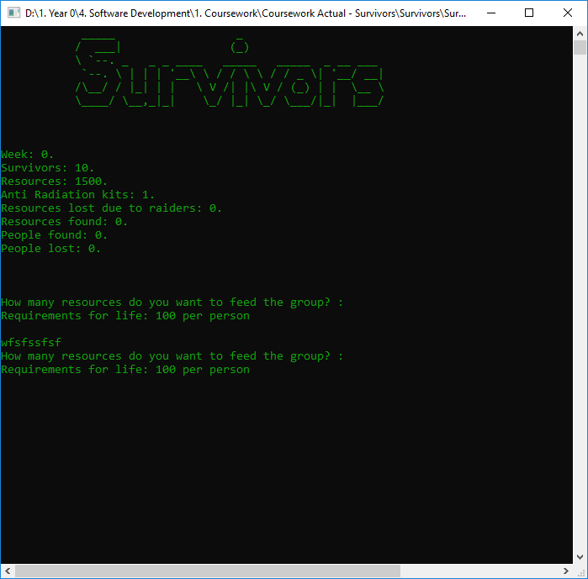

3

3.1
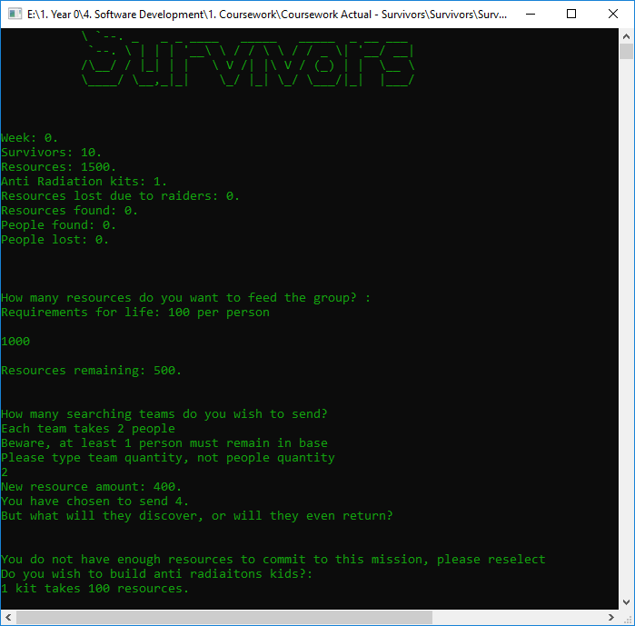

3.2

3.3

3.4
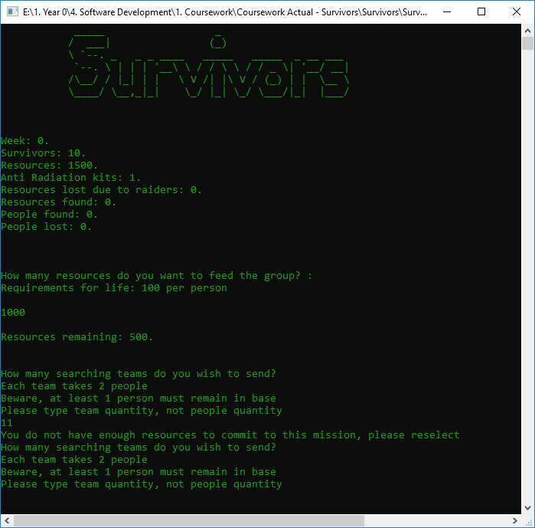

3.5
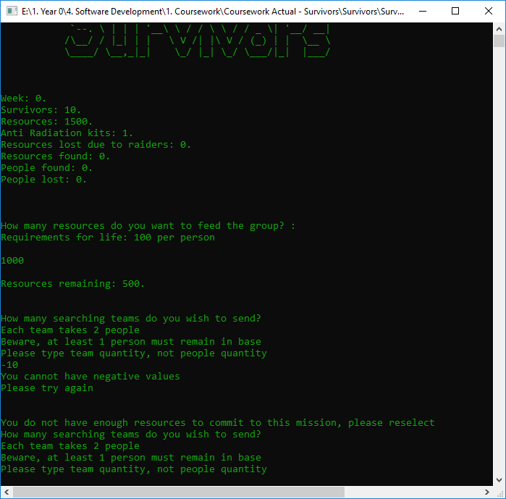

3.6
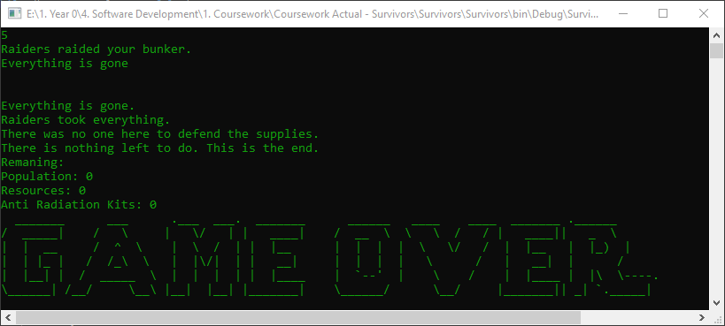

4

4.1
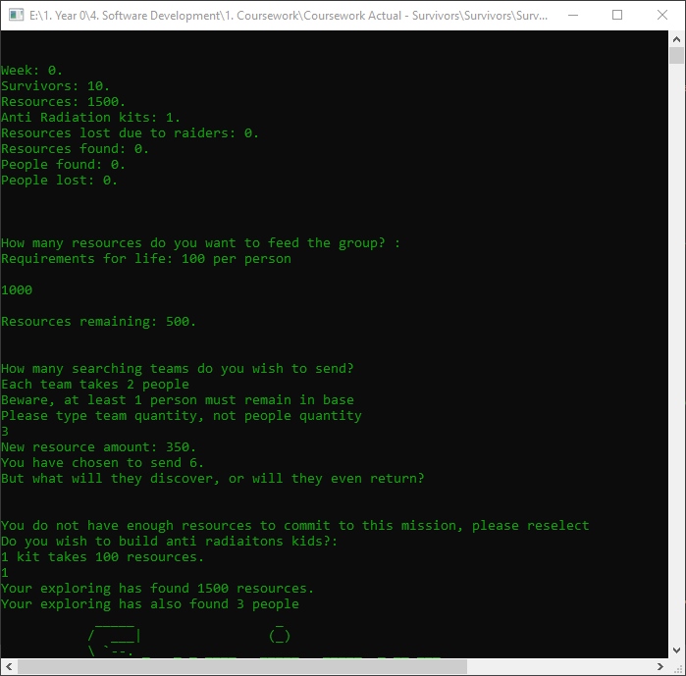

4.2
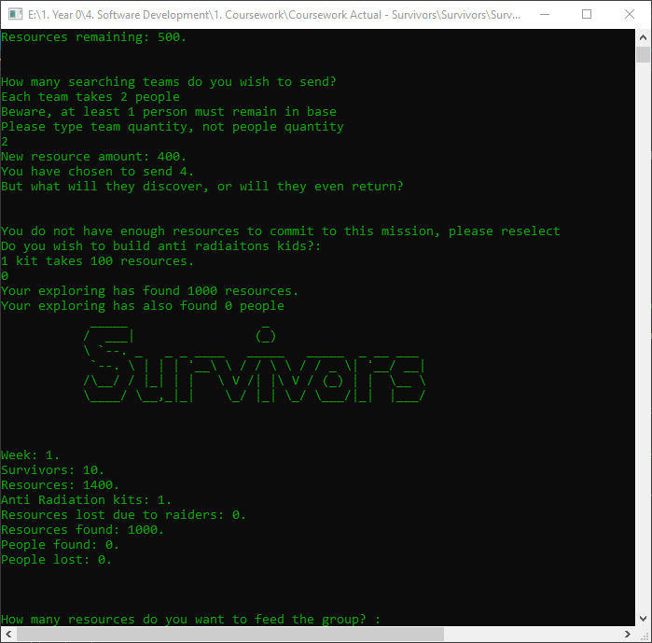

4.3

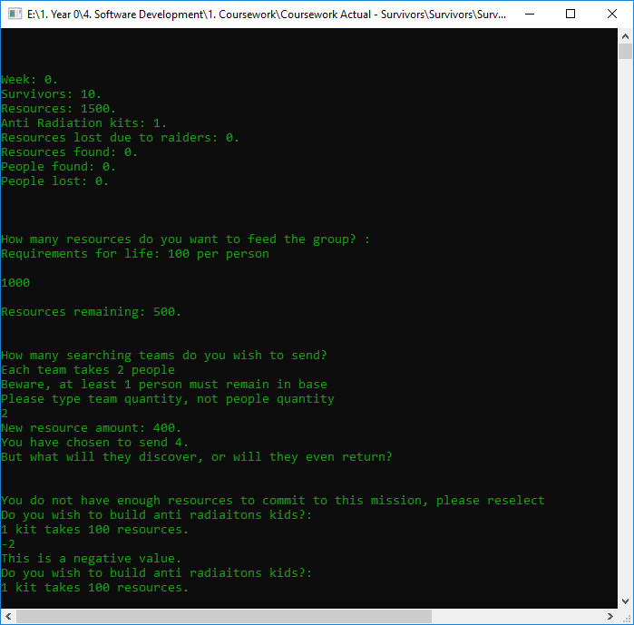

4.4
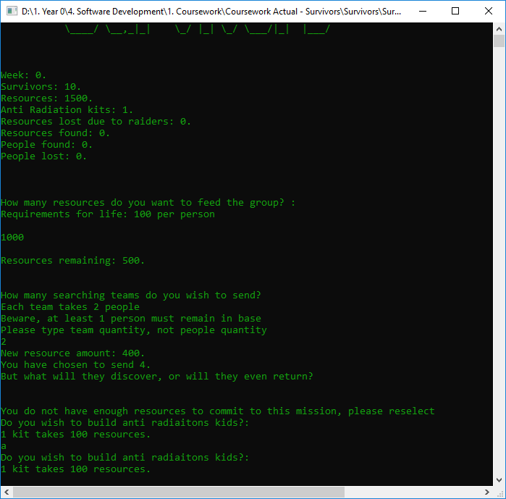

4.5

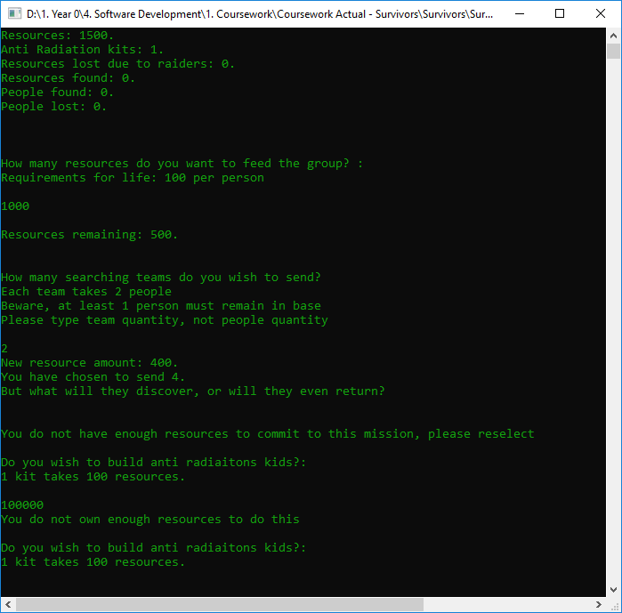

5

5.1
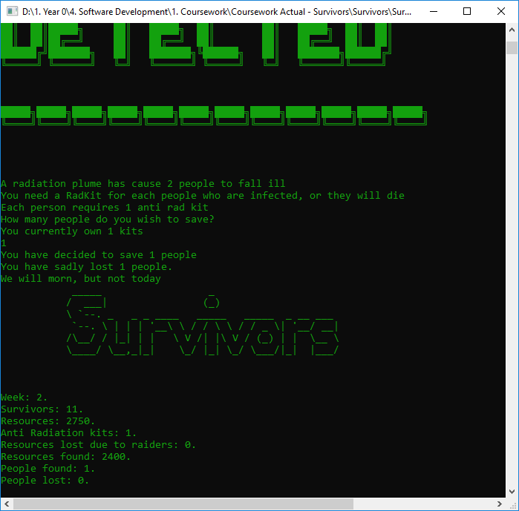

5.2
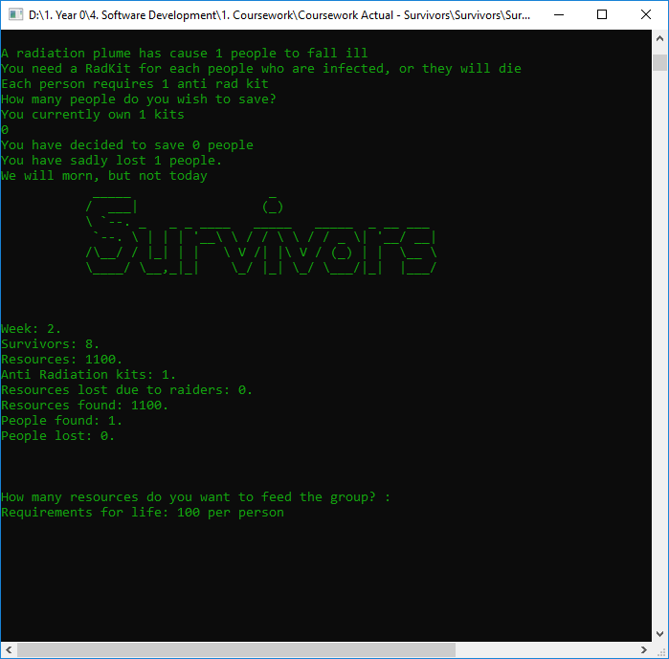

5.3
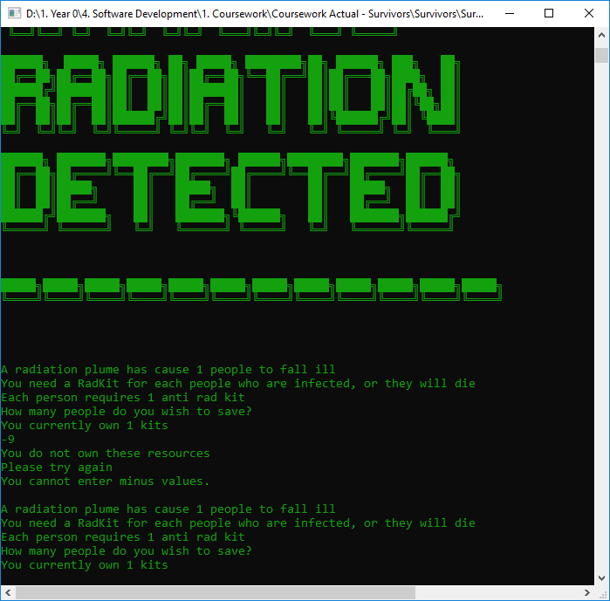

5.4
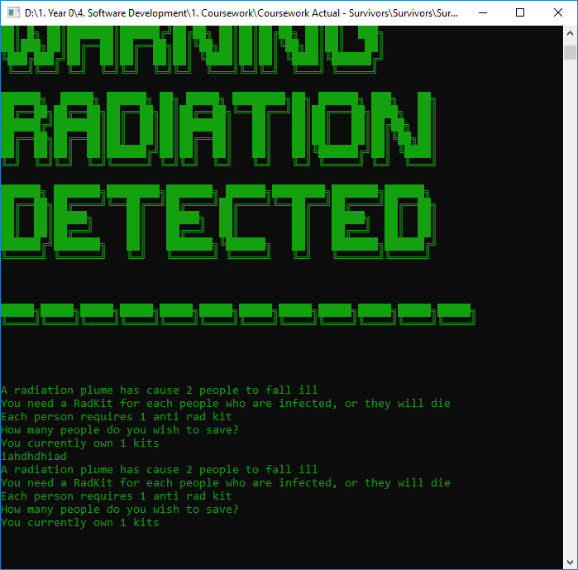

Code

Screenshots
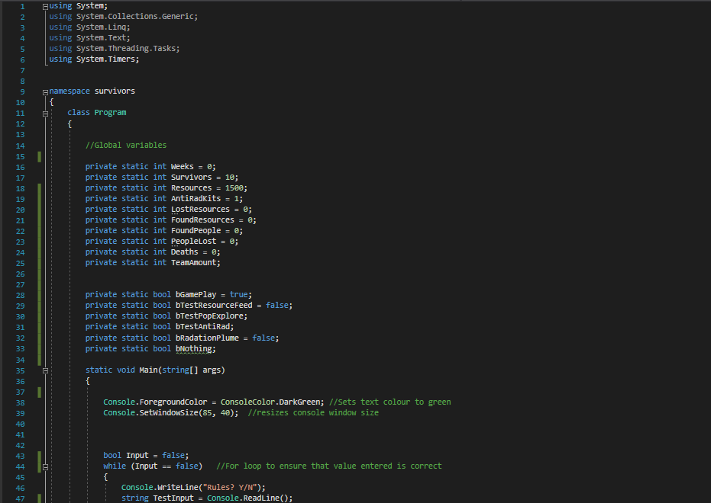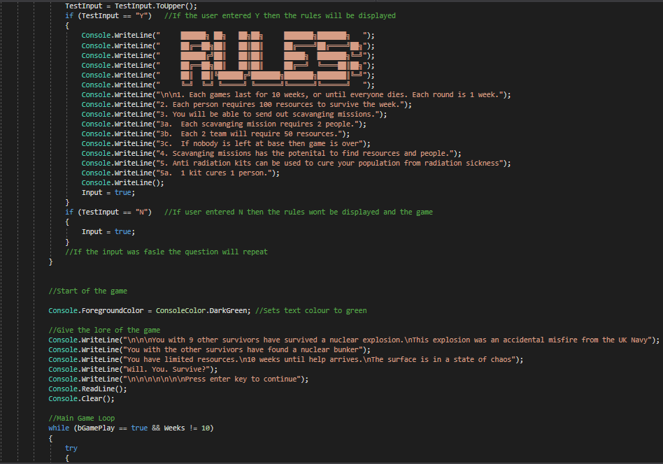
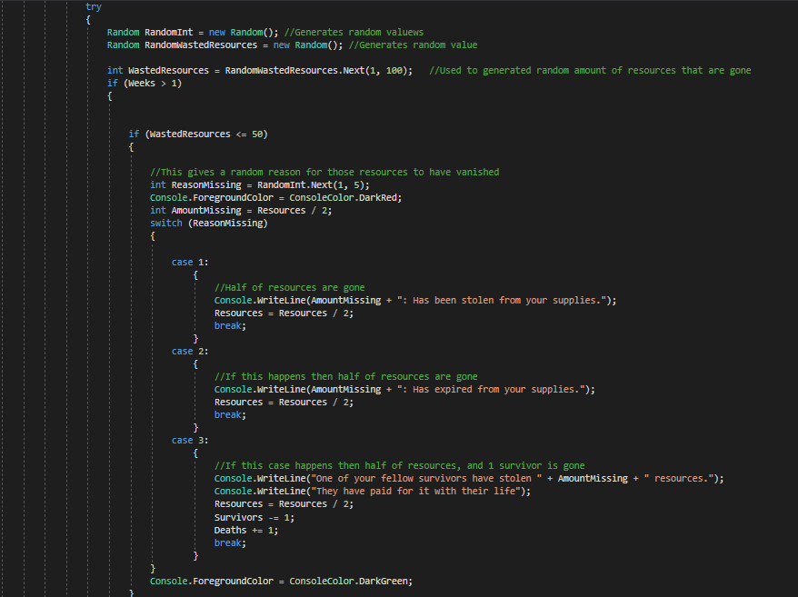
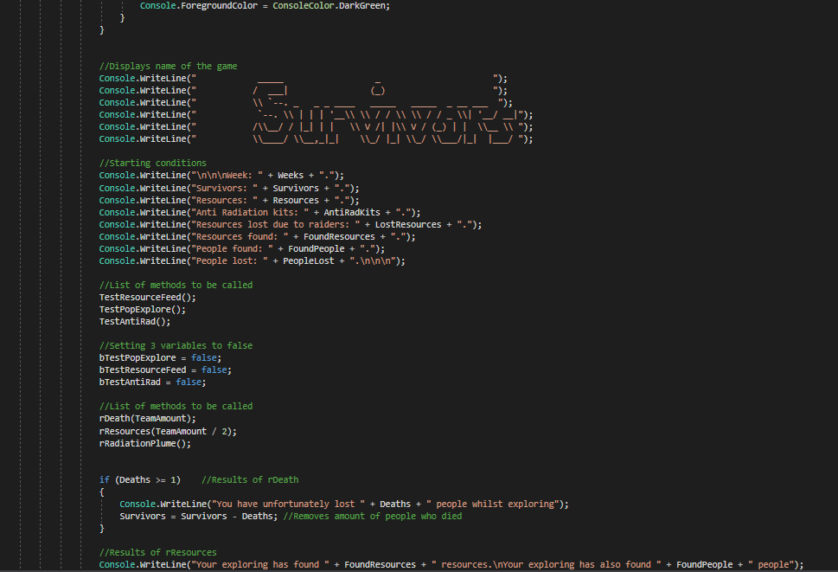
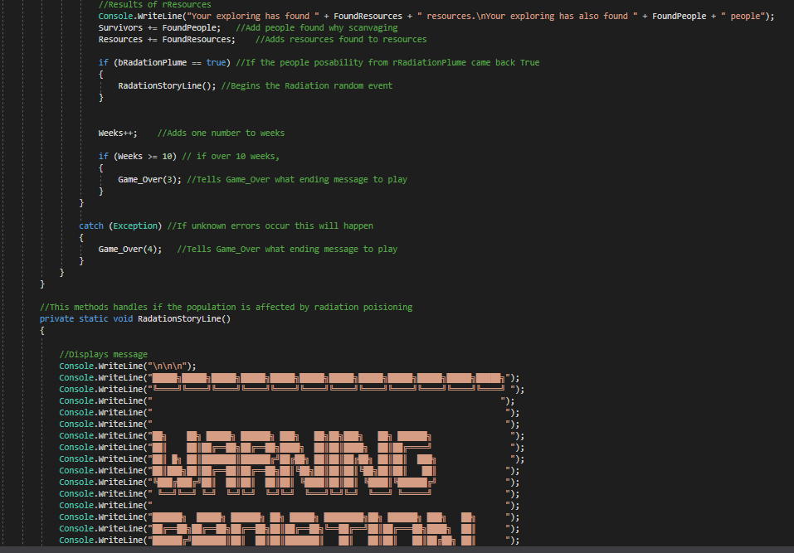
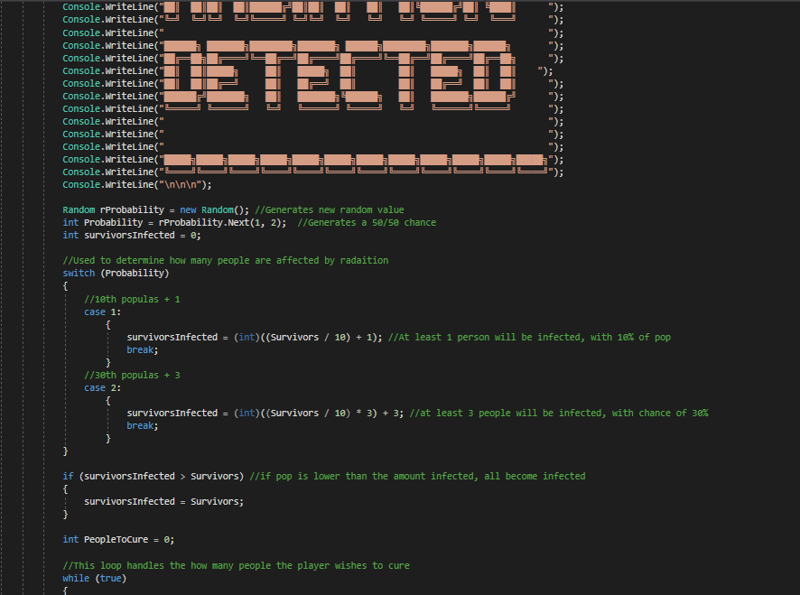
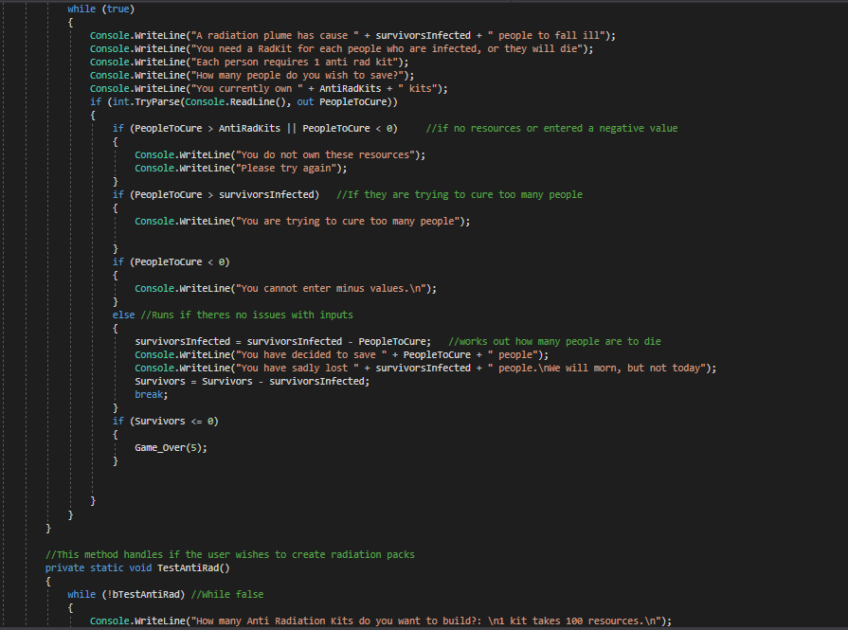
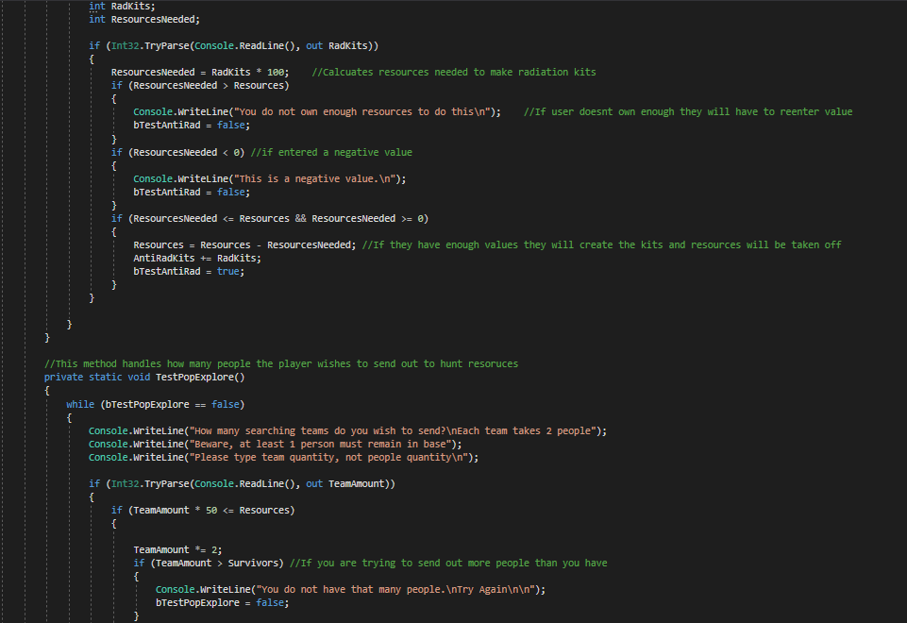
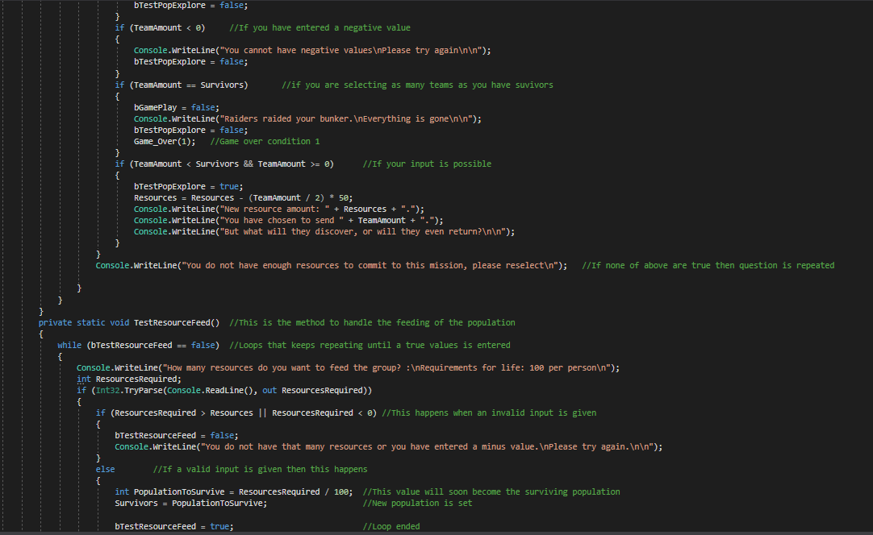
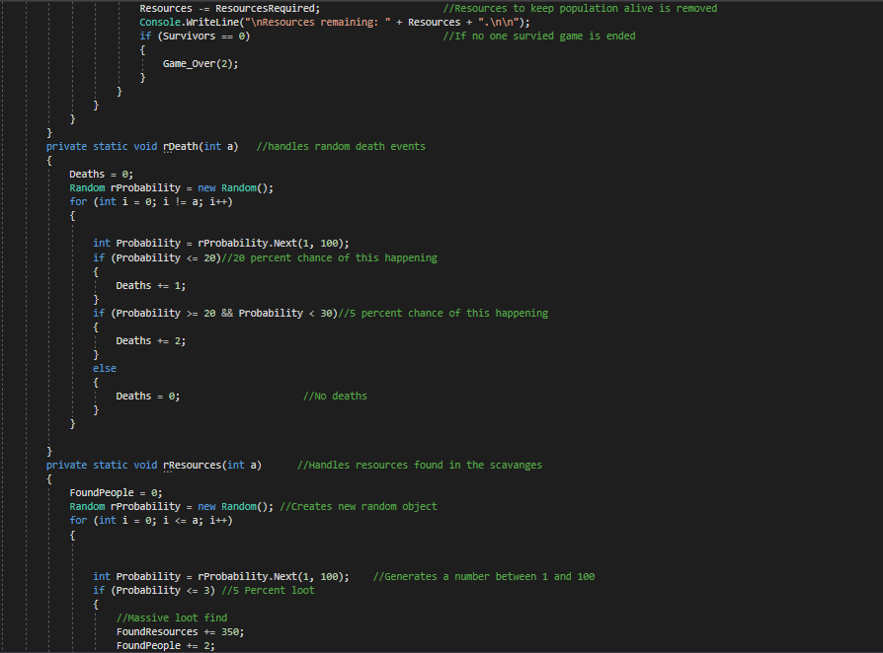
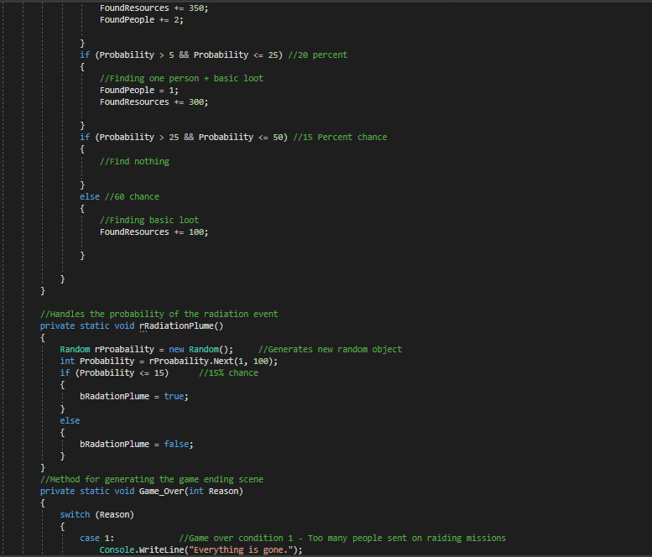
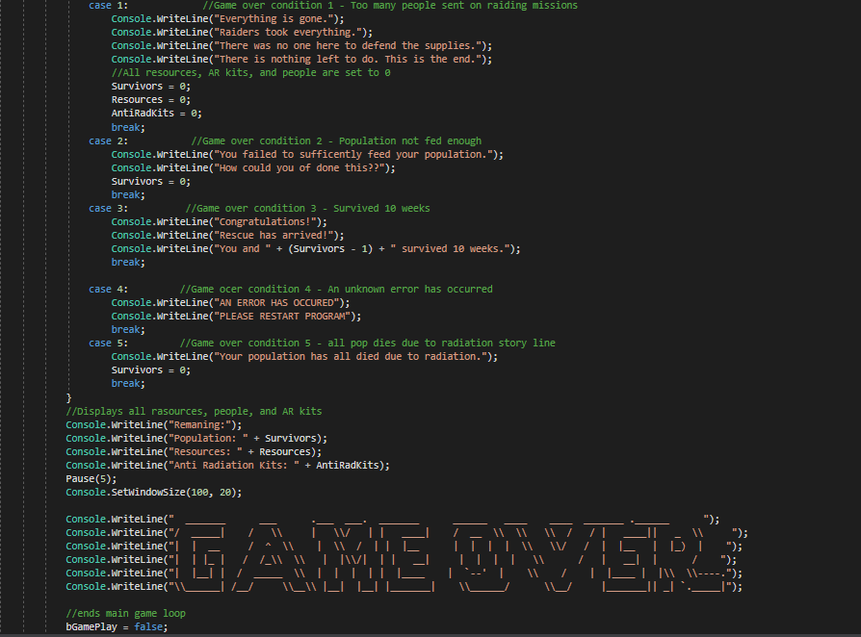
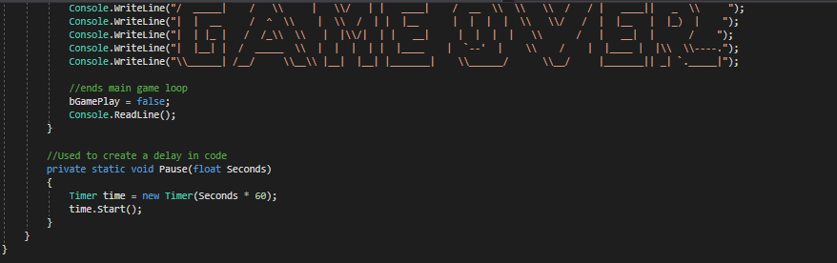

Text Code
using System;
using System.Collections.Generic;
using System.Linq;
using System.Text;
using System.Threading.Tasks;
using System.Timers;

namespace survivors
{
class Program
{

//Global variables

private static int Weeks = 0;
private static int Survivors = 10;
private static int Resources = 1500;
private static int AntiRadKits = 1;
private static int LostResources = 0;
private static int FoundResources = 0;
private static int FoundPeople = 0;
private static int PeopleLost = 0;
private static int Deaths = 0;
private static int TeamAmount;

private static bool bGamePlay = true;
private static bool bTestResourceFeed = false;
private static bool bTestPopExplore;
private static bool bTestAntiRad;
private static bool bRadationPlume = false;
private static bool bNothing;

static void Main(string[] args)
{

Console.ForegroundColor = ConsoleColor.DarkGreen; //Sets text colour to green
Console.SetWindowSize(85, 40); //resizes console window size

bool Input = false;
while (Input == false) //For loop to ensure that value entered is correct
{
Console.WriteLine("Rules? Y/N");
string TestInput = Console.ReadLine();
TestInput = TestInput.ToUpper();
if (TestInput == "Y") //If the user entered Y then the rules will be displayed
{
Console.WriteLine(" ██████╗ ██╗ ██╗██╗ ███████╗███████╗ ");
Console.WriteLine(" ██╔══██╗██║ ██║██║ ██╔════╝██╔════╝██╗");
Console.WriteLine(" ██████╔╝██║ ██║██║ █████╗ ███████╗╚═╝");
Console.WriteLine(" ██╔══██╗██║ ██║██║ ██╔══╝ ╚════██║██╗");
Console.WriteLine(" ██║ ██║╚██████╔╝███████╗███████╗███████║╚═╝");
Console.WriteLine(" ╚═╝ ╚═╝ ╚═════╝ ╚══════╝╚══════╝╚══════╝ ");
Console.WriteLine("\n\n1. Each games last for 10 weeks, or until everyone dies. Each round is 1 week.");
Console.WriteLine("2. Each person requires 100 resources to survive the week.");
Console.WriteLine("3. You will be able to send out scavenging missions.");
Console.WriteLine("3a. Each scavenging mission requires 2 people.");
Console.WriteLine("3b. Each 2 team will require 50 resources.");
Console.WriteLine("3c. If nobody is left at base then game is over");
Console.WriteLine("4. Scavenging missions has the potential to find resources and people.");
Console.WriteLine("5. Anti radiation kits can be used to cure your population from radiation sickness");
Console.WriteLine("5a. 1 kit cures 1 person.");
Console.WriteLine();
Input = true;
}
if (TestInput == "N") //If user entered N then the rules wont be displayed and the game
{
Input = true;
}
//If the input was fasle the question will repeat
}

//Start of the game

Console.ForegroundColor = ConsoleColor.DarkGreen; //Sets text colour to green

//Give the lore of the game
Console.WriteLine("\n\n\nYou with 9 other survivors have survived a nuclear explosion.\nThis explosion was an accidental misfire from the UK Navy");
Console.WriteLine("You with the other survivors have found a nuclear bunker");
Console.WriteLine("You have limited resources.\n10 weeks until help arrives.\nThe surface is in a state of chaos");
Console.WriteLine("Will. You. Survive?");
Console.WriteLine("\n\n\n\n\n\n\nPress enter key to continue");
Console.ReadLine();
Console.Clear();

//Main Game Loop
while (bGamePlay == true && Weeks != 10)
{
try
{
if (Survivors <= 0)
{
Game_Over(5);
}
Random RandomInt = new Random(); //Generates random valuews
Random RandomWastedResources = new Random(); //Generates random value

int WastedResources = RandomWastedResources.Next(1, 100); //Used to generated random amount of resources that are gone
if (Weeks >= 1)
{

if (WastedResources <= 50)
{

//This gives a random reason for those resources to have vanished
int ReasonMissing = RandomInt.Next(1, 5);
Console.ForegroundColor = ConsoleColor.DarkRed;
int AmountMissing = Resources / 2;
switch (ReasonMissing)
{

case 1:
{
//Half of resources are gone
Console.WriteLine(AmountMissing + ": Has been stolen from your supplies.");
Resources = Resources / 2;
break;
}
case 2:
{
//If this happens then half of resources are gone
Console.WriteLine(AmountMissing + ": Has expired from your supplies.");
Resources = Resources / 2;
break;
}
case 3:
{
//If this case happens then half of resources, and 1 survivor is gone
Console.WriteLine("One of your fellow survivors have stolen " + AmountMissing + " resources.");
Console.WriteLine("They have paid for it with their life");
Resources = Resources / 2;
Survivors -= 1;
Deaths += 1;
break;
}
}
Console.ForegroundColor = ConsoleColor.DarkGreen;
}
}

//Displays name of the game
Console.WriteLine(" _____ _ ");
Console.WriteLine(" / ___| (_) ");
Console.WriteLine(" \\ `--. _ _ _ ____ _____ _____ _ __ ___ ");
Console.WriteLine(" `--. \\ | | | '__\\ \\ / / \\ \\ / / _ \\| '__/ __|");
Console.WriteLine(" /\\__/ / |_| | | \\ V /| |\\ V / (_) | | \\__ \\ ");
Console.WriteLine(" \\____/ \\__,_|_| \\_/ |_| \\_/ \\___/|_| |___/ ");

//Starting conditions
Console.WriteLine("\n\n\nWeek: " + Weeks + ".");
Console.WriteLine("Survivors: " + Survivors + ".");
Console.WriteLine("Resources: " + Resources + ".");
Console.WriteLine("Anti Radiation kits: " + AntiRadKits + ".");
Console.WriteLine("Resources lost due to raiders: " + LostResources + ".");
Console.WriteLine("Resources found: " + FoundResources + ".");
Console.WriteLine("People found: " + FoundPeople + ".");
Console.WriteLine("People lost: " + PeopleLost + ".\n\n\n");
FoundResources = 0;
//List of methods to be called
TestResourceFeed();
TestPopExplore();
TestAntiRad();

//Setting 3 variables to false
bTestPopExplore = false;
bTestResourceFeed = false;
bTestAntiRad = false;

//List of methods to be called
rDeath(TeamAmount);
rResources(TeamAmount / 2);
rRadiationPlume();

if (Deaths >= 1) //Results of rDeath
{
Console.WriteLine("You have unfortunately lost " + Deaths + " people whilst exploring");
Survivors = Survivors - Deaths; //Removes amount of people who died
}

//Results of rResources
Console.WriteLine("Your exploring has found " + FoundResources + " resources.\nYour exploring has also found " + FoundPeople + " people");
Survivors += FoundPeople; //Add people found why scanvaging
Resources += FoundResources; //Adds resources found to resources

if (bRadationPlume == true) //If the people posability from rRadiationPlume came back True
{
RadationStoryLine(); //Begins the Radiation random event
}

Weeks++; //Adds one number to weeks

if (Weeks >= 10) // if over 10 weeks,
{
Game_Over(3); //Tells Game_Over what ending message to play
}
}

catch (Exception) //If unknown errors occur this will happen
{
Game_Over(4); //Tells Game_Over what ending message to play
}
}
}

//This methods handles if the population is affected by radiation poisioning
private static void RadationStoryLine()
{

//Displays message
Console.WriteLine("\n\n\n");
Console.WriteLine("█████╗█████╗█████╗█████╗█████╗█████╗█████╗█████╗█████╗█████╗█████╗█████╗");
Console.WriteLine("╚════╝╚════╝╚════╝╚════╝╚════╝╚════╝╚════╝╚════╝╚════╝╚════╝╚════╝╚════╝ ");
Console.WriteLine(" ");
Console.WriteLine(" ");
Console.WriteLine(" ");
Console.WriteLine("██╗ ██╗ █████╗ ██████╗ ███╗ ██╗██╗███╗ ██╗ ██████╗ ");
Console.WriteLine("██║ ██║██╔══██╗██╔══██╗████╗ ██║██║████╗ ██║██╔════╝ ");
Console.WriteLine("██║ █╗ ██║███████║██████╔╝██╔██╗ ██║██║██╔██╗ ██║██║ ███╗ ");
Console.WriteLine("██║███╗██║██╔══██║██╔══██╗██║╚██╗██║██║██║╚██╗██║██║ ██║ ");
Console.WriteLine("╚███╔███╔╝██║ ██║██║ ██║██║ ╚████║██║██║ ╚████║╚██████╔╝ ");
Console.WriteLine(" ╚══╝╚══╝ ╚═╝ ╚═╝╚═╝ ╚═╝╚═╝ ╚═══╝╚═╝╚═╝ ╚═══╝ ╚═════╝ ");
Console.WriteLine(" ");
Console.WriteLine("██████╗ █████╗ ██████╗ ██╗ █████╗ ████████╗██╗ ██████╗ ███╗ ██╗ ");
Console.WriteLine("██╔══██╗██╔══██╗██╔══██╗██║██╔══██╗╚══██╔══╝██║██╔═══██╗████╗ ██║ ");
Console.WriteLine("██████╔╝███████║██║ ██║██║███████║ ██║ ██║██║ ██║██╔██╗ ██║ ");
Console.WriteLine("██╔══██╗██╔══██║██║ ██║██║██╔══██║ ██║ ██║██║ ██║██║╚██╗██║ ");
Console.WriteLine("██║ ██║██║ ██║██████╔╝██║██║ ██║ ██║ ██║╚██████╔╝██║ ╚████║ ");
Console.WriteLine("╚═╝ ╚═╝╚═╝ ╚═╝╚═════╝ ╚═╝╚═╝ ╚═╝ ╚═╝ ╚═╝ ╚═════╝ ╚═╝ ╚═══╝ ");
Console.WriteLine(" ");
Console.WriteLine("██████╗ ███████╗████████╗███████╗ ██████╗████████╗███████╗██████╗ ");
Console.WriteLine("██╔══██╗██╔════╝╚══██╔══╝██╔════╝██╔════╝╚══██╔══╝██╔════╝██╔══██╗ ");
Console.WriteLine("██║ ██║█████╗ ██║ █████╗ ██║ ██║ █████╗ ██║ ██║ ");
Console.WriteLine("██║ ██║██╔══╝ ██║ ██╔══╝ ██║ ██║ ██╔══╝ ██║ ██║ ");
Console.WriteLine("██████╔╝███████╗ ██║ ███████╗╚██████╗ ██║ ███████╗██████╔╝ ");
Console.WriteLine("╚═════╝ ╚══════╝ ╚═╝ ╚══════╝ ╚═════╝ ╚═╝ ╚══════╝╚═════╝ ");
Console.WriteLine(" ");
Console.WriteLine(" ");
Console.WriteLine(" ");
Console.WriteLine("█████╗█████╗█████╗█████╗█████╗█████╗█████╗█████╗█████╗█████╗█████╗█████╗");
Console.WriteLine("╚════╝╚════╝╚════╝╚════╝╚════╝╚════╝╚════╝╚════╝╚════╝╚════╝╚════╝╚════╝");
Console.WriteLine("\n\n\n");

Random rProbability = new Random(); //Generates new random value
int Probability = rProbability.Next(1, 2); //Generates a 50/50 chance
int survivorsInfected = 0;

//Used to determine how many people are affected by radaition
switch (Probability)
{
//10th populas + 1
case 1:
{
survivorsInfected = (int)((Survivors / 10) + 1); //At least 1 person will be infected, with 10% of pop
break;
}
//30th populas + 3
case 2:
{
survivorsInfected = (int)((Survivors / 10) * 3) + 3; //at least 3 people will be infected, with chance of 30%
break;
}
}

if (survivorsInfected > Survivors) //if pop is lower than the amount infected, all become infected
{
survivorsInfected = Survivors;
}

int PeopleToCure = 0;

//This loop handles the how many people the player wishes to cure
while (true)
{
Console.WriteLine("A radiation plume has cause " + survivorsInfected + " people to fall ill");
Console.WriteLine("You need a RadKit for each people who are infected, or they will die");
Console.WriteLine("Each person requires 1 anti rad kit");
Console.WriteLine("How many people do you wish to save?");
Console.WriteLine("You currently own " + AntiRadKits + " kits");
if (int.TryParse(Console.ReadLine(), out PeopleToCure))
{
if (PeopleToCure > AntiRadKits || PeopleToCure < 0) //if no resources or entered a negative value
{
Console.WriteLine("You do not own these resources");
Console.WriteLine("Please try again");
}
if (PeopleToCure > survivorsInfected) //If they are trying to cure too many people
{
Console.WriteLine("You are trying to cure too many people");

}
if (PeopleToCure < 0)
{
Console.WriteLine("You cannot enter minus values.\n");
}
else //Runs if theres no issues with inputs
{
survivorsInfected = survivorsInfected - PeopleToCure; //works out how many people are to die
Console.WriteLine("You have decided to save " + PeopleToCure + " people");
Console.WriteLine("You have sadly lost " + survivorsInfected + " people.\nWe will morn, but not today");
Survivors = Survivors - survivorsInfected;
AntiRadKits = AntiRadKits - PeopleToCure;
break;
}
if (Survivors <= 0)
{
Game_Over(5);
}

}
}
}

//This method handles if the user wishes to create radiation packs
private static void TestAntiRad()
{
while (!bTestAntiRad) //While false
{
Console.WriteLine("How many Anti Radiation Kits do you want to build?: \n1 kit takes 100 resources.\n");

int RadKits;
int ResourcesNeeded;

if (Int32.TryParse(Console.ReadLine(), out RadKits))
{
ResourcesNeeded = RadKits * 100; //Calcuates resources needed to make radiation kits
if (ResourcesNeeded > Resources)
{
Console.WriteLine("You do not own enough resources to do this\n"); //If user doesnt own enough they will have to reenter value
bTestAntiRad = false;
}
if (ResourcesNeeded < 0) //if entered a negative value
{
Console.WriteLine("This is a negative value.\n");
bTestAntiRad = false;
}
if (ResourcesNeeded <= Resources && ResourcesNeeded >= 0)
{
Resources = Resources - ResourcesNeeded; //If they have enough values they will create the kits and resources will be taken off
AntiRadKits += RadKits;
bTestAntiRad = true;
}
}

}
}

//This method handles how many people the player wishes to send out to hunt resoruces
private static void TestPopExplore()
{
while (bTestPopExplore == false)
{
Console.WriteLine("How many searching teams do you wish to send?\nEach team takes 2 people");
Console.WriteLine("Beware, at least 1 person must remain in base");
Console.WriteLine("Please type team quantity, not people quantity\n");

if (Int32.TryParse(Console.ReadLine(), out TeamAmount))
{
if (TeamAmount * 50 <= Resources)
{

TeamAmount *= 2;
if (TeamAmount > Survivors) //If you are trying to send out more people than you have
{
Console.WriteLine("You do not have that many people.\nTry Again\n\n");
bTestPopExplore = false;
Console.WriteLine("You do not have enough resources to commit to this mission, please reselect\n"); //If none of above are true then question is repeated

}
if (TeamAmount < 0) //If you have entered a negative value
{
Console.WriteLine("You cannot have negative values\nPlease try again\n\n");
bTestPopExplore = false;
Console.WriteLine("You do not have enough resources to commit to this mission, please reselect\n"); //If none of above are true then question is repeated

}
if (TeamAmount == Survivors) //if you are selecting as many teams as you have suvivors
{
bGamePlay = false;
Console.WriteLine("Raiders raided your bunker.\nEverything is gone\n\n");
bTestPopExplore = false;
Game_Over(1); //Game over condition 1
Console.WriteLine("You do not have enough resources to commit to this mission, please reselect\n"); //If none of above are true then question is repeated

}
if (TeamAmount < Survivors && TeamAmount >= 0) //If your input is possible
{
bTestPopExplore = true;
Resources = Resources - (TeamAmount / 2) * 50;
Console.WriteLine("New resource amount: " + Resources + ".");
Console.WriteLine("You have chosen to send " + TeamAmount + ".");
Console.WriteLine("But what will they discover, or will they even return?\n\n");
}
}

}
}
}
private static void TestResourceFeed() //This is the method to handle the feeding of the population
{
while (bTestResourceFeed == false) //Loops that keeps repeating until a true values is entered
{
Console.WriteLine("How many resources do you want to feed the group? :\nRequirements for life: 100 per person\n");
int ResourcesRequired;
if (Int32.TryParse(Console.ReadLine(), out ResourcesRequired))
{
if (ResourcesRequired > Resources || ResourcesRequired < 0) //This happens when an invalid input is given
{
bTestResourceFeed = false;
Console.WriteLine("You do not have that many resources or you have entered a minus value.\nPlease try again.\n\n");
}
else //If a valid input is given then this happens
{
int PopulationToSurvive = ResourcesRequired / 100; //This value will soon become the surviving population
Survivors = PopulationToSurvive; //New population is set

bTestResourceFeed = true; //Loop ended

Resources -= ResourcesRequired; //Resources to keep population alive is removed
Console.WriteLine("\nResources remaining: " + Resources + ".\n\n");
if (Survivors == 0) //If no one survied game is ended
{
Game_Over(2);
}
}
}
}
}
private static void rDeath(int a) //handles random death events
{
Deaths = 0;
Random rProbability = new Random();
for (int i = 0; i != a; i++)
{

int Probability = rProbability.Next(1, 100);
if (Probability <= 20)//20 percent chance of this happening
{
Deaths += 1;
}
if (Probability >= 20 && Probability < 30)//5 percent chance of this happening
{
Deaths += 2;
}
else
{
Deaths = 0; //No deaths
}
}

}
private static void rResources(int a) //Handles resources found in the scavanges
{
FoundPeople = 0;
Random rProbability = new Random(); //Creates new random object
if (a != 0)
{
for (int i = 0; i <= a; i++)
{
int Probability = rProbability.Next(1, 100); //Generates a number between 1 and 100
if (Probability <= 3) //5 Percent loot
{
//Massive loot find
FoundResources += 30;
FoundPeople += 2;

}
if (Probability > 5 && Probability <= 25) //20 percent
{
//Finding one person + basic loot
FoundPeople = 2;
FoundResources += 200;

}
if (Probability > 25 && Probability <= 50) //15 Percent chance
{
//Find nothing

}
else //60 chance
{
//Finding basic loot
FoundResources += 100;

}

}
}
else
{
FoundResources = 0;
}

}

//Handles the probability of the radiation event
private static void rRadiationPlume()
{
Random rProabaility = new Random(); //Generates new random object
int Probability = rProabaility.Next(1, 100);
if (Probability <= 15) //15% chance
{
bRadationPlume = true;
}
else
{
bRadationPlume = false;
}
}
//Method for generating the game ending scene
private static void Game_Over(int Reason)
{
switch (Reason)
{
case 1: //Game over condition 1 - Too many people sent on raiding missions
Console.WriteLine("Everything is gone.");
Console.WriteLine("Raiders took everything.");
Console.WriteLine("There was no one here to defend the supplies.");
Console.WriteLine("There is nothing left to do. This is the end.");
//All resources, AR kits, and people are set to 0
Survivors = 0;
Resources = 0;
AntiRadKits = 0;
break;
case 2: //Game over condition 2 - Population not fed enough
Console.WriteLine("You failed to sufficently feed your population.");
Console.WriteLine("How could you of done this??");
Survivors = 0;
break;
case 3: //Game over condition 3 - Survived 10 weeks
Console.WriteLine("Congratulations!");
Console.WriteLine("Rescue has arrived!");
Console.WriteLine("You and " + (Survivors - 1) + " survived 10 weeks.");
break;

case 4: //Game ocer condition 4 - An unknown error has occurred
Console.WriteLine("AN ERROR HAS OCCURED");
Console.WriteLine("PLEASE RESTART PROGRAM");
break;
case 5: //Game over condition 5 - all pop dies due to radiation story line
Console.WriteLine("Your population has all died due to radiation.");
Survivors = 0;
break;
}
//Displays all rasources, people, and AR kits
Console.WriteLine("Remaning:");
Console.WriteLine("Population: " + Survivors);
Console.WriteLine("Resources: " + Resources);
Console.WriteLine("Anti Radiation Kits: " + AntiRadKits);
Pause(5);
Console.SetWindowSize(100, 20);

Console.WriteLine(" _______ ___ .___ ___. _______ ______ ____ ____ _______ .______ ");
Console.WriteLine("/ _____| / \\ | \\/ | | ____| / __ \\ \\ \\ / / | ____|| _ \\ ");
Console.WriteLine("| | __ / ^ \\ | \\ / | | |__ | | | | \\ \\/ / | |__ | |_) | ");
Console.WriteLine("| | |_ | / /_\\ \\ | |\\/| | | __| | | | | \\ / | __| | / ");
Console.WriteLine("| |__| | / _____ \\ | | | | | |____ | `--' | \\ / | |____ | |\\ \\----.");
Console.WriteLine("\\______| /__/ \\__\\ |__| |__| |_______| \\______/ \\__/ |_______|| _| `._____|");

//ends main game loop
bGamePlay = false;
Console.ReadLine();
}

//Used to create a delay in code
private static void Pause(float Seconds)
{
Timer time = new Timer(Seconds * 60);
time.Start();
}
}
}

