% Question 1

load('flydata.mat');

% rho is binary vector of spike (1)

% stim is vector of stimulus at common time period to rho

n = 25; % Index of spike to consider

% Find index of first n spikes, and choose the last, or max, index.

idx = max(find(rho==1, n));

% Plot the 150 timesteps prior to index

spike_trigg = stim(idx-150:idx-1, 1);

plot(300:-2:1, spike_trigg);

hold on

xlabel('Time Before 25th spike (ms)');

ylabel('Stimulus');

title('Stimulus vs. Time Before 25th spike (ms)');

hold off

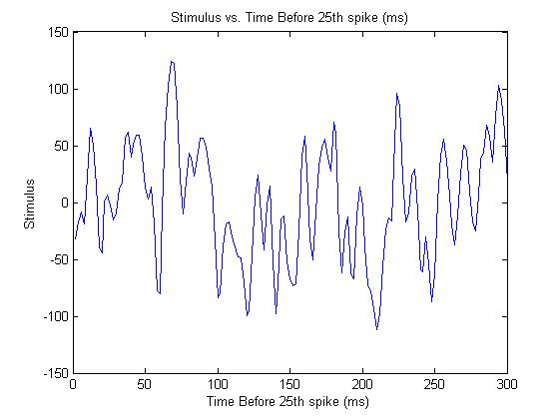

% Question 2

spike_count = 0; % Number of spike that have occured

spike_stimulus_sum = zeros(150, 1); % Summation of all the stimulus

for i = 150:length(rho)

if(rho(i) ==1)

spike_count = spike_count +1;

spike_stimulus_sum = spike_stimulus_sum + stim(i-150 : i-1, 1);

end

end

% Average summation to get STA

spike_stimiuls_average = spike_stimulus_sum/ spike_count;

plot(1:2:300,spike_stimiuls_average);

hold on

xlabel('Time Before spike (ms)');

ylabel('Spike Triggered Average Stimulus');

title(' Question 2: Spike Triggered Average Stimulus vs. Time (ms)');

hold off

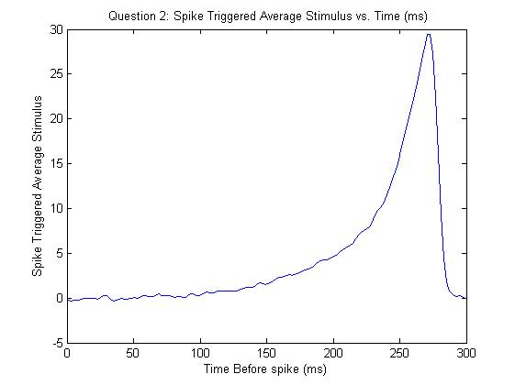

% Question 3

% Question defined variables

m_f_rate = 20; % Mean firing rate

bin_s = 1E-3; % time intervals/bin size of possible spikes

duration = 1; % spike train duration (s)

% Probability of spike in any given 1ms bin

p_interval = m_f_rate* bin_s;

% Create random spikes with p_interval chance

spike_vect = rand((duration/bin_s),1) <= p_interval;

%Plot

plot((duration*bin_s:(duration*bin_s):duration).', spike_vect);

hold on

xlabel('Time (ms)');

ylabel('Spike value (1/0)');

title('Spike value (1/0) vs Time (ms)');

hold off

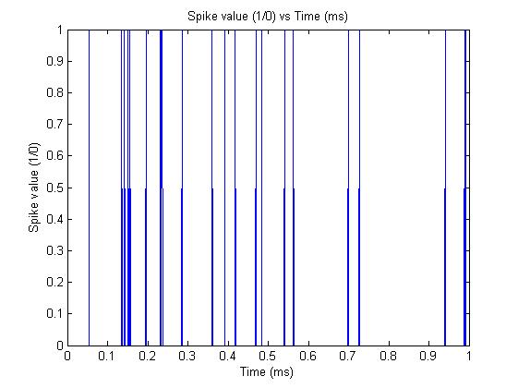

% Question 4

% Question defined variables

m_f_rate = 20; % Mean firing rate

bin_s = 1E-3; % time intervals/bin size of possible spikes

duration = 1; % spike train duration (s)

samples = 1000; % number of spike train trials

% Probability of spike in any given 1ms bin

p_interval = m_f_rate* bin_s;

% Create random spikes with p_interval chance for 1000 trials

spike_vect_samples = rand((duration/bin_s), samples) <= p_interval;

% Question 5

% Average over each trials to get 1000 summations

trials = sum(spike_vect_samples);

% Plot with enough bins for individual (per integer) bins

hist(trials, max(trials))

hold on

xlabel('Number of Spikes');

ylabel('Frequency');

title('Frequency of Spike Count over 1000 trials');

hold off

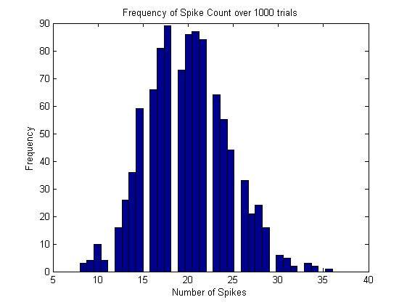

% Question 6

% Calcuate average and variance of trial values and calculate fano factor

avg = mean(trials);

vari = var(trials);

fano = vari/avg % 1.0112