## Written Questions

### Question 1

The problem with the qualitative graph on bayes theorem is the height of the posterior in relation to the prior. Because the domain of the likelihood and the prior are [0,1] then:

$$likelihood ×prior<prior$$

$$posterior<prior$$

As evident in the graph, the posterior is significantly higher which is not possible.

### Question 2

$$\int{L\left(s, s_{bayes}\right)P\left(s | r\right)ds}$$

$$\int{{(s-s_{bayes})}^{2}P\left(s | r\right)ds}$$

$$0=\frac{d}{ds_{bayes}}\int{{(s-s_{bayes})}^{2}P\left(s | r\right)ds}$$

$$0=\int{{\frac{d}{ds_{bayes}}(s-s_{bayes})}^{2}P\left(s | r\right)ds}$$

$$0=\int{-2(s-s_{bayes})P\left(s | r\right)ds}$$

$$\int{sP\left(s | r\right)ds}= \int{s_{bayes}P\left(s | r\right)ds}$$

$$\int{sP\left(s | r\right)ds}= s_{bayes}\int{P\left(s | r\right)ds}$$

$$s_{bayes}=\int{sP\left(s | r\right)ds}$$

### Question 3

$$H({x)=p(x=1)\log_{2}{p\left(x=1\right)+ }p(x=0)\log_{2}{p\left(x=0\right) }}_{}$$

$$H({x)=\frac{1}{3}\log_{2}{\frac{1}{3}+ }\frac{2}{3}\log_{2}{\frac{2}{3} }}_{}$$

$$H({y)=p(y=1)\log_{2}{p\left(y=1\right)+ }p(y=0)\log_{2}{p\left(y=0\right) }}_{}$$

$$H({y)=\frac{2}{3}\log_{2}{\frac{2}{3}+\frac{1}{3}\log_{2}{\frac{1}{3} }}}_{}$$

$$H\left(Y | X\right)= \sum_{x ϵX}{p\left(x\right)H(Y|X=x)}$$

$$H\left(Y | X\right)= \sum_{x ϵ X, yϵY }{p\left(x,y\right)\log_{2}\frac{p(x)}{p(x,y)}}$$

$$H\left(Y | X\right)= \frac{1}{3}\log_{2}{\frac{2/3}{1/3}+ }\frac{1}{3}\log_{2}{\frac{2/3}{1/3}+ }\frac{1}{3}\log_{2}{\frac{1/3}{1/3} }$$

$$H\left(Y | X\right)= \frac{2}{3}$$

$$H(X|Y)= \sum_{x ϵ X, yϵY }{p\left(x,y\right)\log_{2}\frac{p(x)}{p(x,y)}}$$

$$H\left(Y | X\right)= \frac{1}{3}\log_{2}{\frac{2/3}{1/3}+ }\frac{1}{3}\log_{2}{\frac{2/3}{1/3}+ }\frac{1}{3}\log_{2}{\frac{1/3}{1/3} }$$

$$H\left(Y | X\right)= \frac{2}{3}$$

$$H(X,Y)=\sum_{x}{\sum_{y}{P\left(x,y\right)\log_{2}[P(x,y)]}}$$

$$H\left(X,Y\right)=3 × \frac{1}{3}\log_{2}{\frac{1}{3} }$$

$$H\left(X,Y\right)=\log_{2}{\frac{1}{3} }$$

$$I_{m}\left(X,Y\right)=\sum_{x}{\sum_{y}{P\left(x,y\right)\log_{2}\left[\frac{P(x,y)}{P\left(x\right)P(y)}\right]}}$$

$$I_{m}\left(X,Y\right)= \frac{1}{3}\log_{2}{\frac{1/3}{2/9}+ }\frac{1}{3}\log_{2}{\frac{1/3}{4/9}+ }\frac{1}{3}\log_{2}{\frac{1/3}{2/9} }$$

$$I_{m}\left(X,Y\right)= \frac{2}{3}\log_{2}{\frac{3}{2}+ }\frac{1}{3}\log_{2}{\frac{3}{4} }$$

## MATLAB Questions

### Question 1

%Question 1

% variables from question

stimulus_time = 1;

binSize = 1E-3;

numStimPresentations = 100*ones(5, 1);

rateOfStimulus = 10* [1,2,3,4,5].';

seed = 1;

% generated spike train

spikes = generatetrains(stimulus_time, binSize, numStimPresentations, rateOfStimulus, seed);

### Question 2

%Question 2

% Sum over third dimension to get spikes per train for each trial and

% stimulus

spikeSums = sum(spikes, 3);

% find max of each trial and then max of each stimulus to find ultimate max

maxN = max(max(spikeSums));

### Question 3

% Question 3

% Find the maximum number of spikes in a trial for each stimulus

stimulus_max_spike_count = max(spikeSums, [], 2);

% create empty result matrix

pns = zeros(5, max(stimulus_max_spike_count) + 1);

%Used to index colours for plotting of different stimuli.

plot_stimlus_colours = ['r', 'b', 'y', 'g', 'm'];

hold on

% For each stimuli,

for i = 1:5

% go through each possible number of spikes in a trial.

for j = 1:stimulus_max_spike_count(i) + 1

% Find number of occurence and divide by number of trials to get probability

pns(i, j) = sum(spikeSums(i, :) == j-1) / numStimPresentations(i, 1);

end

% plot spike count against probabilities with custom colour

plot(0:1:max(stimulus_max_spike_count), pns(i, :), plot_stimlus_colours(i));

end

% Add design to graph

legend('Stimulus 1', 'Stimulus 2', 'Stimulus 3', 'Stimulus 4', 'Stimulus 5')

xlabel('Number of spikes occured')

ylabel('Probability')

title('The probability of spike totals for given stimuli')

hold off

### 

### Question 4

% Question 4

% Get the ML estimates from the spike_train probabilities. ml_estimates is

% a custom function.

mlEstimate = ml_estimates(pns, max(stimulus_max_spike_count));

% plot and label

plot(0:1:max(stimulus_max_spike_count), mlEstimate);

xlabel('Spike Count');

ylabel('Maximum likelihood Stimulus');

title('ML Stimulus for each spike frequency');

pause

function mlEstimate = ml_estimates( spike_stimulus_probabilities, max_stimulus_spike_count )

% returns a vector of length max_stimulus_max_spike_count + 1 which

% at index i, predicts the most likely stimulus given the spike count

% i-1

% spike_stimulus_probabilities: is a 2D array which the first dimension

% is individual stimuli. The second being a vector of length maximum

% spike count + 1 where index i stores the probability that i-1 spikes

% occured for that stimulus.

% max_stimulus_spike_count: The maximum spikes in any trial for any

% stimuli.

% instantiate empty Nan such that if any spike counts have no

% occurences for any stimuli then no stimulus is predicted

mlEstimate = NaN(1, max_stimulus_spike_count +1);

% for each possible spike count

for i = 1:max_stimulus_spike_count +1

% find maximum probability of each stimulus

[M, I] = max(spike_stimulus_probabilities(:, i));

% if probability is greater than 0 for this index/stimulus, add

if M > 0

mlEstimate(1, i) = I;

end

end

end

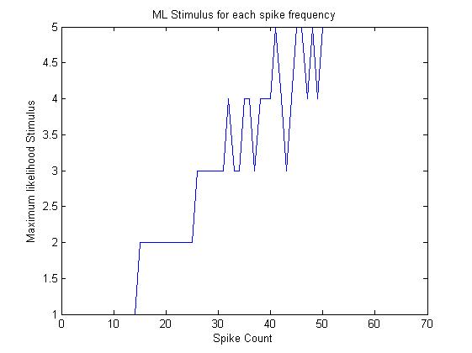

### Question 5

% Question 5

% Get the MAP estimates from the spike_train probabilities. map_estimates

% is a custom function.

mapEstimate = map_estimates(pns, max(stimulus_max_spike_count),numStimPresentations);

% plot and label

plot(0:1:max(stimulus_max_spike_count), mapEstimate);

xlabel('Spike Count');

ylabel('Maximum a posteriori Stimulus');

title('MAP Stimulus for each spike frequency');

function mapEstimate = map_estimates(spike_stimulus_probabilities, max_stimulus_spike_count, numStimPresentations )

% Returns a vector of length max_stimulus_max_spike_count + 1 which at

% index i, predicts the stimulus with the largest MAP given the spike count i-1

% spike_stimulus_probabilities: is a 2D array which the first dimension

% is individual stimuli. The second being a vector of length maximum

% spike count + 1 where index i stores the probability that i-1 spikes

% occured for that stimulus.

% max_stimulus_spike_count: The maximum spikes in any trial for any

% stimuli.

% numStimPresentations: a vector indicating the number of times each

% stimulus is presented.

% instantiate empty Nan such that if any spike counts have no

% occurences for any stimuli then no stimulus is predicted

mapEstimate = NaN(1, max_stimulus_spike_count);

% prior probabilities of each stimulus (proportion to number of trials)

p_s = numStimPresentations/ sum(numStimPresentations);

% for each possible spike count

for i = 1:max_stimulus_spike_count +1

% find maximum probability of each stimulus

[M, I] = max(spike_stimulus_probabilities(:, i).* p_s);

% if probability is greater than 0 for this index/stimulus, add

if M < 0

mapEstimate(1, i) = I;

end

end

end

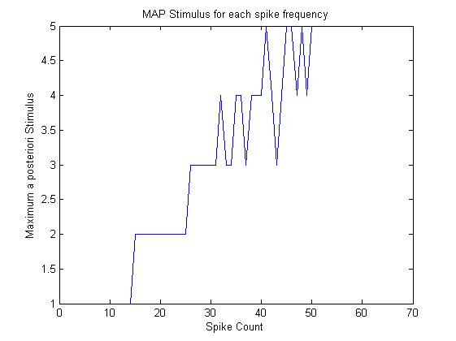

### Question 6

% Question 6

%Change the number of presentations for stimulus 3

new_num_stim_presentations = [100, 100, 400, 100, 100].';

% get MAP and ML for new number of presentation stimulus. Note ML is

% independent of these priors

ml_estimates2 = ml_estimates(pns, max(stimulus_max_spike_count));

map_estimates2 = map_estimates(pns, max(stimulus_max_spike_count), new_num_stim_presentations);

% plot and label

plot(ml_estimates2, 'r')

hold on

plot(map_estimates2, 'b')

xlabel('Spike Count');

ylabel('Estimated stimulus');

title('Estimated Stimulus for each spike frequency');

legend('Maximum Likelihood', 'Maximum a posteriori');

hold off

pause

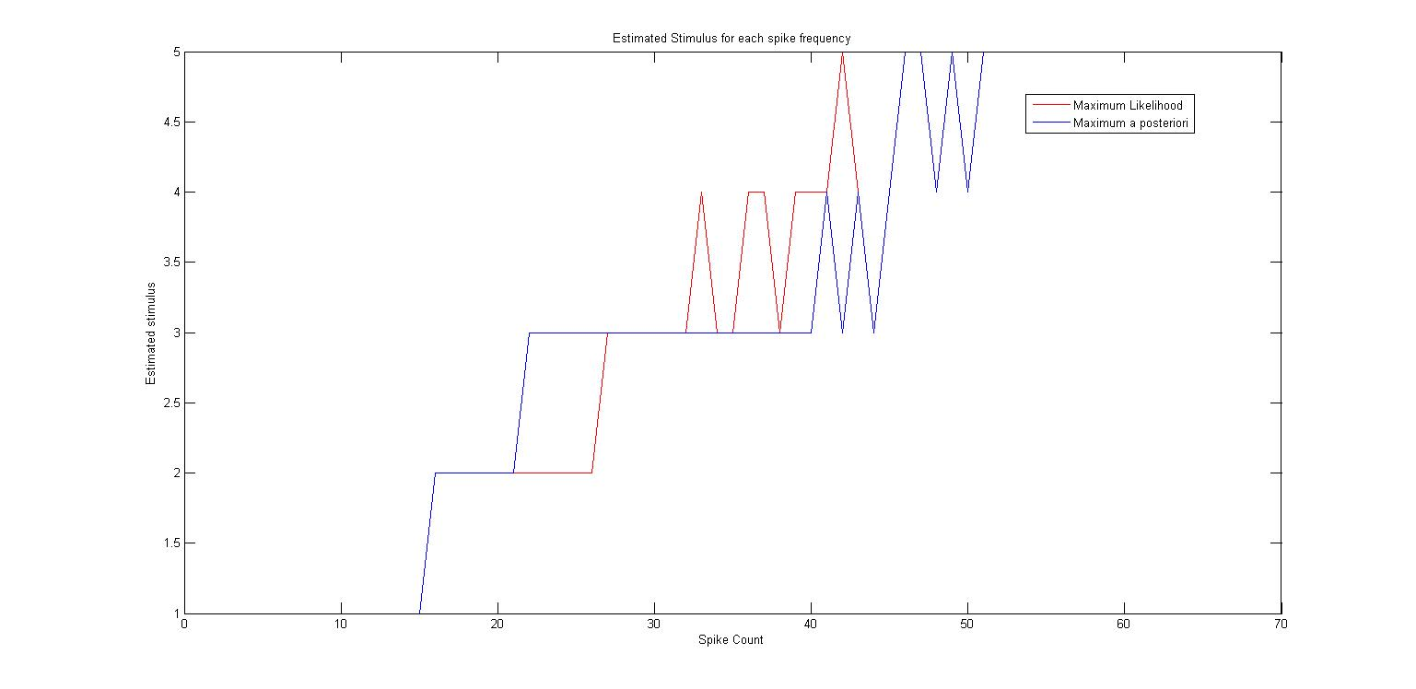

In the case where the prior for stimulus 3 has increased to 50% there is a clear increase in estimation towards stimulus 3 for the MAP. This can be explained by MAP’s consideration of P(s). Given that it is more likely previously, there needs to be more substantial evidence to not estimate stimulus 3. The MAP estimation for equal priors is the same as the ML because when P(s) are equal, they cancel out in terms of priors.

### Question 7

%Question 7

% vector to store mutual information for varying stimulus presentation

% lengths

I_t = zeros(7, 1);

% for each spike_length

for i = 1:7

% create a spike train with new presentation length

spike_trains = generatetrains(i, binSize, numStimPresentations, rateOfStimulus, seed);

% convert spike trains to spiketrain count probabilities

spike_probabilities = trains_to_spike_count_probability(spike_trains ,numStimPresentations );

% find entropy of spikes (0.2 is probability of each stimulus (equal))

I_t(i, 1) = spike_train_mutual_information(spike_probabilities, 0.2);

end

plot(1:7, I_t)

hold on

% Calculate the probability of each stimulus

p_stim = numStimPresentations / sum(numStimPresentations);

% calculate entropy of stimulus in general

H_stim = -1 * sum(p_stim .* log(p_stim))

%plot on same graph and label axis and title.

plot(1:7 , H_stim* ones(1, 7), 'r');

xlabel('Time period of stimulus presentation, (s)')

ylabel('Entropy')

title('Entropy of spike trains of varying presentation lengths compared to entropy of stimulus')

legend('Entropy of varying stimulus presentation lengths')

function spike_count_probabilities = trains_to_spike_count_probability( trains , trials)

% Converts the spike train data, trains, into a 2D array of spike count

% probabilities. The first dimension is individual stimuli and the second

% being a vector of length maximum spike count + 1 where index i

% stores the probability that i-1 spikes occured for that stimulus.

% trains: raw spike train data from generatetrains

% trials: a vector which says how many trials occured for each stimuli

% convert individual spike trains into spike counts per trial

spike_count = sum(trains, 3);

% Find the maximum number of spikes in a trial for each stimulus

stimulus_max_spike_count = max(spike_count, [], 2);

% create probability matrix of [num of stimuli, max spike count + 1]

spike_count_probabilities = zeros(5, max(stimulus_max_spike_count) + 1);

% For each stimuli,

for i = 1:5

% go through each possible spike count

for j = 1:stimulus_max_spike_count(i) + 1

% Find number of occurence and divide by number of trials to get probability

spike_count_probabilities(i, j) = sum(spike_count(i, :) == j-1) / trials(i, 1);

end

end

end

function Im = spike_train_mutual_information( spike_stimulus_probabilities, p_s )

% Returns the expected mutual information of the spike train by

% finding the total entropy and removing the noise.

% spike_stimulus_probabilities: is a 2D array which the first dimension

% is individual stimuli. The second being a vector of length maximum

% spike count + 1 where index i stores the probability that i-1 spikes

% occured for that stimulus.

% p_s is a vector of the prior probabilities of seeing each stimuli.

%}

% find individual entropy components

entropy = -1 * spike_stimulus_probabilities .* log(spike_stimulus_probabilities);

% ignore nan terms (because of limits)

entropy(isnan(entropy)) = 0;

% sum entropy per stimulus

stimulus_entropy = sum(entropy);

% weighted sum of stimulus to find overall noise

H_noise = sum(stimulus_entropy * p_s);

%

p_response = sum(spike_stimulus_probabilities) /5 ;

% individual entropy of responses

entropy_response = -1 * p_response .* log(p_response);

% ignore nan

entropy_response(isnan(entropy_response)) = 0;

% mutual information is response entropy - noise.

Im = sum(entropy_response) - H_noise;

End

### I_t =

### 1.0967

### 1.3603

### 1.4989

### 1.5551

### 1.5961

### 1.5886

### 1.5900

As you can see from the graph below, as the presentation time increases the mutual information approaches the stimulus distribution. This could be due to increasing the presentation time decreases the chance of random neuron firing affecting the true signal.

### 