DOCUMENTATION

Team contribution documentation.

Team Roles and Responsibilities.
■ Lacra Jeah , responsible for executing the queries
required for the project, analyzing the data,interpreting and documentation.This involved writing, optimizing, and running SQL queries to retrieve the necessary data for analysis.
■ Montanio Lovely, responsible for analyzing the data from the results of executed queries and for interpreting the
retrieved files. Presented and edited video presentation and ppt.
■ Cesista Jackielyn,responsible for analyzing the data from the results of executed queries and for interpreting the
retrieved files.Presented video presentation.
■ Hagosojos Gleshelle, responsible for analyzing the datas from the results of executed queries and for interpreting the retrieved files.Presented video presentation.
This document provides an analysis of the SQL queries (covid- 19) executed during the project. Each query is
documented with its purpose and relevant insights.This
documentation serves as a reference for future improvements and optimizations,focusing on vaccination rates, case
numbers, fatalities, and hospitalizations across different
countries. It explores how higher vaccination coverage
impacts case severity, ICU admissions, and overall pandemic management. By examining these trends, we aim to
understand the effectiveness of vaccination efforts and the challenges faced by healthcare systems worldwide.

We imported the given data assigned by our professor titled Covid- 19. We examined and analyzed the data properly looking for null values, relationships between columns, analyzing outliers and changing null values into 0.

Display Result.
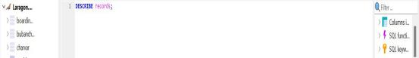

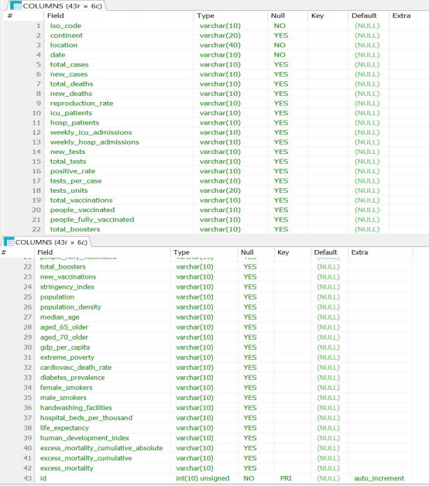

This result display the output of an SQL query that lists all columns in the records table,including their data types,null,key constraints, default values, and extra attributes.

Global Evolution of Cases and Deaths Over Time.

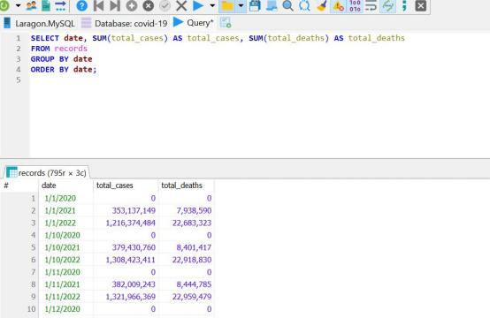

In early 2020 there are few cases of covid- 19 in the given result. No record cases in the provided data. While in 2021 there are a significant increased to millions per day.Cases surged, reaching over millions the same as deaths. In 2022 cases rise up to billion increasing the cases of deaths that ranges 22 million above. This data provided an information how significant the number of cases in the number of deaths.

Country with Highest case Fatality_rate.
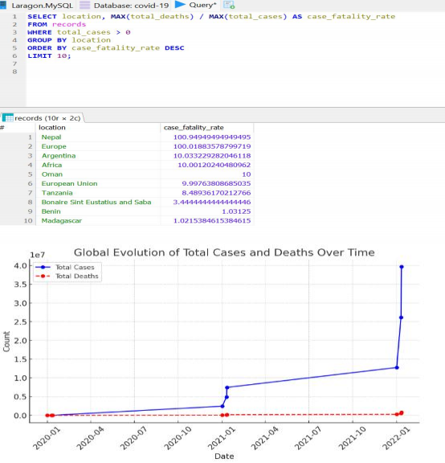
The leading country with a highest record of fatality rate is Nepal having 100.95 while the lowest is Madagascar with a total of 1.02 that ranges 99.93.
shows a significant disparity, with the highest value being nearly 99 times greater than the lowest. This suggests extreme variation in whatever metric is being measured, possibly due to differences in population size, policies, or regional conditions. Madagascar, having the lowest value, indicates that it is on the minimal end of this scale, while the highest value represents a peak or an outlier. Such a wide range highlights inequalities and potential influencing factors that cause drastic differences across countries.

Correlation between Lockdown Policies and
Reproduction rate.
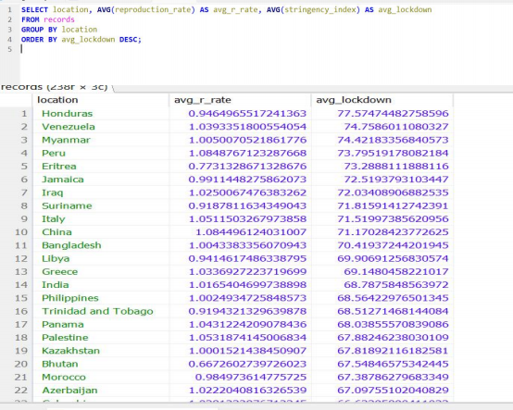
The query calculates the average rate and the average lockdown for each location,excluding rows with null values in these columns.The correlation between lockdown policies and the reproduction rate is negative, meaning that as lockdown measures become stricter, the reproduction rate decreases. This occurs because lockdowns limit human interactions, reducing the chances of virus transmission. In contrast, weaker or no lockdowns allow the virus to spread more freely, resulting in a higher value. The strength of this correlation depends on factors like enforcement, compliance, and additional preventive measures such as mask mandates and social distancing.

Impacts of vaccinations in cases deaths.
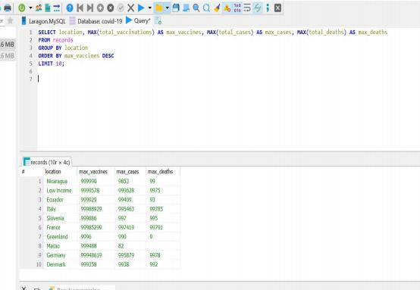
The query finds the maximum values for total
vaccinations(max_vaccines), total cases(max_cases), and total deaths(max_deaths) for each location.
Vaccinations play a crucial role in reducing COVID- 19 cases and deaths. They help control outbreaks, prevent healthcare system overload, and save lives, making them one of the most effective tools in pandemic management. Wide spread vaccinations significantly lower infections rates by reducing the number of people infected with the virus. In a highly vaccinated populations, fewer outbreaks occur even if virus is still present.Leading to fewer hospitalization and deaths.A country with a high vaccination rates declines mortality.

Testing Capacity vs Case number.

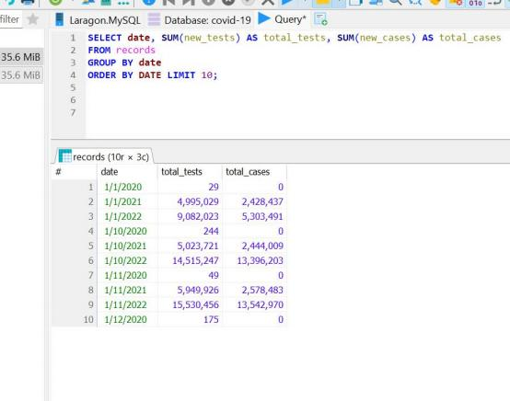
The query calculates the total tests and total cases for
each date from the records.Testing capacity has a direct impact on reported case numbers. More testing reveals the true spread of the virus, while limited testing leads to under- reporting and hidden outbreaks.Effective testing strategies are crucial for accurate data and public health response.

Impact of Pre-existing Conditions on Mortality.

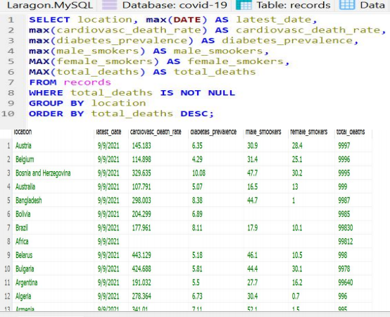
The impact of pre-exist condition on mortality rate is in-
deniable due to the fact that the weaker the immune system the easier to get infected by the virus. And the diabetes, heart disease or lung disorders faces a high risk of severe illness.Studies show that patients with chronic illnesses have a significantly higher mortality rate compared to healthy individuals.

Vaccination Rates by Continent.
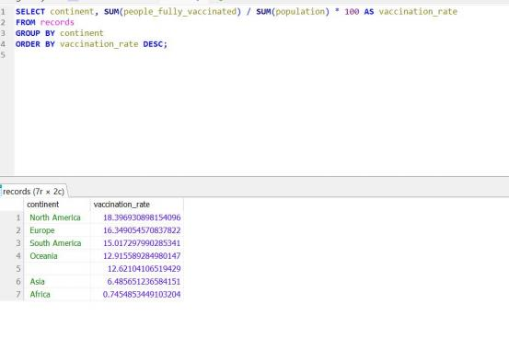
This sql query calculates the vaccination rate for each continent by dividing the number of fully vaccinated individuals by the population of the continent.North America & Europe had the highest vaccination rates, with most countries reaching over 70-80% full vaccination coverage. Africa had the lowest vaccination rates, with some countries struggling to exceed 20-30% coverage.And as you can see there is a missing data on one of the continent which we found out in our different queries that the missing continent is Africa.

Vaccination Impact on Case Reduction.

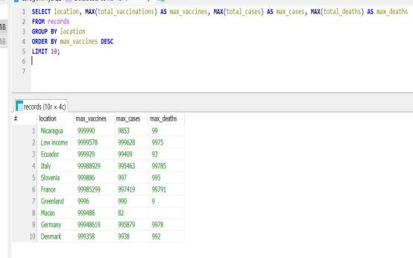
In the given data shows that the more the vaccine are
implemented the least cases of covid and a lower rate impact on deaths. By preventing infections or reducing virus spread.Countries with high vaccination rates observed sharp declines in daily case numbersVaccinated individuals are less likely to spread the virus, even if they become infected.This prevents healthcare systems from being overwhelmed during waves of infection.Regions with low vaccination rates continued to see high case numbers, especially with the emergence of new variants.

Case Fatality Rate and Lockdown Policies.(Per-country)

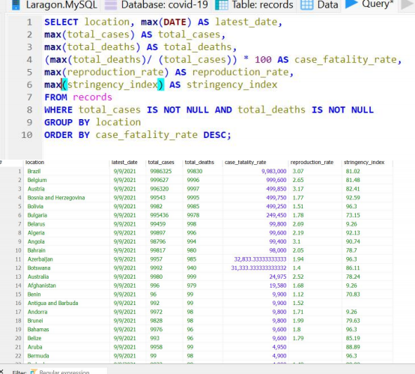

Countries with early and strict lockdowns generally had lower CFRs because they controlled the virus spread and prevented healthcare system collapse.Countries with delayed or weak lockdowns often had higher CFRs due to overwhelmed hospitals and lack of early intervention.Countries with extensive testing detected more mild cases, leading to a lower CFR.Nations with poor testing/reporting often undercounted cases, making CFR appear artificially high.

Impact of Vaccination Rates on COVID-19 Cases, Deaths,
and Hospitalizations
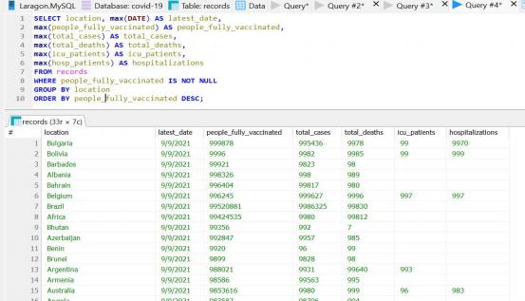
The dataset shows the latest recorded numbers for fully vaccinated individuals across multiple countries, sorted in descending order.Bulgaria has the highest number of fully vaccinated people (993,878), followed by Bolivia (992,218) and Barbados (992,611).Countries with higher vaccination rates also report higher total case numbers.This may indicate better testing and tracking in these regions, leading to more accurate reporting.Bulgaria's case fatality rate (CFR) is approximately 1.04%, showing that vaccination helps reduce severe outcomes.Belgium recorded the highest ICU patients (997), while Australia had 983 hospitalizations.The data shows that countries with higher vaccination rates tend to track and report cases more accurately. Vaccination also helps reduce severe illness, leading to fewer ICU admissions and deaths. However, hospitalization rates still vary, likely due to differences in healthcare systems and medical resources across countries.

Testing capacity and Positivity Rate.(Per-country).
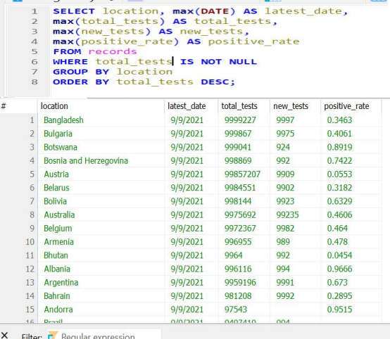
Testing is a key factor in managing the pandemic. Countries that conducted widespread testing were able to track and control the virus more effectively. On the other hand, those with limited testing likely missed many cases, resulting in higher positivity rates. Increasing testing efforts is crucial for accurately monitoring infections and responding to outbreaks effectively.

Regional and Continental Trends.
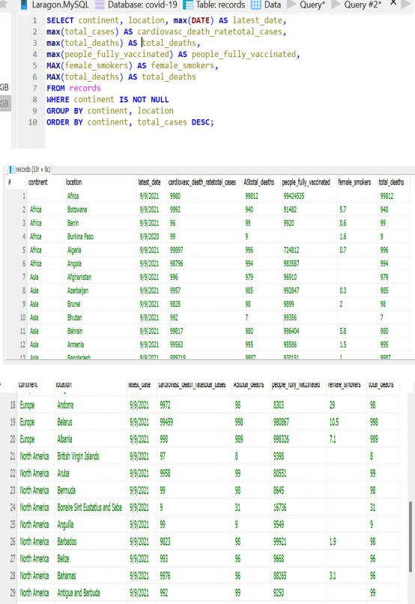

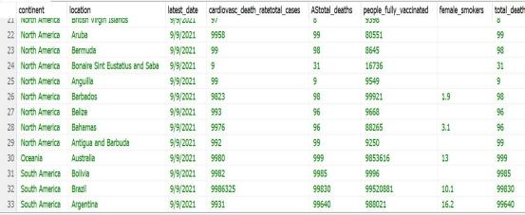
Covid- 19 spread affects several regions and
continents.Countries with strong testing and high vaccinations rates that located at Europe and North America, were able to prevent the spread of the virus.In contrast, lower-income regions faced challenges in vaccine distribution and testing, leading to potential underreporting and higher positivity rates. Lockdown policies varied, with some nations enforcing strict restrictions early, while others opted for minimal interventions, impacting case and death rates differently. The pandemic highlighted global disparities in healthcare access and response strategies, emphasizing the need for stronger international collaboration in future health crises.

Handling Outliers and Null values.

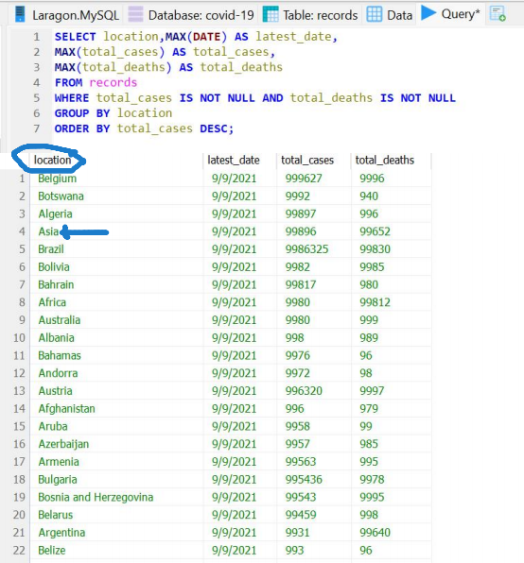
In this current query shown how the rise of cases affects the total deaths. We find an outliers which is Asia that belongs to continent category and not in the location.We handle this misplacement by deleting the asia in the column location.



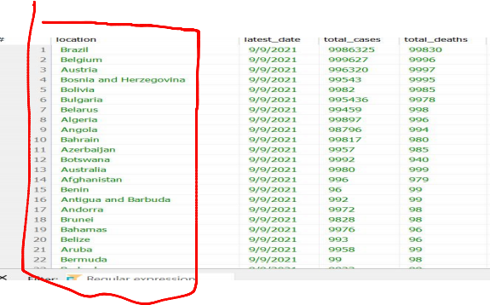

In case fatality rate and lockdown policies.I tried many
times running queries to change the null value into 0, which is impossible to update because the null values I saw in case fatality rate, means that the case fatality rate is not a physical column in our table it is derived inside our query we cannot update it directly because it does not exist in the records table it self.

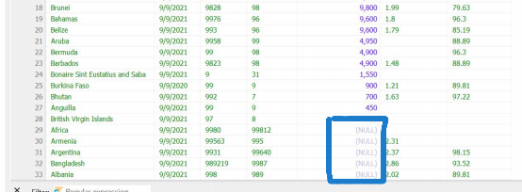

In continent category there is a missing values which is I found out that it is africa.

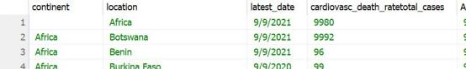

So I update the query to change the value of a missing continent into africa.
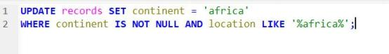
RESULT:
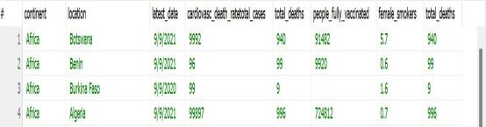
Changing empty values into 0, actualy I tried so many times running a query that will update all null values into 0 but it
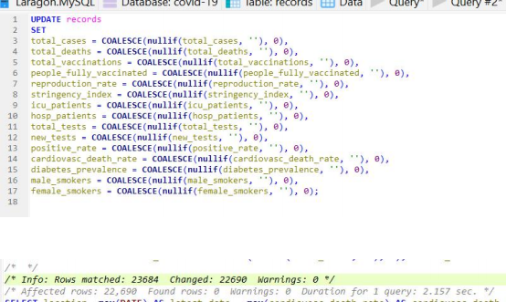
didn’t work after so many failed queries this one finally work.

And as you can see that in the query result it actually works.

Affecting several rows;

Before,

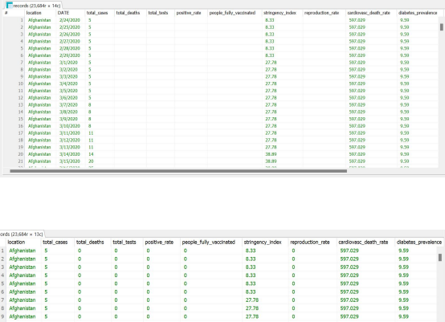

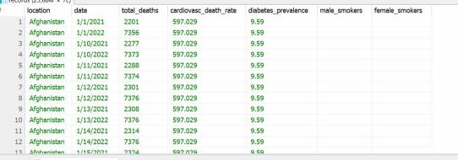
After,

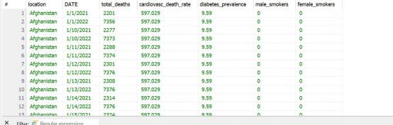
Before,

After,

