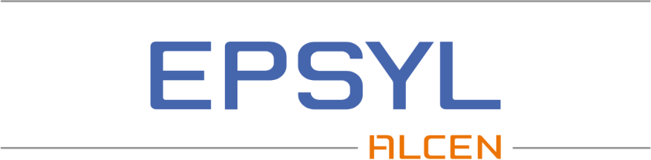

DOSSIER DE COMPÉTENCES

{{header.trigramme}}

{% set postes_actifs = poste_cible | selectattr("active") | list %}{% if postes_actifs %}{{ postes_actifs[0].title }}{% endif %}
{% set skills_actifs = skills_cible | selectattr("active") | list %}{% for skill in skills_actifs %}{{ skill.title }}{% if not loop.last %}, {% endif %}{% endfor %}

Expérience > {{header.xp_duration}} ans

{% if main_skills %}

Compétences Principales
{% if main_skills.bullet %}{% for entry in main_skills.bullet %}

{{entry.title}}{%if entry.description %}
- {% for bullet1 in entry.description %}{{bullet1.title}}{% if bullet1.description %} :
- {% for bullet2 in bullet1.description %}{{bullet2.title}}{% if bullet2.description %} :
- {% for bullet3 in bullet2.description %}{{bullet3.title}}{% if bullet3.description%} : {{bullet3.description}}{% endif %}
- {% endfor %}{% endif %}
- {% endfor %}{% endif %}
- {% endfor %}{% endif %}{% endfor %}
{% endif %}{% if main_skills.table %}
{% for entry in main_skills.table %}{{entry.title}} | {{ entry.description | map(attribute='title') | join(', ') }}
{% endfor %}

{% endif %}{% endif %}{% if formations %}Formations, Diplômes
{% for entry in formations %}{{entry.date}} | {{entry.title}} – {{entry.school}}{% if entry.description %}  {{entry.description}}{% endif %}
{% endfor %}

{% endif %}{% if certifications %}Certifications
{% for entry in certifications %}{{entry.date}} | {{entry.title}}{% if entry.description %}  {{entry.description}}{% endif %}
{% endfor %}

{% endif %}{% if langues %}Langues
{% for entry in langues %}{{entry.title}} | {% if entry.description %}{{entry.description}}{% endif %}
{% endfor %}
{% endif %}{% if xp_pro %}

Expériences professionnelles
{% for item in xp_pro %}
{{item.company}} | {{item.date}}
{{item.poste}}
{% if item.context %}Contexte : {{item.context}}{% endif %}
{% for entry in item.description %}

{{entry.title}}{%if entry.description %}
- {% for bullet1 in entry.description %}{{bullet1.title}}{% if bullet1.description %} :
- {% for bullet2 in bullet1.description %}{{bullet2.title}}{% if bullet2.description %} :
- {% for bullet3 in bullet2.description %}{{bullet3.title}}{% if bullet3.description%} : {{bullet3.description}}{% endif %}
- {% endfor %}{% endif %}
- {% endfor %}{% endif %}
- {% endfor %}{% endif %}{% endfor %}
{% if item.env_tech %}
Environnements techniques{{" : "}}{{ item.env_tech | join(", ") }}
{% endif %}{% endfor %}
{% endif %}

