

ITCOA2-33 Assessments (2025)

Project

1. Project
Faculty: | Information Technology
Module Code: | ITCOA2
Module Name: | Web Server Management
Content Writer: | Jean Labuschagne  (EDUV4955673)
Internal Moderation:
Copy Editor: | Jean Labuschagne
Total Marks: | 100
Submission Week: | Third Block Week 6

Contents
 1
ITCOA2-33 Assessments (2025) 1
Project 1
1. Project 1
1.1 3
1.2 4
1.3 5
1.4 6
2.1 7
3.1 12
3.2 13
3.3 14
3.4 15
3.5 16
4.1 17
4.2 18
4.3 19
4.4 21
4.5 21

1.1 Install Windows Server 2019 on a VM and configure its hostname as TN-SERVER01.
(5 marks)
Deliverables:
· Screenshot of VM creation settings (RAM, HDD, Network).
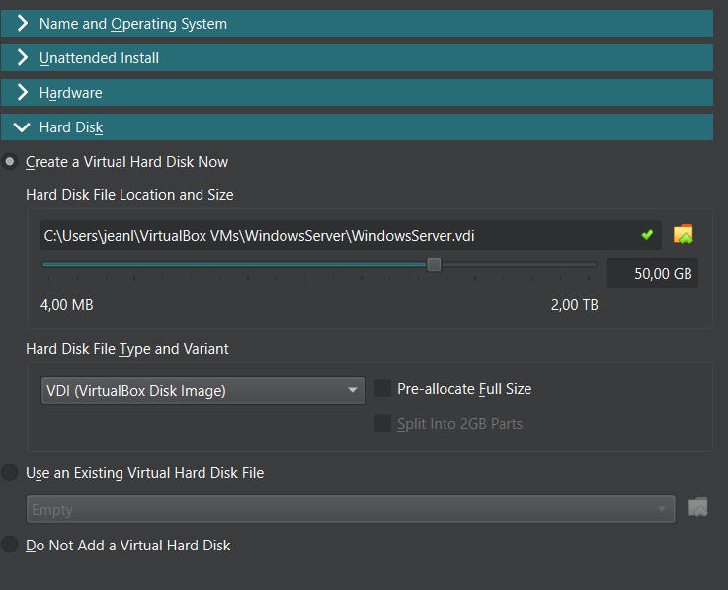
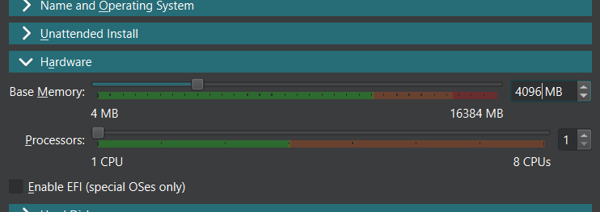
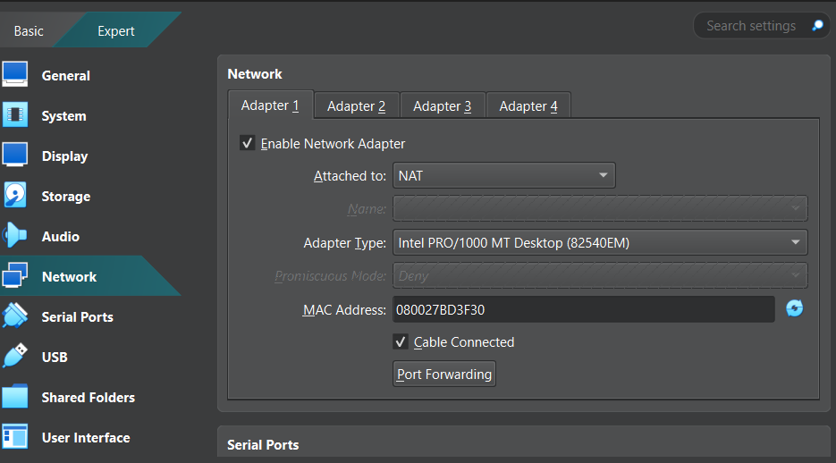

· Screenshot of Windows Server 2019 "Desktop Experience" edition selection during
installation.
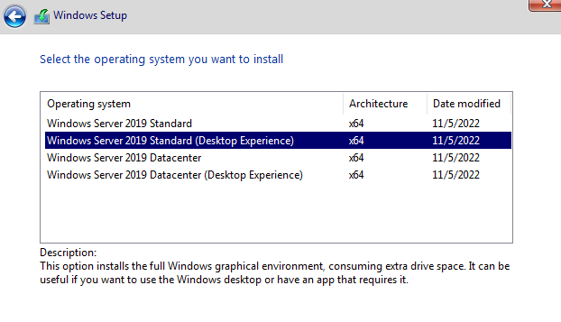
· Screenshot of the TN-SERVER01 hostname configured in System Properties.
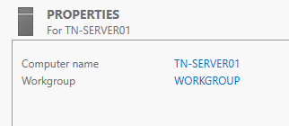
1.2 Install necessary roles and features such as File Server, AD DS, DNS, and DHCP.
(5 marks)
Deliverables:
· Screenshot of the "Select Server Roles" page with AD DS, DNS Server, DHCP Server, and File Server selected.
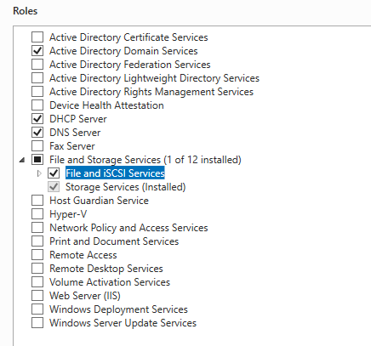

· Screenshot of the "Installation Progress" or "Results" page showing successful installation of all roles.
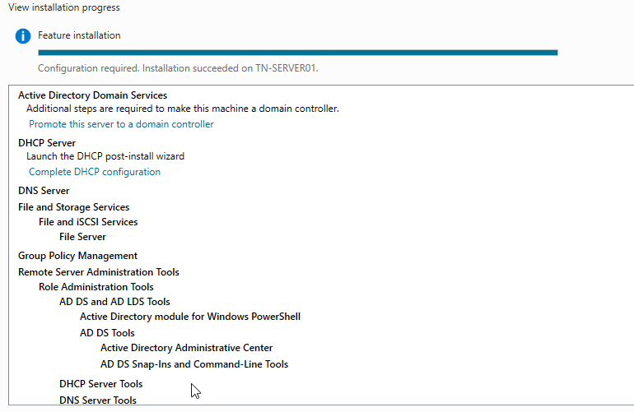
1.3 Configure system updates and enable remote desktop access.
(5 marks)
Deliverables:
· Screenshot of Windows Update showing "Up to date" or updates being installed.
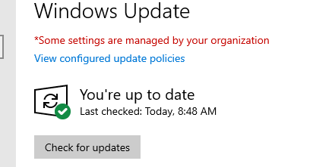
· Screenshot of "System Properties" dialogue with "Allow remote connections to this computer" selected.
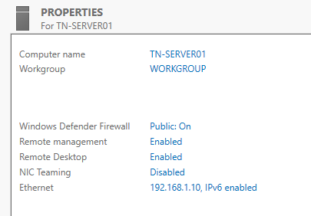
· Screenshot from a client machine (e.g., your host machine or Windows 10 VM) successfully connecting via RDP to TN-SERVER01.
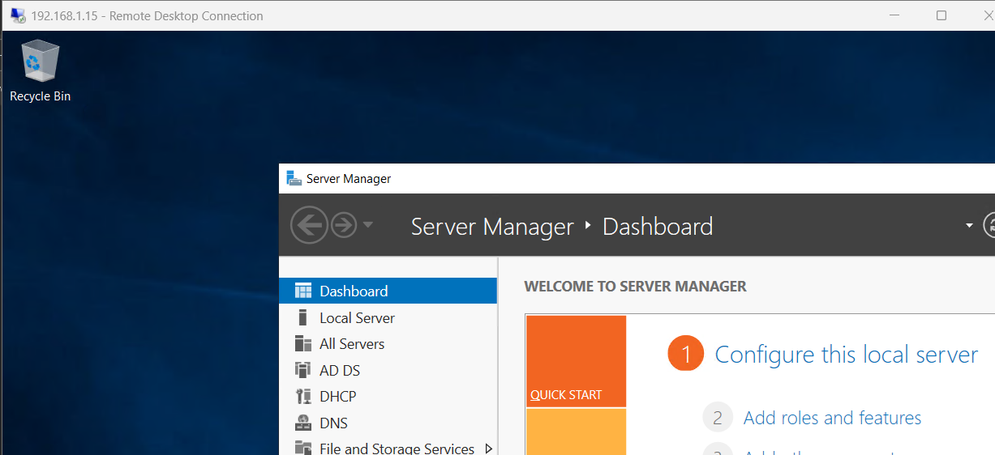
1.4 Demonstrate disk partitioning and user account creation.
(5 marks)
Deliverables:
· Screenshot of Disk Management showing the newly partitioned volume (e.g., D: drive).
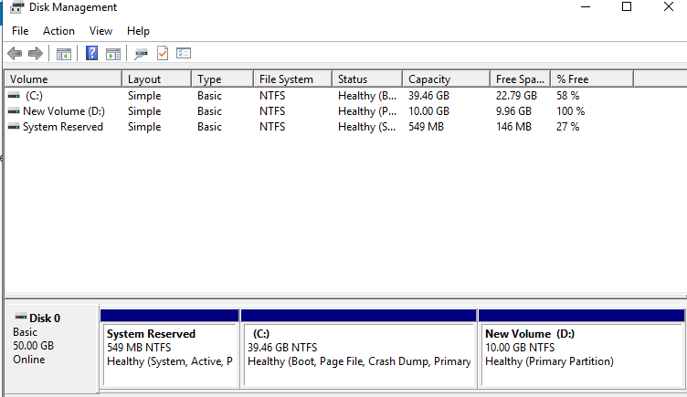
· Screenshot of "Computer Management" showing the newly created local user account.
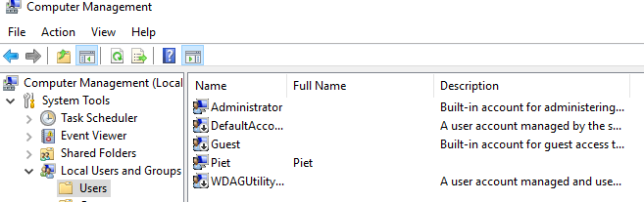

2.1 Promote the server to a Domain Controller and create the domain: technova.local.
(5 marks)
Deliverables:
· Screenshot of the "Deployment Configuration" step showing "Add a new forest" and technova.local entered.
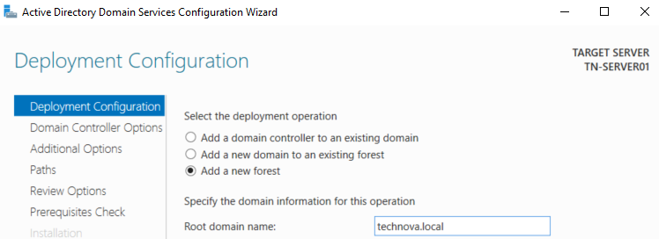
· Screenshot of the successful promotion completion message before the server restarts.
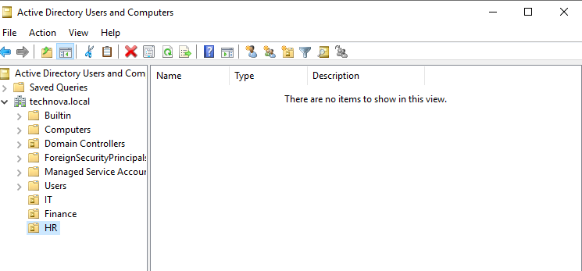
2.2 Create and organise 3 Organisational Units: IT, Finance, and HR.
(5 marks)
Deliverables:
· Screenshot of Active Directory Users and Computers showing the IT, Finance, and HR OUs directly under technova.local.
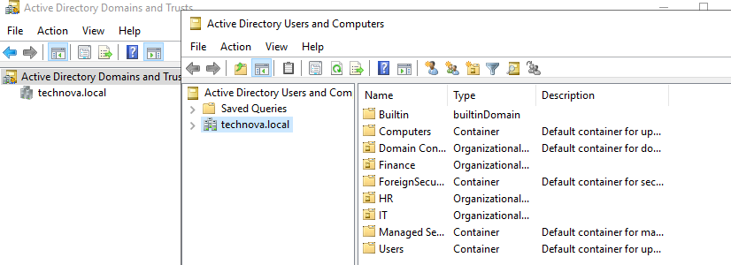
2.3 Create at least 2 users per OU and assign them to groups.
(5 marks)
Deliverables:
· Screenshot of ADUC showing at least 2 users within each of the IT, Finance, and HR OUs.
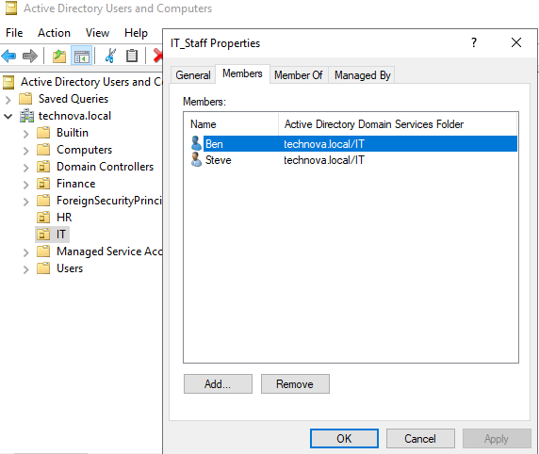
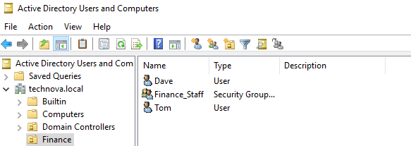
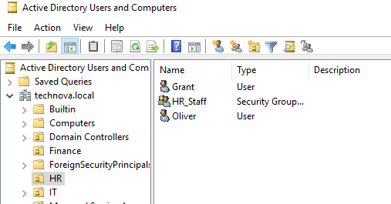
· Screenshot of the "Members" tab for one of the newly created groups (e.g., IT_Staff) showing its assigned users.
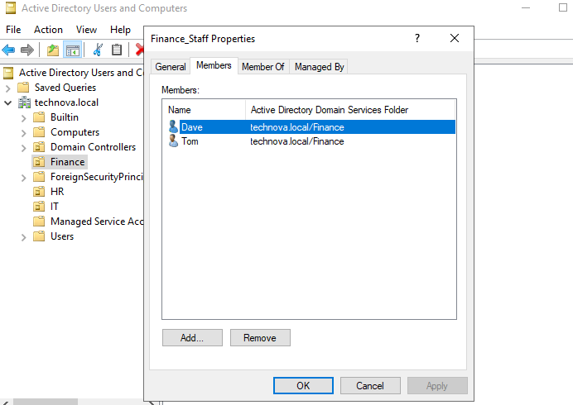
2.4 Configure DNS with forward and reverse lookup zones.
(5 marks)
Deliverables:
· Screenshot of DNS Manager showing the technova.local forward lookup zone.
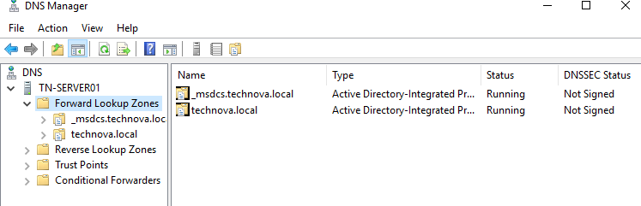
· Screenshot of DNS Manager showing the newly created reverse lookup zone (e.g., 10.168.192.in-addr.arpa).
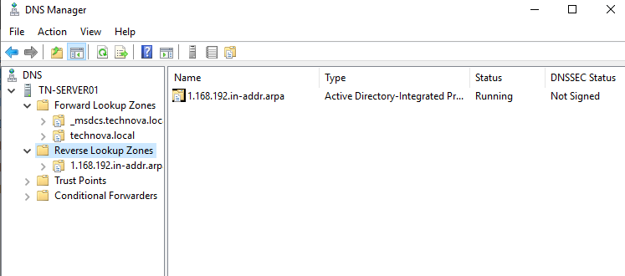
2.5 Set up DHCP with one scope (with 192.168.1.0/24), exclusions, reservations, and lease duration.
(10 marks)
Deliverables:
· Screenshot of the DHCP console showing the authorized server.
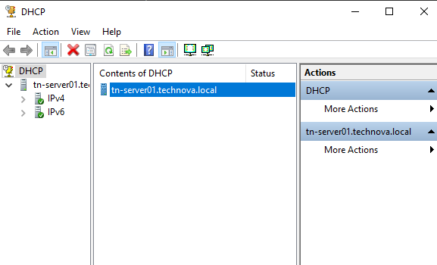
· Screenshot of the "New Scope Wizard" showing the configured IP address range.
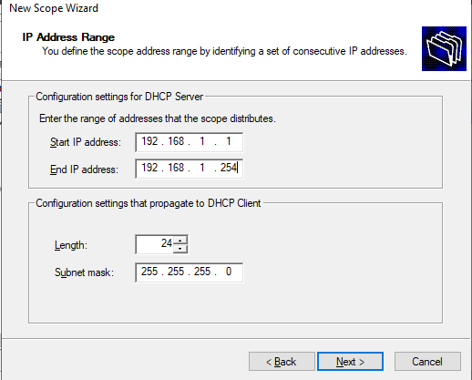
· Screenshot of the "Add Exclusions and Delay" page with the exclusion range.
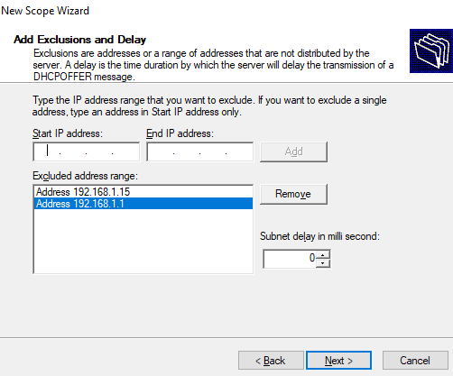
· Screenshot of the "Scope Options" showing the Default Gateway and DNS servers.
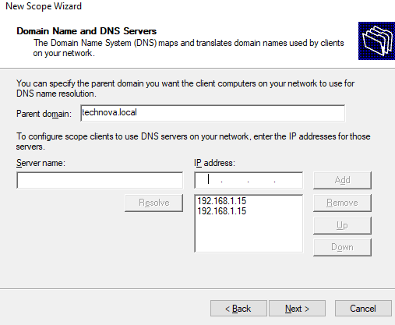
· Screenshot of the "Reservations" node showing the newly created reservation.
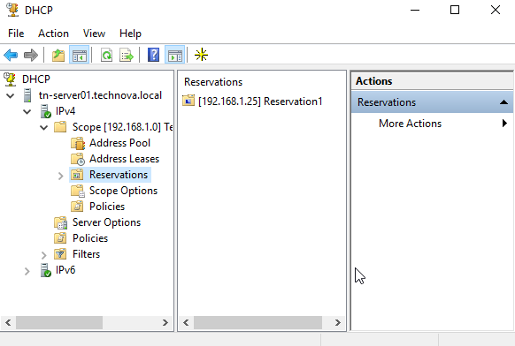
3.1 Create a new Group Policy Object (GPO) to enforce password complexity and screen lock after 10 minutes.
(5 marks)
Deliverables:
· Screenshot of Group Policy Management Console (GPMC) showing TechNova_Security_Policy created.
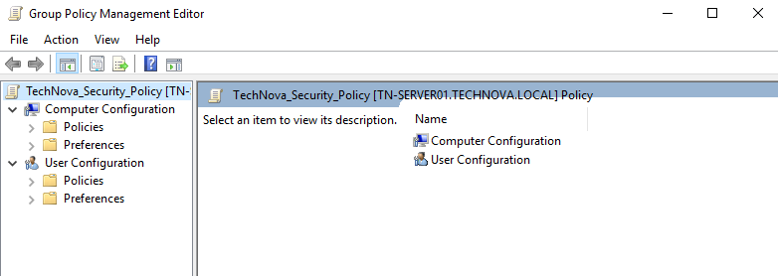
· Screenshots of the configured password complexity and screen lock settings within the GPO editor.

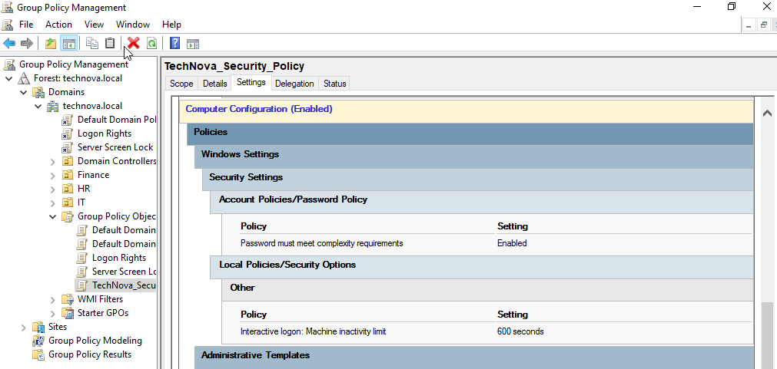
3.2 Link the GPO to the domain and verify its effect using gpresult or rsop.msc.
(5 marks)
Deliverables:
· Screenshot of gpresult /r output on the Windows 10 client showing TechNova_Security_Policy in "Applied Group Policy Objects."
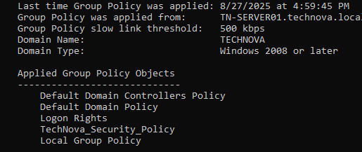
· Screenshot of rsop.msc on the Windows 10 client showing the password complexity and screen lock settings applied.

3.3 Configure an additional GPO to map a network drive to users in the HR OU.
(5 marks)
Deliverables:
· Screenshot of the shared folder permissions on TN-SERVER01.
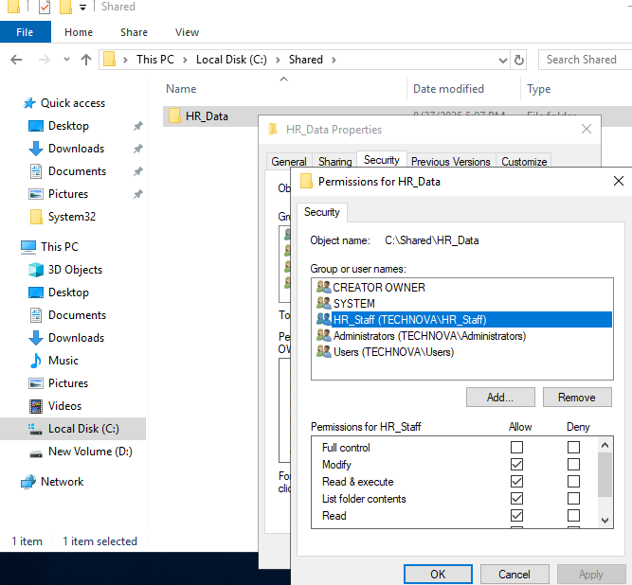
· Screenshot of the "Drive Maps" configuration within the HR_Drive_Map_Policy GPO editor.
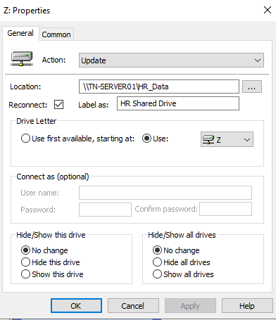
· Screenshot from an HR user's login on the Windows 10 client showing the mapped Z: drive.

3.4 Install Active Directory Certificate Services (AD CS) and issue a basic certificate template.
(5 marks)
Deliverables:
· Screenshot of "Add Roles and Features Wizard" showing AD CS role services selected.
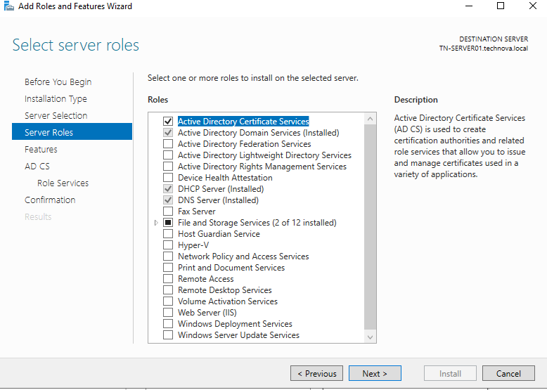
· Screenshot of "Configure Certificate Services" wizard showing "Enterprise CA" and "Root CA" selected.
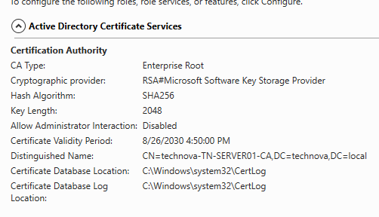
· Screenshot of Certification Authority console showing TechNova_User_Cert listed under "Certificate Templates."
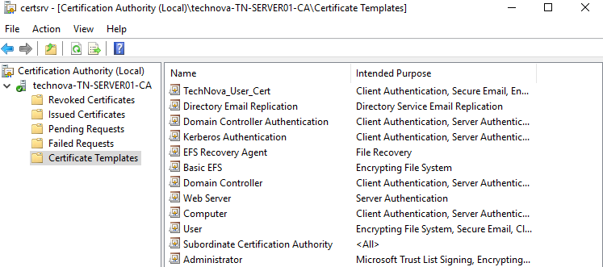
3.5 Export and import a user certificate for encrypted email.
(5 marks)
Deliverables:
· Screenshot of HRUser1's certificate in the "Personal" store of the Windows 10 client.
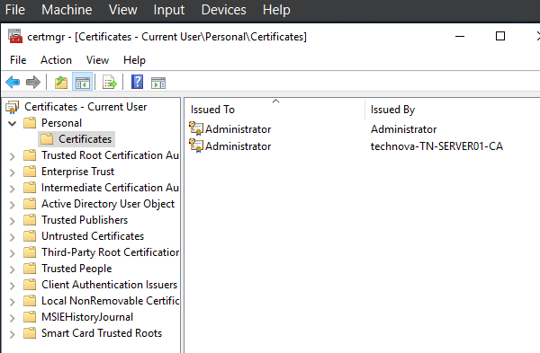
· Screenshot of the "Certificate Export Wizard" showing "Yes, export the private key" selected.
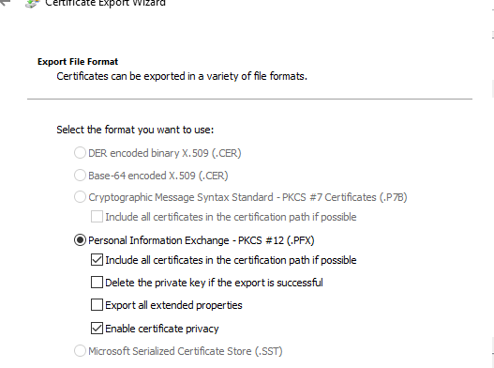
· Screenshot of the "Certificate Import Wizard" confirming successful import on another machine/location.
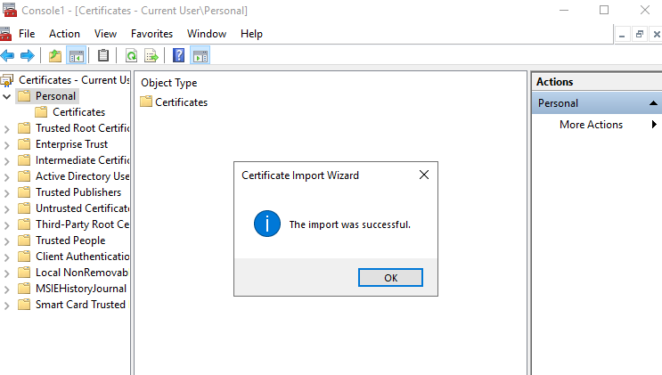
4.1 Install and configure Windows Defender Antivirus and Windows Firewall.
(5 marks)
Deliverables:
· Screenshot of Windows Security showing "Virus & threat protection" status.
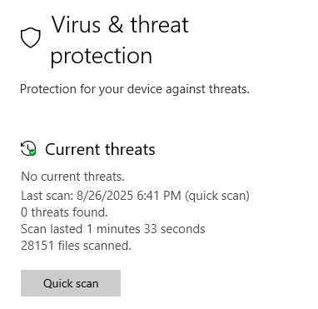
· Screenshot of "Windows Defender Firewall with Advanced Security" showing the firewall status and active profile.
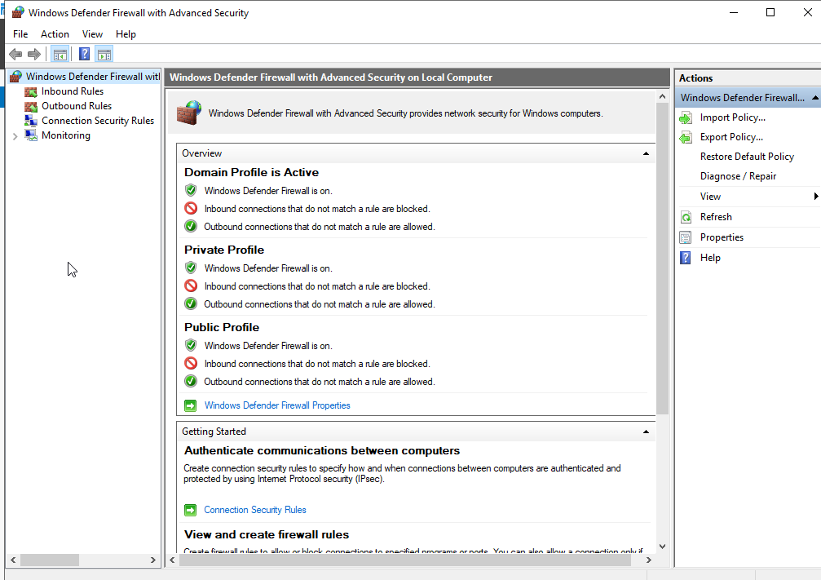

4.2 Create firewall rules to allow RDP and block ICMP ping requests.
(5 marks)
Deliverables:
· Screenshot of "Windows Defender Firewall with Advanced Security" showing the "Remote Desktop (TCP-In)" rule enabled.
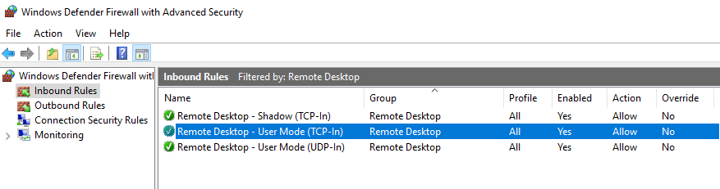
· Screenshot of the "Block_ICMP_Ping" inbound rule created and enabled.
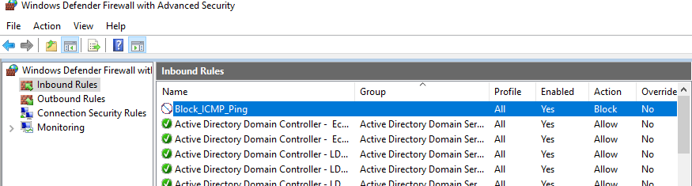
· Screenshot from the Windows 10 client showing a successful RDP connection to TN-SERVER01.

· Screenshot from the Windows 10 client showing a failed ping to TN-SERVER01 after the rule is applied.
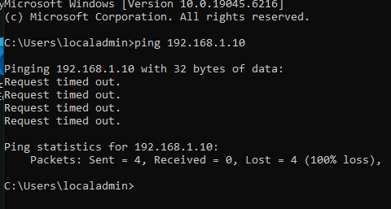
4.3 Configure and test VPN or Direct Access functionality.
(5 marks)
Deliverables:
· Screenshot of Remote Access role services selected.
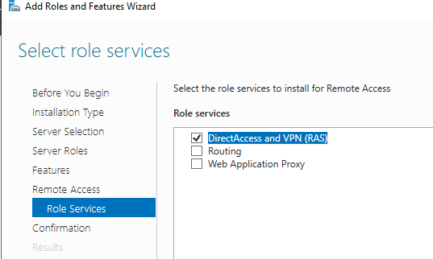
· Screenshot of RRAS console showing the VPN server enabled.
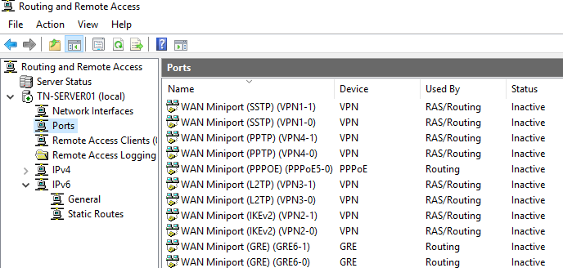
· Screenshot of the Windows 10 client's VPN connection settings.
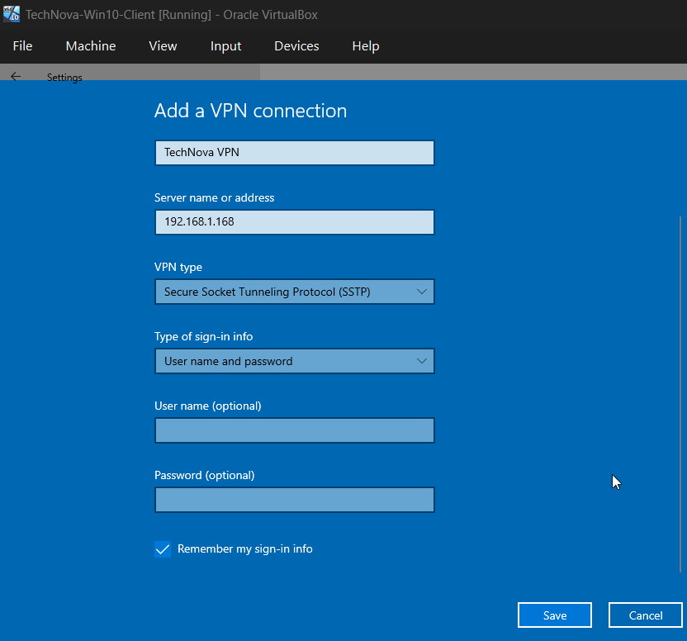
· Screenshot of the Windows 10 client showing a successful VPN connection.

4.4 Demonstrate the use of Remote Access Management Console or PowerShell to manage connections.
(5 marks)
Deliverables:
· Screenshot of "Remote Access Management Console" showing a connected VPN client.
· Screenshot of PowerShell output for Get-RemoteAccessConnection showing active VPN connections.
· Screenshot of PowerShell output for Disconnect-RemoteAccessUser (if you disconnect a user).

4.5 Describe and apply two best practices for hardening Windows Server 2019.
(5 marks)
Deliverables:
· Screenshot demonstrating "least privilege" (e.g., UAC prompt for a standard user).
· Screenshot demonstrating "disable unnecessary services" (e.g., a service set to "Disabled" startup type).

