

Individual Assessment Coversheet
To be attached to the front of the assessment.

Campus: | Tygervalley campus __
Faculty: | IT __
Module Code: | ITDSA2-B12
Group: | Group 1
Lecturer’s Name: | Trudie Lotz
Student Full Name: | Jean Labuschagne __
Student Number: | Eduv4955673

Indicate | Yes | No
Plagiarism report attached

Declaration:
I declare that this assessment is my own original work except for source material explicitly acknowledged. I also declare that this assessment or any other of my original work related to it has not been previously, or is not being simultaneously, submitted for this or any other course. I am aware of the AI policy and acknowledge that I have not used any AI technology to generate or manipulate data, other than as permitted by the assessment instructions. I also declare that I am aware of the Institution’s policy and regulations on honesty in academic work as set out in the Conditions of Enrolment, and of the disciplinary guidelines applicable to breaches of such policy and regulations.
2025/06/30
Date
Signature
Jean Labuschagne

Lecturer’s Comments:
Marks Awarded: %
Date
Signature

Eduvos (Pty) Ltd. (formerly Pearson Institute of Higher Education) is registered with the Department of Higher Education and Training as a private higher education
institution under the Higher Education Act, 101, of 1997. Registration Certificate number: 2001/HE07/008

Contents
Declaration: 1
Lecturer’s Comments: 2
Question 1 4
1.1 4
1.2 6
1.3 7
1.4 9
1.5 9
1.6 10
Question 2 12
2.1 12
2.2 12
2.3 12
2.4 14
2.5 15
2.6 15
2.7 16

Question 1

1.1
CREATE TABLE Provinces (
ProvinceCode VARCHAR2(10) PRIMARY KEY,
ProvinceName VARCHAR2(100)
);
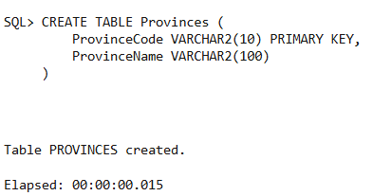
CREATE TABLE Municipalities (
MunCode VARCHAR2(10) PRIMARY KEY,
Name VARCHAR2(100),
AvgPopulation NUMBER,
ProvinceCode VARCHAR2(10),
FOREIGN KEY (ProvinceCode) REFERENCES Provinces(ProvinceCode)
);
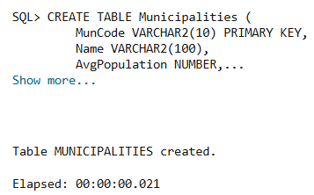
CREATE TABLE Facilities (
FacilityID NUMBER PRIMARY KEY,
Name VARCHAR2(100),
Capacity NUMBER,
Address VARCHAR2(200),
MunCode VARCHAR2(10),
FOREIGN KEY (MunCode) REFERENCES Municipalities(MunCode)
);
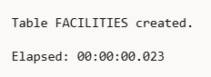
CREATE TABLE Rooms (
RoomNo NUMBER PRIMARY KEY,
Description VARCHAR2(100),
FacilityID NUMBER,
FOREIGN KEY (FacilityID) REFERENCES Facilities(FacilityID)
);
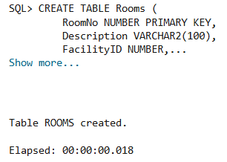
CREATE TABLE Activities (
ActRef NUMBER PRIMARY KEY,
ActivityName VARCHAR2(100)
);
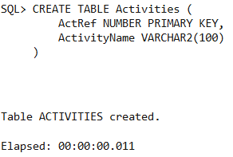
CREATE TABLE Uses (
FacilityID NUMBER,
ActRef NUMBER,
UseDate DATE,
PRIMARY KEY (FacilityID, ActRef, UseDate),
FOREIGN KEY (FacilityID) REFERENCES Facilities(FacilityID),
FOREIGN KEY (ActRef) REFERENCES Activities(ActRef)
);
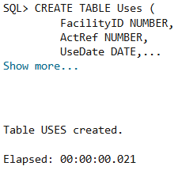

1.2
CREATE SEQUENCE facility_seq START WITH 1 INCREMENT BY 1 NOCACHE NOCYCLE;
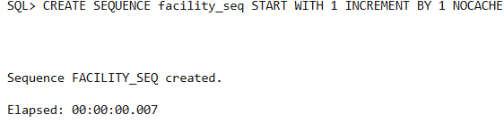
CREATE SEQUENCE room_seq START WITH 1 INCREMENT BY 1 NOCACHE NOCYCLE;
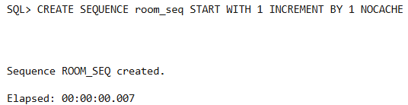
CREATE SEQUENCE activity_seq START WITH 1 INCREMENT BY 1 NOCACHE NOCYCLE;
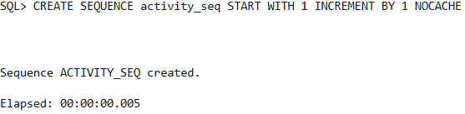

1.3
INSERT INTO Provinces VALUES ('GP', 'Gauteng');
INSERT INTO Provinces VALUES ('WC', 'Western Cape');
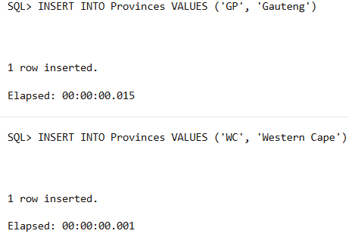
INSERT INTO Municipalities VALUES ('M001', 'Johannesburg', 5800000, 'GP');
INSERT INTO Municipalities VALUES ('M002', 'Cape Town', 4300000, 'WC');
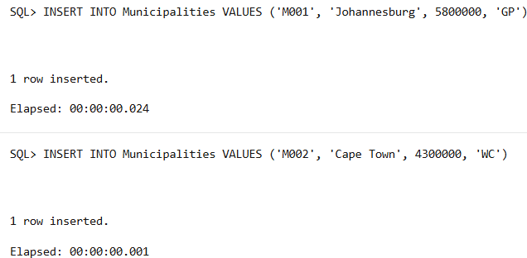
INSERT INTO Facilities VALUES (facility_seq.NEXTVAL, 'Soweto Theatre', 1200, 'Soweto, Johannesburg', 'M001');
INSERT INTO Facilities VALUES (facility_seq.NEXTVAL, 'Artscape', 2500, 'Foreshore, Cape Town', 'M002');
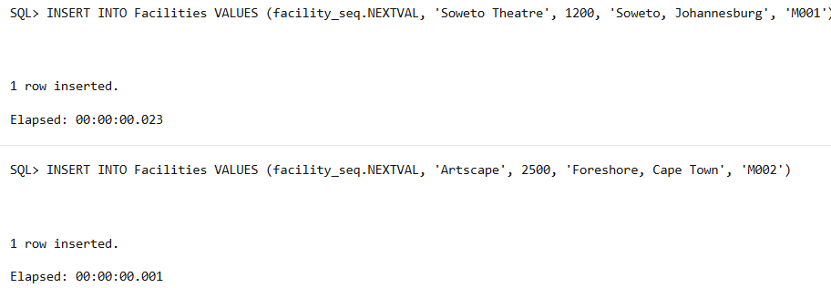
INSERT INTO Rooms VALUES (room_seq.NEXTVAL, 'Theatre Room', 1);
INSERT INTO Rooms VALUES (room_seq.NEXTVAL, 'Exhibition Hall', 2);
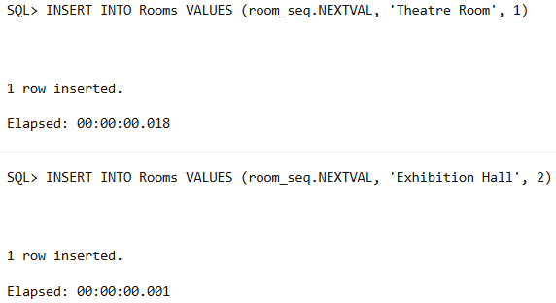
INSERT INTO Activities VALUES (activity_seq.NEXTVAL, 'Music');
INSERT INTO Activities VALUES (activity_seq.NEXTVAL, 'Dance');
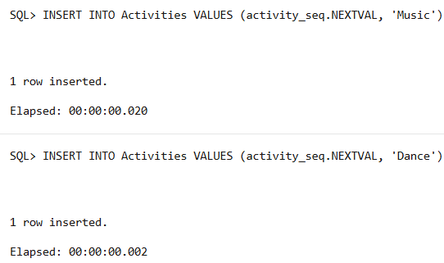

INSERT INTO Uses VALUES (1, 1, TO_DATE('2025-05-01', 'YYYY-MM-DD'));
INSERT INTO Uses VALUES (2, 2, TO_DATE('2025-06-15', 'YYYY-MM-DD'));
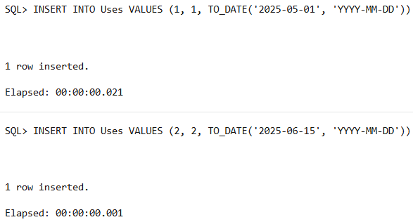

1.4
SELECT COUNT(DISTINCT m.MunCode) AS Mun_Without_Music
FROM Municipalities m
LEFT JOIN Facilities f ON m.MunCode = f.MunCode
LEFT JOIN Uses u ON f.FacilityID = u.FacilityID
LEFT JOIN Activities a ON u.ActRef = a.ActRef AND LOWER(a.ActivityName) LIKE '%music%'
WHERE f.FacilityID IS NULL OR a.ActRef IS NULL;
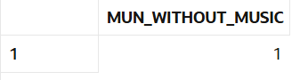

1.5
SELECT DISTINCT p.ProvinceName
FROM Provinces p
JOIN Municipalities m ON p.ProvinceCode = m.ProvinceCode
WHERE m.AvgPopulation >= 4000000;
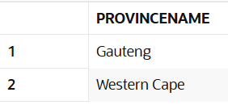

1.6
CREATE OR REPLACE PROCEDURE Province_Capacity_Utilization_procedure IS
BEGIN
FOR rec IN (
SELECT
p.ProvinceName,
COUNT(DISTINCT f.FacilityID) AS NumFacilities,
SUM(f.Capacity) AS TotalCapacity,
COUNT(u.ActRef) AS TotalActivities,
ROUND(
(COUNT(u.ActRef) / NULLIF(SUM(f.Capacity), 0)) * 100,
2
) AS UtilizationPercent
FROM Provinces p
JOIN Municipalities m ON p.ProvinceCode = m.ProvinceCode
JOIN Facilities f ON m.MunCode = f.MunCode
LEFT JOIN Uses u ON f.FacilityID = u.FacilityID
GROUP BY p.ProvinceName
ORDER BY UtilizationPercent DESC
)
LOOP
DBMS_OUTPUT.PUT_LINE('Province: ' || rec.ProvinceName);
DBMS_OUTPUT.PUT_LINE('Facilities: ' || rec.NumFacilities);
DBMS_OUTPUT.PUT_LINE('Capacity: ' || rec.TotalCapacity);
DBMS_OUTPUT.PUT_LINE('Activities: ' || rec.TotalActivities);
DBMS_OUTPUT.PUT_LINE('Utilization: ' || rec.UtilizationPercent || '%');
DBMS_OUTPUT.PUT_LINE('---------------------------------------');
END LOOP;
END;
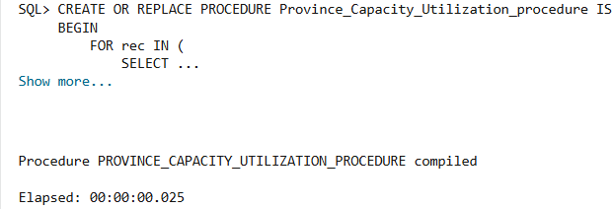
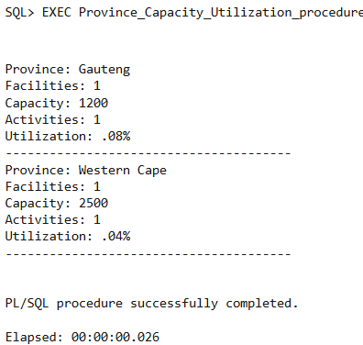

Question 2

2.1
use OLMS
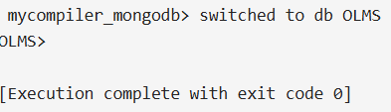

2.2
db.createCollection("Province")
db.createCollection("Municipality")
db.createCollection("Facility")
db.createCollection("Room")
db.createCollection("Activity")
db.createCollection("Uses")
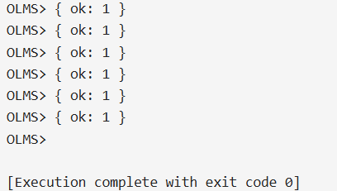

2.3
db.Province.insertMany([
{ provinceCode: "WC", name: "Western Cape" },
{ provinceCode: "KZN", name: "KwaZulu-Natal" }
])
db.Municipality.insertMany([
{ munCode: "CPT", name: "City of Cape Town", avgPopulation: 4005016, provinceCode: "WC" },
{ munCode: "ETH", name: "eThekwini Metropolitan Municipality", avgPopulation: 3702231, provinceCode: "KZN" }
])
db.Facility.insertMany([
{
facilityId: "Arts",
name: "Artscape Theatre Centre",
address: "D.F. Malan St, Foreshore, Cape Town, 8001",
capacity: 1500,
munCode: "CPT"
},
{
facilityId: "ICC",
name: "Durban ICC",
address: "45 Bram Fischer Rd, Durban Central, Durban, 4001",
capacity: 10000,
munCode: "ETH"
}
])
db.Room.insertMany([
{ roomNo: 1, description: "Hall 1", facilityId: "Arts" },
{ roomNo: 2, description: "Hall 2", facilityId: "ICC" }
])
db.Activity.insertMany([
{ activityRef: "MUS01", name: "Music Concert" },
{ activityRef: "EXH01", name: "Art Exhibition" }
])
db.Uses.insertMany([
{
useDate: ISODate("2025-05-20T00:00:00.000Z"),
activityRef: "MUS01",
facilityId: "Arts"
},
{
useDate: ISODate("2025-06-15T00:00:00.000Z"),
activityRef: "EXH01",
facilityId: "ICC"
}
])

2.4
db.Facility.aggregate([
{
$lookup: {
from: "Room",
localField: "facilityId",
foreignField: "facilityId",
as: "rooms"
}
},
{
$project: {
_id: 0,
name: 1,
rooms: {
$map: {
input: "$rooms",
as: "room",
in: {
roomNo: "$$room.roomNo",
description: "$$room.description"
}
}
}
}
}
])
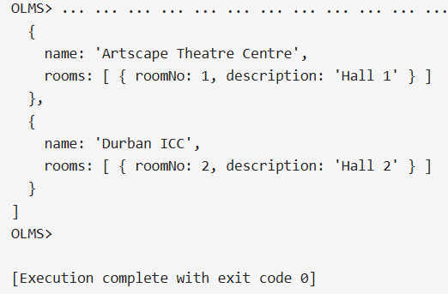

2.5
db.Municipality.find(
{ avgPopulation: { $gte: 3500000 } },
{ _id: 0, name: 1, avgPopulation: 1 }
)
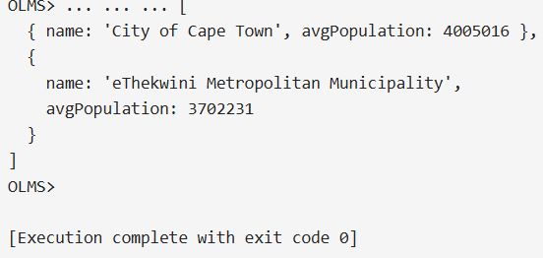

2.6
db.Uses.aggregate([
{
$lookup: {
from: "Facility",
localField: "facilityId",
foreignField: "facilityId",
as: "facility"
}
},
{ $unwind: "$facility" },
{
$project: {
_id: 0,
useDate: 1,
facilityId: 1,
name: "$facility.name",
capacity: "$facility.capacity",
address: "$facility.address"
}
}
])
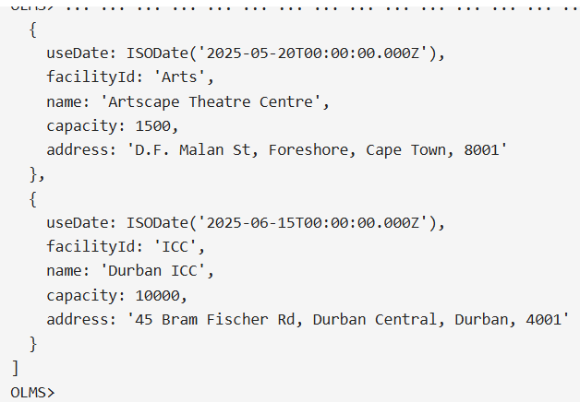

2.7
db.Uses.aggregate([
{
$lookup: {
from: "Activity",
localField: "activityRef",
foreignField: "activityRef",
as: "activity"
}
},
{ $unwind: "$activity" },
{
$lookup: {
from: "Facility",
localField: "facilityId",
foreignField: "facilityId",
as: "facility"
}
},
{ $unwind: "$facility" },
{
$lookup: {
from: "Municipality",
localField: "facility.munCode",
foreignField: "munCode",
as: "municipality"
}
},
{ $unwind: "$municipality" },
{
$lookup: {
from: "Province",
localField: "municipality.provinceCode",
foreignField: "provinceCode",
as: "province"
}
},
{ $unwind: "$province" },
{
$project: {
_id: 0,
activityRef: 1,
activityName: "$activity.name",
useDate: 1,
facilityId: 1,
facilityName: "$facility.name",
capacity: "$facility.capacity",
address: "$facility.address",
municipality: "$municipality.name",
province: "$province.name"
}
}
])
