

Individual Assessment Coversheet
To be attached to the front of the assessment.

Campus: | Tygervalley campus __
Faculty: | IT __
Module Code: | ITDSA
Group: | Group 1
Lecturer’s Name:
Student Full Name: | Jean Labuschagne __
Student Number: | Eduv4955673

Indicate | Yes | No
Plagiarism report attached

Declaration:
I declare that this assessment is my own original work except for source material explicitly acknowledged. I also declare that this assessment or any other of my original work related to it has not been previously, or is not being simultaneously, submitted for this or any other course. I am aware of the AI policy and acknowledge that I have not used any AI technology to generate or manipulate data, other than as permitted by the assessment instructions. I also declare that I am aware of the Institution’s policy and regulations on honesty in academic work as set out in the Conditions of Enrolment, and of the disciplinary guidelines applicable to breaches of such policy and regulations.
2025/05/20
Date
Signature
Jean Labuschagne

Lecturer’s Comments:
Marks Awarded: %
Date
Signature

Eduvos (Pty) Ltd. (formerly Pearson Institute of Higher Education) is registered with the Department of Higher Education and Training as a private higher education
institution under the Higher Education Act, 101, of 1997. Registration Certificate number: 2001/HE07/008

Contents
Declaration: 1
Lecturer’s Comments: 2
Question 1 4
Question 1.1 4
Question 1.2 4
Question 1.3 5
Question 2 5
Question 2.1 5
Question 2.2 5
Question 2.3 6
Question 3 7
Question 3.1 7
Question 3.2 8
Question 3.3 8

Entity name | Associated Attributes
Province | ProvinceCode (PK), ProvinceName
Municipality | MunicipalityCode (PK), MunicipalityName, AvgPopulation, ProvinceCode (FK)
Facility | FacilityID (PK), FacilityName, Capacity, Address, MunicipalityCode (FK)
Room | RoomNo (PK), RoomDescription
ActivityCategory | ActivityCategoryID (PK), CategoryName
FacilityActivity | FacilityID (FK), ActivityCategoryID (FK), ActivityDate

Question 1

Question 1.1

Question 1.2

Province
Primary Key (PK): ProvinceCode
No foreign keys.

Municipality
Primary Key (PK): MunicipalityCode
Foreign Key (FK): ProvinceCode (references Province)

Room
Primary Key (PK): RoomNo
No foreign keys

Cultural Facility
Primary Key (PK): FacilityID
Foreign Keys (FK):
MunicipalityCode
RoomNo

Activity Category
Primary Key (PK): ActivityCategoryID
No foreign keys.

Facility Activity (Intermediate Entity)
Composite Primary Key (PK): FacilityID, ActivityCategoryID, ActivityDate
Foreign Keys (FK):
FacilityID
ActivityCategoryID

Question 1.3

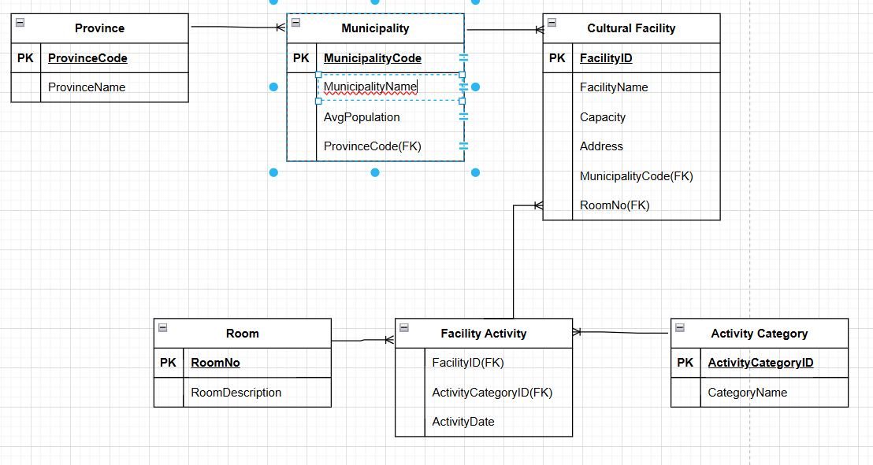

Question 2

Question 2.1
Relationship Entity Pair | Relationship Type
Province – Municipality | One-to-Many: One Province has many Municipalities
Municipality – Cultural Facility | One-to-Many: One Municipality hosts many Cultural Facilities
Room – Cultural Facility | One-to-Many: One Room may contain many Cultural Facilities
Cultural Facility – Facility Activity | One-to-Many: One Cultural Facility can have many Facility Activities
Activity Category – Facility Activity | One-to-Many: One Activity Category is associated with many Facility Activities
Cultural Facility – Activity Category | Many-to-Many (Resolved): Related through Facility Activity entity

Question 2.2
1.
Province(ProvinceCode, ProvinceName)
1NF: Each attribute holds a atomic value.
2NF: The candidate key is ProvinceCode (a single attribute) and ProvinceName depends on it.
3NF: There is no transitive dependency; ProvinceName is directly dependent on ProvinceCode.
2.
Municipality(MunicipalityCode, MunicipalityName, AvgPopulation, ProvinceCode)
1NF: All attributes are atomic.
2NF: The candidate key is MunicipalityCode and every other attribute (MunicipalityName, AvgPopulation, ProvinceCode) is dependent on it.
3NF: There is no transitive dependency. (For example, although ProvinceCode determines the province’s details, those details are stored in the Province table so no redundant data appears here.)

3.
Room(RoomNo, RoomDescription)
1NF: The room number and description are atomic values.
2NF & 3NF: With RoomNo as the sole key, RoomDescription depends on RoomNo and there are no transitive dependencies.
4.
Cultural Facility(FacilityID, FacilityName, Capacity, Address, MunicipalityCode, RoomNo)
1NF: Each attribute (FacilityID, FacilityName, etc.) is atomic.
2NF: FacilityID (the candidate key) fully determines FacilityName, Capacity, Address, MunicipalityCode, and RoomNo.
3NF: No non-key attribute is transitively dependent on FacilityID (for example, Address is stored here even though it is “within a municipality”; the MunicipalityCode serves as a foreign key and its details are in the Municipality table).
5.
Activity Category(ActivityCategoryID, CategoryName)
1NF: Attributes are atomic.
2NF: ActivityCategoryID is the candidate key and CategoryName is dependent on it.
3NF: There are no transitive dependencies.
6.
Facility Activity(FacilityID, ActivityCategoryID, ActivityDate)
1NF: All three attributes are atomic.
2NF: The composite primary key (FacilityID, ActivityCategoryID, ActivityDate) determines any attribute in the relation (in this case, there are no extra non-key attributes).
3NF: With no non-key attributes, there are no transitive dependencies.

All entities are in Third Normal Form since every non-key attribute is fully functionally dependent on the primary key and there are no transitive dependencies.

Question 2.3
Province Table
ProvinceCode | ProvinceName
P01 | Gauteng
P02 | KwaZulu-Natal
Municipality Table
MunicipalityCode | MunicipalityName | AvgPopulation | ProvinceCode
M001 | Johannesburg | 3000000 | P01
M002 | Durban | 2500000 | P02
Room Table
RoomNo | RoomDescription
101 | Theatre
102 | Cinema
Cultural Facility Table
FacilityID | FacilityName | Capacity | Address | MunicipalityCode (FK) | RoomNo (FK)
1 | Modise Cultural Centre | 500 | 123 Main St | M001 | 101
2 | Creative Arts Hub | 300 | 456 West Rd | M002 | 102
Activity Category Table
ActivityCategoryID | CategoryName
1 | Cinema
2 | Circus
Facility Activity Table
FacilityID (FK) | ActivityCategoryID (FK) | ActivityDate
1 | 6 | 01/05/2025
2 | 1 | 04/15/2025

Question 3

Question 3.1
I. Retrieve the city and phone of the author named Mpho Sifiso:
πCity, Phone(σAname=’Mpho Sifiso’(AUTHOR))πCity, Phone​(σAname=’Mpho Sifiso’​(AUTHOR))
II. Retrieve name, address, and phone of publishers in Cape Town:
πPname, Address, PhoneNo(σCity=’Cape Town’(PUBLISHER))πPname, Address, PhoneNo​(σCity=’Cape Town’​(PUBLISHER))
III. Retrieve title and price of novels with page count > 200:
πBook_title, Price(σCategory=’Novel’∧Page_count>200(BOOK))πBook_title, Price​(σCategory=’Novel’∧Page_count>200​(BOOK))
IV. Retrieve ISBN, title, and price of books in Textbook or Novel categories:
πISBN, Book_title, Price(σCategory=’Textbook’∨Category=’Novel’(BOOK))πISBN, Book_title, Price​(σCategory=’Textbook’∨Category=’Novel’​(BOOK))
V. Retrieve ID, name, address, and phone of publishers of novels:
πP_ID, Pname, Address, PhoneNo(PUBLISHER⋈PUBLISHER.P_ID=BOOK.P_IDσCategory=’Novel’(BOOK))πP_ID, Pname, Address, PhoneNo​(PUBLISHER⋈PUBLISHER.P_ID=BOOK.P_ID​σCategory=’Novel’​(BOOK)

Question 3.2

a. Serial Schedule:
Option 1: Execute all operations of M first, then N.
Option 2: Execute all operations of N first, then M.

b. Equivalent Non-Serial Schedule:
Interleave operations of M and N such that the final result matches a serial schedule (e.g., conflict serializable).

Question 3.3
Expression | Minimum Size | Maximum Size | Operation Description
R1×R2 | 9 | 9 | Cartesian product (3×3 = 9).
R1∪R2 | 6 | 6 | Union (all elements distinct).
R1∩R2 | 0 | 0 | No common elements.
R1−R2 | 3 | 3 | All elements of R1 (no overlap with R2).
σStudents>50(R1) | 1 | 1 | Only "60" satisfies the condition.
πStudents(R1) | 3 | 3 | Projection retains all 3 tuples.
R1⋈R2 | 9 | 9 | Natural join = Cartesian product (no common attributes).

