

Individual Assessment Coversheet
To be attached to the front of the assessment.

Campus: | Tygervalley campus __
Faculty: | IT __
Module Code: | ITOOA3-B11
Group: | Group 1
Lecturer’s Name: | Temuso Makhurane
Student Full Name: | Jean Labuschagne __
Student Number: | Eduv4955673

Indicate | Yes | No
Plagiarism report attached

Declaration:
I declare that this assessment is my own original work except for source material explicitly acknowledged. I also declare that this assessment or any other of my original work related to it has not been previously, or is not being simultaneously, submitted for this or any other course. I am aware of the AI policy and acknowledge that I have not used any AI technology to generate or manipulate data, other than as permitted by the assessment instructions. I also declare that I am aware of the Institution’s policy and regulations on honesty in academic work as set out in the Conditions of Enrolment, and of the disciplinary guidelines applicable to breaches of such policy and regulations.
2026/03/12
Date
Signature
Jean Labuschagne

Lecturer’s Comments:
Marks Awarded: %
Date
Signature

Eduvos (Pty) Ltd. (formerly Pearson Institute of Higher Education) is registered with the Department of Higher Education and Training as a private higher education
institution under the Higher Education Act, 101, of 1997. Registration Certificate number: 2001/HE07/008

Contents
Declaration: 1
Lecturer’s Comments: 2
1.1 3
1.2 4
1.3 5
1.4 6
1.5 7
1.6 8
1.7 9

1.1
Actors and their roles
General manager
Assigns store managers to stores
Oversees overall company operations
Defines high-level system requirements

Chief admin clerk
Manages category details
Manages product details
Manages store details
Classifies products into categories

Store manager
Manages stock levels in their store
Orders products
Receives stock
Updates product quantities (on-hand, in-transit, etc.)

Sales staff
Manages customer details
Processes customer orders

Purchasing Manager
Purchases products for the group
Assists with stock procurement

Customer
Places orders
Receives billed orders

1.2
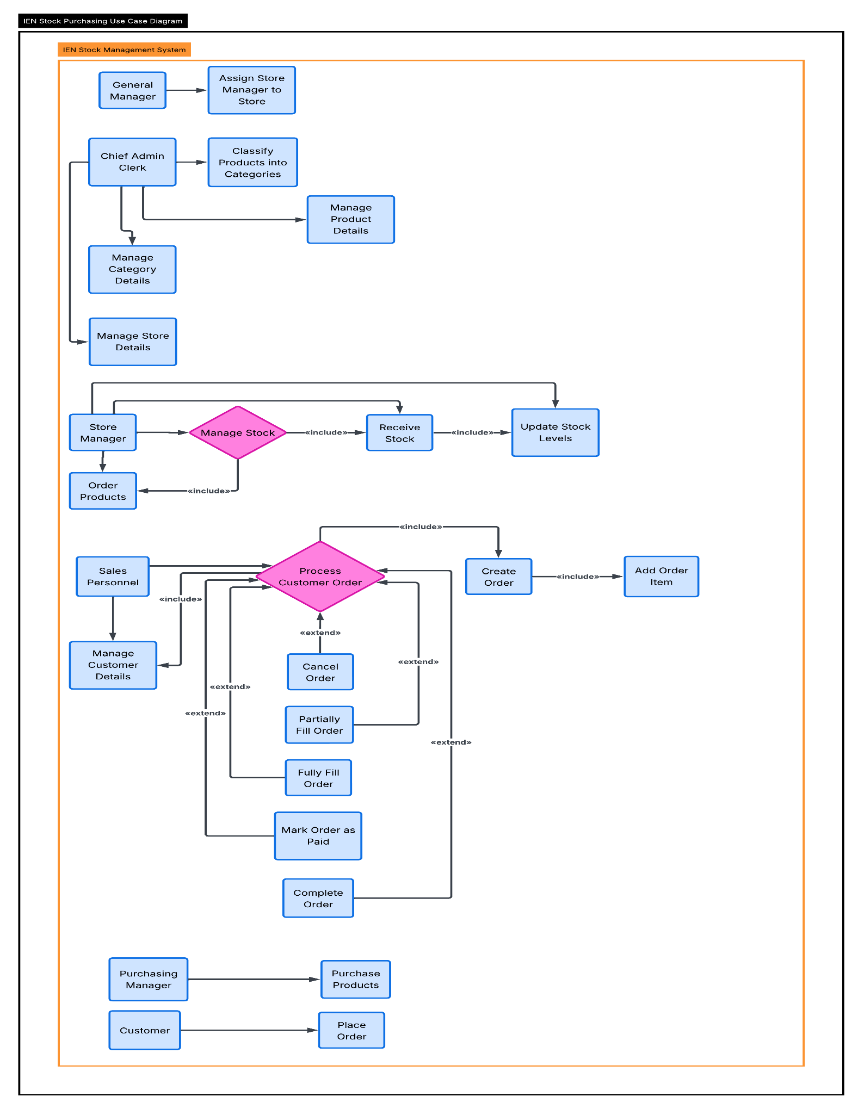

1.3
Use case name:
Process customer order
Scenario:
Sales staff processes a customer’s order by capturing order details, adding order items, checking stock availability from a store, and updating order status.
Triggering Eeent:
A Customer requests to place an order.
Brief description:
This use case allows Sales staff to capture and manage customer orders, assign products from a specific store, record quantities and pricing, and update the order status accordingly.
Actors:
Primary: Sales staff
Secondary: Customer
Supporting: Store manager (stock availability)
Related use cases:
Manage customer details (include)
Add order item (include)
Cancel order (extend)
Partially fill order (extend)
Fully fill order (extend)
Mark order as paid (extend)
Complete order (extend)
Stakeholders:
Customer (receives product & billing accuracy)
Sales staff (order accuracy)
Store manager (stock accuracy)
General manager (business reporting)

1.4
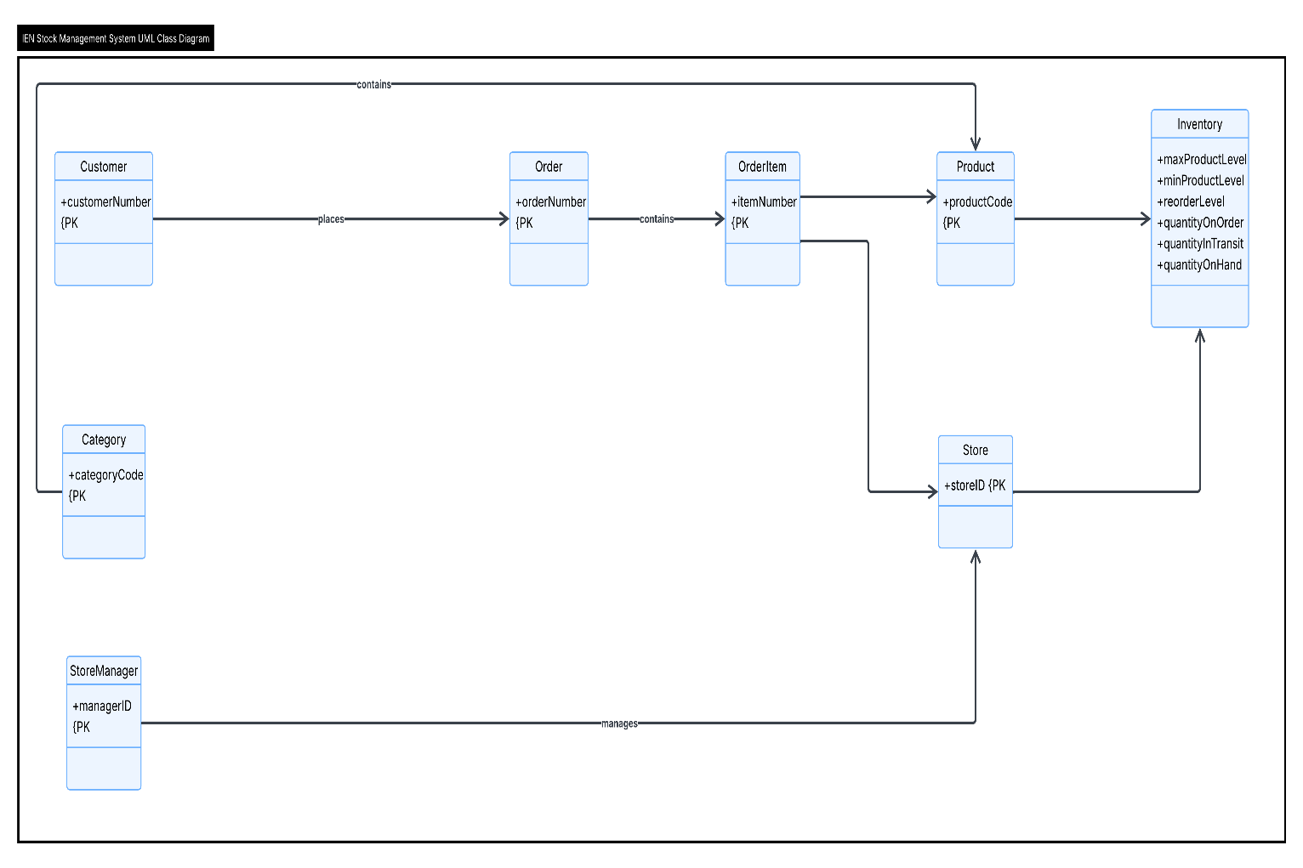

1.5
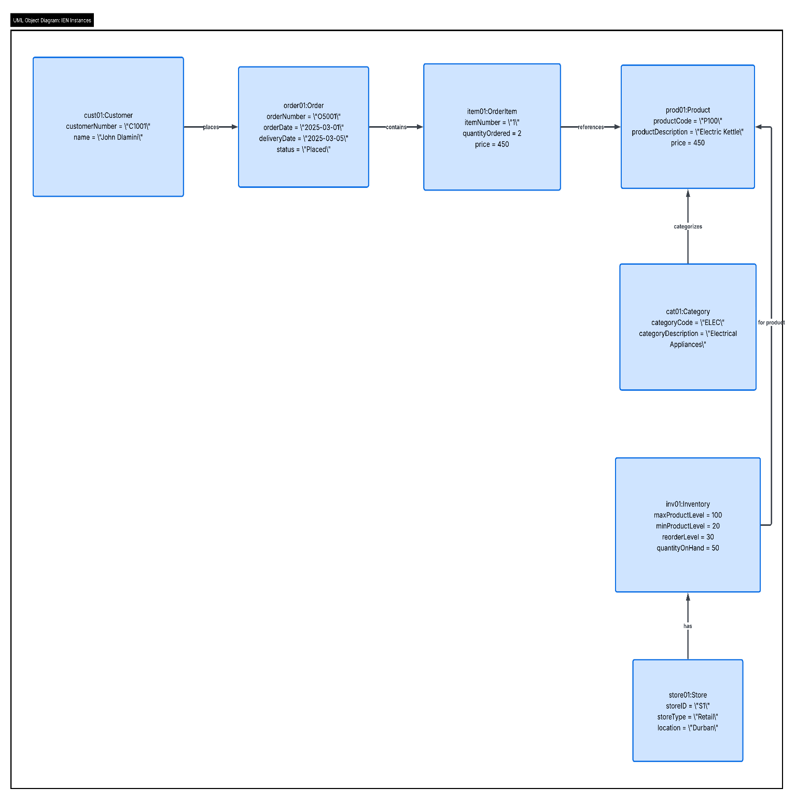

1.6
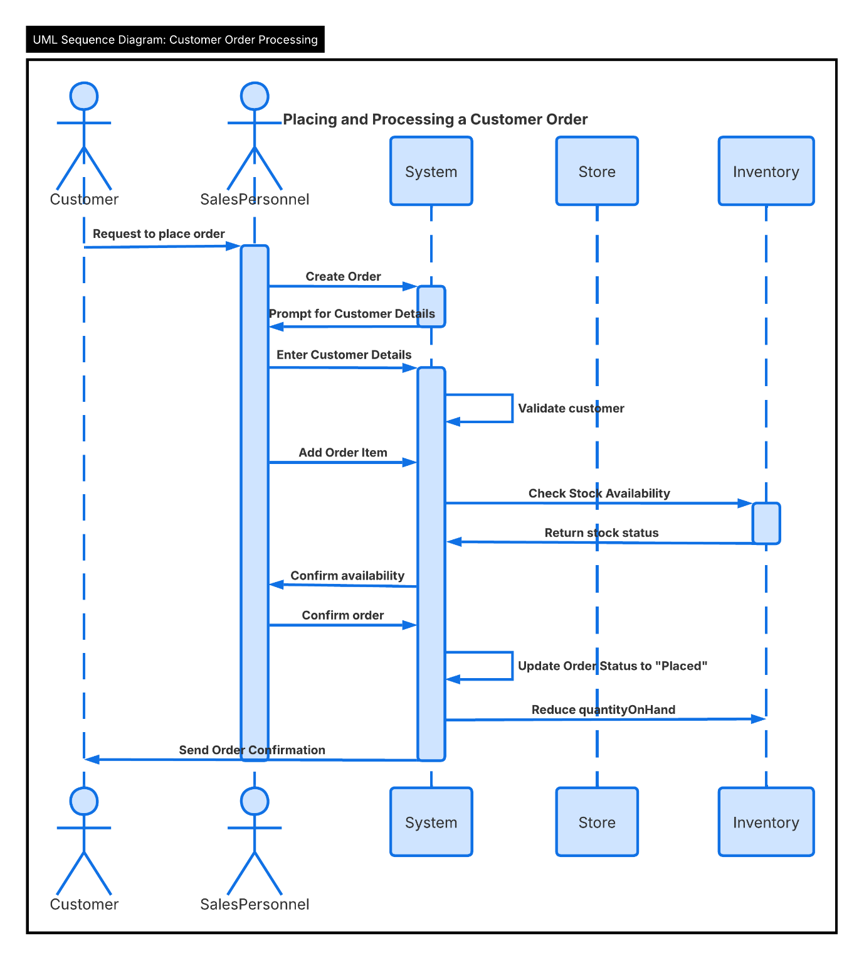

1.7
