

Individual Assessment Coversheet
To be attached to the front of the assessment.

Campus: | Tygervalley campus __
Faculty: | IT __
Module Code: | ITSSA2-B22
Group: | Group 1
Lecturer’s Name: | Vusumuzi Moyo
Student Full Name: | Jean Labuschagne __
Student Number: | Eduv4955673

Indicate | Yes | No
Plagiarism report attached

Declaration:
I declare that this assessment is my own original work except for source material explicitly acknowledged. I also declare that this assessment or any other of my original work related to it has not been previously, or is not being simultaneously, submitted for this or any other course. I am aware of the AI policy and acknowledge that I have not used any AI technology to generate or manipulate data, other than as permitted by the assessment instructions. I also declare that I am aware of the Institution’s policy and regulations on honesty in academic work as set out in the Conditions of Enrolment, and of the disciplinary guidelines applicable to breaches of such policy and regulations.
2025/06/11
Date
Signature
Jean Labuschagne

Lecturer’s Comments:
Marks Awarded: %
Date
Signature

Eduvos (Pty) Ltd. (formerly Pearson Institute of Higher Education) is registered with the Department of Higher Education and Training as a private higher education
institution under the Higher Education Act, 101, of 1997. Registration Certificate number: 2001/HE07/008

Contents
Question 1 – Initial Threat Model 3
1.1 Application Selection 3
1.2 Identified Assets 3
1.3 Scope, Entry Points, Data Flows & Trust Boundaries 3
1.4 Justification 3
Question 2 – STRIDE Threat Identification & Classification 5
2.1 STRIDE Applied 5
2.2 Documented Threats 5
2.3 Prioritization 6
Question 3 – Vulnerability Analysis and Mitigation 7
3.1 Vulnerability Analysis 7
3.2 Proposed Mitigations 7
3.3 Effectiveness Evaluation 7
Question 4 – Updated Threat Model 9
References 11

Question 1 – Initial Threat Model

1.1 Application Selection
A custom web application design was created for StellarPay Digital Banking, supporting secure user accounts, card linking, payments, and real-time transaction management.

1.2 Identified Assets
- User Database
- Transaction Logs
- Audit Logs
- Key Vault
- Public API Endpoint
- Authentication Service
- Transaction Processor
- Notification Service
- Customer
- Bank API
- Payment Gateway

1.3 Scope, Entry Points, Data Flows & Trust Boundaries
Scope: All core processes, data flows, and trust boundaries, covering the public internet, application logic, and secure storage.
Entry Points: Customer login, transaction requests, internal service calls, external API links to Bank API and Payment Gateway.
Data Flows: Login requests, token issuance, payments, logging, audit trails, notifications, and key retrieval.
Trust Boundaries:
- Internet to Public API Endpoint (DMZ)
- Public API to Internal Services
- Internal Services to Data Stores
- Internal Services to External APIs

1.4 Justification
This scope ensures full coverage of sensitive financial data and system interactions, with clear trust boundaries to detect threats at every layer.
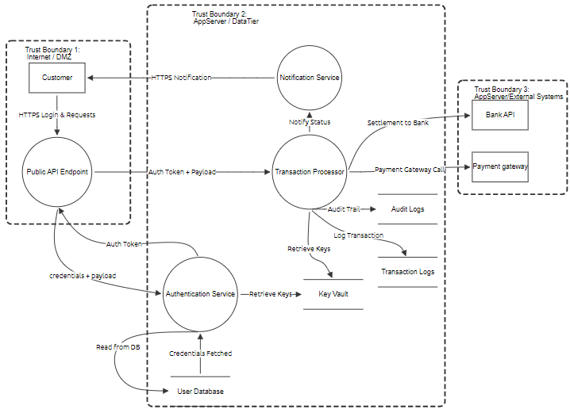

Question 2 – STRIDE Threat Identification & Classification

2.1 STRIDE Applied
The STRIDE method was applied to detect Spoofing, Tampering, Repudiation, Information Disclosure, Denial of Service, and Elevation of Privilege threats across all DFD elements.

2.2 Documented Threats
Below is the identified threat list with status and mitigation:
Component | Title | STRIDE Type | Status | Score | Priority | Description | Mitigation
Customer | Credential Theft via Phishing | Spoofing | Open | High | Critical | Attacker steals credentials. | Use MFA.
Public API Endpoint | API Abuse | Spoofing | Open | High | Critical | Fake requests. | OAuth2, WAF, Rate Limiting.
Public API Endpoint | Parameter Tampering | Tampering | Open | High | High | Modify parameters. | Input validation, integrity checks.
Public API Endpoint | API Flooding | DoS | Open | Medium | Medium | Flood API. | WAF, rate limit.
Authentication Service | Token Scope Abuse | Elevation | Open | High | Critical | Escalate privileges. | RBAC, scoped JWTs.
Authentication Service | Weak Credential Handling | Spoofing | Open | High | High | Weak password or missing MFA. | Strong policy, MFA.
Transaction Processor | Transaction Manipulation | Tampering | Open | High | Critical | Change payment data. | Schema validation, signed payloads.
Transaction Processor | Replay Attack | Elevation | Open | Medium | Medium | Replay transaction. | Nonce, timestamps, idempotency.
Notification Service | Notification Spoofing | Spoofing | Open | Medium | Medium | Fake notifications. | Signed messages.
Notification Service | Notification Overload | DoS | Open | Medium | Medium | Flood messages. | Throttling.
User Database | Unencrypted Data | Info Disclosure | Open | High | Critical | Leak PII. | Encryption.
Key Vault | Secret Exposure | Info Disclosure | Open | High | Critical | Leak keys. | HSM, IAM.
Transaction Logs | Log Tampering | Repudiation | Open | High | High | Alter logs. | WORM, digital signatures.
Audit Logs | Audit Log Disclosure | Info Disclosure | Open | Medium | Medium | Leak audit logs. | Encrypt, access control.

2.3 Prioritization
Critical: Escalation, spoofing, tampering
High: Key leaks, log tampering
Medium: DoS, audit metadata leaks
Example threat(Transaction Logs)
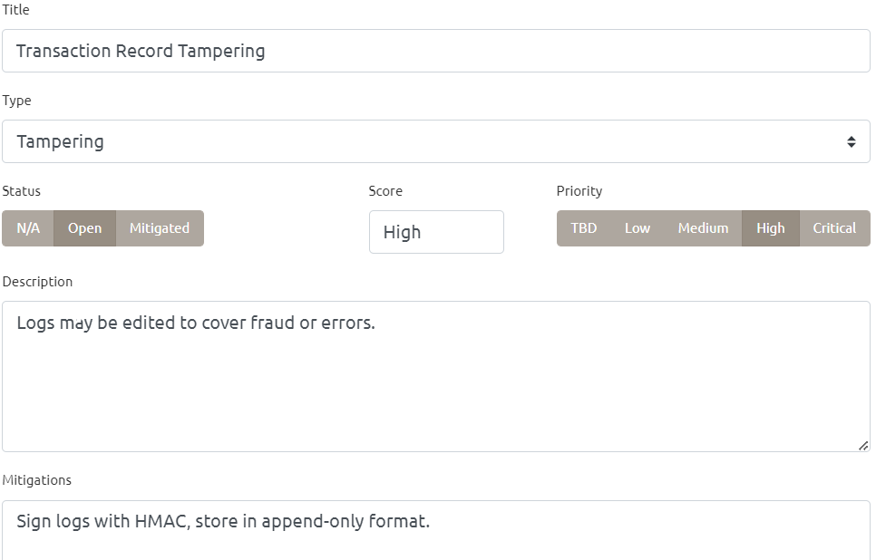

Question 3 – Vulnerability Analysis and Mitigation

3.1 Vulnerability Analysis
Identified vulnerabilities: - Missing/weak authentication - Lack of input validation - Unsigned logs - Plaintext storage of sensitive data

3.2 Proposed Mitigations
- OAuth2, MFA, RBAC, scoped JWTs
- WAF and rate limiting
- Data encryption and HSM storage
- WORM logs, digital signatures
- Verified notifications, throttling

3.3 Effectiveness Evaluation
Proposed controls follow best practices and address core risks. They add cost and usability trade-offs (e.g., CAPTCHA). Residual risks include user-side phishing which requires training.

Example mitigated threat(Transaction Logs)
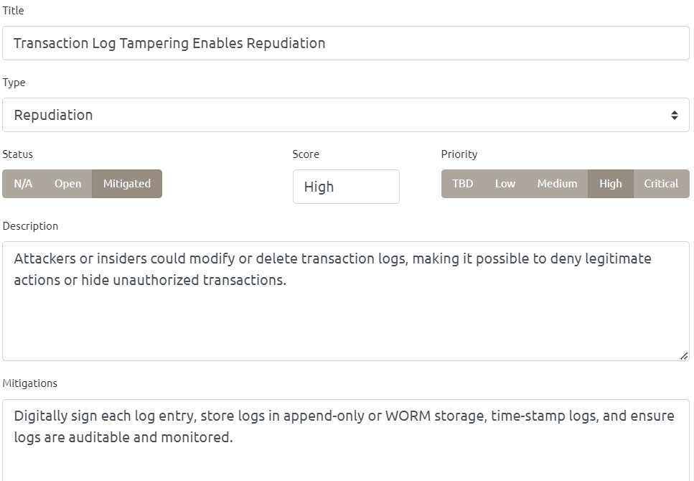

Question 4 – Updated Threat Model
The model was updated to reflect mitigations and improvements:
Component | Title | STRIDE Type | Status | Score | Priority | Description | Mitigation
Customer | Credential Theft via Phishing | Spoofing | Mitigated | High | Critical | Attacker steals credentials. | Use MFA.
Public API Endpoint | API Abuse | Spoofing | Mitigated | High | Critical | Fake requests. | OAuth2, WAF, Rate Limiting.
Public API Endpoint | Parameter Tampering | Tampering | Mitigated | High | High | Modify parameters. | Input validation, integrity checks.
Public API Endpoint | API Flooding | DoS | Mitigated | Medium | Medium | Flood API. | WAF, rate limit.
Authentication Service | Token Scope Abuse | Elevation | Mitigated | High | Critical | Escalate privileges. | RBAC, scoped JWTs.
Authentication Service | Weak Credential Handling | Spoofing | Mitigated | High | High | Weak password or missing MFA. | Strong policy, MFA.
Transaction Processor | Transaction Manipulation | Tampering | Mitigated | High | Critical | Change payment data. | Schema validation, signed payloads.
Transaction Processor | Replay Attack | Elevation | Mitigated | Medium | Medium | Replay transaction. | Nonce, timestamps, idempotency.
Notification Service | Notification Spoofing | Spoofing | Mitigated | Medium | Medium | Fake notifications. | Signed messages.
Notification Service | Notification Overload | DoS | Mitigated | Medium | Medium | Flood messages. | Throttling.
User Database | Unencrypted Data | Info Disclosure | Mitigated | High | Critical | Leak PII. | Encryption.
Key Vault | Secret Exposure | Info Disclosure | Mitigated | High | Critical | Leak keys. | HSM, IAM.
Transaction Logs | Log Tampering | Repudiation | Mitigated | High | High | Alter logs. | WORM, digital signatures.
Audit Logs | Audit Log Disclosure | Info Disclosure | Mitigated | Medium | Medium | Leak audit logs. | Encrypt, access control.
Notification Service | CAPTCHA Accessibility Risk | DoS | Open | Low | Low | CAPTCHA may block some users. | Provide accessible fallback.
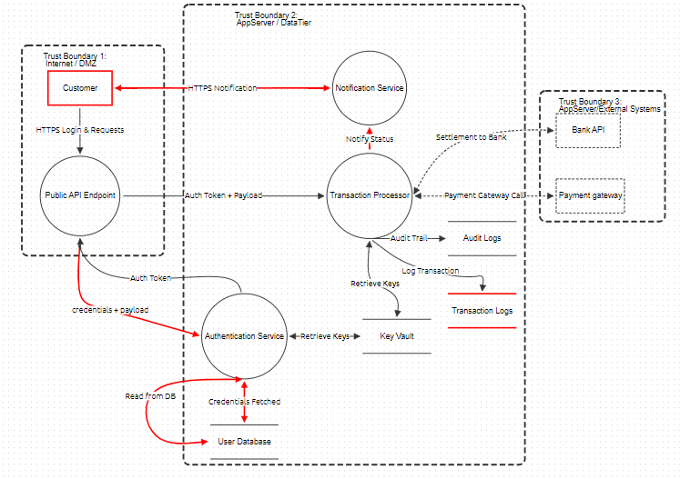

References

Microsoft, 2022. Threats — Microsoft Threat Modeling Tool. Microsoft Learn. [online] Available at: microsoft.com/learn/security/develop/threat-modeling-tool-threats [Accessed 18 May 2025].

OWASP, 2025. OWASP Threat Dragon. OWASP Foundation. [online] Available at: owasp.org/www-project-threat-dragon/ [Accessed 20 May 2025].

“Training6‑OWASP Threat Dragon (Threat Model) Demo” (2024). YouTube. Available at: youtube.com/watch?v=b2uZ9_pzPmQ [Accessed 21 May 2025].

“OWASP Spotlight – Project 22 – OWASP THREAT DRAGON” (2020). YouTube. Available at: youtube.com/watch?v=hUOAoc6QGJo [Accessed 26 May 2025].

“Threat modelling with OWASP Threat Dragon” (2025). YouTube. Available at: youtube.com/watch?v=mL5G8HeI8zI [Accessed 26 May 2025].

Wikipedia, 2025. STRIDE model. [online] Available at: en.wikipedia.org/wiki/STRIDE_model [Accessed 26 May 2025].

Drata, 2025. Using the STRIDE Threat Model: Tutorial & Best Practices. [online] Available at: drata.com/grc‑central/risk/guide-stride-threat-model [Accessed 8 June 2025].

PixelQA, 2023. Understanding STRIDE: A Comprehensive Guide to Threat Modeling. [online] Available at: pixelqa.com/blog/post/understanding‑stride‑a‑comprehensive‑guide‑to‑threat‑modeling [Accessed 8 June 2025].

