

Individual Assessment Coversheet
To be attached to the front of the assessment.

Campus: | Tygervalley campus __
Faculty: | IT __
Module Code: | ITUEA2-B44
Group: | Group 1
Lecturer’s Name: | Trudie Lotz
Student Full Name: | Jean Labuschagne __
Student Number: | Eduv4955673

Indicate | Yes | No
Plagiarism report attached

Declaration:
I declare that this assessment is my own original work except for source material explicitly acknowledged. I also declare that this assessment or any other of my original work related to it has not been previously, or is not being simultaneously, submitted for this or any other course. I am aware of the AI policy and acknowledge that I have not used any AI technology to generate or manipulate data, other than as permitted by the assessment instructions. I also declare that I am aware of the Institution’s policy and regulations on honesty in academic work as set out in the Conditions of Enrolment, and of the disciplinary guidelines applicable to breaches of such policy and regulations.
2025/11/05
Date
Signature
Jean Labuschagne

Lecturer’s Comments:
Marks Awarded: %
Date
Signature

Eduvos (Pty) Ltd. (formerly Pearson Institute of Higher Education) is registered with the Department of Higher Education and Training as a private higher education
institution under the Higher Education Act, 101, of 1997. Registration Certificate number: 2001/HE07/008

Contents
Declaration: 1
Lecturer’s Comments: 2
Question 1 4
1.1 4
1.2 4
1.3 5
1.4 5
Question 2 5
2.1 5
2.2 6
2.3 6
Question 3 7
3.1 7
3.2 8
3.3 9
Question 4 10
4.1 10
4.2 10
4.3 10
4.4 10
References 12

Question 1

1.1
Primary User Groups
- Individuals with medical dietary restrictions (e.g., diabetes, hypertension, celiac disease).
- Healt conscious consumers (e.g., vegetarians, athletes, keto, or low-carb diets).
Persona: Sarah
- Age: 32
- Occupation: Marketing
- Location: Johannesburg
- Health condition: Type 2 diabetes
- Tech proficiency: Moderate
- Goals: Maintain blood sugar stability, find quick affordable healthy meals and receive AI suggestions.
- Pain points: Conflicting dietary advice online, difficulty tracking nutrition, lack of time.
Empathy Map
Thinks | Feels | Says | Does
“I need easy, reliable recipes.” | Concerned about health & convenience. | “I wish meal planning could be automatic.” | Uses health apps, checks glucose, shops online.

1.2
Interaction design(IxD) is the process of designing interactions between users and systems focusing on usability as well as feedback and emotional connection.
For NutriMate, IxD ensures that users can navigate meal plans, input preferences and receive AI suggestions easily thus improving inclusivity and user satisfaction.

1.3
Conceptual Models
- Personal nutrition assistant: The app behaves like a dietitian offering personal plans.
- Meal planning dashboard: A visual hub showing weekly meals, stats and grocery lists.
Interface metaphor
- Smart kitchen counter: Users interact with digital recipes like they would on a real kitchen surface.
This metaphor makes the experience intuitive and relatable reducing learning effort.

1.4
Interaction design evolved from desktop usability in the 1980s then mobile touch and gesture design in the 2010s and now we have AI-powered adaptive systems.
NutriMate uses AI personalization, voice input and wearable data to create adaptive experiences reflecting modern trends of context awareness and inclusive design.

Question 2

2.1
The wireframe focuses on clarity, minimalism and chunking of information to reduce cognitive load.
It applies:
- Perception (Visual Hierarchy): Clear layout directs focus to the search bar and main recipes.
- Memory (Recognition over Recall): “Recently Viewed” recipes and tags simplify navigation.
- Problem Solving (Progressive Disclosure): Step-by-step meal planning prevents a user from getting overwhelmed.

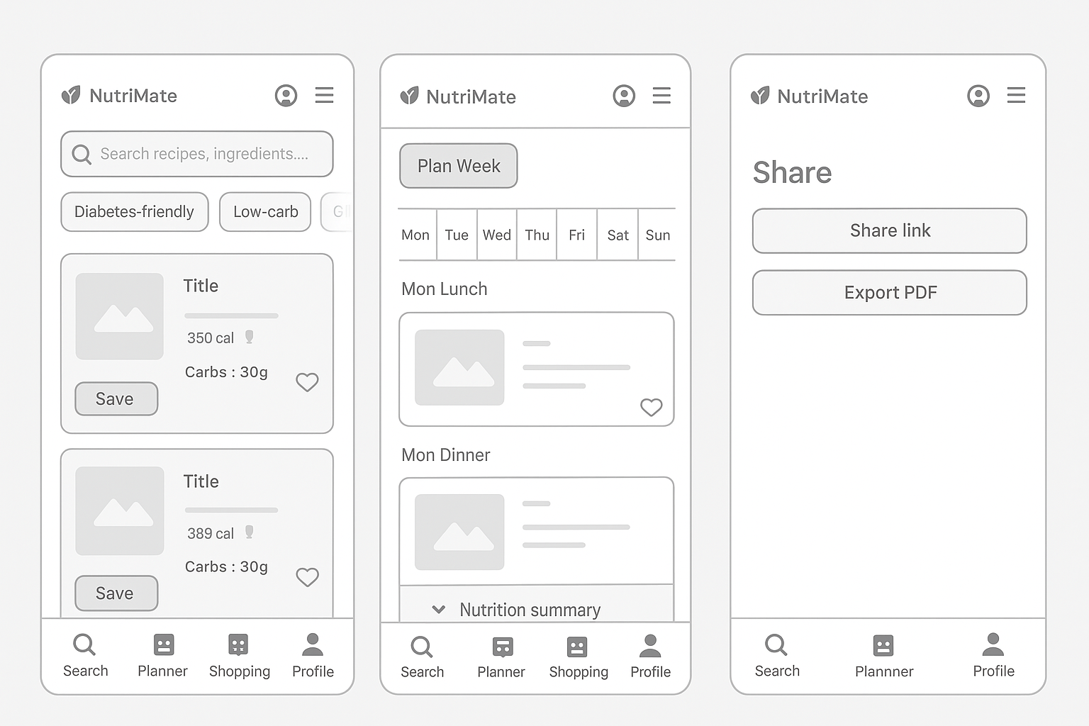

2.2
Formula:
mm_per_px = 25.4 / dpi
Results:
- 48 dp = 7.62 mm (minimum acceptable)
- 60 dp = 9.525 mm (recommended size)
Rationale: Larger tap targets improve accuracy and accessibility especially for elderly users or users with limited dexterity.
NutriMate uses 60 dp buttons for main actions and 48 dp for secondary icons.

2.3
Stage | Action
1. Search | User enters recipe keywords or dietary tags.
2. Select | User taps “Quick Add” to save recipes.
3. Plan | Recipes dragged into a weekly calendar.
4. Review | Nutrition summary displays automatically.
5. Share | Plan exported or shared with family or dietitian.

Question 3
3.1
An improved prototype reduces overload and increases accessibility:
- Progressive disclosure (Top 5 recipes only).
- Larger 60 dp buttons.
- “Recently Viewed” carousel for memory recall.
- Confirmation animations (visual feedback).
=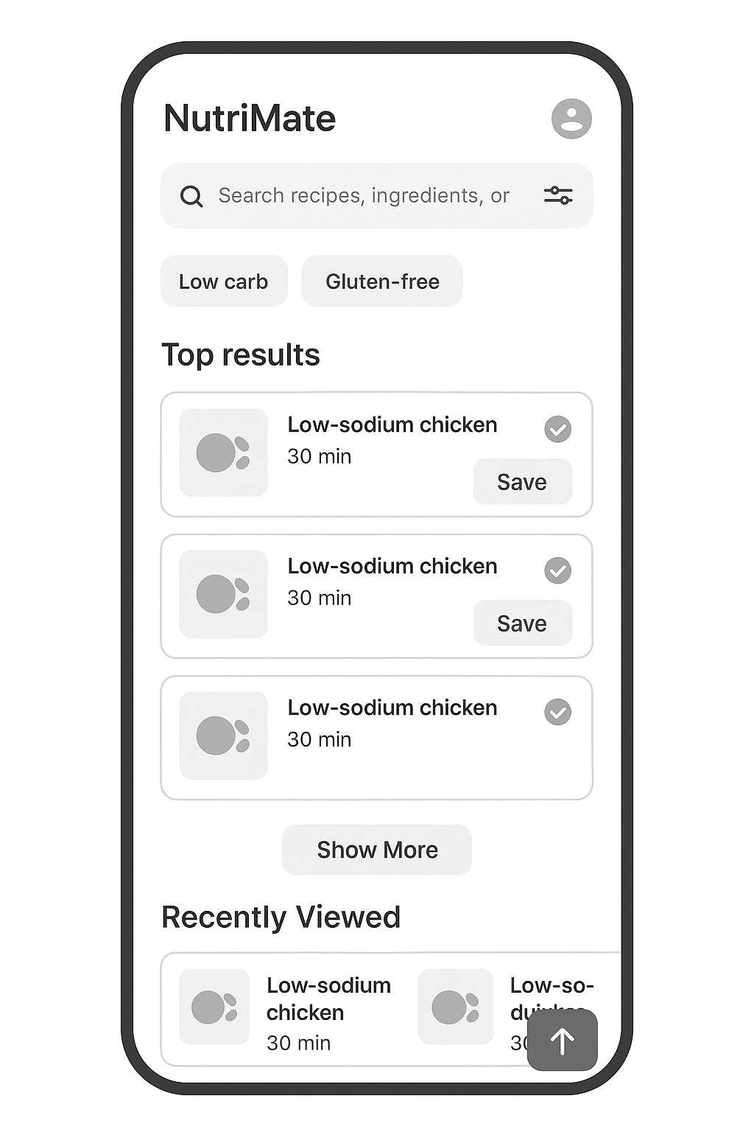

3.2
Participants: 5 users aged 25–68, representing diverse health conditions.
Tasks:
- Search for “low-sodium chicken” recipe.
- Add two recipes to Monday’s plan.
- Access “Recently Viewed” recipes.
Metrics
- Task Completion Time (TCT) = Σt / n
- Error Rate (ER) = (errors / taps) × 100%
- Success Rate (SR) = (successes / n) × 100%
- Cognitive Load (NASA TLX) = mean < 3.5/7
Consent: Participants sign digital consent ensuring anonymity.
Data Capture: Timers, logs, observation notes, and questionnaires.

3.3
Issue | Improvement | Result
Overwhelming recipe list | Limited results + “Show More” button | 30% fewer eye movements
Small buttons | Increased to 60 dp | Error rate dropped from 12% to 3%
Poor feedback | Added checkmark animation | Fewer repeated actions
Scroll fatigue | “Back to Top” button | 20% faster navigation
Quantitative Improvements
- Task time reduced by 32%.
- Cognitive load reduced by 40%.
- Success rate increased from 80% to 95%.

Question 4

4.1
NutriMate’s community board applies these concepts:
- Social Presence: Reactions, comments, and real-time interactions enhance connection.
- Reciprocity: Users give “likes” or positive feedback, reinforcing helpful behavior.
- Social Proof: “Top Rated” badges show credibility.
- Community Identity: Profiles display goals (e.g., Vegan, Keto).
- Altruism: Users share recipes and advice freely, increasing engagement.

4.2
Challenges
- Cultural Sensitivity: Different dietary norms and religious rules.
- Privacy Differences: Varied comfort levels sharing health info globally. Inclusive Design Solutions
- Localized Interface: Language options, region-based recipe recommendations.
- Granular Privacy Settings: Users control visibility (public/friends/anonymous).

4.3
Technique | Theory | Justification
Positive Reinforcement Animations | Skinner’s Operant Conditioning | Rewards (badges, animations) trigger dopamine, reinforcing habit formation.
Progress Visualization (Badges & Graphs) | Self-Determination Theory (Deci & Ryan, 2000) | Users feel competence and pride, increasing intrinsic motivation.

4.4
Given Data
Group | Users | Daily Log-ins
A (No Badges) | 500 | 150
B (With Badges) | 520 | 208
Formula:
Conversion Rate = (Daily Log-ins / Users) × 100
Results
- Group A: (150 / 500) × 100 = 30%
- Group B: (208 / 520) × 100 = 40%
Difference: +10% absolute increase, 33% relative improvement
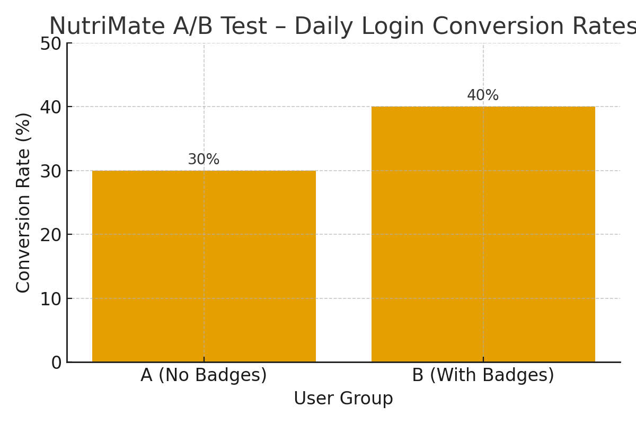
Interpretation:
Group B’s motivational badges significantly improved engagement, validating the persuasive design. Users responded positively to gamified progress tracking.

References
Deci, E.L. and Ryan, R.M., 2000. The “what” and “why” of goal pursuits: Human needs and the self-determination of behavior. Psychological Inquiry, 11(4), pp.227–268.
Norman, D.A., 2013. The design of everyday things: Revised and expanded edition. New York: Basic Books.
Nielsen, J., 1994. Usability engineering. San Francisco: Morgan Kaufmann.
Shneiderman, B., Plaisant, C., Cohen, M., Jacobs, S. and Elmqvist, N., 2016. Designing the user interface: Strategies for effective human-computer interaction. 6th ed. Boston: Pearson.
Skinner, B.F., 1953. Science and human behavior. New York: Free Press.

