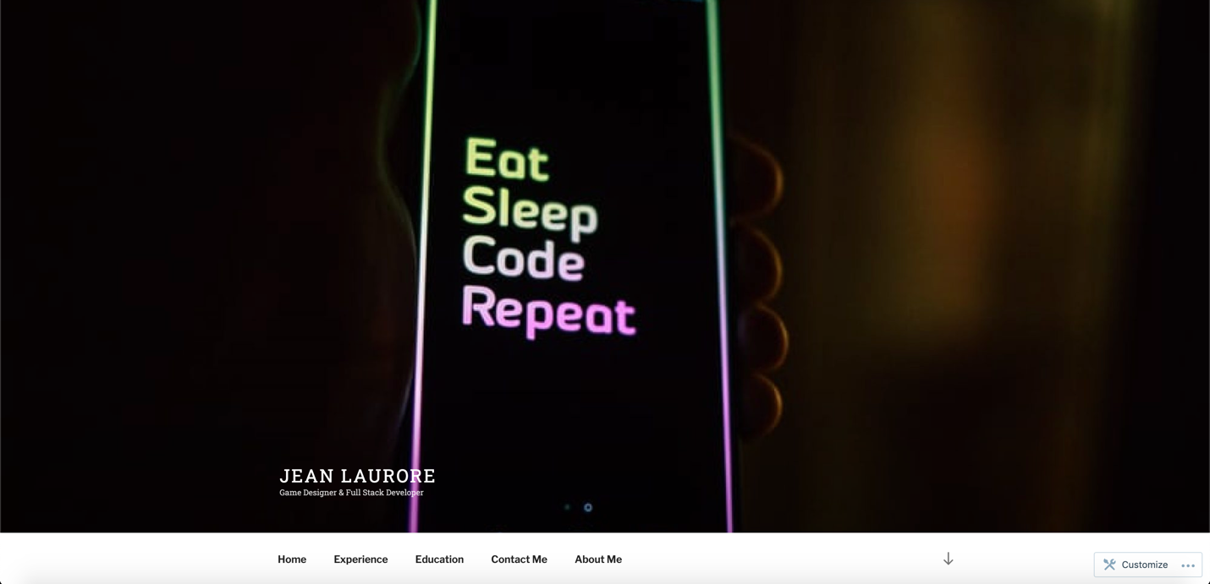

<https://jeanlaurore.com/>