Final Year Project Tracking & Accountability System
Requirements Brief — v1.0 (Baseline for team handover)
Prepared by Ngomituje Samuel· 6 June 2026 · Status: baseline for team handover

1. Purpose
The department keeps good records at the start of the final-project journey (registration, letter approval) and near the end (book submission, defense scheduling), but has little visibility during prototype review and supervision. Those blind spots are where students are most often hurt and where responsibility is today assigned by assumption rather than by evidence.
This system records every state a student passes through — with who acted and when — so that complaints can be resolved from a timestamped record. Its first priority is closing the supervision blind spot; its second is joining all stages into one continuous, auditable timeline for each student.
It also keeps students, supervisors and examiners informed at every step by email, and keeps a record of every message it sends — so “I was never told” can be checked against what the system actually sent.

2. Scope of this draft
This is an early increment of the requirements, not the full specification. It fixes the journey, the actors, the data each stage must capture, the notifications the system sends, and a first prioritisation. Detailed per-module requirements, screens, and acceptance criteria will be added by the team. Delivery will be incremental and timeboxed (see the companion Incremental Delivery Plan).

3. Actors
The people and systems that interact with the platform:
Actor | Role
Student | Registers via the portal, submits the case-study letter and proposal book, and receives notifications. The student follows the meeting dates and times set by the supervisor.
Supervisor | Posts weekly availability, confirms each meeting date and time, signs off the book, and provides their WhatsApp group link(s); notified of new assignments.
Facilitator (Assistant) | The middle-person and day-to-day coordinator for the whole process; keeps the workflow moving, assigns the pre-defense and defense examiners, and maintains supporting information (Section 8). Operational, supporting the HOD’s academic decisions.
Pre-Defense / Defense Examiner | An eligible supervisor assigned to conduct a student’s pre-defense or defense. Notified when assigned, and records the outcome / status. Tracked separately from the students the person supervises (Section 7).
Head of Department (HOD) | Uploads the registered-student list, approves letters, issues preliminary requirements, assigns supervisors, and reads prototype data.
Superadmin | The system owner account, with full access to all data and functions: manages accounts and roles, resets passwords, monitors every log, and configures the system; held by a single individual (Section 8).
Prototype Review System (external) | A separate, existing system that exposes prototype data (schedule, attempts, decisions) read-only via an API.
Email / notification provider (external) | The institution’s email service (e.g., Google Workspace) used to deliver notifications; integrated via API.

4. The student journey
Each student occupies exactly one state at a time, and every transition is recorded with the actor and a timestamp. Figure 1 (next page) shows the full journey; Table 1 lists the trigger for each transition. Every transition also sends an email (Section 6). Pre-defense and defense move forward to the next step — they do not return the student to their supervisor; they are conducted by assigned examiners (Section 7).

Figure 1 — The student journey (state model)
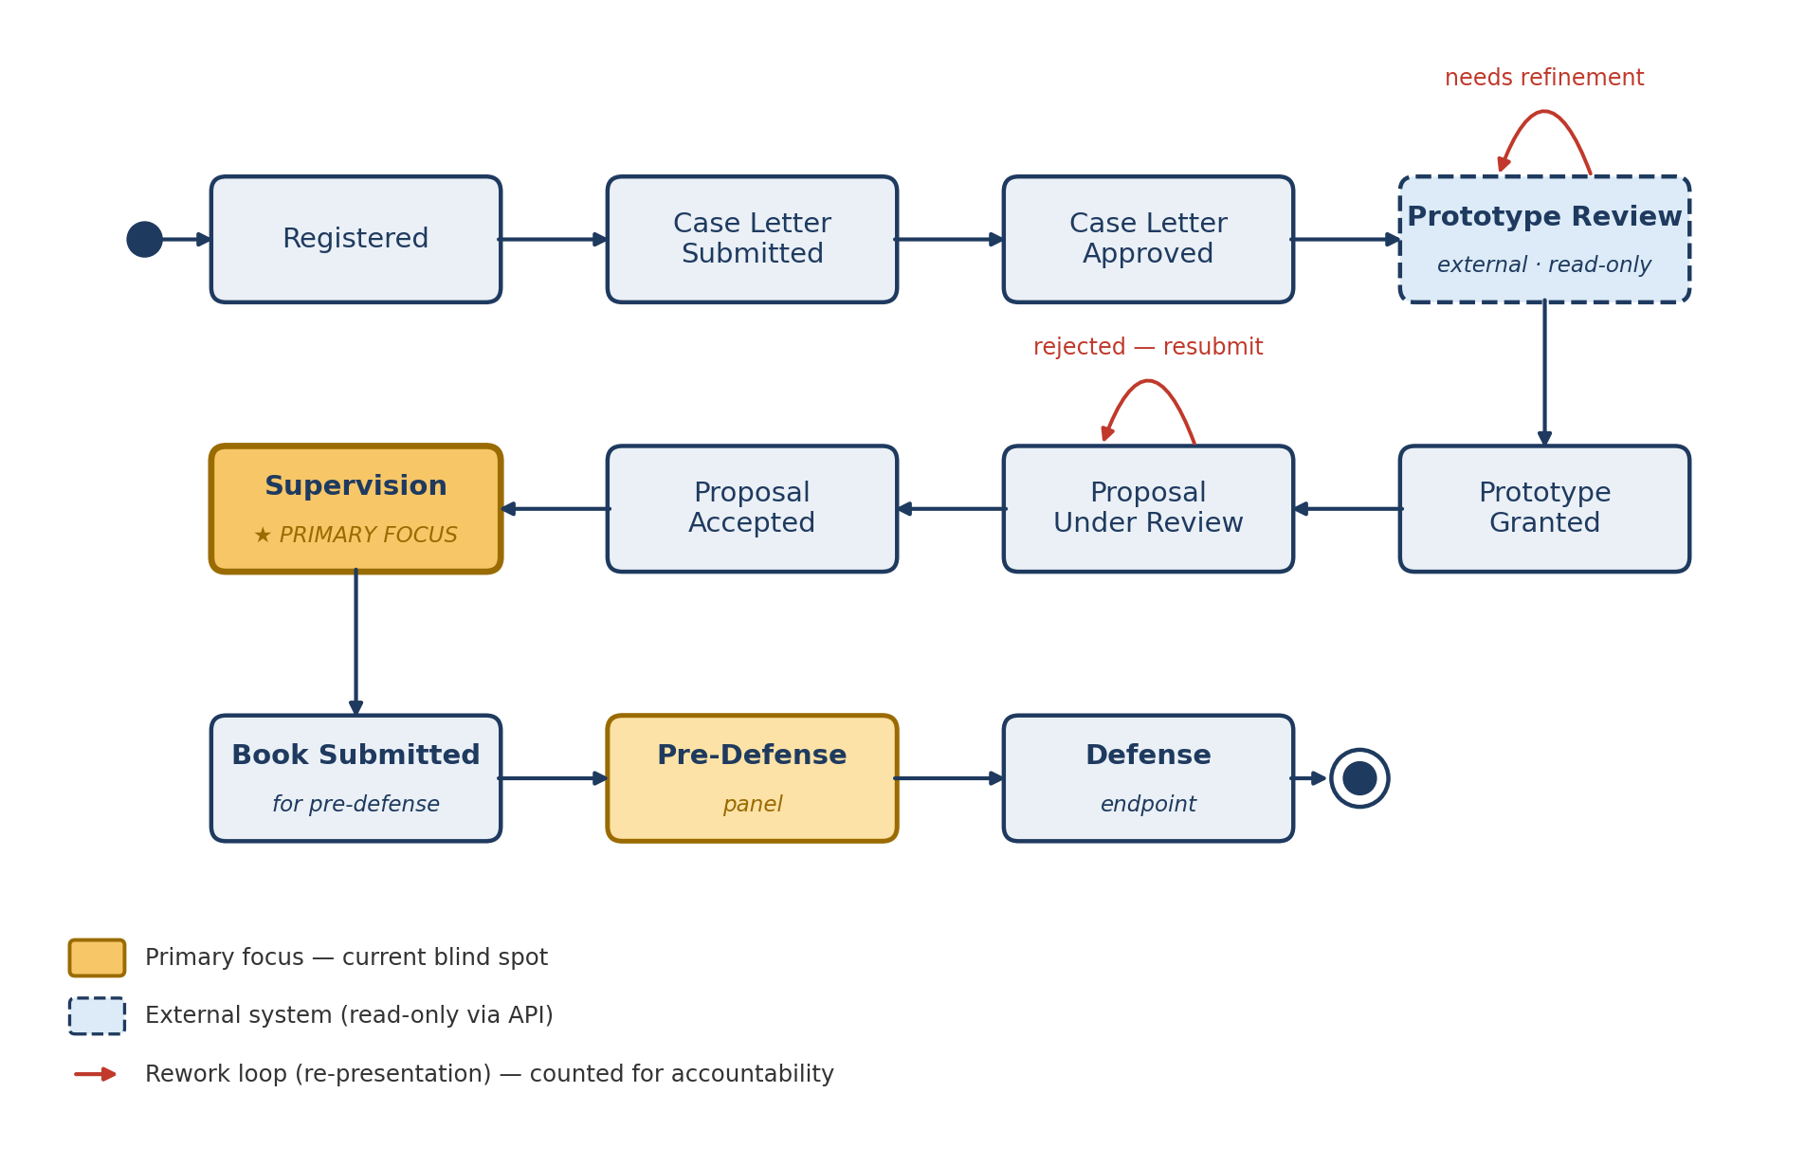
Amber = the primary focus (the supervision blind spot). Dashed blue = the external prototype-review system (read-only via API). Red loops = re-presentation at the same stage, counted for accountability. Pre-defense and defense proceed forward; they do not return to the supervisor.

Table 1 — Transition triggers
From state | To state | Trigger / condition
Registered | Case Letter Submitted | Student submits the case-study letter and form
Case Letter Submitted | Case Letter Approved | HOD approves the letter
Case Letter Approved | Prototype Review | HOD issues preliminary requirements
Prototype Review | Prototype Review | Needs refinement — student re-presents (attempt counted)
Prototype Review | Prototype Granted | Prototype granted
Prototype Granted | Proposal Under Review | Student submits the proposal book
Proposal Under Review | Proposal Under Review | Book rejected — student resubmits (attempt + reason recorded)
Proposal Under Review | Proposal Accepted | Proposal book accepted
Proposal Accepted | Supervision | Department assigns a supervisor
Supervision | Book Submitted | Supervisor signs off; book submitted for pre-defense
Book Submitted | Pre-Defense | Scheduled for pre-defense; examiner(s) assigned
Pre-Defense | Defense | Examiner records the pre-defense as completed / cleared
Defense | — complete — | Defense panel records the result (passed)

5. Key use cases
The diagram below shows the main use cases and the actors who perform them — a useful anchor for the stakeholder discussion.
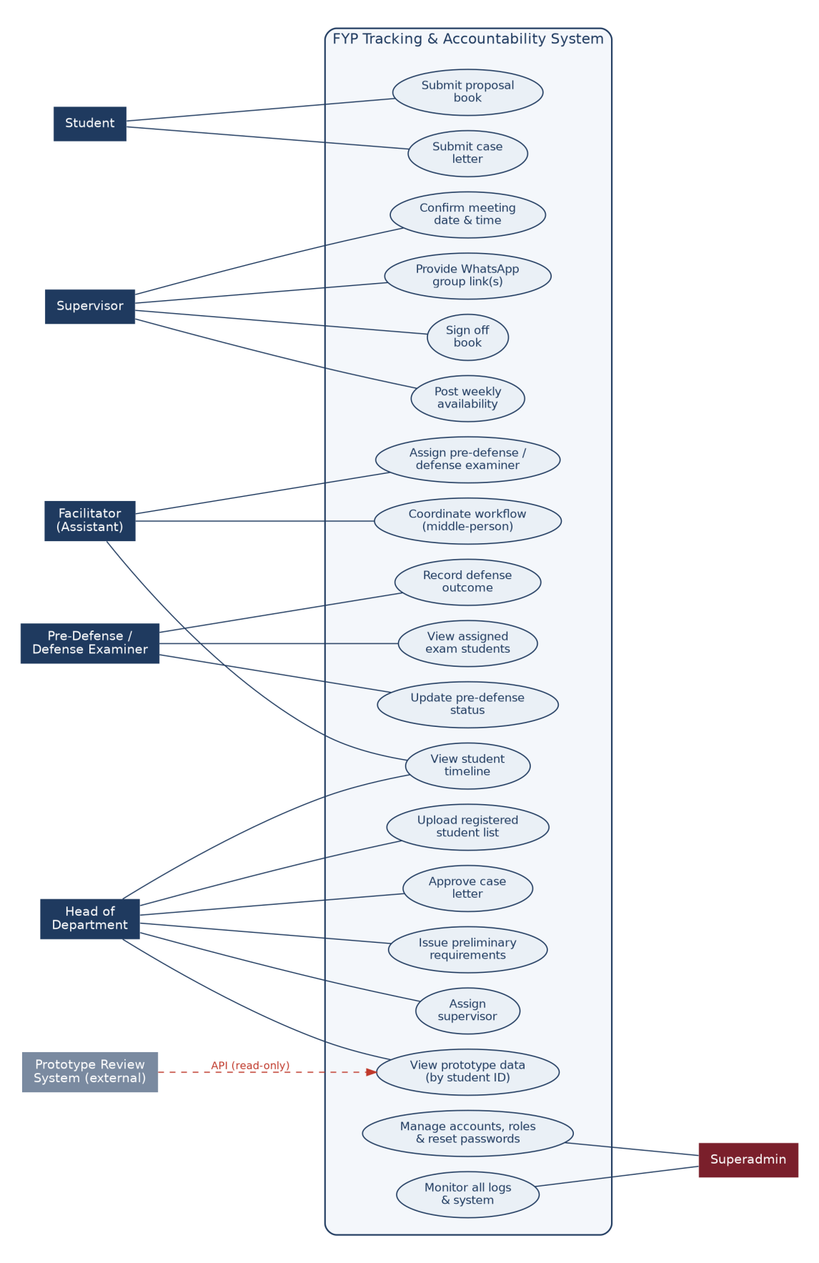
Figure 2 — Use-case overview. Boxes are actors; ellipses are use cases inside the system boundary. The Superadmin has full access beyond the two functions shown; notification, panel and role details are in Sections 6–8.

6. Notifications (email & WhatsApp)
The system holds a verified email address for every student, supervisor and examiner, taken from the registrar’s data and the HOD’s upload. At each milestone, and on key events, it sends an email automatically. Every message is stored in a notification log with the recipient, the time, the contents and the delivery status — part of the accountability record, so that if someone says they were never informed, the exact message the system sent can be shown.
WhatsApp is used through free group links, not a paid messaging service. Each supervisor provides their WhatsApp group link and number; the system stores these — and can hold several links where a supervisor or team runs more than one group — and presents them as a one-click button, including inside the relevant emails. Email remains the system’s own notification channel.

Table 2 — Notification events (email)
Event | Recipient(s) | Key contents
Registration confirmed | Student | Confirms registration; next step is to submit the case-study letter and form
Case letter approved | Student | Letter approved; preliminary requirements issued; now entering Prototype Review
Prototype granted | Student | Prototype approved; next step is to submit the proposal book
Prototype needs refinement | Student | What to improve before re-presenting
Proposal accepted | Student | Proposal accepted; a supervisor will be assigned
Proposal rejected | Student | The reason and what to fix before resubmitting
Supervisor assigned | Student | The supervisor’s name and a one-click link to join the supervisor’s WhatsApp group
Supervisor assigned | Supervisor | The name(s) of the newly assigned student(s)
Assigned to conduct a pre-defense | Examiner | The student(s) assigned for pre-defense, with the schedule (defense panels work the same way)
Reached pre-defense | Student | Confirms the book has moved to pre-defense, with the schedule / details
Defense scheduled / result | Student | The defense date, and afterwards the result or required revisions
The system sends only these defined emails; there is no separate announcements feature. Each email is a template that can be tailored — for example, the message telling a student that a supervisor has been assigned carries the supervisor’s name and the one-click link to join the WhatsApp group. General announcements are handled outside the system.

7. Pre-defense and defense panels
The pre-defense and defense are conducted by examiners — eligible supervisors assigned to a student for this purpose. The flow moves forward from pre-defense to defense and does not return the student to their own supervisor.
- Assignment and alert: the facilitator assigns the examiner(s) for a student’s pre-defense (and the defense panel the same way), and the system emails each examiner the student(s) assigned, with the schedule.
- Recording the outcome: the examiner updates the status of students who have completed their pre-defense — for example, completed and cleared to proceed to defense — and the panel records the defense result.
- Independent of supervision: an examiner’s assigned students are tracked separately from the students they supervise, and the two are never merged. A person can supervise some students and examine others at the same time; the system keeps these assignments, and their notifications, distinct so they do not conflict.

8. Facilitator and Superadmin roles
Alongside the people who move through the workflow, two cross-cutting roles keep the system running day to day.

8.1 Facilitator (assistant)
The facilitator is the middle-person for the whole process — the day-to-day coordinator between students, supervisors, examiners and the HOD. The role is operational rather than decision-making. The facilitator can:
- See the full picture: view every student’s state and timeline across all stages.
- Keep the workflow moving: coordinate the day-to-day steps, group and segment students, and follow up on anything pending.
- Assign pre-defense and defense examiners: assign the examiner(s) for each student’s pre-defense and defense; the system then alerts them by email.
- Coordinate assignment and communication: check that supervisors are assigned and that the right emails have gone out, and chase those that have not.
- Maintain supporting details: keep group and contact records up to date; supervisors provide their own WhatsApp group links.
The facilitator coordinates the journey from registration through to defense, and their role for a student ends once that student has defended. They do not make the academic decisions reserved for the HOD (approving letters, issuing requirements, assigning supervisors, final outcomes), and do not have the unrestricted access of the superadmin.

8.2 Superadmin
The superadmin is the system owner account, with full access to every function and all data. It keeps the system healthy and is used sparingly. The superadmin can:
- Manage users & access: create, enable and disable accounts; assign roles (HOD, supervisor, examiner, facilitator, student); and reset passwords.
- Monitor everything: view all records and every log — the audit log of who changed what, the notification log and email delivery status, and overall system activity and health.
- Configure the system: manage settings — the email integration, the one-year retention period, the prototype-API connection, and the lists of eligible examiners and facilitators.
- Oversee data protection: enforce retention, review access logs, and correct or remove records when required (every such action is itself logged).
- Act anywhere when needed: step into any stage of the workflow — for example to fix a mistaken state — with every action recorded against the superadmin.
Because this account can see and change everything, it is held by a single trusted individual, protected with a strong sign-in, and all of its actions remain in the immutable audit log.

9. What the system records (and the gaps it closes)
The table below summarises what the system records at each stage and where today’s gaps are.
Stage | What the system records | Status today
Registration | HOD-uploaded list of students who registered via the portal, with verified email | Manual, outside system
Case letter | Letter and form submission; approval decision | Partly tracked
Prototype review | Schedule, number of presentations, and decisions — pulled via API | Gap: attempts not counted
Proposal review | Each submission with accept/reject outcome, reason, and attempt number | Gap: rejections not recorded
Supervision | Weekly availability, the meeting date and time confirmed by the supervisor, attendance, and book sign-off | Gap — primary focus
Pre-defense | Date the book was submitted; the examiner(s) assigned; the pre-defense outcome | Gap — secondary
Defense | Defense panel assigned; schedule and final result | Partly tracked
Panels (examiners) | Which examiner is assigned to which student, kept independent of supervision | New
Communications | Every email sent: recipient, time, contents, and delivery status | New
Three gaps this system closes:
- Prototype attempt visibility. Enter a student ID and the system shows, from the external prototype system, the schedule, the number of presentations before the prototype was granted, and the decisions. The last result is cached so it is still available if that system is offline during a dispute.
- Proposal rejection trail. If a book was submitted three times and rejected twice, that is recorded with reasons — provable rather than anecdotal.
- Supervision and panel accountability. Supervisors post availability, confirm meeting dates and times, and sign off; examiners are assigned and record pre-defense and defense outcomes. Every event is timestamped, turning the log into evidence neither side can later deny.

10. Delivery approach
Work is delivered in timeboxed increments, prioritised with the MoSCoW scheme in Section 13. The department chooses what ships first; each increment is verified and corrected before the next begins. The detailed sequence is in the companion Incremental Delivery Plan.

11. Security & data protection
Security and data protection are requirements of every increment, not a later addition. The system holds personal data — names, student IDs, and email addresses — taken from the registrar, so it applies data-protection practice: it collects only what is needed, stores it securely (encrypted in transit and at rest), restricts access by role, keeps personal data for one year (after which it is removed or anonymised), and logs who reads or changes a record. This is intended to align with Rwanda’s personal data protection and privacy law (Law N° 058/2021), supervised by the National Cyber Security Authority.
Students do not give consent inside this system; their consent is obtained by the registrar when they provide their data, and the system relies on that lawful basis, processing only the data the registrar supplies. Access to prototype data is limited to the HOD and the superadmin. Notifications are sent only to the verified address held for a person. The notification log and the event audit log are immutable, because the purpose of the system is to resolve disputes from a reliable record.

12. Architecture & scale
The system integrates with two external services, each behind a thin adapter so a change on the other side affects only one component: the prototype-review system (read-only, queried by student ID) and the email provider.
The prototype-review API contract is not yet finalised. The integration is built now, against an assumed contract and behind that adapter, with a temporary stub standing in for the real service; when the contract is confirmed, only the adapter changes.
WhatsApp uses free group links rather than a messaging API. The data model stores one or more links, and a contact number, per supervisor or team, so additional team links can be added later without changing the design; emails and the app surface these as one-click buttons.
The system is designed for roughly 500–1000 students and 10–50 supervisors per cycle. A relational database (PostgreSQL) with appropriate indexing handles this volume comfortably, and Redis is recommended for caching frequently-read data such as student timelines and lookups, for session storage, and to support the notification queue. Notifications are sent asynchronously through the queue so email never blocks the rest of the system, and failed sends are retried and recorded.
The two systems remain separate; this platform is the system of record for the journey and treats prototype data as a read-only source.

13. Prioritisation (MoSCoW)
A first cut for the team to refine. Priority bands: Must (needed for a usable first release), Should (important, soon after), Could (nice to have), Won’t (explicitly out of this release).
Capability | Priority | Note
Registrar / Excel import of students with verified email | Must | Source of identity and contact data
State tracking and the per-student timeline | Must | The spine of the system
Role-based access, authentication, audit log | Must | Security baseline
Account management, password reset & full monitoring (single superadmin account) | Must | Run and protect a multi-user system
Supervision: availability, supervisor-confirmed meeting times, sign-off | Must | The primary focus
Proposal submission tracking (attempts + rejection reasons) | Must | Closes the rejection-trail gap
Milestone emails (incl. the supervisor-assignment email with WhatsApp link) | Must | Core notification requirement
Notification log (proof of what was sent) | Must | Part of the accountability record
Data-protection controls (secure storage, restricted access, 1-year retention) | Must | Legal and ethical requirement
Prototype-review API integration (adapter + stub against an assumed contract) | Should | Swap in the real API when its contract is ready
Pre-defense / defense examiner assignment (by the facilitator), alert, and status update (independent of supervision) | Should | Panel-stage accountability — newly identified
WhatsApp group-link management & one-click buttons (free links; multiple per supervisor/team) | Should | Email carries the link; in-app buttons follow
Facilitator role: coordination and full-timeline view | Should | The middle-person who keeps things moving
Redis caching layer | Should | Performance headroom at 500–1000 students
Supervisor availability calendar UI | Should | Makes scheduling practical
Email delivery-status tracking (sent / failed / retried) | Should | Strengthens the proof
SMS notifications | Could | For low-connectivity reach
In-app notification centre | Could | Convenience alongside email
Analytics on bottlenecks (e.g., average time per phase) | Could | Insight, not core
General announcements / broadcast messaging | Won’t | Handled outside the system
Building or replacing the prototype-review system | Won’t | Stays separate; integrate via API only
Administering the WhatsApp groups themselves | Won’t | The system stores the link(s) only
Automated grading or plagiarism checks | Won’t | Out of scope
A native mobile app | Won’t | Web-first for this release

