Smart Marketplace POC
Report — Distributed Big Data Environment, Streaming Analytics, and AI Search

MongoDB Replica Set • Redpanda/Kafka • Time-Series Events • Qdrant • Streamlit

Report purpose. This report presents a Smart Marketplace proof of concept that demonstrates distributed storage, replication, streaming ingestion, time-series analytics, and a first AI layer for semantic product search. The project was designed to explain the theory behind a big data environment.

Main technologies | MongoDB, Redpanda, Python, Qdrant, Streamlit, Docker Compose
Execution model | Dockerized services + Python scripts + Streamlit dashboard

Table Of Contents

1. Project introduction 1
2. Distributed system architecture 1
3. How the architecture answers the 3 V’s of big data 2
4. Theory behind the structure and deployment 3
4.1 Replica set and replication 3
4.2 Streaming and partitioned event flow 3
4.3 Time-series storage and aggregation 3
4.4 Simple orchestration 3
5. Practical execution in a few steps 3
Step 1 — Start the distributed stack 3
Step 2 — Load the marketplace product catalog 3
Step 3 — Produce marketplace events 4
Step 4 — Run analytics 4
Step 5 — Run the Streamlit dashboard 4
6. Simple scenario and observed results 4
7. How AI was used 5
7.1 Semantic search design 5
7.2 Query flow 5
7.3 Why this AI layer fits the POC 5
8. Streamlit dashboard snapshots 6
9. Conclusion 7
10. List of Figures 8
11. List of Tables 8
12. References 9

1. Project introduction
The Smart Marketplace POC simulates the data backbone of an online marketplace. A product catalog is stored in MongoDB, user interactions are generated as streaming events, those events are distributed through a Kafka-compatible topic, consumers persist them into MongoDB, analytics are computed on top of the stored data, and AI is used to support semantic product search.
The project was built as a fully local environment so that installation, usage, validation, and failover can all be demonstrated in a controlled way on one machine. This makes the POC strong from a theoretical point of view because the core properties of a big data environment are visible end to end.

2. Distributed system architecture
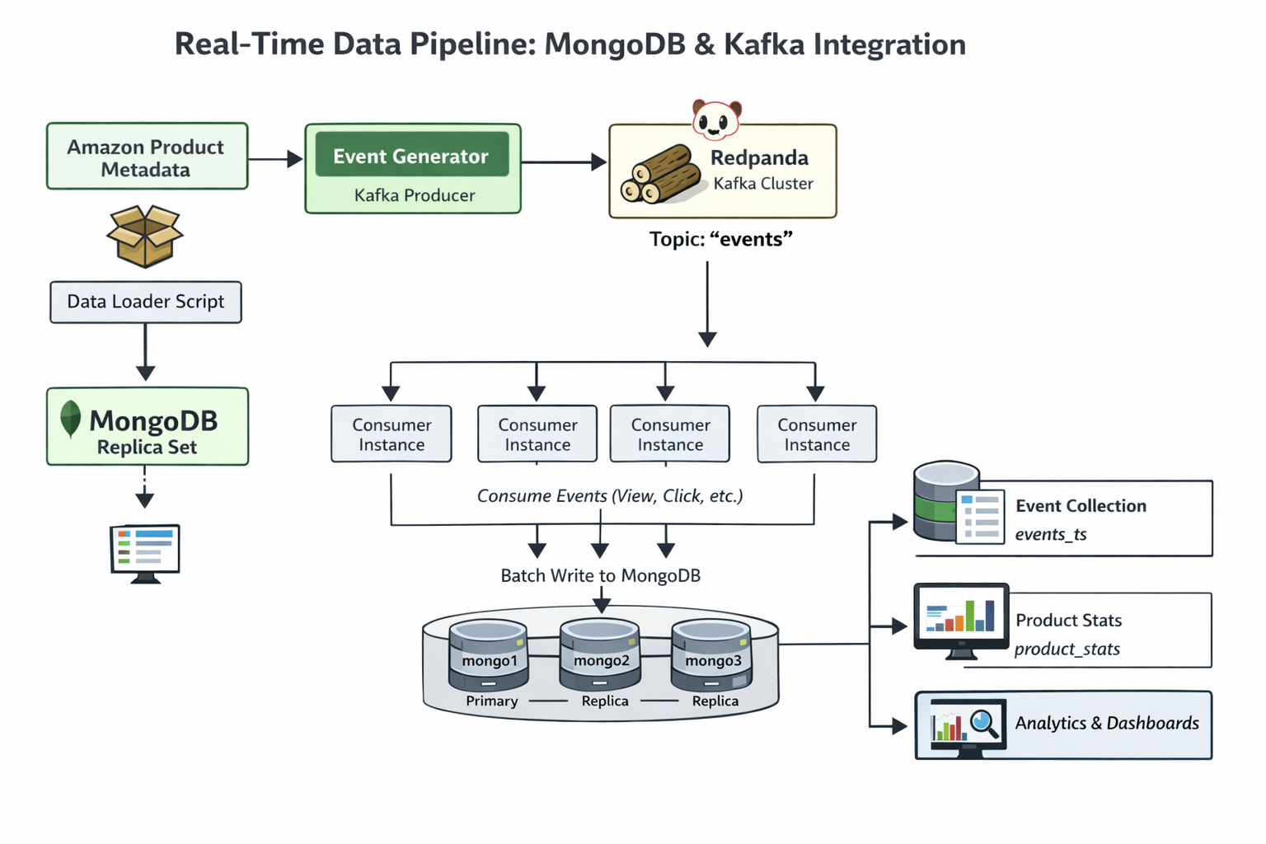
Figure 1 - local architecture of the Smart Marketplace.

The distributed system is composed of five logical layers: a product data layer, a streaming layer, a consumer processing layer, a distributed storage layer, and an AI search layer.

Table 1 - Distributed system components
Component | Role in the POC
MongoDB replica set (mongo1, mongo2, mongo3) | Stores the product catalog, raw event history, and derived statistics while providing redundancy and automatic failover.
Redpanda topic: events (3 partitions) | Receives marketplace interactions such as views, clicks, favorites, and add-to-cart events.
Three consumers in one consumer group | Read from the topic in parallel and write raw events into events_ts while updating product_stats.
Qdrant vector database | Stores product embeddings for semantic retrieval.
Streamlit dashboard | Provides a small visual interface for metrics, semantic search, and controlled operational actions.

3. How the architecture answers the 3 V’s of big data
Table 2 - 3v's of big data
V | How it appears in the POC | Why it matters
Volume | Real product metadata was loaded and a large number of marketplace events were produced and persisted. | Shows the platform can process and store a meaningful workload rather than only a small amount of records.
Velocity | Events are continuously generated, published to the stream, and consumed into a time-series collection. | Demonstrates real-time ingestion and processing.
Variety | Products use a flexible document schema with different specifications across categories. | Shows why a document database is appropriate for marketplace data.

4. Theory behind the structure and deployment

4.1 Replica set and replication
MongoDB was deployed as a three-node replica set. In a replica set, one node is the primary and accepts writes, while the remaining nodes replicate the data as secondaries. If the primary fails, the set elects a new primary. This is the theoretical basis for high availability and fault tolerance in the project.

4.2 Streaming and partitioned event flow
Marketplace events are not written directly from the producer into the database. They are first published to the events topic. Because the topic has three partitions and the consumer group has three members, the workload can be processed in parallel while preserving ordering within each partition.

4.3 Time-series storage and aggregation
The raw event stream is stored in a MongoDB time-series collection called events_ts. Time-series collections are optimized for timestamped measurements and are a natural fit for event logs such as product views and clicks. A second collection, product_stats, stores derived counters so that analytics queries can run faster.

4.4 Simple orchestration
Docker Compose was used to keep the environment simple. All services are declared in one compose file, which makes the stack easy to start, easy to stop, and easy to reproduce.

5. Practical execution in a few steps
All commands below are executed from the project root.

Step 1 — Start the distributed stack
docker compose up -d –build

This starts the MongoDB replica set nodes, Redpanda, Kafka UI, the replica-set initializer, Qdrant, and the three event consumers.

Step 2 — Load the marketplace product catalog
python load_amazon_meta.py --gz .\data\meta_Electronics.json.gz --limit 20000

This loads the product catalog into mini_bigdata_real.products.

Step 3 — Produce marketplace events
$env:TOTAL_EVENTS=100000

$env:REPORT_EVERY=1000

python kafka_producer.py
This generates marketplace interactions and publishes them to the events topic.

Step 4 — Run analytics
python analytics_queries.py --minutes 10 --hours 6 --top 10
This validates that the time-series collection and the derived statistics can be queried in a meaningful way.

Step 5 — Run the Streamlit dashboard
streamlit run .\streamlit\app.py
This opens a small visual interface for counts, semantic search, and controlled operational actions.

6. Simple scenario and observed results
A simple demonstration scenario was used: load the product catalog, publish a large number of events, let the consumers write them into MongoDB, verify analytics, then test failover by stopping the primary node.
Table 3 - observed results
Validation point | Observed result | Interpretation
Products loaded | 20,000 products | A realistic catalog was available for both analytics and AI.
Streaming topic | events with 3 partitions | The ingestion layer supported parallel consumption.
Producer throughput | ≈ 5,226 events/sec on a 100k run | The local stack sustained a meaningful event rate.
Raw event persistence | events_ts populated | The time-series ingestion path worked.
Derived statistics | product_stats populated | Consumer-side aggregation working.
Failover test | Automatic election observed | Replication and availability were verified in practice.
Vector indexing test | 500-product semantic indexing test completed | The AI retrieval layer was successfully initialized.

The failover test showed that the primary node could be stopped, a new primary could be elected automatically, writes could continue, and the original node could rejoin later as a secondary. This directly supports the theoretical explanation of replication and availability.

7. How AI was used
AI became part of the platform through semantic search.

7.1 Semantic search design
The AI layer embeds each product into a vector representation using the sentence-transformers/all-MiniLM-L6-v2 model. The embedding is built mainly from the searchText field, complemented by title, category, brand, and specs. Those vectors are stored in Qdrant, while MongoDB remains the source of truth for the full product documents.

7.2 Query flow
When a user enters a search query, the query is embedded with the same model, Qdrant retrieves the nearest vectors, and the matching productIds are used to fetch full product details from MongoDB. This makes search more intelligent than exact keyword matching and turns the marketplace into a smart retrieval system.

7.3 Why this AI layer fits the POC
The AI extension remains simple enough to run locally, but it is still meaningful: it demonstrates semantic retrieval, a practical smart-marketplace feature, without replacing the distributed data architecture already built.

8. Streamlit dashboard snapshots
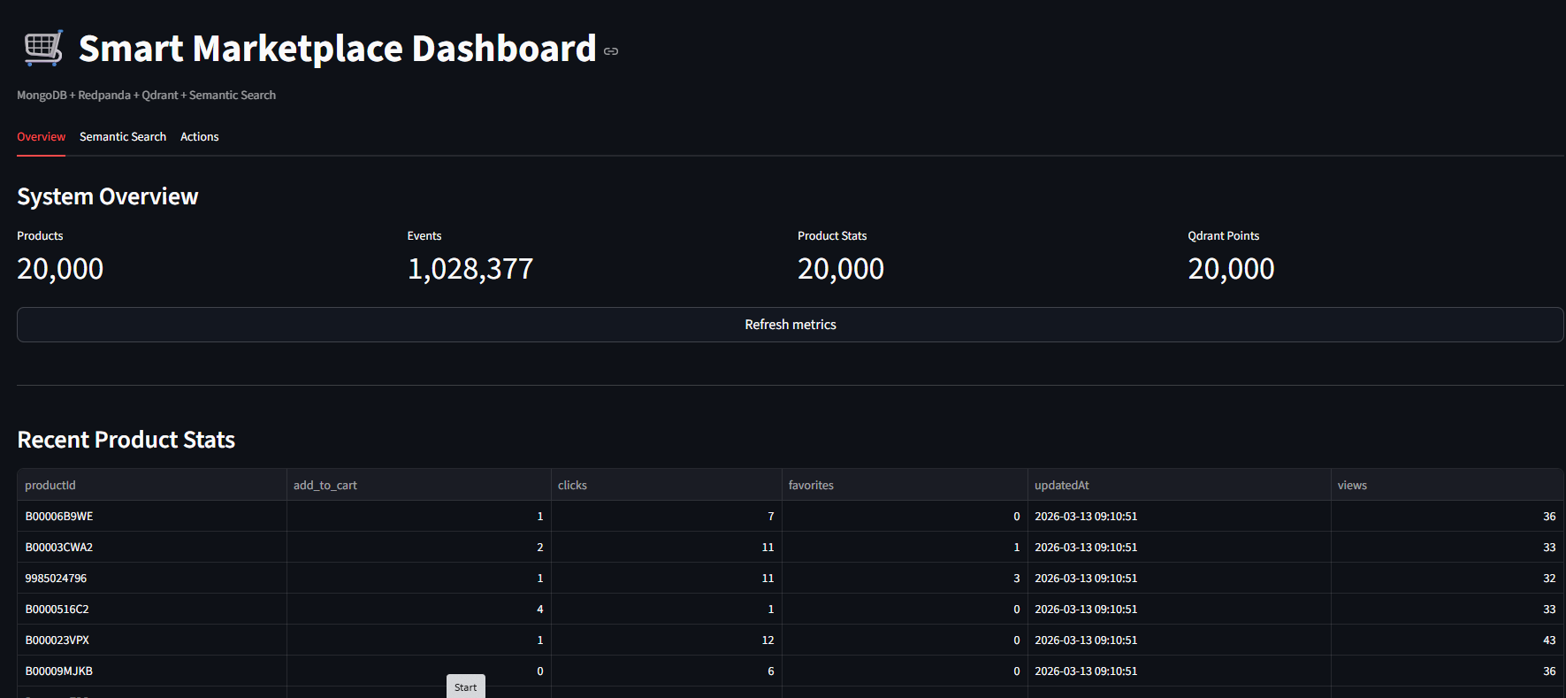
Figure 2 - Streamlit overview dashboard screenshot
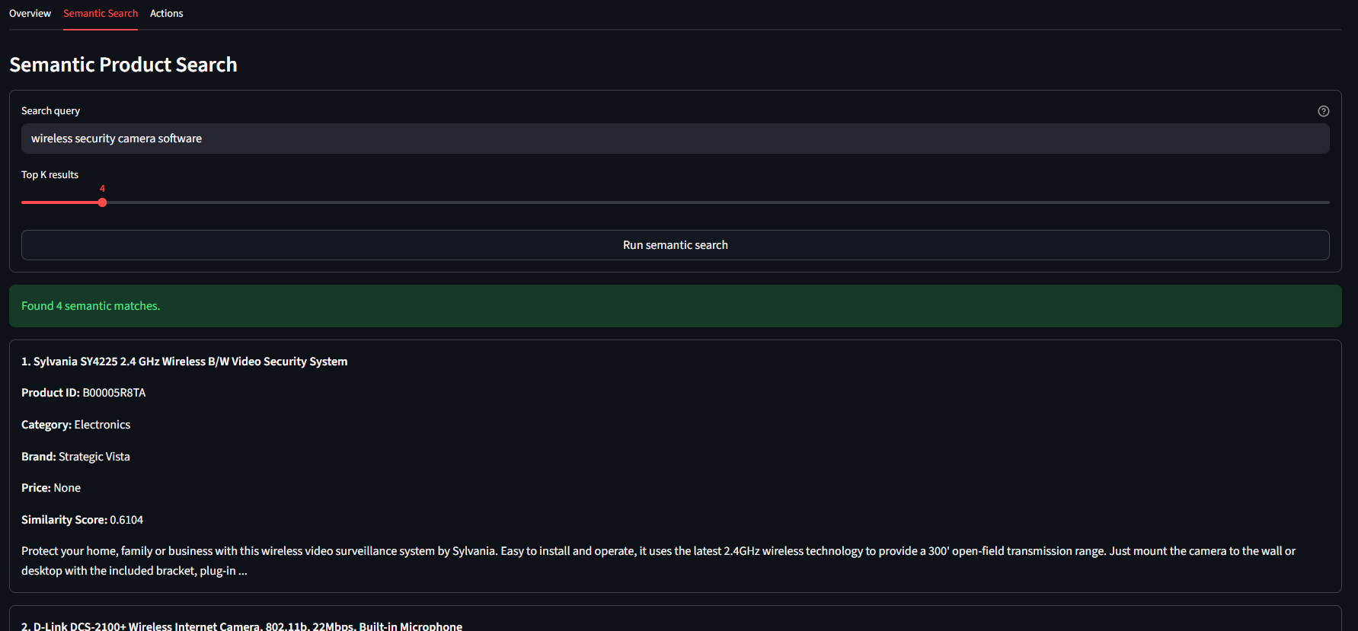
Figure 3 - Streamlit semantic search screenshot

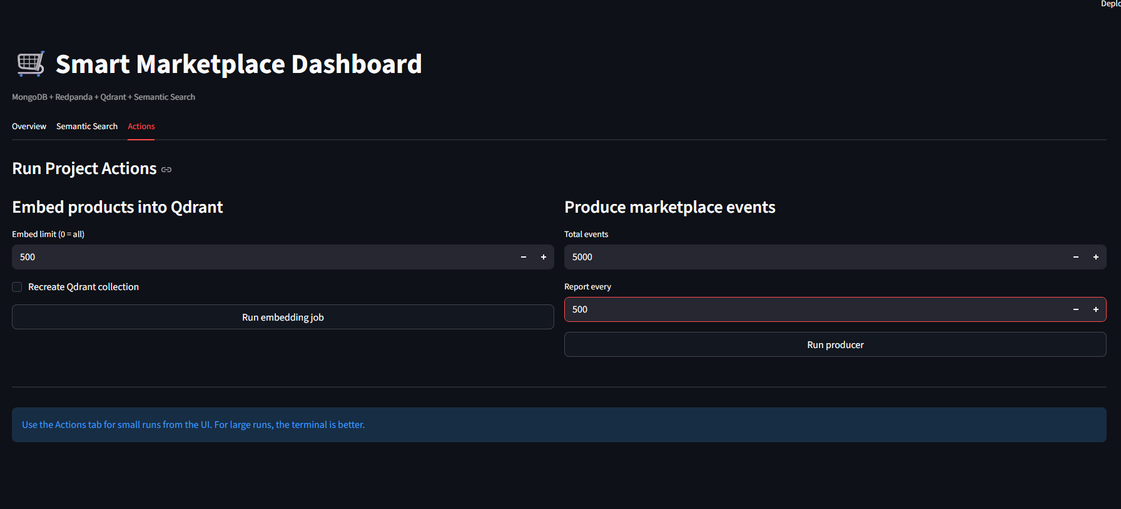
Figure 4 - Streamlit actions tab screenshot.

9. Conclusion
The Smart Marketplace POC demonstrates the core ideas of a distributed big data environment in a compact and reproducible form. It combines replicated storage, partitioned streaming, time-series persistence, analytics, automatic failover, and a first AI search layer.

10. List of Figures

Figure 1 - Final local architecture of the Smart Marketplace POC. 1
Figure 2 - Streamlit overview dashboard screenshot 6
Figure 3 - Streamlit semantic search screenshot 6
Figure 4 - Streamlit actions tab screenshot. 7

11. List of Tables

Table 1 - Distributed system components 2
Table 2 - 3v's of big data 2
Table 3 - observed results 4

12. References

[R1] MongoDB, Inc. “Replication — MongoDB Manual.” MongoDB Documentation. Available: https://www.mongodb.com/docs/manual/replication/
[R2] MongoDB, Inc. “Time Series Collections.” MongoDB Documentation. Available: https://www.mongodb.com/docs/manual/core/timeseries-collections/
[R3] Docker, Inc. “Docker Compose Overview.” Docker Documentation. Available: https://docs.docker.com/compose/
[R4] Redpanda Data, Inc. “Redpanda Documentation.” Redpanda Docs. Available: https://docs.redpanda.com/
[R5] Qdrant Solutions GmbH. “Qdrant Documentation.” Qdrant Docs. Available: https://qdrant.tech/documentation/
[R6] N. Reimers and I. Gurevych. “Sentence-BERT: Sentence Embeddings using Siamese BERT-Networks.” Sentence Transformers Documentation. Available: https://www.sbert.net/
[R7] Hugging Face, Inc. “Hugging Face Hub Documentation.” Hugging Face Docs. Available: https://huggingface.co/docs/hub/
[R8] Snowflake, Inc. “Streamlit Documentation.” Streamlit Docs. Available: https://docs.streamlit.io/
[R9] Anthropic. “Claude.” Anthropic. Used as engineering, writing, and architecture-diagram assistant during implementation and report preparation. Available: https://claude.ai/

