
Master in Data Science

Enterprise Data Management
Road Accident Risk Analysis using MongoDB

Dr. Rima Kilany Chamoun

Table of Content:
- Project Overview ............................................................................................... 3
- Project Objectives ............................................................................................. 3
- Dataset Description ........................................................................................... 3
- General Project Architecture ............................................................................ 5
- Why MongoDB as chosen ................................................................................ 5
- MongoDB in Big Data Context ......................................................................... 6
- MongoDB Theory Covered In Project .............................................................. 6
- Data Exploration .............................................................................................. 11
- Data Cleaning a Preparation for MongoDB ................................................... 14
- MongoDB Atlas and Connection Setup ......................................................... 15
- Data Model ....................................................................................................... 19
- Data Analysis Using Aggregation Queries.................................................... 20
- Hotspot Detection and Risk analysis ............................................................ 22
- AI Components: Accidents severity Prediciton ........................................... 23
- Overall Project Conclusion............................................................................. 28
- References ....................................................................................................... 29

1. Project Overview:
We designed this project to build a Road Accident Risk Analysis System using MongoDB as the database platform and machine learning as the AI component. Our system analyzes accident records, supports scalable storage and querying in a Big Data context, and integrates AI for predictive analytics.
We focused on two main objectives:
1. Predict accident severity 2. Identify high-risk locations
The project combines:
- a NoSQL database layer to store and process large volumes of accident records
- an analytics layer based on aggregation and geospatial concepts
- an AI layer for accident severity prediction
This approach makes our project relevant to both Enterprise Data Management and Big Data analytics.

2. Project Objectives:
The main objectives of our project are to:
- store road accident data in MongoDB
- explore the suitability of MongoDB for Big Data applications
- explain MongoDB architecture, deployment, replication, consistency, and availability
- analyze accident patterns using database queries and aggregation concepts
- predict accident severity using machine learning
- identify high-risk areas using location-related information
- demonstrate how MongoDB can support volume, velocity, and variety

3. Dataset Description:
The dataset we used in this project is a road accident dataset stored in a CSV file called Road Accident Data.csv
It contains approximately 307,973 rows and 23 columns. Each row represents one accident record, while the columns describe different characteristics of the accident.
The most important attributes in the dataset include:
- Accident severity
- Accident date
- Time
- Latitude
- Longitude
- Speed limit
- Weather conditions
- Road surface conditions
- Road type
- Light conditions
- Junction control
- Junction detail
- Urban or rural area
- Vehicle type
- Number of casualties
- Number of vehicles
- Local authority district
This dataset is suitable for both database storage and machine learning because it contains:
- structured numerical data
- categorical data
- temporal data
- geospatial data
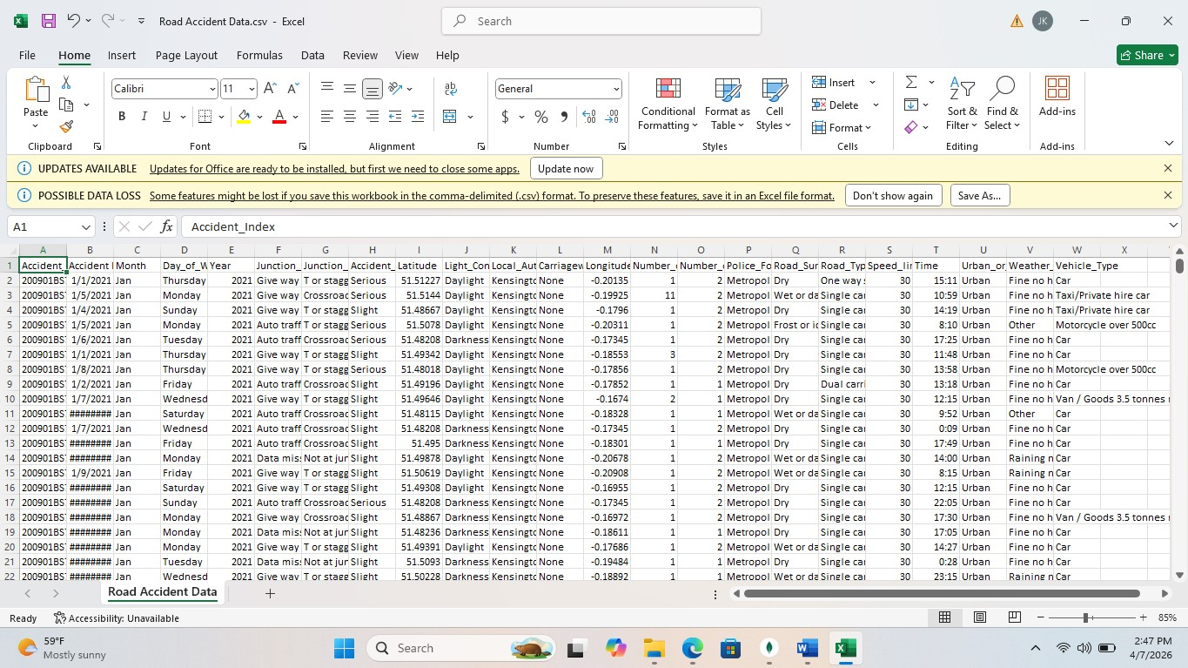

4. General Project Architecture:
We divided our system into three main layers:
4.1 Database Layer
We used MongoDB as the database system for storing and managing accident records.

4.2 Analytics Layer
We used MongoDB queries, indexing, aggregation, and geospatial concepts to analyze accident patterns and identify hotspots.

4.3 AI Layer
We used machine learning models to predict accident severity based on accident conditions.

5. Why MongoDB was chosen:
We selected MongoDB because it is a document-oriented NoSQL database that is well suited for large and flexible datasets.
Its main advantages include:
- schema flexibility
- strong support for semi-structured data
- indexing support
- an aggregation framework
- geospatial capabilities
- replication and sharding support
- cloud deployment through MongoDB Atlas
This makes MongoDB appropriate for our system, since it handles accident records with mixed data types and can support future Big Data growth.

6. MongoDB in Big Data Context :
MongoDB is relevant in Big Data because it can address the three main Big Data dimensions.

6.1 Volume
We can scale MongoDB horizontally through sharding, which allows data to be distributed across multiple machines.

6.2 Velocity
MongoDB supports modern stream-oriented architectures and can be integrated with near-real-time ingestion scenarios. In our project, the dataset is historical, but we can extend the architecture to support streaming accident feeds.

6.3 Variety
Our accidents dataset contains a mixture of:
- numerical features
- text categories
- date and time data
- geospatial coordinates
MongoDB’s flexible document model is well suited to handle this variety.

7. MongoDB Theory Covered in the Project:
MongoDB provides several mechanisms to support scalability, availability, and reliability in Big Data environments. In our project, these concepts are demonstrated through replication, sharding, and configurable read/write operations.

7.1 MongoDB Document Model
We store data in MongoDB as documents grouped into collections, unlike relational databases, which store data in rows and tables.

7.2 Deployment Models
We can deploy MongoDB as:
- a standalone server
- a replica set
- a sharded cluster

7.3 Replication
Replication in MongoDB is implemented using replica sets, where data is duplicated across multiple nodes. A replica set consists of a primary node, which handles write operations, and one or more secondary nodes, which replicate the data from the primary.
This architecture ensures high availability and fault tolerance. In the event of a primary node failure, MongoDB automatically performs a failover by electing one of the secondary nodes as the new primary. This guarantees that the system remains operational without data loss.

Replication of the Road Accident Dataset
In our MongoDB project, replication applies to the entire road_accidents database rather than to individual records or collections. The accidents collection containing the road accident dataset and the hotspots collection containing the derived risk locations are replicated across replica set members. In MongoDB Atlas, this replication is managed automatically by the platform. Data is written to the primary node and then synchronized to secondary nodes. If the primary node becomes unavailable, MongoDB can elect a new primary, ensuring service continuity and improving availability.

7.4 Sharding
Sharding is a technique used by MongoDB to achieve horizontal scaling by distributing data across multiple servers. Instead of storing all data on a single machine, MongoDB divides the dataset into smaller parts called shards, each stored on a different server.
This approach allows the system to handle very large datasets efficiently and improves performance by distributing the workload. A shard key is used to determine how data is partitioned across shards.
In the context of this project, sharding can be conceptually applied by distributing accident data based on fields such as geographic location or time. For example, queries filtering by district demonstrate how data can be efficiently accessed:

results = col.find({"Local_Authority_District": "Kensington and Chelsea"})
This illustrates how data distribution can improve query performance in large-scale systems.
In our project, sharding was demonstrated conceptually due to limitations of the MongoDB Atlas free-tier cluster. In a real deployment, data could be distributed across multiple shards using a shard key such as geographic location. Queries filtering on this key would be efficiently routed to the relevant shard, improving performance and scalability.

7.5 Consistency and Availability Configuration
MongoDB allows flexible configuration to balance consistency, availability, and performance. This is achieved through read concern, write concern, and read preference.

7.5.1 Favoring Consistency
In this project, we demonstrated how MongoDB can be configured to favor data consistency over performance. This is particularly important in applications where accurate and reliable data is critical.
To achieve strong consistency, MongoDB provides configuration options such as read preference, read concern, and write concern.
First, the connection was configured to always read from the primary node using the PRIMARY read preference. This ensures that all read operations return the most up-todate data.
Second, both read concern and write concern were set to "majority". This means that:
- Write operations are only considered successful when confirmed by a majority of replica set members.
- Read operations return only data that has been fully replicated across the majority of nodes.
The following code demonstrates this configuration:
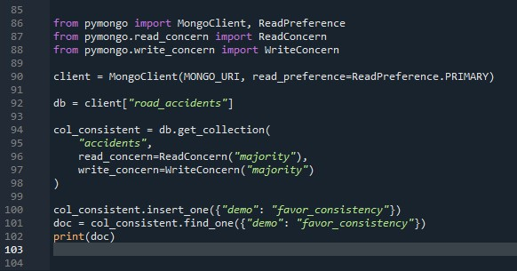
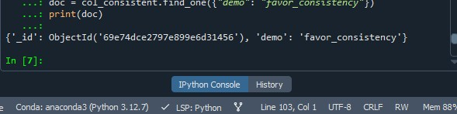
The successful insertion and retrieval of the document confirm that the operation was executed under strong consistency guarantees.
This configuration ensures that the system prioritizes data accuracy and reliability, even if it introduces slightly higher latency. Such an approach is essential in critical systems where incorrect or outdated data cannot be tolerated.

7.5.2 Favoring Availability and Performance
In addition to consistency, MongoDB allows the system to be configured to favor availability and performance. This is useful in applications where fast response times and continuous system access are more important than strict data consistency.
To achieve higher availability, MongoDB provides flexible configuration options such as read preference, read concern, and write concern.
First, the system can be configured to allow reads from secondary nodes using the SECONDARY read preference. This distributes the read workload across multiple nodes and improves system availability.
Second, the write concern can be reduced to w=1, meaning that a write operation is acknowledged as soon as the primary node confirms it, without waiting for replication to other nodes.
Third, the read concern can be set to "local", allowing faster reads even if the data has not yet been fully replicated.
The following code demonstrates this configuration:
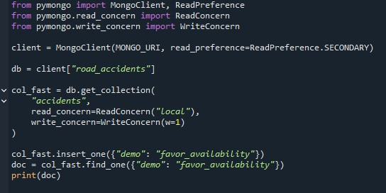
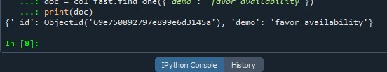

7.6 Geospatial and Analytical Support
MongoDB supports geospatial storage and querying, which makes it relevant for location-based accident analysis.

8. Dataset Exploration:
Our first practical step was to inspect the dataset using Python.
We used this exploration step to:
- verify the size of the dataset
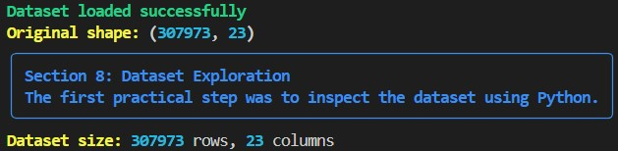
- inspect column names
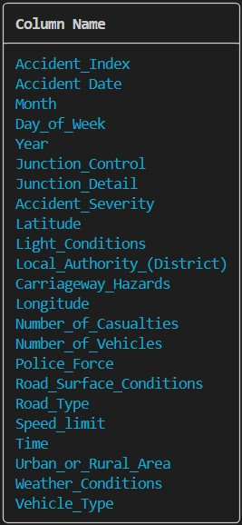
- view sample rows
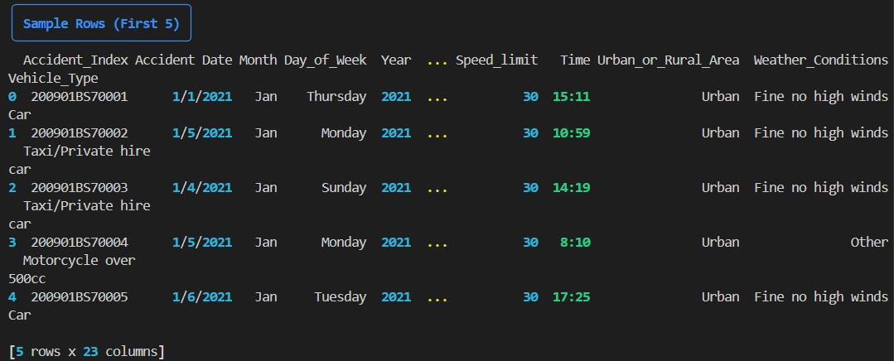

- count missing values
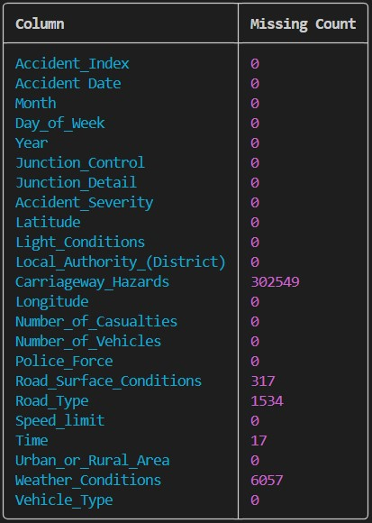
- inspect the class distribution of accident severity
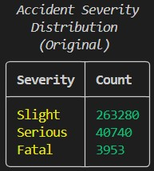
This helped identify the most important columns for both the database and AI components.

9. Data Cleaning as Preparation for MongoDB:
We created a cleaning script to prepare the CSV file for further use.
The cleaning step had the following goals:
- standardize column names
- convert date values
- convert time into hour
- convert latitude and longitude into numeric values • remove records with missing essential fields
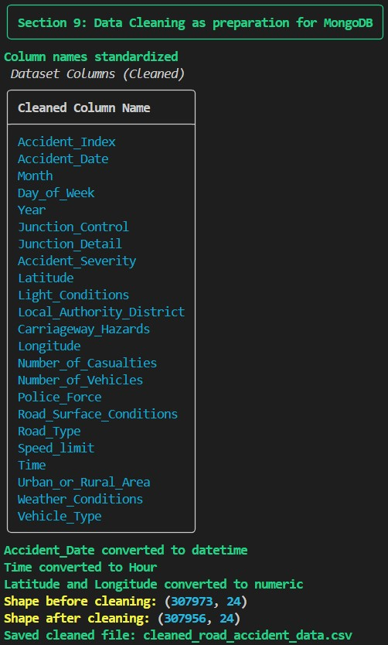

10. MongoDB Atlas and Connection Setup:
We used MongoDB Atlas as a cloud-based database platform to store and manage the road accident dataset. We performed the following steps:
- created a MongoDB Atlas account
- created a free cluster for cloud deployment
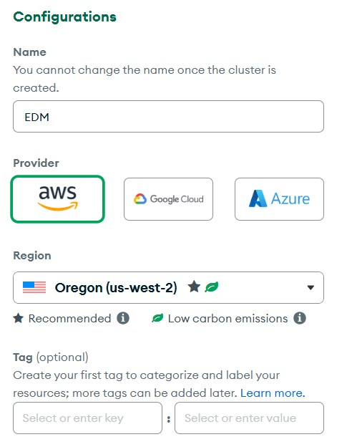
- created a database user with authentication credentials
- added an IP address to allow a secure connection
MongoDB Atlas provides us with a managed cloud environment that ensures scalability, availability, and security without requiring manual server configuration.
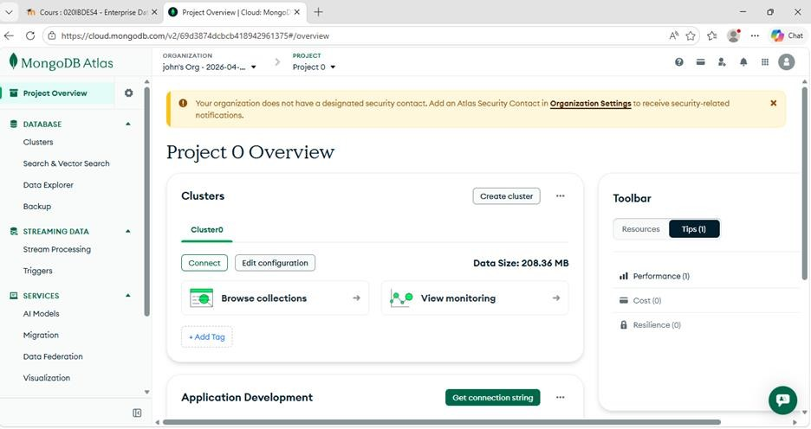

10.1 Connecting using MongoDB Compass
We used MongoDB Compass as a graphical interface to interact with the database. We completed the following steps:
- downloaded and installed MongoDB Compass
- obtained the connection string from MongoDB Atlas
- pasted the connection string into MongoDB Compass • successfully established the connection to the cluster
This allowed us to manage the database more easily, including data import, querying, and analysis.
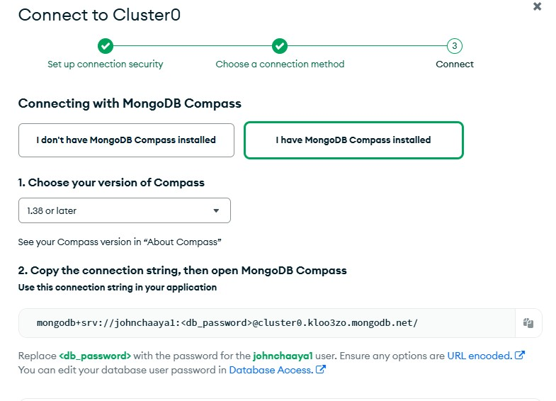

10.2 Connecting using Python (PyMongo)
We used Python to connect to MongoDB programmatically through the PyMongo library. We completed the following steps:
- installed PyMongo library
- established a connection to MongoDB Atlas using the connection string
- accessed the database and collections through Python
This connection allowed us to perform more advanced data processing, including aggregation pipelines and hotspot detection analysis.

10.3 Verifying Replication in MongoDB Atlas
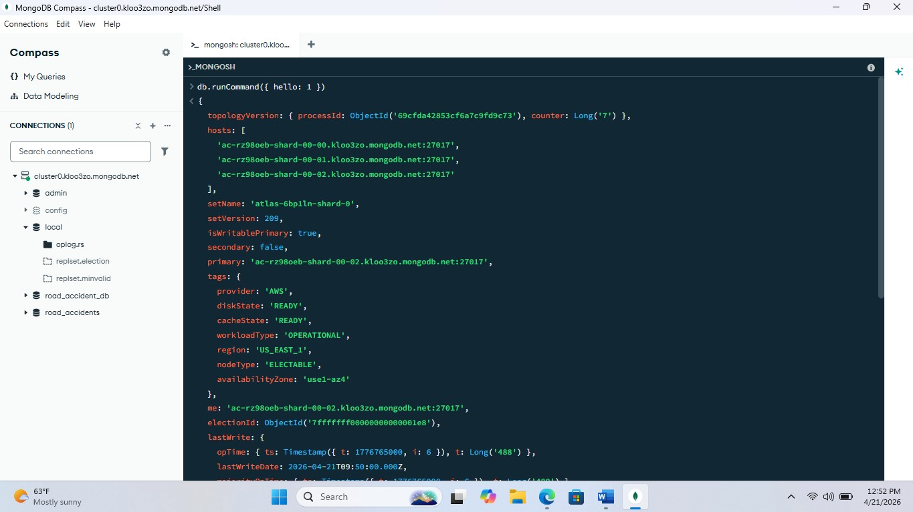
Here we demonstrate replication in MongoDB Atlas.
We run the hello command, which gives us information about the cluster.
As we can see, the cluster has a replica set, shown by the setName field.
We also see multiple hosts, which means the data is replicated across multiple nodes.
The field isWritablePrimary indicates the primary node, which handles write operations.
This confirms that our dataset is replicated across multiple servers, ensuring high availability and fault tolerance.

11. Data Model:
We used MongoDB as a document-oriented database, where data is stored in collections as JSON-like documents. In our project, we stored the data in the "accidents" collection inside the "road_accidents" database.
Each document represents a single road accident and contains several attributes that describe the event. These attributes include information such as accident severity, weather conditions, road surface conditions, speed limit, time of the accident, and geographic location.
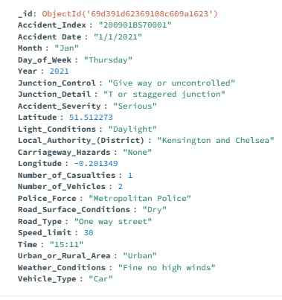

12. Data Analysis using Aggregation Queries:
We used MongoDB’s aggregation framework to analyze the road accident dataset and extract meaningful insights. We implemented the following queries:

• Accidents by Severity
This query groups accidents according to severity levels such as Slight, Serious, and Fatal, then counts how many accidents fall into each category. It helps us understand the overall level of accident danger.

• Accidents by Weather Conditions
This query examines how weather conditions affect accident frequency. It highlights conditions such as rain, fog, and dry weather.

• Accidents by Road Type • Accidents by Speed Limit
Each query uses grouping and sorting operations to summarize large amounts of data efficiently. We then exported the results and visualized them using charts to better understand accident patterns.
These analyses demonstrate MongoDB’s ability to process large datasets through its aggregation framework.

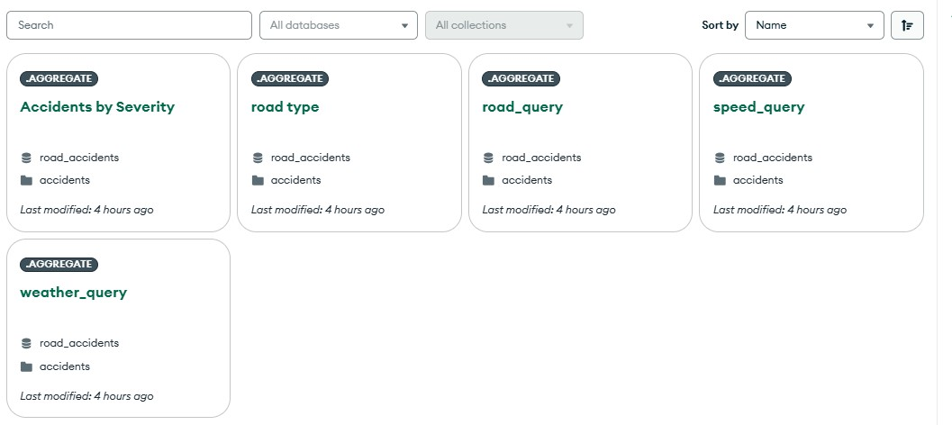

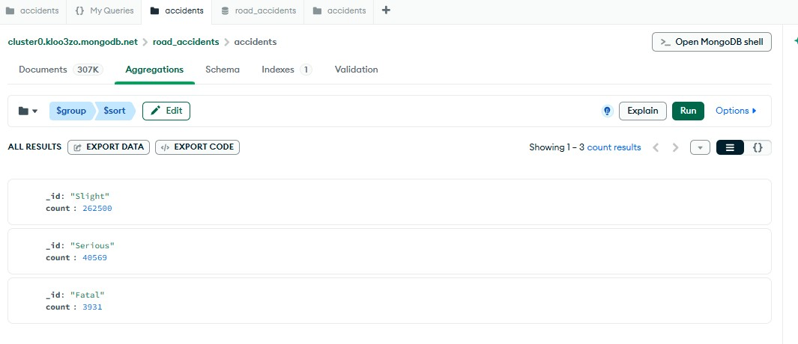

13. Hotspot Detection and Risk Analysis:
To identify high-risk locations, we implemented a hotspot detection analysis using MongoDB aggregation and Python with PyMongo.
Our approach included the following steps:
- rounding geographic coordinates (latitude and longitude) to group nearby accident locations
- aggregating accidents based on these grouped locations • calculating a risk score based on accident severity: o Slight accidents → weight 1 o Serious accidents → weight 3 o Fatal accidents → weight 10

This scoring system gives greater importance to more severe accidents.
We then sorted the results in descending order based on the risk score, and we identified the top 50 most dangerous locations. These locations were stored in a separate collection called "hotspots".
Our hotspot analysis revealed areas with a high concentration of accidents and high severity levels. For example:
- some locations recorded more than 250 accidents
- several hotspots included multiple fatal accidents
- high-risk areas were concentrated in urban zones with dense traffic
The highest-risk location reached a risk score of more than 400, which indicates a significant level of danger.
These results show that MongoDB can be used not only for data storage, but also for advanced analytical tasks such as risk assessment and pattern detection.
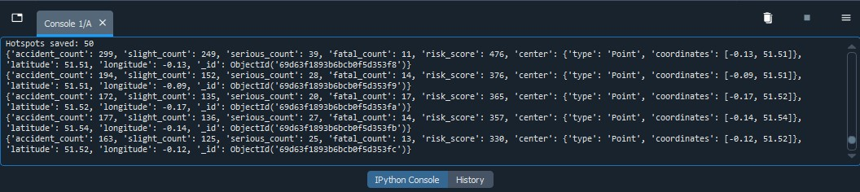

14. AI Component: Accident Severity Prediction:

14.1 Objective
The goal of this component is to predict accident severity (Slight, Serious, Fatal) using accident-related features. We treated this as a supervised classification problem.

14.2 Input Features
We used variables such as:
- Speed limit, weather, road conditions
- Light conditions, junction details
- Urban/rural area, vehicle type
- Day, month, hour
- Number of casualties and vehicles
These features describe the accident context.
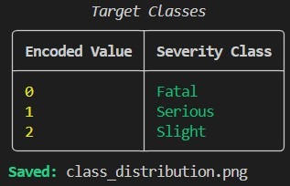

14.3 Preprocessing
- Missing values:
o Numerical → median o Categorical → most frequent
- Categorical variables → One-Hot Encoding
- Target variable → label encoding
- Time converted to Hour

14.4 Train-Test Split
The dataset was split into:
- 80% training
- 20% testing
We used a stratified split to preserve class distribution.

14.5 Models Used
- Random Forest → captures complex relationships
- Logistic Regression → simple baseline model
14.6 Class Imbalance Handling The dataset is imbalanced (more Slight cases).
To address this: • class_weight = "balanced" was used in both models.
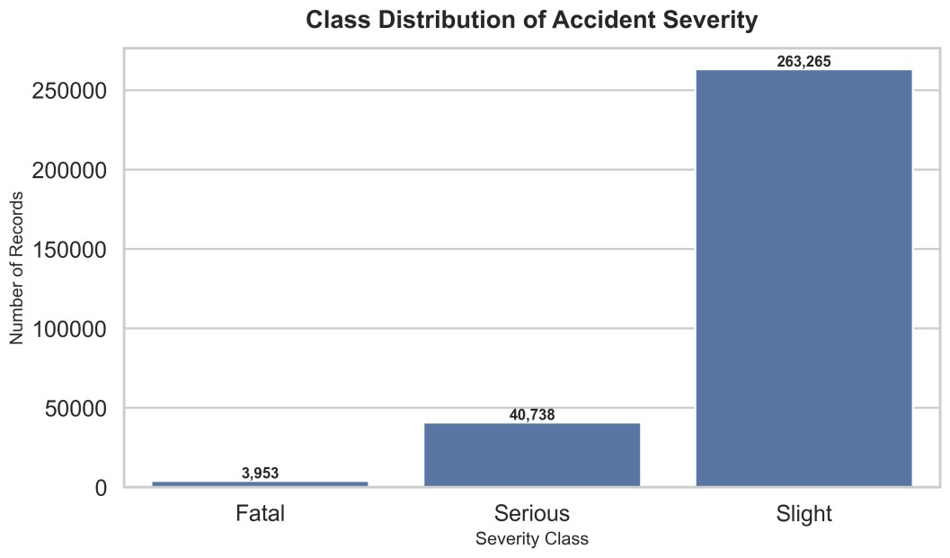

14.
7
Visualizations
:

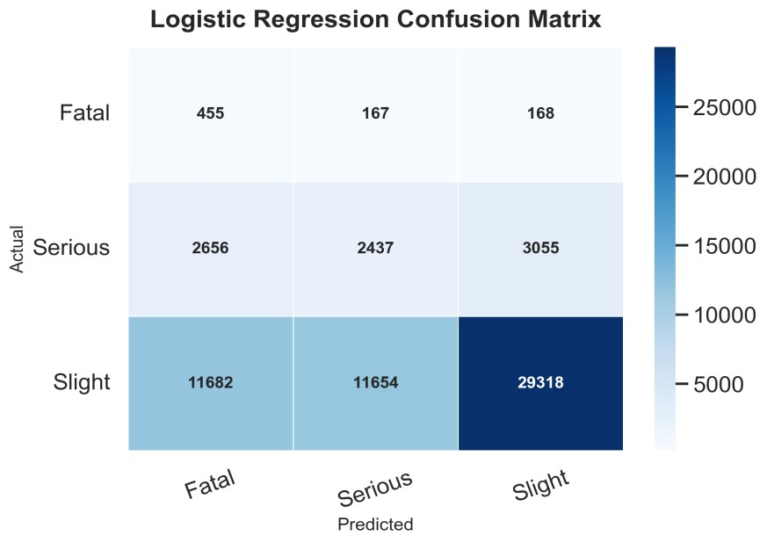
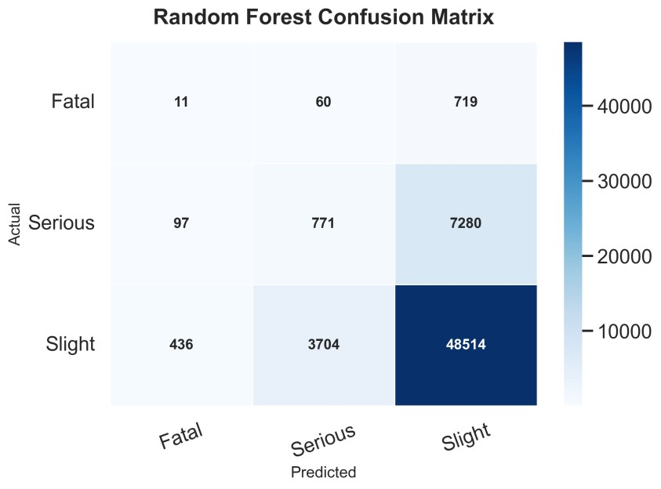

14.8 Results
Best model: Random Forest
- Random Forest accuracy: 0.8004
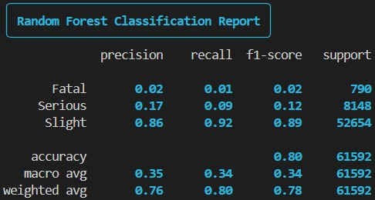
- Logistic Regression accuracy: 0.5230
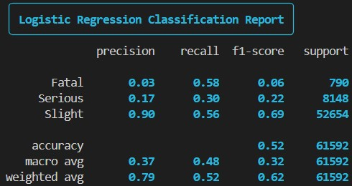
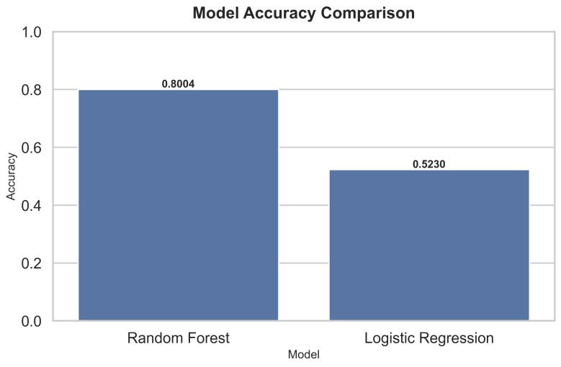
The dataset is imbalanced, making minority classes harder to predict.

14.9 Joblib Models:
Models were saved using joblib, including:
- preprocessing pipeline
- trained model
This allowed us to reuse without retraining.
14.10 Conclusion:
We can use machine learning to predict accident severity based on accident conditions.
In general, Random Forest performs better, but the results are influenced by class imbalance.
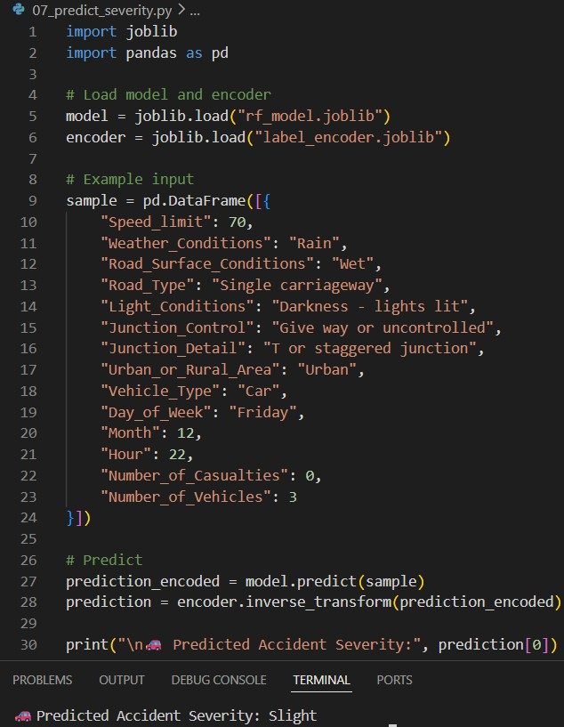

15. Overall Project Conclusion:
Our project demonstrates how MongoDB and AI can be combined in a Road Accident Risk Analysis System. We chose MongoDB because it provides flexibility, scalability, and support for analytical and geospatial use cases in a Big Data context. Our system design shows how accident data can be stored, queried, aggregated, and extended with predictive analytics. MongoDB also supports important enterprise features such as replication for high availability, sharding for horizontal scalability, and configurable read/write operations to balance consistency and performance. Using MongoDB Atlas further simplified deployment while still providing these advanced capabilities.
The AI component successfully showed that accident severity prediction can be approached as a supervised classification problem using accident conditions as input features. We trained and compared two machine learning models and used visual evaluation to analyze their performance.
Overall, our project provides a strong proof of concept for an intelligent road accident analytics platform that could later be extended with live data ingestion, hotspot mapping, and database-integrated predictions.

16. References:

Kaggle Dataset: Road Accident Dataset https://www.kaggle.com/datasets/xavierberge/road-accident-dataset MongoDB Compass Introduction (YouTube Video) https://youtu.be/TCTfP5BTWGQ?si=UfPDiow0dO3RQgFm MongoDB Documentation https://www.mongodb.com/docs/
OpenAI ChatGPT

