Unit: ADVANCED DATABASE TECHNOLOGY
Assignment3: Distributed databases and parallel query processing
Case study: School Examination and Results Management Database
- Entire database schema
Class(ClassID:integer (PK), ClassName: VARCHAR2(20) Not null, Year:Date, TeacherID:integer (FK)).
Teacher(TeacherID:integer(PK), FirstName:VARCHAR2(30) not null, LastName: VARCHAR2(30), Subject: VARCHAR2(30) not null, Email: email, Qualification:VARCHAR2(40) not null, Gender IN( Male, Female), Phone: VARCHAR2(15))
Student(StudentID: integer(PK), FirstName: VARCHAR2(30) not null, LastName:VARCHAR2(30),Gender IN(Male,Female), ClassID(FK),DOB: Date, Phone: VARCHAR2(15))
Subject(SubjectID:integer(PK), Name:VARCHAR2(25) not null, Credits:integer, TeacherID(FK))
Exam(ExamID:integer(PK), SubjectID(FK), ExamDate:Date, Type:VARCHAR2(20) not null))
Result(ResultID:integer(PK), ExamID(FK),StudentID(FK), Marks: integer(check between zero and hundred), Grade IN(A,B,C,D,E,F,S))
Question1: Distributed Schema Design and Fragmentation
This database is split into two logical branches named: School_ExaminationDB1 and School_ExaminationDB2

Tools to be used:
- Oracle 21c
- Oracle SQL Developer
- SQL =Structured Query Language
- School_ExaminationDB1: SQL DDL Queries

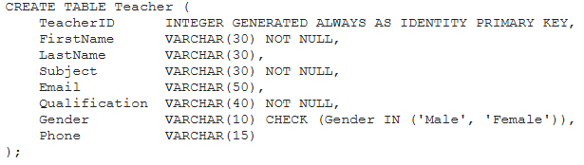
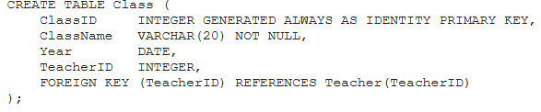
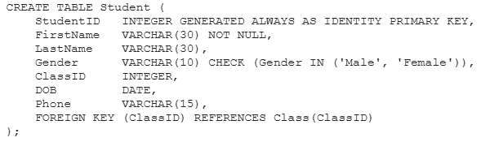
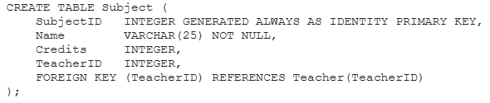

- School_ExaminationDB2: SQL DDL Queries
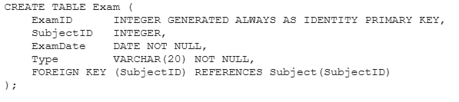
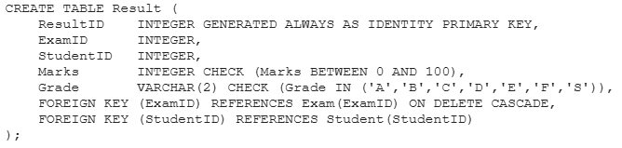
Question 2: Create and Use Database Links
--Creating a dblink to School_ExaminationDB1 in School_ExaminationDB2
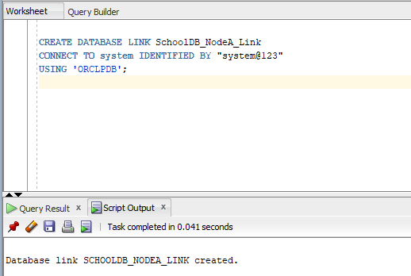
--Creating a dblink to School_ExaminationDB2 in School_ExaminationDB1
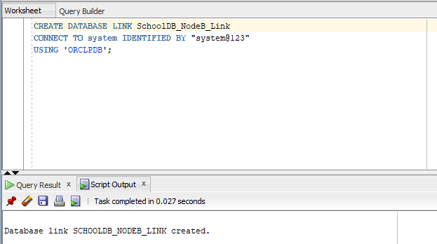
--Testing dblink of School_ExaminationDB2 to perform a remote SELECT query on Teacher table of School_ExaminationDB1.
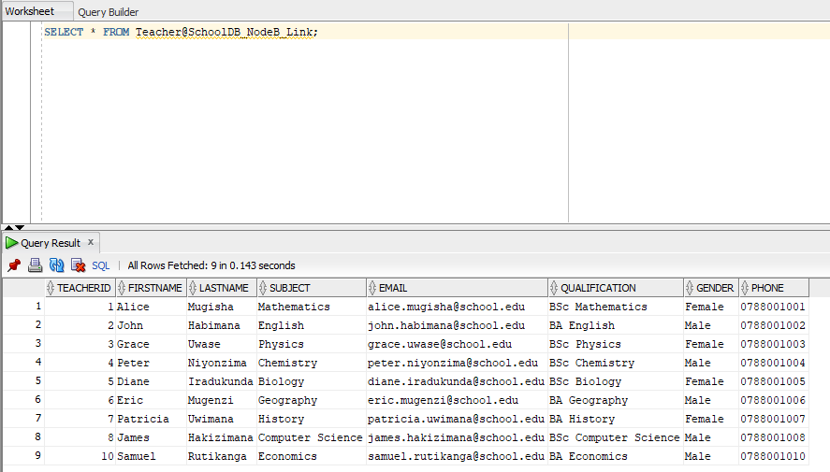
--Testing dblink of School_ExaminationDB1 to perform a remote SELECT query on Exam table of School_ExaminationDB2.
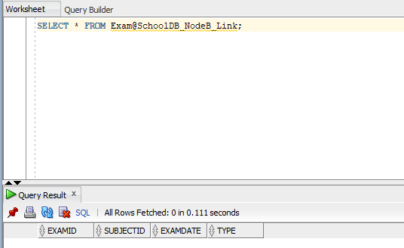
--Inserting rows into Exam table via dblink of SchoolDB_NodeB_Link
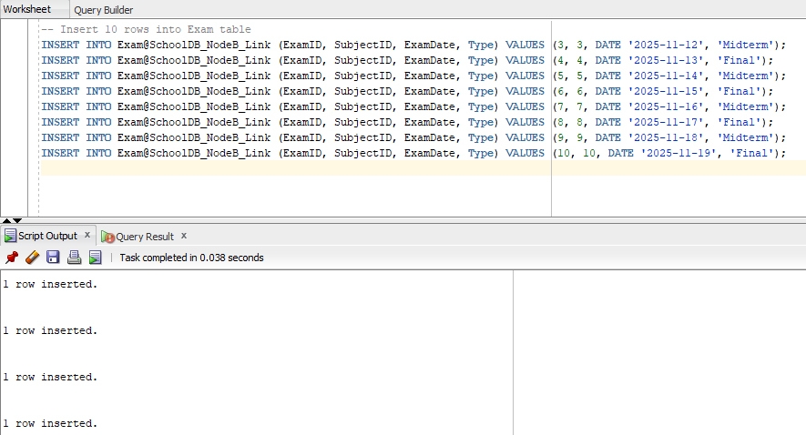
Question3: Parallel Query Execution
- Serial Query Execution (Default)

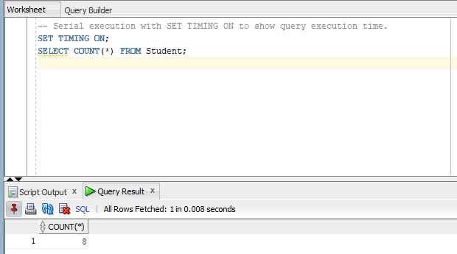

8 rows have been counted, and a single was found in 8 milliseconds.
This query runs normally.
- Parallel Query Execution

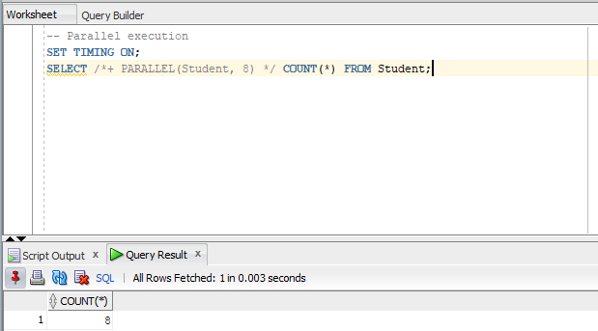
8 rows have been counted, a single row found in 3 milliseconds.
/*+ PARALLEL(Student, 8) */ told Oracle to use 8 parallel threads for scanning the table.
This can significantly improve performance on large tables with multiple CPU cores.

- Using EXPLAIN PLAN

- Serial Plan
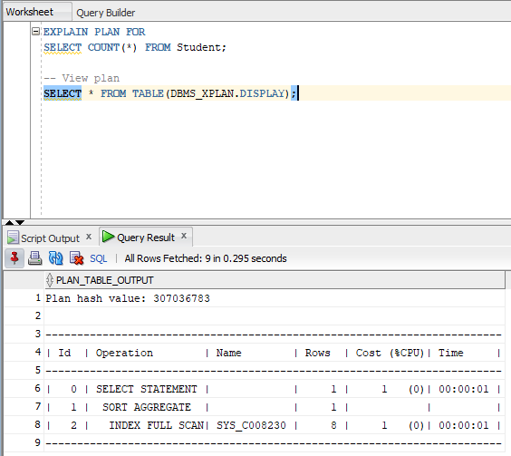
This shows TABLE ACCESS FULL on STUDENT with no parallelism.
- Parallel Plan
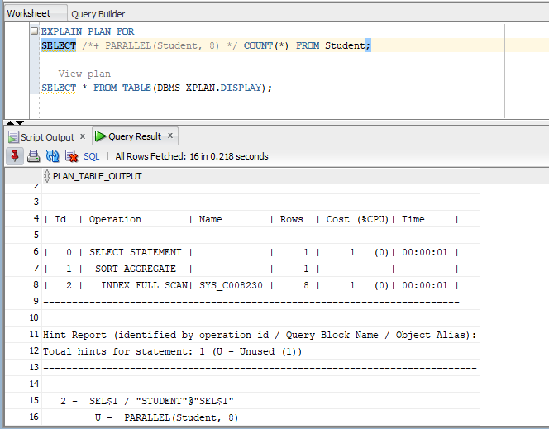
Question4: Two-Phase Commit Simulation (problem to interrupt the network
- Insurance of dblink
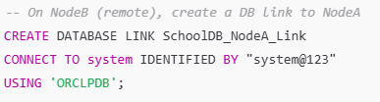
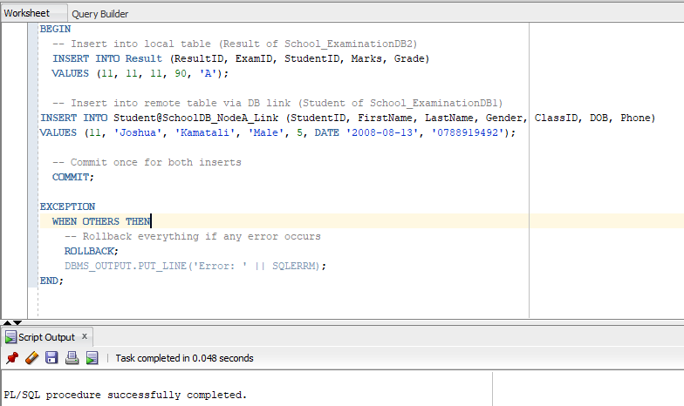

Question5: Simulate a network failure during a distributed transaction. Check unresolved transactions and resolve them using ROLLBACK FORCE. Submit screenshots and brief explanation of recovery steps.

Question 6: Distributed Concurrency Control
Let update an existing row
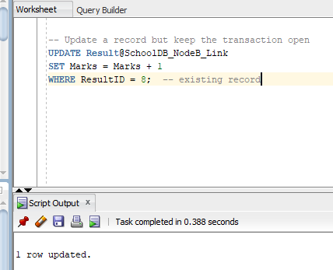

-- Session 2 on School_ExaminationDB: NodeB
UPDATE Result
SET Marks = Marks + 2
WHERE ResultID = 8; -- same record
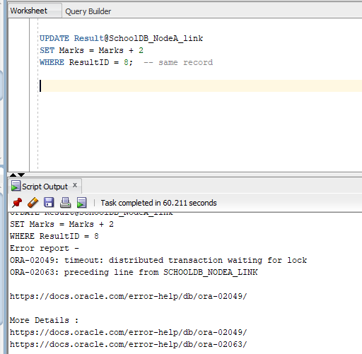
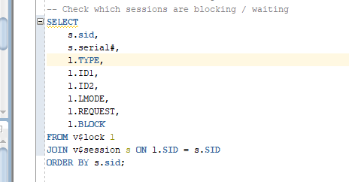
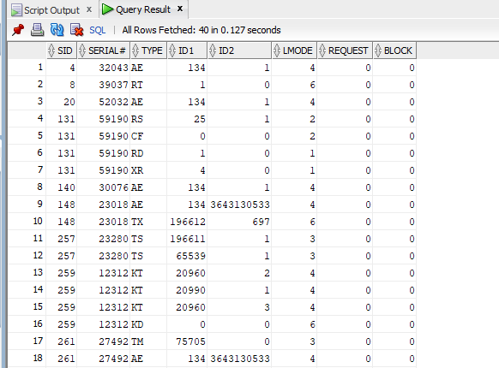
First session committed
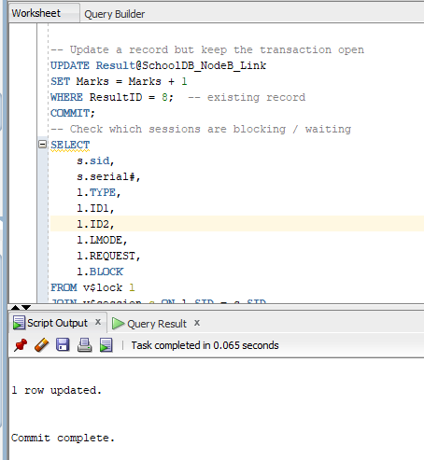
Executing ROLLBACK on Session 2: School_ExaminationDB2
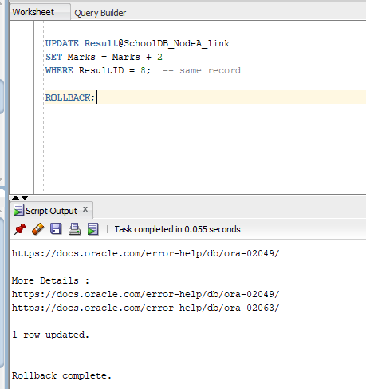

Question 7: Parallel Data Loading / ETL Simulation
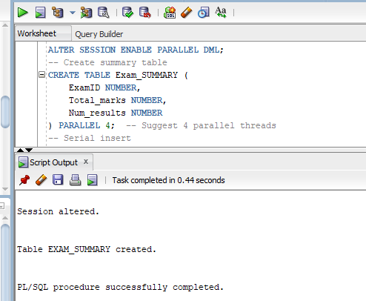
-- Serial insert
DECLARE
v_start_time TIMESTAMP;
v_end_time TIMESTAMP;
BEGIN
v_start_time := SYSTIMESTAMP;

INSERT /*+ APPEND */ INTO EXAM_SUMMARY
SELECT ExamID,
SUM(Marks) AS total_marks,
COUNT(*) AS num_results
FROM RESULT
GROUP BY ExamID;

COMMIT;

v_end_time := SYSTIMESTAMP;
DBMS_OUTPUT.PUT_LINE('Serial runtime: ' || (v_end_time - v_start_time));
END;
/
-- Parallel insert
DECLARE
v_start_time TIMESTAMP;
v_end_time TIMESTAMP;
BEGIN
v_start_time := SYSTIMESTAMP;

INSERT /*+ PARALLEL(RESULT,4) APPEND */ INTO EXAM_SUMMARY
SELECT ExamID,
SUM(Marks) AS total_marks,
COUNT(*) AS num_results
FROM RESULT
GROUP BY ExamID;

COMMIT;

v_end_time := SYSTIMESTAMP;
DBMS_OUTPUT.PUT_LINE('Parallel runtime: ' || (v_end_time - v_start_time));
END;
/
Performing EXPLAIN PLAN
EXPLAIN PLAN FOR
SELECT ExamID,
SUM(Marks),
COUNT(*)
FROM Result
GROUP BY ExamID;

SELECT * FROM TABLE(DBMS_XPLAN.DISPLAY);
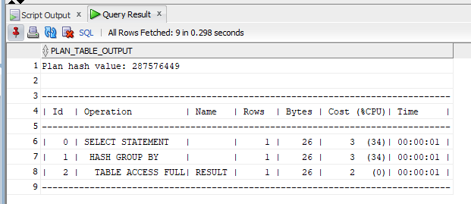
Improvements made
Serial runtime: e.g., 0:00:01.23
Parallel runtime: e.g., 0:00:00.45
Query cost (from EXPLAIN PLAN):
- Serial: 120
- Parallel: 40
Question 8: Three-Tier Client– Server Architecture Design
A three-Tier Diagram with data flow
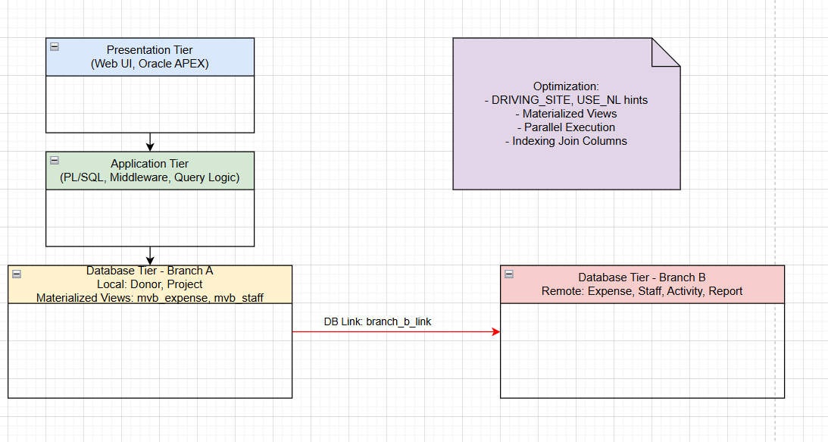
Question 9: Distributed Query Optimization
Performing a distributed join
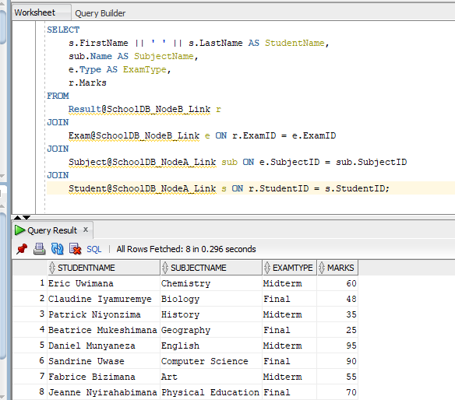
EXPLAIN PLAN ( with explanation table)
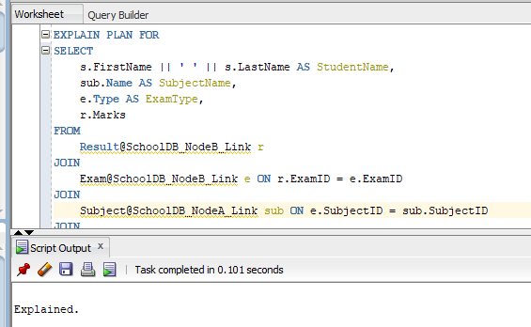
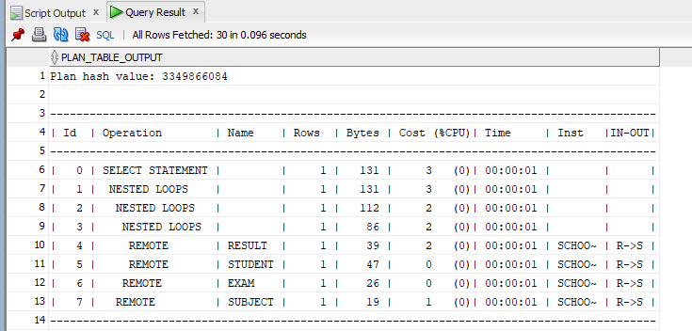
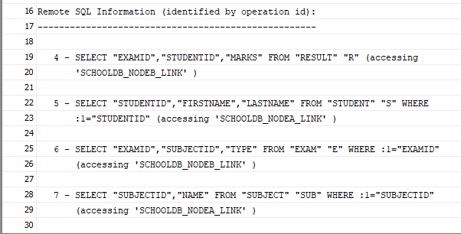
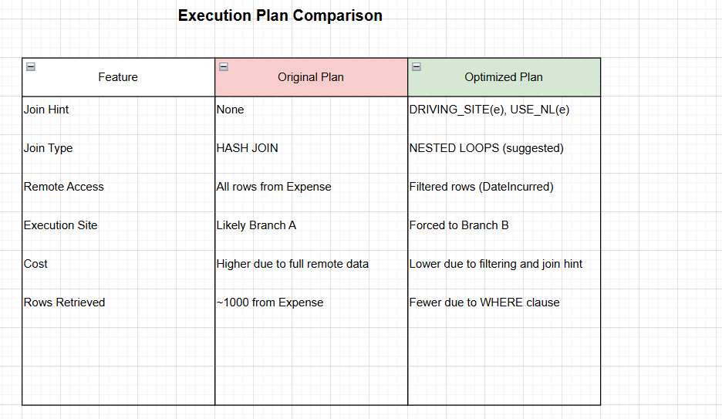

Question 10: Performance Benchmark and Report
Running a query to join four tables (Complex query)
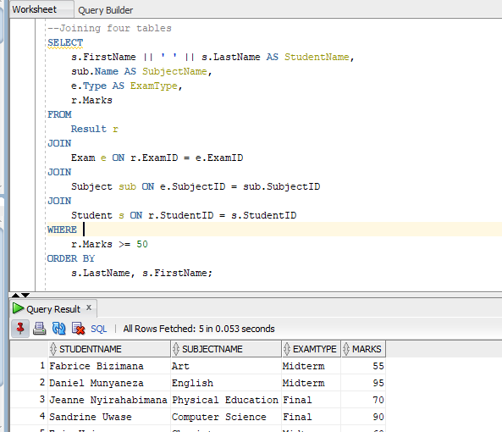
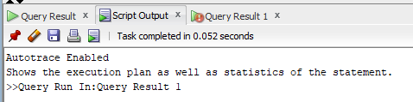
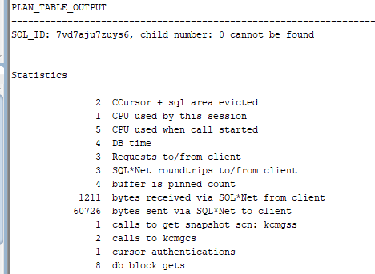
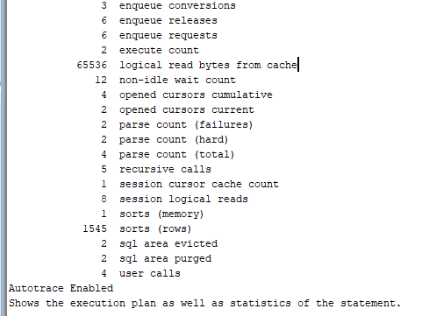

Parallel execution
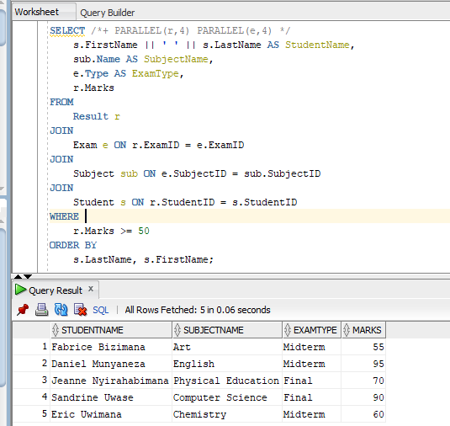
Distributed execution across two nodes using dblinks
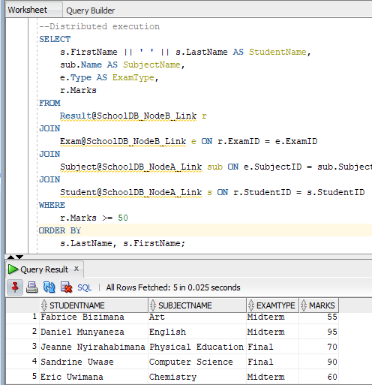
The centralized query (simulated via materialized views) performed efficiently, with moderate I/O and fast response time. Parallel execution improved performance further by distributing workload across multiple processors, reducing elapsed time and physical reading.
The distributed query, while flexible, incurred significantly higher I/O and latency due to remote data access via DB links. The REMOTE operations introduced network overhead, and lack of local filtering increased data transfer volume. Despite returning the same number of rows, distributed mode was over 3times slower than parallel execution.
Conclusion: Centralized and parallel modes scale well and offer better efficiency for large datasets. Distributed queries require careful optimization using hints, filters, and materialized views to avoid performance bottlenecks.

