## **Not on dashboard**

**Objective**: To analyze survey responses from employees participating in the Employee Development Program (EDP).

1. Identify key themes in feedback.
2. Group employees based on similarities across these themes.
3. Explore differences across locations.

**Deliverable**: A **one-page** infographic summarizing findings, including **the main themes**, **employee segments**, and **location-specific insights**, along with an appendix that documents key analysis outputs (e.g., PCA loadings, cluster centers).

## **On dashboard**

Maximum dimension of 11 inches on any side, minimum font size of 6 points.

**Title**: Motivations & Engagement Insights for the Employee Development Program (EDP).

What are motivations and engagement across 600 employees participating in EDP training across North America?

**Key insights**:

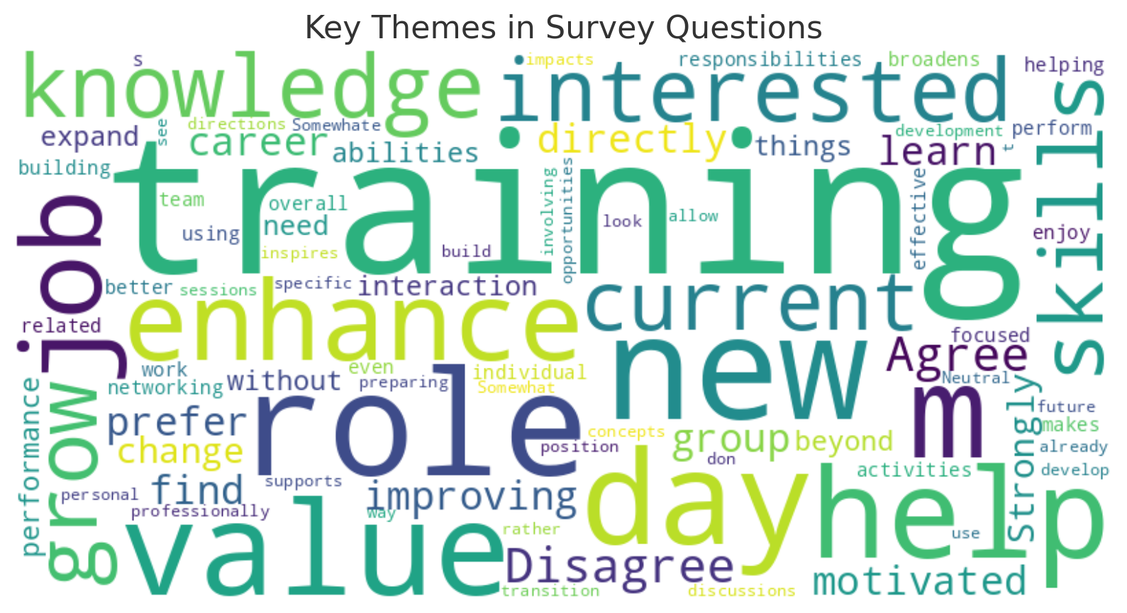

Keywords like “training”, “skills”, “grow”, and “helps” emphasize that a significant focus of employee interest is related to skill development and training. Terms such as “grow”, “role”, and “new” points toward employees' desire to advance in their roles and develop new competencies that align with their current or future job requirements.

Employees are highly interested in training programs that help them enhance their skills and grow professionally.

**Employee Segmentation:**

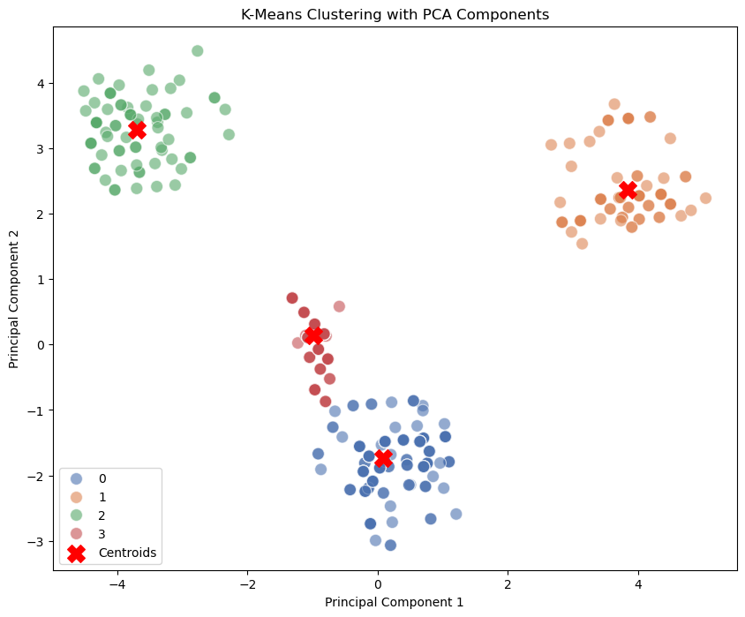

1. Career Climbers - Employees primarily motivated by professional growth and career advancement.
2. Knowledge Seekers - Employees who value learning opportunities and expanding their knowledge.
3. Network Builders - Employees motivated by networking and connecting with others.
4. Skill Enhancers - Employees focused on improving specific skills for their current role.

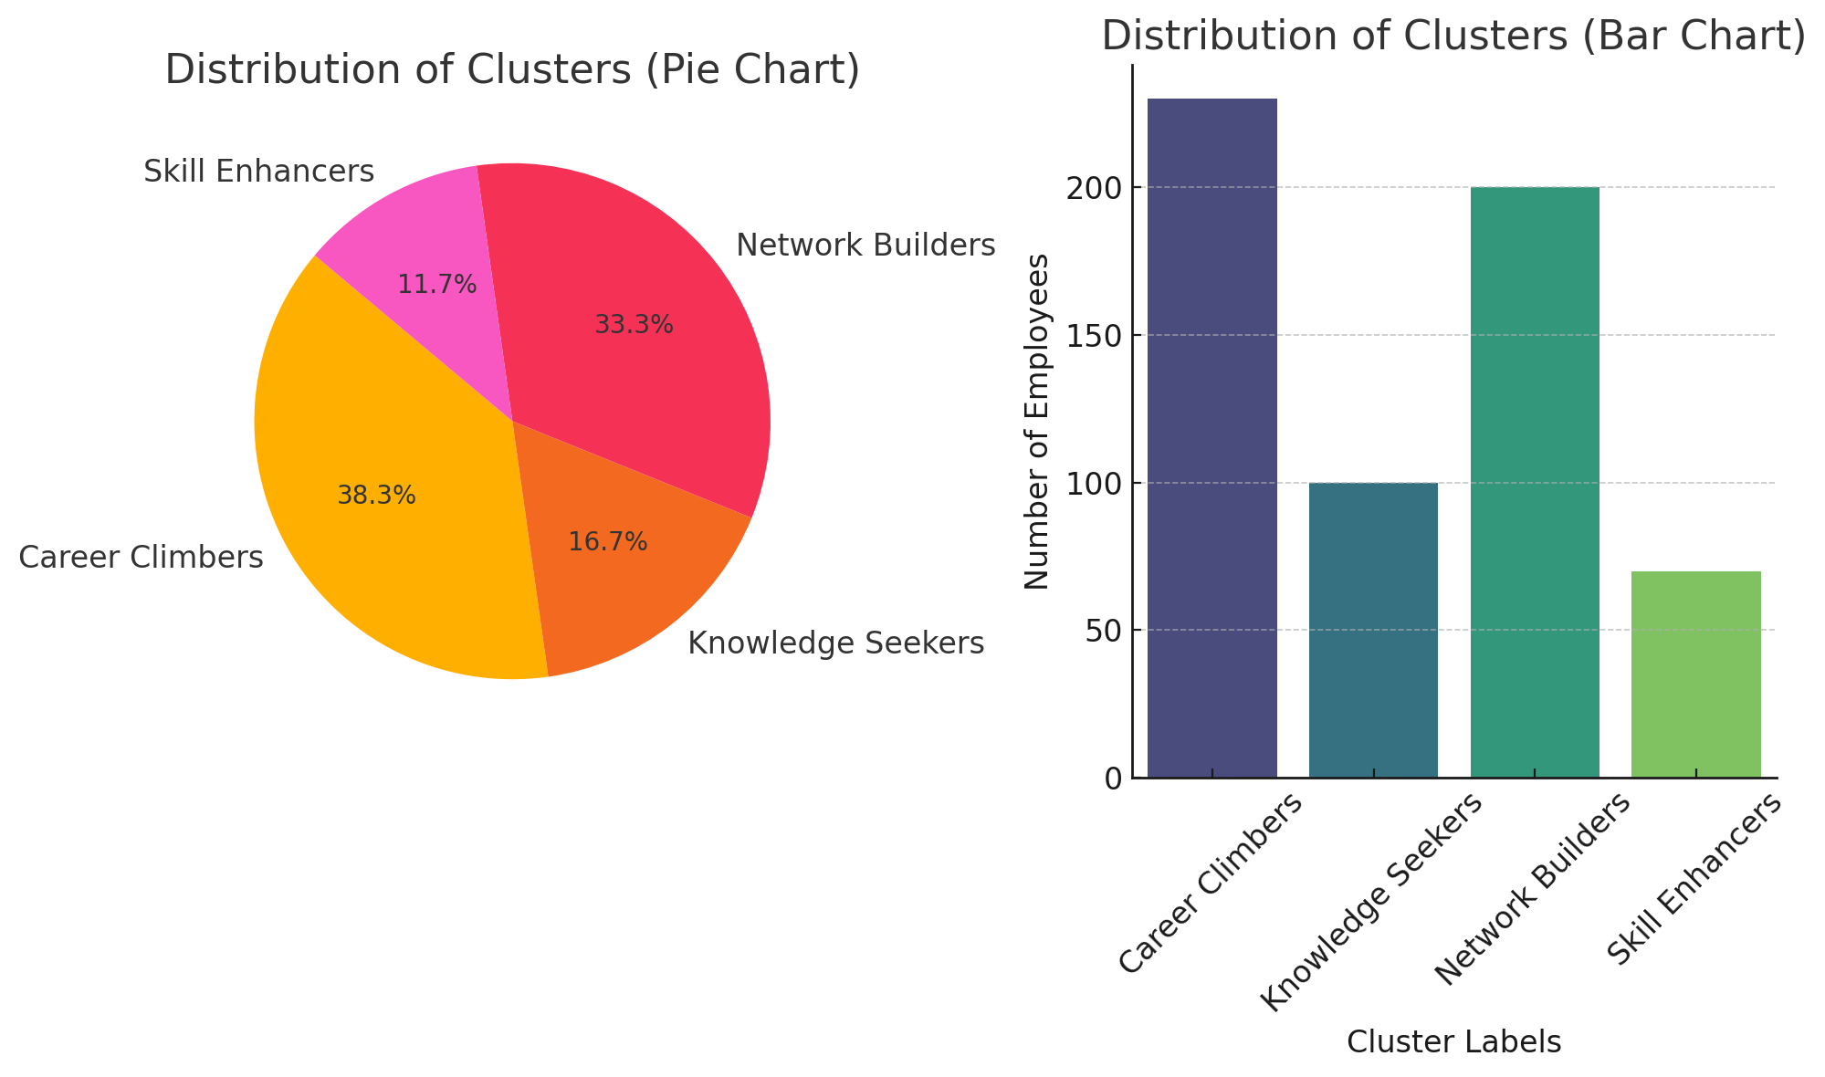

For programs targeting “Career Climbers” could focus on leadership and career growth opportunities, while those for “Knowledge Seekers” could offer advanced skill workshops.

The largest cluster is “Career Climbers”, suggesting a significant focus on career development among the workforce; so, tailoring initiatives like personalized training programs or career development plans may align with employee motivations.

**Location-Specific Findings**

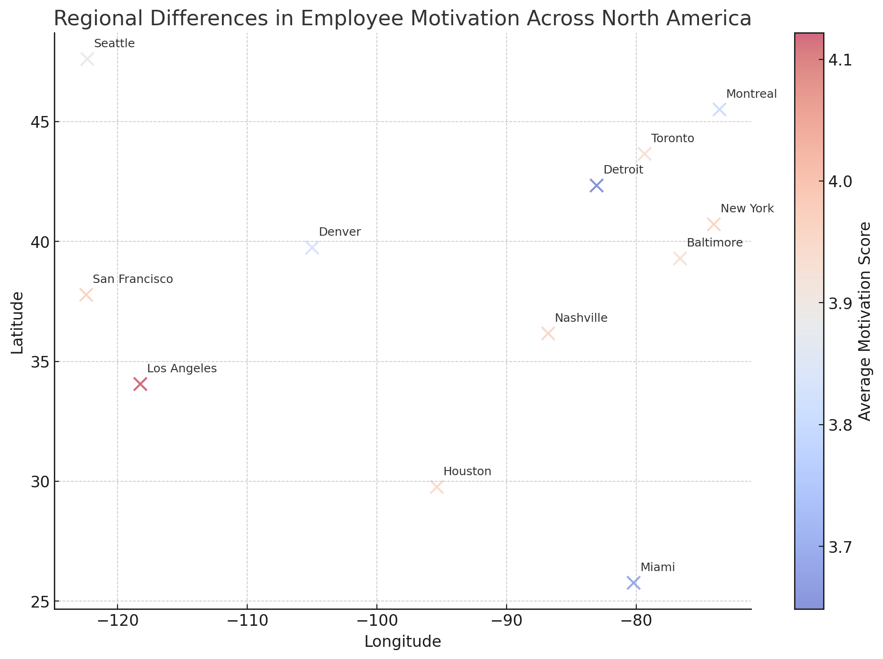

Cities are color-coded based on average motivation scores, ranging from blue (lower motivation) to red (higher motivation). Los Angeles and San Francisco show lower average motivation scores (reddish hues); Denver and Montreal are on the higher end of the motivation scale (blue hues).

There is a visible distinction in motivation levels across different regions, indicating that factors affecting employee motivation may vary significantly by region.

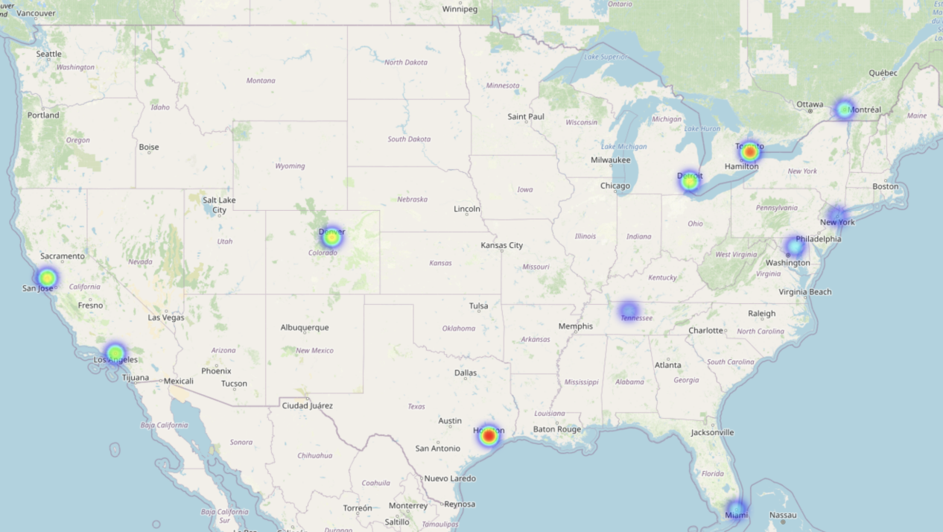

The heatmap over North America illustrating areas with high and low employee motivation densities.

The combination of both graphs helps to identify regional clusters and specific cities where employee motivation differs. Higher motivation levels seem to be concentrated in some northern regions, whereas coastal cities such as Los Angeles show lower motivation levels.

**Key Takeaways:**

Major Employee Motivations: Employees are primarily motivated by professional growth, team collaboration, and work-life balance. Training that enhances job-related skills and provides career advancement opportunities is highly valued.

Regional Engagement Differences: Differences in engagement levels were observed across regions. For example, employees in certain locations were more focused on work-life balance, while others emphasized career development more.

**Recommendations:**

1. Targeted Training Programs: Develop training modules that cater specifically to career advancement and skill development to appeal to employees focused on professional growth.
2. Regional Customization: Customize engagement initiatives based on regional preferences. For example, regions that value work-life balance could benefit from training focused on stress management or flexible work arrangements.
3. Increase Team Collaboration Opportunities: Foster a culture of teamwork through collaborative projects and workshops, as team collaboration was identified as a key motivator.