Ef

Df

|  |  |  |  |
| --- | --- | --- | --- |
|  |  |  | right |
|  |  | center |  |
|  | Middle left |  |
|  |  |  |  |
|  |  | bottom |  |

Dsf

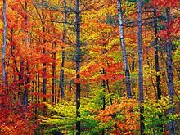

Dsf

Dsfd

[Dsfsdfsdf](http://www.google.fr)

Sd

F

Sdf

Ds

F

Dsfsd dsfds sd sdf sdfds fsd sd fsdfsdf sdf sfefdewdfjewfkjew f wejd wejdf jwedf jwekljdflwejf wjlwerflk weej welkrfj lkwejlf lwejflk wej lkjwelkf jlwkejrflkjwlk fjwelk fjlwkej flkwej flkwejlk fjwelk jflkwejlfk jwelkf jlkwej flkwejf lkjwelk fjlkwejf lkwejf lkjwelkfjlkewj flkewj lkjew

F

Sddfsdf

Sd

F

Sdfsdf

Sdf

Sdfsdf

Sdf

Dsfs

Sdf

sdf

fdf

df

Dsf

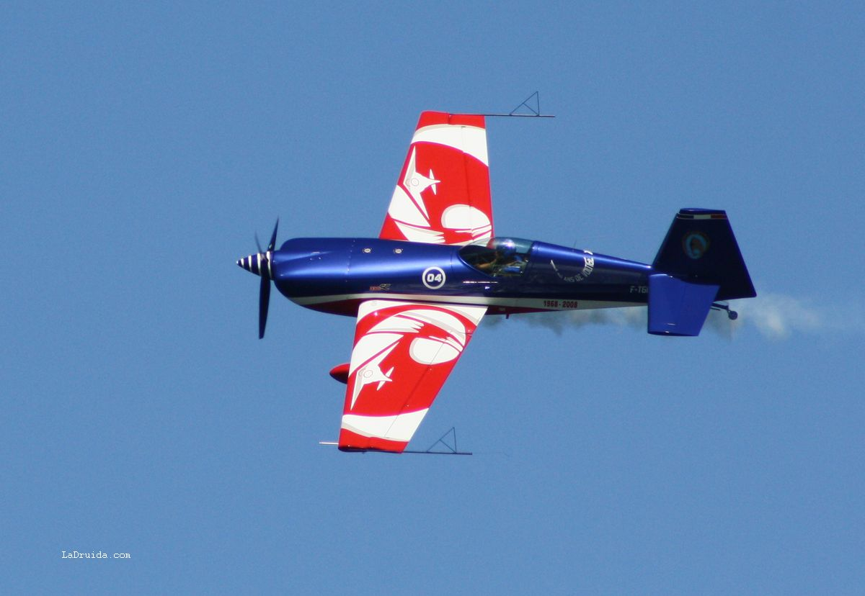Dsfsd dsfds sd sdf sdfds fsd sd fsdfsdf sdf sfefdewdfjewfkjew f wejd wejdf jwedf jwekljdflwejf wjlwerflk weej welkrfj lkwejlf lwejflk wej lkjwelkf jlwkejrflkjwlk

fjwelk fjlwkej flkwej flkwejlk fjwelk jflkwejlfk jwelkf jlkwej flkwejf lkjwelk fjlkwejf lkwejf lkjwelkfjlkewj flkewj lkjew

* Unordered list 1
* Unordered list 2
* Unordered list 3
* Unordered list 4
* Unordered list 5
* Unordered list 6

1. Ordered list 1
2. Ordered list 2
3. Ordered list 3
4. Ordered list 4

Broken list to follow

1. Broken ordered list 1

Some text in between

1. Broken ordered list 2
2. Broken ordered list 3