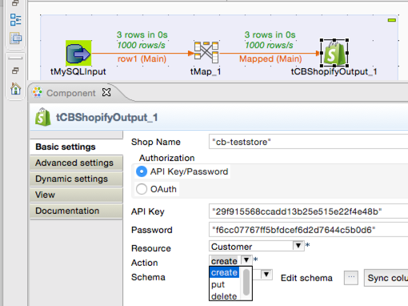

Read conditions & download component here: <http://2cb.li/12-shopify>