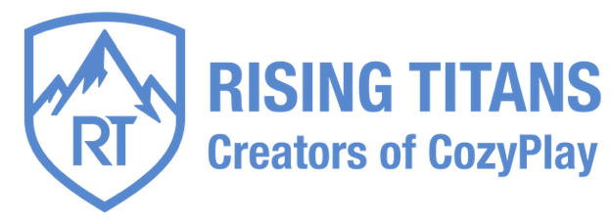

COTTIER Jean-Claude
jcc@risingtitans.co
+33 6 95 32 29 62
LinkedIn

Vision: CozyPlay is the gaming ecosystem built for the 40-80 generation, the largest, wealthiest, and most loyal audience still underserved in video gaming.

$3M Solo. $20 ARPDAU. 0% CAC. The Proof is Already Live.

We've proven the model. Now we're scaling the definitive gaming ecosystem for the underserved, wealthy 40-80 generation.

The Market Blind Spot : A $50B+ Underserved Opportunity
The 40-80 gaming audience is the fastest-growing, wealthiest segment in entertainment, controlling the majority of disposable wealth. They crave accessible, comforting play, yet are ignored by an industry obsessed with Gen Z. This is not a niche, it's a $50B+ global opportunity, left wide open.

De-Risked by Exceptional Bootstrapped Success
Our core technology and games are not a concept. They are a live, profit-generating engine with metrics that defy industry standards.
- Elite Monetization: $3M+ revenue generated solo, bootstrapped, with an astounding $20 Annual Revenue Per Daily Active User—5-10x the industry average for casual games (Ads-Only).
- Proven Loyalty: 50% of our active players have been engaged for over 6 months, a powerful indicator of our games' evergreen appeal.
- Pure Organic Growth: 0% spent on User Acquisition. Proving our core games' exceptional appeal and our unique expertise in organic growth.
- Massive, Untapped Upside: This elite monetization is our baseline. Introducing In-App Purchases and Subscriptions projects a 3-5x increase in user lifetime value (LTV).

Led by a World-Class Architect, Proven Entrepreneur
The vision is executed by a founder with decades of elite-tier experience and a history of building groundbreaking technology from scratch.
- 30+ years' industry experience; U.S. O-1 Visa for Extraordinary Ability.
- Engine Architect for BAFTA award-winning AAA titles.
- Proven Entrepreneur who has founded a successful studio, achieved millions of downloads, and mastered the monetization of this core demographic.
Now building an international, capital-efficient dev team in Cyprus (HQ, IP) and Bangkok, de-risked by an established network and direct access to top talent.

Foundation for Hyper-Growth: Proven IP & Technology
We launch with a monumental head start. The company is built upon its proprietary cross-platform engine and a portfolio of successful, evergreen games. This technology and our deep understanding of this audience position us to become the essential infrastructure for accessible gaming, powering both our own titles and third-party developers.

The Ask: Raising €3 Million to Dominate the Category
Pre-Seed: €3M at €15M Pre-Money
We are raising €3 million to transform a proven, profitable solo venture into the undisputed global home for timeless play. The capital will be strategically deployed to:
- Assemble a world-class, capital-efficient development and marketing team.
- Execute a hyper-growth plan, scaling CozyPlay across all platforms to capture the market.
- Unlock the full monetization potential (IAP/Subs) of our deeply loyal audience.

We have a detailed plan that outlines our clear path to market leadership. The proof is in the data. If building the definitive gaming ecosystem for this demographic is a vision you share, I would be delighted to discuss it further.
Contact: Jean-Claude Cottier at jcc@risingtitans.co

