SIMULACRUM · PRODUCT REQUIREMENTS DOCUMENT
The Calibration Layer
PRD-SIM-CAL-001
Anchoring every simulated outcome to real-world data — shown as a range, with its source and confidence.
Product | Simulacrum (simulacrumai.io)
Owner | Jean M. Delphonse
Version | 1.0 (Draft) · For review
Stack | Flask · SQLAlchemy · MySQL · Claude API · SSE streaming · GoDaddy cPanel / Passenger WSGI
Conventions | 9-character alphanumeric PKs via generate_pk(); all thresholds admin-configurable (never hardcoded); simulation price referenced from Admin → Pricing, never hardcoded.

Contents
1. Summary 2
2. Problem & Strategic Rationale 2
3. Goals & Non-Goals 2
4. Users 2
5. Core Concepts 3
6. Architecture 3
7. Data Model 3
8. Reference Datasets by Layer 4
9. Calibration Methodology 4
10. The Outcome Feedback Loop 4
11. Algorithms to Live By — Explicit Mapping 5
12. UI / UX Specification 5
13. API / Endpoints 7
14. Rollout / Phasing 8
15. Success Metrics 8
16. Risks & Mitigations 8
17. Open Questions 8

1. Summary
The Calibration Layer sits between an agent's raw simulated outcome and what the user sees. It replaces a single model-generated number ($409,104) with an empirically anchored range shown with its source and a confidence tier ($372k–$451k · Moderate · calibrated against BLS OES + Freelance Rate Survey 2025). Over time, a feedback loop lets users report what actually happened, and those real outcomes recalibrate the reference data — a data flywheel available to Simulacrum precisely because it observes individual longitudinal outcomes.
This is a defensibility feature. It converts Simulacrum's core promise — see the consequences before you live them - from a plausible narrative into a checkable forecast, and it is the moat a competitor cannot copy without doing the same data work and owning the same outcome loop.

2. Problem & Strategic Rationale
Today, simulation outcomes are generated by the agent's reasoning. They are internally coherent and useful, but they are not anchored to real-world ground truth, which creates two risks: (a) a credibility ceiling — sophisticated users discount numbers they cannot trace to a source; and (b) an easily-copied product — any team with a good LLM can generate plausible outcomes.
Adjacent platforms have made empirical validation against a transparent, replicable benchmark their central moat. Simulacrum's equivalent, adapted to the individual-career domain, is the Calibration Layer plus the outcome flywheel.

3. Goals & Non-Goals
Goals
- G1. Anchor each agent's key numeric outputs to a credible reference dataset, per layer.
- G2. Present outcomes as ranges with confidence tier and a cited source, not bare point numbers.
- G3. Be honest about uncertainty: thin or proxy data must visibly widen the range and lower the tier.
- G4. Capture real user outcomes and feed them back to improve calibration (the flywheel).
- G5. Keep every threshold admin-configurable; ship the first layer fast (Relaxation — see §14).
Non-Goals
- N1. Not a rewrite of the agents. Calibration wraps their output; it does not replace their reasoning.
- N2. Not financial/legal/tax advice. Calibrated ranges are descriptive benchmarks, not guarantees.
- N3. Not real-time market data feed. Reference data updates on a slow cadence (§8).
- N4. V1 does not calibrate qualitative narrative — only the structured numeric outputs an agent emits.

4. Users
- Simulation user — sees calibrated ranges, sources, and confidence tiers; optionally reports outcomes.
- Skeptical / technical user — opens the methodology drawer to inspect prior → data → posterior.
- Admin — configures datasets, thresholds, tiers, and per-agent calibration in an Admin console.
- The system itself — the nightly recalibration job that consumes outcome reports.

5. Core Concepts
- Raw outcome — the agent's un-calibrated numeric estimate (the prior).
- Reference dataset — an external ground-truth source scoped to a layer (the likelihood).
- Cohort keys — the dimensions that match a user to reference rows (e.g., occupation, metro, seniority).
- Calibrated range — the posterior: low / mid / high (default p10 / p50 / p90, admin-configurable).
- Confidence tier — High / Moderate / Directional, derived from data density and dataset credibility.
- Drift — divergence between reported real outcomes and the current reference distribution; triggers review.

6. Architecture
User inputs ─▶ Agent (Claude API) ─▶ raw outcome ─▶ Calibration Engine ─▶ calibrated result ─▶ UI (SSE)
│ ▲ │
reference lookup │ │ cached posterior "Report outcome"
▼ │ │
Reference Store (MySQL) ◀── nightly recalibration ◀─┘
The Calibration Engine is a Flask service module invoked after the agent emits a structured numeric field. It (1) extracts the numeric field + cohort keys; (2) looks up the matching reference distribution (cached); (3) computes the posterior via Bayesian updating; (4) assigns a confidence tier and attaches the source citation; (5) streams the calibrated result to the UI over the existing SSE channel. Outcome reports are written to outcome_reports; a scheduled job recomputes reference weighting on a cadence gated by an Optimal-Stopping rule (§9, §10).

7. Data Model
All primary keys are CHAR(9) via generate_pk(). All thresholds live in config tables, not code.
reference_datasets
dataset_id (PK) · layer (L1–L5) · name · source · source_url · unit · geography_scope · credibility_tier (A/B/C) · last_refreshed · refresh_cadence_days · is_active
reference_data_points
point_id (PK) · dataset_id (FK) · cohort_json · p10 · p50 · p90 · mean · sample_size · as_of_date
calibration_configs (admin-configurable, per agent)
config_id (PK) · agent_key · layer · dataset_id (FK) · output_field · method (default bayes_precision) · percentiles_json (default [10,50,90]) · min_sample_high · min_sample_moderate · band_floor_pct · drift_threshold_pct · is_enabled
calibration_runs
run_id (PK) · simulation_id (FK) · agent_key · raw_value · cal_low · cal_mid · cal_high · confidence_tier · dataset_id (FK) · method · cohort_json · created_at
outcome_reports (the flywheel)
report_id (PK) · user_id (FK) · simulation_id (FK) · agent_key · reported_value · months_elapsed · cohort_json · is_verified · reported_at
calibration_audit
audit_id (PK) · dataset_id (FK) · drift_pct · n_reports · action (none/flagged/reweighted) · created_at

8. Reference Datasets by Layer
Each layer anchors to sources scoped to its decisions. Sourcing this data is ~80% of the work and the real moat — the engine is easy; credible, well-matched data is not.
Layer | Calibrated fields | Candidate reference sources | Cred.
L1 Active Income | rate, billable-hour realism, income | BLS OES wages (occupation × metro); freelance / consulting rate surveys | A / B
L2 Leveraged | speaking fees, cohort pricing, waitlist→launch conversion | industry fee guides; cohort-course benchmarks | B / C
L3 Productized | opt-in %, sales-page conversion %, refund / churn | published launch & membership benchmarks | B / C
L4 Automated Residual | SEO CTR curves, email open/click, SaaS conversion / churn, ad CPM/CPC | search CTR studies; email & SaaS benchmark reports | B / C
L5 Wealth Deployment | asset-class returns, withdrawal rates, price-to-rent | historical return series; Fed / public market data | A / B

Rule: an output's confidence tier is capped by its dataset's credibility tier — Tier-C data can never render as “High confidence.”

9. Calibration Methodology (Bayesian core)
For a calibrated field the engine computes a posterior by combining the agent's estimate with the reference distribution, precision-weighted:
- Prior = agent raw value with a model-uncertainty spread σ_model (config default).
- Likelihood = reference distribution for the matched cohort (p10/p50/p90 → implied σ_ref).
- Posterior mean = precision-weighted blend (τ_model·raw + τ_ref·p50) / (τ_model + τ_ref), where τ = 1/σ².
- Posterior spread widens as sample_size shrinks (thin data → wide band). Report cal_low / cal_mid / cal_high at the configured percentiles.
Thin-data guard (Overfitting): below min_sample_moderate, the engine refuses to let a sparse reference dominate — it returns the raw value with a widened band and a Directional tier, and the UI says so plainly. Better an honest wide range than a falsely precise narrow one.

10. The Outcome Feedback Loop (flywheel)
After a simulation resolves in the real world, the user can report the actual value. Reports accumulate in outcome_reports. A nightly job:
- Groups verified reports by cohort.
- Compares them to the current reference distribution → computes drift_pct.
- Optimal-Stopping gate: only reweights a cohort once it has ≥ min_reports_to_reweight (config) — don't chase noise from the first few reports.
- If drift exceeds drift_threshold_pct, flags the dataset for review and (optionally) blends reports into an adjusted reference distribution.
This loop is Simulacrum's structural advantage: it observes individual longitudinal outcomes that population-level competitors do not see.

11. Algorithms to Live By — Explicit Mapping
- Bayesian Updating — the calibration itself: prior (agent) updated by likelihood (reference) → posterior (range).
- Overfitting — thin/mismatched data must widen bands and drop to Directional; never over-fit to a sparse source.
- Optimal Stopping (37%) — the recalibration gate: sample enough outcome reports before trusting a reweight; and a stopping rule for how long to hunt for a better dataset before shipping.
- Explore vs. Exploit — dataset investment: exploit known-good Tier-A sources for hub agents; explore new sources for the long tail.
- Caching — reference lookups and posteriors are memoized per (agent_key, cohort_hash); reference data changes slowly, so cache aggressively and invalidate on refresh.
- Scheduling (shortest-job-first, weighted) — calibrate the highest-impact hub agents first: the Rate Card (L1) is the root every other agent references, so it is calibrated before anything else.
- Relaxation — ship Layer 1 calibration alone as a good-enough proof before all five layers; a shipped approximation beats a perfect launch that never arrives.

12. UI / UX Specification
The interactive mockup ships alongside this PRD as calibration_ui_mockup.html (Midnight Gold theme). The figure below shows the calibrated result card in its High- and Moderate-confidence states with the methodology drawer open.
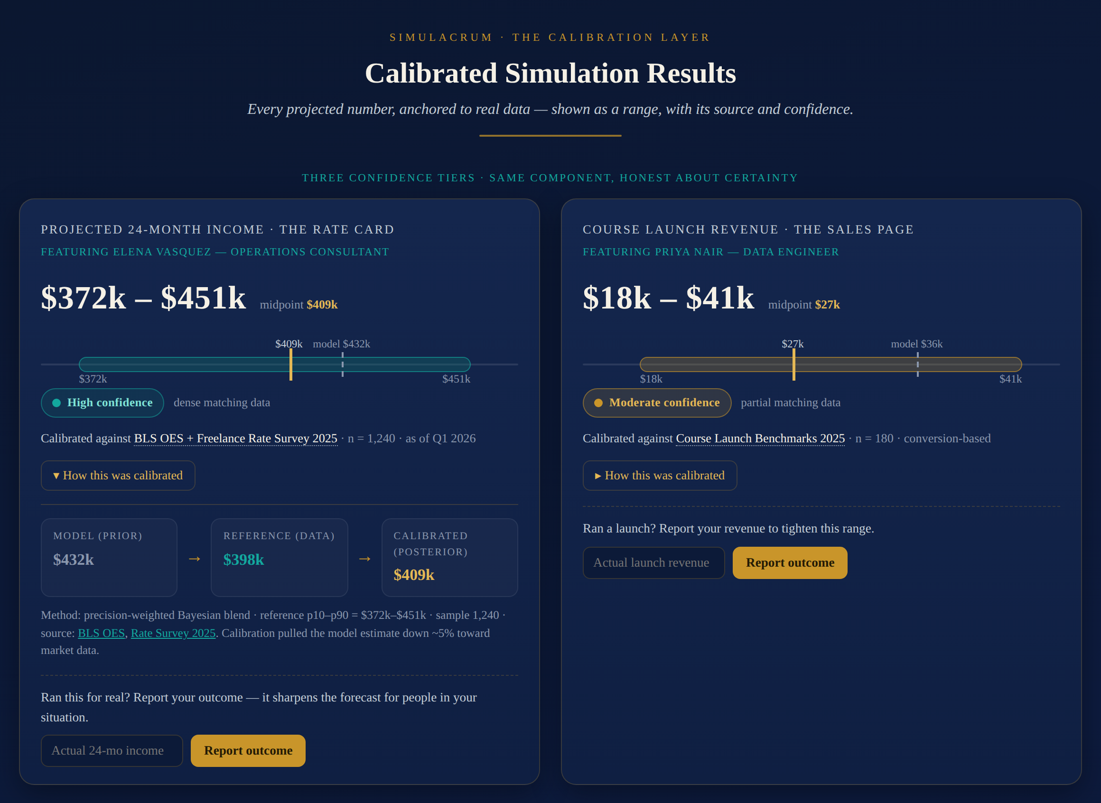
Figure 1 — Calibrated result cards (High and Moderate tiers), methodology drawer expanded.

12.1 Design principles
- Range, not point. Never show a lone number for a calibrated field — always low–high with the mid marked.
- Glanceable truth. A user grasps “how confident, anchored to what” in under two seconds via the tier chip and one-line source.
- Cite the source, always. Every calibrated value carries a visible “calibrated against …” line. Transparency is the trust moat.
- Honest about uncertainty. Low confidence is shown, not hidden — a wide amber band reads as more trustworthy, because it is not pretending.
- Progressive disclosure. The card is simple by default; the methodology (prior → data → posterior) lives in an optional drawer.

12.2 The Calibrated Result Card (anatomy)
Top-to-bottom: field label; headline range (large, with the midpoint marked); confidence band; tier chip; source line with an info affordance; a “How this was calibrated” drawer toggle; and an outcome-report affordance.

12.3 Confidence band
A horizontal bar: the shaded region is low→high (p10–p90) in the tier color; a solid gold tick marks the calibrated midpoint; a dashed tick marks the raw model estimate so the user sees how far calibration moved it. Endpoint labels for low and high. A wider band literally looks less certain.

12.4 Confidence tier chip
- High (teal) — dense, Tier-A/B data. “High confidence · dense matching data.”
- Moderate (gold) — some data, wider band. “Moderate · partial matching data.”
- Directional (amber) — thin/proxy data. “Directional only — treat as a signal, not a forecast.” The chip is tappable and explains what would raise the tier.

12.5 Methodology drawer
Collapsed by default. Expanded, it shows a three-step visual — Model estimate (prior) → Reference data (likelihood) → Calibrated range (posterior) — with the three numbers, sample size, dataset name + link, method, and the data's as-of date. This is where a skeptical user is converted.

12.6 Directional / low-data state
Thin data must look different, not just read differently: a visibly wider amber band, an inline note (“we don't yet have strong data for your exact situation, so this is directional — reporting your real outcome later will sharpen it”), and the proxy dataset named in the drawer.

12.7 Outcome-reporting widget (flywheel)
A one-field, low-friction form on any resolved simulation (“Ran this for real? Report your outcome”). On submit, a warm confirmation frames the contribution. Reported values are private by default; only aggregated, de-identified distributions influence reference data.

12.8 Admin calibration console
Midnight-Gold admin surface with a Datasets tab (CRUD, upload/refresh, credibility tier, cadence), per-agent config (bind output_field to a dataset; set percentiles, min_sample_*, band_floor_pct, drift_threshold_pct, enable toggle), and a Drift monitor with one-click reweight/flag. If calibration is offered as a gated capability, the gate references the simulation price configured in Admin → Pricing; no price is hardcoded here.

12.9 Responsive, accessibility & streaming states
- Mobile: the card stacks (range → full-width band → chip + source → drawer); the band keeps a legible min-width.
- Accessibility: tier is never color-only (label + icon); band ticks carry ARIA value labels; WCAG-AA contrast on navy.
- SSE: a skeleton range + “calibrating…” shimmer while streaming; the band animates from the raw tick to the calibrated range so the anchoring is visible; graceful degrade to the raw value on failure.

13. API / Endpoints (Flask)
- POST /api/simulate — existing; each numeric field now returns a calibration object {raw, low, mid, high, tier, dataset, method, cohort} when a config exists.
- GET /api/calibration/:run_id — fetch stored calibration detail for the drawer.
- POST /api/outcomes — submit an outcome report.
- Admin: /admin/api/datasets · /configs · /drift — dataset & config CRUD and drift review.
- All numeric responses stream over the existing SSE channel; the calibration object is emitted as a trailing event per field.

14. Rollout / Phasing
- Phase 0 — Proof (Relaxation): calibrate only the Rate Card (L1) against BLS OES + one rate survey; full UI on that one field. Ship, measure trust lift.
- Phase 1 — Layer 1 complete: all 11 L1 agents; admin console v1; caching.
- Phase 2 — Layers 5 and 3: strong public data (L5) and high commercial value (L3) next, scheduled shortest-job-first by data availability × impact.
- Phase 3 — Layers 2 & 4 + flywheel: remaining layers; enable outcome reporting and the nightly recalibration job.
- Phase 4 — Drift-driven reweighting: activate report-based reweighting once volume clears the Optimal-Stopping gate.

15. Success Metrics
- Trust: % of simulations where the user opens the source/methodology; self-reported confidence lift.
- Coverage: % of numeric fields with an active calibration config; % rendered High/Moderate vs Directional.
- Flywheel: outcome-report submission rate; # cohorts clearing the reweight gate; measured drift trend.
- Business: conversion/retention delta for users who see calibrated vs raw outputs.

16. Risks & Mitigations
- R1 — Bad/mismatched data is worse than none. → credibility-tier caps; Directional default; conservative sourcing; drawer transparency.
- R2 — Data sourcing is the real cost. → phase by data availability; start with free, defensible Tier-A sources (BLS, Fed).
- R3 — False precision / liability. → ranges not points; explicit “not advice” microcopy; L5 always routes to “execute with a professional.”
- R4 — Cold-start (no reports). → calibration works day one on reference data alone; the flywheel is additive, not required.
- R5 — Cache staleness. → per-dataset refresh cadence; invalidate on refresh; as_of_date shown in the drawer.

17. Open Questions
- Is calibration a free trust feature for all simulations, or a gated capability? (If gated, it references the Admin → Pricing simulation price — decision pending.)
- Minimum credible sourcing for L2 (speaking fees) and long-tail L4 metrics — buy, scrape-with-permission, or partner?
- Do we surface a single blended tier per simulation, or per-field tiers only? (V1: per-field.)
Applies the standing Simulacrum conventions: Algorithms to Live By lenses (§11), admin-configurable thresholds, 9-char alphanumeric PKs, Midnight Gold theme, SSE streaming, and no hardcoded simulation price.

