Project Online → Planner Premium
Migration Tool
User Manual
A step-by-step guide for the migration consultant

Version 1.0
May 2026
For consultants performing Project Online → Project for the Web migrations

Contents
- 1. About this document
- 2. Before you start
- 3. Application overview
- 4. The five wizard steps
- 4.1 Step 1 — Configure & Fetch
- 4.2 Step 2 — Field Mapping
- 4.3 Step 3 — Create Columns / Validate Schema
- 4.4 Step 4 — Import Data
- 4.5 Step 5 — Validation Report
- 5. Working with the Excel template
- 6. Troubleshooting
- 7. Reference — terminology and field types

1. About this document
This manual is written for the consultant who runs an actual migration from Microsoft Project Online to Planner Premium (Project for the Web in Dataverse). It walks through every screen of the wizard, explains every decision that has to be made, and gives ready-made answers to the most common questions and error messages.
You do not need to be a developer to use this tool, but you do need to understand the source and target environments well enough to make the right choices in Step 1 and Step 2. If you are unsure about any concept — migration mode, data source, custom field, lookup table — start with section 7 (Reference) and come back to the step you were on.

Conventions used in this manual
- Italic is used for screen titles, button labels, and field names.
- Monospace is used for filenames, URLs, technical identifiers, and code/API names.
- Screenshots show the app in real situations; your data and number of records will be different.
- "Click" and "tap" are used interchangeably depending on whether you use a mouse or a touchscreen.

2. Before you start
Before opening the migration tool, make sure the following items are in place. Spending ten minutes on this checklist will save hours of back-and-forth later.

Source environment
- Project Online (PWA) URL in the form https://your-tenant.sharepoint.com/sites/pwa — you need read access to the Project Online instance from the same browser session you will use for the migration.
- Or — a filled Excel template if you are not migrating from a live PWA. The template can be downloaded from the app itself in Step 1.
- Knowledge of which Project Online custom fields, lookup tables, and project owners need to make it to the target.

Target environment
- The Dataverse organization URL of the target environment (e.g. https://contoso.crm4.dynamics.com). This is the same URL you use to open the Power Platform admin center for that environment.
- A target unmanaged solution in the target Dataverse environment. The solution publisher prefix (cr123_, exp_, etc.) is used as the prefix for every column the tool creates. If no suitable solution exists yet, ask a Power Platform admin to create one before starting.
- Project for the Web must be enabled in the target environment. The migration tool relies on the standard msdyn_project, msdyn_projecttask, and msdyn_projectteam tables.
- Sufficient privileges. You need to be able to read solution metadata, create columns, create global option sets, create lookup entities (in schema modes), and write to project / task / team-member tables. A System Customizer + a project user role is usually enough.

Browser and session
- Use a modern Chromium-based browser (Edge, Chrome).
- Use the same browser tab for the duration of a migration run — closing the tab during import will cancel work in progress.
- Keep the device awake. The wizard does not migrate in the background after a sleep.
Important — A migration run is not reversible by the tool. The Import step rebuilds schedules — existing tasks, dependencies, and assignments on selected target projects are cleared first. Always test in a non-production environment before running against production data.

3. Application overview
The migration tool is a single-page wizard with five sequential steps. You move forward by completing the current step; you can go back at any time without losing earlier work, except for an import in progress, which can be stopped but not undone.

The five steps at a glance
Step | What you do | What the app does
1. Configure & Fetch | Pick the mode, source, and target. | Reads custom fields, lookup tables, and (if applicable) data from the source.
2. Field Mapping | Match Project Online fields to Dataverse columns. | Suggests target column types and shows which fields are still unmapped.
3. Create Columns | Confirm creation of columns and option sets. | Creates global option sets, custom columns, and (schema-only mode) lookup entities and entries.
4. Import Data | Select which projects to migrate and start the import. | Imports resources, projects, team members, tasks, dependencies, and assignments in batches.
5. Validation Report | Review what succeeded, what was skipped, and export reports. | Aggregates per-entity counts, lists errors and skipped values, generates CSVs.

The three migration modes
The mode you pick in Step 1 determines what the wizard does in Step 3 and Step 4. Read this table carefully — choosing the wrong mode is the most common source of confusion in the field.
Mode | What it creates in Dataverse | What it migrates | When to use
Full migration | Missing columns, option sets, and tracking metadata. | Selected projects and related records. | Building a new migration target from scratch.
Data only | Nothing — reuses what is there. | Selected projects and related records into an existing schema. | Running data into a target that has already been prepared (second PWA, production after test, customer-prepared schema).
Schema only | Columns, option sets, custom lookup entities, and lookup entries. | No project, task, resource, or assignment data. | Preparing a target environment before someone else does the data import.

The two data sources
Source | When to use | How it works
Project Online (PWA URL) | You have direct access to a live Project Online tenant. | The app reads projects, tasks, resources, assignments, custom fields, and lookup tables over the SharePoint OData APIs.
Upload File (Excel/CSV) | You do not have direct access to the PWA, or you want to clean / curate data before migrating. | You download an Excel template, fill it in, and upload it. The rest of the wizard behaves identically.

Header bar — always available
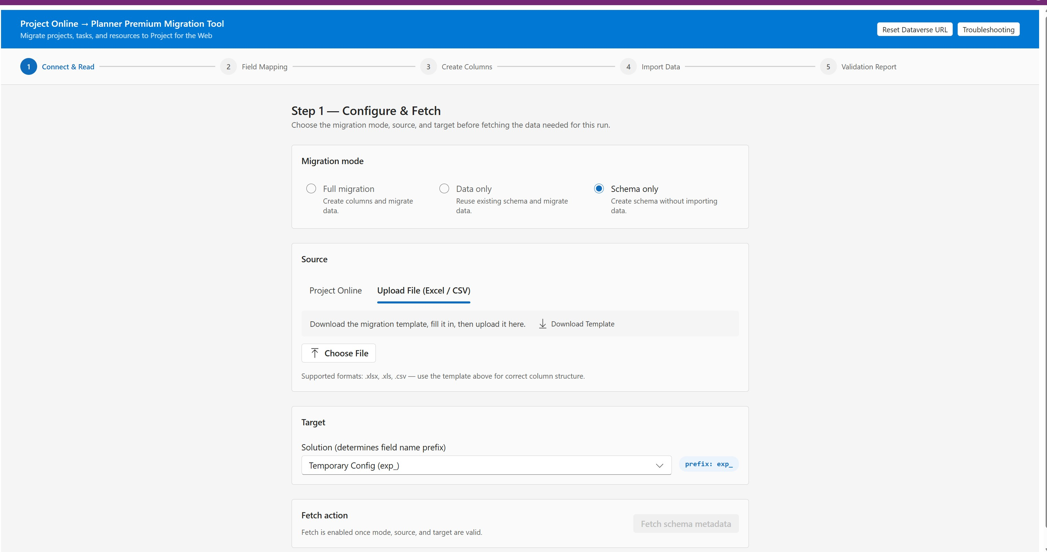
Figure 3.1 — The wizard header with step indicator and global actions
The blue header bar at the top of the screen contains two utility buttons that are always available, regardless of which step you are on:
- Reset Dataverse URL — clears the manually entered Dataverse organization URL and reloads the app. Use this if you connected to the wrong environment and want to start over with a different URL.
- Troubleshooting — opens a hidden diagnostic page that inspects column metadata in the target environment. This is mainly useful for troubleshooting field-mapping problems (see section 6).

4. The five wizard steps

4.1 Step 1 — Configure & Fetch
Step 1 is the most important step in the whole wizard. Every choice here cascades through the other four steps, so take your time.

4.1.1 Connecting to Dataverse (first launch)
The very first time you open the app, you will see a "Configure Dataverse Environment" dialog. The app needs to know the URL of the target Dataverse organization before anything else can happen.
- Paste the full target Dataverse organization URL (for example https://contoso.crm4.dynamics.com) into the field.
- Click Validate & Continue.
- The app stores the URL for this browser only. If you switch browsers or clear site data, you will need to enter it again.
Note — If you make a typo or want to switch to a different environment later, click "Reset Dataverse URL" in the header bar at the top of the wizard.

4.1.2 Choosing the migration mode

Figure 4.1 — Step 1 with Schema only selected
Three radio buttons at the top of Step 1 represent the migration modes. Pick one before you do anything else.
- Full migration — for a fresh target that has no migration columns yet. The wizard will create both schema and data.
- Data only — for a target where columns and option sets already exist. The wizard will reuse them. After you pick this mode, the app will scan the target schema during the fetch.
- Schema only — for preparing a target. The wizard will create columns, option sets, and custom lookup entities, but will not import any project data.
Heads up — Switching mode after fetching data will reset the wizard. The app warns you before this happens.

4.1.3 Setting the migration scope (data and schema-only modes)
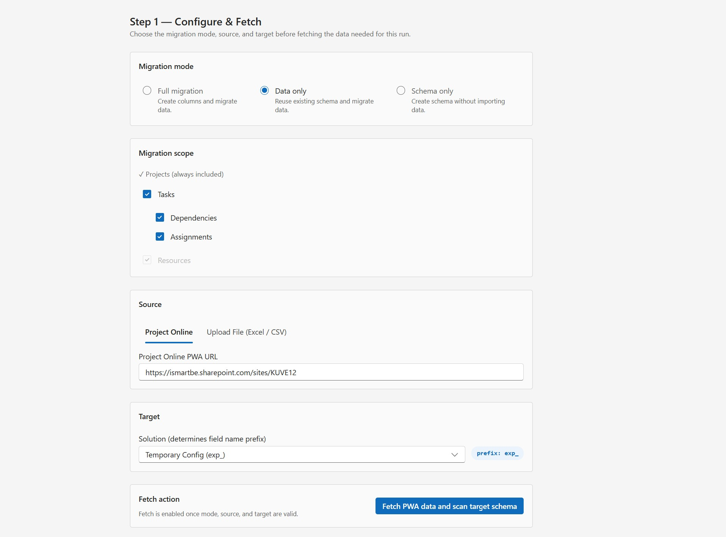
Figure 4.2 — Step 1 in Data only mode with migration scope visible
When the mode is Full or Data only, you will see a Migration scope panel with four checkboxes:
- Tasks — enables the import of project tasks.
- Dependencies — predecessor/successor links between tasks. Greyed out unless Tasks is checked.
- Assignments — who works on which task. Greyed out unless Tasks is checked.
- Resources — project team members (always included when needed for assignments).
Projects are always included — they are the unit of migration. Unchecking Tasks effectively turns the run into a project-metadata-only migration.

4.1.4 Selecting the data source
A tab control lets you choose between Project Online (live PWA URL) and Upload File (Excel/CSV).

Project Online source
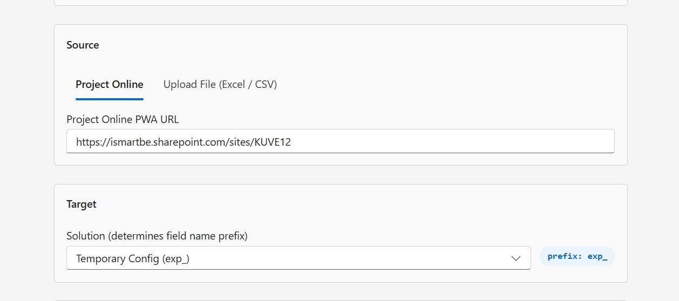
Figure 4.3 — Project Online source with PWA URL field
- Enter the PWA URL, e.g. https://contoso.sharepoint.com/sites/pwa. Use the URL exactly as it appears in your browser when you open the PWA homepage — without trailing slashes or query parameters.
- Make sure you are signed in to SharePoint / Microsoft 365 in this browser. The app uses your existing session; there is no separate login.

Upload File source
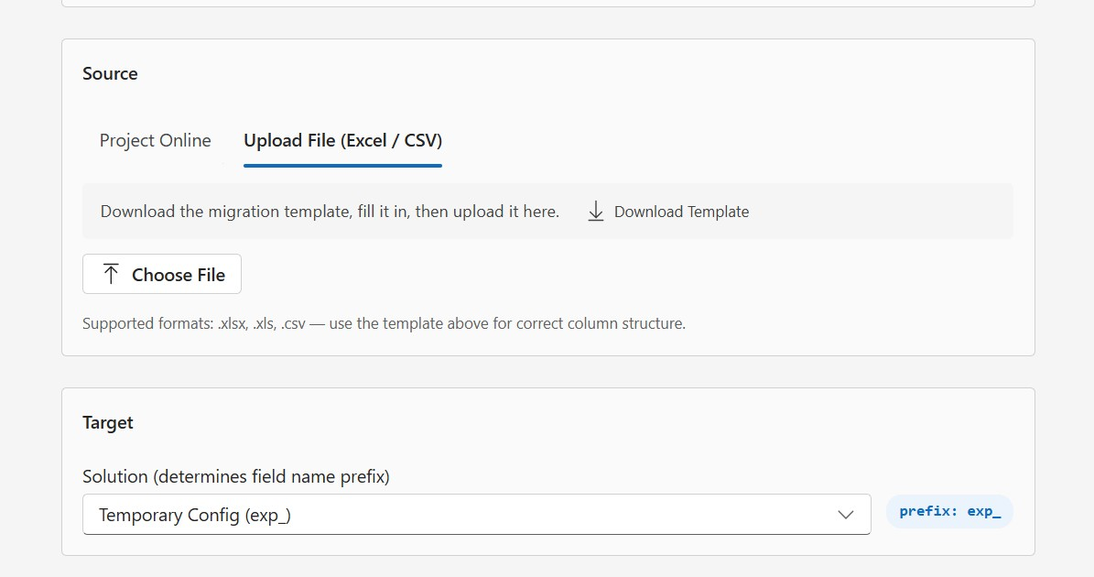
Figure 4.4 — Upload File source (empty state)
- Click Download Template. The app generates an empty Excel template tailored to the current app version.
- Open the downloaded file and fill in the data on the appropriate sheets (Projects, Tasks, Resources, etc.). See section 5 for details on each sheet.
- Save the workbook.
- Back in the app, click Choose File and select the saved template. The filename is shown next to the button as confirmation.
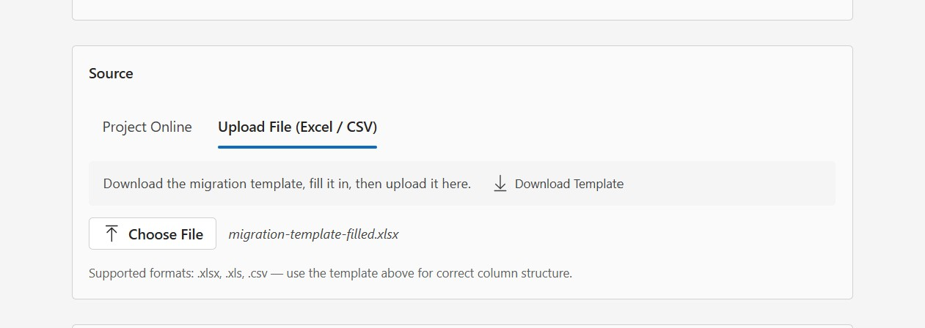
Figure 4.5 — Upload File source after a file has been selected

4.1.5 Selecting the target solution
The Target section contains a single dropdown listing unmanaged solutions in the target environment. The publisher prefix of the selected solution (shown as a chip next to the dropdown) becomes the prefix on every column the tool creates.
Heads up — Picking the wrong solution at this stage means columns will be created with the wrong prefix and will end up in the wrong logical container. Check with the customer or admin which solution to target before you continue.

4.1.6 Fetching the data
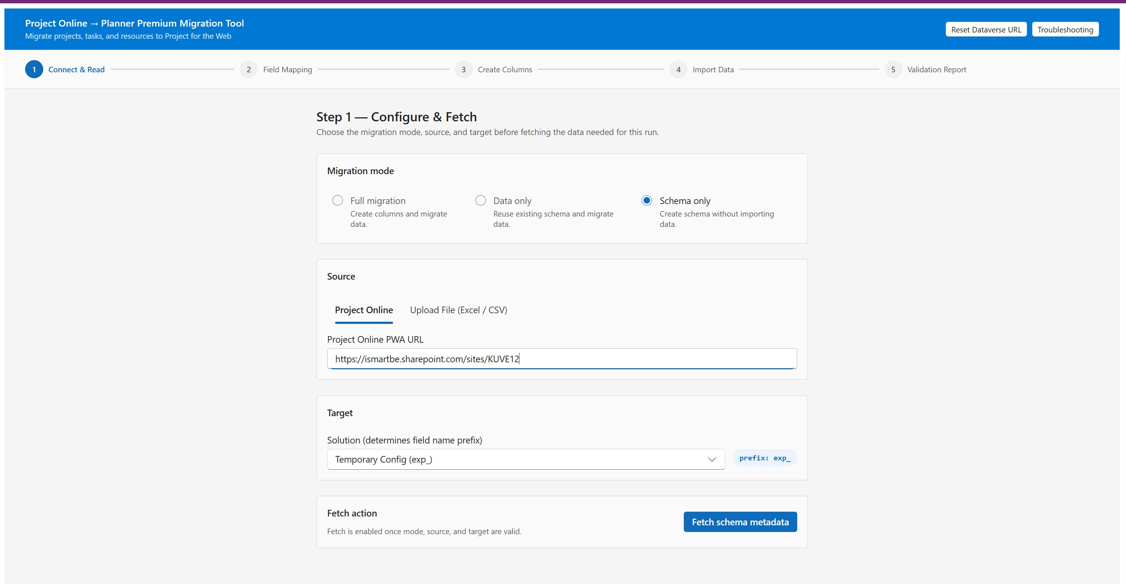
Figure 4.6 — Step 1 ready to fetch, with mode, source, and target configured
Once mode, source, and target are valid, the Fetch action button at the bottom becomes enabled. The button label adapts to the chosen mode:
- Fetch PWA data (Full mode + Project Online source)
- Fetch PWA data and scan target schema (Data only mode + Project Online source)
- Fetch schema metadata (Schema only mode — only custom fields and lookup tables are needed)
- Load file (when using the upload source)
While the fetch is running, a progress panel shows each entity being read:
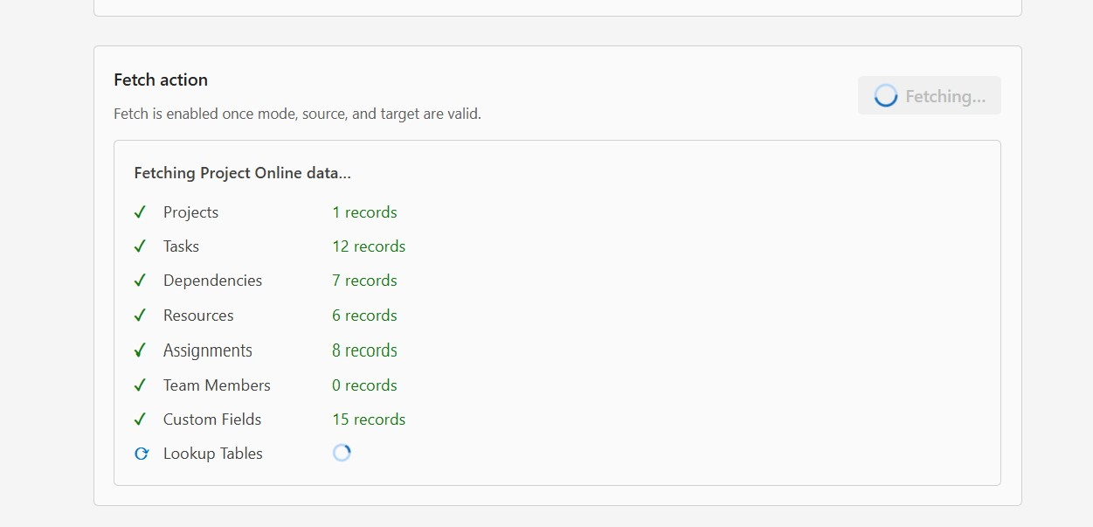
Figure 4.7 — Fetch in progress
When fetching completes, a row of summary tiles shows what was found:
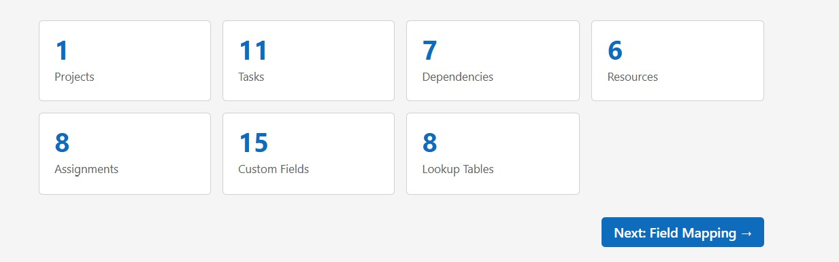
Figure 4.8 — Fetch result tiles. Click Next: Field Mapping to continue.
Note — If the fetch fails on a network error or authentication error, check that the PWA URL is correct, that you are signed in to SharePoint in this browser, and that you have permission to read Project Online data. See section 6 for common error messages.

4.2 Step 2 — Field Mapping
Step 2 is where you decide what each Project Online custom field becomes in Dataverse. The app auto-detects sensible column types — your job is to review the suggestions, override where needed, and confirm.

4.2.1 The mapping table
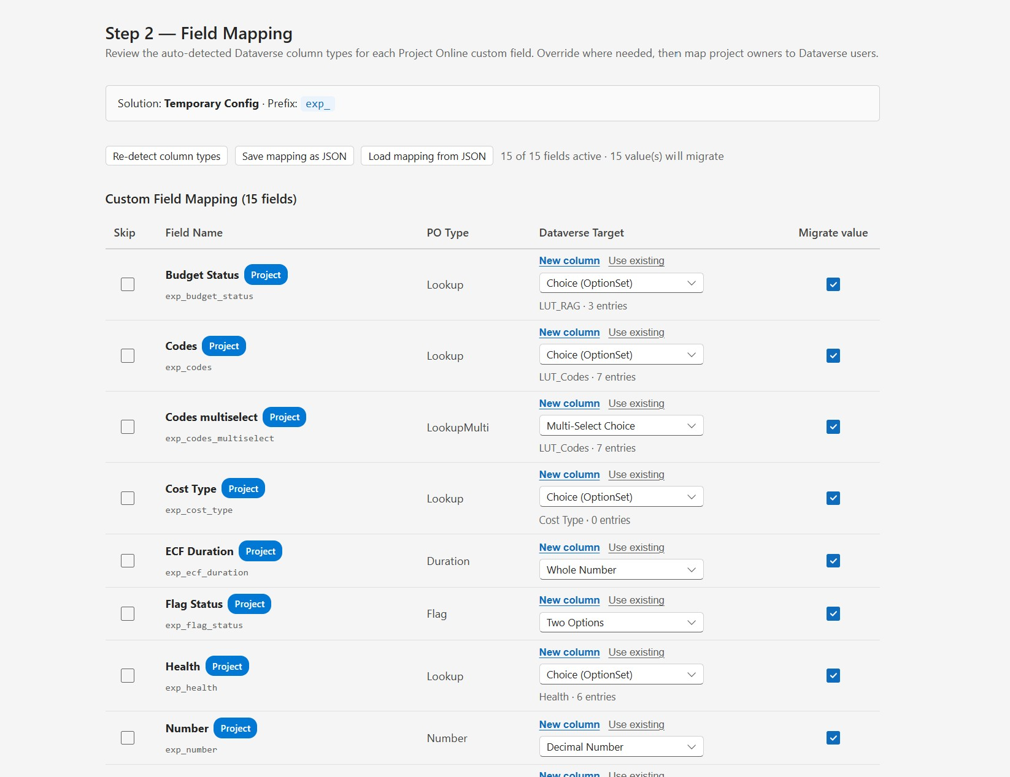
Figure 4.9 — Step 2 mapping table in Full migration mode
Each row in the table represents a Project Online custom field. The columns are:
- Skip — checkbox. When checked, this field is excluded from the migration entirely.
- Field Name — the Project Online display name and the entity tag (Project / Task / Resource).
- PO Type — the type of the field in Project Online (Text, Number, Date, Cost, Duration, Flag, Lookup, LookupMulti, etc.).
- Dataverse Target — either New column (the tool will create one) or Use existing (you pick a column that is already there).
- Migrate value — checkbox. Unchecking this in Data only mode skips data migration for the value while keeping the column.

4.2.2 New column vs Use existing
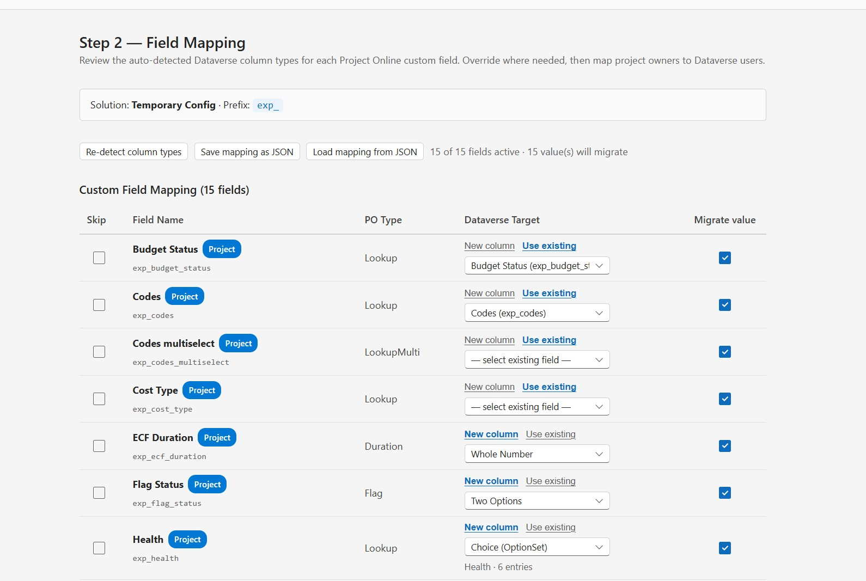
Figure 4.10 — Switching between New column and Use existing
For every field you can choose:
- New column — select the column type from the dropdown (Single Line of Text, Multiple Lines of Text, Choice (OptionSet), Multi-Select Choice, Whole Number, Decimal Number, Date Only, Two Options, etc.). The tool will create the column in Step 3.
- Use existing — pick a column that already exists in the target solution. Useful when columns are pre-created or when you want to reuse a standard Dataverse field.
In Data only mode, every field defaults to Use existing — that mode does not create columns.

4.2.3 Reading the status indicators (Data only mode)
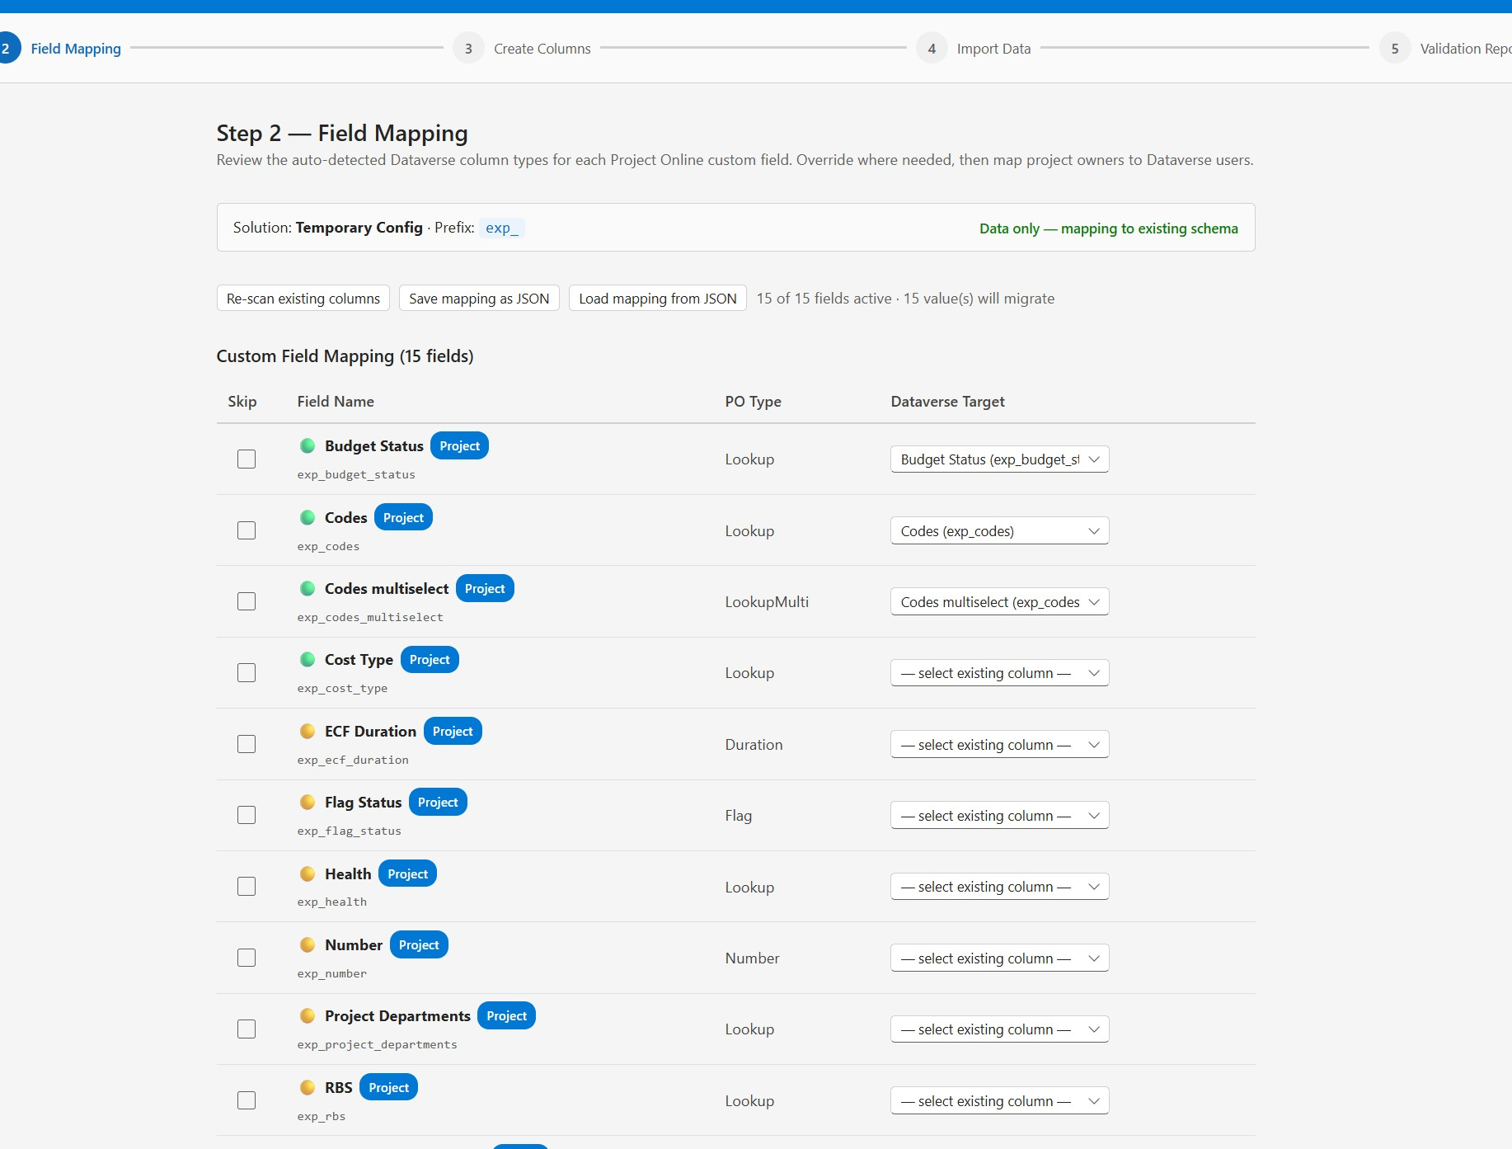
Figure 4.11 — Step 2 in Data only mode with colored indicators
In Data only mode, a small colored dot next to each field name tells you the resolver status:
- Green — the field is mapped to an existing column and all its option-set or lookup values can be resolved.
- Amber — the field is not yet mapped, or some option-set / lookup values cannot be resolved and will be skipped during import.
- Red — the field is mapped but the target column has a type mismatch that the resolver cannot bridge.

4.2.4 Skipping fields you do not need
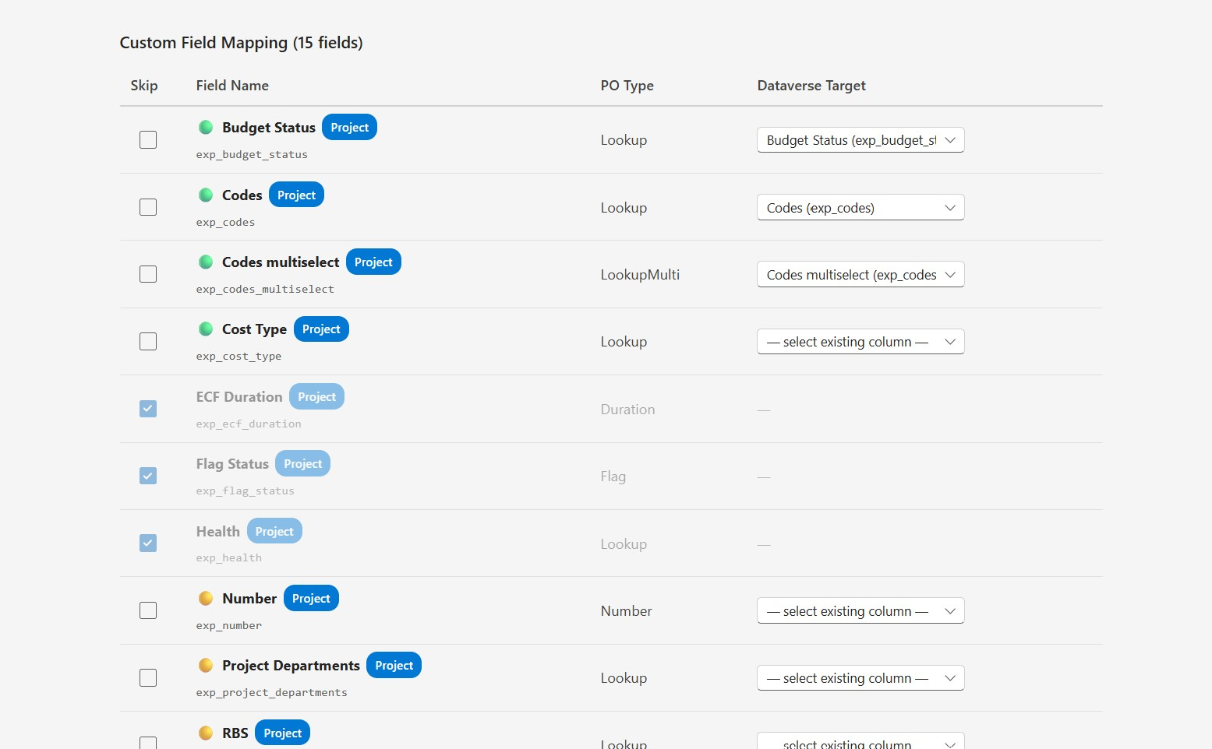
Figure 4.12 — Three fields skipped (greyed out)
Tick the Skip checkbox to exclude a field from the migration. The row greys out and the dropdown becomes inactive. This is useful for:
- Fields that no longer apply in the new environment.
- Fields the customer has explicitly asked to drop.
- Fields whose values are messy and would do more harm than good if migrated.

4.2.5 The unmapped fields warning
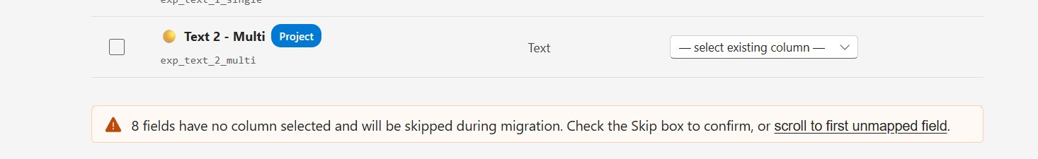
Figure 4.13 — Warning at the bottom of Step 2
At the bottom of the table, a yellow warning bar tells you how many fields are still unmapped. You can either:
- Click "scroll to first unmapped field" to jump to the next problem row, or
- Tick the Skip checkbox on any field you do not need, which removes it from the unmapped count.
The Next button stays enabled even with unmapped fields, but those values will be silently dropped if you continue. The warning exists so you cannot do this by accident.

4.2.6 Save and load mapping (JSON)
Above the table you will find three utility buttons:
- Re-detect column types (Full / Schema-only) or Re-scan existing columns (Data only) — runs the auto-detection again. Use this if you imported a new mapping from JSON and want to overwrite manual edits.
- Save mapping as JSON — downloads a JSON file with the current mapping configuration. Save this between sessions or share it with a colleague.
- Load mapping from JSON — uploads a previously saved JSON file. The app applies the mapping where the field names still match the current source.
Tip — Saving the mapping is recommended on any non-trivial migration. If something goes wrong later and you need to re-fetch, you can restore the mapping in one click instead of redoing the work.

4.3 Step 3 — Create Columns / Validate Schema
Step 3 takes the mapping decisions from Step 2 and either creates the columns in Dataverse or validates that they already exist, depending on the mode.

4.3.1 Step 3 in Full or Schema-only mode
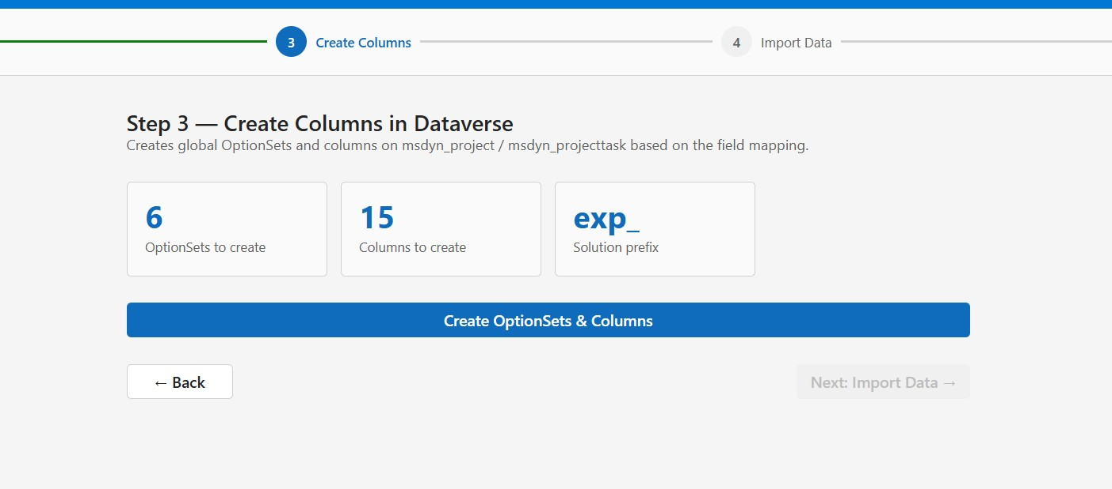
Figure 4.14 — Step 3 before creation, in Full mode
The page shows three summary tiles:
- Number of OptionSets to create.
- Number of Columns to create.
- The solution prefix that will be applied.
Click Create OptionSets & Columns. Progress streams into a log panel that records each item as it is created, skipped, or fails.
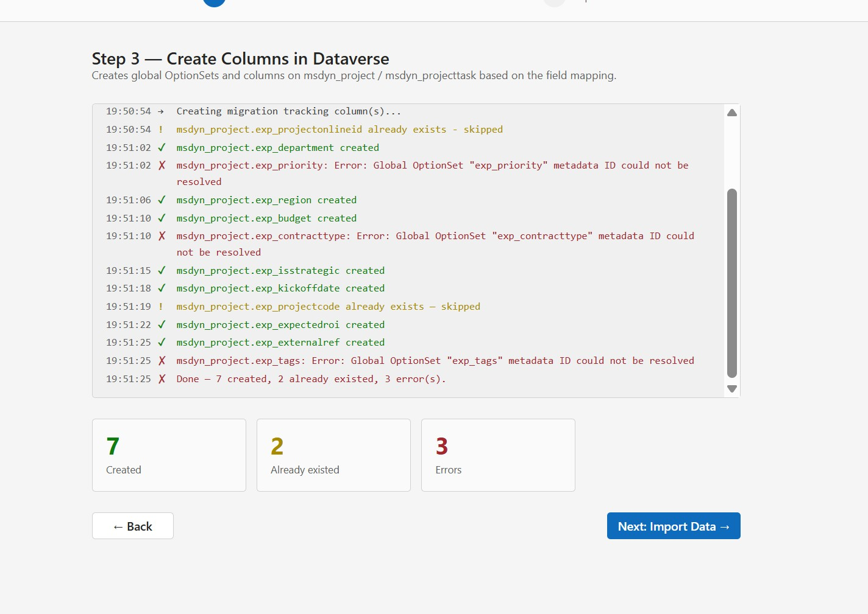
Figure 4.15 — Step 3 creation log with successes, skips, and errors
Three indicators at the bottom of the log summarize the result:
- Created — columns or option sets that the tool successfully added.
- Already existed — items that were already in the solution. The tool reuses them rather than failing.
- Errors — items that could not be created. Common causes include locked option sets, schema name collisions, or temporary Dataverse errors. See section 6 for guidance.
Tip — Step 3 is safe to re-run. The tool detects existing columns and option sets and treats them as "already existed", so a re-run after fixing an error will pick up where the previous run failed.

4.3.2 Step 3 in Data only mode
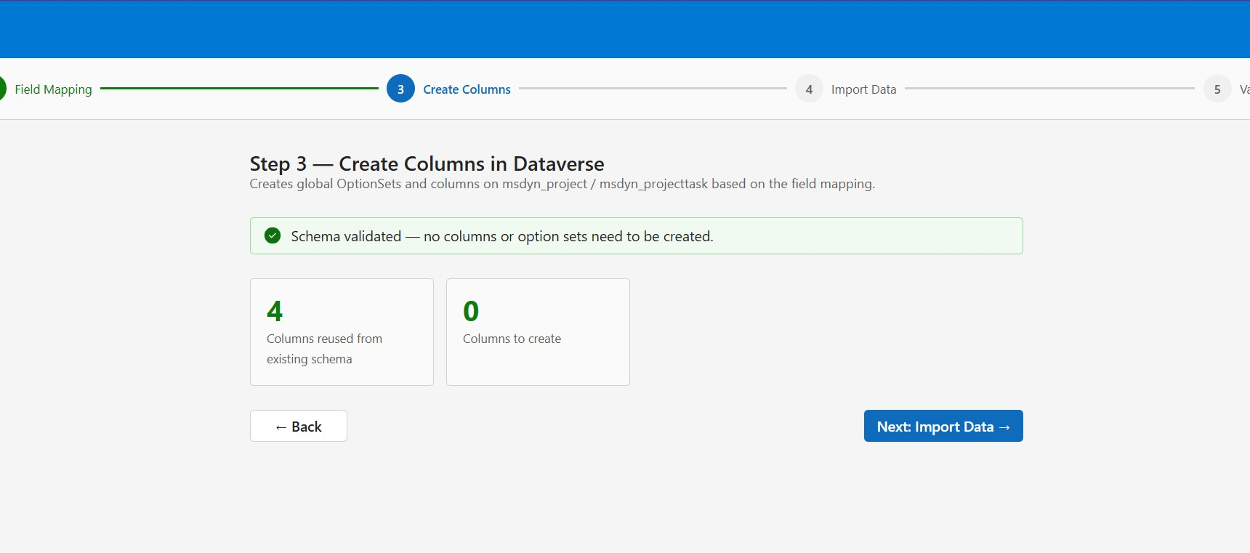
Figure 4.16 — Step 3 in Data only mode: validation only, no creation
In Data only mode, Step 3 is read-only. The app verifies that the columns selected in Step 2 actually exist and shows a green "Schema validated" banner. If anything is missing or has changed, the banner turns into an error and you must go back to Step 2.

4.4 Step 4 — Import Data
Step 4 is where the actual data lands in Dataverse. It is also the step that takes the longest, and the one where you have the most fine-grained control.

4.4.1 Confirming you understand schedule rebuild
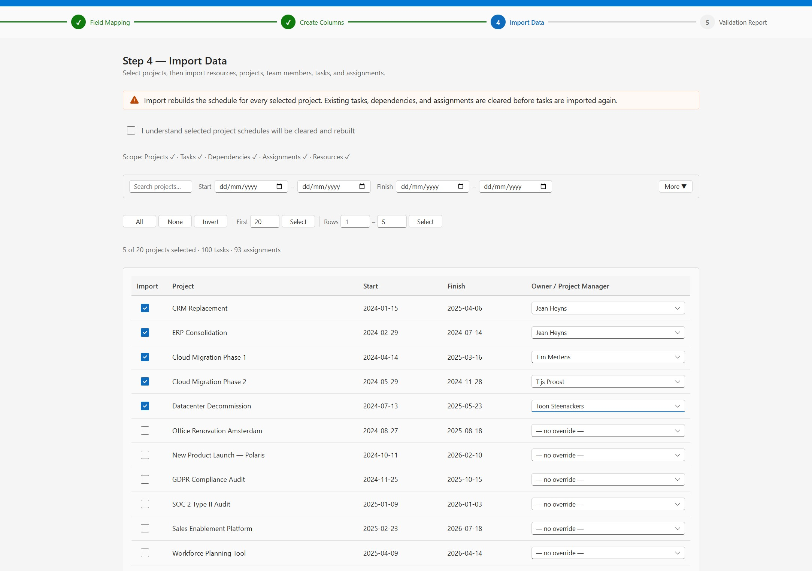
Figure 4.17 — Step 4 project selection table
At the top of Step 4 there is an orange warning bar and a confirmation checkbox:
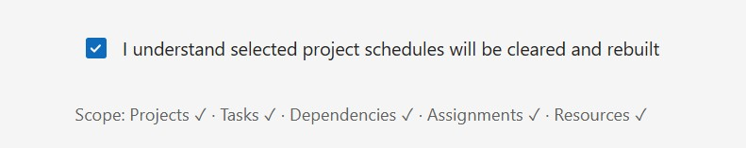
Figure 4.18 — The required confirmation checkbox
You must tick "I understand selected project schedules will be cleared and rebuilt" before the Start Import button becomes available. This is a deliberate safeguard — for any project that already has a migration link, the existing tasks, dependencies, and assignments are deleted before tasks are recreated.

4.4.2 Filtering and selecting projects
The project table supports several ways to narrow down the list:
- Free-text search — matches the project name.
- Date range filters — Start (from / to) and Finish (from / to) for window-based selection.
- More ▼ — additional filters like owner, project name pattern, etc.
- All / None / Invert — bulk selection of the visible rows.
- First N or Rows X–Y — select a numbered range of rows. Useful for running pilots of 5 or 10 projects before committing to the full set.
Below the filters, a counter shows X of Y projects selected · N tasks · N assignments. This is your sanity check before clicking Start Import.

4.4.3 Per-project owner override
Each row has an Owner / Project Manager dropdown. By default it shows "— no override —", which means the resolved Dataverse user (matched on the Project Online owner email) is used.
If a Project Online owner has no matching Dataverse user, or you want to deliberately reassign ownership for migrated projects, pick a Dataverse system user from the dropdown.

4.4.4 Starting and monitoring the import
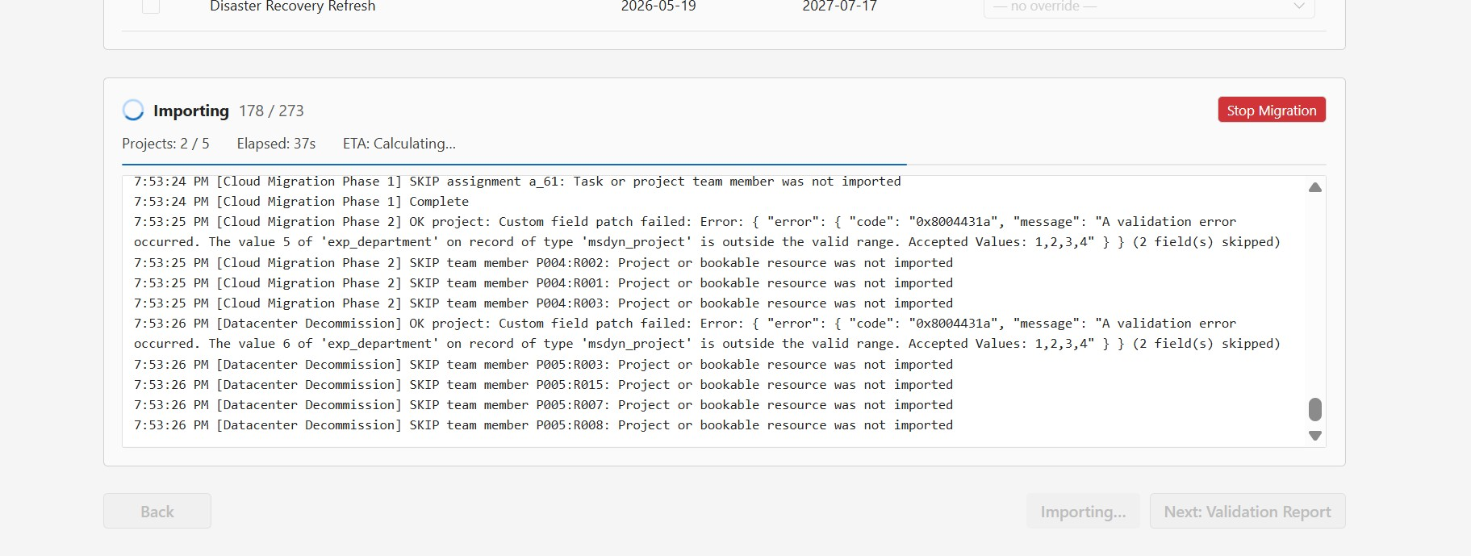
Figure 4.19 — Import in progress with the Stop Migration button
Click Start Import. A progress panel appears with:
- Importing N / M — the total number of operations completed and remaining.
- Projects: A / B — projects fully completed out of the total selected.
- Elapsed and ETA — how long it has been running and an estimate of remaining time.
- A streaming log — per-record OK / SKIP / ERROR with the reason.
- Stop Migration — a red button that aborts the run cleanly. Projects currently being processed will finish before stopping.
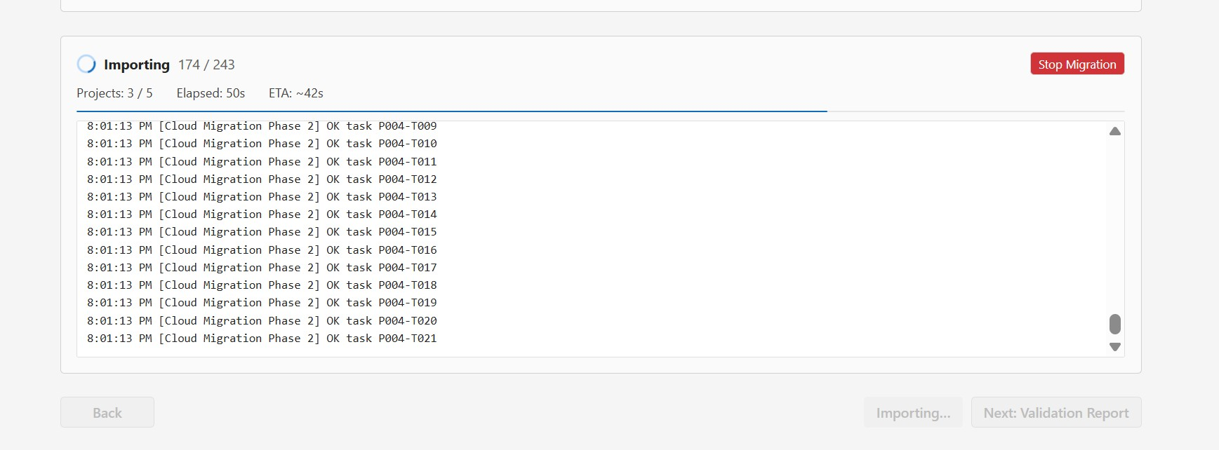
Figure 4.20 — Importing a batch of tasks
Heads up — Closing the browser tab during the import will trigger a "Leave site?" confirmation. If you accept, work in progress is lost and the target may be left in a partially-migrated state. Always use Stop Migration instead.

4.4.5 Import completion
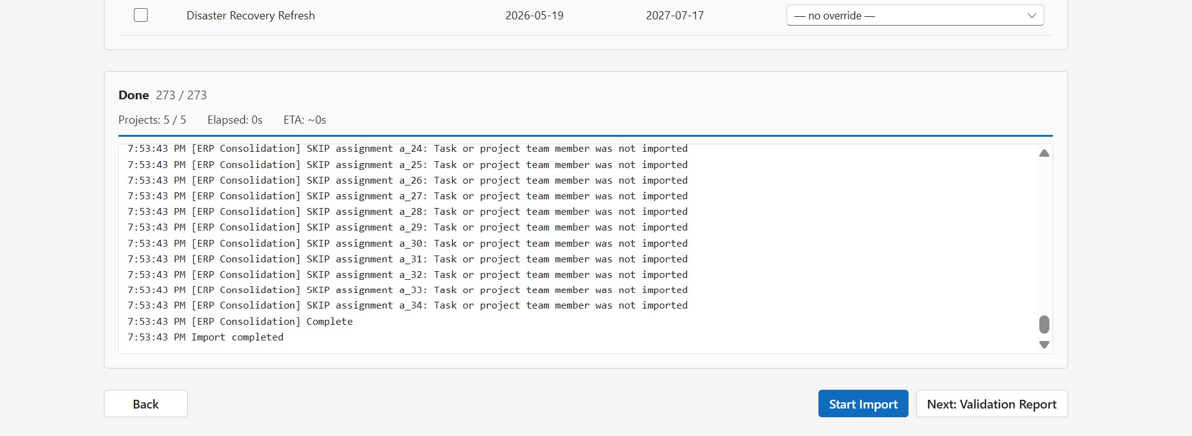
Figure 4.21 — Import complete
When the import finishes, the panel shows Done N / N. The Next: Validation Report button on the bottom-right becomes enabled.
4.5 Step 5 — Validation Report
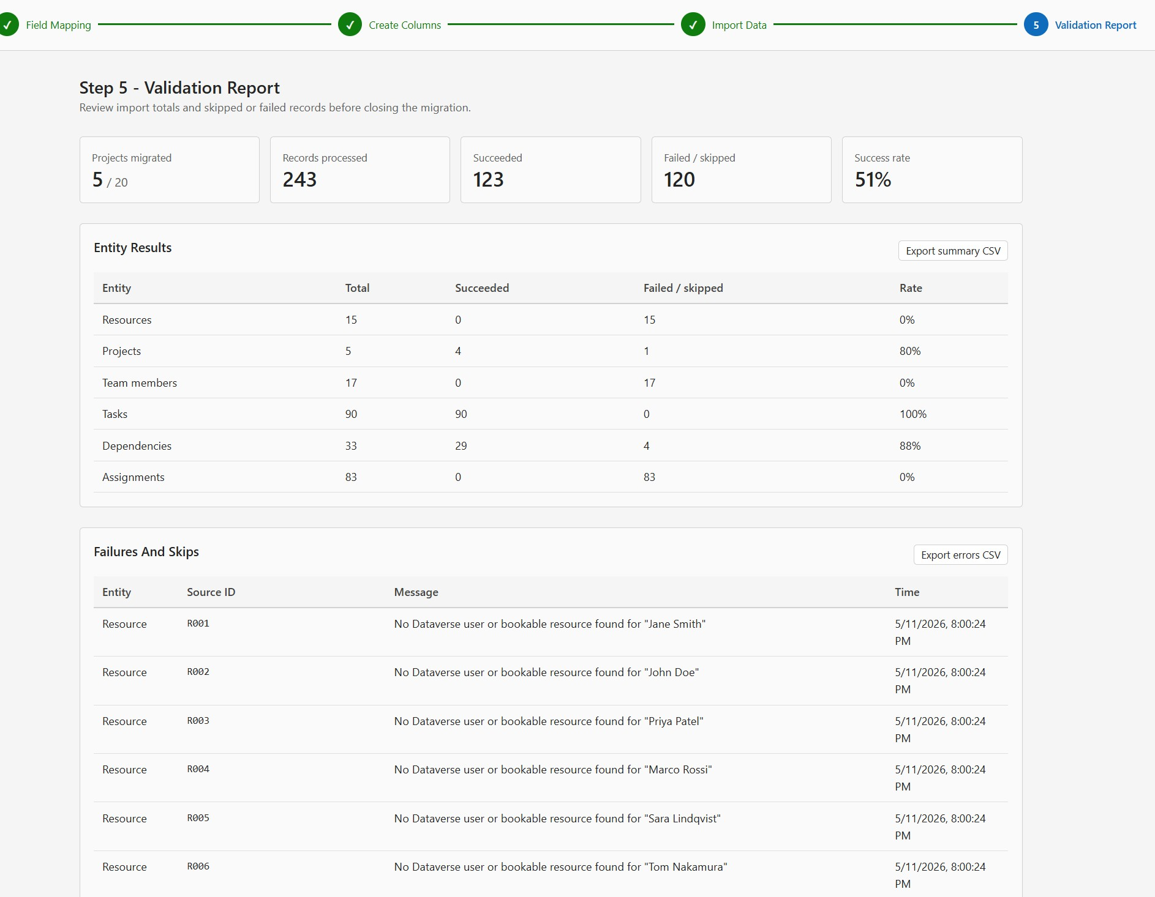
Figure 4.22 — Step 5 — the validation report
Step 5 is the deliverable. Five summary tiles at the top give you the headline numbers:
- Projects migrated — how many of the selected projects landed (e.g. 5 / 20).
- Records processed — total operations across all entities.
- Succeeded — records that landed cleanly.
- Failed / skipped — records that did not land. Skip reasons are tracked, not just counted.
- Success rate — Succeeded ÷ Records processed.

4.5.1 Entity Results table
Below the tiles, the Entity Results table breaks down per entity: Resources, Projects, Team members, Tasks, Dependencies, Assignments. Each row shows Total / Succeeded / Failed-or-skipped / Rate. This is the first place to look when you see an imperfect success rate — it tells you whether the problem is in resources, tasks, or assignments.
Click Export summary CSV to download a machine-readable version of this table.

4.5.2 Failures and Skips table
Below Entity Results, every individual failure or skip is listed with the entity, source ID (e.g.
Click Export errors CSV to download the full list.

4.5.3 Skipped Fields panel (Data only mode)
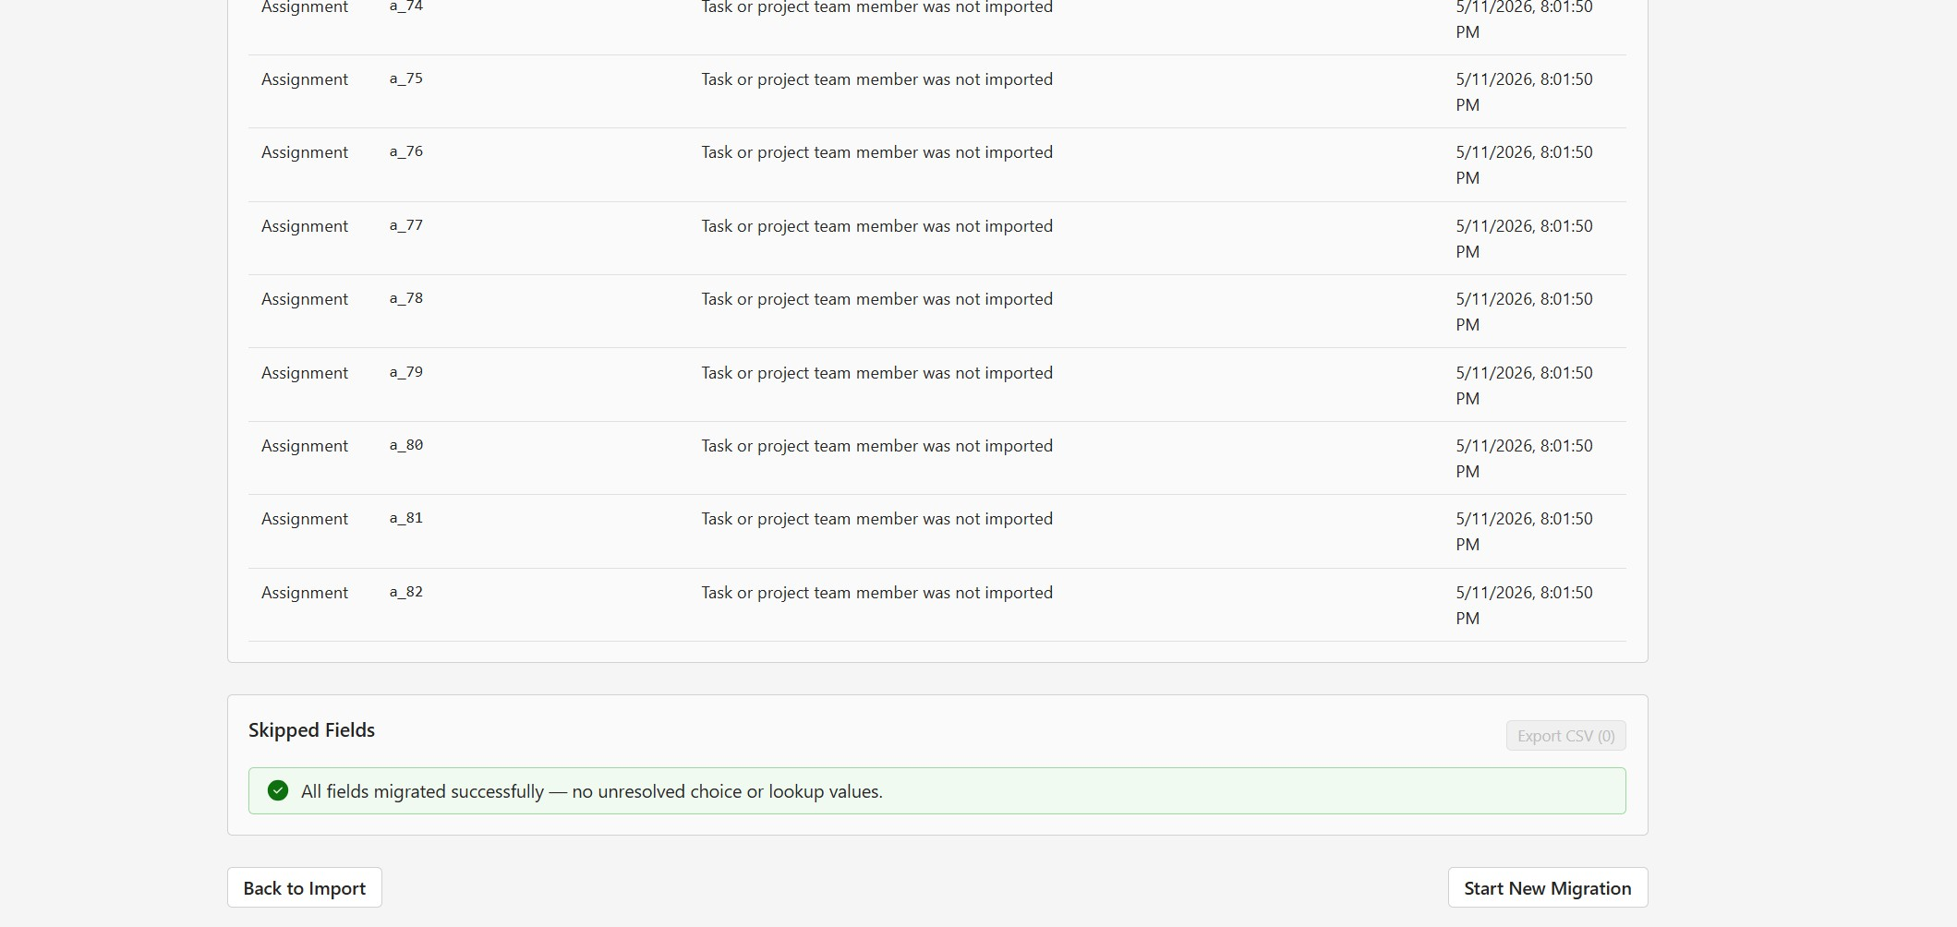
Figure 4.23 — Skipped Fields panel at the bottom of Step 5
In Data only mode, an additional panel — Skipped Fields — lists individual choice or lookup values that could not be resolved against the existing schema. For example, a Project Online status "On Hold" with no equivalent option in the target Status column will appear here. Click Export CSV to share the list with whoever maintains the target option sets.
If everything resolved cleanly, the panel shows a green "All fields migrated successfully" banner.

4.5.4 Starting a new migration
At the bottom of Step 5 you have two buttons:
- Back to Import — returns to Step 4. Useful if you want to re-run the same selection or change owner overrides.
- Start New Migration — resets the wizard. The Dataverse URL and any saved mappings on disk are preserved; everything else returns to a clean state.

5. Working with the Excel template
The Upload File data source uses a structured Excel workbook with one sheet per entity type. Download a fresh template from Step 1 every time the app updates — the column layout can change between versions.

5.1 Sheets in the template
Sheet | Required? | Purpose
Projects | At least one row recommended | Project metadata and custom field values.
Tasks | Optional | Tasks per project. Required for schedule migration.
Resources | Optional | People who work on projects. Required when Assignments or TeamMembers are filled.
Assignments | Optional | Which resource works on which task. Requires Tasks and Resources.
Dependencies | Optional | Predecessor/successor links between tasks.
TeamMembers | Optional | Project membership. If left empty, derived from Assignments.
CustomFields | Optional | Definitions of custom columns referenced from Projects.
LookupValues | Optional | Entries that lookup-type custom fields can pick from.

5.2 Common rules
- Do not rename sheets or columns. The app will refuse to load a file with renamed structure.
- Empty rows are ignored.
- Dates can be in any Excel date format. If you type dates as plain text, use ISO format (YYYY-MM-DD).
- Boolean values are TRUE or FALSE. An empty cell means "not set".
- IDs (ProjectId, TaskId, ResourceId) must be unique within their sheet.
- References (e.g. TaskId in the Assignments sheet) must match an ID elsewhere in the file.

5.3 Custom fields in the Projects sheet
To migrate custom field values for projects, add a column to the Projects sheet whose header matches a ColumnHeader value in the CustomFields sheet. The app reads the value per project and applies it via Step 2 mapping.
Heads up — Custom field columns in the Tasks sheet are not migrated due to a Project schedule API limitation. The app reads them but ignores the values; you will see a warning in the upload validation panel.

6. Troubleshooting
Common problems, what causes them, and how to fix them. Look here first before opening a ticket.

6.1 Connection and fetch errors
Symptom | Cause | Fix
Fetch fails with 401 or 403 | Not signed in to SharePoint in this browser, or no permission on the PWA. | Open the PWA URL in a new tab, sign in, and reload the migration tool.
Fetch returns 0 projects | PWA URL is reachable but no projects exist, or projects are not visible to your account. | Verify in Project Online directly; check that you have the Read Projects permission.
"Could not resolve Dataverse organization URL" | The environment variable is unset and no manual URL was entered. | Click Reset Dataverse URL in the header and enter the correct URL.
Solution dropdown is empty | Account has no access to any unmanaged solutions, or you connected to the wrong environment. | Verify the Dataverse URL; check user role in Power Platform admin center.

6.2 Mapping issues (Step 2)
Symptom | Cause | Fix
Amber dot in Data only mode | Some option-set or lookup values cannot be resolved against the target column. | Continue if values can be skipped, or add the missing options in the target option set before re-running.
Red dot in Data only mode | The chosen target column has a type mismatch that cannot be bridged. | Pick a different target column or switch to New column.
"Use existing" dropdown is empty | No columns of the correct type exist in the target solution. | Either create columns manually first, or switch to New column.

6.3 Column creation errors (Step 3)
Symptom | Cause | Fix
"Global OptionSet metadata ID could not be resolved" | Transient Dataverse caching issue with global option sets. | Re-run Step 3. The option set is usually created but not yet readable; a second run resolves it.
"Schema name already exists" | A column with the same name exists in another solution. | Use a different solution prefix, or rename the source field display so it generates a different logical name.
Errors creating the same column twice | Re-running Step 3 after a partial success. | This is expected — the tool reports them as "already existed", not as errors. If you see ERROR specifically, check the message for the real cause.

6.4 Import errors (Step 4)
Symptom | Cause | Fix
"No Dataverse user or bookable resource found for X" | A Project Online resource has no matching user/bookable resource in the target. | Either create the user/bookable resource in the target before importing, or accept the skip and the assignment will be omitted.
"Task or project team member was not imported" | A task or team member was skipped earlier in the same project, so its dependent assignment cannot land. | Look earlier in the same project log for the original failure — that is the real cause.
"Value X is outside the valid range. Accepted Values: 1,2,3,4" | A choice value in the source has no equivalent in the target option set. | In Data only mode, add the missing option to the target option set. In Full mode, this should not happen — re-run Step 3.
Import gets very slow toward the end | Normal — task and assignment batches process in the schedule API which has rate limits. | Let it finish. The ETA is conservative; actual time is usually shorter.

6.5 The Troubleshooting page
The Troubleshooting button in the header opens a diagnostic page that inspects column metadata in the target. Use it when:
- You see a red dot in Step 2 Data only mode and want to understand the type mismatch.
- A choice column is failing to resolve values and you want to see the actual option set IDs.
- A lookup column is behaving unexpectedly and you want to inspect its target table and relationships.
The page shows a JSON view of the column metadata. Most fields are self-explanatory; the key ones are AttributeType, OptionSetName, and IsGlobal.

7. Reference — terminology and field types

7.1 Terminology
Term | Meaning
PWA | Project Web App — the SharePoint-hosted Project Online site (typical URL pattern: /sites/pwa).
Dataverse | The data platform behind Power Platform / Project for the Web — what Project Online migrates into.
Planner Premium / Project for the Web | The target product. Built on Dataverse using the msdyn_project, msdyn_projecttask, and msdyn_projectteam tables.
Solution | A container in Dataverse that groups columns, tables, and other components. Has a publisher prefix (e.g. exp_, cr123_).
Publisher prefix | The 2–8 letter prefix used on logical names of components created inside a solution.
Custom field | A field added to Project Online beyond the out-of-the-box ones.
Lookup table | In Project Online: a managed list of values that a Lookup-type custom field can pick from. The equivalent in Dataverse is a global option set or a custom lookup entity.
Option set / Choice | Dataverse term for a list of predefined values on a column.
OperationSet | A Dataverse API pattern used by Project for the Web for batching writes to the schedule (tasks, assignments).

7.2 Project Online field types and their Dataverse equivalents
PO Type | Default Dataverse target | Notes
Text | Single Line of Text | Length up to 255 characters.
Memo / Multi-line | Multiple Lines of Text | Up to 2,000 by default; can be widened in Dataverse.
Number | Decimal Number | Override to Whole Number when the source values are integers.
Cost | Decimal Number | Tool does not auto-create Currency columns.
Date | Date Only | Time component is dropped.
Flag / Boolean | Two Options | Yes/No mapping.
Duration | Whole Number | Stored as days.
Lookup | Choice (OptionSet) | Lookup table entries become option set values.
LookupMulti | Multi-Select Choice | Multiple selections allowed.

7.3 What is and is not migrated
- Migrated: project metadata, project custom field values, tasks, task hierarchy, task dates and percent complete, dependencies, project team members, assignments, resources (where matched), lookup tables (as option sets or custom lookups).
- Not migrated: task custom field values (API limitation), the implicit Project Online summary/root task, calendars, working times, baselines, document libraries, project sites, security settings, OData reporting customizations.

