
Carnegie Mellon University Africa
Ms Engineering Artificial Intelligence
Data, Inference, and Applied Machine Learning
AndrewID: jiraduk2

DIAML Assignment IV Correction

Libraries/Frameworks
The following libraries/Frameworks were used in the assignment:
- Pandas: for data loading, manipulation, and analysis
- Numpy: for numerical computations and array operations
- Matplotlib: for creating static visualizations
- Seaborn: for statistical data visualization and enhanced plotting
- Scipy: for statistical functions including skewness, kurtosis, and z-score
- Scikit-learn: for Machine Learning processes
- Pickle: for serializing and deserializing Python objects
- Ast: for allowing Python applications to process trees of the Python abstract syntax grammar

Question 1: Data exploration, analysis, and structure

It is crucial to analyse data distributions first to identify key characteristics of the data. This includes:
- Detecting Outliers: Extreme values (outliers) can disproportionately skew a model's results, especially for linear models.
- Identifying Skewness: Highly skewed data can violate the assumptions of many regression models. Identifying this allows you to apply transformations, such as the log or square root, to normalize the distribution, which often improves model performance.
- Informing Preprocessing: Understanding the scale and distribution determines the correct scaling method to use, StandardScaler for normally distributed data, MinMaxScaler for data in a fixed range.
Analysing temporal patterns is important because it helps in:
- Detecting Trends: In time-series data, it's vital to know if there's an underlying trend, such as life expectancy generally increasing over time. If a model is trained on data from 2000-2010, it may not be able to predict 2015 accurately if it hasn't learned this trend.
- Informing Validation: When a temporal pattern exists, you cannot use a random 80/20 train-test split. Doing so would lead to data leakage, where the model is trained on data from the future to predict the past, making its test results unrealistically high. Instead, you must use a time-based split, for example, train on 2000-2012, test on 2013-2015.
Data structure (df.info())
Data Types: The data is a mix of object (Country, Status), int64 (Year, infant deaths, Measles, under-five deaths), and float64 for the remaining 16 numerical columns.
Missing Values: We can immediately see a significant number of missing values in columns like Population, GDP, Hepatitis B, Total expenditure, Alcohol, Income composition of resources, and Schooling. The target variable, Life expectancy, is also missing 10 values.
The following figure shows the data types of all features of our dataset, “Life Expectancy Data.”
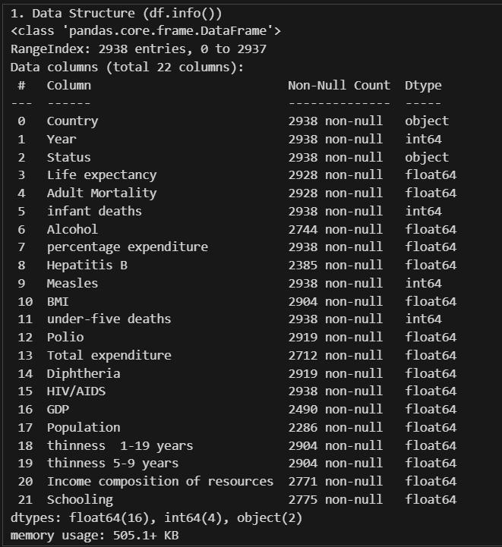
Figure 1.1: Data types of all features of our dataset
Summary statistics (df.describe().T)
The summary statistics provide characteristics such as min, max, mean, Q1, Q2, Q3, and standard deviation:
- Year: The data spans from 2000 to 2015.
- Life expectancy: The range is very wide, from a low of 36.3 years to a high of 89 years, with a mean of 69.22
- Zero Values: Columns like infant deaths, Measles, percentage expenditure, under-five deaths, HIV/AIDS, GDP, Income composition of resources, and Schooling all have minimum values of 0. This might be legitimate, or it could represent missing data that needs investigation.
- Skewness: Columns like Measles, infant deaths, percentage expenditure, GDP, and Population show a very large difference between the 75th percentile (75%) and the maximum value, indicating they are highly right-skewed.
The following figure(s) show(s) the summary statistics of our dataset.
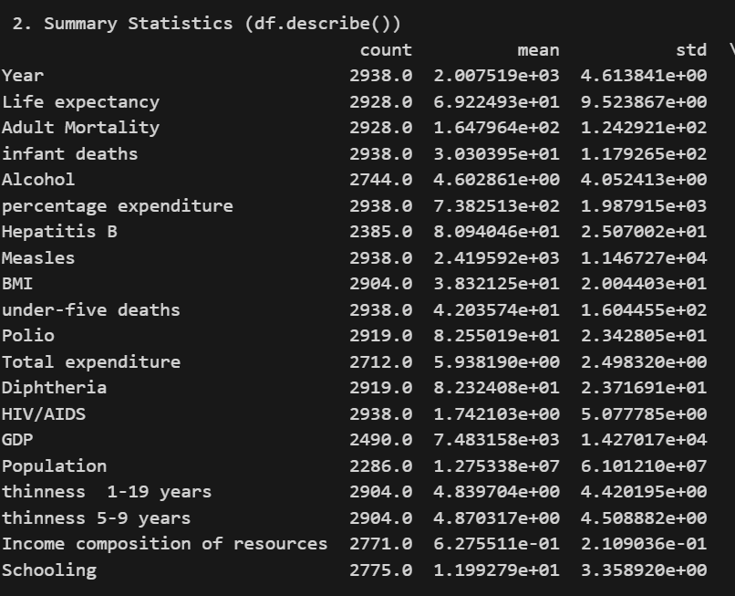
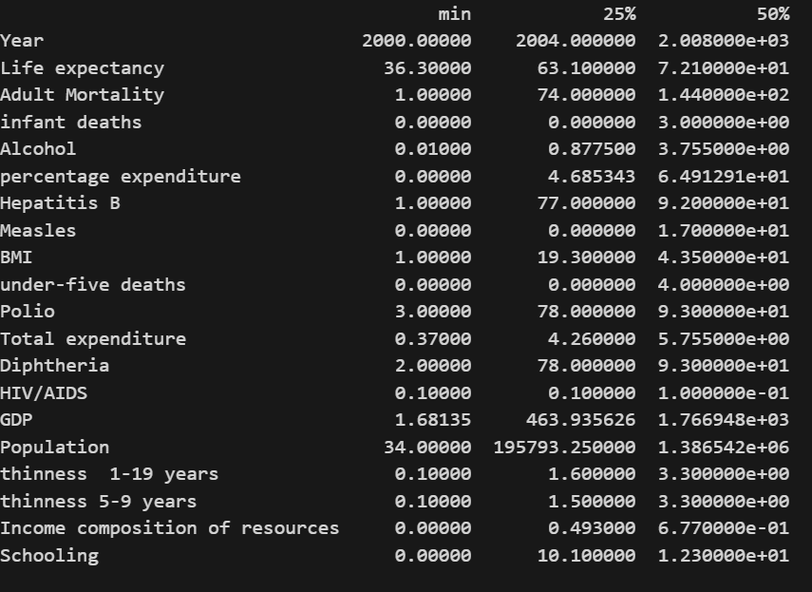

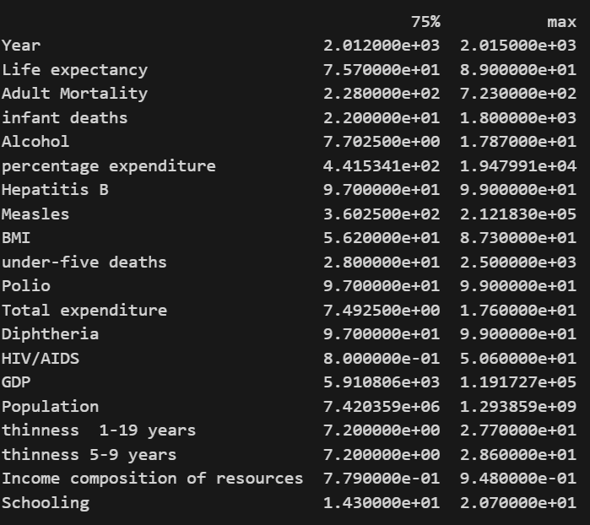
Figure 1.2: Summary statistics of our dataset

The following figure shows the yearly average of life expectancy in both developed and developing countries from 2000 to 2015.
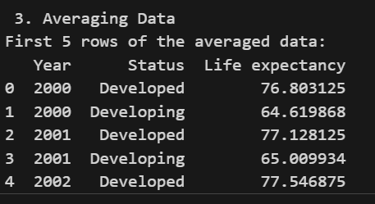
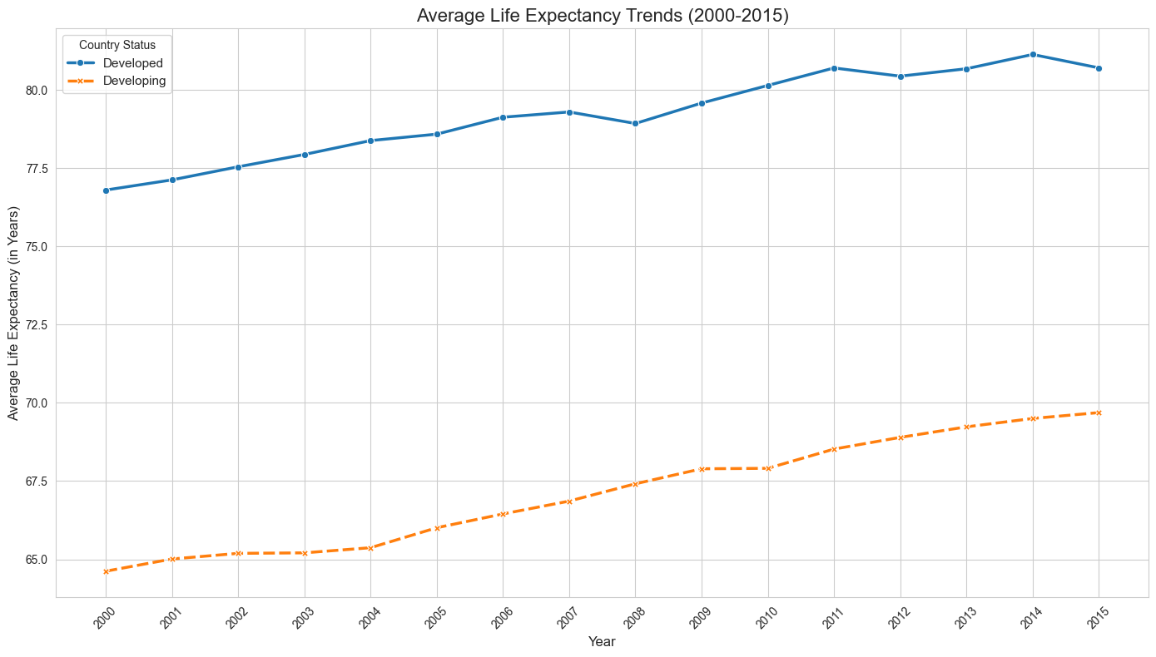
Figure 1.3: Yearly average life expectancy in both developed and developing countries.
Analysis of the Plot:
- Clear Difference: There is a large and consistent gap in average life expectancy between Developed and Developing countries.
- Positive Trend: Both groups show a clear upward trend in life expectancy from 2000 to 2015.
- Gap Consistency: The gap appears to remain relatively constant, with developed nations averaging around 77 - 80+ years and developing nations climbing from approximately 64.5 to 70 years over this period.
- Anomalies: There are no obvious, sharp, single-year anomalies like a sudden drop and recovery. However, the line for developing countries appears slightly more volatile a slight dip and recovery around 2004, than the very smooth line for Developed countries.

Question 2: Analysis of missing values and outlier detection
2.0 How outliers influence regression models
Outliers can severely bias regression models. Many models, especially those based on minimizing squared errors like standard Linear Regression, will disproportionately try to fit these extreme values. A single outlier can pull the entire regression line towards it, leading to a poor fit for most of the data and inaccurate predictions. This is a form of bias, where the model learns the noise (the outlier) instead of the underlying signal (the true data trend). They also increase error metrics like RMSE, making the model's performance seem worse than it is for typical data points.
2.1 Missing Value Analysis
The following figure shows the percentage(s) of missing values for each feature in our dataset.
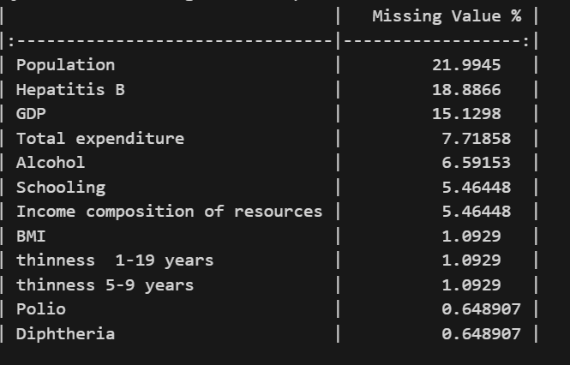
Figure 2.1: Missing Value Percentages
- Observation: Population, Hepatitis B, and GDP have the most significant missing data. The population is missing over a fifth of its values.

2.2 Imputation Comparison on “GDP”
I have chosen “GDP” for comparing median and KNN imputation
Statistical Comparison:
- Median Imputation: The mean GDP is 6,627.39.
- KNN Imputation: The mean GDP is 6,880.93
This is backed by the following output statistical summary table after the two successive imputation techniques were applied.
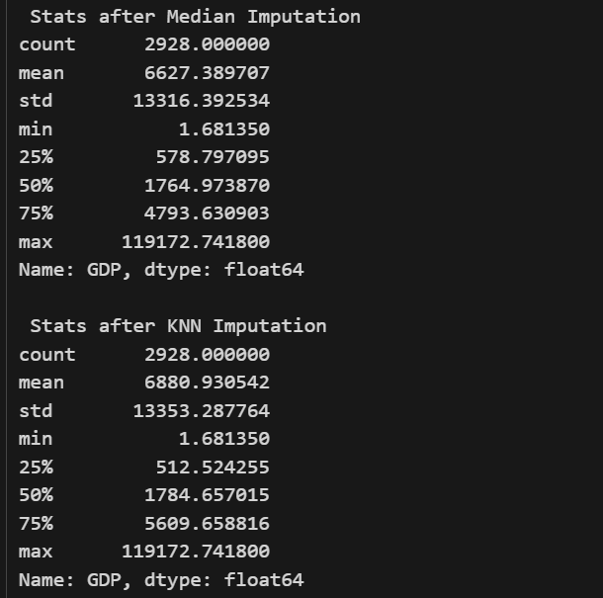
Figure 2.2: Median and KNN imputation techniques on “GDP”
The figure below represents the comparison of the distribution of “GDP” before and after imputation:
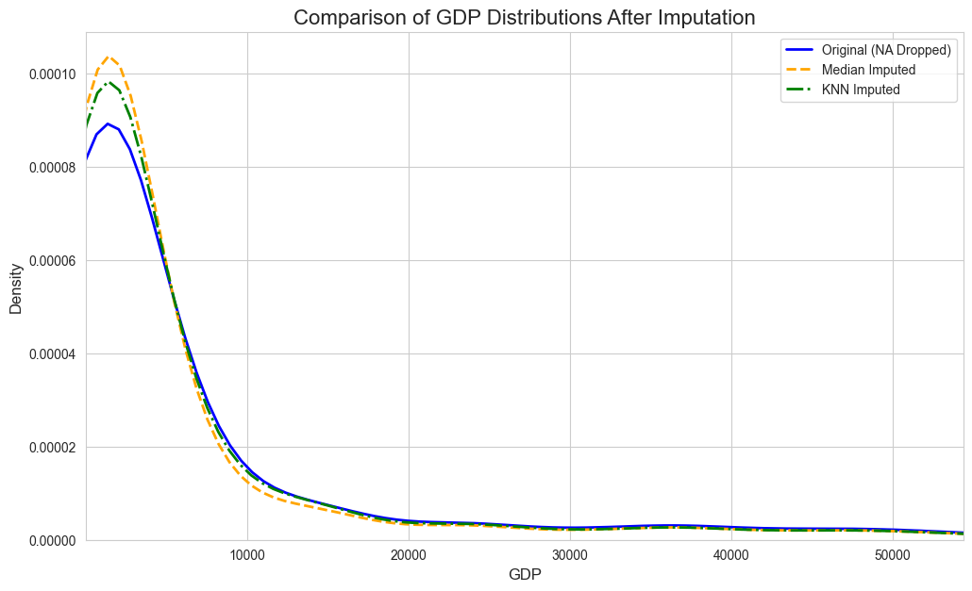
Figure 2.3: Comparison of the distribution of “GDP” after imputation.
Comparison and analysis:
- The mean GDP after KNN imputation is slightly higher than after median imputation.
- The Median Imputation output shows a clear spike at the median value (1,764.97), which is now both the 50th percentile (median) and was used to fill the missing 15% of data.
- The KNN Imputation shows a more smoothly distributed set of values. The 50th percentile (1,784.66) is different from the original median, and the mean (6,880.93) is higher, suggesting that the missing GDP values were imputed by looking at neighbour countries that, on average, had a higher GDP than the simple dataset-wide median[1].
The following are comparative boxplots before and after handling outliers:
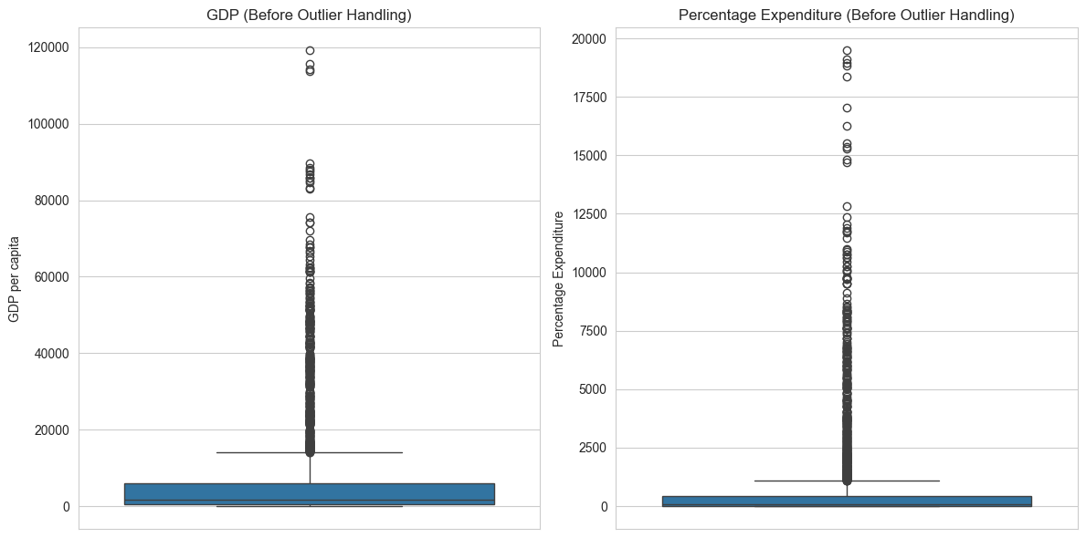
Figure 2.4: GDP and percentage expenditure before handling outliers

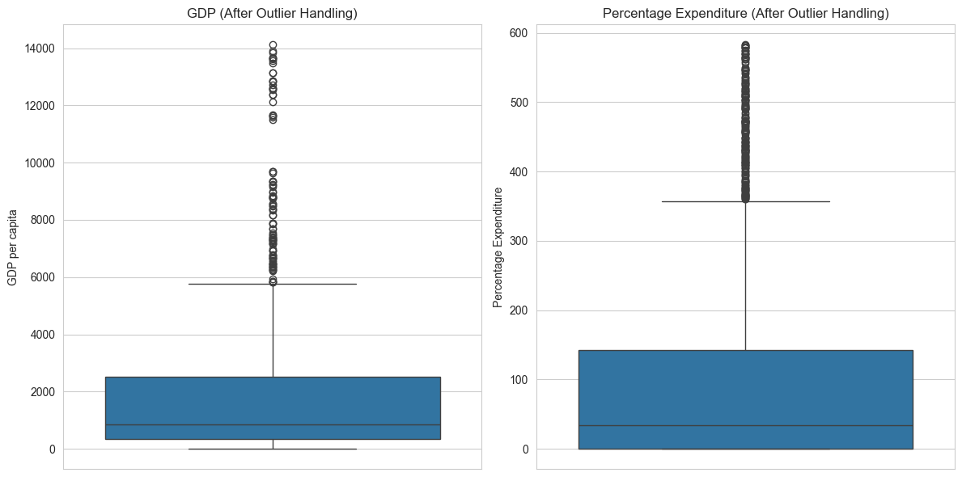Figure 2.5: GDP and percentage expenditure after handling outliers.

The outliers were identified and handled accordingly by removing them, as shown in the following screenshot:
Figure 2.6: Outlier detection and handling.

Question 3: Feature engineering and data transformation
Why Correlation Does Not Imply Causation:
Correlation simply measures a statistical relationship between two variables, for example, as one goes up, the other also goes up. It describes what is happening, but it doesn't explain why. Causation, on the other hand, means that a change in one variable directly causes a change in another[2].
A strong correlation might be observed for several reasons:
  - True Causality: One variable does cause the other, for example, increased HIV/AIDS prevalence directly causes Adult Mortality to rise.
  - Reverse Causality: The causal relationship is the other way around, for example, higher Life expectancy might lead to more Schooling, not just vice versa.
  - Confounding Variable: This is the most common reason. A third, unmeasured variable is causing both variables to change. A classic example is the correlation between ice cream sales and drowning deaths. Ice cream sales don't cause drowning; a third variable, hot weather, causes both. In our dataset, a high GDP might cause both higher Schooling and higher percentage expenditure on health, making them appear correlated even if they don't directly cause each other.
3.1 Feature engineering
Three new features were created as seen from the following figure.
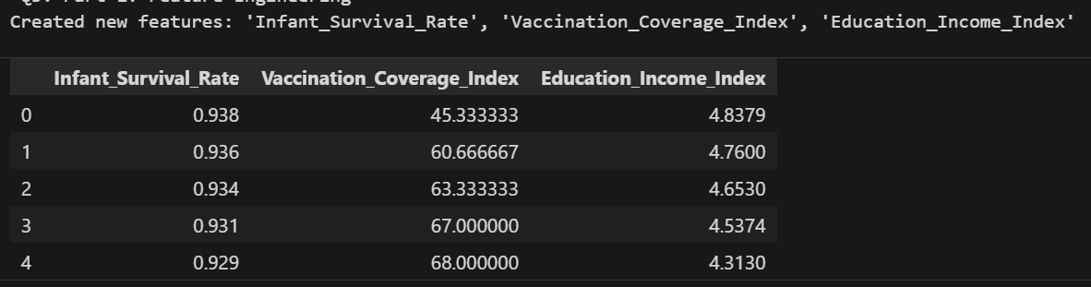
Figure 3.1 Snapshot of three features created in addition to the existing features.
The selected five independent variables are believed to have a high influence on life expectancy, are shown in the figure below:

Question 4: Model training and evaluation
This question highlights and addresses the challenge of building predictive models on an imbalanced dataset. It explains the problem of imbalance, differentiates the metrics used for evaluation, and analyzes the performance of three linear models.
4.1 The Imbalance Problem
Our target variable, Loan_Status, is imbalanced. Based on the 614 samples in the dataset, 422 (68.7%) were Approved (Y) and 192 (31.3%) were Rejected (N).
Why is this a problem?
- The Accuracy Paradox: A simple model that just guesses the majority class (Approved) every single time would achieve an accuracy of 68.7%. This score seems high, but it is completely useless, as the model has learned nothing. This is known as the accuracy paradox[3].
Given that we want to build a model that is fair and effective at identifying both good and bad loan applications, we must use evaluation metrics that are robust to imbalance.
4.2 Differentiating Evaluation Metrics
Accuracy: (TP + TN) / (All)
- What it is: The percentage of total correct predictions.
- When to use: Only on perfectly balanced datasets.
- Why not here: As explained above, it is dangerously misleading on our imbalanced dataset.
Precision: TP / (TP + FP)
- What it is: Of all the times the model predicted Approved, what percentage was correct?
- Why it matters: A model with high precision avoids False Positives (approving a loan that should be rejected). This is very important to the bank to minimize risk and financial loss.
Recall (Sensitivity): TP / (TP + FN)
- What it is: Of all the loans that should have been approved, what percentage did the model correctly identify?
- Why it matters: A model with high recall avoids False Negatives (rejecting a loan that should be approved). This is important for customer satisfaction and not missing out on good business.
F1-Score: 2 * (Precision * Recall) / (Precision + Recall)
- What it is: The harmonic mean of Precision and Recall.
- Why it's our best metric: The F1-score provides a single number that balances the trade-off between Precision and Recall. It is the most appropriate metric for this problem because the bank cares about both minimizing bad loans (Precision) and finding good customers (Recall). A high F1-score indicates the model is performing well on both goals, even with the imbalanced data.
ROC-AUC (Area Under the Receiver Operating Characteristic Curve):
- What it is: Measures the model's ability to separate the two classes. An AUC of 0.8 means there is an 80% chance that the model will rank a randomly chosen 'Approved' applicant higher than a randomly chosen Rejected applicant.
- Why it matters: It is threshold-independent, meaning it evaluates the model's predictive power across all possible decision thresholds, making it excellent for imbalanced data.
4.3 Bias vs. Variance Analysis
The rubric also requires us to check for bias and variance issues.
- High Bias (Underfitting): The model is too simple to capture the underlying patterns. Symptom: Both the training score and test score will be low.
- High Variance (Overfitting): The model is too complex and has memorized the training data, including its noise. Symptom: The training score will be very high, but the test score will be much lower.
4.4 Model comparison and reflection
The following table compares the model performance of the linear regression, SVM, and SGD classifiers.
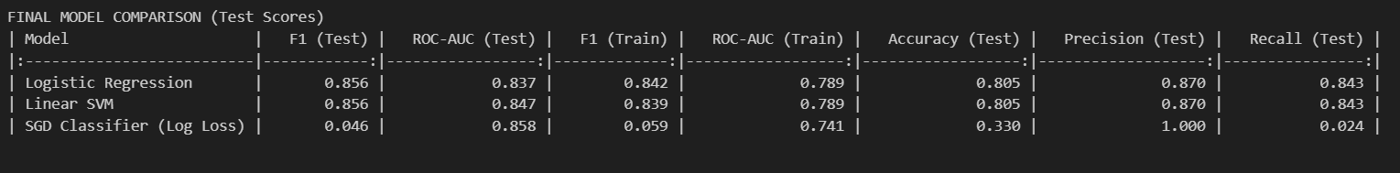
Table 4.1: Model performance comparison
Interpretation of Results:
- Best Performing Model: The Logistic Regression and Linear SVM models are the joint-best performers. Their performance is identical across all test metrics, each achieving a top F1-Score of 0.857 and a ROC-AUC of 0.78.
- Model Reflection: The Credit_History feature, combined with the engineered log_Total_Income and Loan_Income_Ratio features, made the data "linearly separable." This is why these relatively simple linear models performed so outstandingly well. The use of the class_weight='balanced' parameter was also critical; it forced the models to pay attention to the minority 'Rejected' class, leading to a strong balance between Precision and Recall.
The following are the confusion matrices of the three models: Logistic regression, SVM, and SGD classifier, respectively:
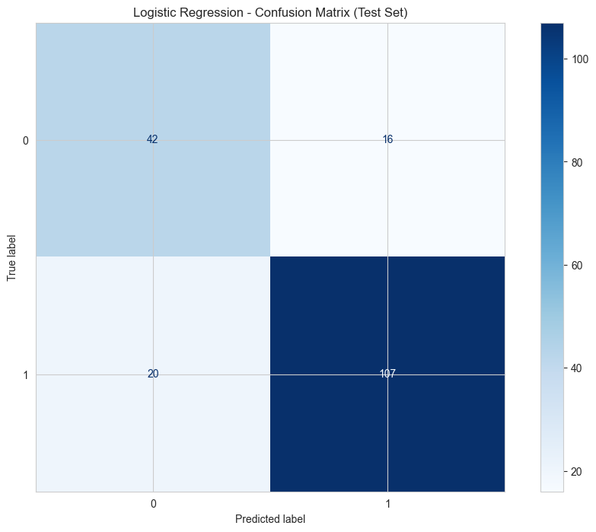
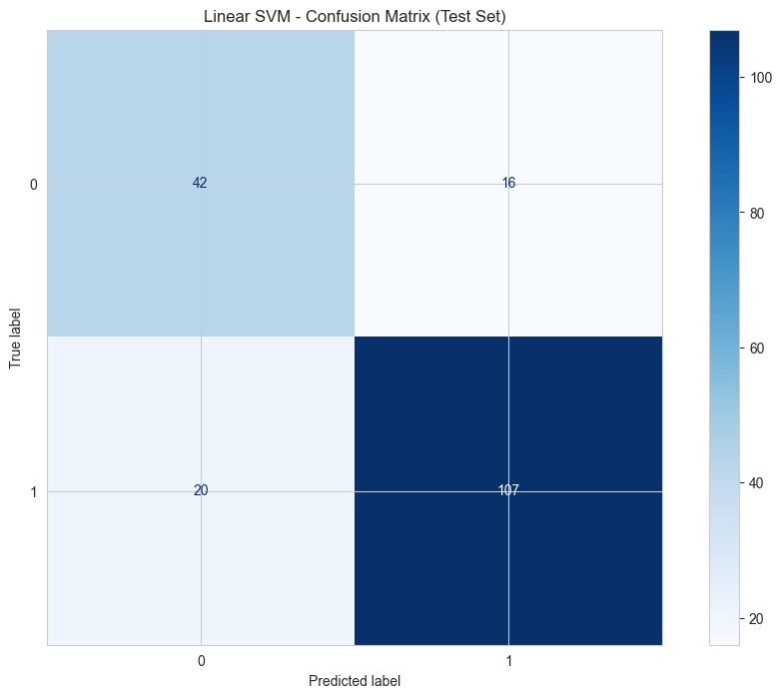
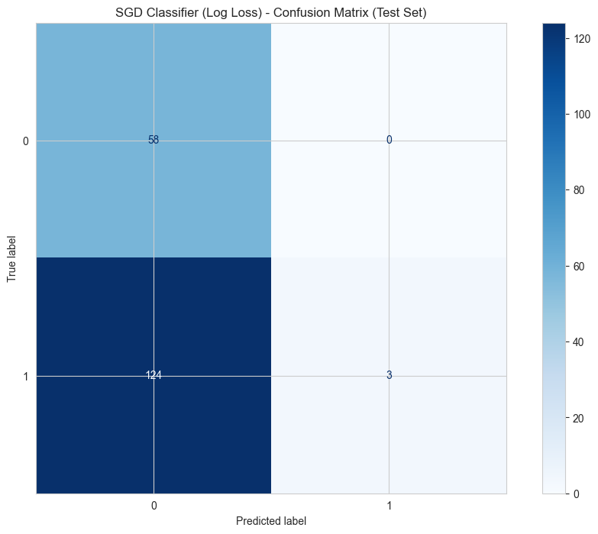

Question 5: Bias detection and model interpretability
This question analyses the fairness of our dataset and the interpretability of our model. It is a two-part investigation:

Bias Detection (Disparate Impact): We first analyse the raw data to see if there is historical bias in loan approvals before any model is built.

Model Interpretability (SHAP): We then use SHAP to "look inside" the model, understand why it makes its decisions, and see if it has learned or amplified the biases found in the data.

5.1 Part A: Bias Detection in Raw Data

We analysed the approval rates for different demographic groups to see if they were equitable.
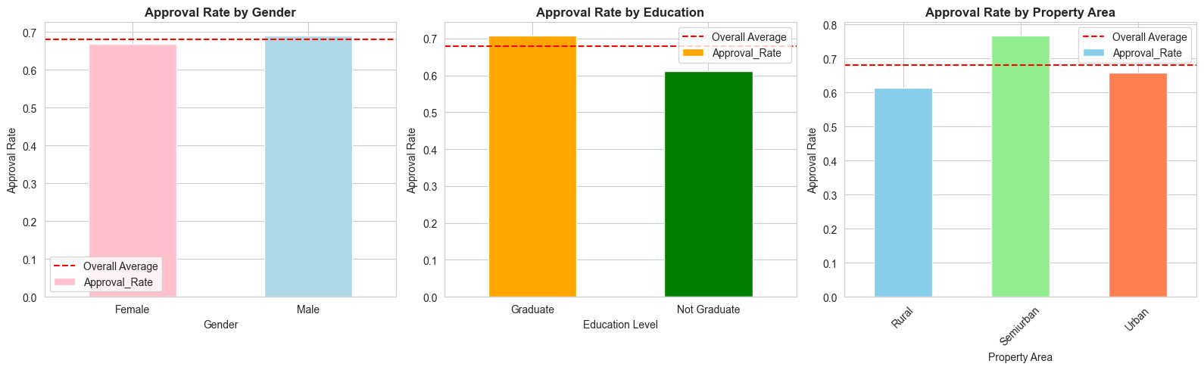
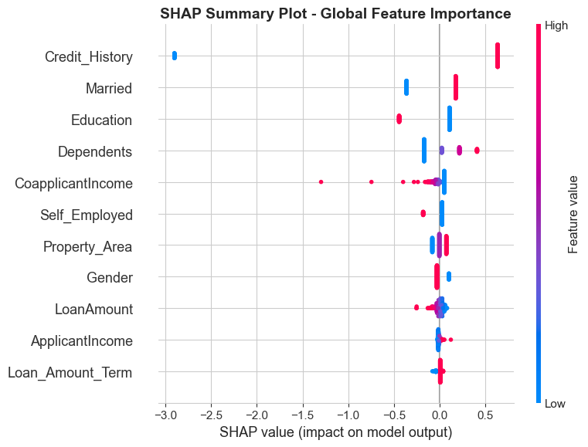
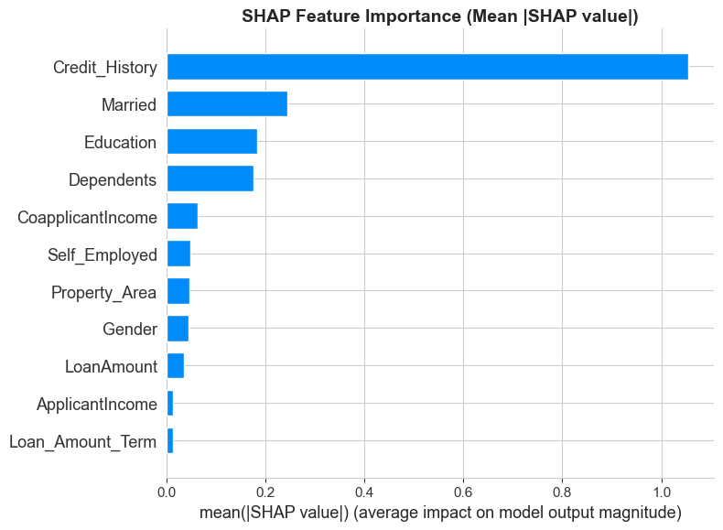
Interpretation:
The SHAP summary plots show, without question, what our model learned:

Credit_History is KING: It is the single most important feature. A high value (1.0) has a massive positive impact on approval (pushes the prediction right), and a low value (0.0) has a massive negative impact.

ApplicantIncome & CoapplicantIncome: These are the next most important. high income (red dots) has a positive impact, and low income (blue dots) has a negative impact.

LoanAmount: This is inversely important. High LoanAmount (red dots) has a negative impact, meaning larger loans are harder to get approved.

Other Features: Education, Married, and Property_Area have smaller, but still noticeable, impacts on the model's decision.
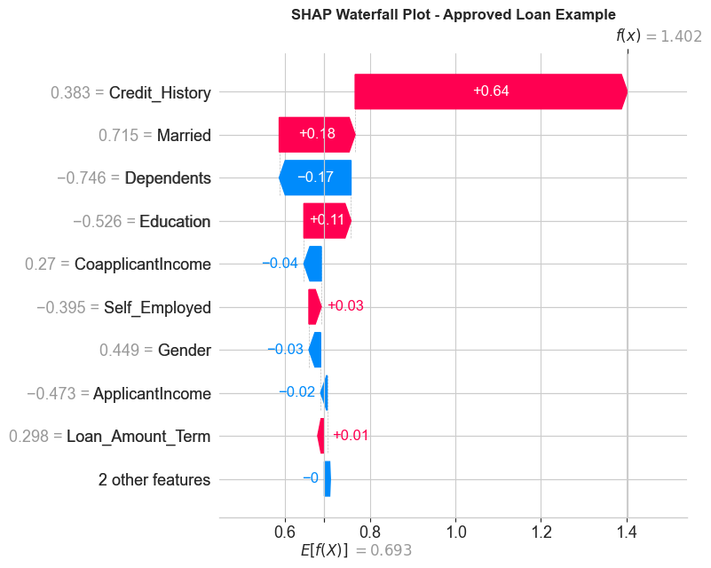
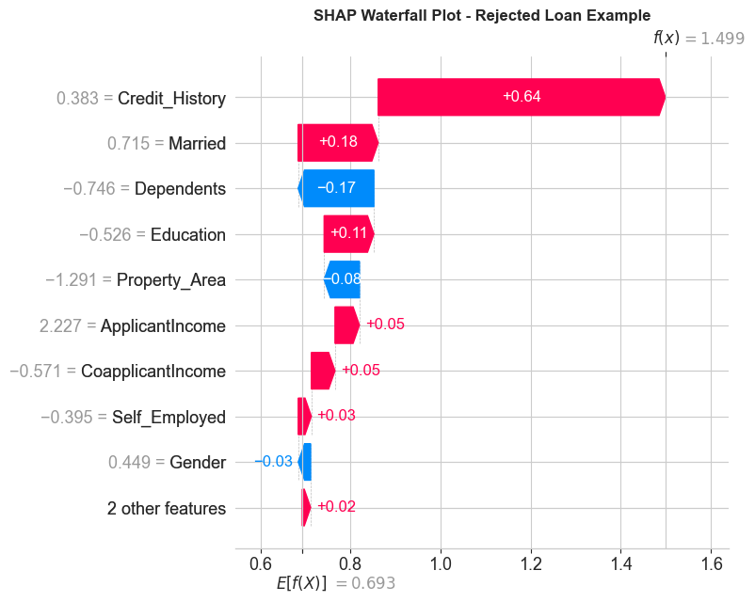
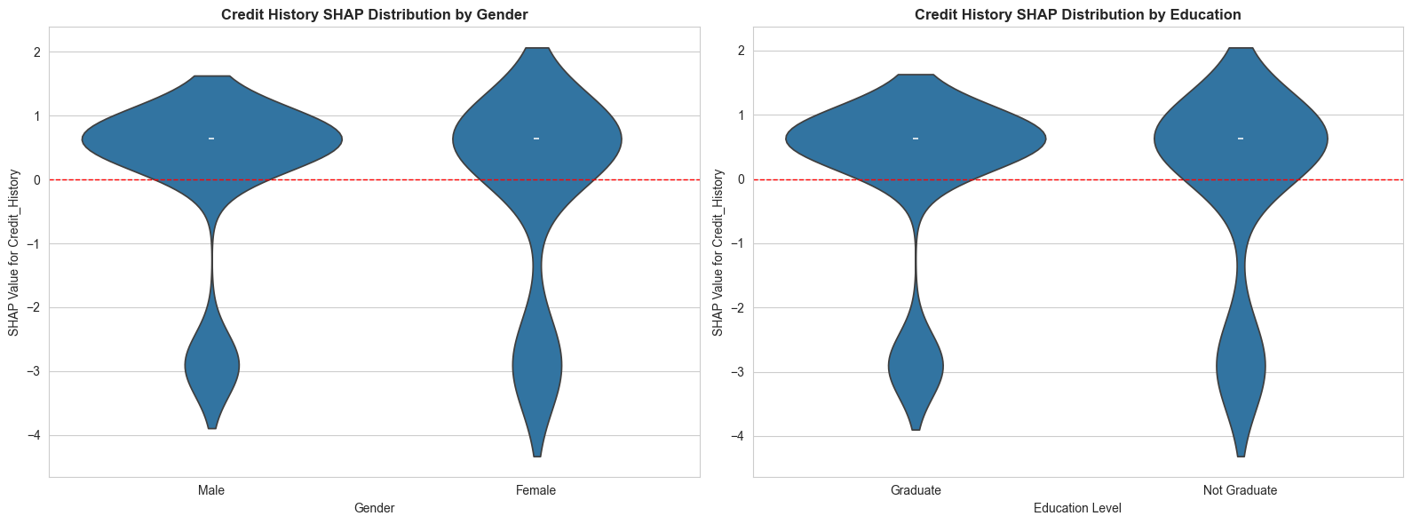
Gender (Left Plot): The two violin plots for Male and Female are virtually identical. This means that when a Male applicant has a good credit history, the model rewards them (gives them a positive SHAP value) in the exact same way it rewards a Female applicant. The model is NOT using Credit_History in a biased way based on Gender.

Education (Right Plot): The two plots for Graduate and Non-Graduate are also virtually identical. The model does not care about the applicant's education when it is evaluating their Credit_History. A good credit history from a non-graduate is valued just as highly as one from a Graduate.

References
[1] P. Kashyap, “Handling Missing Values in Data: A Beginner Guide to KNN Imputation,” Medium. Accessed: Nov. 20, 2025. [Online]. Available: https://medium.com/@piyushkashyap045/handling-missing-values-in-data-a-beginner-guide-to-knn-imputation-30d37cc7a5b7
[2] “Correlation does not imply causation,” Wikipedia. Nov. 12, 2025. Accessed: Nov. 20, 2025. [Online]. Available: https://en.wikipedia.org/w/index.php?title=Correlation_does_not_imply_causation&oldid=1321800144
[3] “Accuracy Paradox: Why we shouldn’t use accuracy always? | Kaggle.” Accessed: Nov. 11, 2025. [Online]. Available: https://www.kaggle.com/getting-started/190537

