Cognition & Behaviour Platform

Room 307, Systems Building

320 Yueyang Rd, Shanghai 200031, CHINA

✉ [i.andolina@ion.ac.cn](mailto:i.andolina@ion.ac.cn)

✆ +86 021 54921747

Tuesday, 27 August 2019

Dear Sir / Madam,

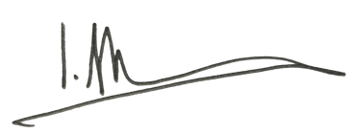Yours sincerely,

Ian Max Andolina Ph.D.

Institute of Neuroscience, CAS