Name: Jean-Luc Bordessoule E-mail: jl.bordessoule@btinternet.com

Date: 1 August 2011

Award: Dissertation Proposal – MSc Professional Computing

Supervisor: Bob Hobbs

Detection of Surfaces and Volumes
from Geological and User Data

Part I (Certificate): Specification. Analysis of the Available Technology and Know How
Part II (Diploma): Design. Workflow of the Features Extraction and Decision Making
Part III (Dissertation): Implementation. Towards an Implementation of the Software

- Introduction
The Certificate and the Diploma reports were mainly analytical, and helped to define the scope of the study.
The Dissertation uses the experience previously gained to implement the software using tools available in the Open Source community.

- Dissertation Background

The Dissertation begins with reflections on the approach that conducted the study.

The Certificate focused on the Medical Imaging, trying to find out what can be done. Existing techniques were recognized, and available source code collected. From the users' help of existing products related to the geological visualisation and interpretation, entities important to the business were identified.

Following the clues provided by the existing software, the Diploma focused on the Earth and particularly the field of the reservoir build-up, identification and exploitation. Information concerning the different knowledge that influence or are required for the understanding of reservoir engineering were identified. This analysis identified not only the knowledge but also pin-pointed the rules and constraints that apply to the topic. It enabled the definition and specification of seismic and stratigraphic grids that are the repository for the information.

Although the subjects of medical and seismic imaging are different, human body in one case and Earth structure in the other case, there are similarities in the approach.

Both fields need to identify surfaces, volumes and anomalies and use indirect measurements (imaging) to base their interpretation on, before physically gaining access by surgery or by drilling.

It might be objected that the structure of the human body is always the same whereas the geology of a deposit is unique. Although it is true, the creation of a deposit obeys to rules that are known and geologic structures can be recognized on large scales.

Finally, from the mathematical point of view, the tools being used -such as data analysis, signal processing, fluid mechanics- are the same.

The initial approach dealt with surface and volume extraction. It did lead to the information propagation, where knowledge, rules and constraints are taken into account in a given order. It was called the workflow. The purpose is now to use the previous work to actually tackle the implementation of the software.

3. Project Aims and Objectives

A great part of the Certificate and Diploma has been inspired by reading and analysing of materials. It was required to understand the topic.

Now, the aim is the implementation. For visualisation, several tools exists as Open Source, such as Qt, OpenCV, OpenInventor, Vtk and OpenCascade. Other source code providing an implementation of the algorithms have been listed at the Certificate level.

The purpose is to optimize the efficiency of the development, the scope being the software development, the analysis of the results obtained and how programming knowledge-based systems or constraint programming might apply.
As a result, the following topics have been identified:

Project Management:
- Implement the objects for the information storage, such as the point sets, line, surface and grids specified at the Diploma level.
- Implement the steps for the information propagation. It follows a specific order which is (a) the storage of the points history, (b) the storage of the point set, (c) line generation (d) surface generation, (e) volume generation, (f) grid building, (g) grids connection. At the stage, the frame should provide support for applicative domains such as fluid propagation and seismic modelling.
- Investigate the different Open Source resources, and choose the most suitable.
- Implement the visualisation.

Analysis of the results:
The purpose is to see how far it is possible to go using an approach which tries to reflect the history of a deposit and the order imposed by natural constraints.

Relevant programming topics:
- Expert systems, or knowledge-based systems provide an approach. It will be interesting to validate how this study does in fact follows this approach. It might help to reconsider some aspects.
- Constraint programming might offer a theoretical and practical insight and help to solve some issues.

A rough estimate is that 70% of the Dissertation will be based on the programming aspects of the implementation, 15% on the discussion of the results and 15% on the technical aspect related to knowledge and constraints.

4. Project Challenges

Obviously, implementing a software that could imitate Petrel or Gocad -references in the field of reservoir engineering- is a goal that might not be attainable!

The main challenge is to test and validate the ideas and the approach.
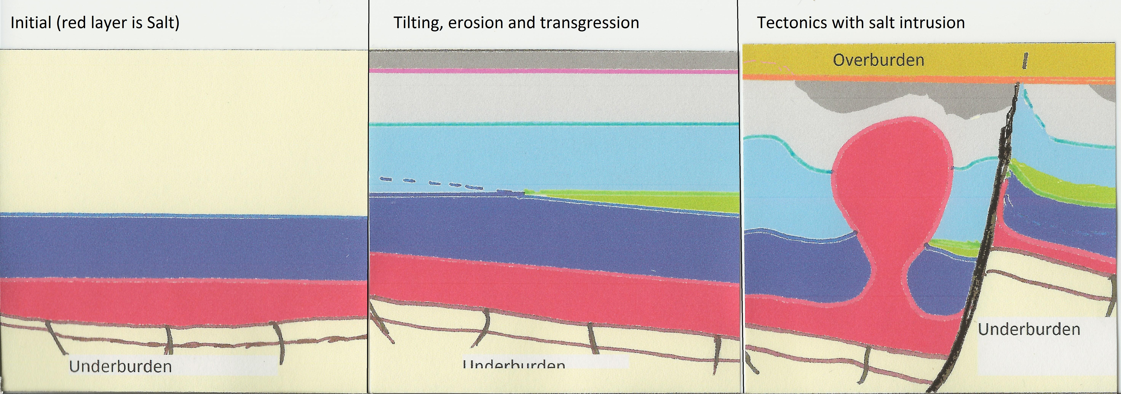
Being able to provide a model and an interactive visualisation of the below sequence will be quite honourable as it is the purpose of this study as indicated in the title “Detection of Surfaces and Volumes from Geological and User Data” and the main difficulty in reservoir engineering.
In order to limit the risks the steps indicated in 3.2 (Project Management) could be followed.

The resulting challenge is the correct use of the time available and the efficiency of the development. Hence, this Dissertation is more about the conduct of the software development, the originality and efficiency of the methods used then a theoretical discussion.

Finally, the discussion about the tools used for the implementation (probably Visual Studio, C++, OpenInventor and OpenCV) should be brief as they are not the main topics. In the same way, techniques from Expert systems and constraint programming should be discussed with the aim in mind.

5. Programme Phases

5.1 Phases and Contents
The phases reflect the above described aims and objectives.

5.2 Time Frames
In fact, the study must be completed by September 2012.

6. Deliverables
The project deliverables are as follow:
- The Dissertation,
- The software

7. Resources
The following resources will be required:
- A PC with editing, printing and programming facilities.
- The documents and information collected at the Certificate and Diploma levels.

8. References
The references defined at the Certificate and Diploma levels.
Experience gained in previous software development (description of software architecture) might be used.

