

**Stakeholder Satisfaction Driven Quality Management in Higher Education**

How the voice of stakeholders can be considered to improve Quality Management Systems of Higher Education Institutions

Gdańsk, 2025

# SUMMARY

# Abstract

# INTRODUCTION [10-15]

## Background on Higher Education Management (JPSZ) [2-3]

In a modern, super quickly evolving economy, knowledge and scientific development play a key role (cf. Castro Laszlo & Laszlo, 2002). Therefore results of the work of higher education institutions (HEI) become a key determinant of the widely perceived success in the modern economy, serving as a driving force for economic development (cf. Puente et al., 2021). In this context, universities play significant role due to their impact on innovations commercialised with technology industries. As it can be observed that “higher education is a reflection of the social, scientific, technical, and economic potential of any country” (Grudowski, 2020), then finding effective solutions for quality management systems of HEI seems to be all the more critical. How challenging it may be is reflected in opinions that “the search for solutions concerning organisation and management (…) is an endless story” (Leja & Pawlak, 2021).

For a better understanding of management challenges for universities, it is important to refer to their historical evolution background. Universities underwent transformations, starting from the 12th century, induced by both external conditions (varying influences of secular and ecclesiastical authorities, technological changes, politics and demographics) and new ideas emerging among the elites or those working at universities. Brief summary of main stages of universities evolution has been presented in the Table 1.

Table 1 Trends in Changes in European Universities from the Middle Ages to the Present

| **Time Period** | **Description of the Main Trends in Changes in European Universities** |
| --- | --- |
| 12th century | Emerging organizations originating from associations of teachers and students forming in cities independently of monastic schools. A key facilitating factor was urbanization. |
| 13th century | The establishment and support of universities by the ruling authorities. |
| 14th century | Increased professionalization and secularization of society, leading to a growing demand for education. Enhanced employment opportunities through education resulted in an increase in the number of students. |
| 15th century | Rulers began to recognize the potential of an educated workforce and provided greater support for the education of an ever-increasing number of students. |
| 16th century | A saturation of the market with graduates led to rising unemployment among educated individuals. There emerged a perceived threat to aristocratic dominance from educated individuals originating from lower social strata. |
| 17th century | The aristocratization of education through the limitation of scholarships for poorer students and an increased emphasis on the socializing role of education. |
| 18th century | A heightened demand for education in new disciplines, fueled by technological advancements and changes in state organization. This period also saw the deconfessionalization of universities and their increased subordination to state authorities. |
| 19th century | The state-supported implementation of the university model as formulated by Kant and realized through the Humboldt model, with research becoming the dominant focus. |
| First quarter of the 20th century | The flourishing of the liberal university model, inspired by non-German concepts of academic freedom in teaching and research, led to the idea of *Lehr- und Lernfreiheit*. |
| Second quarter of the 20th century | The influence of socialist totalitarian regimes led to the subordination of universities to the state, with research increasingly commissioned by the state to support prevailing ideologies. |
| Third quarter of the 20th century | A post-war return to pre-war university ideals, though implemented under the new conditions of rapid technological development and the marketization of education. |
| Fourth quarter of the 20th century | The internationalization of universities, education, and science, supported by state and international regulations. |

Source: (Cwynar, 2005; De Ridder-Symoens, 2020; Kim, 2009; Leja, 2011; Szefler, 2024)

It’s worth noting that the stages of universities’ evolution described briefly in Table 1 show an increasing speed of modifications of concepts for the role of HEI, especially in the 20th century. What is not presented in this simplified form is the fact that a number of these changes were happening in parallel in different regions of the world. The most significant parallel development of universities is between the English-American private universities market and continental European universities, with public universities being impacted by governments. While for private universities, cooperation with business became quite natural and the range of it developed significantly at the same time, public universities in Europe were enhancing more the area of research and teaching that serves society. While these different concepts of what university should be existed together multiple globalisation processes led to the emergence of the concept of triple helix to describe modern economies where universities, businesses and governments cooperate in a mutually reinforcing system. Nevertheless, one of the most important objectives remains preparing the student for future independence. As Geitz and de Geus write “(...) an important goal of higher education is to support students to exercise control over their own learning and to help them develop skills and learn strategies to take the lead. It should aim to educate students in such a way that they become self-regulative learners, resulting in a lifelong, sustainable impact on their personal and professional development” (Geitz & de Geus, 2019, p. 2). This reality coexists with a high recognition of the academic culture which has roots in the medieval universities’ predecessors even from the 12th century. Some the most important manifestations of the academic culture is “ commitment to collegiality coupled with autonomy” and “emphasis on peer review and individual specialization” (Austin, 1990, p. 65). Topic of organisational culture is discussed in more depth in section 3.4.

Given the considerations outlined above, it can be noticed that from a management perspective, HEIs differ from traditional business organisations. They need to consider both business and government relations, but it’s also necessary to cooperate with other universities with which they compete. Overall environment of the university relations seems to be very complex. The most significant parties that HEIs’ managers need to consider are presented in Figure 1.

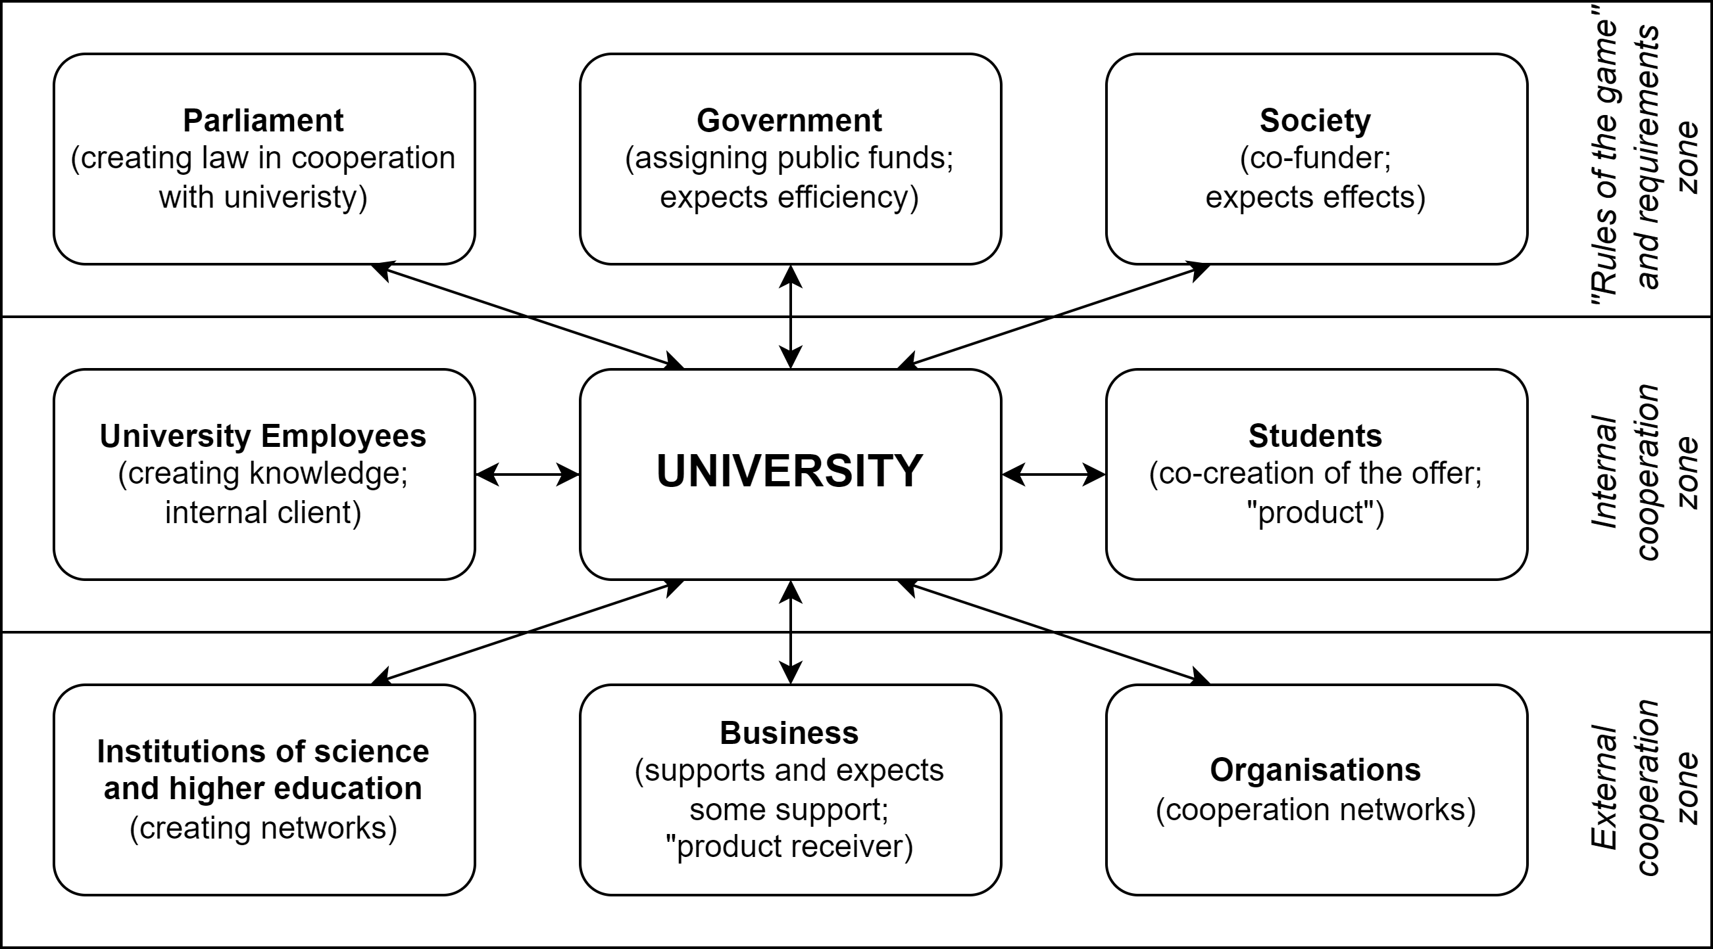

Figure 1 The University’s Relational Environment

Source: (Leja, 2019, p. 13; Szefler, 2024)

Despite numerous groups that need to be considered, another complexity from a management perspective is the high impact of prestige economy within the academic motivations mix (Blackmore & Kandiko, 2011, p. 400), which leads to a preference for prestige-maximisation over profit-maximisation (Tayar & Jack, 2013, p. 154). Also, universities provide a long-term “production” cycle, as either research or teaching results are not fully predictable, as they have a strong human factor. Because of it, any improvement activities will “require a ‘can-do’ attitude and a creative and flexible approach to defining goals and refining working practices” (Newby, 1999, p. 266).

The authors of this study propose to include a set of stakeholder management tools within quality management systems to support continuous improvement processes in the environment of higher education institutions. The role of stakeholders for HEIs will be discussed in a more detailed way in the following subsection.

## The Role of Stakeholders in Higher Education (JPSZ) [2-3]

In today’s rapidly changing economic and academic environment, the role of stakeholders has become increasingly vital to the governance, performance, and quality assurance of higher education institutions. These institutions are intricately woven into a complex ecosystem of relationships which are related to various obligations and expectations. In some cases, these expectations may become mutually incompatible. From the management of the HEI perspective, understanding at least the main groups that are crucial for shaping the quality of the institution’s services becomes almost mandatory. The importance of that is even stronger because of the specificity of higher education and scientific services, where various groups are shaping the quality, and at the same time, the other various groups are perceiving it and assessing. Moreover, the environment of these complex relations is not static. It evolves, expressing multiple social, economic and technological changes.

The most commonly recognised stakeholder groups of universities are students and overall university employees. They together form a community that can be perceived as a university. As the services of HEI are so much intangible, it could exist without any infrastructure, but cannot without students and teachers who are scientists. This understanding has its roots in the traditional model of the university as a place for sharing and acquiring scientific knowledge. It’s also important to emphasise that nowadays university employees are not only academics but also all administrative and supportive staff, who deliver a crucial contribution to the quality of the institutions’ overall services. Students, after graduation, become alumni, and then they gain the opportunity to verify their skills and competence in real life. This process may lead to a change in their perception of the quality of the university services. Good education and great skills bring value not only to former students but also to the businesses they contribute to. As such, another important stakeholder group are employers. In the scientific environment, any progress comes through creativity, critical inquiry, and peer verification. These processes cannot be fully effective without established cooperation with scientists from other institutions worldwide. From this perspective, other HEIs – even competitors – become stakeholders as potential partners in collaboration. Sometimes it comes in the form of bilateral cooperation or broader networks and consortia involving multiple institutions. Universities possess significant potential to have a great impact on society. That’s why, for most of their history, universities have been of great interest to authorities and policymakers. This attention may be an expression of the overall society’s interests, but sometimes, especially for public universities, it entails regulatory oversight aligned with the priorities of funders.

Within such a complex environment, the traditional quality assurance approach appears to be insufficient. Focusing solely on internal compliance and performance may lead to adhering to perfect internal procedures that are no longer relevant. It may also cause the emergence of a perception of reality which is far from facts. Therefore, applying principles of Total Quality Management appears to be appropriate. These are customer focus, fact-based management, human-oriented management and continuous improvement. These principles will be discussed in more detail in subsection 4.1. With regard to HEIs, it is challenging to determine a consistent definition of the customer, which often leads to issues with the application of the TQM systems and practices (cf. Owlia & Aspinwall, 1997, p. 529; Vijaya Sunder, 2016, p. 162). Although TQM has a proven track record of many successful applications in a wide range of businesses, there is very limited evidence of analogical in HEIs. There are several reasons identified in the literature on the topic, and one of them is the ambiguity surrounding the definition of customer. In the context of universities, it seems to be more natural to adopt the concept of stakeholders instead and apply insights from the stakeholder management theory in order to strengthen quality management processes of HEIs. One of the pioneers of that theoretical foundation is Robert Edward Freeman, who defined in 1984 the *Stakeholder Management Capability* (Zakhem, 2008). According to Freeman “an organization which understands its stakeholder map and the stakes of each group, which has organizational processes to take these groups and their stakes into account routinely as part of the standard operating procedures of the organization and which implements a set of transactions or bargains to balance the interests of these stakeholders to achieve the organization’s purpose, would be said to have high (or superior) stakeholders management capability” (Freeman, 2010). This approach is reflected in the normative quality system, based on the TQM foundations, related to managing educational institutions, which is the ISO 21001:2018 standard. One example is requirement 4.2 *Understanding the needs and expectations of interested* parties, which states that: “the organization shall determine: a) the interested parties that are relevant to the EOMS (Educational Organisation Management System); b) the relevant requirements of these interested parties” (ISO 21001, 2018). Much research shows that organisations which listen and adapt to their stakeholders’ feedback tend to increase their legitimacy, trust and relevance, which positively impact their business results (cf. Freeman et al., 2010; Kennon et al., 2009). This is achieved through the improving quality of the organisation’s services.

Given the above, for higher education institutions, it appears undeniable that continuous improvement of quality cannot occur without a high level of stakeholder management practices. As with modern quality management systems requirements and stakeholder management practices, the key responsibilities are within the leadership of the organisation. These are managers who shape the organisation’s quality culture that might support successful quality improvements for various stakeholders. More on this topic will be discussed in subsection 3.4. However, a good quality culture is the core of a healthy and successful organisation, the inherent part of any improvement is the effective feedback and measurement of improvements. For so complex services such as those offered by universities, measuring quality for their interested groups remains a significant challenge, as it is not easy to determine how well the organisation is satisfying the requirements of its stakeholders.

## Importance of Stakeholders Satisfaction (JPSZ) [2-3]

The concept of measuring satisfaction originates from the well-grounded research on organisational performance. In the field of service quality, customer satisfaction has become one of the primary measures. Many of these indicators are based on customers’ overall perception of how well the organisation serves them. According to research by Iacobucci et al. and Spreng and MacKoy, there is a correlation between service quality and customer satisfaction (cf. Iacobucci et al., 1995, pp. 280–281; Spreng & Mackoy, 1996, pp. 203–204). Furthermore, there are widely used measures like the Customer Satisfaction Index (CSI) and Net Promoter Score (NPS), which assess the overall customer satisfaction. These are applied as high-level indexes that can serve as a general overall trend indicator inspiring more detailed research on the quality level and enabling more consistent improvements design.

Perception of quality has a strong theoretical and practical background in the field of quality sciences. Several of the most recognised service quality models lead to the conclusion that consumers’ perception of quality is the central factor integrating many other detailed quality-related measures. One of the foundations for this idea is found in the work of Parasuraman, Zeithaml and Berry, who created the service quality model (SERVQUAL) which emphasises the meaning of measuring the gap between expected service and perceived service (cf. Parasuraman et al., 1985, p. 44; Stoma, 2012, p. 65). As a result of the popularity of SERVQUAL much research has been conducted and other parameters added in order to better understand different factors’ impact on the service quality and their mutual relations. One example of these enhanced service quality models is the integrated service quality model proposed by Gummesson, presented in the Figure 2.

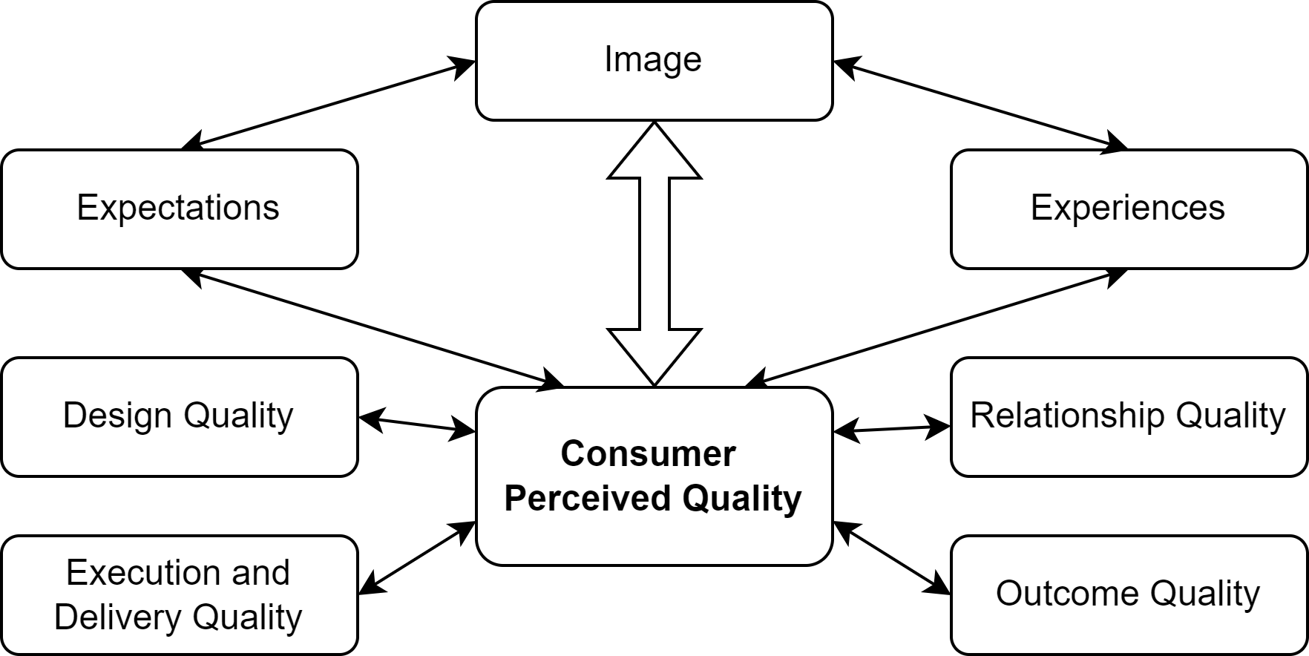

Figure 2 Integrated service quality model 4Q

Source: own compilation based on (Gummesson, 2008; Stoma, 2012, p. 53; Szefler, 2024)

Gummesson’s model of service quality emphasises the role of relationships, which, in a more complex service outcome receivers environment, can be linked to concepts developed in stakeholder management theory. This aspect appears to be especially important considering the conditions of the higher education institutions. The model proposed by Spreng and MacKoy (1996), presented in the Figure 3, adds important elements such as desires and expectations, which are essential when addressing the complexities of measuring HEIs’ stakeholder satisfaction and attempts to understand factors shaping its levels.

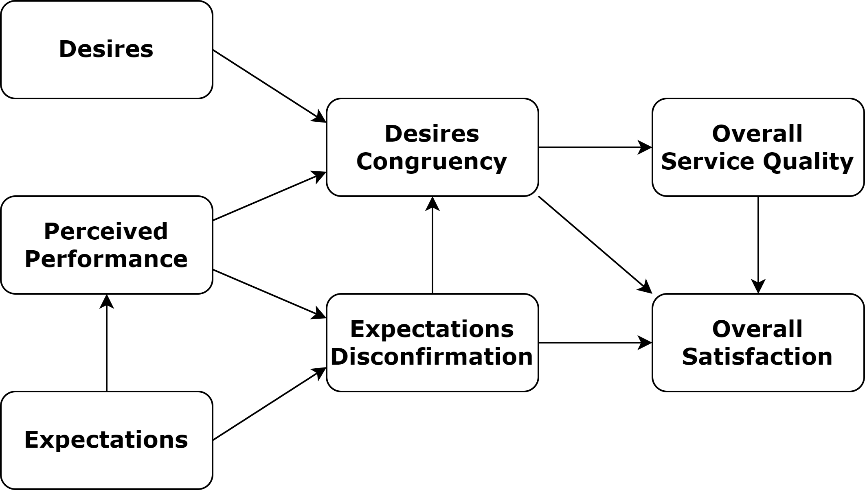

Figure 3 Satisfaction-Service Quality Model

Source: (Spreng & Mackoy, 1996, p. 203)

Similarly to customer satisfaction, comparable concepts can be applied to stakeholders’ satisfaction measures, allowing for the inclusion of voices from a much broader range of interested groups beyond just clients (users / consumers) of the organisation’s products. While this type of research might be more complex and challenging, the idea stems from the same roots and aims to develop an index that captures the overall impact of various factors shaping the organisation’s stakeholders’ satisfaction as the key aggregated indicator of the organisation’s performance. Another key reason why stakeholder satisfaction is especially relevant for universities is its impact on the perceived reputation (cf. Mendoza-Villafaina & López-Mosquera, 2024; Qazi et al., 2022). In the context of the HEI market, institutional reputation is a very important measure of both academic standing and scientific impact. This likely explains why the mechanisms of the prestige economy rules (see subsection 1.1) exert such an influence on the institutional behaviour. This reinforces the role of stakeholder satisfaction as a natural and essential performance measure for universities. As an aggregated high-level indicator, it needs to be used as a foundation for further research and organisational learning on the important factors driving the long-term stakeholder satisfaction. It is worth emphasising the importance of adopting a long-term perspective. Since HEIs “products” are the result of long-term processes, the only appropriate perspective for management and improvements efforts assessment is the long-term. This adds an additional layer of complexity and challenges to quality management, making the art of managing HEIs even more demanding.

## Overview of Quality Management in Higher Education (PGR)

## Objectives and Structure of the Monograph (PGR)

# Understanding Stakeholder Satisfaction in Higher Education [25-30]

## Definition of Stakeholders in Higher Education (JPSZ) [7-8]

## Key Stakeholder Groups for HEI (JPSZ) [7-8]

## Expectations and Needs of Stakeholder Groups (JPSZ) [6-7]

## Methods for Measuring Stakeholder Satisfaction (JPSZ) [6-7]

# Foundations of Quality Management [40-60]

## The Concept of Quality (PGR)

## Category of Excellence (PGR)

## The Quality Assurance Approach (PGR)

## Quality Culture (PGR)

# Quality Management Concepts and Methodologies for Higher Education [40-60]

## Total Quality Management (TQM) as the Basis of Improvement (PGR)

## Lean Management (PGR)

## Six Sigma and Lean Six Sigma (PGR)

## Normative Management Systems (PGR)

# Applying Quality Management to Enhance Stakeholder Satisfaction [30-40]

## Aligning Quality Management Approaches with Stakeholder Needs (JPSZ) [7-9]

## Integration of Quality Management Systems in Higher Education Institutions (JPSZ) [7-9]

## Stakeholder Satisfaction Driven Quality Management (JPSZ) [12-16]

## Challenges and Best Practices (JPSZ) [5-7]

# Conclusion [10-15]

## Summary of Key Points (JPSZ) [4-6]

## Implications for Higher Education Management (JPSZ) [3-5]

## Recommendations for Future Research (JPSZ) [3-4]

# Bibliography

Austin, A. E. (1990). Faculty cultures, faculty values. *New Directions for Institutional Research*, *1990*(68), 61–74.

Blackmore, P., & Kandiko, C. B. C. B. (2011). Motivation in academic life: a prestige economy. *Research in Post-Compulsory Education*, *16*(4), 399–411. https://doi.org/10.1080/13596748.2011.626971

Castro Laszlo, K., & Laszlo, A. (2002). Evolving knowledge for development: the role of knowledge management in a changing world. *Journal of Knowledge Management*, *6*(4), 400–412. https://doi.org/10.1108/13673270210440893

Cwynar, K. M. (2005). THE IDEA OF THE UNIVERSITY IN EUROPEAN CULTURE. *Polityka i Społeczeństwo*, 60–72.

De Ridder-Symoens, H. (2020). Universities and Their Missions in Early Modern Times. In L. Engwall (Ed.), *Missions of Universities : Past, Present, Future* (pp. 43–61). Springer International Publishing. https://doi.org/10.1007/978-3-030-41834-2_4

Freeman, R. E. (2010). *Strategic Management: A stakeholder apporach*. Cambridge University Press.

Freeman, R. E., Harrison, J. S., Wicks, A. C., Parmar, B., & de Colle, S. (2010). Stakeholder theory: The state of the art. In *Stakeholder Theory: The State of the Art*. https://doi.org/10.1017/CBO9780511815768

Geitz, G., & de Geus, J. (2019). Design-based education, sustainable teaching, and learning. *Cogent Education*, *6*(1), 1647919. https://doi.org/10.1080/2331186X.2019.1647919

Grudowski, P. (2020). *Perspektywa jakości w szkolnictwie wyższym. O modelu QualHE*. PWE.

Gummesson, E. (2008). *Total Relationship Marketing* (3rd ed.). Routledge. https://doi.org/10.4324/9780080880112

Iacobucci, D., Ostrom, A., & Grayson, K. (1995). Distinguishing Service Quality and Customer Satisfaction: The Voice of the Consumer. *Journal of Consumer Psychology*, *4*(3), 277–303. https://doi.org/10.1207/s15327663jcp0403_04

ISO 21001. (2018). *Educational organizations - Management systems for educational organizations - Requirements with guidance for use*.

Kennon, N., Howden, P., & Hartley, M. (2009). Who really matters? A stakeholder analysis tool. *Extension Farming Systems Journal*, *5*(2), 9–17. http://www.csu.edu.au/__data/assets/pdf_file/0018/109602/EFS_Journal_vol_5_no_2_02_Kennon_et_al.pdf

Kim, T. (2009). Shifting patterns of transnational academic mobility: A comparative and historical approach. *Comparative Education*, *45*(3), 387–403. https://doi.org/10.1080/03050060903184957

Leja, K. (2011). *Koncepcje zarządzania współczesnym uniwersytetem*. https://doi.org/10.13140/RG.2.1.3539.1529

Leja, K. (2019). *Misja społecznie odpowiedzialnego uniwersytetu* (pp. 11–13). w: Jastrzębska E., Przybysz M., Społeczna odpowiedzialność. Znaczenie dla uczelni i sposoby wdrażania, Ministerstwo Nauki i Szkolnictwa Wyższego, Ministerstwo Inwestycji i Rozwoju, 2019.

Leja, K., & Pawlak, A. (2021). Uczelnia organizacją w odcieniu turkusu - szansa czy iluzja? *E-Mentor*, *2 (89)*, 15–24.

Mendoza-Villafaina, J., & López-Mosquera, N. (2024). Educational experience, university satisfaction and institutional reputation: Implications for university sustainability. *The International Journal of Management Education*, *22*(3), 101013. https://doi.org/10.1016/j.ijme.2024.101013

Newby, P. (1999). Culture and quality in higher education. *Higher Education Policy*, *12*(3), 261–275. https://doi.org/10.1016/S0952-8733(99)00014-8

Owlia, M. S., & Aspinwall, E. M. (1997). TQM in higher education ‐ a review. *International Journal of Quality & Reliability Management*, *14*(5), 527–543. https://doi.org/10.1108/02656719710170747

Parasuraman, A., Zeithaml, V. A., & Berry, L. L. (1985). A Conceptual Model of Service Quality and Its Implications for Future Research. *Journal of Marketing*, *49*(4), 41–50. https://doi.org/10.1177/002224298504900403

Puente, C., Fabra, M. E., Mason, C., Puente-Rueda, C., Sáenz-Nuño, M. A., & Viñuales, R. (2021). Role of the Universities as Drivers of Social Innovation. *Sustainability*, *13*(24), 13727. https://doi.org/10.3390/su132413727

Qazi, Z., Qazi, W., Raza, S. A., & Yousufi, S. Q. (2022). The Antecedents Affecting University Reputation and Student Satisfaction: A Study in Higher Education Context. *Corporate Reputation Review*, *25*(4), 253–271. https://doi.org/10.1057/s41299-021-00126-4

Spreng, R. A., & Mackoy, R. D. (1996). An empirical examination of a model of perceived service quality and satisfaction. *Journal of Retailing*, *72*(2), 201–214. https://doi.org/10.1016/S0022-4359(96)90014-7

Stoma, M. (2012). *Modele i metody pomiaru jakości usług*. http://www.qrpolska.pl/files/file/M3.pdf

Szefler, J. P. (2024). *Stakeholders satisfaction measurement for improvement of quality management system of Polish technical universities*. Gdańsk University of Technology.

Tayar, M., & Jack, R. (2013). Prestige-oriented market entry strategy: the case of Australian universities. *Journal of Higher Education Policy and Management*, *35*(2), 153–166. https://doi.org/10.1080/1360080X.2013.775924

Vijaya Sunder, M. (2016). Lean Six Sigma in higher education institutions. *International Journal of Quality and Service Sciences*, *8*(2), 159–178. https://doi.org/10.1108/IJQSS-04-2015-0043

Zakhem, A. (2008). Stakeholder Management Capability: A Discourse–Theoretical Approach. *Journal of Business Ethics*, *79*(4), 395–405. https://doi.org/10.1007/s10551-007-9405-5

# Annexes