Acoustoelectric Neural Recording

Author: Jean Rintoul

Date: April 18 2023

**Goal:**

1. Demodulation artefact test using 500khz transducer, and preamplifier.
2. Try to run ae_demod_vep_noise_test.py as a dummy run with LED not plugged in, to see the height of the center US frequency. How big is it?
3. Can I see a VEP? @7Hz, @14Hz?
4. If so, run a bunch of times.
5. Move US so it is positioned directly over but not touching mouse brain, using petri dish with US gel… do comparative measurements.

**Experiment Pre- Prep:**

1. Get the programs ready to run and check all hardware arrangements the day before.
2. Turn the fridge in the room OFF because it adds noise!
3. Turn on the oxygen tank for the experiment area to 15psi.
4. Turn on the heat mat, turn on the lights.
5. Check the isoflurane level and fill if needed.
6. Turn on heat mat. Turn on gas canister, but not yet the motor or power up.
7. Turn on microscope light.
8. Turn on stereotaxic positioner.
9. Have injectable saline syringe ready.
10. Prepare ultrasound transducer and mount in place with parafilm ready. Do this by filling plastic box with water, submerging transducer and using a pipette to remove any air bubble.
11. Get ultrasound gel ready with dispensing syringe.
12. Ensure the software is loaded into the raspberry PI ready to control the LED.
13. Ensure LED is plugged in.
14. Place paper sticking tape read to adhere the end of the electrodes in place.
15. Get timer out and place on table, to record duration of experiment.
16. Add a waste bag to the side of the table.
17. Obtain some toothpicks to use in adding/removing gel.

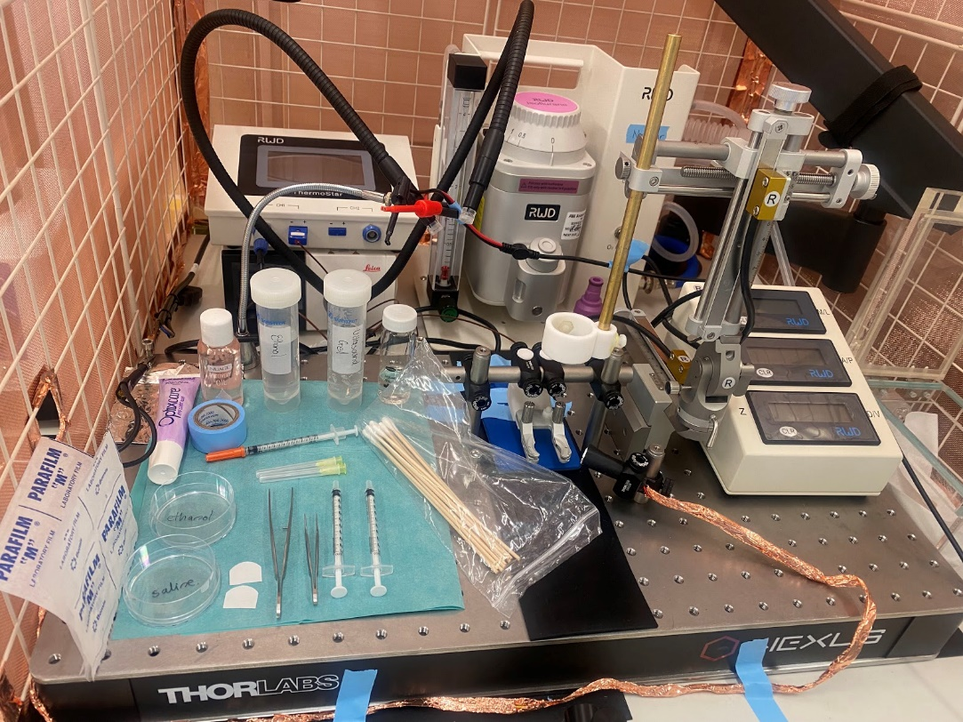

**Experiment:**

1. Anesthetize the mouse in the induction chamber. Iso to 3%, timer 2 minutes.
2. Take mouse out of chamber and move to the Neurotar. Isoflurane at 2%.
3. Toe pinch, watch breathing rate. It should be one breath per second.
4. Apply Optix care eye lube to eyes to protect them from drying out.
5. Inject mouse with 0.25ml of saline through sub-cutaneous injection.

NOTE WELL: The nosecone has a second tube inside it, this tube must be rotated to the bottom of the nosecone to fit snug over the mouse nose.

1. turn on the oxygen. 2
2. turn up the isoflurane anaesthetic system to 2
3. Turn on motor on gas canister.
4. Toe pinch. Cover with warming cover.
5. Remove the bandaid with oil.
6. Connect the reference, and electrode over V1 to the SR560 preamp. The GND should be connected to the reference as well.

**Proposed steps:**

1. Demodulation artefact test using 500khz transducer, and preamplifier.

2. Try to run ae_demod_vep_noise_test.py as a dummy run with LED not plugged in, to see the height of the center US frequency. How big is it?

3. Can I see a VEP? @7Hz, @14Hz?

4. If so, run a bunch of times.

5. Move US so it is positioned directly over but not touching mouse brain, using petri dish with US gel… do comparative measurements.

**Clean Up and Power Down:**

1. Turn Iso up to 2 for 2 minutes.
2. unplug the stimulation electrodes.
3. Move mouse from neurotar and place back in cage.
4. turn off isoflurane on experiment rig.
5. Turn off the oxygen cylinder for experiment rig, letting it flow out of anaesthetic apparatus.
6. Once empty, turn down PSI to 0, and then turn off oxygen on anaesthetic apparatus.
7. Turn off all hardware on experiment rig.
8. Wet some mouse food in a petri dish ready for it to wake up.
9. Lock computer.
10. wash all surgical instruments with anti-bacterial scrub, dry on towels alongside plastic containers.
11. tidy up all used items.
12. Turn off all equipment on surgical bench and oxygen machine.
13. Write down new weights on gas canisters on surgical bench and experiment area.
14. turn off power board.
15. cover area with plastic sheet.
16. replace cover on faraday cage.
17. put mouse in freezer in the other experiment room.
18. Do a final check all systems are off.
19. leave and turn off lights.