# Recording and stimulating using recovered screw electrode mouse:

(Isoflurane edition, following description in <https://doi.org/10.1016/j.ultras.2022.106888>)

Author: Jean Rintoul

Date: February 1 2023

Notes:

Attempt 1:

Weight: 30.0g

DOB: 13.10.2022

Cage: 105673

Experiment Usage Number: 1

I put too much cement on sides and doesn’t fit in neurotar.

Attempt 2:

Weight: 29.6g

DOB: 13.10.2022

Cage: 104605

Experiment Usage Number: 1

Attempt 3: Back to Cage: 104605. This mouse had a little cement trimmed away, but almost fit but not quite the first time. Trying it again, it still doesn’t fit.

Next thing to try with these mice is ketamine/xylazine and no neurotar at all. Friday.

Attempt 4:

**Ketamine/Xylazine specific instructions:**

**Note: A tick is 0.01ml, or one mark on the insulin syringe we use.**

On the top you can see dosage and concentrations of drugs we use. The units in the table are in terms of 'ticks' in our insulin syringes so e.g. 2 ticks = 0.02 ml. In practice it is hard to dose anything finer than 0.5 tick. If the mouse is v light (~20g), we’d give it 2 ket + 1 xyl ticks. If heavier (~25-30g), it can get 2.5 ket + 1.5 xyl. I’d err on the side of caution because it is easy to overdose them and then the experiment is over. The mouse will be anaesthetized very fast if it is straight after isoflurane induction or may take several minutes if done from awake. Expect the mouse to wake up after an hour after first dose. Check for responses every 10 minutes. If you get a response, readminister 1 tick of ket and see if this is sufficient.

**Goal:**

1. Can I induce a motor cortex response from ultrasound modulation. Video or EMG recording.

**Experiment Pre- Prep:**

1. Get the programs ready to run and check all hardware arrangements the day before.
2. Turn on the oxygen tank for the experiment area to 15psi.
3. Turn on the heat mat, turn on the lights.
4. Check the isoflurane level and fill if needed.
5. Turn on heat mat. Turn on gas canister, but not yet the motor or power up.
6. Turn on microscope light.
7. Turn on stereotaxic positioner.
8. Have injectable saline syringe ready.
9. Get DEET crème ready for shaving and saline for washing the area.
10. Prepare ultrasound transducer and mount in place with parafilm ready. Get ultrasound gel ready with dispensing syringe.
11. Sterilize EMG electrodes.
12. Ensure anesthesia system is set to chamber.

**Experiment:**

1. Anesthetize the mouse in the induction chamber. Iso to 3%, timer 2 minutes.
2. Take mouse out of chamber and move to the nosecone. Isoflurane at 2%.
3. Toe pinch, watch breathing rate. It should be one breath per second.
4. Apply Optix care eye lube to eyes to protect them from drying out.
5. Use some Deet cream on the right forepaw, then wash it off with saline such that the skin overlying the right brachioradialis muscle group is exposed.
6. Inject mouse with 0.25ml of saline through sub-cutaneous injection.
7. Move the mouse from the prep area to the experiment table, and place on top of the foam mat such that the forepaws hang down.
8. Fit headplate into neurotar, fit nosecone as soon as possible.

NOTE WELL: The nosecone has a second tube inside it, this tube must be rotated to the bottom of the nosecone to fit snug over the mouse nose.

1. turn on the oxygen. 1.5
2. turn up the isoflurane anaesthetic system to 2
3. Toe pinch. Cover with warming cover.
4. **Rough Calibration:**
5. Position transducer by eye, as close as I can, coming in at a 30 degree angle so that US pressure reaches the bottom of the screw.
6. Apply US gel to skull.
7. Slowly move US transducer down until it is a little less than 0.8cm above the skull.

**Fine Calibration:** M1 (Anterior-Posterior: −0.25 mm, Medial-Lateral = +1.5 mm; from the Bregma). To calibrate, wires should be attached to the M1 screw and the reference screw and then the US transducer positioned overhead. Use the size of the PRF to assess the size of the AE effect.

i.e. python ae_calibrate_with_prf.py

Use gain of 1000 on the preamp, 1Hz high pass filter on preamp. software: 300 Hz and 1 kHz band pass filter.

440kPa, under 0.5% isoflurane, provided a 40mV signal amplitude. With anesthesia washout period, the amplitude was larger. Larger pressure amplitudes indicate neuronal saturation and didn’t work as well.

No EMG was noticed when Iso was above 0.5%, and the amplitude after washout was far larger than 0.5% Iso.

A decline in success rate was observed at pressures > 385kPa.

Ideal target range: 330kPa ->550kPa visual response was better (at 0% Iso).

**Note: Paper recommends a 2% Iso maintenance level, followed by a 2 minute Iso washout period such that toe pinch response is possible.**

1. **Ultrasound calibration amplitudes for planar transducer:**

**i.e. V_in = 0.05, 200kPa, or V_in = 0.1, 380kPa, V_in = 0.2, 550kPa.**

**Paper shows 330kPa minimum to get response.**

**Method 1:** Motor Response method. (requires low anaesthesia level, 0.5%) with EMG recording. 330kPa?

* Run python USMEP.py in 0.5mm movement increments.
* The only feedback I can get, is going to be the EMG/motor response amplitude.
* Try this at M1, and S1 in case one is easier than the other.
* If I get either EMG or video to work in any of these – take a video. s

Method 2: AE screw method. (mouse can be in deeper anaesthesia, is it finds the pressure focus with the AE effect, and not via EMG – and the applied field is of higher frequency amplitude than should effect neural signals). Transducer may need to be at an angle, such that the pressure can reach the bottom of the screw.

1. Screw electrode at the location of the right forepaw in M1, with reference in cerebellum.
2. Inject 8khz signal through, and use the voltage monitor signal to determine the AE amplitude.
3. Move in transducer in 0.5mm increments, measuring amplitude at the sum and difference frequency each time. Map in X and Y.
4. When this amplitude is largest, it means pressure and electric signal are mixing maximally.

Once maxima is found, reduce anaesthesia level until US induced EMG/Motor movements are elicited.

If I can illicit US neuromodulation here, I should also be able to try AE neuromodulation.

1. **Place the EMG electrodes:**

Insert acupuncture needle probes as shown below:

An electromyography (EMG) electrode was implanted in the brachioradialis muscle group of the right forelimb, and another electrode was embedded between the 3rd and 4th carpometacarpal joints to obtain the EMG recordings.

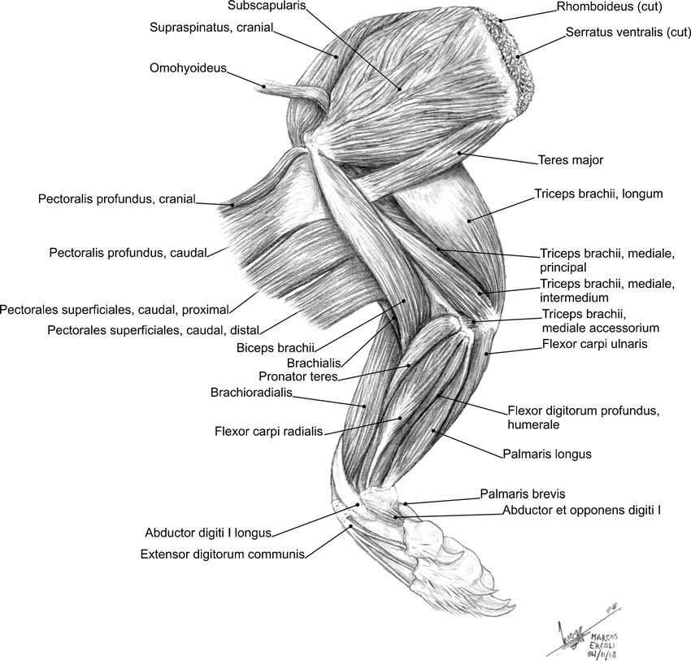

**END**

**Try doing this at 2 locations, the forelimb area and whisker area:**

* **Coordinates: MEP Forelimb Location: ML 2mm left of bregma. AP 0 mm (optional: pending whether mouse is for e stim or us stim.)**
* **Somatosensory Whisker Location: ML 3.5mm left of bregma. AP -2 mm (optional: pending whether mouse is for e stim or us stim.)**

**http://labs.gaidi.ca/mouse-brain-atlas/?ml=3.5&ap=-2&dv=0**

**QUESTION: they have the end of the cone closer to the mouse skull… what is the actual depth I should be stimulating at?**

**Clean Up and Power Down:**

- Turn Iso up to 2 for 2 minutes.

- unplug the stimulation electrodes.

- Move mouse from neurotar and place back in cage.

- turn off isoflurane on experiment rig.

- Turn off the oxygen cylinder for experiment rig, letting it flow out of anaesthetic apparatus.

- Once empty, turn down PSI to 0, and then turn off oxygen on anaesthetic apparatus.

- Turn off all hardware on experiment rig.

- Wet some mouse food in a petri dish ready for it to wake up.

- Lock computer.

- wash all surgical instruments with anti-bacterial scrub, dry on towels alongside plastic containers.

- tidy up all used items.

- Turn off all equipment on surgical bench and oxygen machine.

- Write down new weights on gas canisters on surgical bench and experiment area.

- turn off power board.

- cover area with plastic sheet.

- replace cover on faraday cage.

- put mouse in freezer in the other experiment room.

- Do a final check all systems are off.

- leave and turn off lights.