Steps to create block chain:

1.The initial step is to open a new directory and to cd into that directory, once in we run the puppeth

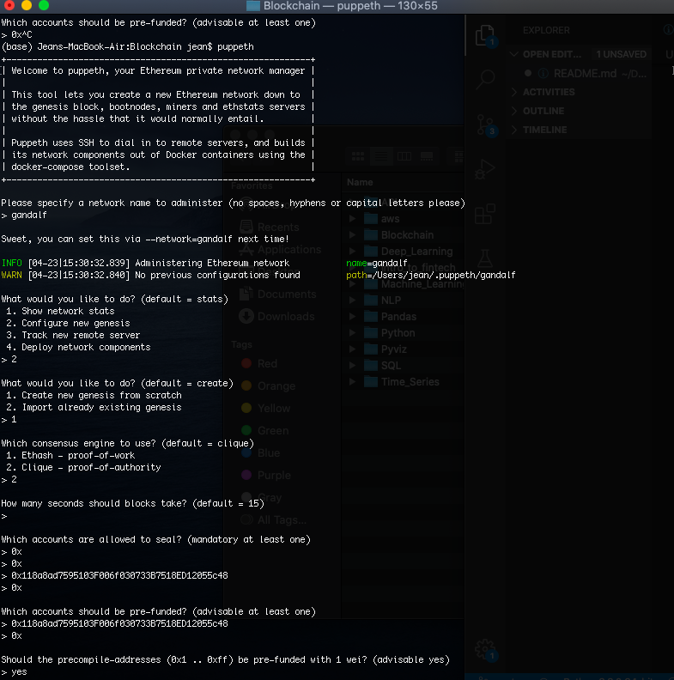

As you can see above we select a network name “gandalf”, select o configure a new genesis and create a new genesis from scratch.

As per the instuctions for the homework we chose the clique and linked it the testnet address from my Cryto (testnet address: “0x118a8ad7595103F006f030733B7518ED12055c48”)

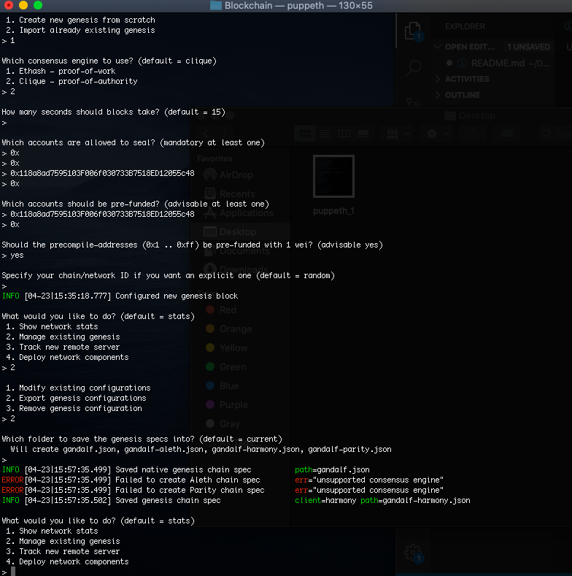

Once the puppet is run we confirm that we have the gandalf.json file in the folder.

2. Next step is to create the nodes :

We close the existing terminal and start a new one to create the nodes , we are creating 2 nodes for this activity.

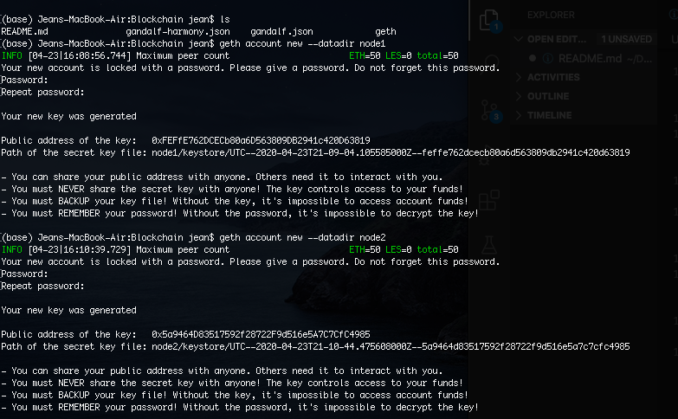

3. Initialize the node :

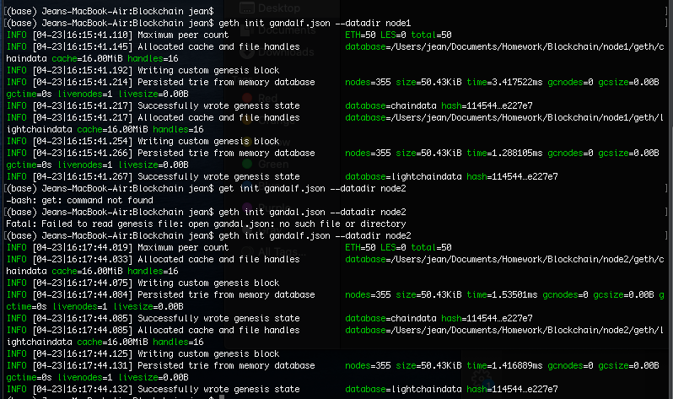

4 .Running the nodes:

Once the nodes are initialized we run then in two different terminals and we link node 1 to node two by copying the P2P : enode://fdb6281f3033d965a3727851396d644f6418c841cadd60d6ad7b057b80b270107c125cb9dc013a75e0cc85a4af886728e042382f2e389c010c1e9121626ff774@127.0.0.1:30303

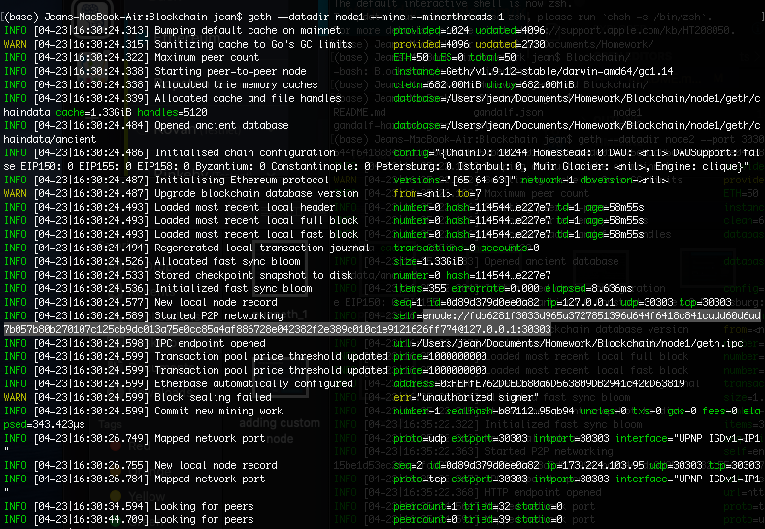

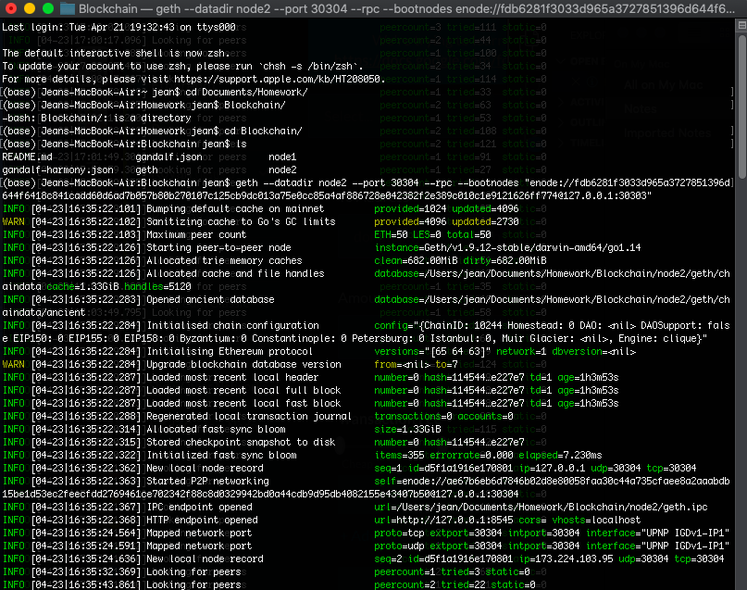

5. My Crypto :

Once both the nodes are running I go to my crypto and change network and add new network , this is to make it connect to my network.

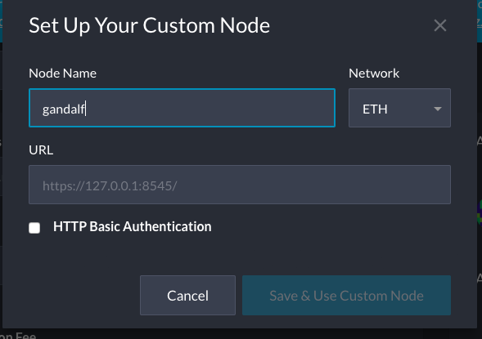

I add in my node name “gandalf” to have it connected .

And then I can see the results :

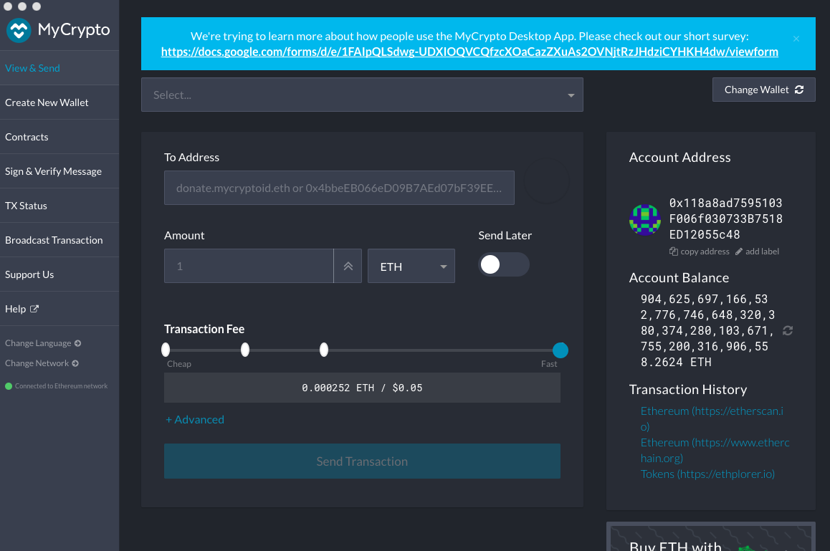

The balance in my account has changed for $0 to $ 984,625,697… this means that the transfer was successful.