MAVIA
How an uploaded learning material is processed
From upload to learning path — anatomy, computations, and why each label is assigned
Worked throughout on the two Solid, Liquid and Gas uploads
Lesson-1_Solid-Liquid-and-Gas.pdf · states-of-matter-accessible.pdf
21 September 2026 · branch jean-latest

Contents

1. How to read this guide
This guide follows one real lesson through the whole system. Every number, label, score and piece of text in it was read out of the live database after the lesson was published on 21 September 2026 — nothing here is illustrative or invented.
The lesson is Solid, Liquid and Gas, uploaded as two PDFs that teach the same material at different levels of detail. That is the normal case in MAVIA, and it is the case that shapes almost every design decision described here.
Part 2 names the parts of an uploaded file and labels them directly on screenshots of both PDFs. Part 3 follows the processing step by step, with the actual computations. Part 4 explains the parts that changed and why. Part 5 lists what is still unresolved.
The four labelled screenshots in Part 2 are the real uploaded files. Every box is placed from the text coordinates in the PDF itself, and every object number in a label is the row id in the live database, so a claim in this guide can always be checked against the file it came from.

2. Anatomy of an uploaded learning material

2.1 The vocabulary
Six words carry most of the meaning in this system. They are worth getting exactly right, because several of them changed meaning during development.
Term | In the code | What it is
Learning material | LearningMaterial | One uploaded PDF. A topic normally has two or more.
Learning object | LearningObject | One extracted teachable chunk of a PDF — a passage, a list, or a figure with its written description. The smallest unit the system stores.
Concept | LearningObjectGroup | The same teachable idea, gathered across PDFs. A concept is one step of the learning path.
Bundle | derived, not stored | All objects of ONE PDF inside one concept, in that PDF's own order. A concept holds one bundle per PDF.
Version | role on the bundle | What one PDF's bundle is used for: Normal, Simplified, Elaborated or Extra.
Prerequisite edge | ConceptPrerequisite | "Concept A should be learned before concept B." Either accepted or pending a teacher's decision.

The fields on a learning object
Extraction writes five fields that the rest of the pipeline depends on. Two of them do far more work than they appear to.
Field | Meaning | What depends on it
order | Position in its own PDF | Bundle order; the temporal-order criterion in the learning path
kind | text or image | Images need stricter evidence before they are grouped automatically
section_title | The heading the passage sat under | THE primary grouping signal. Runs of objects form from this.
title | The passage's own heading | Concept naming; the fallback grouping signal when section_title is empty
content | The narration itself | Versions, questions, audio, and every learning-path computation
section_title is the field to watch. It is how the system discovers that four separate objects are really one teachable unit. Where it is empty, that discovery does not happen, and the cost appears much later as missing edges in the learning path.

2.2 PDF A — Lesson-1_Solid-Liquid-and-Gas.pdf
Ten learning objects. This file teaches at a coarse grain: one passage per idea.
The two pages below are the actual uploaded PDF, with each region labelled with the learning object it became. The boxes are drawn from the real text positions in the file.
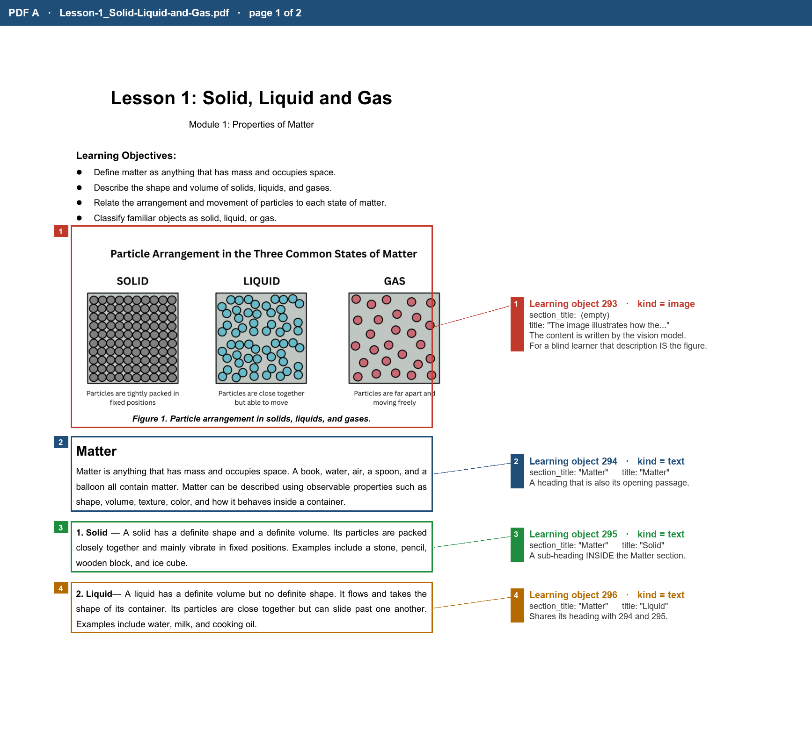
Figure 1 — PDF A, page 1. A figure object, a heading that is also a passage, and two sub-headings that share one section_title.
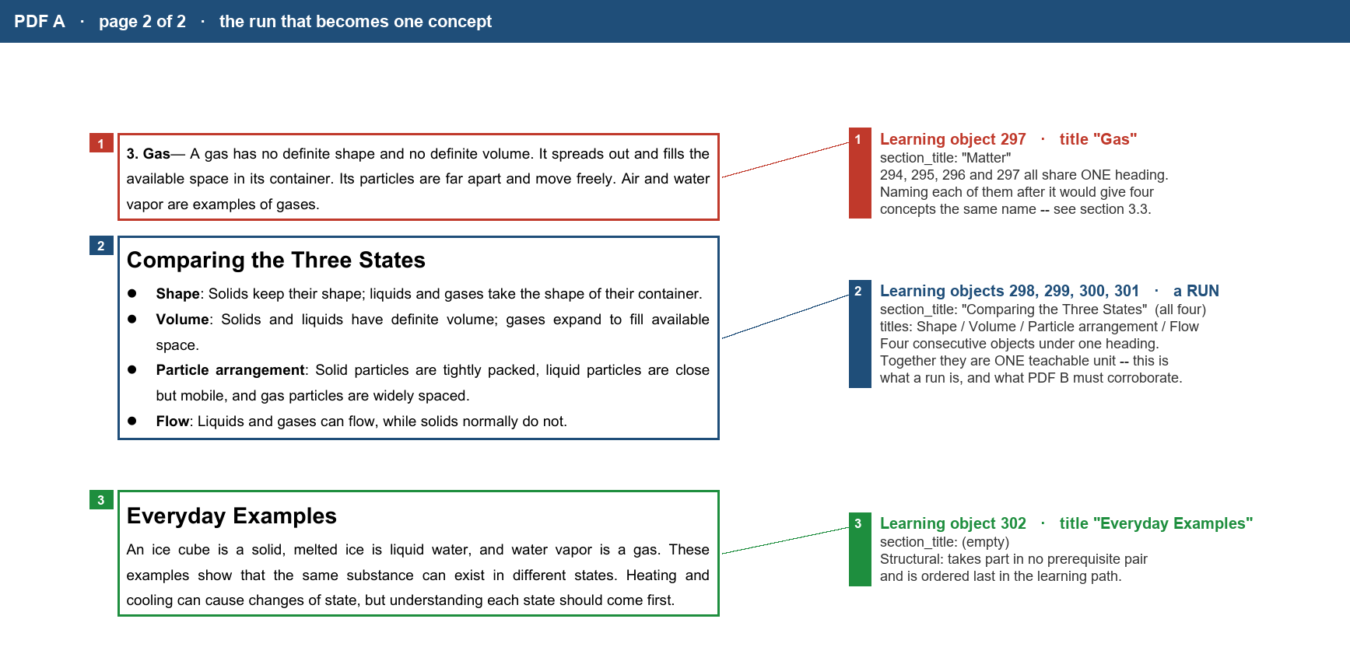
Figure 2 — PDF A, page 2. Box 2 is a run: four consecutive objects under one heading, which together form a single teachable unit.
The same ten objects as a reference table:
obj | kind | section_title | title | What it is, anatomically
293 | image | (empty) | The image illustrates how the arrangement… | A figure. Its content was written by a vision model; its title is the first 100 characters of that description.
294 | text | Matter | Matter | Section heading AND its opening passage.
295 | text | Matter | Solid | A sub-heading inside the Matter section.
296 | text | Matter | Liquid | Sub-heading, parallel to Solid.
297 | text | Matter | Gas | Sub-heading, parallel to Solid.
298 | text | Comparing the Three States | Shape | First of a RUN of four under one heading.
299 | text | Comparing the Three States | Volume | Run member.
300 | text | Comparing the Three States | Particle arrangement | Run member.
301 | text | Comparing the Three States | Flow | Run member — the run ends here.
302 | text | (empty) | Everyday Examples | Closing examples. No heading recorded.
Two things to notice. Objects 295, 296 and 297 all sit under the single heading "Matter" — so the heading does not name them; each keeps its own title. And objects 298–301 are a run: four consecutive objects sharing one heading, which together are one teachable unit.

2.3 PDF B — states-of-matter-accessible.pdf
Nineteen learning objects. The same lesson at a much finer grain: each state gets a section, a diagram description and its own examples list.
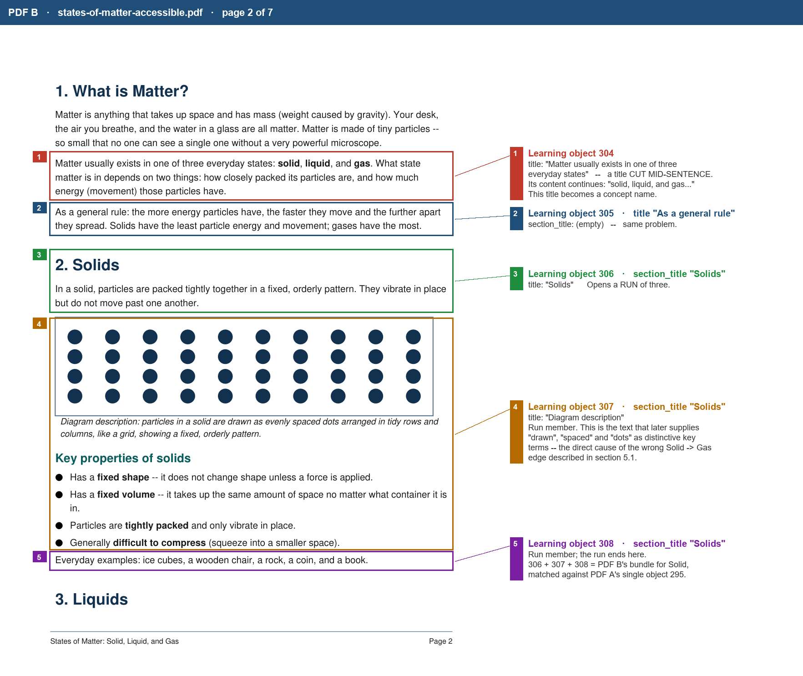
Figure 3 — PDF B, page 2. Boxes 3, 4 and 5 are one run under the heading "Solids": section, diagram description and examples. All three together answer PDF A's single object 295.
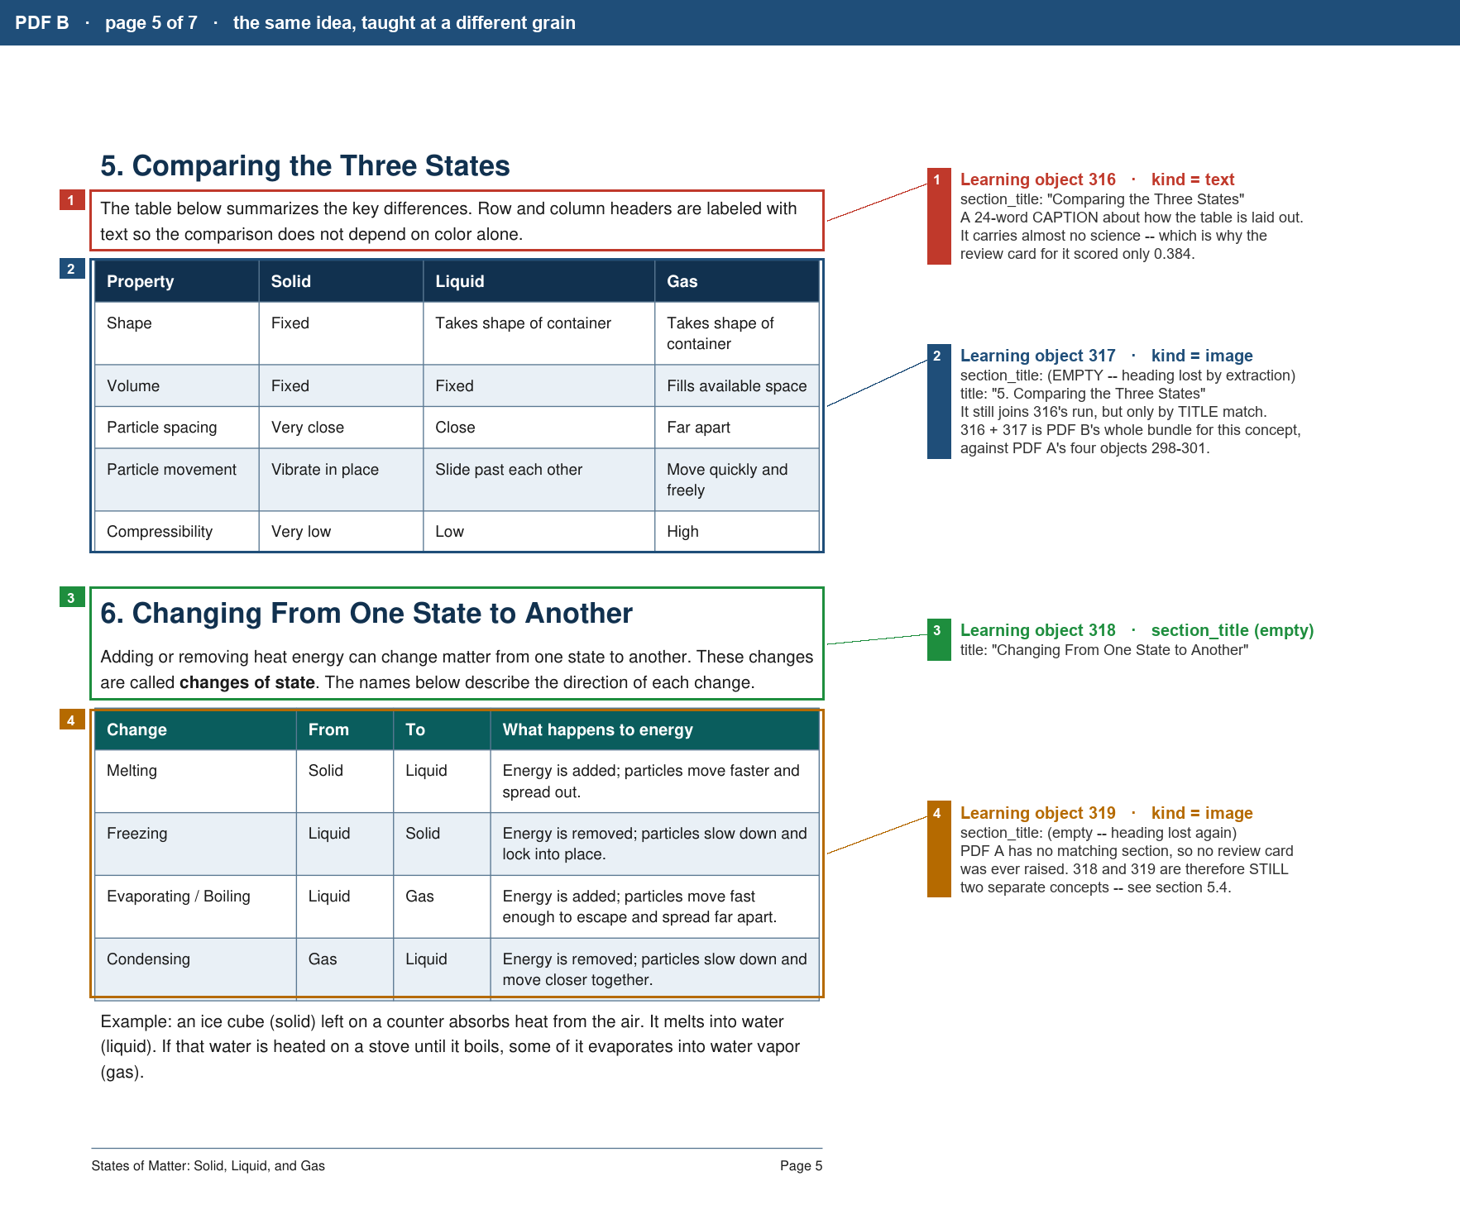
Figure 4 — PDF B, page 5. The same idea PDF A teaches as four bullet objects is here a caption plus a table figure — and both figures lost their section_title in extraction.
The same nineteen objects as a reference table:
obj | kind | section_title | title | What it is, anatomically
304 | text | (empty) | Matter usually exists in one of three everyday states | Opening passage. Its title is a sentence cut mid-way — the content continues "solid, liquid, and gas…".
305 | text | (empty) | As a general rule | Second opening passage, same title problem.
306 | text | Solids | Solids | Opens a RUN of three.
307 | text | Solids | Diagram description | Run member — a figure's written description.
308 | text | Solids | Everyday examples | Run member. The run ends here.
309 | text | Liquids | Liquids | Opens a RUN of four.
310 | text | Liquids | Diagram description (Part 1 of 2) | Run member, split by the chunker.
311 | text | Liquids | Diagram description (Part 2 of 2) | Run member, the other half.
312 | text | Liquids | Everyday examples | Run member.
313 | text | Gases | Gases | Opens a RUN.
314 | text | Gases | Diagram description | Run member.
315 | text | Gases | Everyday examples | Sits under Gases but is a closing list.
316 | text | Comparing the Three States | Comparing the Three States | A caption: 24 words about how the table is laid out.
317 | image | (empty) | 5. Comparing the Three States | The table figure itself. Heading LOST by extraction; only the numbered title survives.
318 | text | (empty) | Changing From One State to Another | Caption for the next figure.
319 | image | (empty) | 6. Changing From One State to Another | The figure. Heading lost again.
320 | text | (empty) | Example | A worked example.
321 | text | Everyday Examples | Everyday Examples | Caption.
322 | image | (empty) | 7. Everyday Examples | Figure. Heading lost.

2.4 The central difficulty: the two files disagree about grain
Put the two side by side and the problem the whole grouping design exists to solve becomes obvious.
The idea | PDF A teaches it as | PDF B teaches it as
Solid | 1 object (295) | 3 objects (306, 307, 308) — section, diagram, examples
Liquid | 1 object (296) | 4 objects (309–312)
Gas | 1 object (297) | 2 objects (313, 314)
Comparing the Three States | 4 objects (298–301) — Shape, Volume, Particle arrangement, Flow | 2 objects (316, 317) — caption and table figure
Neither file is wrong. A concept therefore cannot be "one object from each PDF" — it has to hold however many objects each file spends on the idea. That is what a bundle is, and it is the single biggest change in the pipeline.

3. How the material is processed, step by step

3.1 Upload and extraction
The PDF is parsed into the ordered learning objects shown above. Figures become objects whose content is written by a local vision model, because a blind learner cannot see the figure and the description IS the lesson content for that object.
The teacher then confirms the objects for each file. Nothing downstream looks at a file whose objects are unconfirmed.

3.2 Grouping objects into concepts
This is the step that reconciles the two grains. It runs in three stages, and it deliberately refuses to guess.

Stage 1 — find runs inside each PDF
A run is two or more consecutive objects sharing a non-empty section_title, extended by an immediately following object whose title equals that heading once numbering is stripped and plurals are folded.
That extension rule is why object 317, titled "5. Comparing the Three States" with no
PDF A: [298 Shape, 299 Volume, 300 Particle arrangement, 301 Flow]
heading = "Comparing the Three States" -> a run of 4

PDF B: [316 Comparing the Three States, 317 "5. Comparing the Three States"]
heading = "Comparing the Three States" -> a run of 2
(317 joins by TITLE, its heading is empty)

Stage 2 — require corroboration from the other PDF
A run is never acted on alone. Document structure by itself over-merges: a "Matter" section holds Matter, Solid, Liquid and Gas, and merging those would be a disaster. The run becomes a concept only when another file names the same unit with a matching heading or title.
Pure similarity scores cannot do this job either. Measured on this lesson, the cross-encoder scored nearly every item of one PDF between 0.5 and 0.65 against every section of the other — no threshold separates a real match from noise. Structure finds the candidate; the score only confirms it.

Stage 3 — act, or ask
Score | What happens | Why
≥ 0.60 | The objects are placed into one concept automatically | Confident enough that asking would waste the teacher's time
0.30 – 0.60 | A review card is raised for the teacher | Plausible but not certain — the teacher decides
< 0.30 | Nothing | Below this, matches were noise
Images carry an extra rule, added 21 September 2026: a figure is never grouped automatically on wording alone, only with label corroboration. Two AI-written figure descriptions share stock phrasing and scored 0.6+ against each other regardless of subject — three separate wrong pairings came from this before the rule existed.

What actually happened on this lesson
Card | Pairs | Score | Teacher's decision
141 | 295 Solid ↔ 306 Solids | 0.648 | auto-placed (≥ 0.60)
142 | 296 Liquid ↔ 309 Liquids | 0.625 | auto-placed
143 | 297 Gas ↔ 313 Gases | 0.616 | auto-placed
144 | 297 Gas ↔ 314 Diagram description | 0.610 | auto-placed
147 | [298,299,300,301] ↔ [316,317] | 0.384 | ACCEPTED by the teacher
148 | 302 ↔ [321,322] | 0.545 | accepted
145 | 302 Everyday Examples ↔ 320 Example | 0.547 | accepted
146 | 293 particle figure ↔ 322 examples figure | 0.569 | REJECTED — wrong subject
Card 147 is the important one. It scored only 0.384 — below the automatic threshold — because a 24-word caption about table layout does not read much like four short attribute passages. The system asked instead of guessing, and it was right to: accepting it was worth four prerequisite edges in the final learning path (section 3.8).
Card 146 is the counter-example. At 0.569 it scored higher than the correct card, purely on shared figure-description style, and it pairs a particle diagram with an examples table. The teacher rejected it. This is exactly the case the image rule exists to route to a human.

The result
Twenty-nine objects across two PDFs became 12 concepts. Four of them hold objects from both files:
Concept | Bundle from PDF A | Bundle from PDF B
Solid | 295 | 306, 307, 308
Liquid | 296 | 309, 310, 311, 312
Gas | 297 | 313, 314
Comparing the Three States | 298, 299, 300, 301 | 316, 317
Everyday Examples | 302 | 320, 321, 322

3.3 Naming the concept
A concept's name matters more than it looks: it is read aloud to the learner, and it is the strongest single term in the learning-path computation. The rule has one condition:
- A bundle of two or more objects takes its section heading as the concept name.
- A bundle of exactly one object keeps that object's own title.
The second half is not a detail. Objects 295, 296 and 297 all sit under the heading "Matter". Applying the heading rule to them would name three different concepts "Matter" — and the learning path vetoes any edge between two concepts sharing a name, so Solid, Liquid and Gas would have lost every edge between them and the rest of the lesson.

3.4 Content versions
Each concept is offered to the learner at three levels. The roles are assigned per bundle, not per object — a role belongs to everything one PDF wrote about the concept.
Role | Meaning
Normal | The baseline wording. One PDF's bundle supplies it.
Simplified | Plainer wording for a learner who is struggling.
Elaborated | Fuller wording for a learner who wants more.
Extra | Additional wording kept but not offered as one of the three.
Gemma reads the bundles and assigns the roles, with a stated confidence and reason. For the Solid concept:
obj 295 (PDF A) -> ORIGINAL confidence 0.95
"the most complete and balanced initial description of matter,
providing definitions, examples, and key properties"

obj 306 (PDF B) -> ELABORATED confidence 0.85
"provides a more detailed explanation of solids, including a visual
representation (grid) and a discussion of compressibility"

=> stored as bundle_roles { PDF B: ELABORATED }
assigned_by { PDF B: llm_validated }
A version a PDF supplies stores no copied text. Its text is its objects. Only a generated version creates stored rows, and those are written one object of the Normal bundle at a time — a long bundle in a single request is where Gemma returns invalid JSON.
Roles are only written down by a run that was actually asked to classify, or by the teacher. Simply opening the review screen records nothing (see section 4.5).

3.5 Questions and audio
A question bank is generated per concept from its Normal text only, so a learner is never asked about wording they were not given.
Every object and every generated version is then converted to speech with Edge TTS and cached by a digest of the narration, voice and provider — so re-publishing does not re-synthesise text that has not changed. For this lesson: 20 playlist clips and 40 version rows, all present on disk.

3.6 The publish gate
Before anything is published the system checks that every concept has its versions and every version has real audio. The gate refuses rather than shipping a lesson with a silent track or a missing version — for a blind learner, silent audio is not a cosmetic defect, it is the lesson disappearing.

3.7 Building the prerequisite graph
This is where the computations live. The thesis commits to three criteria and a vote, each traceable to published work. Concepts that are structural furniture — Everyday Examples and the like — take part in no pair at all and are ordered last.

Step 1 — give each concept its key terms
A concept can be referred to by its name, or by the distinctive terms it introduces. Both are collected, with three rules:
- A term used by more than 34% of the topic's concepts belongs to none of them. In a states-of-matter lesson, "particles" is used everywhere and carries no information.
- A distinctive term belongs to the concept that introduces it — the earliest one using it — not the one using it most.
- The concept's name weighs as much as all its other terms combined, because naming a concept is the plainest possible reference to it.
For the Solid concept, computed live:
Solid — 36 key terms, total weight 139.104

name "solid" weight 69.552
terms vibrate, stone, pencil, wooden, block, ice, cube,
orderly, pattern, evenly, mainly, ... (35 terms)
each weight ln(10/1) = 2.303

69.552 + 35 x 2.303 = 139.104

Step 2 — measure reference in both directions
This is the RefD idea (Liang et al., 2015): A is a prerequisite of B when B refers to A more than A refers to B. The score is the weighted share of A's key terms that B's text actually uses.
ref(A -> B) = sum of weights of A's key terms found in B's text
-------------------------------------------------
total weight of A's key terms
Worked on the real lesson — the strongest edge in the topic:
Solid -> Comparing the Three States

A's terms found in B : column, past, place, row, solid, spaced
matched weight : 76.788 ("solid" alone is 69.552)
total weight of A : 139.104

ref_forward = 76.788 / 139.104 = 0.552
ref_backward = 0.000
margin = 0.552 -> reference votes YES
One shortcut exists. If concept B sits under a heading named after concept A — "Solid" under the heading "Matter" — reference is set straight to 1.0 without counting terms. Sitting inside a section is the strongest statement of dependence a document can make.

Step 3 — the three criteria vote
Criterion | Question it answers | Source
Temporal order | Does A come before B in the merged document order? | Wang et al. 2016
Semantic reference | Does B refer to A more than A refers to B? | Liang et al. 2015 (RefD)
Foundationality | Is A referred to a lot while referring little itself? (inbound / outbound ratio, by a margin of 0.25) | Aytekin & Saygin 2024
Votes | Outcome
3 of 3 | Accepted — becomes an edge
2 of 3 | Pending — raised to the teacher
fewer | Discarded
One guard matters: position alone can never create an edge. Temporal order votes on one direction of every single pair — with 12 concepts that is 132 votes cast before a word has been read — so at least one content criterion must agree as well.
Two vetoes then remove pairs the votes allowed: two concepts sharing a name cannot depend on each other, and if B mentions A only to contrast with it ("unlike a solid…"), reading B does not build on A.

Step 4 — order the graph
Kahn's algorithm turns the accepted edges into a sequence. Structural concepts are appended at the end. The published order for this lesson:
1 Matter usually exists in one of three everyday states
2 The image illustrates how the arrangement of tiny particles…
3 As a general rule
4 Matter
5 Solid
6 Liquid
7 Gas
8 Comparing the Three States
9 Changing From One State to Another
10 Changing From One State to Another
11 Everyday examples
12 Everyday Examples

3.8 How good is the result?
The teacher hand-specified the correct edges and order for this lesson. That gold standard is the acceptance test. The lesson was scored twice — once before the teacher answered the grouping review queue, once after.
Measure | Gold standard | Before answering cards | After answering cards
Concepts | 7 | 20 | 12
Required edges accepted | 10 / 10 | 6 / 10 | 9 / 10
Forbidden edges | 0 | 0 | 1
Order | — | matches | matches
Answering one review card was worth four edges. The four that were missing beforehand — Solid, Liquid and Gas each pointing to Comparing, and Comparing pointing to Changing — were all pending, never absent, and the stored evidence showed exactly why: two criteria of three fired strongly, and only foundationality failed, because the Comparing concept had fragmented into six pieces and no piece accrued enough inbound reference.
The companion lesson, Reproduction Among Flowering Plants, reproduced its gold result exactly on this same publish: 4 of 8 required edges, the same four recorded gaps and no new ones, zero forbidden edges, and an order identical to the gold sequence.

4. What changed, and why
Each entry below states the problem that was observed, what caused it, what was done, and why that fix rather than another.

4.1 A concept could hold only one object per PDF
Problem. PDF B teaches Solid as a section, a diagram description and an examples list. Those three objects could not join the concept that PDF A's single Solid passage belonged to.
Cause. A concept admitted at most one object per PDF. The teacher worked around it with a manual Merge button that combined several objects into one row — which rewrote lesson text, so a wrong guess was destructive, and undoing it discarded hand-edited versions and audio.
Fix. The one-object-per-PDF limit was removed and the Merge feature was deleted entirely. A concept now holds an ordered bundle per PDF, derived on demand from one helper that every consumer reads through.
Why this fix. The teacher's intent — "these three objects are the same teachable unit as that one" — is a fact about the documents, so it should be derived rather than clicked. Keeping objects whole means nothing is destructive: a wrong bundle is corrected with a move, not an undo that regenerates content.

4.2 Three concepts were all named "Matter"
Problem. Solid, Liquid and Gas were each given the name "Matter", and then lost every prerequisite edge connecting them to the rest of the lesson.
Cause. A concept took its bundle's section heading as its name. In PDF A all three sit under the single heading "Matter", so all three got that name — and the learning path vetoes any edge between two concepts sharing a name.
Fix. A bundle takes its heading as the concept name only when it holds two or more objects. A single-object bundle keeps that object's own title.
Why this fix. A heading over several objects names the unit they form; a heading over one object names the whole section, not the object. The distinction is exactly the multi-object condition, so the rule is a description of the documents rather than a patch.

4.3 Figures were grouped with the wrong figures
Problem. Three separate wrong pairings, including a particle-arrangement diagram grouped with an Everyday Examples table.
Cause. Two AI-written figure descriptions share stock phrasing — "the image illustrates…", "drawn as… dots" — and scored 0.6+ against each other regardless of what they actually depicted. The score was measuring house style, not subject.
Fix. An image is never grouped automatically on wording alone. It needs label corroboration as well; otherwise the pairing becomes a review card.
Why this fix. The similarity signal is genuinely unreliable for this content, and no threshold separates it, so the correct response is to route the decision to a human rather than to re-tune a number. On this lesson the rule worked: card 146 scored 0.569 and was correctly rejected by the teacher.

4.4 A published lesson shipped a silent version, and a two-PDF topic could not publish at all
Problem. After versions supplied by a PDF stopped storing copied text, audio generation produced a silent track for those versions, and the publish completeness gate refused every two-PDF topic.
Cause. Both consumers decided whether a version existed by counting stored version rows. A PDF-supplied version has no such row — its text is its objects — so both read "no version" for versions that were plainly there.
Fix. Both were changed to ask for the concept's bundles instead of counting rows.
Why this fix. The rule is now explicit: anything that counts stored rows to decide whether a version exists is wrong. Both defects were invisible to a fully passing test suite, because the publish test mocked the middle of the pipeline and used a single PDF — which is why this pair is called out rather than quietly fixed.

4.5 The grouping step was already classifying versions
Problem. A concept showed Simplified or Elaborated in step 1 — the grouping step — before the teacher had reached the classification step and before Gemma had seen it.
Cause. The endpoint behind the whole topic screen called the version assignment on every page load. Even without the model it compared readability, chose a role, and wrote it to the database. Opening the page was recording a decision.
Fix. Only a run that was actually asked to classify writes a role now. A read still computes and returns the proposal, but records nothing; the role badge was removed from the grouping step.
Why this fix. Step 1 answers "which objects teach the same thing". A role is an answer to a different question, and showing a provisional guess in the place where decisions are made invites a teacher to trust something nobody decided.

4.6 Publishing failed on one concept with "Gemma did not return valid JSON"
Problem. One concept failed all three attempts, every time, blocking the entire publish.
Cause. Gemma wrote both versions correctly and within their word limits, then closed the last string with a typographic right quote instead of a straight one. The string never terminated, so the constrained decoding never saw the object close, generation ran to the token limit, and the tail filled with the prompt's own word limits echoed back.
Fix. When a reply will not parse, the quote delimiters are repaired and the result is kept only if it then parses.
Why this fix. The model's output was correct; only its envelope was malformed. Repairing the envelope preserves what it wrote — including a curly apostrophe mid-sentence — while a reply that genuinely needs its own quotes rewritten still fails to parse and is still refused.

4.7 Publishing failed repeatedly on audio
Problem. Edge TTS reported that it could not connect, across several attempts and several networks.
Cause. Diagnosed twice as a blocked host, which was wrong. Probing ten times instead of once showed 2 successes in 10: the host was always reachable and the network simply dropped most handshakes. Because each clip was attempted once and then raised, a single dropped clip ended the run for every clip after it.
Fix. Each clip is retried up to 20 times, 1.5 seconds apart, and a partial file from a dropped stream is deleted before the retry.
Why this fix. A dropped connection returns immediately, so an attempt costs about a second while giving up costs the whole publish. Deleting the partial file matters independently: a half-rendered narration that was mistaken for a finished clip would reach a blind learner as truncated audio.

4.8 The learning path proposed reversed and spurious edges
Problem. On the two gold lessons the criteria accepted 0 of 10 and 1 of 8 required edges, and one summary table collected 13 wrong ones.
Cause. Reference was measured as the similarity between concept A's name and concept B's text. Similarity is symmetric; dependence is not. Of eight misses measured, seven were the correct pair pointing the wrong way.
Fix. Reference was replaced with the RefD key-term measure described in section 3.7, head-word mentions and section containment were added, Examples-type concepts were excluded from pairing and ordered last, and the cross-section cap was removed.
Why this fix. RefD asks a directional question — does B refer to A more than A refers to B — which is the question dependence actually poses. After the change the same two lessons scored 10 of 10 and 4 of 8.

5. What is still unresolved
These are open as of 21 September 2026, roughly in order of how much they cost.

5.1 One wrong prerequisite edge is live
The published path accepts Solid → Gas. Solid, liquid and gas are parallel states; neither is groundwork for another. A learner would be told to master Solid before Gas.
The stored evidence names the cause precisely:
Solid -> Gas [accepted]
temporal 1 · reference 1 · foundational 1
ref_forward = 4.816 / 139.104 = 0.0346
terms found = compress, dot, drawn, spaced
Those four "distinctive terms" are not science. They come from the two diagram descriptions now bundled into the concepts:
Solid: "particles in a solid are drawn as evenly spaced dots…"
Gas: "particles in a gas are drawn as widely spaced dots…"
Same vision model, same house style, same rendering vocabulary. The criteria assign those terms to the earliest concept using them and then see the other concept "using" them, at a reference score of 0.035 — noise that passes because the required margin is zero.
This is the figure-description problem of section 4.3 reappearing inside the learning path rather than inside grouping.
A simple minimum on the reference score will not work. Legitimate accepted edges in this same run sit just as low: Matter → Comparing at 0.0257 and Gas → Changing at 0.0207. A floor that killed 0.0346 would kill those too. The candidate fix is to stop rendering vocabulary — drawn, dots, spaced, shown, illustrates, diagram — counting as distinctive at all, since it describes the medium rather than the science.

5.2 The test suite cannot catch that class of failure
The gold fixtures hold an older upload's text, which contains no such figure descriptions. The gold path test therefore passes while the live output carries a forbidden edge. A fixture built from the text the current extraction actually produces would close this gap, and is arguably the most valuable single thing outstanding.

5.3 Figure descriptions have not been regenerated
The description prompt was rewritten as Role / Task / Context / Format, with a no-preamble rule and an instruction not to restate the lesson text. The existing descriptions predate it. One concept is still named:
"The image illustrates how the arrangement of tiny particles
relates to the different states of matte"

-- cut mid-word at 100 characters
That string is a concept name, a learning-path key term, and something a blind learner hears read aloud. This item was deferred twice as cosmetic; section 5.1 shows it is not.

5.4 Caption-and-figure pairs with no partner stay split
"Changing From One State to Another" is still two concepts — a caption object and its figure, both from PDF B. PDF A has no matching section, so no corroboration exists and no review card was raised. They have to be joined by hand with the Move to… control. This is the one remaining required edge missing from the lesson.

5.5 Extraction quality
- Titles are cut mid-sentence. "Matter usually exists in one of three everyday states" is a title whose content continues "solid, liquid, and gas…". These become concept names.
- Section headings are lost on figures. Objects 317, 319 and 322 all have an empty section_title. The title-matching fallback compensates, but it is a fallback.
- Descriptions phrased around what is drawn rather than what is true create false prerequisites, as section 5.1 shows.

5.6 Four known gaps on the companion lesson
On Reproduction Among Flowering Plants, four required edges remain unmade: stamen→pollination and pistil→pollination come out pending, and pollination→fertilization and fertilization→seed are not proposed at all. The causes are known — the linking words (pollen, anther, stigma) are used by too many concepts to count as distinctive, and there is no stemming, so "fertilized" never matches "fertilization".
These were deliberately left rather than tuned away. The constants are already fitted to two lessons, and tuning them further on the same two lessons would fit noise. A third lesson is what the criteria actually need.

5.7 Smaller items
- Empty concepts are not cleaned up when a material is deleted. A stale concept carries its version selection, so a re-upload can inherit a role or a locked name for text that no longer exists.
- There is no frontend test runner, so the bundle controls are verified by reading the code and by clicking them.

All figures, scores and text in this guide were read from the live database on 21 September 2026, after both topics were published.

