Topic Modeling with Latent Dirichlet Allocation: Methodology and Preliminary Results
Corpus: AI ethics, generative AI, and large language models (Scopus, 2018–2026) Generated: 2026-11-08 18:24 Repository: https://github.com/JeanVydes/bertlda Full configuration: outputs/results/config/model_configuration_full.json
Scope note. This document presents the methodology and preliminary results of the LDA topic model. The collection and de-duplication process (PRISMA, Scopus) is summarized in Section 1; the modeling corpus in this repository is the Scopus export of 20,000 records. Fields marked [TO COMPLETE] must be taken from the previous delivery for the final version.

1. Corpus collection and de-duplication

1.1 Sources and search strategy
The systematic review collected records from Scopus only (no Web of Science integration is used in this delivery). The corpus targets the intersection of artificial intelligence, generative AI, large language models, and their ethical, social, regulatory, and safety dimensions:
- Source: Scopus (only source used in this delivery)
- Scopus search string: ( "generative AI" OR "large language model*" OR "language model" OR "foundation model*" OR GPT OR chatbot OR "text generation" ) AND ( governance OR ethics OR regulation OR "responsible AI" OR "algorithmic accountability" OR "AI policy" ) AND PUBYEAR AFT 2017 AND PUBYEAR BEF 2028 AND ( LIMIT-TO ( LANGUAGE , "English" ) ) AND PUBYEAR > 2017 AND PUBYEAR < 2027
- Scopus query date: 2026-10-11 (query performed four weeks before the current date)
The export used in this delivery contains 20,000 Scopus records (field Source = Scopus), with title, abstract, keywords, year, source, affiliations, affiliation country, document type, and DOI. The observed time window is 2018-2026; the year 2026 is incomplete because the export was performed during that year.

1.2 PRISMA process
The PRISMA 2020 process (Page et al., 2021) is summarized below for the Scopus modeling corpus.
Metric | Value
Total records | 20000
With title | 20000
With abstract | 20000
With both | 20000
Without useful text | 0
DOI duplicates | 20
Title duplicates | 59
Excluded by length | 495
USABLE DOCUMENTS | 19505
Year range | 2018-2026
Countries (normalized) | 86
Corpus ALL CAPS | 0.0%
Uppercase normalization | False
Docs >350 words | 739
Distinct sources | 5697

- Records identified (Scopus): 20,000
- Records without title or abstract: 0
- Excluded by length (< 20 words): 495
- Duplicates detected: 20 by DOI and 59 by title (retained and reported as a limitation)
- Final documents for LDA: 19,505
- Normalized countries: 86
- Distinct sources: 5,697

1.3 PRISMA flow diagram
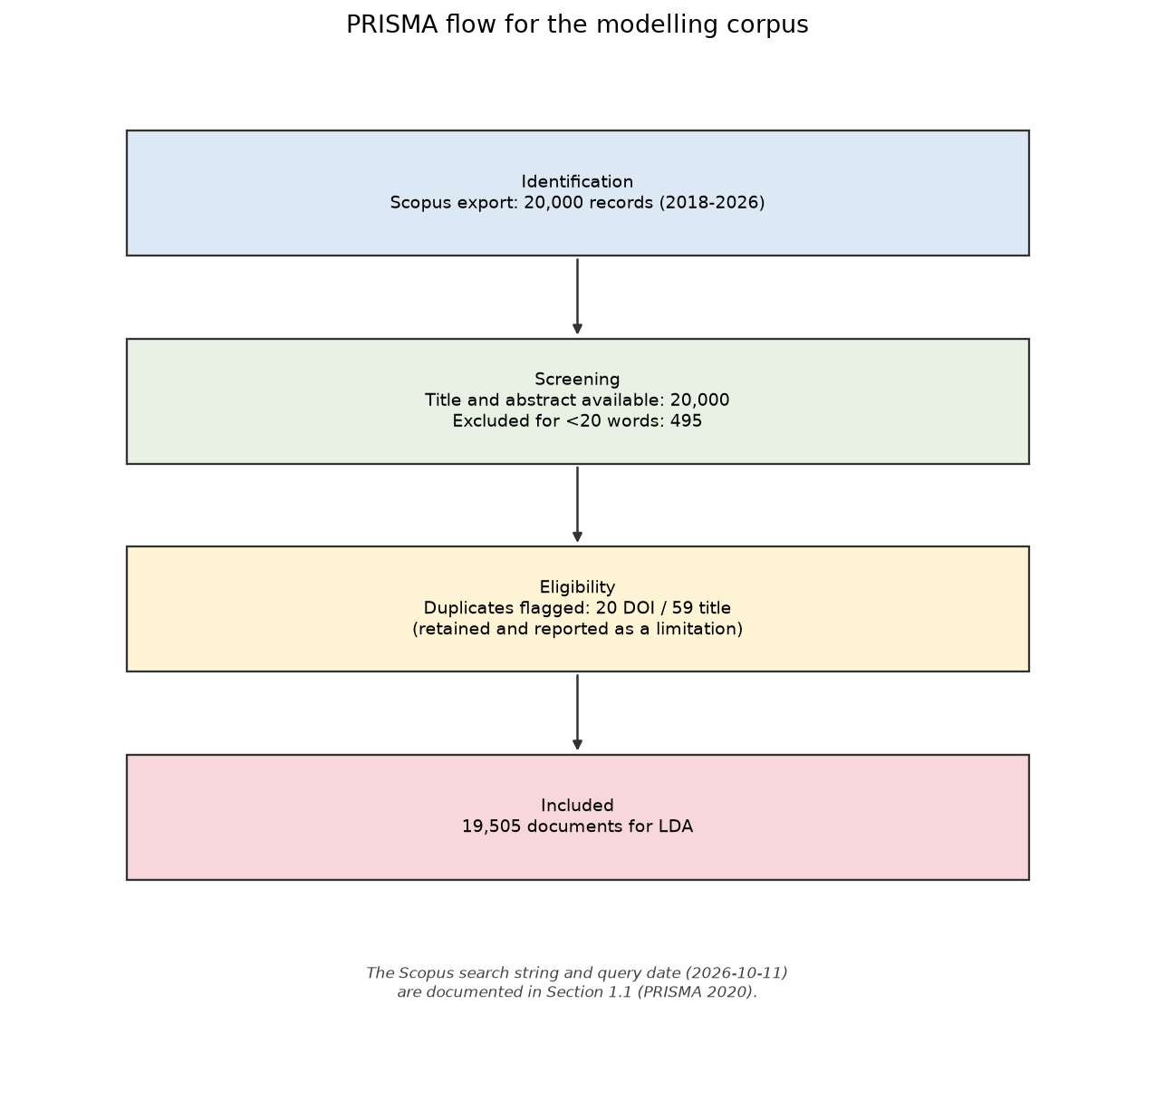
Figure 1. PRISMA flow diagram
The diagram above documents the flow of the Scopus corpus actually modeled (identification, screening, eligibility, inclusion).

1.4 Final corpus
The final corpus contains 19,505 documents with sufficient text for modeling. The annual distribution shows a strong concentration in recent years, consistent with the rise of generative AI:
Year | Documents | %
2018 | 2 | 0.0100
2019 | 1 | 0.0100
2021 | 1 | 0.0100
2022 | 31 | 0.1600
2023 | 556 | 2.8500
2024 | 2763 | 14.1700
2025 | 6883 | 35.2900
2026 | 9268 | 47.5200

2. Text preprocessing

2.1 Fields used
Title and abstract (Title + Abstract) were used. Author and index keywords (Author Keywords, Index Keywords) are available in the export but were not concatenated to the input text, in order to avoid duplicating terms and to keep a homogeneous representation across documents.

2.2 Techniques applied
- Unicode normalization and lowercasing.
- Editorial noise removal: URLs, e-mail addresses, numeric citations,
copyright notices, licenses, and "published by" sentences.
- Tokenization by whitespace over cleaned text.
- WordNet lemmatization (nouns first, then verbs).
- Stopword removal in four layers:
- English functional stopwords (NLTK);
- editorial stopwords (Elsevier, Springer, MDPI, "journal", "abstract", etc.);
- methodological stopwords ("study", "results", "method", "approach", etc.);
- AI-ethics domain terms and valid acronyms.
- Length filtering: tokens shorter than 3 characters are discarded, except
valid acronyms (ai, llm, gpt, nlp, gdpr, etc.).
- Bigrams: collocations are detected with gensim.models.phrases
(min_count=59, threshold=8), for example generative_ai, artificial_intelligence, machine_learning.
- Vocabulary filtering: the training dictionary removes terms with
document frequency below 39 and above 0.5 of documents.
- No aggressive stemming: lemmatization is preferred to preserve topic
interpretability.

2.3 Tools
- Python 3.13 and NLTK for tokenization, stopwords, and lemmatization.
- Gensim 4.4 for bigrams, dictionary, BoW corpus, and LDA.
- pandas / NumPy for data manipulation.
- Matplotlib for figures.

2.4 Preprocessing results
Metric | Value
Modeled documents | 19,505
Total tokens | 2,361,836
Tokens per document (mean) | 121.09
Training vocabulary | 4,533
Evaluation vocabulary | 23,887
Documents with empty BoW | 0
Total stopwords | 288

Cleaning is implemented in src/bertlda/text_processing.py and applied deterministically in src/bertlda/phase1a_lda_diagnostic.py.

3. LDA model foundations
Latent Dirichlet Allocation (Blei, Ng & Jordan, 2003) is a hierarchical generative model for collections of discrete documents. Each document is represented as a mixture of a fixed number of topics, and each topic as a distribution over the vocabulary. Formally, for a document d:
θ_d ~ Dirichlet(α), z_{d,n} ~ Categorical(θ_d), w_{d,n} ~ Categorical(φ_{z_{d,n}})
where θ_d is the document's topic proportion vector, z_{d,n} is the latent topic of word n, and φ_k ~ Dirichlet(η) is the word distribution of topic k. The joint likelihood integrates out the latent variables, and is approximated by variational inference or Gibbs sampling; Gensim uses online variational inference.
LDA is appropriate for this corpus because:
- documents are short, heterogeneous texts (title + abstract), where a
probabilistic mixture model is more stable than hard clustering;
- the objective is to describe the thematic structure and its evolution,
not to classify documents into predefined categories;
- the document-topic matrix (Theta) supports downstream analysis with
HJ-Biplot, LDAvis, and trend models;
- AI-ethics literature is interdisciplinary: a single document can combine
governance, bias, privacy, and technical evaluation, which favors a mixed representation.

4. Selecting the number of topics (K)

4.1 Coherence metrics
Two complementary metrics were evaluated:
- C_v (Röder, Both & Hinneburg, 2015): combines semantic similarity
between words, a sliding window, and mutual confirmation; it is the reference metric for comparing topics in scientific corpora.
- NPMI (Bouma, 2009): normalized pointwise mutual information; it
penalizes spurious associations and is easily interpretable in [-1, 1].
Topic diversity (proportion of unique words in the top-10 of all topics), perplexity, dominance (share of the most frequent topic), and the normalized entropy of the size distribution were also recorded.

4.2 Evaluated range and decision criterion
K = 4–40 (37 values) was evaluated. The coherence curve reaches its global maximum at K = 40 (C_v = 0.5696), but the gain over K = 27 is marginal (+0.0056) and concentrated in the plateau region. K = 27 was selected for the following reasons:
- Coherence plateau: K = 27 already lies on the plateau
(C_v = 0.5640; NPMI = +0.0749).
- Parsimony and interpretability: 27 topics produce a manageable
thematic structure aligned with the dimensions of AI ethics (safety, bias, governance, education, health, etc.).
- Diversity: the top-10 diversity is 0.7889, high for this
corpus size.
- Dominance: the most frequent topic concentrates 10.6%
of documents, below the excessive-dominance threshold (40%).
- Stability: the sensitivity analysis (Section 6) confirms that the
K = 27 structure is comparable to its neighbours.
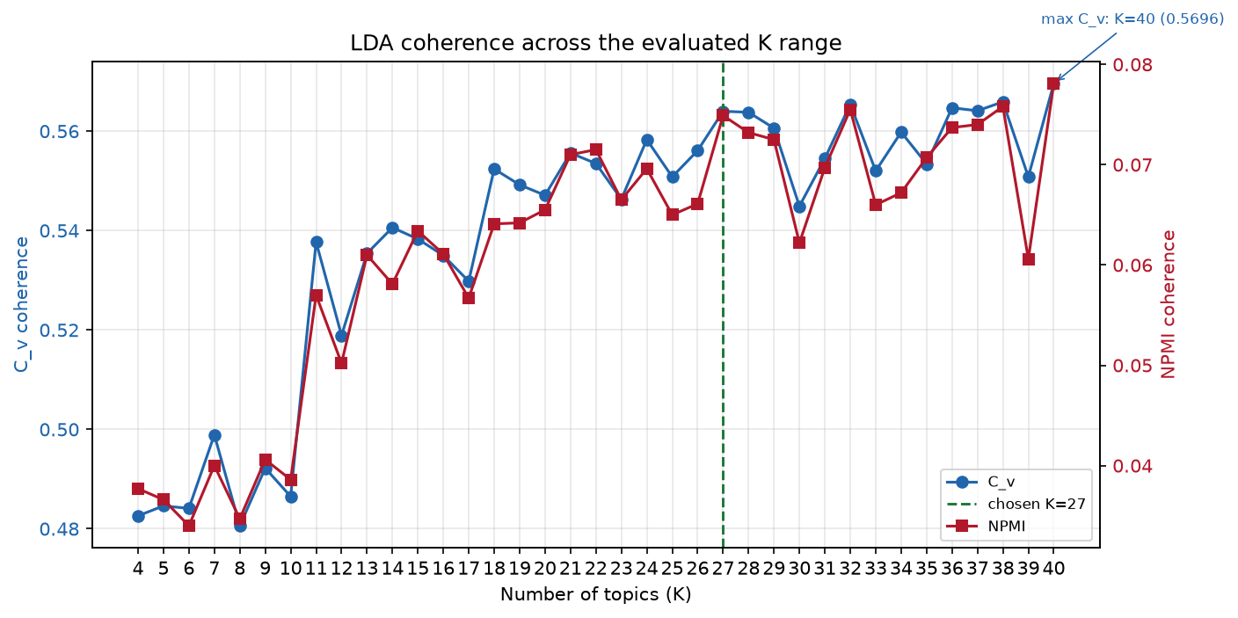
Figure 2. LDA coherence by number of topics

4.3 Full K-search table
K | C_v | NPMI | Diversity | Perplexity | Dominance | Entropy | Empty topics
4 | 0.4826 | 0.0377 | 0.8750 | -7.4130 | 0.2740 | 0.9953 | 0.0000
5 | 0.4846 | 0.0366 | 0.8200 | -7.3861 | 0.2516 | 0.9891 | 0.0000
6 | 0.4841 | 0.0340 | 0.7500 | -7.3658 | 0.2298 | 0.9882 | 0.0000
7 | 0.4989 | 0.0400 | 0.7429 | -7.3513 | 0.2060 | 0.9864 | 0.0000
8 | 0.4806 | 0.0347 | 0.7125 | -7.3453 | 0.1863 | 0.9894 | 0.0000
9 | 0.4922 | 0.0406 | 0.7444 | -7.3327 | 0.1491 | 0.9917 | 0.0000
10 | 0.4865 | 0.0386 | 0.7000 | -7.3298 | 0.1390 | 0.9884 | 0.0000
11 | 0.5377 | 0.0570 | 0.8091 | -7.3059 | 0.1288 | 0.9860 | 0.0000
12 | 0.5189 | 0.0502 | 0.7750 | -7.3105 | 0.1518 | 0.9818 | 0.0000
13 | 0.5354 | 0.0610 | 0.7769 | -7.3168 | 0.1238 | 0.9689 | 0.0000
14 | 0.5406 | 0.0581 | 0.8000 | -7.3209 | 0.1774 | 0.9542 | 0.0000
15 | 0.5383 | 0.0634 | 0.7467 | -7.3229 | 0.1963 | 0.9564 | 0.0000
16 | 0.5350 | 0.0611 | 0.7688 | -7.3216 | 0.1148 | 0.9638 | 0.0000
17 | 0.5298 | 0.0567 | 0.7588 | -7.3233 | 0.1171 | 0.9573 | 0.0000
18 | 0.5524 | 0.0641 | 0.7778 | -7.3192 | 0.1360 | 0.9524 | 0.0000
19 | 0.5492 | 0.0642 | 0.8000 | -7.3205 | 0.1566 | 0.9499 | 0.0000
20 | 0.5471 | 0.0655 | 0.7450 | -7.3280 | 0.1346 | 0.9500 | 0.0000
21 | 0.5556 | 0.0710 | 0.7952 | -7.3287 | 0.1251 | 0.9556 | 0.0000
22 | 0.5535 | 0.0715 | 0.7818 | -7.3270 | 0.1247 | 0.9444 | 0.0000
23 | 0.5463 | 0.0665 | 0.7826 | -7.3371 | 0.1059 | 0.9505 | 0.0000
24 | 0.5583 | 0.0696 | 0.7792 | -7.3304 | 0.1160 | 0.9568 | 0.0000
25 | 0.5508 | 0.0650 | 0.7800 | -7.3335 | 0.1264 | 0.9047 | 0.0000
26 | 0.5561 | 0.0661 | 0.7654 | -7.3405 | 0.1183 | 0.9474 | 0.0000
27 | 0.5640 | 0.0749 | 0.7889 | -7.3363 | 0.1056 | 0.9398 | 0.0000
28 | 0.5638 | 0.0732 | 0.7679 | -7.3404 | 0.0852 | 0.9367 | 0.0000
29 | 0.5606 | 0.0725 | 0.7655 | -7.3312 | 0.0864 | 0.9199 | 0.0000
30 | 0.5449 | 0.0622 | 0.7867 | -7.3426 | 0.0854 | 0.9192 | 0.0000
31 | 0.5545 | 0.0697 | 0.8065 | -7.3472 | 0.0843 | 0.9157 | 0.0000
32 | 0.5654 | 0.0755 | 0.7781 | -7.3458 | 0.0757 | 0.9279 | 0.0000
33 | 0.5520 | 0.0660 | 0.7545 | -7.3501 | 0.0744 | 0.9278 | 0.0000
34 | 0.5598 | 0.0672 | 0.7647 | -7.3557 | 0.0783 | 0.9224 | 0.0000
35 | 0.5534 | 0.0707 | 0.7800 | -7.3563 | 0.1022 | 0.9203 | 0.0000
36 | 0.5647 | 0.0737 | 0.7833 | -7.3615 | 0.1113 | 0.9030 | 0.0000
37 | 0.5641 | 0.0740 | 0.7892 | -7.3628 | 0.0750 | 0.9268 | 0.0000
38 | 0.5659 | 0.0758 | 0.7421 | -7.3675 | 0.0748 | 0.9174 | 0.0000
39 | 0.5508 | 0.0606 | 0.7615 | -7.3717 | 0.0898 | 0.8916 | 0.0000
40 | 0.5696 | 0.0781 | 0.7825 | -7.3704 | 0.0928 | 0.9118 | 0.0000

5. Model configuration and execution

5.1 Library and software
- Gensim 4.4.0, single-process LdaModel implementation.
- Python 3.13; the environment is reproduced with uv sync.
- Global seed 42.
- Exports are CSV-only (never xlsx); intermediate checkpoints use .pkl.

5.2 Hyperparameters
Parameter | Value
Number of topics (K) | 27
Alpha (document-topic prior) | asymmetric
Eta / beta (topic-word prior) | 0.5
Iterations (passes) | 50
Internal iterations per document | 50
Random seed | 42
Documents | 19,505
Vocabulary | 4,533
Implementation | gensim.models.ldamodel.LdaModel

The alpha/eta search evaluated 16 combinations (4 alpha values × 4 eta values). The best combination was alpha = `asymmetric`, eta = `0.5` (C_v = 0.5861). The 8 best combinations are:
alpha | eta | C_v | NPMI | Dominance
asymmetric | 0.5 | 0.5861 | 0.0861 | 0.0890
0.01 | 0.5 | 0.5779 | 0.0812 | 0.0771
symmetric | 0.5 | 0.5748 | 0.0808 | 0.0789
0.1 | 0.5 | 0.5713 | 0.0793 | 0.0815
asymmetric | 0.01 | 0.5657 | 0.0776 | 0.1273
asymmetric | 0.05 | 0.5656 | 0.0765 | 0.1268
0.01 | 0.05 | 0.5649 | 0.0748 | 0.1023
symmetric | symmetric | 0.5640 | 0.0749 | 0.1056

5.3 Reproducibility
The full code lives in src/bertlda/. The sequence is:
uv sync
uv run python src/bertlda/preprocess_corpus.py
uv run python src/bertlda/phase0_audit.py
uv run python src/bertlda/phase1a_lda_diagnostic.py
uv run python src/bertlda/phase1b_lda_decision.py
uv run python src/bertlda/phase1c_lda_final.py
uv run python src/bertlda/phase5_sensitivity.py
uv run python src/bertlda/phase6_report.py
The full configuration, library versions, metrics, and artifact inventory are exported to outputs/results/config/model_configuration_full.json.

5.4 Final model metrics
Metric | Value
C_v | 0.5761
NPMI | +0.0818
Diversity (top-10) | 0.7741
Perplexity | -7.2693
Dominance | 0.0844
Normalized entropy | 0.9475
Empty topics | 0

Note on C_v comparability. The K grid (Section 4) uses alpha="symmetric" and passes=30; the final model uses alpha="asymmetric", eta="0.5", and passes=50. Its C_v (0.5761) therefore does not exactly match the grid value for K = 27 (0.5640). Comparisons are valid within each configuration.

6. Model sensitivity analysis
The sensitivity analysis evaluates three sources of variation: random seed, K neighbourhood, and alpha/eta hyperparameters. Two metrics are used to compare runs:
- Jaccard overlap between the top-10 words of aligned topics. Alignment is
solved with the Hungarian algorithm over cosine similarity between topic-word distributions.
- Adjusted Rand Index (ARI) between the dominant-topic assignments of two
runs.

6.1 Stability across random seeds
5 seeds (42, 43, 44, 45, 46) were trained for each K in the neighbourhood, with passes=10. The table reports the mean and standard deviation over all seed pairs:
K | Jaccard mean | Jaccard SD | Jaccard min | ARI mean | ARI SD | ARI min | C_v mean | C_v SD
25 | 0.3459 | 0.0344 | 0.3005 | 0.2457 | 0.0270 | 0.2085 | 0.5458 | 0.0100
26 | 0.3102 | 0.0393 | 0.2361 | 0.2464 | 0.0333 | 0.2021 | 0.5460 | 0.0118
27 | 0.3192 | 0.0242 | 0.2756 | 0.2413 | 0.0280 | 0.1985 | 0.5511 | 0.0095
28 | 0.2942 | 0.0355 | 0.2585 | 0.2228 | 0.0281 | 0.1761 | 0.5433 | 0.0074
29 | 0.3050 | 0.0257 | 0.2631 | 0.2594 | 0.0329 | 0.1995 | 0.5497 | 0.0096

The table above summarizes seed stability for each K in the neighbourhood. Jaccard is computed over the top-10 words of topics aligned with the Hungarian algorithm; ARI is computed over the dominant-topic assignment of each document.
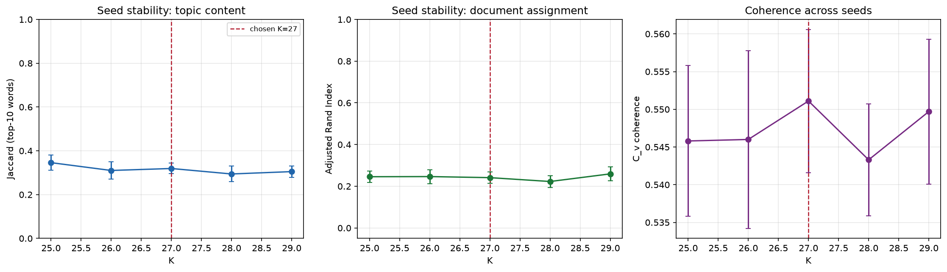
Figure 3. LDA stability across seeds

6.2 Stability across K
The table compares each neighbourhood model against the reference model (K = 27, seed 42). Best Jaccard is the best overlap of each model topic with a reference topic; the last column reports how many reference topics are covered with Jaccard ≥ 0.5.
K | Best Jaccard mean | Median | Min | Max | Topics ≥ 0.5 | Topics | Reference topics covered ≥ 0.5
25 | 0.4412 | 0.4286 | 0.0000 | 1 | 11 | 25 | 11
26 | 0.4048 | 0.3810 | 0.0000 | 1 | 8 | 26 | 8
27 | 1 | 1 | 1 | 1 | 27 | 27 | 27
28 | 0.3844 | 0.4286 | 0.0000 | 1 | 10 | 28 | 10
29 | 0.3715 | 0.3333 | 0.0000 | 0.8182 | 11 | 29 | 11

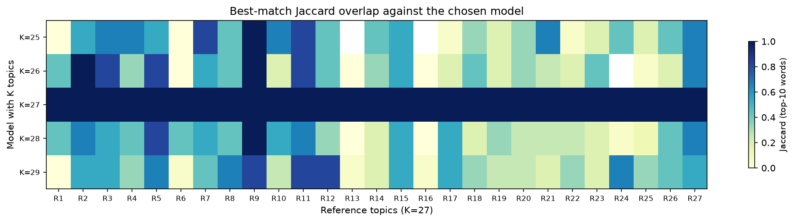
Figure 4. Overlap across K values

6.3 Sensitivity to alpha and eta
The 16-combination grid shows small C_v differences between configurations (range 0.0288). The selected configuration (alpha=asymmetric, eta=0.5) remains among the best and yields the highest coherence. This suggests the thematic structure is reasonably robust to prior choice, as long as alpha remains asymmetric or close to symmetric.

6.4 Robustness conclusion
For the selected K (27), seed stability is moderate: mean Jaccard 0.3192 (SD 0.0242, minimum 0.2756) and mean ARI 0.2413 (SD 0.0280, minimum 0.1985). The highest-volume topics (T3, T23, T20, T1) are recovered most consistently, while the smallest topic (T16) is more sensitive. The 27-topic structure is considered sufficiently robust for an exploratory analysis, with the recommendation to report low-frequency topics as provisional. This result is consistent with the topic-model stability literature (Greene, O'Callaghan & Cunningham, 2014; De Waal & Barnard, 2008; Koltcov, Koltsova & Nikolenko, 2014).

7. Biplot and LDAvis methods

7.1 HJ-Biplot
The HJ-Biplot (Galindo-Villardón, 1986), an extension of Gabriel's biplot (1971), represents rows and columns of a matrix simultaneously through a singular value decomposition. For a centered matrix X:
X = U · D · Vᵀ
row coordinates are A = U·D and column coordinates B = V·D. The key property is that the scalar product a_i · b_j approximates the value x_ij, so rows and columns are interpreted in the same space. The representation quality of each marker is measured with the squared cosine:
cos²_i = (a_i1² + a_i2²) / Σ_k a_ik²
and analogously for columns. The global quality is the mean of the squared cosines. Three biplots were built:
- Years × topics: each row is a year (with at least 20 documents) and each
column a topic; the value is the mean topic probability for that year.
- Countries × topics: each row is one of the 12 countries with most documents;
the value is the mean topic probability.
- Documents × topics: a random sample of 1500
documents, colored by dominant topic.
Dataset | Rows | Columns | Axis 1 (%) | Axis 2 (%) | Mean row cos² | Mean column cos²
Years x topics | 5 | 27 | 77.5300 | 18.1100 | 0.8999 | 0.8827
Countries x topics | 12 | 27 | 59.6600 | 23.1100 | 0.5619 | 0.4612
Document sample x topics | 1500 | 27 | 10.3400 | 8.2100 | 0.1760 | 0.1080

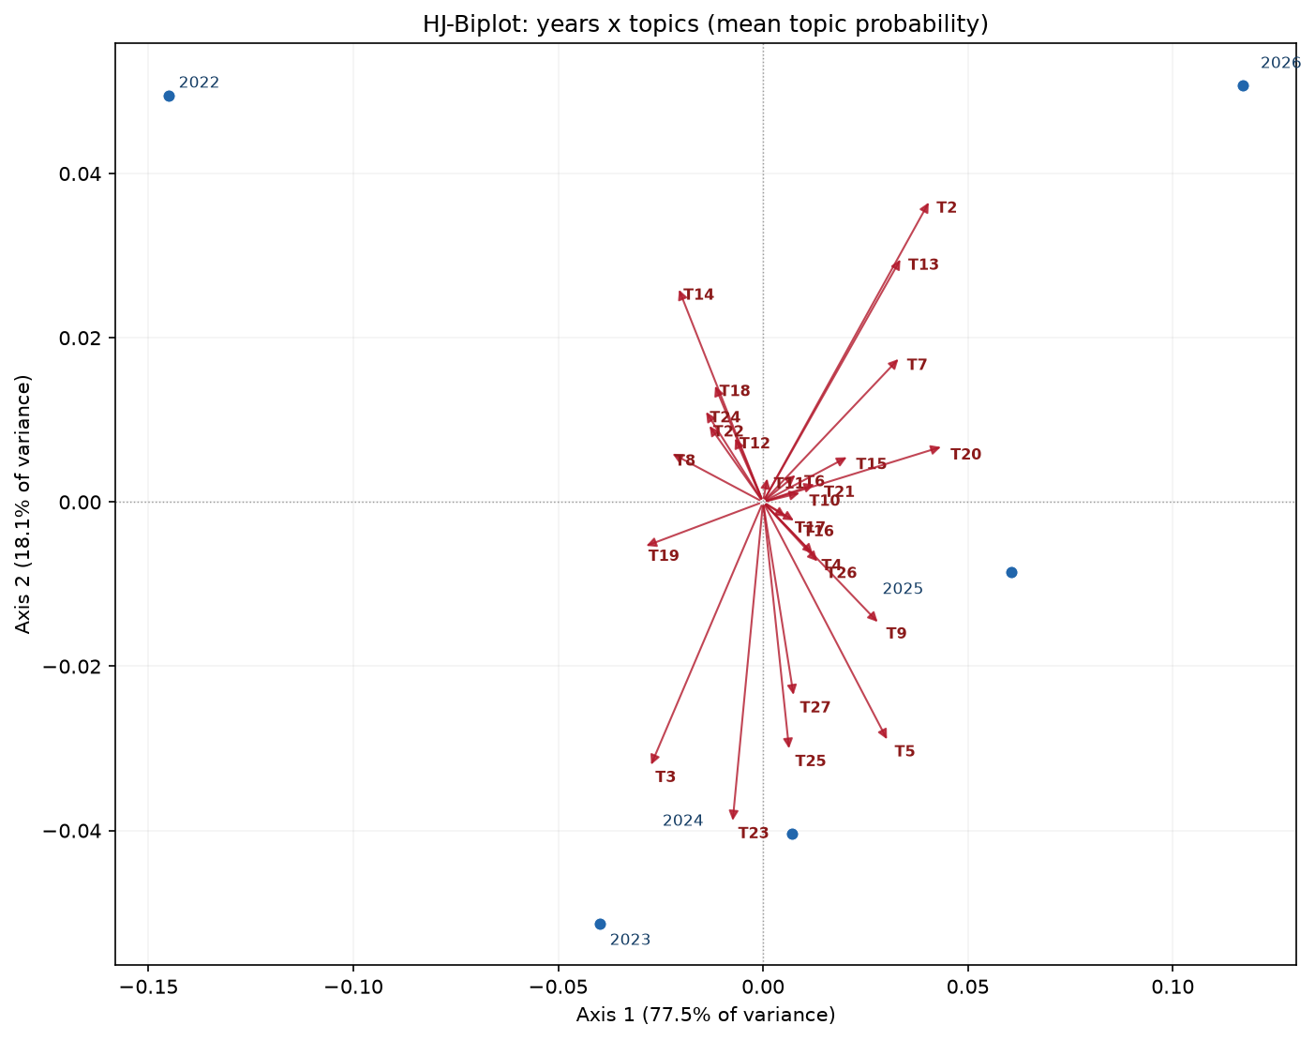
Figure 5. HJ-Biplot years × topics
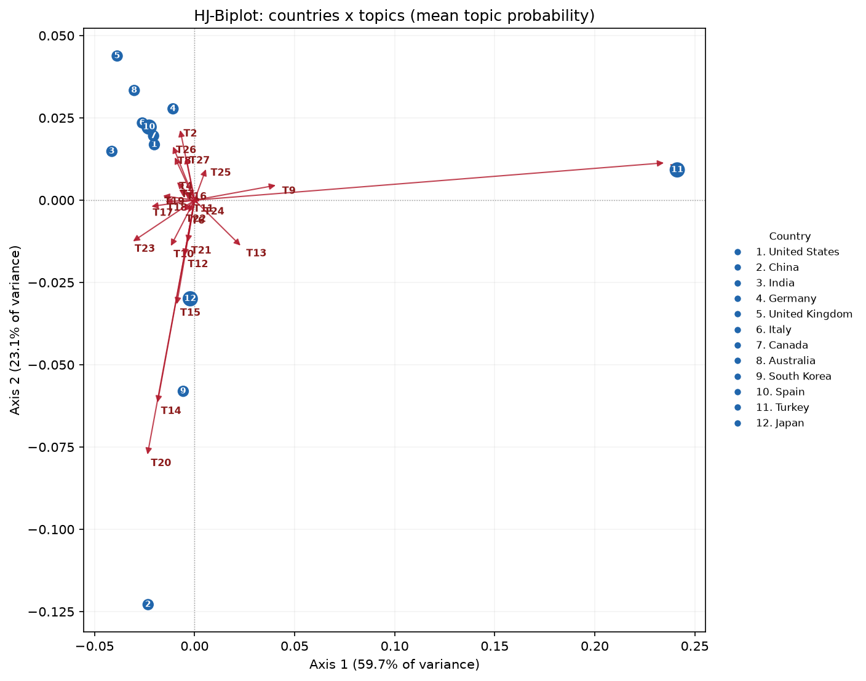
Figure 6. HJ-Biplot countries × topics
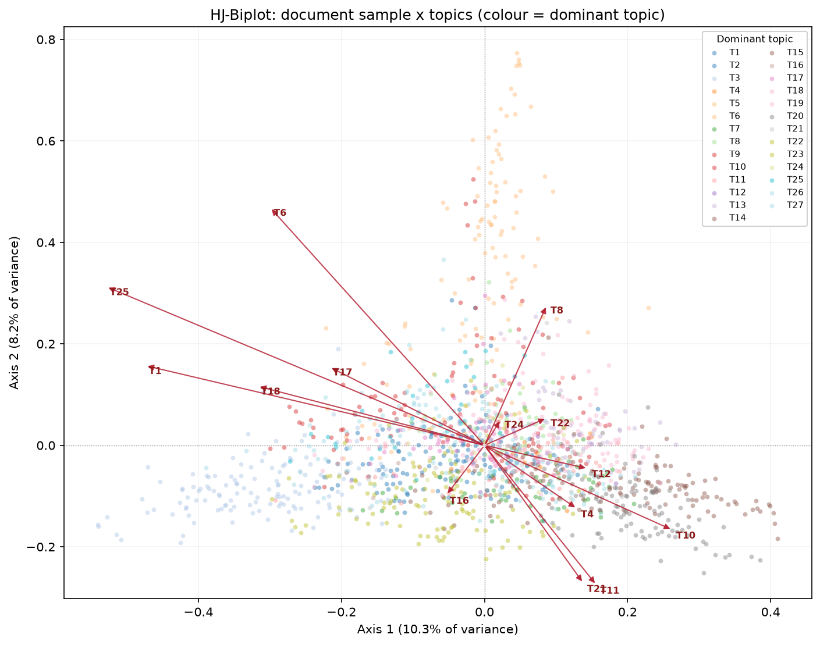
Figure 7. HJ-Biplot documents × topics
Reading. In the years biplot, proximity between a year and a topic means that topic gains relative weight in that year; recent years (2024–2026) shift toward generative AI, agents, and model evaluation topics. In the countries biplot, countries are identified by number with a side legend; each country's position summarizes its mean thematic profile: countries with high applied-AI output align with systems and applications topics, while countries more oriented to governance align with ethics and policy topics. Mean representation quality (cos²) indicates how much of each marker's variation the two axes capture; high values (> 0.7) allow confident reading of that marker position.

7.2 LDAvis
LDAvis (Sievert & Shirley, 2014) combines two views:
- Intertopic distance map: topics are projected into two dimensions from
the distance between their word distributions. Bubble size is proportional to topic prevalence in the corpus. Nearby topics share vocabulary and may overlap.
- Relevant-term ranking: for each topic, words are ranked by
relevance:
relevance(w | t) = λ · p(w | t) + (1 − λ) · p(w | t) / p(w)
where λ ∈ [0,1] weights conditional frequency against term exclusivity. λ = 0.6 was used (the value recommended by Sievert & Shirley for exploration), and rankings for λ = 0 and λ = 1 were also exported.
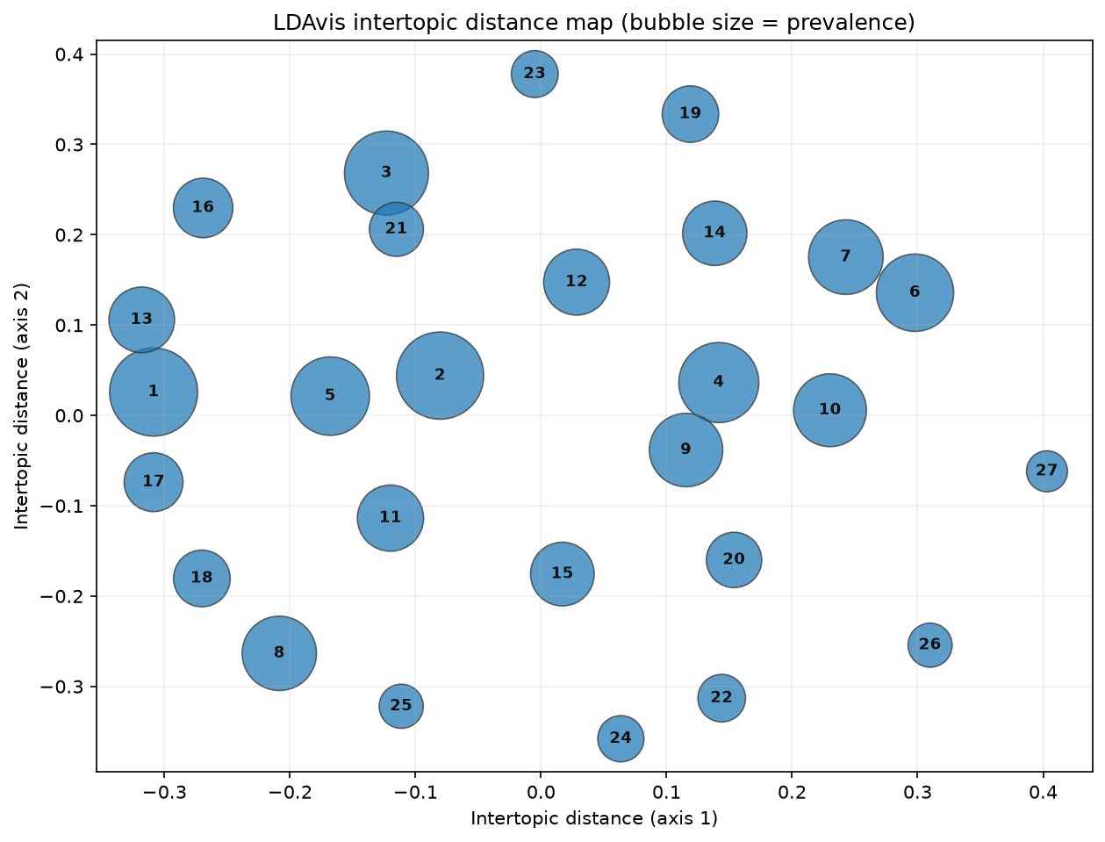
Figure 8. LDAvis intertopic distance map
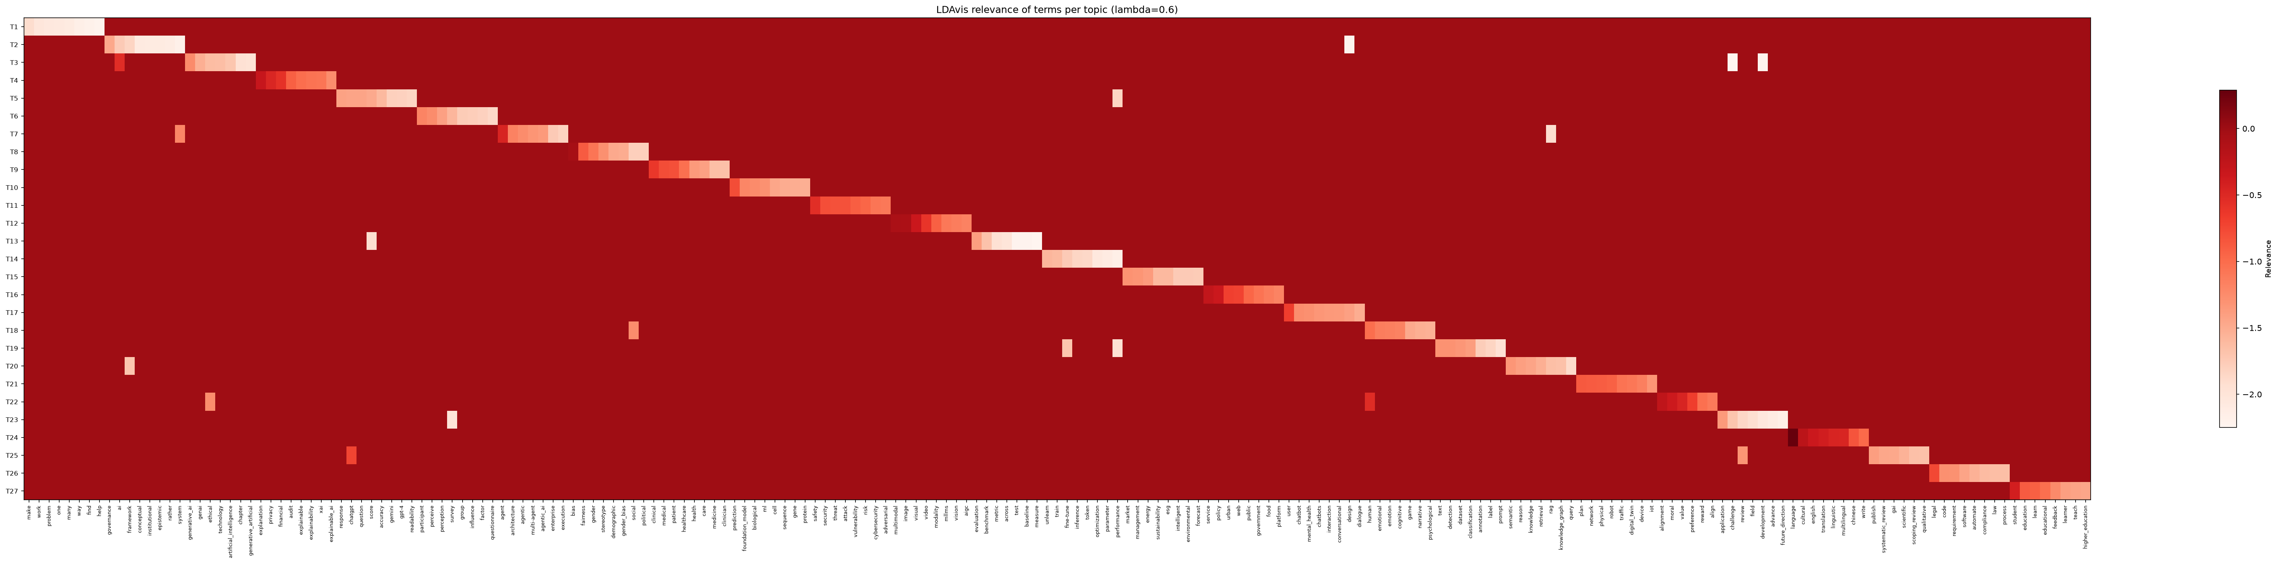
Figure 9. LDAvis term relevance heatmap
The full interactive viewer is in `outputs/visualizations/LDAvis.html`.
Relevant-term ranking (λ = 0.6):
Topic | Term | Relevance (λ=0.6)
1 | make | -1.9061
1 | work | -2.0260
1 | problem | -2.0544
1 | one | -2.0643
1 | many | -2.0965
1 | way | -2.1533
2 | governance | -1.4754
2 | ai | -1.7458
2 | framework | -1.8406
2 | conceptual | -2.0854
2 | institutional | -2.0922
2 | epistemic | -2.0966
3 | ai | -0.5374
3 | generative_ai | -1.2487
3 | genai | -1.5243
3 | ethical | -1.6333
3 | technology | -1.6445
3 | artificial_intelligence | -1.7119
4 | explanation | -0.3093
4 | privacy | -0.4823
4 | financial | -0.5804
4 | audit | -0.9192
4 | explainable | -1.0140
4 | explainability | -1.0563
5 | response | -1.4187
5 | chatgpt | -1.4401
5 | question | -1.4426
5 | score | -1.4832
5 | accuracy | -1.5976
5 | gemini | -1.7996
6 | participant | -1.1916
6 | perceive | -1.2583
6 | perception | -1.4120
6 | survey | -1.5801
6 | group | -1.7614
6 | influence | -1.7797
7 | agent | -0.4618
7 | architecture | -1.1732
7 | system | -1.2051
7 | agentic | -1.2517
7 | multi-agent | -1.3265
7 | agentic_ai | -1.3595
8 | bias | -0.0389
8 | fairness | -0.8845
8 | gender | -1.0786
8 | stereotype | -1.2881
8 | demographic | -1.4773
8 | gender_bias | -1.5010
9 | clinical | -0.6310
9 | medical | -0.7912
9 | patient | -0.8103
9 | healthcare | -1.0350
9 | health | -1.3673
9 | care | -1.4132
10 | prediction | -0.7855
10 | foundation_model | -1.2005
10 | biological | -1.2422
10 | ml | -1.2941
10 | cell | -1.4533
10 | sequence | -1.5049
11 | safety | -0.5508
11 | security | -0.8021
11 | threat | -0.8158
11 | attack | -0.8171
11 | vulnerability | -0.9028
11 | risk | -0.9524
12 | multimodal | -0.0837
12 | image | -0.0909
12 | visual | -0.3375
12 | video | -0.6130
12 | modality | -0.9154
12 | mllms | -1.0967
13 | evaluation | -1.3949
13 | benchmark | -1.6801
13 | score | -1.9246
13 | metric | -1.9603
13 | across | -2.0082
13 | test | -2.2250
14 | unlearn | -1.5762
14 | train | -1.6102
14 | fine-tune | -1.7543
14 | inference | -1.8443
14 | token | -1.8693
14 | optimization | -2.0574
15 | market | -1.3062
15 | management | -1.3182
15 | energy | -1.3745
15 | sustainability | -1.5976
15 | esg | -1.6021
15 | intelligent | -1.7468
16 | service | -0.2831
16 | policy | -0.3468
16 | urban | -0.6942
16 | web | -0.7174
16 | public | -0.9587
16 | government | -1.0533
17 | user | -0.6800
17 | chatbot | -1.2621
17 | mental_health | -1.2788
17 | chatbots | -1.3350
17 | interaction | -1.3539
17 | conversational | -1.3628
18 | human | -1.0166
18 | emotional | -1.1349
18 | emotion | -1.1499
18 | cognitive | -1.1713
18 | social | -1.2560
18 | game | -1.4818
19 | text | -1.3059
19 | detection | -1.3067
19 | dataset | -1.3321
19 | classification | -1.3875
19 | fine-tune | -1.7099
19 | annotation | -1.7681
20 | semantic | -1.3283
20 | reason | -1.4064
20 | knowledge | -1.4447
20 | retrieval | -1.5218
20 | rag | -1.6462
20 | knowledge_graph | -1.6721
21 | plan | -0.8694
21 | network | -0.8910
21 | physical | -0.8986
21 | robot | -0.9243
21 | traffic | -1.0564
21 | digital_twin | -1.0812
22 | alignment | -0.2511
22 | moral | -0.3600
22 | value | -0.4605
22 | human | -0.5263
22 | preference | -0.6786
22 | reward | -1.0361
23 | application | -1.3617
23 | challenge | -1.6965
23 | review | -1.8585
23 | field | -1.9321
23 | survey | -1.9946
23 | development | -2.0451
24 | language | 0.2892
24 | cultural | -0.2247
24 | english | -0.3524
24 | translation | -0.3981
24 | linguistic | -0.4615
24 | multilingual | -0.4697
25 | chatgpt | -0.7402
25 | review | -1.3218
25 | publish | -1.3882
25 | systematic_review | -1.4609
25 | gai | -1.4752
25 | scientific | -1.5561
26 | legal | -0.7587
26 | code | -1.2817
26 | requirement | -1.2948
26 | software | -1.4401
26 | automate | -1.5392
26 | compliance | -1.6226
27 | student | -0.4137
27 | education | -0.8911
27 | learn | -0.9129
27 | educational | -1.0275
27 | feedback | -1.2317
27 | learner | -1.3979

7.3 Comparison and complementarity
The HJ-Biplot provides a multivariate, structural reading: it shows how years, countries, and documents are positioned relative to topics, with an explicit representation-quality measure (cos²). It answers questions such as "which topics characterize the most productive countries?" or "how does the thematic profile change over years?".
LDAvis provides a term-topic reading: it shows which words define each topic, how topics overlap, and which terms are most relevant for a given λ. It is useful for interpreting and labeling topics and for detecting redundant topics.
The two methods are complementary: the biplot says where documents, years, and countries lie in the thematic space; LDAvis says why a topic is interpreted in a given way, from its terms. Their convergence — topics close in LDAvis that also appear close in the biplot — reinforces the validity of the thematic structure.

8. Preliminary results and interpretation

8.1 Descriptive corpus characterization
Temporal distribution. The corpus covers 2018-2026, with an explosion of publications from 2023:
Year | Documents | %
2018 | 2 | 0.0100
2019 | 1 | 0.0100
2021 | 1 | 0.0100
2022 | 31 | 0.1600
2023 | 556 | 2.8500
2024 | 2763 | 14.1700
2025 | 6883 | 35.2900
2026 | 9268 | 47.5200

Main sources/journals. Output concentrates in NLP/AI conference proceedings and open-access journals:
Source | Documents | %
Proceedings of the Annual Meeting of the Association for Computational Linguistics | 542 | 2.7800
Lecture Notes in Computer Science | 365 | 1.8700
CEUR Workshop Proceedings | 281 | 1.4400
Conference on Human Factors in Computing Systems - Proceedings | 278 | 1.4300
IEEE Access | 260 | 1.3300
Advances in Neural Information Processing Systems | 232 | 1.1900
Communications in Computer and Information Science | 218 | 1.1200
Proceedings of Machine Learning Research | 179 | 0.9200
Lecture Notes in Networks and Systems | 164 | 0.8400
Applied Sciences (Switzerland) | 158 | 0.8100

Countries. The United States and China concentrate slightly more than two fifths of the corpus; the tail includes India, Germany, the United Kingdom, Italy, Canada, and Australia:
Country | Documents | %
United States | 4538 | 23.7100
China | 3888 | 20.3200
India | 1022 | 5.3400
Germany | 999 | 5.2200
United Kingdom | 891 | 4.6600
Italy | 617 | 3.2200
Canada | 500 | 2.6100
Australia | 487 | 2.5400
South Korea | 449 | 2.3500
Spain | 316 | 1.6500

Document types. Articles and conference papers predominate, with a relevant share of reviews:
Document type | Documents | %
Article | 8319 | 42.6500
Conference paper | 8011 | 41.0700
Review | 1806 | 9.2600
Book chapter | 838 | 4.3000
Note | 164 | 0.8400
Book | 127 | 0.6500
Editorial | 80 | 0.4100
Letter | 53 | 0.2700
Short survey | 47 | 0.2400
Conference review | 42 | 0.2200

Institutions. Affiliations were extracted from the Scopus Affiliations column. The table shows the institutions with most documents:
Institution | Documents | %
University of California | 354 | 1.8100
Stanford University | 326 | 1.6700
Tsinghua University | 322 | 1.6500
Carnegie Mellon University | 255 | 1.3100
Zhejiang University | 249 | 1.2800
National University of Singapore | 239 | 1.2300
Nanyang Technological University | 217 | 1.1100
University of Oxford | 211 | 1.0800
Shanghai Jiao Tong University | 203 | 1.0400
University of Washington | 201 | 1.0300

Bibliometric overview. The corpus is recent, dominated by AI/NLP conferences and journals, with a strong presence of the United States and China. The mix of document types (articles, conference papers, reviews) suggests a consolidating field, with much applied output and a growing layer of ethical and regulatory reflection.

8.2 LDA model results
The table below summarizes the 27 topics: identifier, proposed label, number of documents with dominant topic, main terms, and the country with most documents in the topic (by volume).
Topic | Proposed label | Documents | Top terms | Leading country
1 | Human problem-solving and AI-assisted work | 1168 | work, make, system, ai, problem, one, human, task, find, question | United States
2 | AI governance and framework design | 1064 | ai, framework, governance, system, design, across, structure, rather, evidence, support | United States
3 | Generative AI ethics, technology, and societal challenges | 1647 | ai, generative_ai, technology, artificial_intelligence, ethical, genai, challenge, development, tool, generative_artificial | United States
4 | Privacy, explainability, and financial trust | 181 | privacy, explanation, financial, audit, framework, transparency, explainability, explainable, trust, sensitive | United States
5 | ChatGPT response quality and performance evaluation | 996 | response, chatgpt, question, accuracy, score, performance, compare, test, quality, gpt-4 | United States
6 | Perception, trust, and AI adoption surveys | 437 | participant, ai, survey, perceive, perception, finding, group, influence, among, impact | United States
7 | Agentic systems, architecture, and enterprise workflows | 686 | agent, system, architecture, framework, agentic, multi-agent, agentic_ai, ai, rag, workflow | United States
8 | Bias, fairness, gender, and stereotype in prompts | 644 | bias, fairness, gender, prompt, social, stereotype, across, demographic, output, group | United States
9 | Clinical, medical, and healthcare AI | 881 | clinical, medical, patient, healthcare, health, care, support, medicine, include, clinician | United States
10 | Prediction, foundation models, and biological sequence learning | 503 | prediction, foundation_model, machine_learn, ml, biological, feature, learn, predict, sequence, representation | China
11 | Safety, cybersecurity, and adversarial robustness | 512 | safety, risk, security, attack, threat, vulnerability, cybersecurity, adversarial, detection, defense | United States
12 | Multimodal and vision-language models | 182 | multimodal, image, visual, video, modality, vision, mllms, generation, foundation_model, vlms | China
13 | Evaluation, benchmarks, and performance measurement | 784 | evaluation, benchmark, across, score, test, metric, prompt, assessment, performance, framework | United States
14 | Training, fine-tuning, and machine unlearning | 1098 | train, fine-tune, performance, task, unlearn, inference, optimization, introduce, framework, learn | China
15 | Intelligent management, markets, and energy systems | 700 | management, system, framework, market, energy, intelligent, integrate, power, process, technology | China
16 | Public policy, digital services, and urban platforms | 111 | policy, service, public, information, urban, platform, web, digital, government, access | United States
17 | User interaction, chatbots, and conversational support | 768 | user, design, interaction, system, support, chatbots, chatbot, mental_health, conversational, dialogue | United States
18 | Human cognition, emotion, and social simulation | 551 | human, social, cognitive, emotional, emotion, agent, theory, narrative, behavior, interaction | United States
19 | Text detection, datasets, and classification | 1081 | text, detection, dataset, classification, performance, prompt, fine-tune, generate, task, datasets | United States
20 | Retrieval, knowledge graphs, and semantic generation | 1277 | framework, reason, knowledge, semantic, retrieval, rag, structure, system, generation, query | China
21 | Networks, robotics, simulation, and digital twins | 223 | plan, system, network, environment, physical, robot, simulation, control, scenario, traffic | China
22 | Alignment, values, and moral decision-making | 244 | human, alignment, value, moral, preference, ethical, align, decision, decision-making, reason | United States
23 | Application challenges, reviews, and field advances | 1498 | application, challenge, review, development, include, field, advance, capability, potential, survey | China
24 | Language, culture, translation, and multilingual corpora | 126 | language, cultural, translation, english, linguistic, multilingual, write, chinese, text, context | China
25 | ChatGPT in academic and systematic literature reviews | 499 | chatgpt, review, include, publish, tool, identify, literature, scientific, systematic_review, qualitative | United States
26 | Law, regulation, compliance, and software requirements | 732 | legal, process, code, requirement, automate, software, regulatory, regulation, compliance, case | United States
27 | AI in education and student learning | 912 | student, learn, education, educational, feedback, tool, skill, assessment, chatgpt, teach | United States

Thematic reading. The topics can be grouped into five blocks:
- Risk, security, and policy: T11 (cybersecurity, adversarial robustness),
T4 (privacy, explainability, trust), T26 (law, regulation, compliance), T16 (public policy, digital services), and T22 (alignment, values).
- Governance and ethics: T3 (generative AI, ethics, societal challenges),
T2 (AI governance frameworks), T8 (bias, fairness, gender), T6 (perception, trust, adoption), and T24 (culture, language, translation).
- Applications and evaluation: T9 (clinical health), T27 (education),
T14 (training, fine-tuning, unlearning), T13 (benchmarks, evaluation), T23 (application reviews and advances), and T15 (management, energy).
- Interaction and agents: T17 (chatbots, conversational support),
T7 (agentic systems, enterprise workflows), T18 (cognition, emotion), T20 (retrieval, knowledge graphs), and T21 (networks, robotics, simulation).
- Technical core: T19 (text detection, datasets, classification),
T10 (prediction, foundation models), T12 (multimodal, vision-language), T5 (ChatGPT evaluation), T25 (academic reviews), and T1 (human problem-solving and AI-assisted work).
The highest-volume topics are also the most stable in the sensitivity analysis; the smallest topics should be read as residual or emerging themes.

8.3 Biplot interpretation
- Years: 2022–2023 align with foundational and early-application topics;
2024–2026 shift toward generative AI, agents, RAG, and model evaluation. The direction of topic vectors shows which themes gain relative weight.
- Countries: by volume, the United States and China occupy central
positions; European and Latin American countries spread toward governance, health, and education topics. Positions must be read together with representation quality: if a country has low cos², its plane position is unreliable.
- Documents: the document cloud shows a clear separation between technical
evaluation documents (T13, T5, T19) and ethics/governance documents (T3, T8, T11), with an overlap zone in interaction and agents (T17, T7).
Global biplot quality is reported in the Section 7.1 table. High mean cos² values mean the first two axes capture a large part of the structure; low values call for cautious interpretation.

8.4 LDAvis interpretation
- Intertopic map: generative-AI (T3), evaluation (T13), and training
(T14) topics appear close because they share technical vocabulary. Ethics (T8) and governance (T2) topics separate from the technical core. Small topics (T16, T24) appear isolated, consistent with their low volume.
- Bubble size: T3 is the most prevalent topic, followed by the other
large applied and evaluation topics; the smallest topics have the smallest bubbles.
- Relevance: with λ = 0.6, the most relevant terms per topic combine
frequency and exclusivity. For example, T11 is defined by adversarial, attack, privacy, security; T9 by clinical, patient, diagnosis; T20 by rag, retrieval, knowledge. The full ranking is in outputs/results/lda/ldavis_relevance_terms.csv.

8.5 Integrative synthesis
The three sources converge on a coherent thematic structure:
- Corpus description: explosive growth, conference and AI-journal
dominance, high concentration in the United States and China.
- Biplot: separation between a technical core (evaluation, training,
applications) and a normative core (governance, bias, security), with recent years shifting toward the former.
- LDAvis: technical topics share vocabulary and overlap; ethics topics
separate; small topics are more fragile.
Overall, the corpus is not homogeneous: it combines a technical layer (model evaluation, fine-tuning, RAG, multimodality) with a normative layer (ethics, governance, bias, privacy, security). The 27-topic LDA captures this duality and provides a defensible basis for the phase-4 trend analysis.

9. References
Bender, E. M., Gebru, T., McMillan-Major, A., & Shmitchell, S. (2021). On the dangers of stochastic parrots: Can language models be too big? In Proceedings of the 2021 ACM Conference on Fairness, Accountability, and Transparency (pp. 610–623). https://doi.org/10.1145/3442188.3445922
Blei, D. M., Ng, A. Y., & Jordan, M. I. (2003). Latent Dirichlet allocation. Journal of Machine Learning Research, 3, 993–1022.
Bouma, G. (2009). Normalized (pointwise) mutual information in collocation extraction. In Proceedings of the Biennial GSCL Conference (pp. 31–40).
Chang, J., Gerrish, S., Wang, C., Boyd-Graber, J., & Blei, D. M. (2009). Reading tea leaves: How humans interpret topic models. In Advances in Neural Information Processing Systems 22 (pp. 288–296).
De Waal, A., & Barnard, E. (2008). Evaluating topic models with stability. In Proceedings of the 19th Annual Symposium of the Pattern Recognition Association of South Africa (pp. 79–84).
Floridi, L., Cowls, J., Beltrametti, M., Chatila, R., Chazerand, P., Dignum, V., Luetge, C., Madelin, R., Pagallo, U., Rossi, F., Schafer, B., Valcke, P., & Vayena, E. (2018). AI4People—An ethical framework for a good AI society: Opportunities, risks, principles, and recommendations. Minds and Machines, 28(4), 689–707. https://doi.org/10.1007/s11023-018-9482-5
Gabriel, K. R. (1971). The biplot graphic display of matrices with application to principal component analysis. Biometrika, 58(3), 453–467. https://doi.org/10.1093/biomet/58.3.453
Galindo-Villardón, M. P. (1986). Una alternativa de representación simultánea: HJ-Biplot. Questiió, 10(1), 13–23.
Greene, D., O'Callaghan, D., & Cunningham, P. (2014). How many topics? Stability analysis for topic models. In Machine Learning and Knowledge Discovery in Databases (ECML PKDD 2014) (LNCS 8724, pp. 498–513). Springer. https://doi.org/10.1007/978-3-662-44848-9_32
Grimmer, J., & Stewart, B. M. (2013). Text as data: The promise and pitfalls of automatic content analysis methods for political texts. Political Analysis, 21(3), 267–297. https://doi.org/10.1093/pan/mps028
Jobin, A., Ienca, M., & Vayena, E. (2019). The global landscape of AI ethics guidelines. Nature Machine Intelligence, 1(9), 389–399. https://doi.org/10.1038/s42256-019-0088-2
Koltcov, S., Koltsova, O., & Nikolenko, S. (2014). Latent Dirichlet allocation: Stability and applications to studies of user-generated content. In Proceedings of the 2014 ACM Conference on Web Science (pp. 161–165). https://doi.org/10.1145/2615569.2615680
Lau, J. H., Newman, D., & Baldwin, T. (2014). Machine reading tea leaves: Automatically evaluating topic coherence and topic model quality. In Proceedings of the 14th Conference of the European Chapter of the Association for Computational Linguistics (pp. 530–539). https://doi.org/10.3115/v1/E14-1056
Manning, C. D., Raghavan, P., & Schütze, H. (2008). Introduction to information retrieval. Cambridge University Press.
Mittelstadt, B. D., Allo, P., Taddeo, M., Wachter, S., & Floridi, L. (2016). The ethics of algorithms: Mapping the debate. Big Data & Society, 3(2), 1–21. https://doi.org/10.1177/2053951716679679
Page, M. J., McKenzie, J. E., Bossuyt, P. M., Boutron, I., Hoffmann, T. C., Mulrow, C. D., Shamseer, L., Tetzlaff, J. M., Akl, E. A., Brennan, S. E., Chou, R., Glanville, J., Grimshaw, J. M., Hróbjartsson, A., Lalu, M. M., Li, T., Loder, E. W., Mayo-Wilson, E., McDonald, S., … Moher, D. (2021). The PRISMA 2020 statement: An updated guideline for reporting systematic reviews. BMJ, 372, n71. https://doi.org/10.1136/bmj.n71
Röder, M., Both, A., & Hinneburg, A. (2015). Exploring the space of topic coherence measures. In Proceedings of the Eighth ACM International Conference on Web Search and Data Mining (pp. 399–408). https://doi.org/10.1145/2684822.2685324
Sievert, C., & Shirley, K. (2014). LDAvis: A method for visualizing and interpreting topics. In Proceedings of the Workshop on Interactive Language Learning, Visualization, and Interfaces (pp. 63–70). https://doi.org/10.3115/v1/W14-3110
Weidinger, L., Mellor, J., Rauh, M., Griffin, C., Uesato, J., Huang, P.-S., Cheng, M., Glaese, M., Balle, B., Kasirzadeh, A., Kenton, Z., Brown, S., Hawkins, W., Stepleton, T., Biles, C., Birhane, A., Haas, J., Rimell, L., Hendricks, L. A., … Gabriel, I. (2021). Ethical and social risks of harm from language models (arXiv:2112.04359). arXiv. https://arxiv.org/abs/2112.04359

Appendix A. Reproducibility and repository structure
bertlda/
├── raw_corpus.csv # Scopus export (not tracked if large)
├── src/bertlda/
│ ├── config.py # central configuration
│ ├── text_processing.py # cleaning, stopwords, lemmatization
│ ├── phase0_audit.py # corpus audit + descriptive figures
│ ├── phase1a_lda_diagnostic.py # tokenization + K search
│ ├── phase1b_lda_decision.py # K decision + alpha/eta search
│ ├── phase1c_lda_final.py # final LDA + Theta + topic summary
│ ├── phase3_visualizations.py # similarity, top-words, topic x year/country
│ ├── phase5_sensitivity.py # seed/K sensitivity
│ └── phase6_report.py # config JSON, biplot, LDAvis, report
├── outputs/
│ ├── models/lda/lda_final.model
│ ├── results/config/model_configuration_full.json
│ ├── results/lda/*.csv
│ └── visualizations/*.png|.svg|.html
└── docs/Methodology_LDA.md

Appendix B. Main artifact inventory
- outputs/models/lda/lda_final.model — final LDA model.
- outputs/results/lda/lda_theta.csv — document-topic matrix (19,505 × 27).
- outputs/results/lda/lda_topic_summary.csv — labels, keywords, and leading country.
- outputs/results/lda/lda_ranking.csv — topic ranking by frequency.
- outputs/results/lda/lda_k_search.csv — K grid.
- outputs/results/lda/lda_alpha_eta_search.csv — alpha/eta grid.
- outputs/results/lda/lda_sensitivity_seeds.csv — seed stability.
- outputs/results/lda/lda_sensitivity_k.csv — stability in the K neighbourhood.
- outputs/results/lda/hjbiplot_*.csv — HJ-Biplot coordinates and qualities.
- outputs/results/lda/ldavis_relevance_terms.csv — term relevance.
- outputs/results/config/model_configuration_full.json — full configuration.
- outputs/visualizations/LDAvis.html — interactive viewer.
- docs/Methodology_LDA.md — this document.

