作业二
Fitting:
模型参数配置:
learning_rate = 0.2
train = tf.train.AdamOptimizer(learning_rate).minimize(loss)
30000个epoch
每1000次迭代输出一次loss
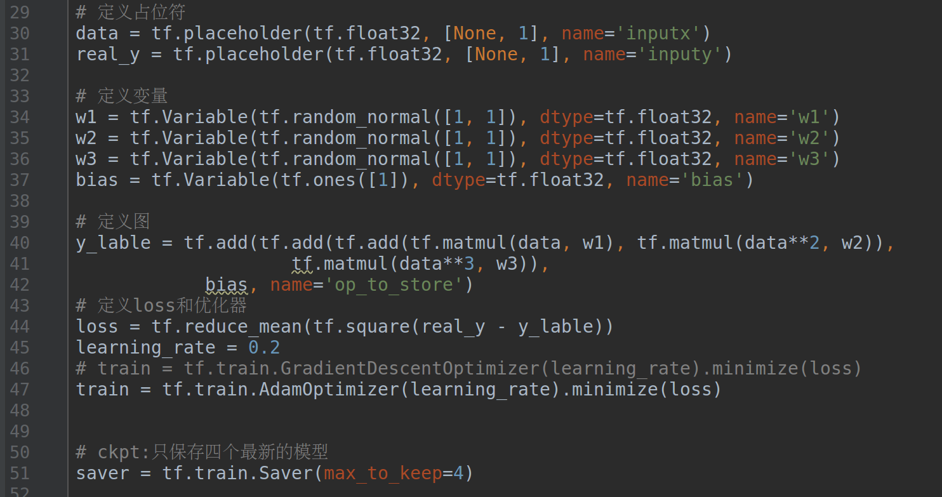
程序运行截图:
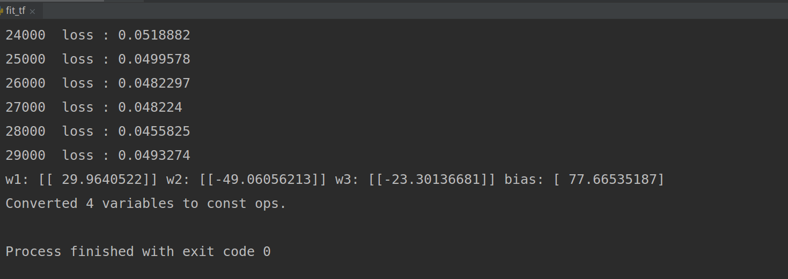
拟合的三次函数:
y = 29.9640522 x - 49.06056213 x**2 – 23.30136681 x**3 + 77.66535187
绘制的图像:
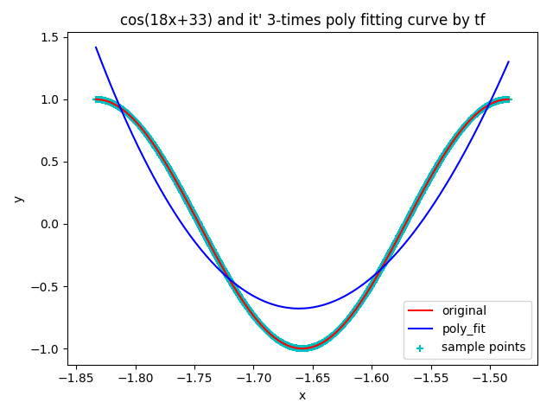
ckpt recovery:
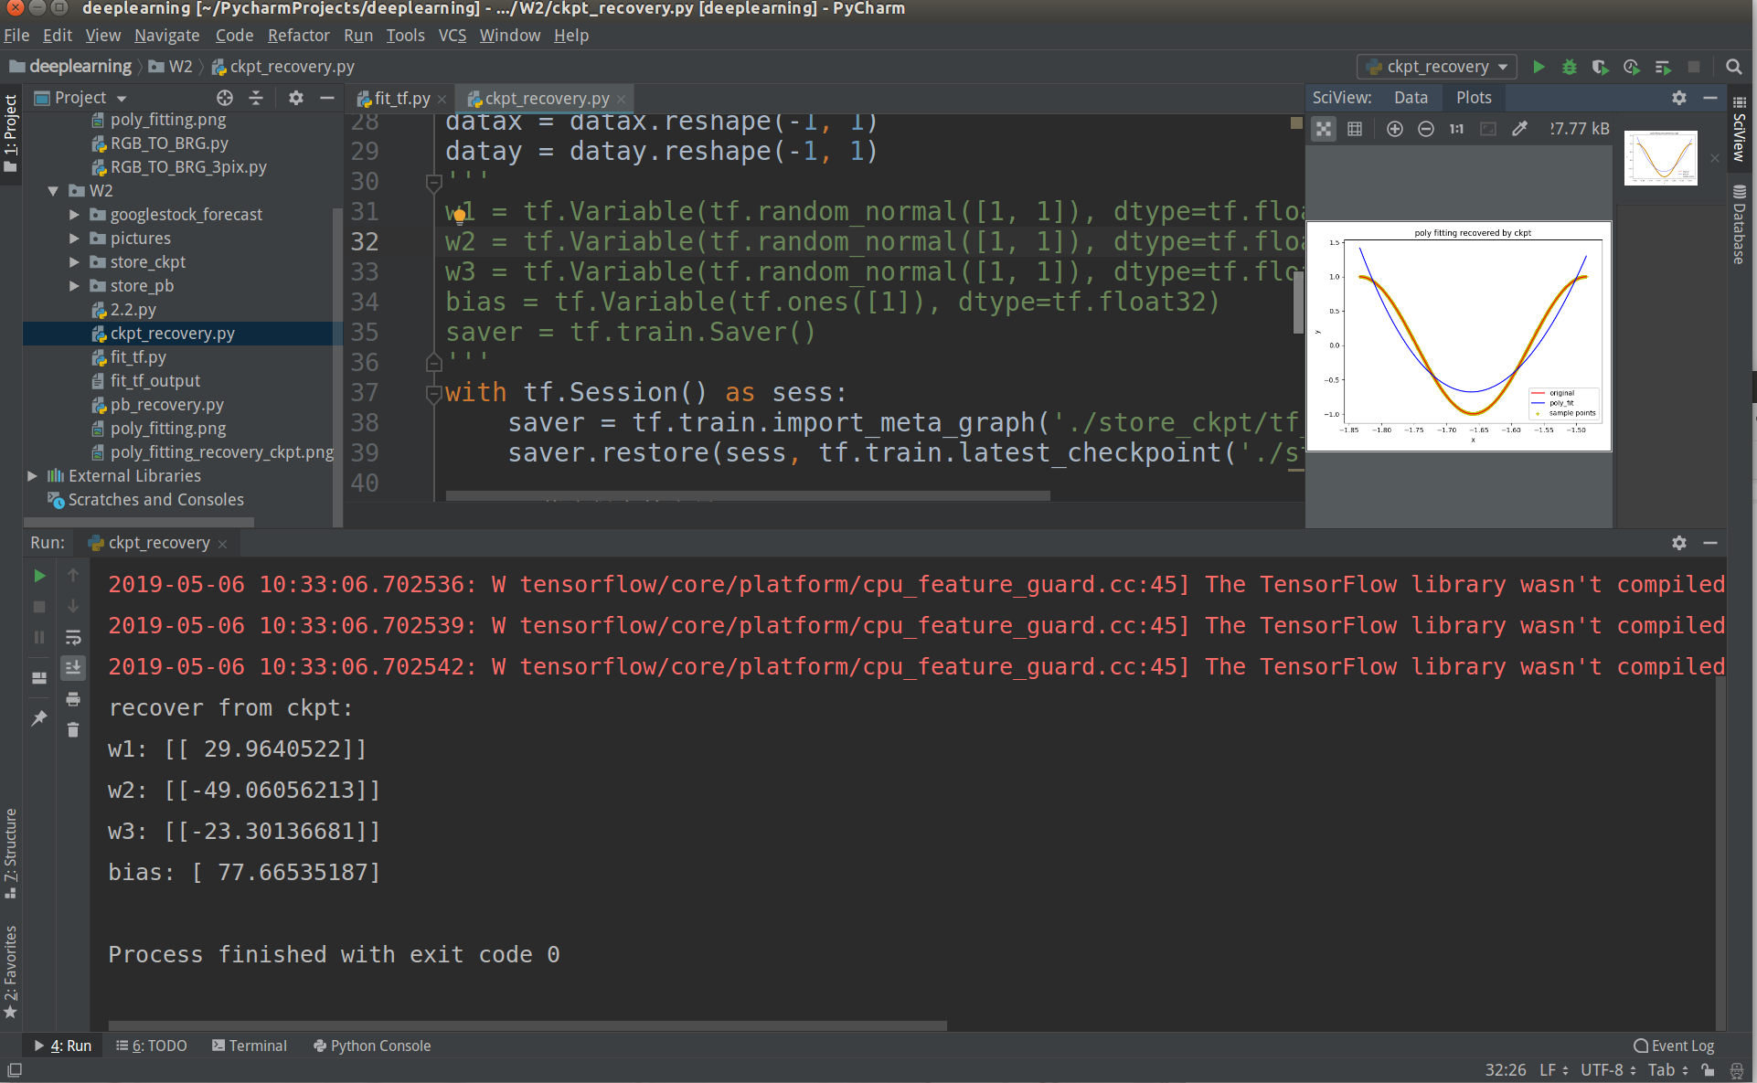
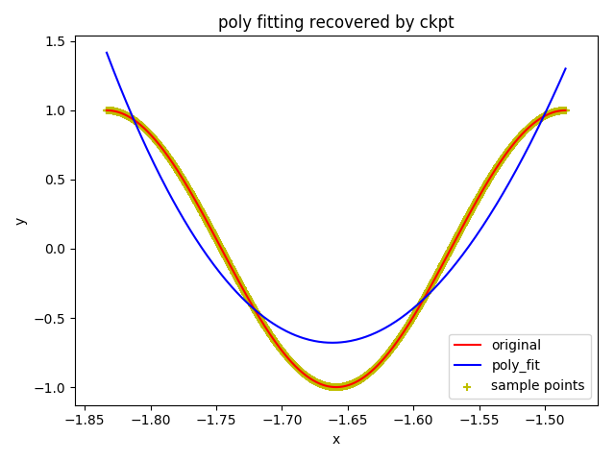
pb recovery:
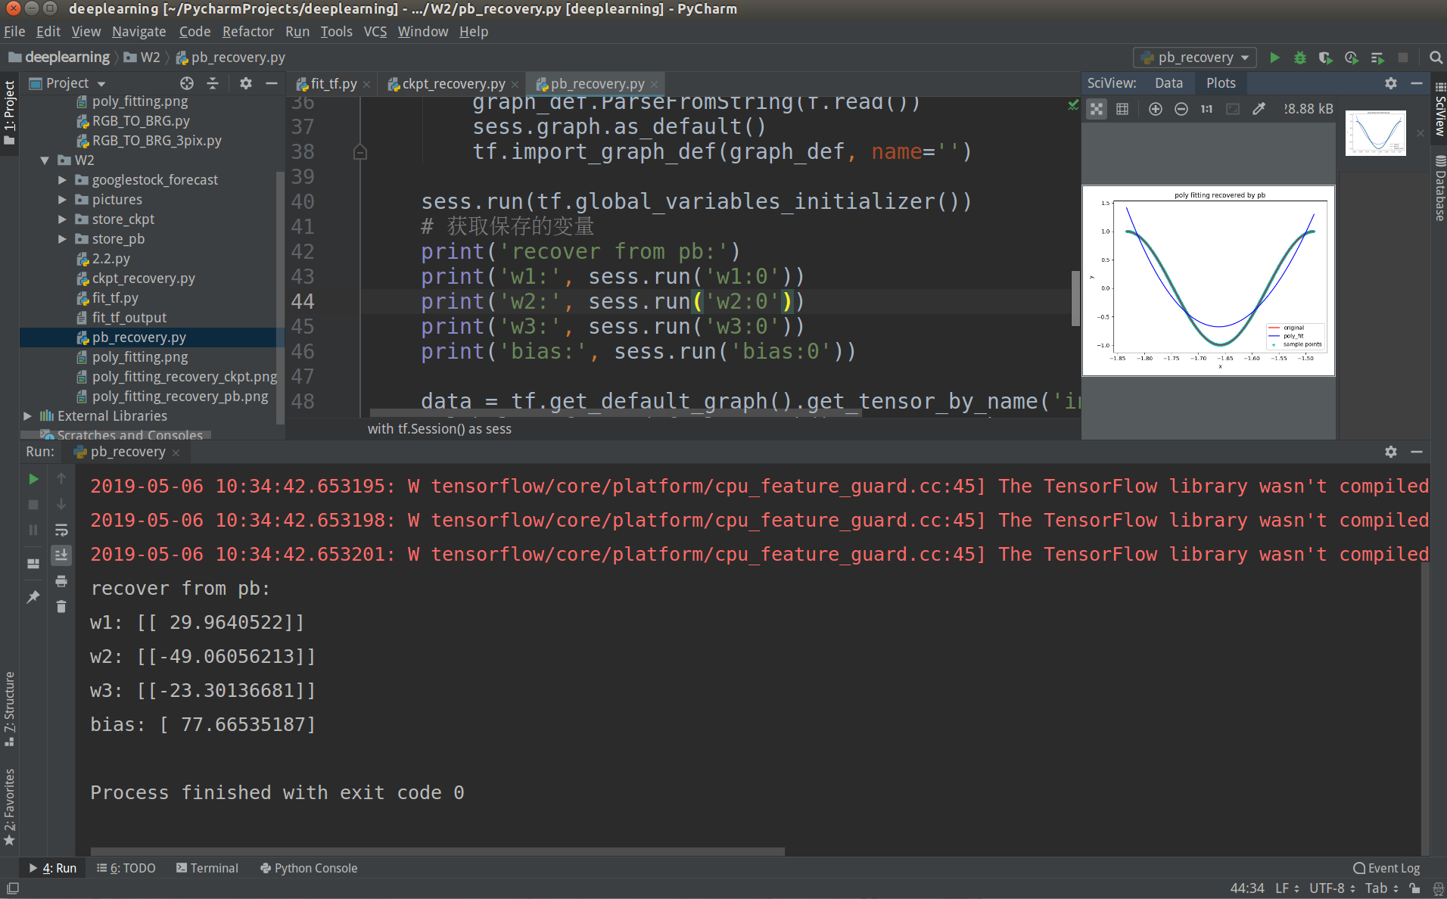
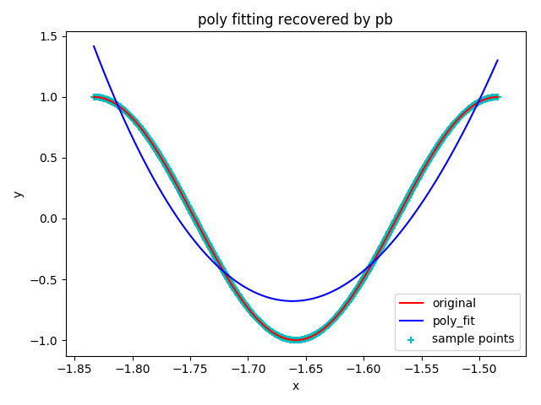
进阶代码：
import tensorflow as tf
x = tf.Variable(tf.constant(1, tf.float32))
y = 1 - tf.div(tf.sin(x), x)
train = tf.train.GradientDescentOptimizer(0.002).minimize(y)
init = tf.global_variables_initializer()
with tf.Session() as sess:
sess.run(init)
for i in range(10000):
sess.run(train)
print('当前最小值为：', sess.run(y), '对应x为:', sess.run(x))

进阶运行结果:
