作业三

**运行结果：**

490 times iterations' accuracy is: 0.901300 , loss is: 0.339850

test:[accuracy,loss]: [0.9012, 0.375386]

**运行截图：**

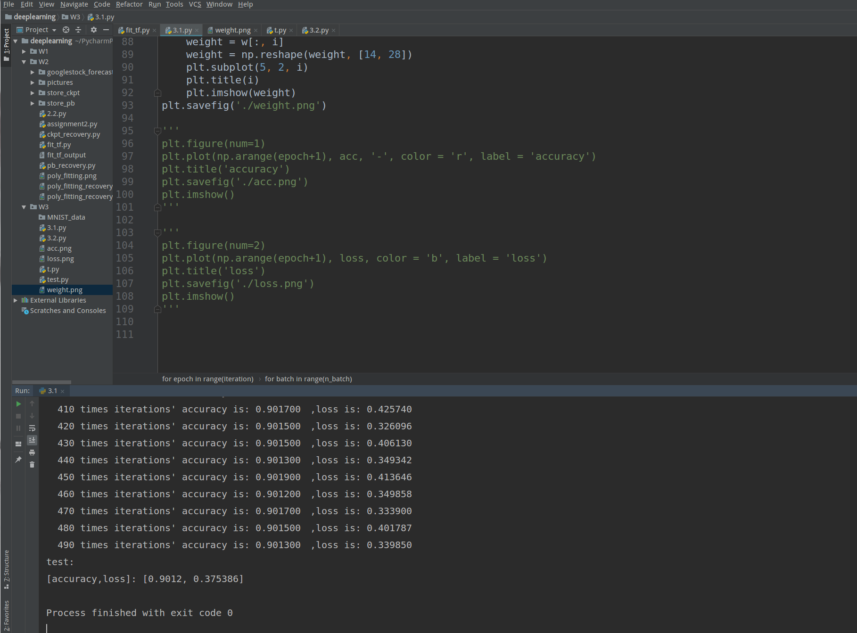

**运行过程：**

/home/zpp/anaconda3/envs/tensorflow/bin/python /home/zpp/PycharmProjects/deeplearning/W3/3.1.py

Extracting /home/zpp/download/file/MNIST/train-images-idx3-ubyte.gz

Extracting /home/zpp/download/file/MNIST/train-labels-idx1-ubyte.gz

Extracting /home/zpp/download/file/MNIST/t10k-images-idx3-ubyte.gz

Extracting /home/zpp/download/file/MNIST/t10k-labels-idx1-ubyte.gz

107

2019-05-21 13:31:25.369400: W tensorflow/core/platform/cpu_feature_guard.cc:45] The TensorFlow library wasn't compiled to use SSE4.1 instructions, but these are available on your machine and could speed up CPU computations.

2019-05-21 13:31:25.369415: W tensorflow/core/platform/cpu_feature_guard.cc:45] The TensorFlow library wasn't compiled to use SSE4.2 instructions, but these are available on your machine and could speed up CPU computations.

2019-05-21 13:31:25.369419: W tensorflow/core/platform/cpu_feature_guard.cc:45] The TensorFlow library wasn't compiled to use AVX instructions, but these are available on your machine and could speed up CPU computations.

2019-05-21 13:31:25.369423: W tensorflow/core/platform/cpu_feature_guard.cc:45] The TensorFlow library wasn't compiled to use AVX2 instructions, but these are available on your machine and could speed up CPU computations.

2019-05-21 13:31:25.369426: W tensorflow/core/platform/cpu_feature_guard.cc:45] The TensorFlow library wasn't compiled to use AVX512F instructions, but these are available on your machine and could speed up CPU computations.

2019-05-21 13:31:25.369429: W tensorflow/core/platform/cpu_feature_guard.cc:45] The TensorFlow library wasn't compiled to use FMA instructions, but these are available on your machine and could speed up CPU computations.

0 times iterations' accuracy is: 0.751800　,loss is: 1.541779

10 times iterations' accuracy is: 0.844000　,loss is: 0.596829

20 times iterations' accuracy is: 0.862500　,loss is: 0.552590

30 times iterations' accuracy is: 0.870400　,loss is: 0.517404

40 times iterations' accuracy is: 0.877400　,loss is: 0.493777

50 times iterations' accuracy is: 0.881600　,loss is: 0.525024

60 times iterations' accuracy is: 0.883200　,loss is: 0.381032

70 times iterations' accuracy is: 0.885500　,loss is: 0.387560

80 times iterations' accuracy is: 0.887400　,loss is: 0.479776

90 times iterations' accuracy is: 0.889000　,loss is: 0.374242

100 times iterations' accuracy is: 0.889400　,loss is: 0.427843

110 times iterations' accuracy is: 0.891400　,loss is: 0.463463

120 times iterations' accuracy is: 0.891800　,loss is: 0.419130

130 times iterations' accuracy is: 0.893400　,loss is: 0.378033

140 times iterations' accuracy is: 0.893800　,loss is: 0.440063

150 times iterations' accuracy is: 0.894500　,loss is: 0.335205

160 times iterations' accuracy is: 0.895300　,loss is: 0.418341

170 times iterations' accuracy is: 0.895600　,loss is: 0.344219

180 times iterations' accuracy is: 0.895500　,loss is: 0.425364

190 times iterations' accuracy is: 0.897100　,loss is: 0.420520

200 times iterations' accuracy is: 0.897000　,loss is: 0.393213

210 times iterations' accuracy is: 0.897300　,loss is: 0.407631

220 times iterations' accuracy is: 0.897800　,loss is: 0.385820

230 times iterations' accuracy is: 0.898500　,loss is: 0.336289

240 times iterations' accuracy is: 0.898700　,loss is: 0.458893

250 times iterations' accuracy is: 0.899200　,loss is: 0.355125

260 times iterations' accuracy is: 0.899300　,loss is: 0.397733

270 times iterations' accuracy is: 0.900100　,loss is: 0.398033

280 times iterations' accuracy is: 0.899800　,loss is: 0.409161

290 times iterations' accuracy is: 0.899700　,loss is: 0.367369

300 times iterations' accuracy is: 0.899800　,loss is: 0.441711

310 times iterations' accuracy is: 0.900200　,loss is: 0.361639

320 times iterations' accuracy is: 0.900100　,loss is: 0.381419

330 times iterations' accuracy is: 0.900800　,loss is: 0.398157

340 times iterations' accuracy is: 0.900700　,loss is: 0.392525

350 times iterations' accuracy is: 0.901000　,loss is: 0.420787

360 times iterations' accuracy is: 0.900700　,loss is: 0.358621

370 times iterations' accuracy is: 0.900700　,loss is: 0.381673

380 times iterations' accuracy is: 0.901100　,loss is: 0.328832

390 times iterations' accuracy is: 0.901300　,loss is: 0.357989

400 times iterations' accuracy is: 0.900800　,loss is: 0.364708

410 times iterations' accuracy is: 0.901700　,loss is: 0.425740

420 times iterations' accuracy is: 0.901500　,loss is: 0.326096

430 times iterations' accuracy is: 0.901500　,loss is: 0.406130

440 times iterations' accuracy is: 0.901300　,loss is: 0.349342

450 times iterations' accuracy is: 0.901900　,loss is: 0.413646

460 times iterations' accuracy is: 0.901200　,loss is: 0.349858

470 times iterations' accuracy is: 0.901700　,loss is: 0.333900

480 times iterations' accuracy is: 0.901500　,loss is: 0.401787

490 times iterations' accuracy is: 0.901300　,loss is: 0.339850

test:

[accuracy,loss]: [0.9012, 0.375386]

Process finished with exit code 0