作业三进阶

**运行结果：**

20000 times iteration: accuracy: 0.9131 , loss: 0.2131

test_accuracy: 0.9166

**运行截图：**

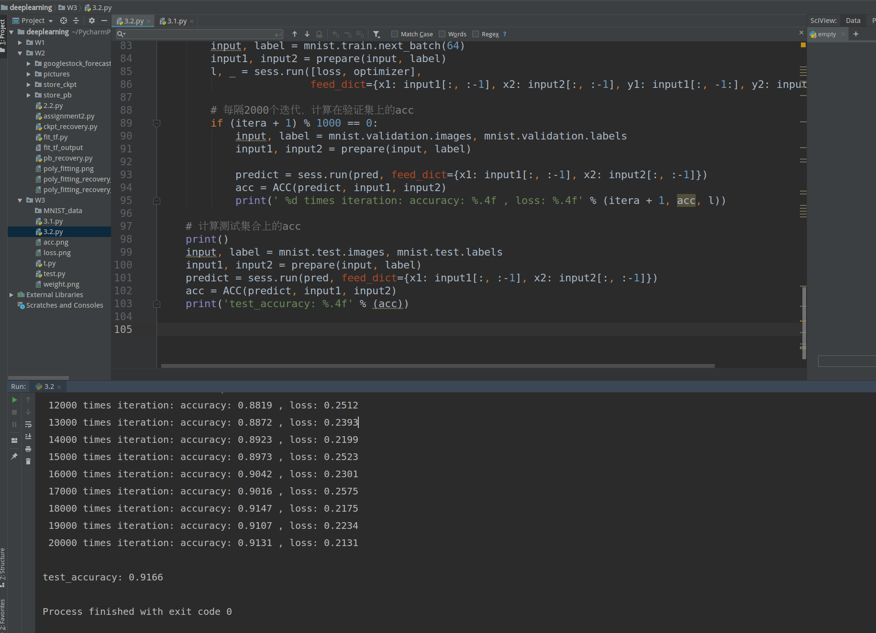

**运行过程：**

/home/zpp/anaconda3/envs/tensorflow/bin/python /home/zpp/PycharmProjects/deeplearning/W3/3.2.py

WARNING:tensorflow:From /home/zpp/anaconda3/envs/tensorflow/lib/python3.6/site-packages/tensorflow/contrib/learn/python/learn/datasets/mnist.py:262: extract_images (from tensorflow.contrib.learn.python.learn.datasets.mnist) is deprecated and will be removed in a future version.

Instructions for updating:

Please use tf.data to implement this functionality.

Extracting /home/zpp/download/file/MNIST/train-images-idx3-ubyte.gz

Extracting /home/zpp/download/file/MNIST/train-labels-idx1-ubyte.gz

Extracting /home/zpp/download/file/MNIST/t10k-images-idx3-ubyte.gz

Extracting /home/zpp/download/file/MNIST/t10k-labels-idx1-ubyte.gz

1000 times iteration: accuracy: 0.5521 , loss: 0.3796

2000 times iteration: accuracy: 0.6403 , loss: 0.3524

3000 times iteration: accuracy: 0.7095 , loss: 0.3066

4000 times iteration: accuracy: 0.7720 , loss: 0.3179

5000 times iteration: accuracy: 0.8014 , loss: 0.2563

6000 times iteration: accuracy: 0.8158 , loss: 0.2781

7000 times iteration: accuracy: 0.8466 , loss: 0.2907

8000 times iteration: accuracy: 0.8548 , loss: 0.2755

9000 times iteration: accuracy: 0.8593 , loss: 0.2608

10000 times iteration: accuracy: 0.8705 , loss: 0.2077

11000 times iteration: accuracy: 0.8764 , loss: 0.2232

12000 times iteration: accuracy: 0.8819 , loss: 0.2512

13000 times iteration: accuracy: 0.8872 , loss: 0.2393

14000 times iteration: accuracy: 0.8923 , loss: 0.2199

15000 times iteration: accuracy: 0.8973 , loss: 0.2523

16000 times iteration: accuracy: 0.9042 , loss: 0.2301

17000 times iteration: accuracy: 0.9016 , loss: 0.2575

18000 times iteration: accuracy: 0.9147 , loss: 0.2175

19000 times iteration: accuracy: 0.9107 , loss: 0.2234

20000 times iteration: accuracy: 0.9131 , loss: 0.2131

test_accuracy: 0.9166

Process finished with exit code 0