Project Proposal

Tick Task

Jean Redfearn

18201997

x18201997@student.ncirl.ie

Higher Diploma in Science in Computing

Specialisation Software Systems

09/10/2022

# Objectives

The main objective of this project is to create, troubleshoot, and deploy a web-based application that will allow users of third-party time management software utilities to import and use the data from the proprietary system, into a freeware utility, Tick Task, to allow access to view their upcoming tasks on that system, and to track tasks that have been completed to-date on same.

The scope of this project is limited to integration of Microsoft Outlook calendar data, Apple calendar data, and, Google appointment and planning data. Other time/people/project management tools have been discounted from consideration for this project, as, Apple, Microsoft and Google have a combined market share of approximately 91.5% in this sector, ***Fig. 1.1***.

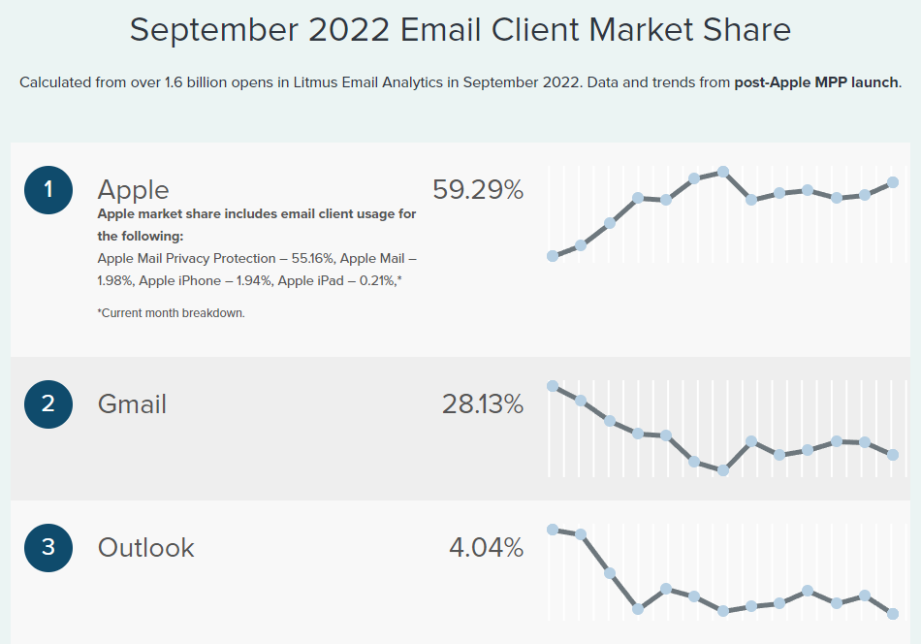

*Figure 1.1 - Email Client - Market Share - September 2022*

(Litmus, 2022)

The software will be able to perform these following tasks

* Register and login functionalities
* Add, edit, delete tasks
* Mark tasks as completed

Supplementary objectives of this project will be to ensure that this application adheres to ‘freeware’ principles. This approach requires a minimalistic strategy with regards to the creation, use and storage of this utility, with a view to distributing the software to as many users as possible, with as little input or support as possible.

Therefore, another objective of this project will be to make the user interface as user-friendly, and self-explanatory, as possible. The utility will need to be ‘plug-and-play’ in its simplicity.

# Background

The need for this project was identified during a brainstorming session that was held by the project initiator. The session participants are all current work colleagues of the initiator, working in the same company.

The company lacks a dedicated task management tool for its staff. This affects the productivity of many of the staff within the company, at multiple levels, and has been highlighted, by the staff, to management on a number of occasions. However, this has resulted in no satisfactory resolution of the issue.

Once the need for the project was identified by the initiator, the requirements for executing the project were then estimated. And, the full scope of the project was defined.

Through further discussion with colleagues in the company, an alignment with the current business strategy was established, this resulted in a need for a ‘Freeware’ solution mentioned above, due to the budget constraints of the company.

Once the scope of the project was defined, a timeline could then be estimated. A Gantt chart was drafted and accompanies this paper in **Section 4**, below.

The assumptions made for this project, and the criteria that the project initiator has set out for measuring the success or failure of this project, are;

1. It is assumed that this utility can be hosted on a website indefinitely, the cost of which will be covered by the company that uses it.
2. It is assumed that no mediator will be required to manage user login details and GDPR concerns.
3. It is assumed that stakeholders do not require interface or data transferral from their email utility, and therefore, this functionality is outside the limitations of this project scope.
4. The success of this project will be defined by the evaluation **Section 7**, below.

# Technical Approach

Spring Boot will be the main tool used in this project to help develop the web application. Further studying is needed, in order to execute the software Spring Boot. The full course found on Udemy “The course Learn Spring Boot in 100 Steps by Ranga Karanam” demonstrates how to build a web application using Spring Boot. This course further explains in detail how to use Auto Configuration, Spring Initializer, Starter Projects and how to build REST API. Additional materials used for learning Spring Boot is from Spring Boot’s website <https://spring.io/guides/gs/spring-boot/>

Requirements on developing this application are designed from stakeholders and creating user stories to help establish a list of requirements that is needed to capture requirements efficiently.

Research on the internet on steps to create a web application will be used as guidelines for this project.

The main approach to implement this web application for this project, has been implemented into 5 steps. (GL, 2021)

1. Planning
2. Analysis
3. Design and develop
4. Testing
5. Deploy and launch

A Gantt chart has also been created in this order to help keep track of this project.

To develop this web application, Eclipse IDE will be used and synced with Spring Boot. Spring Boot will also be used for debugging and testing different functions of the software.

# Project Plan

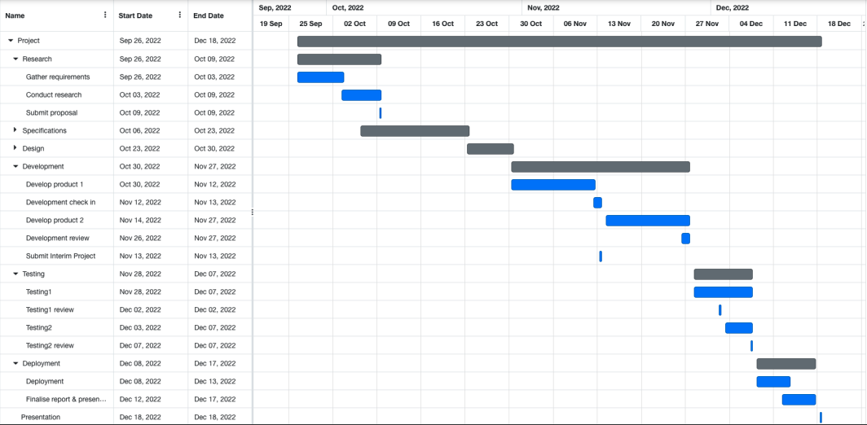

PDF attached for better visibility of Gantt chart

# Technical Details

The 5 steps from the technical approach is applied to implement the application with help of the following software and programming language.

* Spring Boot is used to create a framework, build, test and deploy the web application. Spring Boot has add-ons to help build the web application all in this one tool which helps reduce development time.
* Bootstrap which is part of Spring Boot is added on and used for styling the layouts of the webpage by using HTML, CSS and JavaScript to build the front end of this application.
* Java is the language used for building and developing the back end software and Spring Boot.
* MySQL is the database system used to develop and store the application’s database and will be connected to the application by connecting with Spring Boot.

# Evaluation

Software testing is a process of verification and validation of the software to check whether the software is working as expected. A list of requirements has been created for the software and by testing out each of these requirements, it will be used to evaluate the system. Testing the software will help identify any bugs or issues so they’re fixed prior to launching and deploying the software. As Spring Boot is used in this project for framework, it is also used for unit testing, functional testing, performance testing and integration testing the software. Spring Boot has additional features for testing such as JUnit is being used to cover all unit testing while Apache JMeter is used for performance testing.

Thorough research from end users will help create user stories. These user stories help create a software to meet their needs and to have a better understanding of what the users want to achieve. This research is to ensure that the software is going to meet all end user’s needs.

Jean Redfearn 08/10/2022

Signature of student and date

# Works Cited

GL, K., 2021. *Develop Your Web Application With 8 Easy Steps [2022].* [Online]   
Available at: https://www.neoito.com/blog/web-application-development-beginners-guide/  
[Accessed 6 October 2022].

Litmus, 2022. *Litmus.* [Online]   
Available at: https://www.litmus.com/email-client-market-share/  
[Accessed 07 10 2022].