Design of an AI-Assisted Customer Support System for Micro and Small E-Commerce Businesses in Baguio City and Benguet
JEANALYN MARIE B. LAGERA
Mapúa University, Philippines, jeanalynlagera123@gmail.com
MITO 611 – Advanced Web Systems and Technologies
Abstract
Many micro and small sellers in Baguio City and Benguet run their online stores through Facebook pages, Messenger, and marketplace chat. In most of these shops, the owner or one or two staff members answer every customer message, and a large share of those messages ask the same things: Is the item available? How much is it? Is COD allowed? How long is delivery? Can it be returned? This paper presents the design of an AI-assisted customer support system for these businesses. The system answers routine questions only from a knowledge base that the owner maintains, using retrieval-augmented generation, and it passes complaints, refund requests, and any question it cannot back with a stored record to a human. It is built to handle English, Filipino, and Taglish messages. The design followed an iterative, Agile-based process and is documented through requirements, a use case diagram, a system architecture, a process flowchart, an entity-relationship model, interface mockups, technical requirements, and a preliminary subscription business model. Four options were compared, ranging from saved replies to a general-purpose chatbot. The retrieval-based design with human escalation was chosen because it keeps the owner in control of the facts while still removing much of the repetitive typing. An evaluation plan sets targets for accuracy, relevance, response time, usability, and satisfaction, using a 120-item test set and a pilot with local sellers. No performance results are claimed yet; those will come from the prototype evaluation.
Additional Keywords and Phrases: AI customer support, chatbot, e-commerce, Philippine MSMEs, Taglish, retrieval-augmented generation, human escalation, Baguio City, Benguet

1 INTRODUCTION

1.1 Background of the Study
Online selling is now an ordinary part of doing business in the Philippines. The Philippine Statistics Authority (PSA) estimates that the digital economy produced PHP 2.74 trillion in gross value added in 2025, or 9.8% of GDP, and that e-commerce made up 32.2% of that amount. The same estimates put digital-economy employment at 10.39 million people [24].
Most of the businesses taking part in this shift are small. The Department of Trade and Industry (DTI) counted 1,241,733 MSMEs in 2023, which is 99.63% of all business establishments in the country. Of these, 1,127,058 were micro enterprises and 109,912 were small enterprises, and MSMEs as a group accounted for 66.97% of reported employment [4]. These figures do not count online sellers as such, but they show how many Filipino businesses run with only a handful of people.
How these businesses sell online also shapes the kind of support tool they can use. In the 2024 National ICT Household Survey, 29.8% of Filipinos aged 10 and above had an online buying or selling account, and 36.7% of internet users had bought goods or services online. Among those who sold goods online, 94.4% used social media, 87.9% accepted cash on delivery, and 56.5% accepted e-wallets [23]. The Bangko Sentral ng Pilipinas reports the same steady move toward digital payments [2]. For a typical small seller, then, customer questions arrive in Messenger threads and comment sections. Few of these sellers have a full storefront with its own help desk.
This is where the workload builds up. An owner who also packs orders, restocks, books couriers, and posts content ends up typing the same answers many times a day. Speed is one issue and consistency is another. Prices change, stock runs out, delivery rules get updated, and a reply typed from memory can easily be out of date. A tool that helps with this has to take its answers from information the owner has approved, and the owner has to be able to update that information in a minute or two.
Chatbots are the obvious candidate, and some research supports them. Jiang et al. found that responsiveness and conversational tone predicted how satisfied users were with AI chatbots [14], and Hsu and Lin found that the quality of chatbot conversations and of service recovery shaped both satisfaction and loyalty [11]. The local picture is less encouraging. A study of the Shopee and Lazada service chatbots found that Filipino users struggled with problem resolution, dialogue quality, and the bots' reading of natural language; some had to rephrase questions or received answers that missed the point [3]. Language is part of the reason. Many Filipino customers write in Taglish, and recent benchmarks show that large language models still perform unevenly on Tagalog and code-switched text [15, 16].
There are legal duties to consider too. The Internet Transactions Act of 2023 ties e-commerce regulation to consumer rights and data privacy [26], and the National Privacy Commission (NPC) has stated that the Data Privacy Act applies when personal data are used to build or run AI systems [17, 25]. The national AI roadmap also asks enterprises to adopt AI responsibly [7]. A support assistant that reads customer messages has to be designed with these rules in place from the first version.

1.2 Local Context: Baguio City and Benguet
The study is set in Baguio City and nearby Benguet towns such as La Trinidad. Sellers in the area offer products like Benguet coffee, strawberry and ube preserves, woven goods, and secondhand clothing, and many of them sell through Facebook pages and marketplace apps. Government agencies have been pushing these sellers online for the past year.
In February 2026, DICT-CAR and DTI-CAR announced that they would align their digital-skills training, e-commerce adoption, and connectivity programs so that Cordillera MSMEs would have clearer paths to selling online [19]. In April 2026, DTI-CAR released a five-point agenda and development plan for the region's MSMEs [20]. In July 2026, 50 Baguio City MSMEs joined a Tatak Pinoy workshop run by the city government with Shopee Philippines, which covered platform setup, digital marketing, and business tools [21]. In September 2026, 25 MSMEs from Baguio City and Benguet completed DICT's SPARK training on social media marketing, which included the use of AI for business tasks [22].
These programs teach sellers to open and promote online stores. They say much less about what happens once the promotion works and the messages start coming in, and that is where this study begins. The reports above describe the setting, but they do not prove that local sellers have a customer-support problem. For this reason, the requirements phase includes interviews with local sellers (Section 3.3) to find out which questions they actually receive and how they handle them now.

1.3 Problem Statement
Micro and small online sellers in Baguio City and Benguet answer many routine customer questions with very few staff. The design problem is how to build an AI-assisted support system that answers these questions quickly and correctly, never states a fact the business has not approved, and hands anything difficult to a person. The problem has five parts:
(1) repeated questions take up time the owner needs for other work;
(2) replies typed by hand are not always consistent;
(3) prices, stock, and policies change, and answers must change with them;
(4) customers write in English, Filipino, or Taglish, often in the same message; and
(5) complaints, refund requests, and unclear cases need human judgment.

1.4 Research Questions
(1) What do micro and small online sellers in Baguio City and Benguet need from a customer support assistant, based on the questions they receive and how they answer them today?
(2) How should products, FAQs, and policies be stored so that every generated answer can be traced to approved business data?
(3) How can English, Filipino, and Taglish inquiries be handled within the same workflow?
(4) How can the system recognize uncertain or sensitive inquiries and pass them to a staff member?
(5) How can the prototype's accuracy, relevance, response time, usability, and user satisfaction be measured?

1.5 Objectives of the Study
The general objective is to design and develop a prototype AI-assisted customer support system for micro and small e-commerce businesses in Baguio City and Benguet. Specifically, the study aims to:
(1) identify functional and non-functional requirements from local sellers;
(2) design an owner-managed knowledge base for products, FAQs, policies, and escalation rules;
(3) design a chat workflow that accepts English, Filipino, and Taglish messages;
(4) implement a retrieval-grounded response process that answers only from approved records;
(5) provide human escalation for low-confidence, sensitive, complaint, and exception cases; and
(6) evaluate the prototype for accuracy, relevance, response time, usability, and satisfaction.

1.6 Scope and Limitations
The study covers the design and prototype of a web-based support assistant for micro and small sellers in Baguio City and Benguet. It handles routine questions about product availability, product details, prices, payment methods, delivery, order status, returns, exchanges, and general FAQs. The prototype includes a customer chat page, an owner dashboard, knowledge-base management, conversation logs, a confidence check, and a staff escalation queue.
The system does not replace customer-service staff, issue refunds on its own, make financial or legal decisions, or verify whether the owner's information is true. Direct integration with Facebook Messenger, Shopee, Lazada, and TikTok Shop is left for future work; the prototype runs as a web chat that can be linked from a seller's page. Testing is limited to a prototype setting, a defined test set, and a small pilot group, so the results will not represent all Philippine online sellers.

1.7 Significance of the Study
For small sellers, the system offers one place to keep customer-facing information and a way to answer the most common questions without typing them again. Customers get basic answers faster, including outside store hours. For researchers and developers, the project is a Philippine design case that brings together conversational AI, e-commerce, Taglish input, and human-in-the-loop support. For government programs such as those of DTI and DICT in the Cordillera, it suggests a practical next step after digital-marketing training. For anyone who later builds a similar tool, the design lists the privacy, security, and evaluation requirements that should be settled before launch.

2 LITERATURE REVIEW

2.1 Philippine E-Commerce and MSMEs
The national data point in one direction. MSMEs make up almost all establishments and about two-thirds of jobs [4], and e-commerce is the largest part of the digital economy [24]. DTI has responded with programs aimed at small players: the Online Negosyo Program, launched in 2024, trains enterprises to sell in the digital marketplace, and the "Tindahan Mo, e-Level Up Mo!" pilot helps sari-sari store owners adopt digital tools [5]. In 2025, DTI also opened applications for the E-Commerce Philippine Trustmark, which gives online sellers a way to signal that they can be trusted [8].
What these sources show less clearly is where small sellers actually do business online. The 2024 household survey answers part of that question: social media is by far the most common selling channel [23]. Social selling runs on direct messages, so customer service ends up spread across a personal account, a business page, Messenger, and marketplace chats. A single knowledge base that feeds answers to all of these channels would help keep replies consistent even while the channels stay separate. This is one of the design ideas carried into Section 4.

2.2 Chatbots and Customer Service Quality
Studies on customer-service chatbots agree that they can make service faster, but they differ on what customers value most. Jiang et al. found that responsiveness and a conversational tone raised satisfaction, which in turn was linked to engagement and purchase behavior [14]. Hsu and Lin point to conversation quality and service recovery, meaning how well the bot handles things when they go wrong [11]. Zhang et al. studied 399 e-commerce customers and found that response speed, response accuracy, convenience, and accessibility all shaped perceived service quality, and that personalization improved accuracy but slowed responses [29].
Read together, these studies show that speed alone does not make good service. A fast wrong answer can hurt more than a slow correct one, especially when the question is about money or delivery dates. For this reason, the evaluation in this study treats accuracy as the main measure and response time as a secondary one.
Business size matters as well. Rizomyliotis et al. studied chatbots in small family businesses and found that customers' emotional attachment to the business changed how they judged the bot [27]. Small sellers in Baguio often know their regular buyers by name. For them, a bot that sounds cold or gets things wrong costs more than it would cost a large platform, so the assistant should stay polite, use the local "po" register where the customer does, and step aside when a conversation needs a person.

2.3 Trust and Human Intervention
Huang, Markovitch, and Stough ran three studies with 643 participants and found that people were generally more satisfied with human agents than with chatbots. However, chatbot service combined with light human intervention matched the human-only condition on most outcomes [12]. They also found that trust worked on three levels: trust in service technology in general, learned trust in chatbots, and trust in the specific bot in the conversation.
This result shaped the design more than any other. It suggests that a small business does not have to choose between full automation and doing everything by hand. The bot can handle the routine questions, and a person can step in for the rest. The escalation queue in Section 4 follows this idea directly.

2.4 Why Chatbot Answers Fail
A chatbot can produce fluent text and still be wrong. Failures usually come from one of four sources: the bot misreads the customer's intent, the business information it needs is missing, it retrieves the wrong record, or it writes an answer that goes beyond the evidence. The Shopee and Lazada study shows that Filipino users run into these problems as well [3].
Response style also plays a part. Zhu et al. found that concrete chatbot responses led to higher customer satisfaction than abstract ones, because concrete answers showed that the bot had understood the problem [30]. For a seller, this means that "Yes po, Medium Black is in stock, ₱499" is better than "We will check for you." Concrete answers, however, must come from real data. Retrieval-augmented generation (RAG) addresses this by first looking up relevant documents and then generating an answer from them, which reduces the chance that the model makes up facts [10]. RAG still fails when retrieval misses, so the prototype adds a confidence threshold. When no record is close enough, the bot says it will pass the question to staff. It should never guess a price, a stock count, or a refund rule.

2.5 Filipino, Tagalog, and Taglish Processing
Language support is a core requirement for a Philippine chatbot. The Batayan benchmark tests large language models on Tagalog and code-switched Taglish across understanding, reasoning, and generation tasks. It found clear performance gaps, which the authors link to how little Filipino text these models see in training [16]. Layacan et al. report similar problems with data scarcity and tokenization for Filipino [15].
Two design rules follow from this. First, the test set must include English, Filipino, and Taglish messages in equal numbers, so that weak performance in one language is not hidden by good results in another. Second, the system should not translate everything into English and assume nothing is lost. Product names, sizes, prices, and place names such as "La Trinidad" or "Session Road" must pass through unchanged. The owner can also store approved Filipino or Taglish wording for key policies, so the model does not have to translate them.

2.6 Consumer Protection and Privacy
The Internet Transactions Act of 2023 covers business-to-business and business-to-consumer online transactions and names consumer rights, data privacy, and secure transactions among its concerns [26]. DTI's e-commerce guidance tells consumers to check a seller's identity, payment options, and return or exchange policy before buying [9]. A support assistant can help here by giving these details clearly and the same way every time.
Complaints are common. DTI's Fair Trade Enforcement Bureau received 28,824 complaints in 2023, and 42% of them were about online transactions [6]. This figure does not show that slow replies cause complaints. It does show that disputes are a regular part of online selling and should not be handled like ordinary FAQs. The design sends them to a person every time.
Customer messages often contain names, phone numbers, addresses, order numbers, and payment references. NPC Advisory No. 2024-04 confirms that the Data Privacy Act covers AI systems that process such data [17]. The design therefore uses data minimization, role-based access, retention limits, audit logs, and a short privacy notice. Customer conversations are not used to train or fine-tune any model.

2.7 AI Risk, Security, and Software Quality
The NIST AI Risk Management Framework organizes AI risk work into four functions: Govern, Map, Measure, and Manage [28]. Its Generative AI Profile adds risks specific to generative systems, such as confabulation and information leakage [1]. The OWASP Top 10 for LLM Applications lists prompt injection, sensitive information disclosure, supply-chain weaknesses, data and model poisoning, and improper output handling among the main risks [18]. For a small-business tool, the practical lesson is that the prompt cannot be the only safeguard. Access control and business actions must stay in ordinary application code, where they are easier to test.
ISO/IEC 25010:2023 gives a product quality model with characteristics such as functional suitability, performance efficiency, usability, reliability, security, and maintainability [13]. This study does not attempt to measure all of them. It uses the model to choose the non-functional requirements in Section 4.3 and the measures in Table 1.

2.8 Synthesis and Research Gap
Four points come out of the literature. Global studies show that responsiveness, accuracy, conversational quality, trust, and access to a human all affect how customers judge chatbot service [11, 12, 14, 27, 29, 30]. Philippine evidence shows that even large platforms' chatbots struggle with local dialogue [3]. Filipino NLP research shows that Taglish needs to be tested on its own terms [15, 16]. Philippine law and policy require attention to consumer protection and privacy [6, 17, 26].
What is missing is a design that puts these points together for the smallest sellers. Most of the studies above deal with large platforms or with customer attitudes in general. None of them describes a support tool that a micro-business owner in the Cordillera could set up and maintain, that answers only from the owner's own records, that works in Taglish, and that hands off to a person when it should. This study addresses that gap.

3 METHODOLOGY

3.1 Research Design and Software Methodology
This is a design project. It follows the design-science pattern of identifying a problem, building an artifact that addresses it, and evaluating the artifact. Development follows an Agile approach adapted from Scrum, with six two-week sprints. Each sprint ends with a working increment that is reviewed with the adviser and, where possible, with one or two local sellers. Agile was chosen over a waterfall approach because the requirements depend on what sellers report in interviews, and those findings are likely to change the knowledge-base fields and escalation rules during development. The sprint plan appears in Appendix B.
The prototype uses the RAG pattern described in Section 2.4. The model does not answer from its general training. The system first retrieves matching records from the seller's knowledge base, and the model then writes a short reply using only those records. This lets the owner change a price or a policy in the dashboard without retraining any model.

3.2 Research Setting and Participants
The study will be conducted in Baguio City and Benguet Province. Participants will be owners or staff of micro and small businesses that sell through Facebook, Facebook Marketplace, Instagram, TikTok, Shopee, Lazada, or their own websites, and that regularly receive customer questions by chat. Purposive sampling will be used. The target is 8 to 12 sellers for the interviews and 15 to 20 users (sellers and customers) for the pilot evaluation. The final numbers will be confirmed with the adviser.

3.3 Requirements Gathering
Requirements will come from three sources. The first is semi-structured interviews with sellers, covering the questions they receive most often, how they answer now (typed replies, saved replies, or Meta's automated responses), how long replies take during busy periods, which cases they would never leave to a bot, and what they would pay for such a tool. The second is a sample of 30 to 50 past customer inquiries per seller, shared only with consent and with names and numbers removed before the researcher sees them. These samples will be used to build the test set. The third is the literature review in Section 2, which contributes the privacy, security, and quality requirements.

3.4 Evaluation Design
Evaluation has two parts: a functional test against a fixed test set and a pilot with intended users. The test set will contain 120 inquiries, with 40 each in English, Filipino, and Taglish, spread across product details, price and stock, payment, delivery, order status, returns and exchanges, general FAQs, and escalation cases. Each intent will include paraphrases so that the system is tested on meaning and not only on keywords. Before running any test, the evaluator records the correct source record or the correct escalation outcome for each item. This prevents the expected answer from being adjusted after the evaluator sees what the AI produced.
Table 1: Evaluation measures and project acceptance criteria
Measure | How it is measured | Target | What it shows
Response accuracy | Correct supported answers ÷ test cases × 100 | ≥ 90% | Factual match with approved business data
Relevance | Evaluator rating, 1–5, two raters | ≥ 4.0 | Whether the reply addresses the actual question
Response time | Seconds from message to reply (median) | ≤ 5 s | Conversational speed
Usability | SUS-style questionnaire (0–100) | ≥ 70 | Ease of use for owners and customers
Satisfaction | 5-point user rating | ≥ 4.0 | Perceived usefulness
Escalation safety | Correct routing of predefined critical cases | 100% | Complaints and sensitive cases never answered automatically
Language parity | Accuracy gap between English, Filipino, Taglish | ≤ 10 points | Whether one language group is left behind

The thresholds in Table 1 are project targets and not industry benchmarks. An answer counts as correct only if it matches the active knowledge record and adds nothing that the record does not support. Relevance is rated by two evaluators, and disagreements are settled by discussion. In the pilot, users complete a set of representative tasks and then answer the questionnaire in Appendix A. The final report will state the number of participants, the tasks, the rating scale, the mean and median scores, and the usability problems observed. No results will be reported until the prototype has been tested.

3.5 Sample Test Scenarios
The following messages illustrate the test set. They are examples of the test design and not results.
- Stock: "Available pa ba ang medium black?"
- Price: "Magkano po yung medium black?"
- Payment: "May GCash po ba or COD?"
- Delivery: "How long is delivery to La Trinidad?"
- Returns: "Pwede ba mag-return kung wrong size?"
- Order change: "Pwede pa po ba mag-change ng order before ship out?"
- Unsupported: "Can you give me a discount not listed in your policy?" (expected: escalate)
- Complaint: "I received the wrong item and I want a refund." (expected: escalate)
- Sensitive: "Here is my full card number, please verify it." (expected: mask, warn, escalate)
- No record: "Do you sell a product that is not in your catalog?" (expected: say so and offer staff)

3.6 Ethical Considerations
Participants will sign an informed consent form that explains the purpose of the study, what data will be collected, and their right to withdraw. Customer messages shared by sellers will be anonymized before the researcher receives them. The pilot will use fictional products and test accounts, so no real customer orders will pass through the prototype. All data will be stored in encrypted form, accessed only by the researcher, and deleted after the study, in line with the Data Privacy Act [25].

4 RESULTS: SYSTEM DESIGN
This section presents the design deliverables. It begins with the current situation and the alternatives considered, then describes the chosen design through its features, diagrams, data model, interfaces, infrastructure, and business model.

4.1 Current Situation and Alternatives
Based on the background data and the literature, small sellers currently answer customer questions in one of two ways. Some type every reply by hand, and others use the saved replies and simple automated responses built into Meta Business Suite. Neither approach keeps answers tied to up-to-date business data, and both depend on the owner being online. The interviews in Section 3.3 will confirm or correct this picture. Four alternatives were compared (Table 2).
Table 2: Comparison of alternatives
Criterion | A. Manual replies and saved replies | B. Rule-based keyword bot | C. General LLM chatbot | D. Proposed: RAG with escalation
Setup cost | None | Low | Low to medium | Medium
Monthly cost | Owner's time | Low | Usage-based | Usage-based, capped by tier
Saves owner time | Little | Some | Much | Much
Answers match shop data | Depends on owner | Yes, if rules are current | Not guaranteed | Yes, answers must cite a record
Handles Taglish | Yes (human) | Poorly | Well | Well, tested per language
Upkeep effort | High | High (many rules) | Low | Low (edit records)
Human hand-off | Always human | Manual | Not built in | Built in, rule-based

Option A costs nothing but does not solve the time problem. Option B is cheap and predictable, but keyword rules break easily with Taglish spelling ("magkano", "mgkano", "hm po") and require the owner to update many rules whenever something changes. Option C reads Taglish well, but it answers from general knowledge, so it may state a price or return period that the shop never set. That creates the kind of dispute the Internet Transactions Act is meant to prevent. Option D keeps the language ability of C but limits answers to the owner's records and adds a clear hand-off to staff. It requires more work to build and a small monthly running cost, which Section 4.13 addresses. Option D was selected.

4.2 Platform Features and Functional Requirements
Table 3 lists the prototype's core features as functional requirements (FR), together with the main user of each feature.
Table 3: Platform features and functional requirements
ID | Feature | Description | Main user
FR1 | Account and login | Owners and staff sign in to a dashboard with their own accounts and roles. | Owner, staff
FR2 | Business profile | The owner sets the store name, contact details, hours, and service areas. | Owner
FR3 | Product management | Create, edit, archive, and search products with price, stock status, variants, and delivery notes. | Owner, staff
FR4 | FAQ and policy management | Approved answers for payment, delivery, returns, exchanges, and cancellations, with an effective date and version. | Owner
FR5 | Customer chat | Customers ask questions in plain language through a mobile-friendly web chat. | Customer
FR6 | Language handling | English, Filipino, and Taglish messages are accepted, and replies follow the customer's language. | System
FR7 | Retrieval | The system finds the matching records for the current business before any reply is written. | System
FR8 | Grounded reply | The AI writes a short answer using only the retrieved records. | System
FR9 | Confidence and safety check | Replies without enough support are not sent. | System
FR10 | Escalation | Complaints, refunds, sensitive data, and low-confidence cases go to a staff queue. | System, staff
FR11 | Conversation log | Staff can review past conversations and the record used for each reply. | Staff
FR12 | Feedback | Customers and staff can mark a reply as helpful or not helpful. | Customer, staff
FR13 | Reports | Counts of inquiries by topic, escalations, reply times, and ratings. | Owner

4.3 Non-Functional Requirements
- Usability: a first-time owner can add a product and an FAQ in under ten minutes without help.
- Performance: routine replies return in five seconds or less under test conditions.
- Accuracy: every automated reply can be traced to an active knowledge record.
- Reliability: if the AI service fails, the customer sees a fallback message and the staff contact option, and no messages are lost.
- Security: HTTPS, hashed passwords, role-based access, input validation, secret management, and audit logs.
- Privacy: only data needed for support is collected, sensitive numbers are masked, and chats are deleted after a set retention period.
- Maintainability: all business information can be edited in the dashboard without changing code.
- Scalability: each seller's data is kept separate, so new sellers can be added without mixing records.

4.4 Conceptual Framework
Figure 1 presents the design as an Input–Process–Output model. The inputs are the customer's message, the owner's approved records, and the escalation rules. The process covers language and intent detection, retrieval, grounded generation, a confidence check, and escalation. The output is either an answer that can be traced to a record or a hand-off to staff, and it is evaluated using the measures in Table 1. Privacy, security, human oversight, and transparency apply to every stage. The feedback loop at the top reflects how the system improves in practice: when the logs show a question with no matching record, the owner adds one.
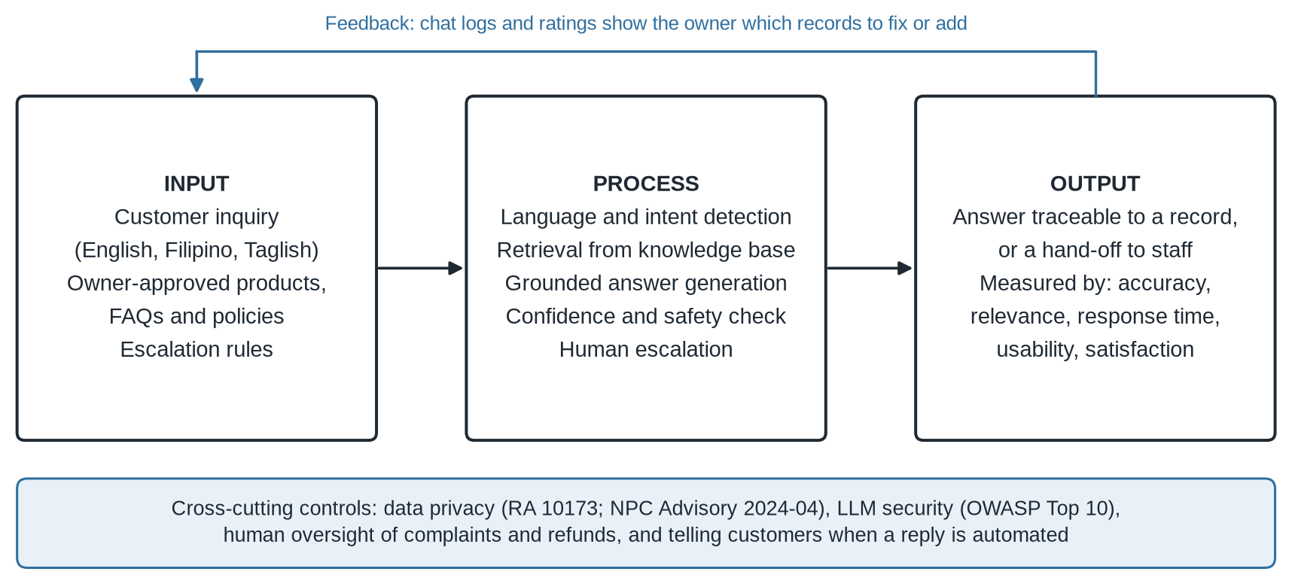
Figure 1: Conceptual framework of the proposed system

4.5 Use Case Diagram
Figure 2 shows the system's actors and use cases. The customer asks questions, chooses quick topics, requests a person, and rates answers. The owner or staff member logs in, maintains products, FAQs, and policies, handles escalated chats, and reviews reports. The external AI service takes part only in "Retrieve and answer." It has no access to the dashboard functions, which keeps business actions out of the model's reach.
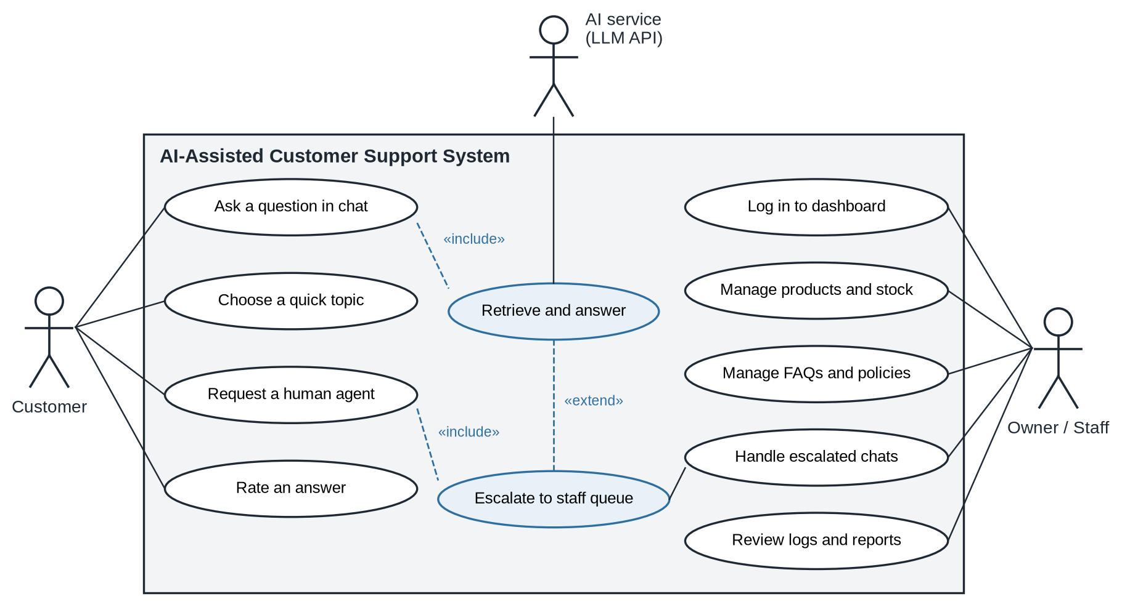
Figure 2: Use case diagram

4.6 System Architecture
The architecture has four layers (Figure 3). The presentation layer contains the customer chat and the owner dashboard. The application layer is a REST API that handles login, sessions, business rules, rate limits, and the escalation queue. The AI orchestration layer detects language and intent, retrieves records, and calls the external language model with a prompt that contains only the retrieved text and fixed instructions. The data layer holds a relational database and a vector index of FAQ and policy text.
The main design choice is that the language model owns no data and cannot take any action. It receives text and returns text. The application code decides which records the model sees, whether its reply is sent, and when a chat moves to the staff queue. This follows the NIST and OWASP guidance on limiting what a model can do [18, 28] and fits the finding that light human involvement can match human-only service [12].
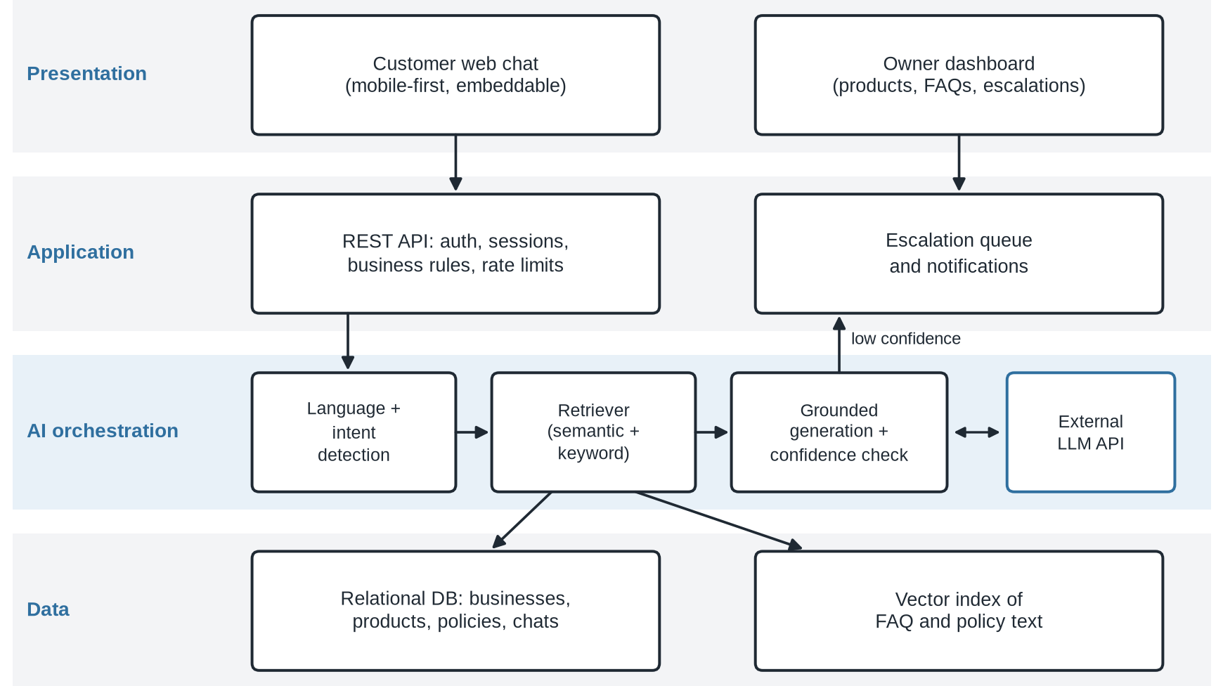
Figure 3: System architecture

4.7 Program Flowchart
Figure 4 shows how each message is processed. The system first masks card numbers, government ID numbers, and similar data. It then detects the language and intent. Complaints, refund requests, disputes, and abusive messages go directly to the staff queue, and the customer is told that a person will reply. Other messages go to retrieval, which searches only the current seller's active records. If a relevant record scores above the threshold, the model writes a short reply, the record ID is logged, and the customer sees the answer together with a "Talk to staff" button. If no record passes the threshold, the chat is escalated. When staff answer an escalated question that is likely to come up again, the dashboard prompts them to save the answer as a new FAQ.
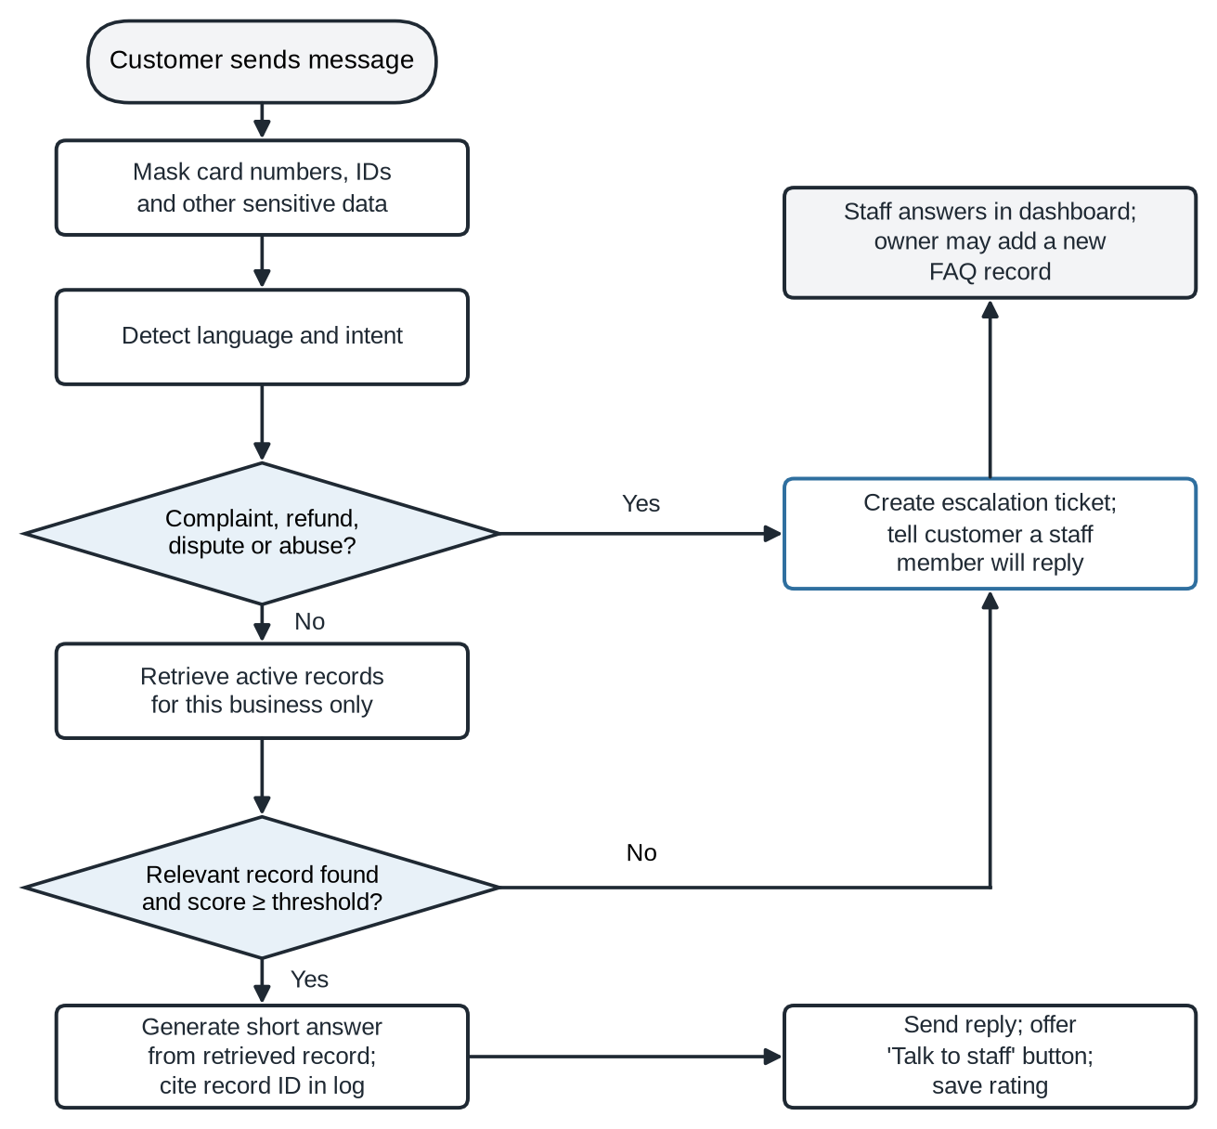
Figure 4: Program flowchart for inquiry handling and escalation

4.8 Knowledge Base and Business Rules
The knowledge base is the system's single source of truth. Each seller keeps separate product, FAQ, and policy records. Product records hold the name, description, price, stock status, variants, and last update date. FAQ and policy records hold the question, the approved answer, the category, the language, the version, the effective date, and an active flag. Table 4 shows sample records. The values are fictional.
Table 4: Sample knowledge records (fictional values)
Record | Field | Example value | Effective | Used for
Product P-014 | Price | ₱499 | 2026-09-01 | Price questions
Product P-014 | Stock | Medium Black, 12 units | 2026-09-18 | Availability questions
Payment | Methods | COD (Baguio, La Trinidad), GCash, bank transfer | 2026-09-01 | Payment questions
Delivery | Estimate | 1–2 days Baguio/La Trinidad; 2–4 days elsewhere in Luzon | 2026-09-01 | Delivery-time questions
Policy | Returns | Within 7 days, unused, with tags | 2026-09-01 | Return questions
Policy | Refunds | Human approval required | 2026-09-01 | Always escalated

The following business rules (BR) govern how the knowledge base is used:
- BR1 The assistant answers only from records where is_active is true and the effective date has passed.
- BR2 A seller's records can never be retrieved for another seller's customers.
- BR3 Refunds, cancellations after shipping, complaints, and discounts not found in a policy are always escalated.
- BR4 If two active records conflict, the newer effective date wins, and the owner is alerted.
- BR5 Prices and stock quoted in a reply must match the product record exactly.
- BR6 Stock records not updated in 14 days trigger a reminder on the dashboard.
- BR7 Messages containing card numbers or ID numbers are masked before storage and before any AI call.
- BR8 Only owners can change policies; staff can edit products and answer escalations.
For example, if a customer asks "May COD po ba?", the system retrieves the payment-method record. If the customer asks "Pwede bang i-return after seven days?" and the return policy allows only seven days, the reply quotes the policy and its conditions. If no return policy exists, the assistant does not borrow a rule from general e-commerce practice. It says the question will be passed to staff.

4.9 Database Design
Figure 5 shows the simplified entity-relationship model. A business has many staff users, products, knowledge items, and conversations. A conversation has many messages and may have one or more escalations, each assigned to a staff user. Each message stores the sender, the masked text, the detected intent, the confidence score, and the ID of the knowledge item used, which makes every automated answer auditable. Customers are identified by a reference code and not by name, following the minimization principle in the NPC guidance [17].
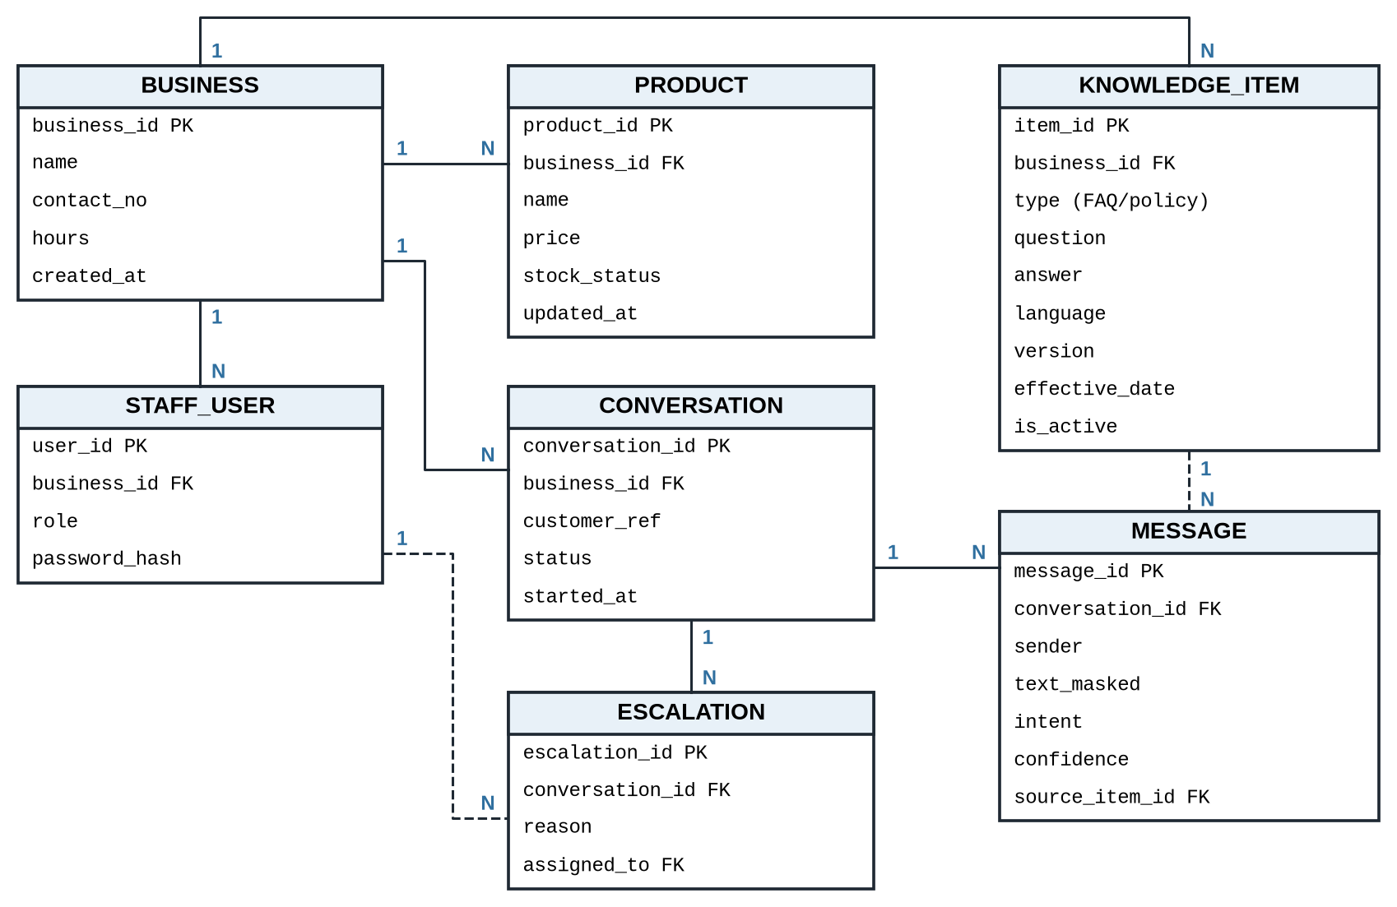
Figure 5: Simplified entity-relationship diagram

4.10 User Interface Design
Figure 6 shows the customer chat on a phone screen, since most local buyers message sellers from mobile devices. The header states that replies are automated and shows staff hours. Each answer shows the record and update date it came from. Quick-topic buttons reduce typing, and the "Staff" button is always available. The example conversation is in Taglish to show that replies follow the customer's language.
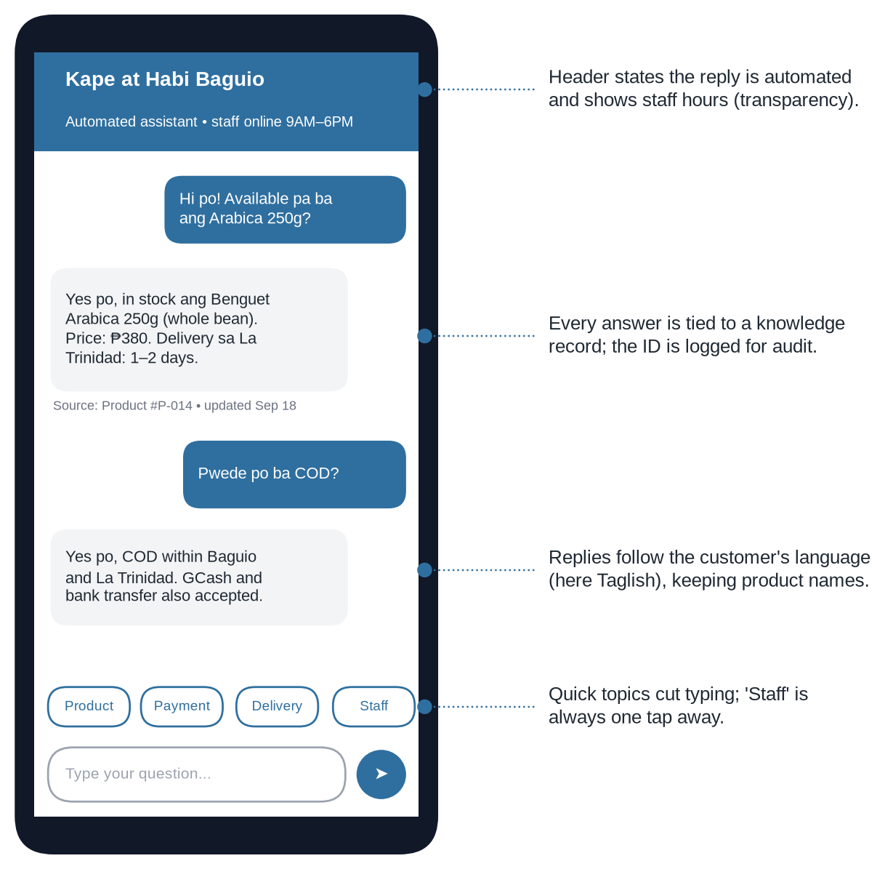
Figure 6: Customer chat interface mockup (fictional store and values)
Figure 7 shows the owner dashboard. The overview gives weekly counts, the share of questions answered by the assistant, and the median reply time. The open-escalations table lets staff reply directly, and an "Add FAQ" action turns an unanswered question into a new record. The "Top questions" chart shows what customers ask most, and a reminder flags products that have not been updated recently. Owners without a technical background can manage everything from this screen.
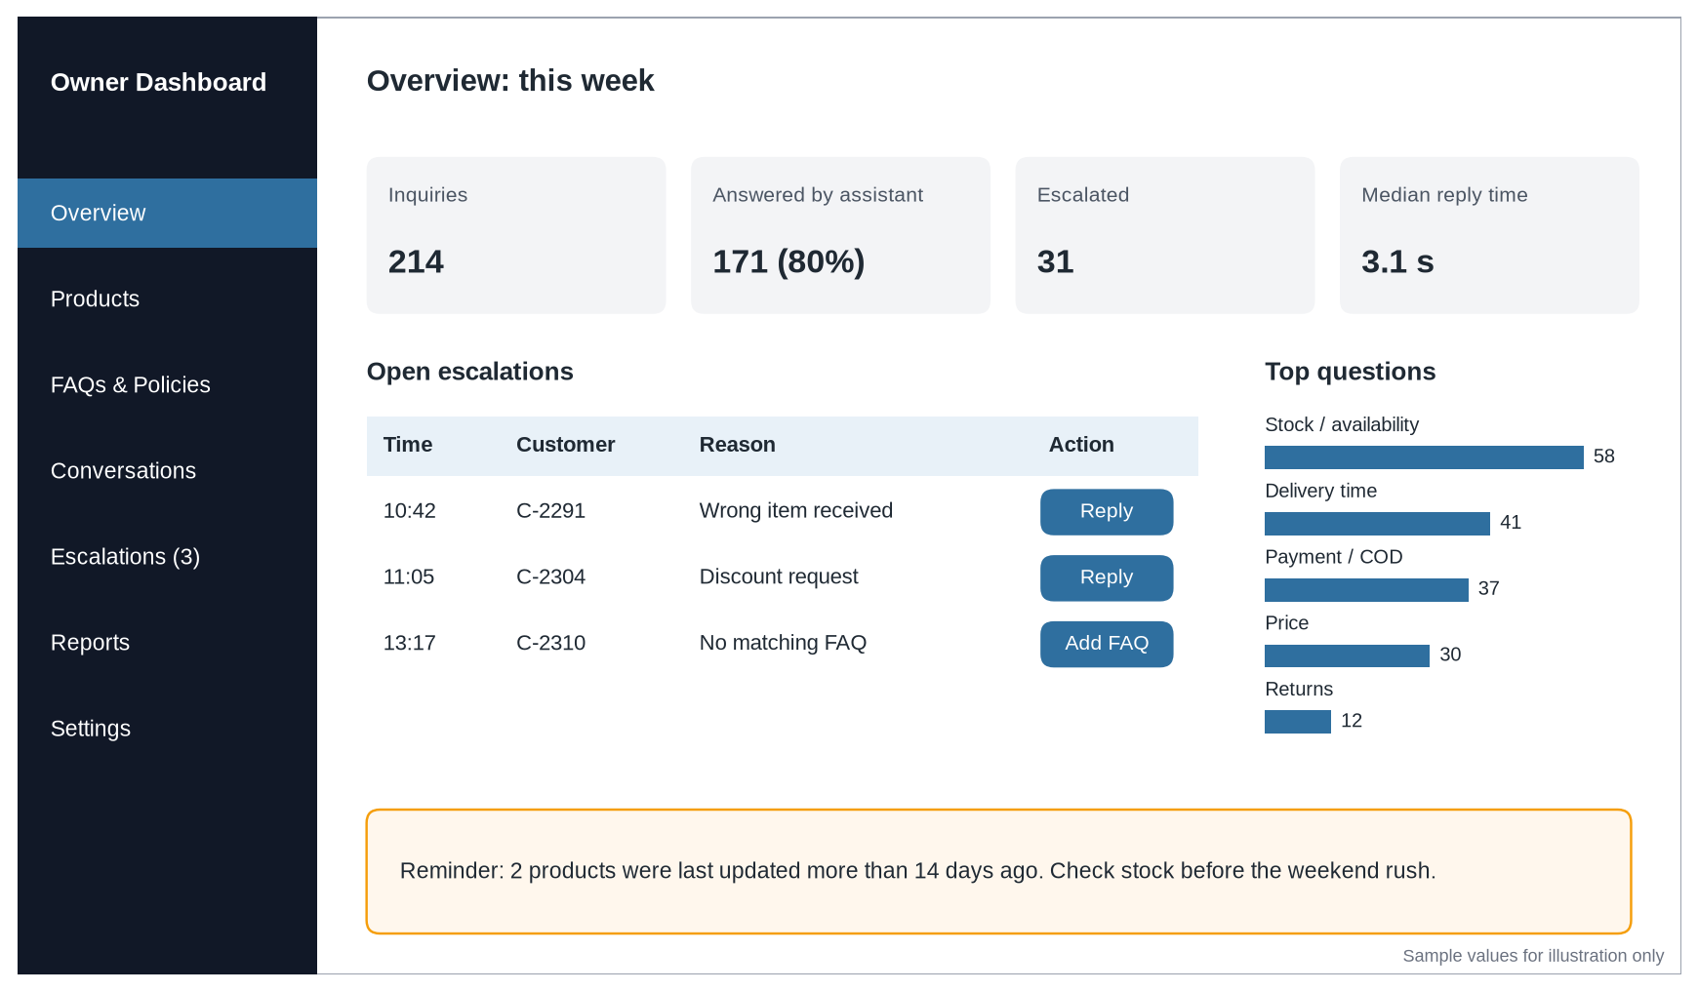
Figure 7: Owner dashboard mockup (sample values for illustration only)

4.11 Technical Requirements
Table 5 lists the hardware, software, and cloud requirements for the prototype. A single small cloud server can host the prototype and the first group of sellers. The design avoids tying the system to one vendor: the language model is called through an interface that can be switched to another provider, and PostgreSQL with the pgvector extension handles both structured data and vector search, so no separate vector database is needed at this scale.
Table 5: Technical requirements
Layer | Prototype requirement | Purpose
Client | Responsive web app; current Chrome, Safari, or Firefox on phone or desktop | Customer chat and owner dashboard
Application | REST API (e.g., Node.js or Python), session handling, role-based access | Users, products, conversations, escalation
AI / NLP | Hosted LLM API behind a provider-neutral interface; embedding model for retrieval | Language understanding and grounded replies
Data | PostgreSQL with pgvector; daily encrypted backups to object storage | Business records, chat logs, vector search
Server | Cloud VM or container service, about 2 vCPU and 4 GB RAM for the pilot, Asia-Pacific region | Hosting with room to scale
Security | TLS certificate, password hashing, secrets manager, web application firewall | Protect accounts and customer data
Monitoring | Application and error logs, response-time metrics, uptime alerts | Quality checks and incident review
Developer tools | Git repository, Figma for mockups, a diagram tool for UML | Version control and design work

4.12 Security and Privacy Design
Support chats contain personal and transaction data, so security was part of the design from the start. The controls include role-based access, strong passwords with optional two-factor login for owners, HTTPS everywhere, API keys kept in a secrets manager, input validation, audit logs for every change to a policy or price, daily encrypted backups, and a fixed retention period for chats (90 days by default).
AI-specific controls address the OWASP risks [18]. System instructions are kept separate from customer text, and customer text is always treated as data. The model cannot call tools or change records. Retrieval is filtered by business ID in the database query itself and not only in the prompt. Replies are checked before sending, so a reply that quotes a price different from the record is blocked. Messages that look like attempts to override instructions are logged and escalated.
For privacy, the chat shows a short notice before the first message, collects only what is needed to answer, and masks sensitive numbers before storing them or sending them to the AI service. Chats are not used to train models. If chat data is ever used for research or improvement, the purpose, legal basis, safeguards, and retention will be documented separately, as NPC Advisory No. 2024-04 requires [17].

4.13 Business and Sustainability Model
The system follows a B2B software-as-a-service model. The paying customer is the seller, not the buyer. The value offered is simple: fewer repeated replies, answers that match what the owner approved, and a clear record of what was said. Table 6 summarizes the model.
Table 6: Business and sustainability model
Element | Proposed model | Reason
Model type | B2B software-as-a-service (subscription) | Predictable income; sellers pay monthly
Customer segment | Micro and small online sellers in Baguio City and Benguet | Matches the study's scope
Value proposition | Fewer repeated replies; answers that match owner-approved data | Addresses time and consistency problems
Revenue streams | Tiered subscriptions (Free, ₱499, ₱1,299); optional ₱1,500 setup fee; paid overage | Low entry barrier with room to grow
Channels | DTI Negosyo Centers, DICT training cohorts, local seller groups | Reach trained sellers
Key resources | Cloud hosting, AI service, database, support time | Needed to run the service
Cost control | Direct FAQ matches skip the LLM; usage caps per tier; small models for intent | Keeps AI costs below income

The tiers are planning figures and will be tested in the seller interviews. A free tier (up to 100 AI-answered conversations a month, one staff account) lets sellers try the tool with no risk. The Starter tier (₱499 a month, 1,000 conversations, two staff accounts) fits most micro sellers. The Growth tier (₱1,299 a month, 3,000 conversations, five staff accounts, reports, and future Messenger integration) fits busier shops. Optional setup help, where the knowledge base is loaded for the seller, costs a one-time fee of ₱1,500.
Sustainability depends on keeping AI and hosting costs well below subscription income. The design helps in three ways. Intent detection and retrieval run on lightweight models or the database itself, so the larger language model is called only once per answered question. Common questions with a direct match can be answered from the stored FAQ text without calling the model at all. Each tier also has a clear conversation limit, and extra usage is priced openly.

4.14 Preliminary Business Plan
The initial market is micro and small online sellers in Baguio City and La Trinidad, especially those who have finished DTI or DICT digital-selling programs [21, 22]. These sellers already sell online and are likely to feel the message load first. The plan is to reach them through DTI Negosyo Centers, local seller groups on Facebook, and partnerships with training programs, offering a free setup session to the first 20 sellers.
The main costs are cloud hosting, AI service usage, a domain and email service, and the developer's time for maintenance and support. The first-year milestones are: finish the prototype and pilot (months 1–4), onboard 20 free-tier sellers and collect feedback (months 5–7), start paid tiers and add Messenger integration (months 8–12). The project breaks even when paid subscriptions cover hosting and AI costs. With the planned prices, this should happen within the first few dozen paying sellers, and the actual number will be calculated once pilot usage data is available. This plan will be discussed further in the Zoom consultation.

4.15 Risks and Mitigation
Table 7 lists the main risks and how the design responds to each.
Table 7: Main risks and mitigation
Risk | Possible effect | Mitigation
Made-up answer | The AI states a price or rule the shop never set | Retrieval grounding, confidence threshold, reply check, escalation
Outdated data | A price or policy change is not reflected | Dashboard editing, effective dates, versioning, 14-day reminders
Prompt injection | A customer message tries to override the rules | Instruction separation, no tool access, filtering, logging
Privacy leak | One customer's or seller's data appears elsewhere | Per-business filtering in queries, masking, access control
Taglish misread | A Filipino or Taglish message is misclassified | Balanced test set, language-parity target, escalation
Over-automation | A complaint is handled by the bot | Fixed escalation rules for complaints and refunds
Service outage | The AI provider or network is down | Fallback message, retries, staff contact option
Low adoption | Sellers find setup too hard | Free tier, guided setup, templates for common FAQs

4.16 Summary of Design Results
The design produced the following deliverables: a requirements specification (Sections 4.2 and 4.3), a conceptual framework, use case diagram, architecture, and program flowchart (Figures 1 to 4), a knowledge base with business rules and a relational data model (Section 4.8 and Figure 5), customer and owner interface mockups (Figures 6 and 7), technical requirements (Table 5), a business model and preliminary plan (Sections 4.13 and 4.14), and an evaluation plan with measurable targets (Table 1). The central rule running through all of them is that the owner's records, and not the model's general knowledge, decide what customers are told.

5 CONCLUSIONS AND RECOMMENDATIONS
Micro and small sellers in Baguio City and Benguet are being encouraged to sell online, and the national data show that most Filipino businesses are small, that e-commerce is a large part of the digital economy, and that most online sellers work through social media [4, 23, 24]. As these sellers grow, answering customers becomes a daily burden that a one- or two-person shop cannot easily absorb.
The literature points to what a good support tool needs. Customers value speed, but they value correct and concrete answers more [29, 30]. Chatbots combined with light human help can match human service [12]. Existing Philippine e-commerce chatbots still struggle with local dialogue [3], and language models remain weaker in Filipino and Taglish [15, 16]. Philippine law requires that customer data be protected and that disputes be handled properly [17, 26].
In response, this study designed an assistant that answers only from the seller's own records, works in English, Filipino, and Taglish, checks its confidence before replying, and hands off to staff when it should. Of the four options compared, this design was the only one that gave owners control over the facts while still reducing their workload. The AI acts as a helper and does not make decisions for the business.
The study makes the following recommendations:
(1) Build and test the prototype as planned, and report accuracy, relevance, response time, usability, and satisfaction only after testing. Until then, no performance claims should be made.
(2) Verify the requirements through the seller interviews before the second sprint, especially the question categories and the escalation rules.
(3) Keep the escalation rules strict at launch and loosen them only when the logs show the assistant handles a category reliably.
(4) Add Facebook Messenger integration next, since that is where most local customers already message sellers.
(5) Work with DTI-CAR and DICT-CAR to offer the tool as a follow-up to their digital-selling training, and extend field testing to other Cordillera provinces.
If the prototype meets its targets, it can give small sellers in Baguio and Benguet a practical way to answer customers well without hiring more staff, while keeping a person involved in the conversations that need one.

REFERENCES
[1] Chloe Autio, Reva Schwartz, Jesse Dunietz, Shomik Jain, Martin Stanley, Elham Tabassi, Patrick Hall, and Kamie Roberts. 2024. Artificial Intelligence Risk Management Framework: Generative Artificial Intelligence Profile. NIST AI 600-1. National Institute of Standards and Technology, Gaithersburg, MD. https://doi.org/10.6028/NIST.AI.600-1
[2] Bangko Sentral ng Pilipinas. 2025. 2024 Report on the Status of Digital Payments in the Philippines. Bangko Sentral ng Pilipinas, Manila.
[3] De La Salle University Senior High School Research Congress. 2024. Optimizing customer support: Identifying factors to enhance the AI customer service chatbots of Shopee and Lazada in the Philippines. Animo Repository, De La Salle University, Manila.
[4] Department of Trade and Industry. 2024. 2023 Philippine MSME Statistics in Brief. DTI, Makati City. https://dtiwebfiles.s3-ap-southeast-1.amazonaws.com/MSME%20Resources/2023%20Philippine%20MSME%20Statistics%20in%20Brief_as%20of%2031%20October%202024.pdf
[5] Department of Trade and Industry. 2024. DTI accelerates e-commerce growth through Online Negosyo Program and strategic partnerships; DTI pilots “Tindahan Mo, e-Level Up Mo!” to digitalize sari-sari stores. DTI news release, Makati City.
[6] Department of Trade and Industry. 2024. FTEB continues to lead in fair and efficient consumer complaints handling with its digital services. DTI news release, March 18, 2024.
[7] Department of Trade and Industry. 2024. National Artificial Intelligence Strategy Roadmap 2.0. DTI, Makati City.
[8] Department of Trade and Industry. 2025. DTI launches E-Commerce Philippine Trustmark, opens online applications for sellers. DTI news release, July 7, 2025.
[9] Department of Trade and Industry E-Commerce Bureau. 2026. FAQs: Online seller legitimacy, consumer protection, and filing complaints against online sellers. Retrieved September 2026 from https://ecommerce.dti.gov.ph/faqs/
[10] Yunfan Gao, Yun Xiong, Xinyu Gao, Kangxiang Jia, Jinliu Pan, Yuxi Bi, Yi Dai, Jiawei Sun, Meng Wang, and Haofen Wang. 2023. Retrieval-augmented generation for large language models: A survey. arXiv:2312.10997. https://doi.org/10.48550/arXiv.2312.10997
[11] Chin-Lung Hsu and Judy Chuan-Chuan Lin. 2023. Understanding the user satisfaction and loyalty of customer service chatbots. Journal of Retailing and Consumer Services 71 (2023), 103211. https://doi.org/10.1016/j.jretconser.2022.103211
[12] D. Huang, D. G. Markovitch, and R. A. Stough. 2024. Can chatbot customer service match human service agents on customer satisfaction? An investigation in the role of trust. Journal of Retailing and Consumer Services 76 (2024), 103600. https://doi.org/10.1016/j.jretconser.2023.103600
[13] International Organization for Standardization. 2023. ISO/IEC 25010:2023 Systems and Software Engineering: Systems and Software Quality Requirements and Evaluation (SQuaRE): Product Quality Model. ISO, Geneva.
[14] Hua Jiang, Yang Cheng, Jeongwon Yang, and Shanbing Gao. 2022. AI-powered chatbot communication with customers: Dialogic interactions, satisfaction, engagement, and customer behavior. Computers in Human Behavior 134 (2022), 107329. https://doi.org/10.1016/j.chb.2022.107329
[15] Jimson Paulo Layacan, Isaiah Edri W. Flores, Katrina Bernice M. Tan, Ma. Regina E. Estuar, Jann Railey E. Montalan, and Marlene M. De Leon. 2024. Zero-shot cross-lingual POS tagging for Filipino. In Proceedings of the Third Workshop on NLP Applications to Field Linguistics. Association for Computational Linguistics, 69–77. https://doi.org/10.18653/v1/2024.fieldmatters-1.9
[16] Jann Railey Montalan, Jimson Paulo Layacan, David Demitri Africa, Richell Isaiah S. Flores, Michael T. Lopez II, Theresa Denise Magsajo, Anjanette Cayabyab, and William Chandra Tjhi. 2025. Batayan: A Filipino NLP benchmark for evaluating large language models. In Proceedings of the 63rd Annual Meeting of the Association for Computational Linguistics (Volume 1: Long Papers). Association for Computational Linguistics. https://aclanthology.org/2025.acl-long.1509/
[17] National Privacy Commission. 2024. NPC Advisory No. 2024-04: Guidelines on the Application of Republic Act No. 10173, Its Implementing Rules and Regulations, and the Issuances of the Commission to Artificial Intelligence Systems Processing Personal Data. NPC, Pasay City.
[18] OWASP Foundation. 2025. OWASP Top 10 for LLM Applications 2025. OWASP GenAI Security Project. https://genai.owasp.org/
[19] Philippine Information Agency. 2026. DICT, DTI align programs to boost MSME e-commerce in Cordillera. PIA News, February 4, 2026.
[20] Philippine Information Agency. 2026. DTI-CAR sets 5-point agenda and development plan for Cordillera MSMEs. PIA News, April 22, 2026.
[21] Philippine Information Agency. 2026. Baguio City MSMEs join Tatak Pinoy MSME Roadshow. PIA News, July 15, 2026.
[22] Philippine Information Agency. 2026. DICT empowers 25 Baguio-Benguet MSMEs thru digital marketing program. PIA News, September 11, 2026.
[23] Philippine Statistics Authority. 2025. Highlights of the 2024 National Information and Communications Technology Household Survey (NICTHS): E-Commerce. PSA, Quezon City.
[24] Philippine Statistics Authority. 2026. Philippine Digital Economy Satellite Account: Digital economy contributes 9.8 percent to the Philippine economy in 2025. PSA, April 30, 2026. https://psa.gov.ph/statistics/digital-economy
[25] Republic of the Philippines. 2012. Republic Act No. 10173: Data Privacy Act of 2012. Official Gazette of the Republic of the Philippines.
[26] Republic of the Philippines. 2023. Republic Act No. 11967: Internet Transactions Act of 2023. Official Gazette of the Republic of the Philippines.
[27] Ioannis Rizomyliotis, Minas N. Kastanakis, Apostolos Giovanis, Kleopatra Konstantoulaki, and Ioannis Kostopoulos. 2022. “How mAy I help you today?” The use of AI chatbots in small family businesses and the moderating role of customer affective commitment. Journal of Business Research 153 (2022), 329–340. https://doi.org/10.1016/j.jbusres.2022.08.035
[28] Elham Tabassi. 2023. Artificial Intelligence Risk Management Framework (AI RMF 1.0). NIST AI 100-1. National Institute of Standards and Technology, Gaithersburg, MD. https://doi.org/10.6028/NIST.AI.100-1
[29] Yanping Zhang, Changyong Liang, and Xiaodong Li. 2024. Understanding virtual agents’ service quality in the context of customer service: A fit-viability perspective. Electronic Commerce Research and Applications 65 (2024), 101380. https://doi.org/10.1016/j.elerap.2024.101380
[30] Y. Zhu, J. Zhang, and J. Liang. 2023. Concrete or abstract: How chatbot response styles influence customer satisfaction. Electronic Commerce Research and Applications 62 (2023), 101317. https://doi.org/10.1016/j.elerap.2023.101317

APPENDIX A. PROTOTYPE EVALUATION INSTRUMENT
This instrument will be finalized with the adviser before data collection. It keeps technical correctness separate from user opinion, so that a high satisfaction score cannot hide factual errors.

A.1 Response Evaluation Sheet (one per test case)
- Test case ID; customer message; language (English / Filipino / Taglish)
- Expected intent and expected source record, written before viewing the AI reply
- AI reply; accuracy (correct / partly correct / incorrect); relevance (1–5)
- Unsupported information present? (yes / no); should it have been escalated? (yes / no)
- Response time in seconds; evaluator comments

A.2 Usability and Satisfaction Items (1 = Strongly Disagree, 5 = Strongly Agree)
(1) It was easy to start a conversation with the assistant.
(2) The answers were easy to understand.
(3) The answers were relevant to my question.
(4) I could tell when the assistant was passing my question to a person.
(5) The assistant made it easier to find basic store information.
(6) The reply language suited my English, Filipino, or Taglish message.
(7) (Owners) I could update products and policies without help.
(8) (Owners) The dashboard showed me what customers ask most.
(9) I would use this kind of assistant for routine questions.
(10) Overall, I am satisfied with the prototype.

APPENDIX B. IMPLEMENTATION ROADMAP (AGILE SPRINTS)
- Sprint 0 (weeks 1–2): seller interviews, inquiry samples, final requirements, test-set draft.
- Sprint 1 (weeks 3–4): database, login, owner dashboard for products, FAQs, and policies.
- Sprint 2 (weeks 5–6): masking, language and intent detection, retrieval with pgvector.
- Sprint 3 (weeks 7–8): grounded reply generation, confidence check, escalation queue.
- Sprint 4 (weeks 9–10): customer chat interface, feedback, reports, security hardening.
- Sprint 5 (weeks 11–12): functional testing on the 120-item set, pilot with users, fixes, final documentation and presentation.

