[TITLE OF THE ANALYSIS]

Last update: 05/07/2024

1. Define the purpose of the analysis (STPA Step 1)

1.1 Define and frame the problem

[Try to identify the system boundaries. Feel free to use a drawing of the system in addition to text sentences aiming to delimit the system under analysis].

1.2 Stakeholders

[Stakeholders identify unacceptable losses to them in the system].

1.3 System purpose and goal

[Some safety/security analysts prefer listing system goals]
SG-1 - ….
SG-2 - ….
SG-3 - …
SG-4 – …

[Some safety/security analysts prefer to use some template text]

A system to provide
- Ut suscipit mi vitae mi sollicitudin, a cursus mauris vestibulum.

by means of
- Ut suscipit mi vitae mi sollicitudin, a cursus mauris vestibulum.
- Ut suscipit mi vitae mi sollicitudin, a cursus mauris vestibulum.
- Ut suscipit mi vitae mi sollicitudin, a cursus mauris vestibulum.
- Ut suscipit mi vitae mi sollicitudin, a cursus mauris vestibulum.

in order to
- Ut suscipit mi vitae mi sollicitudin, a cursus mauris vestibulum.

1.4 Assumptions

[Identify the assumptions]
AS-1 - ….
AS-2 - ….
AS-3 - …
AS-4 –

1.5 Identify losses and accidents

L1:
L2:
L3:
L4:

1.6 Identify system hazards and system level constraints

1.6.1. Identify system hazards

[Hazards can optionally have sub-hazards. Hazards/sub-hazards must be traced back to one or more Losses]

H1: Ut suscipit mi vitae mi sollicitudin, a cursus mauris vestibulum. [L-1] [L-2] [L-3]
H2: Ut suscipit mi vitae mi sollicitudin, a cursus mauris vestibulum.
H3: Ut suscipit mi vitae mi sollicitudin, a cursus mauris vestibulum.
H3.1: Ut suscipit mi vitae mi sollicitudin, a cursus mauris vestibulum.
H3.2: Ut suscipit mi vitae mi sollicitudin, a cursus mauris vestibulum.
…
H4: Ut suscipit mi vitae mi sollicitudin, a cursus mauris vestibulum.
H5: Ut suscipit mi vitae mi sollicitudin, a cursus mauris vestibulum.
H6: Ut suscipit mi vitae mi sollicitudin, a cursus mauris vestibulum.

1.6.2. Identify system constraints

[System Constraints – SCs - must be traced back to one or more Hazards]

SC1: Ut suscipit mi vitae mi sollicitudin, a cursus mauris vestibulum. [H1] [H2] [H3.1]
SC2: Ut suscipit mi vitae mi sollicitudin, a cursus mauris vestibulum.
SC3: Ut suscipit mi vitae mi sollicitudin, a cursus mauris vestibulum.
SC4: Ut suscipit mi vitae mi sollicitudin, a cursus mauris vestibulum.
SC5: Ut suscipit mi vitae mi sollicitudin, a cursus mauris vestibulum.
SC6: Ut suscipit mi vitae mi sollicitudin, a cursus mauris vestibulum.
SC7: Ut suscipit mi vitae mi sollicitudin, a cursus mauris vestibulum.
…

2. Model the Control Structure (STPA Step 2)

2.1 System Components

[Identify the components/controllers responsible to enforce the constraints previously identified to avoid system migration to a hazardous state.]

- C1:
- C2:
- C3:

2.2 Component (controller) process model variable and values

Component | Process model variable | Process model variable values
C1 | variable1  variable 2  …  variable n | [VALUE 1, VALUE 2, VALUE N, UNKNOWN]  [VALUE 1, VALUE 2, UNKNOWN]  [VALUE 1, VALUE 2, UNKNOWN]
C2
C3
…
Cn

Note: The process model variables reside within the components of a control structure. These variables are used by the respective component control algorithm (in case of the component be a controller) and are mandatory input to Step 3 – Identify the Unsafe Control Actions. For simple examples, instead of using a tabular format as above to identify the process model (variables and values), it is better to include them within the components of the visual control structure, as the example below for train door controller system. In the example, there are 5 variables (door obstruction, door position, train position, train motion, emergency). Each of these variables may be attributed some discrete values, for example, the variable door position may have one of the following values ate one point in time (Fully open, Fully closed, Partially open, Unknown):

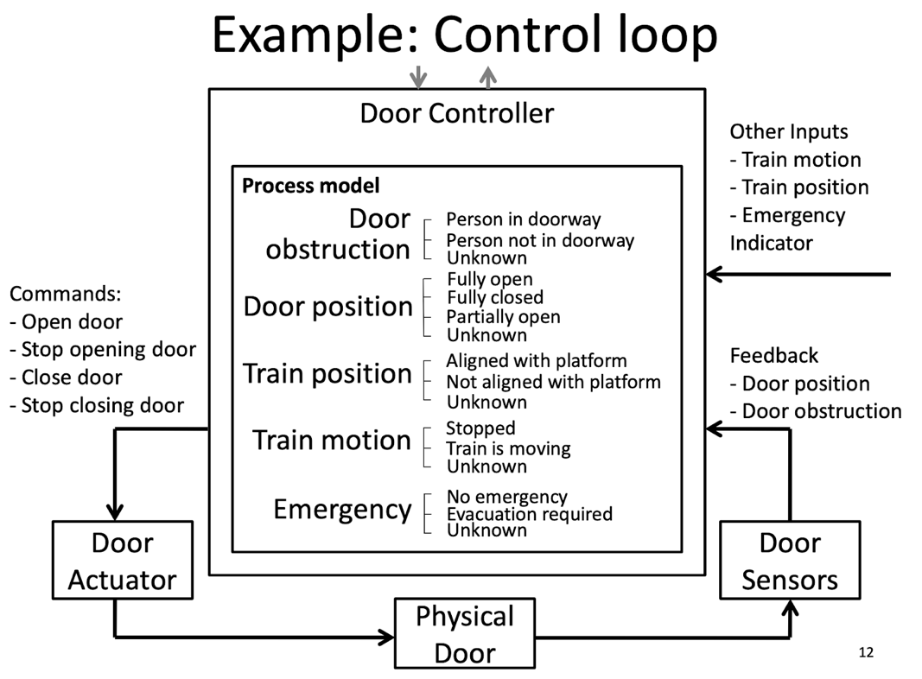

2.3 Component (controller) algorithm

Component | Algorithm
C1 | If variable1 == x then {  …  } else {  …  }
C2 | If variable1 == x and variable 2 == y then {  …  } else {  …  }

2.4 Component responsibilities

[Responsibilities – Rs - must be traced back to one or more Safety Constraints - SCs]

Component/Controller Name
R1 |  | SSC1  SSC3  SSC3.1  …
R2 |  | SSC1
R3 |  | …
R4 |  | …
R5 |  | …
… |  | …
… |  | …

2.5 System Level Control Structure

[Represent the System level control structure. Guideline: at this level try to use at most 3 components at a higher level of abstraction. The Control Actions and Feedback between components in the control structure are derived from the Responsibilities previously identified (and, hence, derived also from the System Safety Constraints)].

2.6 Control structure (Refinement/Zoom of the System Level control structure to be analyzed)

[Zoom the System level control structure to the level you are interested. Notice that STPA can be used to model System Development and System Operations Control Structure.]

3. Identify Unsafe Control Actions (STPA Step 3)

3.1 Identify Unsafe Control Actions - UCAs

[Unsafe Control Actions – UCAs - must be traced back to one or System Hazards - Hs]
Controller name
Control action | Not providing causes hazard | Providing causes hazard | Too early, too late, out of order | Stopped too soon,  Applied too long
CA1 | UCA-1: [CONTROLLER] does not provide [CA] during/when ...  [H1], [Hn]  UCA-2:  [controller] does not provide CA during/when ...  [H1] |  |  | N/A
CA2 |  | UCA-2: [CONTROLLER] provides [CA] during/when ...  [H1], [Hn]
... |  |  | N/A
... | N/A
... |  |  |  | UCA-2: [CONTROLLER] provides [CA] too late during/when ...  [H1], [Hn]

3.2 Identify controller constraints
[Controller Constraints – C - must be traced back to one or more UCAs]
Unsafe Control Actions | Controller constraint(s)
UCA-1 | C-1, C-2
UCA-2 | C-2
UCA… | C..
UCA-n | C-n

4. Identify loss scenarios (STPA Step 4)

[A loss scenario describes the causal factors that can lead to the unsafe control actions and to hazards. My answer to this step can be found at the end of this document. I use the following images to help me accomplish this step:]

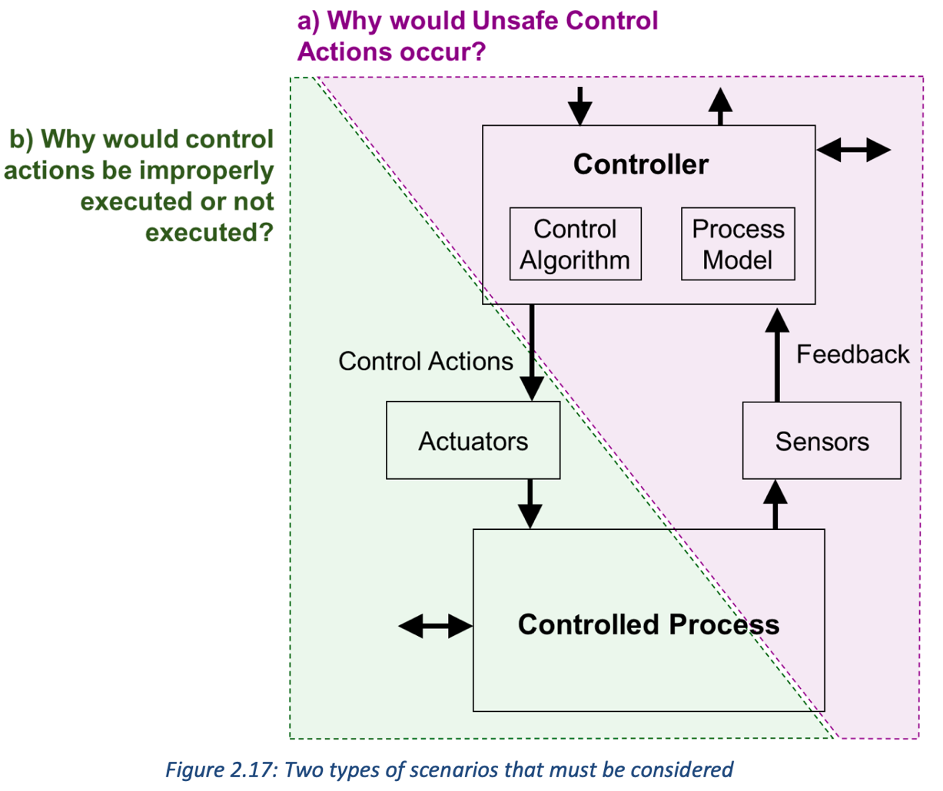
Source: STPA Handbook, page 43

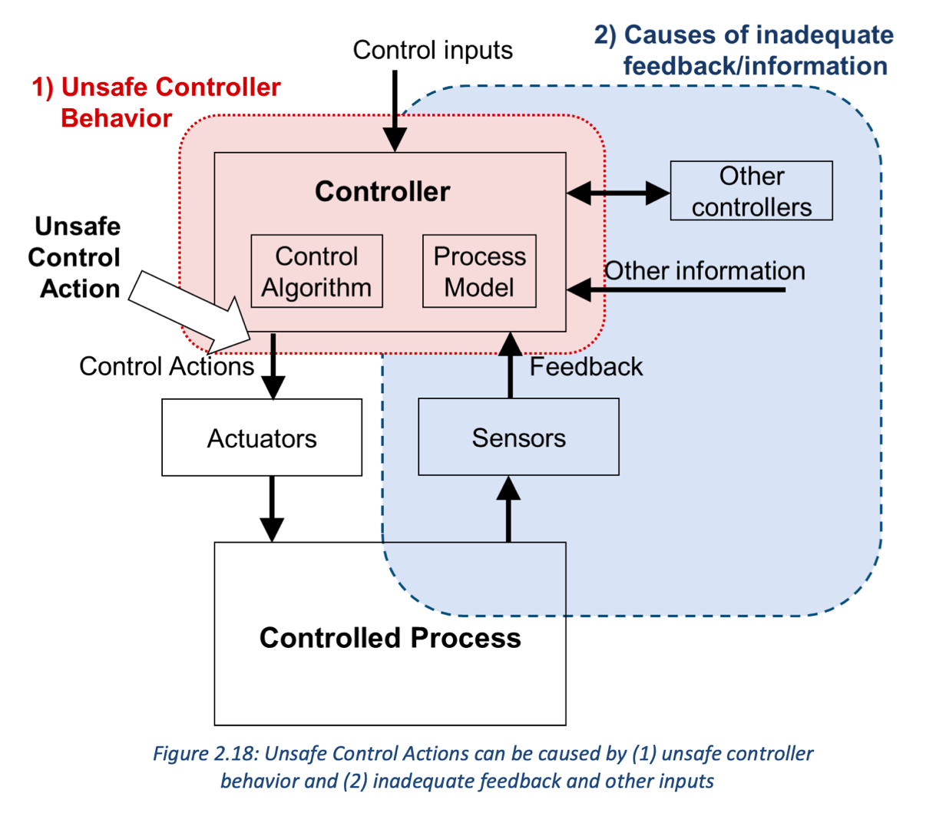
Source: STPA Handbook, page 44

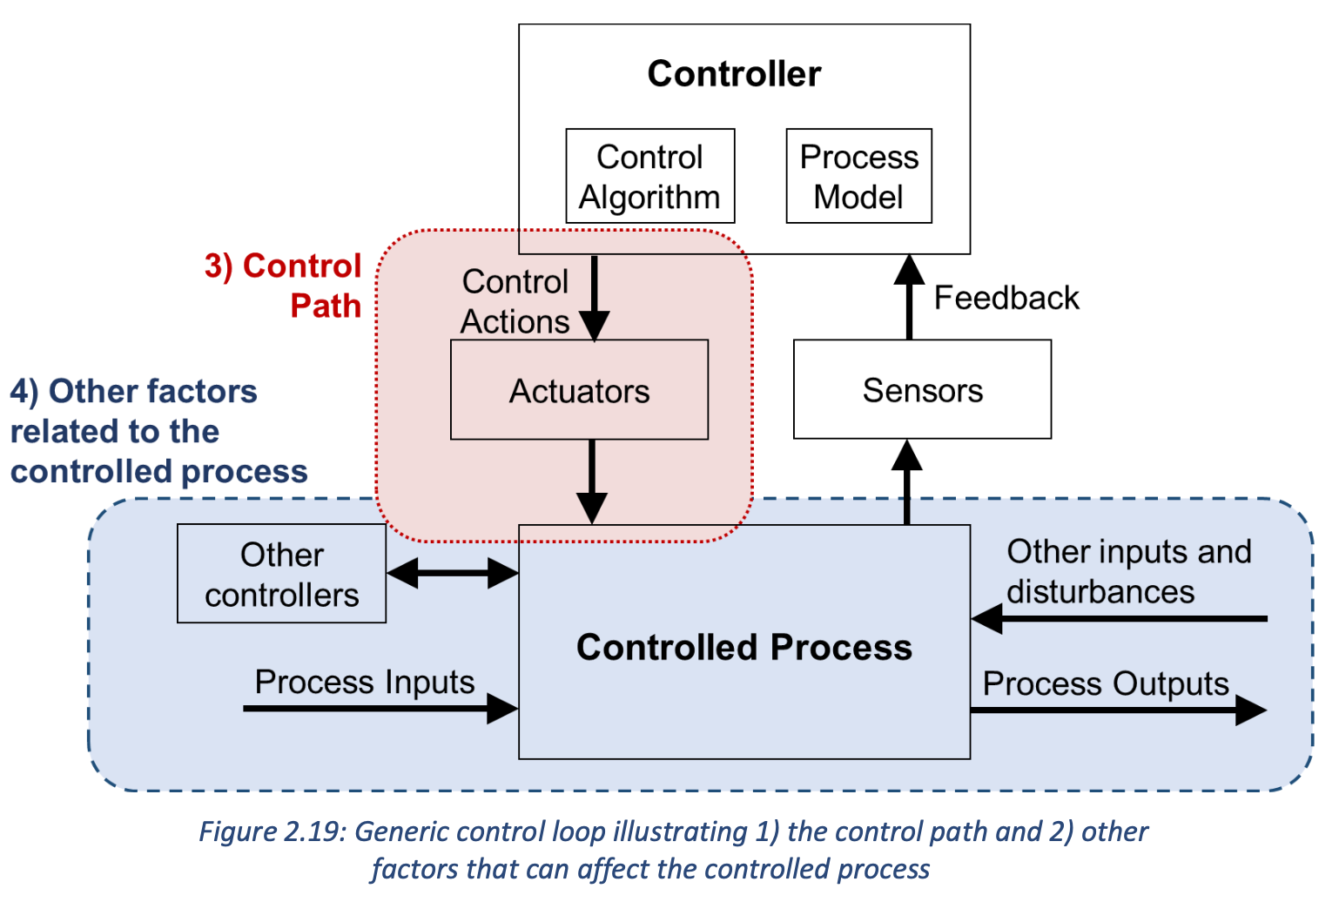
Source: STPA Handbook, page 49

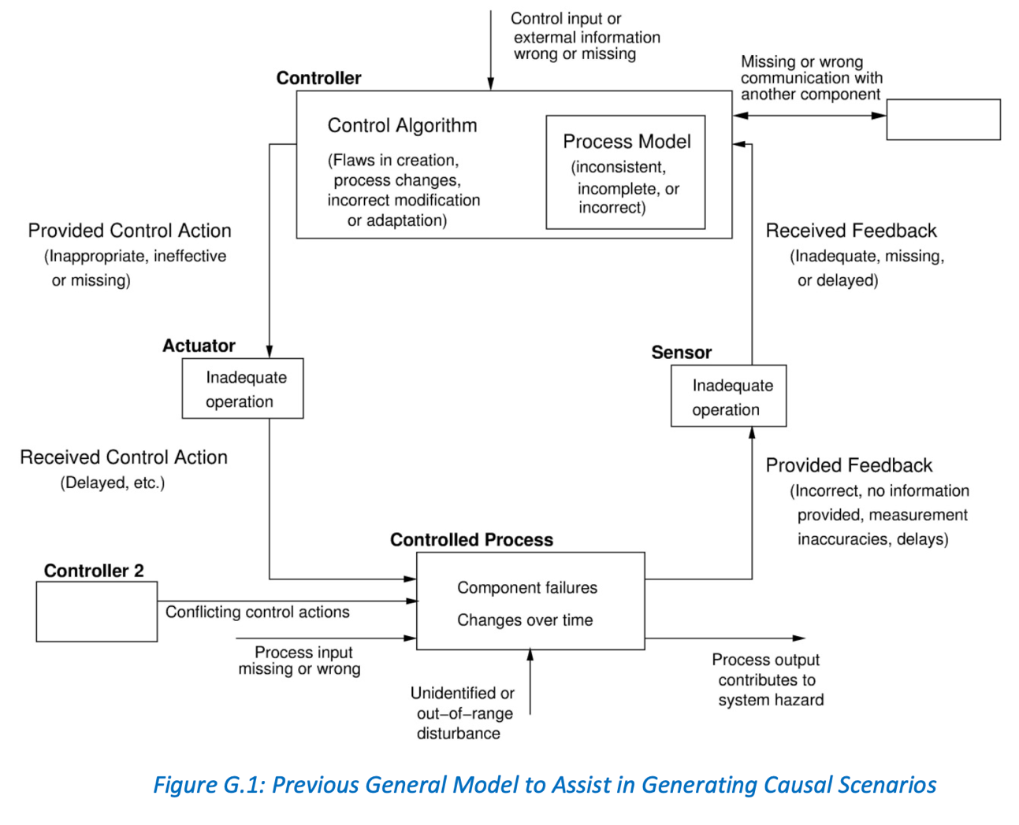
Source: STPA Handbook, page 178 (See the next figure to an updated version of this image)

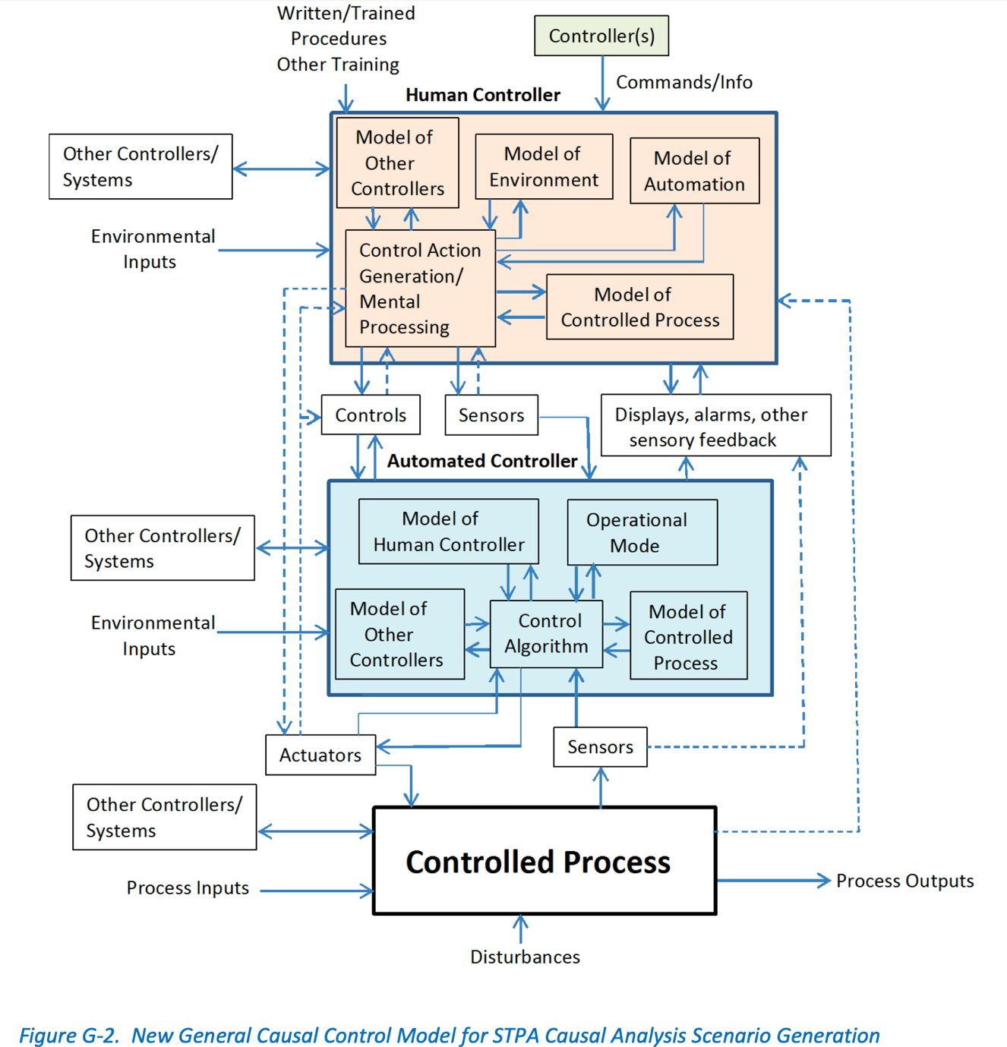

Source: STPA Handbook, page 179

[In addition to the images above, see Summary of Step 4 document on Moodle for more instructions on how to perform/document this step].

Unsafe Control Action name
Scenario | Associated causal factors | Recommendations | Rationale
Scenario 1
Scenario 2
Scenario 3
…
…
Scenario n

