Lab 2: Inheritance

# 1. Instruction

1. Click the provided link on CourseVille to create your own repository.
2. Create a “java project” and set the project name in this format **Lab2_2023_1_{ID}_{FIRSTNAME}**, e.g., **Lab2_2023_2_6531999921_Somsak**.
3. Initialize Git in your project directory
   1. Add .gitignore and set up your git.
   2. Create your remote repository from a given link.
   3. Commit and push initial codes to your GitHub repository.
4. Implement all the classes and methods following the details given in the problem statement file which you can download from CourseVille.
   1. You should create a commit with meaningful messages when you finish each part of your program.
   2. Don’t wait until you finish all features to create a commit.
5. Test your codes with the provided JUnit test cases, they are inside package **test.grader**
   1. If you want to create your own test cases, please put them inside package **test.student**
   2. Aside from passing all test cases, your program must be able to run properly without any runtime errors.
6. After finishing the program, create a UML diagram for classes in package logic.unit and put the result image (UML.png) at the root of your project folder.
7. Export your project into a jar file called **Lab2_2023_1_{ID}** and place it at the root directory of your project. Make sure you export all your source (.java) files. You can open the jar file with any zip software to check it. Your jar file must include source code. For example: **Lab2_2023_1_6531234521.jar.**
8. Push all other commits to your GitHub repository.

# 

# 2. Problem Statement: Lopburi Monkey War

In the beautiful land called “Lopburi” lies the realm of the Monkeys. One day, The Apes, who have evolved from the stray monkeys of long ago, arrived to invade and attempt to destroy Lopburi. As the Monkey King, you need to assemble an army and lead them to fight back against the invasion of the malevolent Apes, thus restoring Lopburi to its former greatness.

In this lab, we will be coding a game regarding the situation above. In this game, you will command your hand-picked army of Monkeys to fight against the invading Apes. If any monkey (or ape) has a health point (HP) equal to 0, that monkey will die. There are 5 types of monkey:

* BaseMonkey
* MuscleMonkey
* MommyMonkey
* UgabugagaMonkey
* Ape (which technically a descendant of monkey)

Every monkey has a *hp*, an *atk*, and a *def* (a health point,an attack power, and a defend power in that order) Each type can attack their enemy.

A BaseMonkey is a monkey who doesn’t have any special skill.

* When a BaseMonkey attacks, he will deal damage equal to its *atk* subtract with the enemy *def* to the targeted ape

A MuscleMonkey is a monkey who possesses a skill named “*buff*”

* When a MuscleMonkey attacks, he will deal damage 2 times with its *atk* subtract with the enemy *def* to the targeted ape.
* When a MuscleMonkey uses *buff*, it will increase its own *atk* and *def*.

A MommyMonkey is a monkey who possesses a skill named “*birth*”

* MommyMonkey cannot attack.
* When a MommyMonkey uses *birth*,it will birth a BaseMonkey with lower attribute.

A UgabugagaMonkey is a monkey who possesses a skill named “*heal*”

* When a UgabugagaMonkey attacks, he will deal damage to its *atk* subtract with the enemy *def* to the targeted ape.
* When a UgabugagaMonkey uses *heal*, it will heal the targeted monkey.

An Ape is a monkey who possesses a skill named “*Attack AOE*”

* When an Ape attacks, it will deal damage to its *atk* subtract with the enemy *def* to the targeted ape.
* When an Ape uses skill, it will attack all monkeys in the fields.

The program example is shown below. The program should be run from the Main class in the package main.

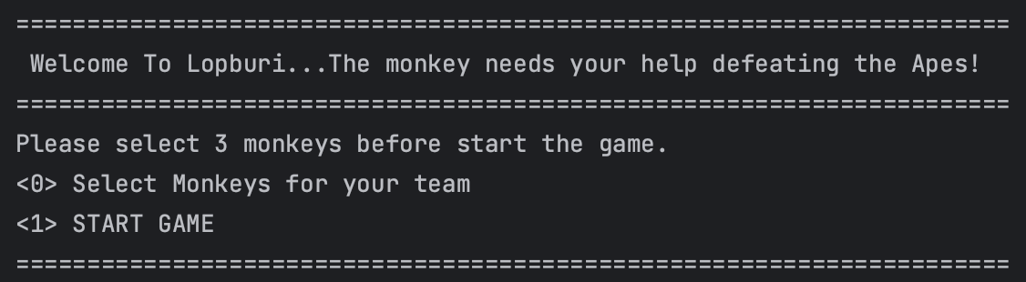

(start game menu)

There are 2 options:

1. <0> Select monkey for your team
   * This option will present four types of monkeys that you can choose from to help you fight the ape. You will need to select three monkeys.

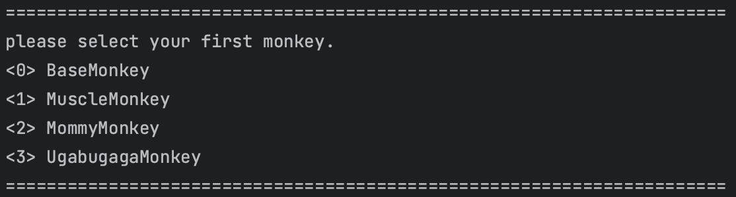

(Select monkey menu)

1. <1> START GAME
   * This choice will begin the game. Once the game starts, a menu will show up, letting you pick a monkey to take actions. Your turn will finish either after using 5 skill points or if you press “<i>End turn” to end your turn.

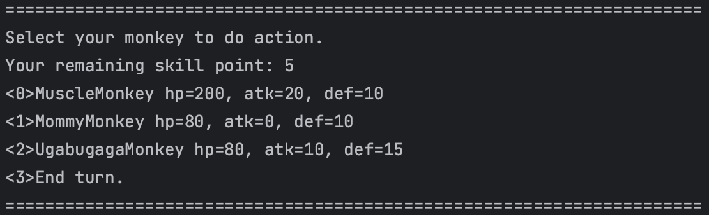

(select monkey menu)

Once you've selected a monkey, the action menu will appear, allowing you to choose from three actions. The first is a normal attack, the second is a special skill that depends on the type of monkey and its corresponding skill, and the last option is to go back to reselect the monkey for performing an action.

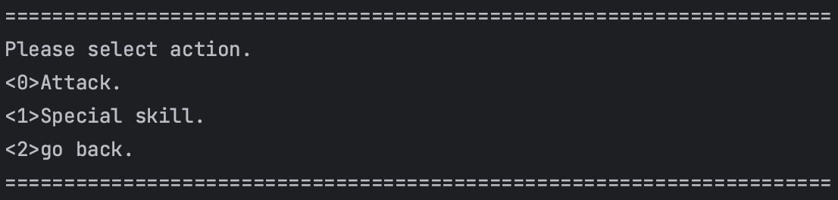

(action menu)

If you decide to attack the enemy, the menu will display a list of apes. You will need to choose the specific ape you want to attack.

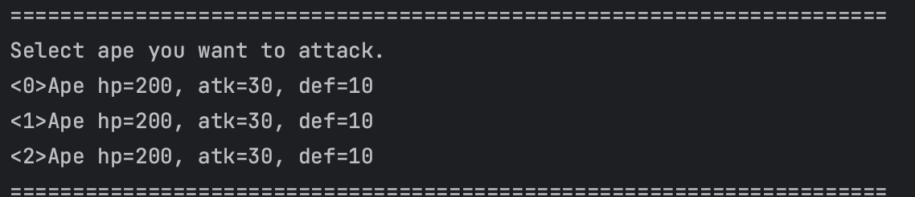

(list of apes)

When your turn is finished, the game will switch to the Ape's turn. You'll then see what actions the apes take during their turn.

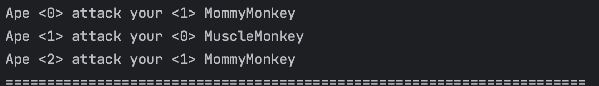

(this is what apes do in their turn)

The game will end when your entire team is defeated or when all the apes are defeated.

# 

# 3. Implementation Details

## **3.1 Package monkey** /* You must implement this package from scratch */

### **3.1.1 Class BaseMonkey** /* You must implement this class from scratch */

Variable

| Name | Description |
| --- | --- |
| - int maxHP | This is BaseMonkey’s maxHp.  maxHp cannot be less than 0. |
| - int hp | This is BaseMonkey’s hp.  Hp cannot be less than 0 and cannot be more than maxHp. |
| - int atk | This is BaseMonkey’s atk.  Atk cannot be less than 0. |
| - int def | This is BaseMonkey’s def.  Def cannot be less than 0. |

Method

| Name | Description |
| --- | --- |
| + BaseMonkey() | Initialize this BaseMonkey with the following attribute set  -maxHp to 30  -Hp to maxHp  -atk to 20  -def to 5 |
| + BaseMonkey(int maxHp, int atk, int def) | Initialize this BaseMonkey with the following attribute set  -maxHp to maxHp  -Hp to maxHp  -atk to atk  -def to def |
| + void attack(BaseMonkey m) | This monkey attacks the given monkey, then the enemy would be dealt damage equal to atk-def (minus). |
| + String getType() | Return a monkey’s type as String |
| + String toString() | Return string in this following format.  <Monkey’s Type> hp=<hp> atk=<atk> def=<def>  (example is in the last picture in the previous page) |
| + getter,setter of all fields | getter,setter of all fields. |

### **3.1.2 Class MommyMonkey** /* You must implement this class from scratch */

Method

| Name | Description |
| --- | --- |
| + MommyMonkey(int hp, int atk, int def) | Initialize this MommyMonkey with the following attribute set  -maxHp to maxHp  -Hp to maxHp  -atk to atk  -def to def  Hint: Try to use “super” |
| + void attack(BaseMonkey m) | Do nothing |
| + void birth() | Initialize BaseMonkey by calling default constructor then add it to the monkey container in the game system.  Hint:you can see a usage example of the game system in main(In method skillFlow(BaseMonkey m) ). |

### **3.1.3 Class MuscleMonkey** /* You must implement this class from scratch */

Variable

| Name | Description |
| --- | --- |
| - final int POWER_UP | Set power up to 4 |

Method

| Name | Description |
| --- | --- |
| + MuscleMonkey(int maxHp,int atk , int def) | Initialize this MuscleMonkey with the following attribute set  -maxHp to maxHp  -Hp to maxHp  -atk to atk  -def to def  Hint: Try to use “super” |
| + void attack(BaseMonkey m) | Attack the given monkey 2 times. |
| + void buff() | Increase this monkey atk and def by power up |

### **3.1.4 Class UgabugagaMonkey** /* You must implement this class from scratch */

Variable

| Name | Description |
| --- | --- |
| - final int DEBUFF | Set debuff to 1 |
| - final int HEAL | Set heal to 10 |

Method

| Name | Description |
| --- | --- |
| + UgabugagaMonkey(int maxHp, int atk, int def) | Initialize this UgabugagaMonkey with the following attribute set  -maxHp to maxHp  -Hp to maxHp  -atk to atk  -def to def  Hint: Try to use “super” |
| + void attack(BaseMonkey m) | Attack the given monkey by decreasing the attacked monkey’s atk and def by debuff |
| + void heal(BaseMonkey m) | Heal the given monkey without exceeding the maximumHP. |

### **3.1.5 Class Ape** /* You must implement this class from scratch */

Method

| Name | Description |
| --- | --- |
| + Ape(int maxHp, int atk, int def) | Initialize this Ape with the following attribute set  -maxHp to maxHp  -Hp to maxHp  -atk to atk  -def to def  Hint: Try to use “super” |
| + void attack(BaseMonkey m) | Attack the given monkey. |
| + void void attackAOE() | Attack all of monkeys in the game  Hint: -How to get all monkeys in the game. Check GameSystem class.  -GameSystem class is where the ArrayList of monkeyContainer is.Which method return an array of monkeyContainer? |

## **3.2 Package logic.game** /* You must implement something in this package */

### **3.2.1 Class GameSystem** /* You must implement 2 methods in this class */

Variable

| Name | Description |
| --- | --- |
| - final ArrayList<BaseMonkey> monkeyContainer | Initialize ArrayList of monkey container |
| - final ArrayList<BaseMonkey> apeContainer | Initialize ArrayList of ape container |
| - int gameState | Set to 0.  This is the state of the game. |
| - int sp | Set sp to 5 |
| - boolean gameEnd | True when monkey container or ape container is empty |
| - GameSystem instance | A static instance of a game system. This will make sure that there is only one game system when our program is running. |

Method

| Name | Description |
| --- | --- |
| + GameSystem getInstance() | Get a game system. |
| - GameSystem() | This is the Constructor.  Add all the ape to its ArrayList.  Set gameEnd to false. |
| + void addApe() | /*You must implement this method */  Add 3 new apes to its container  Each of the apes has  -100 maxHp.  -15 atk.  -10 def. |
| + boolean isGameEnd() | Check that the game is over. |
| + void printMonkeyStatus() | Print monkey status with format. |
| + void removeDeadEntity(ArrayList<BaseMonkey> entityContainer) | /*You must implement this method */  Loop over an entityContainer, then check whether each entity’s hp is equal to 0.  If the entity’s hp is equal to 0, then (1)  remove that entity from entityContainer and (2) call method showDeadMessage. |
| + void showDeadMessage(BaseMonkey monkey, int index) | Show a dead monkey message. |
| + getter setter of the field | Getter/setter of the field. |

## **3.3 Package application**

### **3.3.1 Class Main**

This class is the main program. You don’t have to implement anything in this class.

You can test the program by running this class.