# Internet Systems Development

# Introduction

## Introduction

1. This week is all about introducing you to the working environment you will use for this module. The core goal of the module is to introduce you to the means to connect a web site to a database and develop skills in producing the code to manage that connection. To run such a system you will need a server, as much of the work you produce will not be recognised by the browser.

## Exercise 1 – Preparing a Home Page

1. Identify an appropriate point in your network file structure to create a new folder for this module. Call that folder ISD. Inside the folder create a new text document and call it ISDwk1.html.
2. Open Sublime and drag and drop your ISDwk1.html file onto Sublime to open it for editing.
3. Copy the code below into your ISDwk1.html file and save. This file will be the home page of the work you develop during this module. There is no style or layout added, but you should add your own look and feel. Prepared carefully this will provide a useful way to demonstrate your work to future employers, for example if you are applying for a placement year.

<!DOCTYPE html>

<html lang="en">

<head>

<title>Internet Systems Development</title>

<link type="text/css" rel="stylesheet" href="main.css" />

</head>

<body>

<header>

<h1>Paul Doney C123456</h1>

</header>

<nav>

<ul>

<li><a href=ISDwk1.html>Home</a></li>

<li><a href=ISDwk2.php>PHP Fundamentals</a></li>

<li><a href=ISDwk3.php>Further Fundamentals of PHP</a></li>

<li><a href=ISDwk4.php>PHP and HTML Forms</a></li>

<li><a href=ISDwk5.php>PHP and MySQL</a></li>

</ul>

</nav>

<section id="container">

<h1>Internet Systems Development</h1>

<p>You can style this page in any way that you wish you should, you should

add further links as you produce other material. By the end of this

module you should have links to all the work you produce included

in the navigation </p>

</section>

<footer>

<small>My Footer Information</small>

</footer>

</body>

</html>

## Exercise 2 –Working with a server

1. When developing your web site, you will need a local version and a remote version of the site. The local version you will store in your ISD folder. Your remote site will be stored on in your **webpages** directory on the student web server ([www.aet.leedsbeckett.ac.uk](http://www.aet.leedsbeckett.ac.uk) ).
2. The local version of your site will be your master version, this is the one you will edit before copying onto the server for testing. As you will be working with PHP and MySQL there is very little testing you can do on the local version of your site, as the PHP/MySQL functionality needs to be hosted on a web server.
3. You should have windows open in your workspace to view both your local and remote sites at all times. A screen grab illustrating what you need is shown below, with further instructions following that.

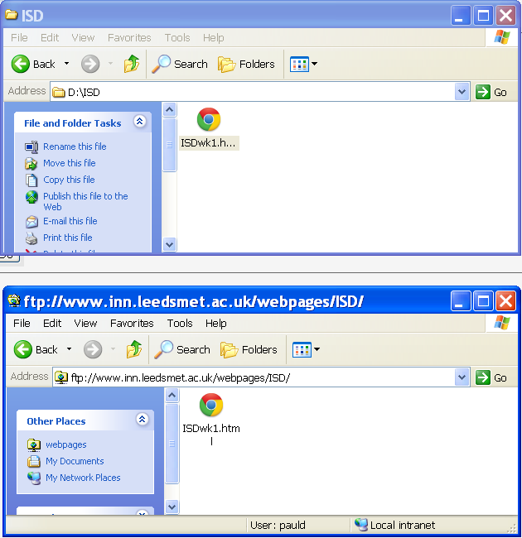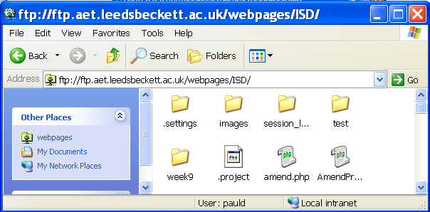

Login into student server using an ftp protocol through the computer interface and drag and drop your **ISD** folder from your local site.

After copying across to the server, right click in the window and chose refresh.

To copy a file from your local site, simply drag and drop onto your remote site

1. To open a window onto your sever space you need to open a computer window and type in the address bar ftp://ftp.aet.leedsbeckett.ac.uk . **DO NOT** use a browser for this as the browsers do not have an ftp client installed. You will be offered a login box and the login details are likely to be the details you were issued with when you first joined the university. If you have forgotten your password you will need to go to the help desk JG221 and ask for your login to the student server and to phpMyAdmin (more on what this is later) to be changed.
2. Once you have logged into your server space, you need to open the webpages directory. All your files **MUST** be stored inside this folder if you are to view them in a browser. Drag and drop your local ISD folder onto your server space, you may need to right click and refresh to visually see the folder in your server space.
3. Note: Whilst you can drag and drop a file from your local version of your site onto the browser to view the HTML and CSS, you cannot simply drag and drop a file from the server onto the browser to see the PHP/MySQL functionality. You need to view your site on the server by typing the URL below into the address bar:

<http://www.aet.leedsbeckett.ac.uk/~cxxxxxx/ISD/>

1. The cxxxxxx should be replaced with your student ID. This path will default to listing your files in the ISD folder. If there was an index.html file in the folder then this would be launched. The reason for not suggesting your home page uses the standard index.html name is that being able to browse your files through a browser will be useful when developing and testing files.

**Your complete workspace will require Sublime (or alternative text editor), a browser (suggest Chrome) and windows for your local and remote files. Overleaf you will find a screen grab of what this might look like. You should set up this workspace at the beginning of each session. Note: If you find the background and fonts on Sublime not to your liking it is easy to change, through the preferences option – or simply opt to use a text editor of your choice.**

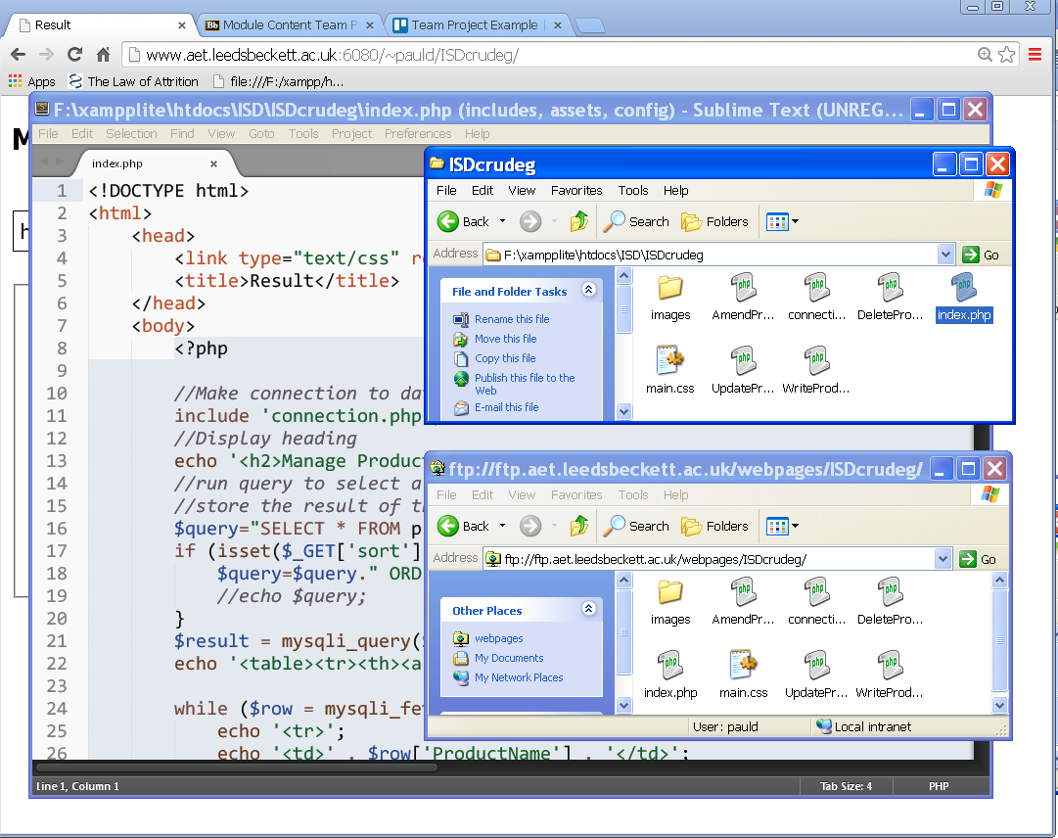

## Exercise 3 –Working with a server

1. Below you will find the code for a simple web page that includes HTML, CSS and PHP. Create the three files included in the page, save them as test.html, test.css and message.php.

Store them inside a sub-folder of your local ISD folder called test .

1. Test the files locally by dragging test.html to a browser tab. If working fully the message embedded into your message.php file will be displayed.
2. Something missing? – because this is just running locally, the PHP will not be translated by the browser, this must be done on the server.

Copy your files onto the student server by dragging and dropping your local test folder onto your server space inside your remote ISD folder.

1. Enter the url of your test.html page into the address bar of the browser to test the page on the server.

<http://www.aet.leedsbeckett.ac.uk/~cxxxxxx/ISD/>test/test.html

1. Still something missing? – unless you tell the server that some PHP is present in the code, it will be ignored. You do this by giving your file a .php extension

Rename your local version of test.html to test.php and copy onto the server.

1. Test both your local version of test.php and your remote version.
2. All being well your remote version is now displaying the PHP generated message. But your css style may still be missing. The remote server is case sensitive so you must be very careful when naming files etc. In this case check the link to your css file, in particular the use of any capitals.

HTML

<!DOCTYPE html>

<html lang="en">

<head>

<title>My web document</title>

<link href="Test.css" rel="stylesheet" type="text/css" />

</head>

<body>

<section id="container">

<p>

Below is a PHP generated message:-

</p>

**<?php**

include "message.php";

**?>**

</section>

</body>

</html>

CSS

html {

color**:** black**;**

background-color**:** silver**;**

}

body {

font-family**:** verdana**,** helvetica**,** arial**,** sans-serif**;**

font-size**:** 20px**;**

}

PHP

**<?php**

// Print some words to the screen

print "If all is well then this message will be seen when you browse this web page";

**?>**

## Exercise 4 –Accessing the student server from home

1. A request has been made for a VPN connection to the server. We will keep you informed on any progress.

## Exercise 5 –Setting up your own server

1. An alternative to using the student server, is to use your own server, which you can set up on a USB stick or one of your own machines. **You should be aware that final hand-in of work MUST be via the student server and any attempt to submit work any other way will be subject to a penalty.**

However, use of your own server can have some advantages and as long as you make sure you are competent at transferring work from one server to another, there should not be a problem. The transfer of HTML, PHP and CSS files is straightforward, but the transfer of database tables is a bit more complex. This will be dealt with when we reach working with databases.

1. The server we recommend is called **Xampp** and this can be downloaded from:

<https://www.apachefriends.org/index.html>

1. There are versions for all operating systems. For Windows there is a **lite** version that can be installed on a USB stick. Chose this version:

<http://sourceforge.net/projects/xampp/files/XAMPP%20Windows/5.5.28/>

PD has always had problems in the past with the **exe** version, so always downloads the **zip** version.

1. Download this yourself and save in C:\temp\ (Note: check the C:\ drive on your machine and delete any installations of **Xampp** that you find there before you start your installation).
2. **Unzip** the file you have downloaded, this should take a few minutes to unpack. Once unpacked you will have a Xampp folder. Open this and find the setup_xampp.bat file, double click to run. Select the **refresh** option if offered.

Note: **Very important – Always run setup when moving between networks.**

1. Now find the **xampp_control.exe** and double click. Click the **Start** button for the **apache** server and wait until the server has started. Do the same for **MySQL**. Minimise the Control Panel.

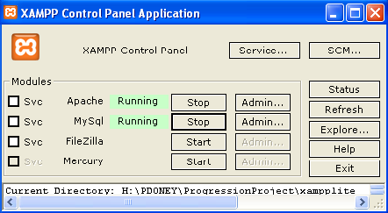

1. Go to Chrome and type <http://localhost> in the address bar. Click the **English** link if requested.
2. You are now running web pages from a web server.
3. To run any web pages on your server you need to put them in the appropriate directory. The directory is called htdocs. Drag and drop your ISD folder into the htdocs folder, so that you have a copy on your Xampp server.
4. Browse your test.php page running on your new Xampp server:

<http://localhost/ISD/test/test.php>

1. When you have time you may want to consider setting up an xampp server on a USB stick.

**Do not use Xampp if you are concerned about managing your files.**

**The potential for confusion between student server, local site on the network and any site hosted on a USB – not to mention any copies you establish on home machines – is significant. You will have to be vigilant and back-up scrupulously if you are to avoid problems. Please don’t fall into the trap of completing all of you work on Xampp and transferring to the student server just before the submission of work. If you are not confident you can cope with the differences, then stick to using the student server only.**