Multi-View 3D Reconstruction and Point Cloud Generation: Incremental Structure-from-Motion, Failure Analysis and Learned-Feature Extensions

Lee Tze Hian [U2423241F]
College of Computing and Data Science
Nanyang Technological University, Singapore
CT3205 Computer Vision for AI, Assignment 2

Abstract—We implement an incremental multi-view 3D reconstruction pipeline from the geometry up: feature matching with geometric verification, essential-matrix pose recovery with the cheirality test, linear triangulation, PnP-based registration into a common frame, sparse bundle adjustment and reprojection checks. Against the COLMAP model of the dataset, twelve south-building images reconstruct to 10,934 points with camera positions within 0.11% of the trajectory extent and rotations within 0.18°. Four controlled experiments vary the number of images, the detector, the viewpoint change and the image quality: more images do not always improve accuracy, RootSIFT outperforms SIFT, ORB, AKAZE and BRISK, matching collapses beyond about 35° of viewpoint change, and blur is the most destructive degradation. We log every success and failure, including a reconstruction that registered all images with low reprojection error yet was 51% wrong because of an EXIF-orientation bug, and a building loop that fragments into disconnected image clusters. Advanced work adds a rectified-SGBM dense stage (23× more points), GPU learned matching with DISK and LightGlue, and a comparison with COLMAP. Own iPhone captures of four objects (330 photos), self-calibrated from fundamental matrices (validated to 0.5% on south-building and to about 1% by a chessboard), reconstruct completely; a transparent bottle, chosen as a negative case, yields geometry only where it is opaque. The main lesson is that reprojection error and registration counts can hide a wrong or incomplete reconstruction.
Keywords—structure from motion, multi-view geometry, essential matrix, bundle adjustment, dense stereo, learned local features, failure analysis

Introduction
Recovering the 3D structure of a static scene and the positions of the cameras that photographed it, from overlapping images alone, is the core problem of structure from motion (SfM) [1], [8]. In the stereo laboratory a scene was reconstructed from a pair of images by estimating the relative camera motion from feature correspondences and triangulating. This work extends that pipeline to many views: it must produce feature correspondences, relative camera poses, 3D points, a sparse point cloud, camera positions and orientations, and a reprojection of the points into the input images.

The aim is not an attractive point cloud but an understanding of each stage and of how reconstruction quality depends on the images. We therefore implemented the pipeline ourselves instead of calling an existing SfM package, evaluated it quantitatively against the COLMAP model shipped with the datasets, and investigated how the number and arrangement of images, the feature detector and the image quality affect the result. Our contributions are:
- an incremental SfM pipeline with explicit essential-matrix decomposition and cheirality test, DLT triangulation, PnP registration, track management and sparse bundle adjustment (Section III);
- four controlled experiments and a quantitative comparison with COLMAP (Section V);
- a fully logged study of challenging scenarios including failures and a diagnosed implementation bug (Section VI);
- advanced work: dense stereo reconstruction, GPU learned-feature matching (DISK + LightGlue) and an analysis of what COLMAP does that our pipeline does not (Sections III-I, III-J and V).
Main findings: the pipeline agrees with COLMAP to about 0.1% in camera position; accuracy is not monotonic in the number of images; matching collapses near 35° of viewpoint change; and several failures were silent—the reconstruction looked successful by reprojection error and registration count while being wrong.

Datasets

South-building (main dataset)
The south-building set of the COLMAP dataset collection [15] has 128 photographs (3072×2304) of a brick building taken from the ground, with a SIMPLE_RADIAL camera (f = 2559.7 px, k₁ = −0.0205). The baseline and control sequence uses 12 images (P1180181–P1180203, every second frame); the dense reconstruction uses 16 consecutive images. Images are scaled to 1600 px on the long side and undistorted, and the camera matrix is scaled accordingly. Consecutive frames have about 12° of parallax and matching survives up to about 35° (Section V-D).

Person Hall (challenging dataset)
330 photographs (5616×3744, OPENCV model, k₁ = −0.109) of a walk around a brick building that returns to its start (Fig. 1d–f). It contains heavy foliage, repetitive arched windows, sun flare, strong scale changes and 48 portrait photographs carrying an EXIF orientation tag (Section VI).

Own photographs
Five capture sets of four objects (330 photographs) were taken by hand with an iPhone 16 Pro Max main camera (24 mm-equivalent, f/1.78, 1/100 s, ISO 80–125, JPEG, 5712×4284; 10 frames at 4032×3024 with the same field of view). The camera was walked once round a stationary object standing on a pedestal in a textured office, at roughly constant distance, without turning the object: a yellow warning sign at two heights (82 + 37 photos), a fire extinguisher (83), snacks (71) and a transparent bottle (57), the last chosen on purpose as a negative case (Fig. 10–11, Section VI). Shooting distance ~ 200 – 300mm, camera angle ~ level to object, less the elevated downward shots for the warning sign, office fluorescent white lighting.

Ground truth and its limits
The COLMAP sparse models shipped with the datasets are used only for the camera intrinsics and for evaluation, never as input to our reconstruction. They are reconstructions themselves, so “error” below means disagreement with COLMAP, and our intrinsics are COLMAP’s rather than self-calibrated.
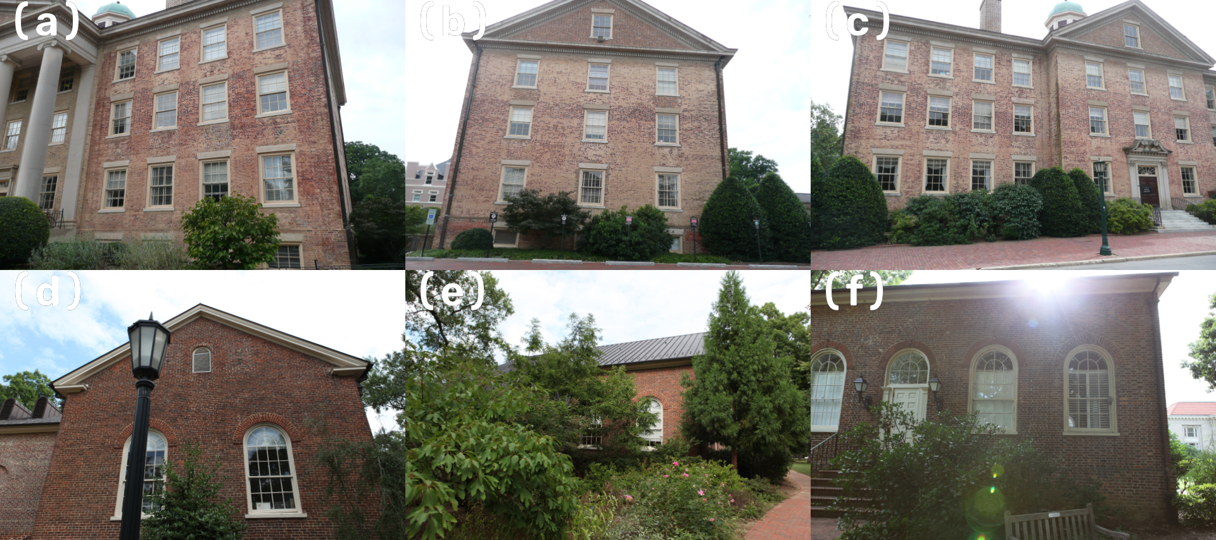
- Representative input images. (a)–(c) south-building; (d) Person Hall clean facade, (e) foliage, (f) arched windows with sun flare.

Methodology

Feature detection and description
We use RootSIFT [2], [3] (SIFT with L₁-normalised, square-rooted descriptors), detecting 8000 keypoints per image with a contrast threshold of 0.02. SIFT, ORB, AKAZE and BRISK (OpenCV [13]) are compared in Experiment B and learned DISK features in Section III-J.

Matching and filtering
Matches pass a cascade (Fig. 2): raw nearest-neighbour matching; Lowe’s ratio test (0.8); a mutual (cross-check) test; and geometric verification by RANSAC [5] on the essential matrix (five-point solver [4]) with a 1 px threshold. We judge correctness against the COLMAP epipolar geometry (Sampson distance < 1.5 px): green lines are correct, red are wrong. For the initial pair, 8000 raw matches (4,467 wrong) reduce to 3164 after the ratio and mutual tests (81 wrong) and 3077 after RANSAC (none wrong).
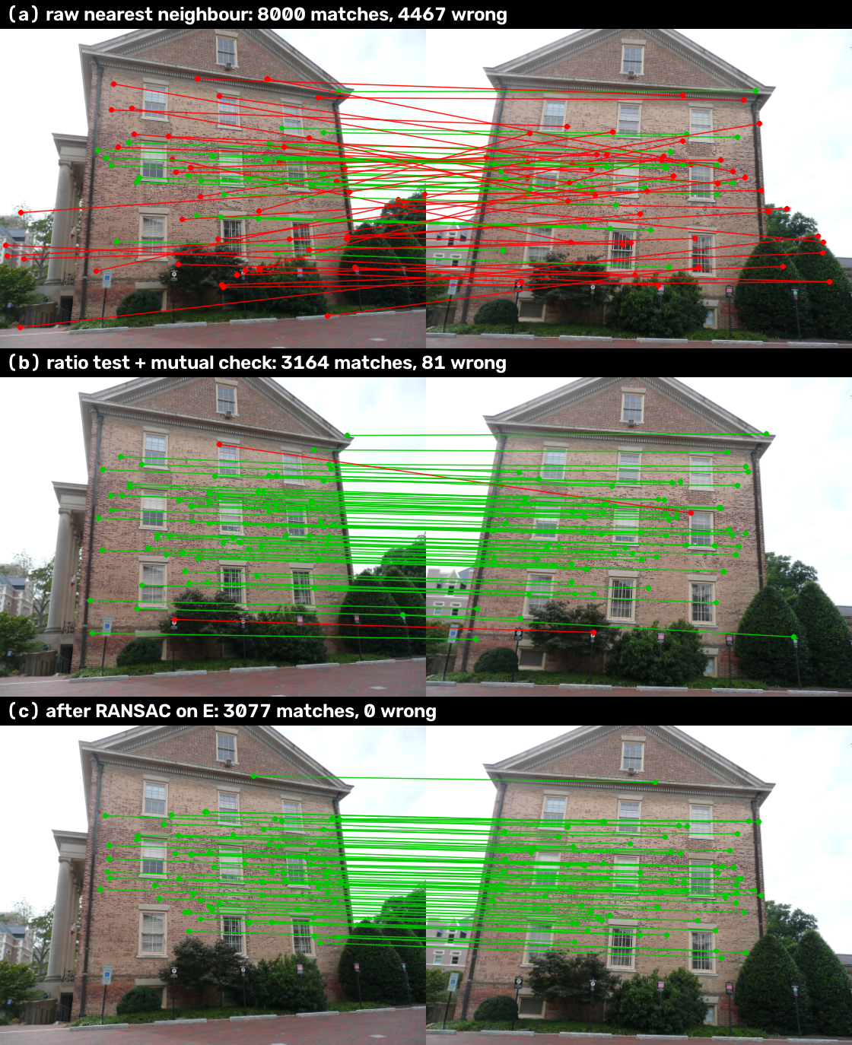
- Match filtering for the initial pair (P1180189, P1180191): (a) raw nearest neighbour, (b) ratio test and mutual check, (c) after RANSAC. Green = correct, red = wrong under COLMAP geometry. 70 randomly chosen matches drawn.

Essential matrix and relative camera pose
For normalised image points x₁, x₂ of the same 3D point, the essential matrix satisfies
E = [t]× R, x₂^{T} E x₁ = 0 (1)
and is estimated from the verified matches and the camera matrix K. Its SVD gives four candidate poses, R ∈ {UWV^{T}, UW^{T}V^{T}} combined with t = ±u₃, so the pose is ambiguous. The physically valid solution is selected by the cheirality condition: the triangulated points must lie in front of both cameras. On the initial pair the four candidates place 0, 3077, 0 and 0 points in front of both cameras, so exactly one is valid; our rotation agrees with OpenCV’s recoverPose to 0.0°.

Multi-view camera pose estimation
Common frame. The first camera of the initial pair defines the world, P₁ = K[I | 0], and the baseline of that pair defines unit scale (monocular reconstruction is defined only up to scale). The initial pair is chosen among the best-connected candidates by the number of valid triangulated points weighted by median parallax (at least 3°), which avoids near-pure-rotation pairs whose depth is ill-conditioned.
Registering images. Matches whose partner keypoint already belongs to a 3D point give 2D–3D correspondences. The image with the most correspondences is registered by PnP with RANSAC (EPnP minimal sets [6], 3 px threshold) followed by Levenberg–Marquardt refinement, which yields P_{i} = K[R_{i} | t_{i}] directly in the common frame. New points are then triangulated between the new image and every registered image, and existing tracks are extended.
Why PnP instead of chaining relative poses. Chaining pairwise transforms, R_{i} = R_{i,i−1}R_{i−1}, accumulates error and leaves the translation scale of every pair undetermined. PnP against the shared 3D points inherits a single consistent scale and ties every camera to the same structure. A track stores, for each 3D point, the keypoint that observes it in each image; it links images and supports PnP, triangulation and bundle adjustment. After each registration, bundle adjustment (III-F) refines everything and observations with error above 2 px or negative depth are dropped. Fig. 3 shows the result: twelve cameras on an arc around the building.
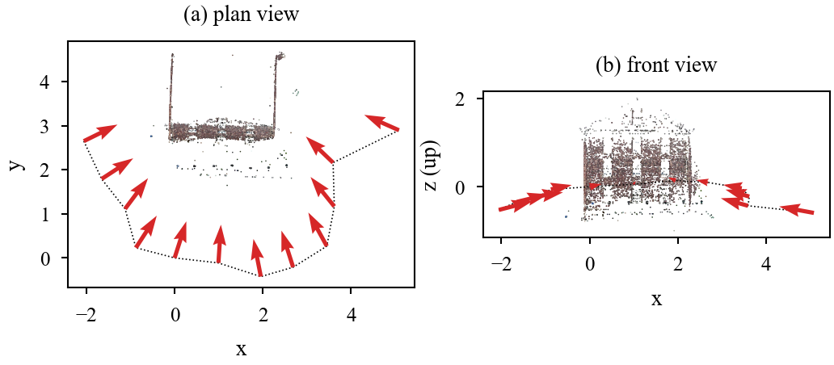
- Baseline reconstruction (12 images, 10,934 points): (a) plan view and (b) front view with camera positions and viewing directions (red arrows). The scene is levelled using the cameras’ mean up-axis.

Triangulation
For a correspondence with projection matrices P₁, P₂ (in normalised coordinates), each view contributes two linear equations on X, with rows x p₃ − p₁ and y p₃ − p₂ where p_{k} are the rows of P. The four stacked rows give AX = 0, solved by the singular vector of the smallest singular value (DLT [1]); geometrically the projection matrices define two viewing rays and X is their intersection. A point is accepted only if its depth is positive in both cameras, its reprojection error is below 2 px and its triangulation angle exceeds 1.5° (small angles give unreliable depth). Our DLT agrees with OpenCV’s triangulatePoints to 8×10⁻¹².

Bundle adjustment
We minimise the robust reprojection error over all camera poses (the first camera fixed) and all 3D points,
min Σ_{ij} ρ( ‖ π(K, R_{i}X_{j} + t_{i}) − x_{ij} ‖² ) (2)
with a Huber loss and the sparse Jacobian structure (each residual depends on one camera and one point), using SciPy’s trust-region least squares [7]. After each registration it lowers the RMS error by roughly 5–35%.

Point cloud, visualisation and reprojection
Point colours are sampled from the images; clouds are exported as PLY and inspected with Matplotlib, Open3D and a self-contained interactive WebGL page. For every camera the 3D points are projected back,
x_{i} ~ P_{i} X, P_{i} = K[R_{i} | t_{i}] (3)
and compared with the detected features (Fig. 4). A large reprojection error indicates a wrong camera pose, a poorly triangulated point (small parallax), a false match or a wrong calibration. Points seen in only two views satisfy the constraints almost by construction, so we also report the error for points seen in three or more views.
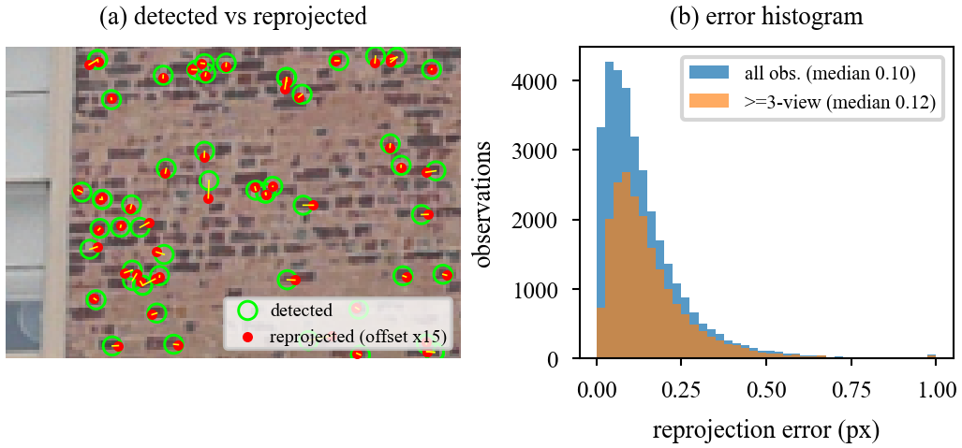
- Reprojection check. (a) Detected features (green circles) and reprojected 3D points (red); the offset between them is magnified ×15 so it is visible. (b) Error histogram over all observations of the baseline (1600 px images).

Evaluation protocol
We align our model to COLMAP by a Sim(3) transform (Umeyama [12], inside RANSAC, with an optical-axis term when camera centres are nearly collinear) and report the camera position error relative to the trajectory extent, the rotation error, the fraction of our points within 2% of that extent from a COLMAP point, and completeness. Runtimes are wall-clock times on a laptop, on the CPU unless the GPU (RTX 3050, 6 GB) is stated.

Dense stereo reconstruction (advanced)
Given the poses, neighbouring registered cameras are rectified so epipolar lines become image rows, matched by semi-global matching [9] (block 5) within a disparity range derived from the sparse depths, and back-projected. Depth maps are fused by voxel voting: a voxel is kept only if at least two different stereo pairs place a point in it.

Learned features and GPU matching (advanced)
DISK [10] detects keypoints with 128-D descriptors and LightGlue [11] matches them with a transformer that reasons over both images; both are pretrained (no training by us) and run through Kornia [14] on the GPU. We also ported our brute-force ratio-plus-mutual matcher to the GPU; it returns identical matches and is 10.9× faster per pair (0.029 s versus 0.319 s). Because learned matching gives true pairs thousands of inliers, we raise the pair-acceptance threshold from 25–40 to 150 inliers when using it (Section V-G).

Self-calibration of the phone camera (own captures)
The phone is uncalibrated. EXIF gives the 35 mm-equivalent focal length (24 mm), which converts to pixels through the image diagonal, f = 24 · diag / 43.27 (the common long-side/36 mm shortcut is right only for 3:2 images and was 4% too small here). We refine it by self-calibration from fundamental matrices: for the true K, E = K^{T} F K has two equal singular values, so for a grid of f (square pixels, principal point at the image centre) we compute
c(f) = (σ₁ − σ₂) / (σ₁ + σ₂), σ = svd(K(f)^{T} F K(f)) (4)
over 40–60 RANSAC-verified pairs and take the f minimising the median of c. On south-building this recovers COLMAP’s calibrated focal length to 0.5% (1326.5 against 1333.2 px from 38 pairs). On the four own sets it gives 1137–1159 px at 1600 px, 2.5–4.5% above the EXIF value and consistent across sets; all own reconstructions use a common factor of 1.04. An independent chessboard calibration of the same phone (40 photos, 25 mm squares) gives 1156 px, within 0.2% of this value (1153–1163 px across distortion models and photo subsets); its fit error is high (RMS 6 px) because the oblique views were defocused and the paper was not perfectly flat, so we quote the agreement as about ±1%. Two alternatives failed: choosing f by reprojection error was inconclusive (fewer images register at low f, which lowers the error spuriously), and refining f inside bundle adjustment stayed at its wrong starting value (±12%) on south-building, probably because focal length and depth are weakly separable for a near-planar scene.

Experimental Design
All experiments share one control: 12 south-building images (P1180181–P1180203, stride 2), RootSIFT with 8000 features, 1600 px, ratio 0.8 plus mutual check, RANSAC at 1 px, PnP and bundle adjustment. Each changes exactly one variable. Metrics: images registered, 3D points (and points seen in at least three views), mean track length, reprojection error, camera position and rotation error, completeness, verified inliers per pair and runtime.
- A – number of images (N = 3–20, nested subsets). Hypothesis: more points with diminishing returns; runtime roughly quadratic from all-pairs matching.
- B – detector (SIFT, RootSIFT, ORB, AKAZE, BRISK). Hypothesis: SIFT-type descriptors beat binary ones on wide baselines.
- C – viewpoint change (frame stride 1–6 with 8 images, plus a two-view study). Hypothesis: stride 1 gives poor depth, very large strides break matching, with an optimum between.
- D – image quality (blur σ = 1–8 px, noise σ = 10–50, resolution 1200–200 px, contrast ×0.5–0.1, gamma 2.0–3.5). Hypothesis: blur and low resolution hurt most; contrast changes little because descriptors are gradient-normalised.
Challenging scenarios use 11 Person Hall cases with an outcome rule fixed in advance (success: at least 90% of images registered and position error below 2%) and five own phone captures, one of them a deliberate negative case. The advanced work compares classical, GPU and learned matching and COLMAP.

Results

Baseline reconstruction
All twelve images register (Table I). Fig. 3 shows the cloud with camera positions and orientations; Fig. 4 the reprojection check: mean error 0.14 px, median 0.10 px at 1600 px (about 0.27 px at the original resolution), 0.16 px for points seen in at least three views. Poses agree with COLMAP to 0.11% (position) and 0.18° (rotation).
- Baseline reconstruction (12 images)
Quantity | Value
Images registered | 12 / 12
3D points (seen in ≥ 3 views) | 10,934 (4,986)
Mean track length | 2.95
Reprojection error, all obs. (mean / median) | 0.138 / 0.103 px
Reprojection error, ≥ 3-view (mean) | 0.158 px
Camera position error (rel. to extent) | 0.11 %
Camera rotation error (mean / max) | 0.18° / 0.37°
Points within 2% of a COLMAP point | 99.4 %
Run time | about 1 min

Experiment A: number of images
Points grow from 1.4 k to 23 k and runtime roughly quadratically (212 s at N = 20), as hypothesised (Table II, Fig. 5a). Accuracy is not monotonic: position error is best at N = 8 (0.08%) and worse at N = 16 and 20 (0.41%, 0.29%); weaker-overlap frames and accumulated drift are plausible causes but were not isolated. The mean reprojection error rises from 0.11 to 0.18 px as tracks lengthen: with N = 3 only 21 points are seen in three views and two-view points fit almost exactly. N = 4 registers only three images (a link of 9–10 inliers is noise) and its accuracy score is unreliable because three nearly collinear cameras make the Sim(3) alignment ill-posed; a camera-independent ICP alignment places 78–80% of its points within 2%, so it is a fragile, not a wrong, reconstruction.
- Experiment A: number of images
N | Reg. | Points | ≥ 3 views | Cam. err % | Time s
3 | 3/3 | 1,448 | 21 | 0.17 | 1.5
4 | 3/4 | 2,232 | 70 | 0.62ª | 3.7
6 | 6/6 | 6,589 | 2,237 | 0.13 | 14
8 | 8/8 | 8,889 | 4,097 | 0.08 | 28
12 | 12/12 | 10,934 | 4,986 | 0.11 | 62
16 | 16/16 | 18,849 | 9,193 | 0.41 | 139
20 | 20/20 | 23,294 | 12,375 | 0.29 | 212
ªAlignment on three nearly collinear cameras is unreliable.

Experiment B: feature detector
RootSIFT is best (Table III): it registers all images and yields 483 verified inliers per pair; plain SIFT gives 452 and 11/12. ORB, the fastest, finds four times fewer inliers, registers 8/12, has a reprojection error of 0.35 px and about ten times the camera error; AKAZE and BRISK lie between. The hypothesis holds, with the caveat that the binary detectors were not tuned.
- Experiment B: detectors (same 12 images)
Detector | Reg. | Points | Inliers/pair | Reproj. px | Cam. err %
SIFT | 11/12 | 9,414 | 452 | 0.129 | 0.12
RootSIFT | 12/12 | 10,934 | 483 | 0.138 | 0.11
ORB | 8/12 | 3,706 | 115 | 0.351 | 1.23
AKAZE | 8/12 | 5,112 | 201 | 0.222 | 0.20
BRISK | 9/12 | 6,642 | 271 | 0.209 | 0.13

Experiment C: viewpoint change
All eight images register at strides 1–2, six at stride 3 and only 2–3 at strides 4–6, while verified inliers fall from 988 to 140 (Fig. 5b). A two-view study (frames i, i+k) gives 2,520, 1,270 and 377 inliers at median parallax 12.6°, 24° and 34°, and noise level (9–10) beyond: matching collapses near 35° of viewpoint change. Accuracy is lowest at stride 1 (92% of points within 2% against 99%), consistent with weak depth from small baselines. Even consecutive south-building frames have about 12° parallax, so the true small-baseline regime is not reached.
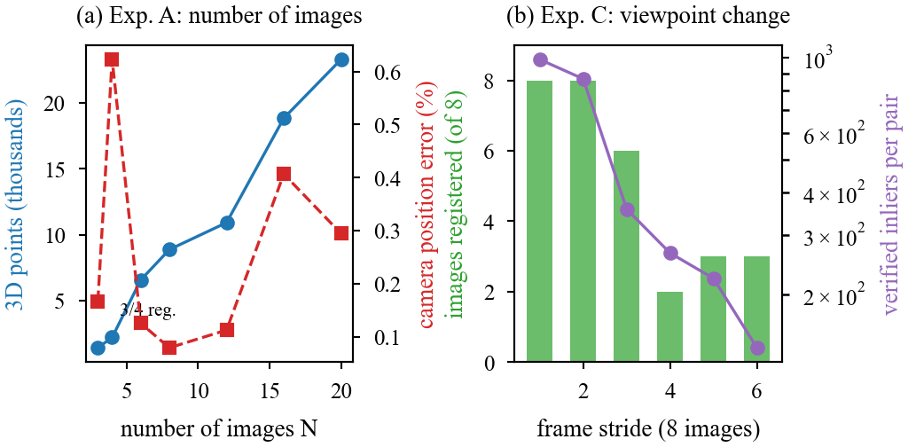
- (a) Experiment A: 3D points (blue) and camera position error (red) against the number of images. (b) Experiment C: images registered (bars, of 8) and verified inliers per pair (line) against frame stride.

Experiment D: image quality
Degradation appears mostly as lost points and images rather than pose drift: for runs that still register, camera error stays at 0.1–0.4%, except at 400 and 200 px resolution (0.6% and 1.5%) (Fig. 6). Blur is the most destructive: σ = 2 halves the points, σ = 4 leaves 7% and 8/12 images. Noise σ = 25 leaves 14% (8/12) and σ = 50 fails. Down to 800 px keeps 47% of the points; 400 px keeps 8%. Contrast ×0.25 still registers 11/12 but ×0.1 cannot initialise; darkening by gamma does not hurt. The hypothesis holds.
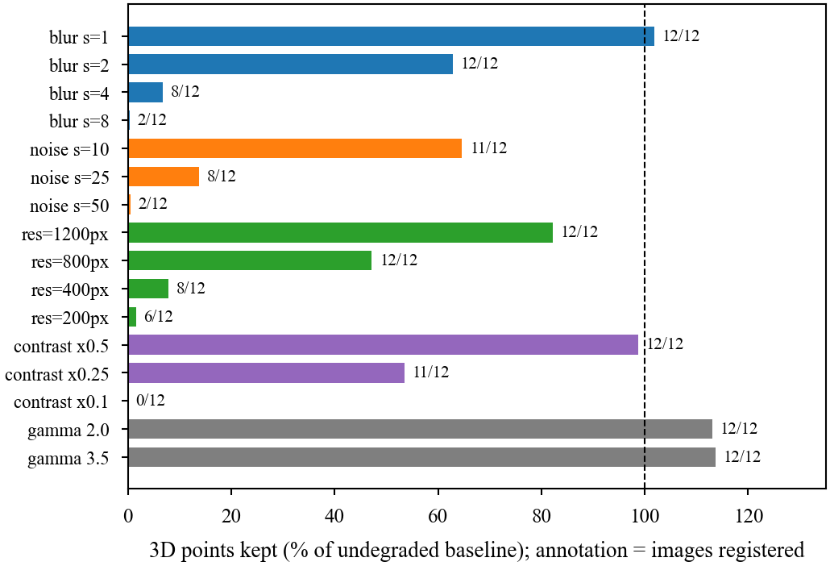
- Experiment D: 3D points kept (% of the undegraded baseline) for each degradation; numbers show images registered of 12.

Dense reconstruction
Fifteen rectified stereo pairs from 16 consecutive images give 428,018 fused points, 23.5× the sparse cloud (18,216), fused in 18 s (Fig. 7). In the reconstructed volume 66.4% of COLMAP’s points have one of ours within 2% of the scene radius (sparse 58.5%) and the median gap to COLMAP’s surface points falls from 1.4% to 0.5%; individual dense points are about 35% noisier than sparse ones (per-pixel disparity versus sub-pixel features). Fusion support is the main quality knob: requiring one pair gives 1.1 M points but only 46% on the dominant facade plane; three pairs give 224 k points with 80%. Pairs three frames apart collapse (76 points), matching the limit of Experiment C.
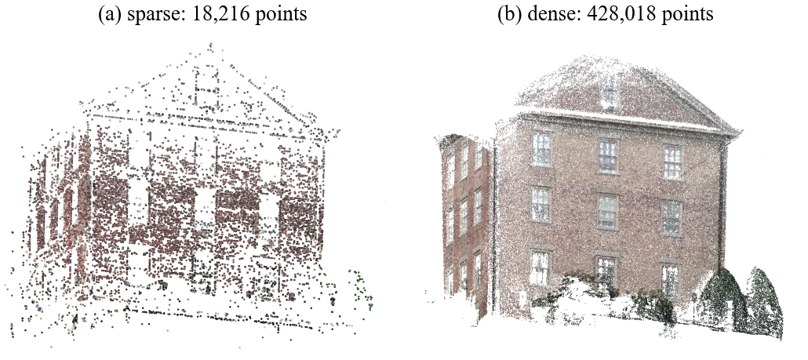
- Sparse (a) and dense (b) clouds of the same 16-image sequence, front view.

Learned features and comparison with COLMAP
On image pairs scored with COLMAP’s geometry (Fig. 8a), correct inliers under sun flare rise from 379 (RootSIFT) to 3,056 (DISK with the ratio test) and 3,400 (DISK + LightGlue); for foliage the medians are 4, 28 and 229, and for scale change 174, 809 and 1,124. Of 13 weak links that cut the whole building loop, 0, 5 and 8 are bridged (at least 25 correct matches). Wide viewpoint change still defeats every method. In full reconstructions (Table IV) learned matching yields 1.8× the points and 4.6× the inliers per pair but a 2.7× higher reprojection error and about twice the camera error, as DISK keypoints lie on the integer pixel grid.
A second silent failure. At strides 4–6 learned matching registered more images (6, 4, 8 of 8) but the models were wrong (59–85% camera error). In the stride-6 case 8 of 19 verified pairs were false, with a median of only 68 inliers against 2,357 for correct pairs. Our SIFT-era thresholds could not separate them; raising the pair threshold to 150 inliers removed them (3–4 images registered, nearly all correct).
Compared with COLMAP on identical images (Table V; its model restricted to points seen by our images), poses agree to 0.03–0.11% (0.20% with learned matching). Our point counts are 0.6–2.3× COLMAP’s with similar track lengths. Our lower reprojection error is not evidence of superiority: our intrinsics are COLMAP’s refined calibration, its error is averaged over a model constrained by all 128 images, and our acceptance thresholds differ. COLMAP additionally uses retrieval-based matching, two-view geometry classification, a more elaborate next-view selection, local bundle adjustment, intrinsics refinement, re-triangulation, sub-model merging and a PatchMatch dense stage; our pipeline has none of these (it registers the image with the most correspondences and densifies with SGBM).
- Classical, GPU and learned matching (south-building, 12 images)
Quantity | RootSIFT CPU | RootSIFT GPU | DISK + LightGlue
3D points | 10,934 | 10,938 | 20,084
Points ≥ 3 views | 4,986 | 4,989 | 12,501
Inliers per pair | 483 | 483 | 2,245
Mean track length | 2.95 | 2.95 | 3.83
Reprojection (px) | 0.138 | 0.138 | 0.379
Camera error (%) | 0.11 | 0.12 | 0.20
Run time (s) | 78 | 68 | 116

- Ours versus COLMAP on identical images
Images | Pts ours | Pts COLMAP | Track o/C | Reproj. o/C (px) | Cam. err %
south 12 | 10,934 | 8,830 | 2.95/2.69 | 0.27/0.48 | 0.11
south 12, DISK | 20,084 | 8,830 | 3.83/2.69 | 0.73/0.48 | 0.20
south 16 | 18,216 | 11,577 | 3.89/3.82 | 0.29/0.46 | 0.05
hall A | 12,584 | 17,780 | 3.03/3.07 | 0.39/0.60 | 0.03
hall C | 6,509 | 10,777 | 3.33/4.61 | 0.52/0.78 | 0.11
Reprojection errors at original resolution; ours uses COLMAP’s intrinsics.
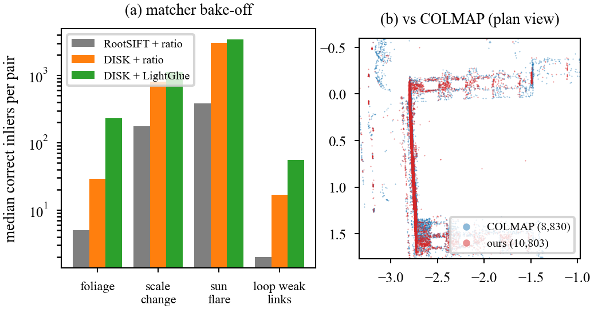
- (a) Median correct RANSAC inliers per pair for three matchers on hard pairs (log scale). (b) Plan view of our 12-image cloud (red) and COLMAP’s points seen by the same images (blue), Sim(3)-aligned.

Challenging Scenarios and Failure Analysis
Person Hall provides foliage, repetition, sun flare and a closed loop. We ran the unchanged default pipeline on 11 cases, plus one loop run with relaxed thresholds (Table VI), and logged every outcome.
- Person Hall cases
Case | Tests | Reg. | Cam. err | Outcome
A facade | reference | 12/12 | 0.03% | success
B foliage | occlusion | 2/12 | n/a | failure
C arches+flare | repetition | 12/12 | 0.11% | success†
D corner turn | scale change | 11/12 | 0.07% | success
Stride 2–8 | viewpoint | 8/8 (×4) | ≤ 0.75% | success
F loop, 55 | whole loop | 15/55 | 0.66% | failure
F3 loop, 110 | whole loop | 44/110 | 0.16% | failure (partial)
F3, relaxed | thresholds | 45/110 | 0.19% | failure (partial)
F3, learned | whole loop | 59/110 | 53% | failure (drift)
†After fixing the EXIF bug; the first run of C was 12/12 registered but 51% wrong.
Foliage (case B). Only 2 of 12 images register (63 points). Fig. 9a: a tree hides the wall; the 74 surviving matches are all correct against COLMAP geometry but too few and confined to the visible wall—a failure by occlusion, not by false matches.
A silent failure caused by our loader (case C). The first run registered all 12 images with 0.6 px reprojection error and 6.5 k points, yet its camera error was 51% and its rotation error 139°. 50 of 60 verified pairs contradicted COLMAP although their matches looked right, and COLMAP’s relative rotation between the consecutive sampled frames IMG_1228 and IMG_1230 was 91°. 48 of the 330 photographs carry an EXIF portrait tag: OpenCV’s imread silently rotates them, while COLMAP (and our single landscape camera matrix) uses the stored pixels. With IMREAD_IGNORE_ORIENTATION the error fell to 0.11% (case D from 0.97% to 0.07%). South-building has no tagged photographs, so earlier results are unaffected. A low reprojection error and full registration therefore do not validate a reconstruction.
Corner turn and viewpoint sweep. In case D, IMG_1313 is lost; the photographer stepped back, so it shows the corner from about twice the distance (a likely scale-change failure, not measured). All four stride sweeps succeed and accuracy slips only at stride 8 (0.75%): stride is not comparable across datasets, parallax is.
Whole loop. With every sixth image (55) only 15 register: the pair graph (edge = at least 25 verified inliers) has 15 connected components (Fig. 9b), so incremental SfM cannot cross the gaps. Every third image (110) registers 44 cameras, accurately (0.16%) but covering one side; relaxed thresholds merge the graph into 3 components yet registration stays at 45 of 110: connectivity is necessary but not sufficient, since a new image also needs 12–20 matches with existing 3D points. Learned matching registers 59 cameras but only 10 are correct; errors grow smoothly along the chain (Fig. 9c) although 372 of 403 verified pairs are individually correct (median rotation error 0.62°): accumulated drift without loop closure, not false links. The cause (for example coarse keypoint localisation) was not isolated by a controlled test.
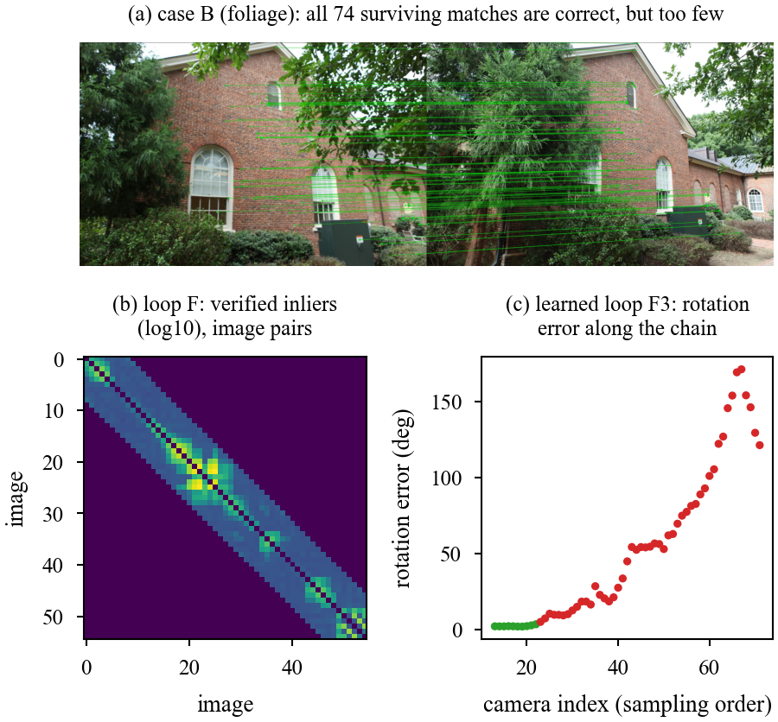
- Failure evidence. (a) Foliage pair: all 74 surviving matches are correct but too few. (b) Whole loop F: verified inliers per image pair (log scale) fall into disconnected clusters. (c) Learned loop F3: rotation error of each registered camera along the chain (green = correct, red = wrong).
Own captures. All 330 photographs register (Table VII) and independent geometry checks agree: the camera centres of each orbit form a near-circular path with 369–392° of angular coverage, 5–9% radius spread and 1–3% height spread, and the two yellow-sign rings sit consistently in one model. All-pairs matching also links the start and end of each orbit, which windowed matching would not. With no ground truth, quality is judged by reprojection error (0.38–0.59 px at 1600 px, against 0.14 px on south-building with COLMAP’s calibration, i.e. the residual limits of an uncalibrated phone), track statistics and inspection. The yellow sign, fire extinguisher and snacks are positive examples (Fig. 10): both faces of the sign with legible text, the extinguisher’s label, valve and handle, and the wrinkled snack bag.
- Own captures (iPhone 16 Pro Max)
Set | Imgs | Reg. | Points | Track | Reproj. px | Dense pts
yellow sign | 119 | 119 | 28,131 | 3.91 | 0.59 | 322,793
fire extinguisher | 83 | 83 | 22,995 | 4.63 | 0.43 | 576,819
snacks | 71 | 71 | 44,621 | 4.18 | 0.42 | 1,033,713
bottle, classical | 57 | 57 | 14,254 | 3.38 | 0.38 | 35,330
bottle, DISK+LG | 57 | 57 | 67,129 | 2.98 | 0.57 | 25,188
Dense points: inside a cylinder around the object.
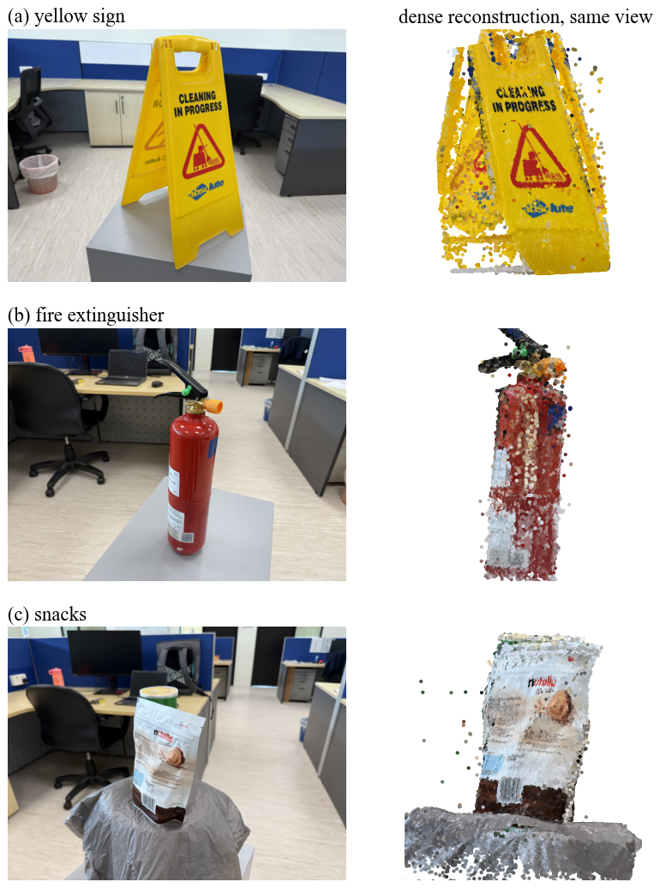
- Own captures, positive examples: input photo (left) and dense reconstruction seen from the same direction (right) for (a) the yellow sign (both heights), (b) the fire extinguisher and (c) the snacks.
Dense-stage lessons. The first dense result was a diffuse blob. Two causes were found by looking at it: the fusion voxel was sized from the whole office, far too coarse for a small object, and neighbouring frames are only about 5° apart on these orbits, too small a stereo baseline. Fusing only a cylinder around the orbit axis with a voxel sized to it, and pairing frames two to three apart (10–16°), fixed both. The glossy, uniformly red extinguisher also needed more permissive stereo settings (13,700 to 76,622 points in the same region; Table VII uses a taller region).
Negative case: transparent bottle. It registers 57/57 with both pipelines, yet geometry exists only where the object is opaque: the red label and the black cap reconstruct densely, while the clear body is almost empty or noise (Fig. 11), because the camera sees the background through it and matching assumes one appearance per surface. DISK + LightGlue gives the same result with 4.7× more sparse points but a higher reprojection error (0.57 against 0.38 px) and four times the run time: learned features do not rescue transparency.
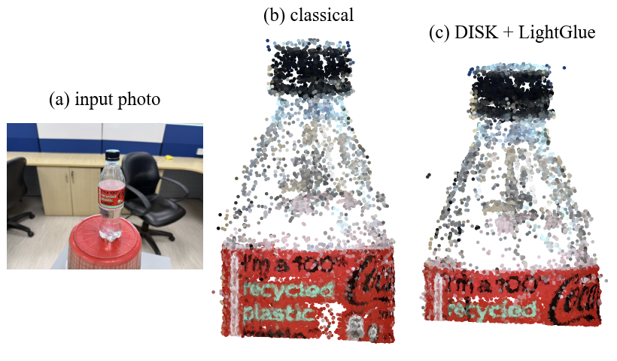
- Negative case, transparent bottle: (a) input photo; dense reconstruction with (b) classical and (c) DISK + LightGlue matching. Only the opaque label and cap are recovered.

Discussion
Viewpoint and features. Parallax, not frame stride, controls quality: too little and depth is poorly conditioned (stride 1 accuracy 92% against 99%), too much (about 35°) and matching fails. Learned features move this limit slightly (stride 3–4 on south-building) but not fundamentally, and they trade localisation precision for match count. Scene properties (foliage, repetition, loops) caused every failure; none was fixed by a threshold.
Reconstruction errors. Reprojection error is necessary but not sufficient: two-view points fit by construction and a globally wrong model can have a small error. Registration count is not quality either (SIFT loop: 44 accurate cameras; learned loop: 59 cameras, 49 wrong). Independent validation found both the EXIF bug and the wrong learned models.
Missing regions and limitations. Foliage, sky and glass produce no points; dense stereo is unreliable on thin structures; COLMAP covers ground and foliage that we miss. Limitations: one main sequence; RANSAC variation not averaged (re-runs reproduced identical numbers); COLMAP is a reference, not truth; for the COLMAP datasets the intrinsics are COLMAP's, not estimated; no loop closure, local bundle adjustment or sub-model merging; binary detectors untuned; mainly building-scale data.
Own captures. Careful capture mattered more than algorithm choice: one lens, constant distance and overlapping neighbours (hundreds of verified matches) let all four objects reconstruct without per-set tuning, unlike the Person Hall loop. The limits were physical: transparent and glossy surfaces break the assumptions of matching and stereo, and an uncalibrated phone caps accuracy. The chessboard confirmed the self-calibrated focal length to about 1%, but there is no ground truth for the reconstructions themselves, so their metric accuracy cannot be stated.
Improvements. Loop-closure detection by image retrieval; local bundle adjustment and merging of sub-models; sub-pixel refinement of learned keypoints; vegetation masking; denser sampling; and GPU matching of all pairs (about 6.5 h on CPU for the full loop, an estimated 26 min at the measured GPU speed).

Conclusion
An incremental SfM pipeline implemented from the geometry up reproduces COLMAP’s camera poses to about 0.1% when matches are good, and a rectified-SGBM stage densifies the result 23-fold. Controlled experiments show that more images do not always help, that RootSIFT is the best detector tested, that matching collapses near 35° of viewpoint change and that blur is the most damaging degradation. The most important lessons concern evaluation: reprojection error and registration counts can hide wrong reconstructions, as an orientation bug and learned-matching drift showed. Learned features are valuable on hard pairs but not a free upgrade: they need stricter verification and gave noisier geometry. Our own phone captures reconstruct completely after self-calibration, except that a transparent bottle yields only its opaque parts.

AI Usage Declaration
Tools: Claude (Claude Code, models Claude Sonnet 5.5 and Claude Opus 5.5, Anthropic). Used for: writing and debugging the pipeline, experiment and analysis scripts; producing figures, videos and the interactive viewer; diagnosing failures (for example the EXIF bug); and drafting the progress log, the demo script and this report. AI-assisted parts: most code in the repository folders sfm/, scripts/ and experiments/, and first drafts of the text. Verification and modification: all numbers were produced by running the scripts; reconstructions were checked against the COLMAP ground truth; pose recovery and triangulation were cross-checked against OpenCV; failures were investigated instead of being reported at face value.

Supporting Materials
Github Repository:
- https://github.com/Jeb-Lee/CT3205_CV_02
YouTube:
- https://youtu.be/3m35kcUR3wg

References
- R. Hartley and A. Zisserman, Multiple View Geometry in Computer Vision, 2nd ed. Cambridge, U.K.: Cambridge Univ. Press, 2004.
- D. G. Lowe, “Distinctive image features from scale-invariant keypoints,” Int. J. Comput. Vis., vol. 60, no. 2, pp. 91–110, 2004.
- R. Arandjelović and A. Zisserman, “Three things everyone should know to improve object retrieval,” in Proc. IEEE CVPR, 2012, pp. 2911–2918.
- D. Nistér, “An efficient solution to the five-point relative pose problem,” IEEE Trans. Pattern Anal. Mach. Intell., vol. 26, no. 6, pp. 756–770, 2004.
- M. A. Fischler and R. C. Bolles, “Random sample consensus: A paradigm for model fitting with applications to image analysis and automated cartography,” Commun. ACM, vol. 24, no. 6, pp. 381–395, 1981.
- V. Lepetit, F. Moreno-Noguer, and P. Fua, “EPnP: An accurate O(n) solution to the PnP problem,” Int. J. Comput. Vis., vol. 81, no. 2, pp. 155–166, 2009.
- B. Triggs, P. McLauchlan, R. Hartley, and A. Fitzgibbon, “Bundle adjustment—A modern synthesis,” in Vision Algorithms: Theory and Practice, LNCS 1883. Berlin, Germany: Springer, 2000, pp. 298–372.
- J. L. Schönberger and J.-M. Frahm, “Structure-from-motion revisited,” in Proc. IEEE CVPR, 2016, pp. 4104–4113.
- H. Hirschmüller, “Stereo processing by semiglobal matching and mutual information,” IEEE Trans. Pattern Anal. Mach. Intell., vol. 30, no. 2, pp. 328–341, 2008.
- M. Tyszkiewicz, P. Fua, and E. Trulls, “DISK: Learning local features with policy gradient,” in Proc. NeurIPS, 2020.
- P. Lindenberger, P.-E. Sarlin, and M. Pollefeys, “LightGlue: Local feature matching at light speed,” in Proc. IEEE/CVF ICCV, 2023.
- S. Umeyama, “Least-squares estimation of transformation parameters between two point patterns,” IEEE Trans. Pattern Anal. Mach. Intell., vol. 13, no. 4, pp. 376–380, 1991.
- G. Bradski, “The OpenCV library,” Dr. Dobb’s J. Softw. Tools, 2000.
- E. Riba, D. Mishkin, D. Ponsa, E. Rublee, and G. Bradski, “Kornia: An open source differentiable computer vision library for PyTorch,” in Proc. IEEE WACV, 2020.
- J. L. Schönberger, “COLMAP datasets (South Building, Person Hall).” [Online]. Available: https://demuc.de/colmap/datasets/

