**Cognizant Deep Skilling - Digital Nurture 4.0**

**1. ReactJS-HOL**

**Open Command Prompt:**

npm install -g create-react-app

npx create-react-app myfirstreact

cd myfirstreact

code .

**src/App.js**

import React from 'react';

function App() {

return (

<div>

<h1>Welcome to the first session of React</h1>

</div>

);

}

export default App;

**Start the React App:**

npm start

**Output:**

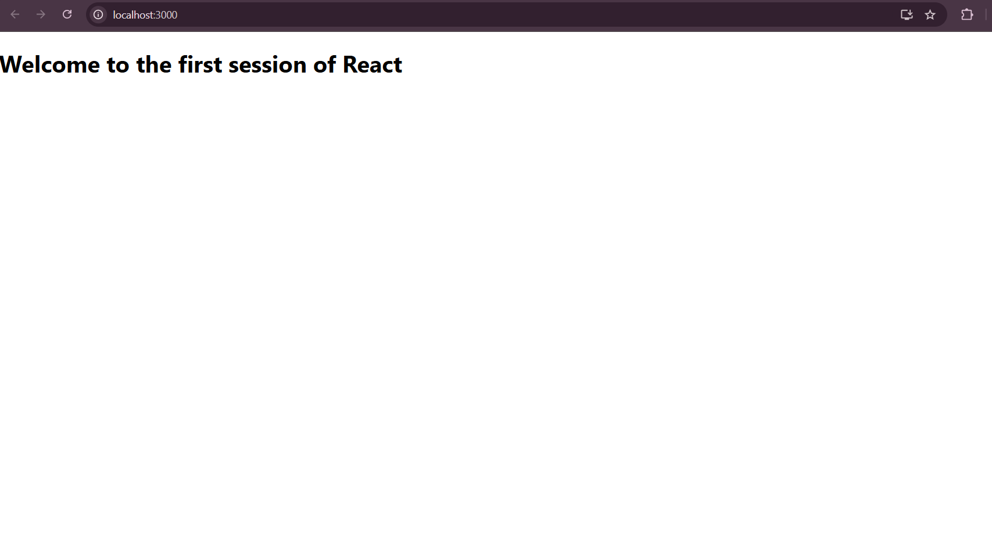

**2. ReactJS-HOL**

**Open Command Prompt:**

npx create-react-app StudentApp

cd StudentApp

code .

**src/Components/Home.js**

import React, { Component } from 'react';

class Home extends Component {

render() {

return (

<div>

<h2>Welcome to the Home page of Student Management Portal</h2>

</div>

);

}

}

export default Home;

**src/Components/About.js**

import React, { Component } from 'react';

class About extends Component {

render() {

return (

<div>

<h2>Welcome to the About page of the Student Management Portal</h2>

</div>

);

}

}

export default About;

**src/Components/Contact.js**

import React, { Component } from 'react';

class Contact extends Component {

render() {

return (

<div>

<h2>Welcome to the Contact page of the Student Management Portal</h2>

</div>

);

}

}

export default Contact;

**src/App.js**

import React from 'react';

import Home from './Components/Home';

import About from './Components/About';

import Contact from './Components/Contact';

function App() {

return (

<div className="App">

<Home />

<About />

<Contact />

</div>

);

}

export default App;

**Run the React App:**

npm start

**Output:**

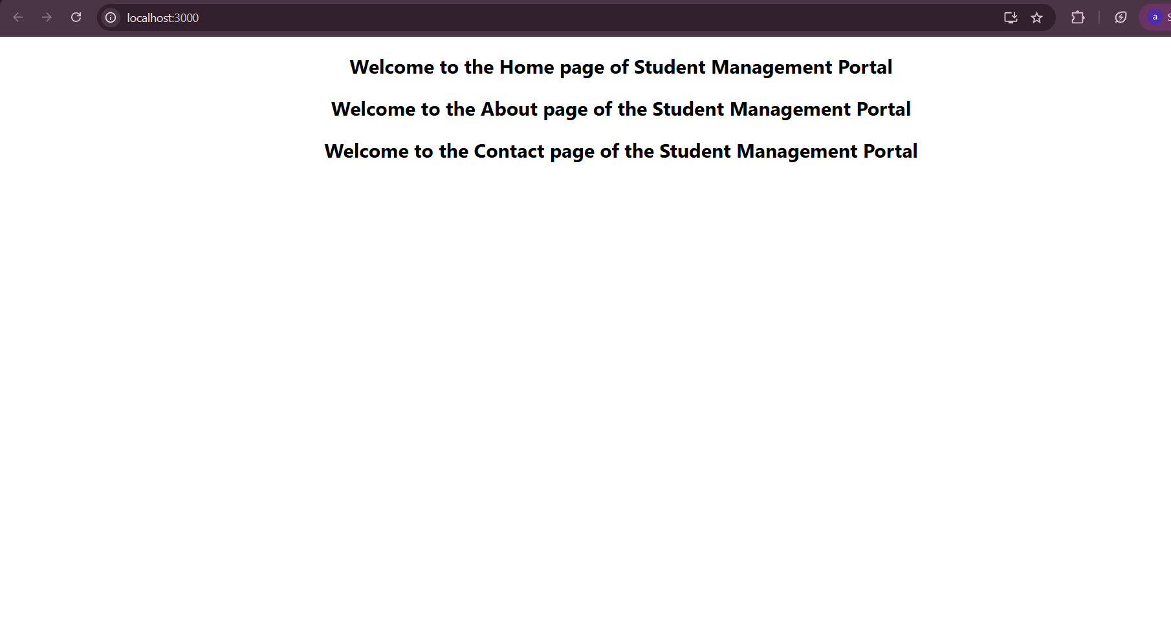

**3. ReactJS-HOL**

**Open Command Prompt:**

npx create-react-app scorecalculatorapp

cd scorecalculatorapp

code .

**src/Components/CalculateScore.js**

import React from 'react';

import '../Stylesheets/mystyle.css';

function CalculateScore(props) {

const average = props.total / props.goal;

return (

<div className="score-card">

<h2>Student Score Details</h2>

<p><strong>Name:</strong> {props.name}</p>

<p><strong>School:</strong> {props.school}</p>

<p><strong>Total Marks:</strong> {props.total}</p>

<p><strong>Subjects:</strong> {props.goal}</p>

<p><strong>Average Score:</strong> {average.toFixed(2)}</p>

</div>

);

}

export default CalculateScore;

**src/Stylesheets/mystyle.css**

.score-card {

background-color: #f0f8ff;

border: 2px solid #4b9cd3;

padding: 20px;

margin: 30px auto;

width: 60%;

border-radius: 10px;

text-align: left;

box-shadow: 0px 10px rgba(0, 0, 0, 0.1);

}

.score-card h2 {

color: #4b9cd3;

text-align: center;

}

.score-card p {

font-size: 18px;

line-height: 1.5;

}

**src/App.js**

import React from 'react';

import './App.css';

import CalculateScore from './Components/CalculateScore';

function App() {

return (

<div className="App">

<CalculateScore name="Ajitha R" school="Grace Matric School" total={480} goal={5} />

</div>

);

}

export default App;

**Run the React App:**

npm start

**4. ReactJS-HOL**

**Open Command Prompt:**

npx create-react-app blogapp

cd blogapp

code .

**src/Post.js**

import React from 'react';

function Post(props) {

return (

<div className="post">

<h2>{props.title}</h2>

<p>{props.body}</p>

</div>

);

}

export default Post;

**src/Posts.js**

import React, { Component } from 'react';

import Post from './Post';

class Posts extends Component {

constructor(props) {

super(props);

this.state = {

posts: [],

hasError: false,

};

}

// Fetch posts from API

loadPosts = () => {

fetch('https://jsonplaceholder.typicode.com/posts')

.then((response) => response.json())

.then((data) => this.setState({ posts: data }))

.catch((error) => {

console.error('Error fetching posts:', error);

this.setState({ hasError: true });

});

};

// Life cycle method

componentDidMount() {

this.loadPosts();

}

// Catch rendering errors

componentDidCatch(error, info) {

console.error('Caught error:', error);

alert('Something went wrong while rendering the component!');

this.setState({ hasError: true });

}

render() {

if (this.state.hasError) {

return <h2>Oops! An error occurred while displaying posts.</h2>;

}

return (

<div>

<h1>Blog Posts</h1>

{this.state.posts.map((post) => (

<Post key={post.id} title={post.title} body={post.body} />

))}

</div>

);

}

}

export default Posts;

**src/App.js**

import React from 'react';

import './App.css';

import Posts from './Posts';

function App() {

return (

<div className="App">

<Posts />

</div>

);

}

export default App;

**Run the React App:**

npm start

**Output:**

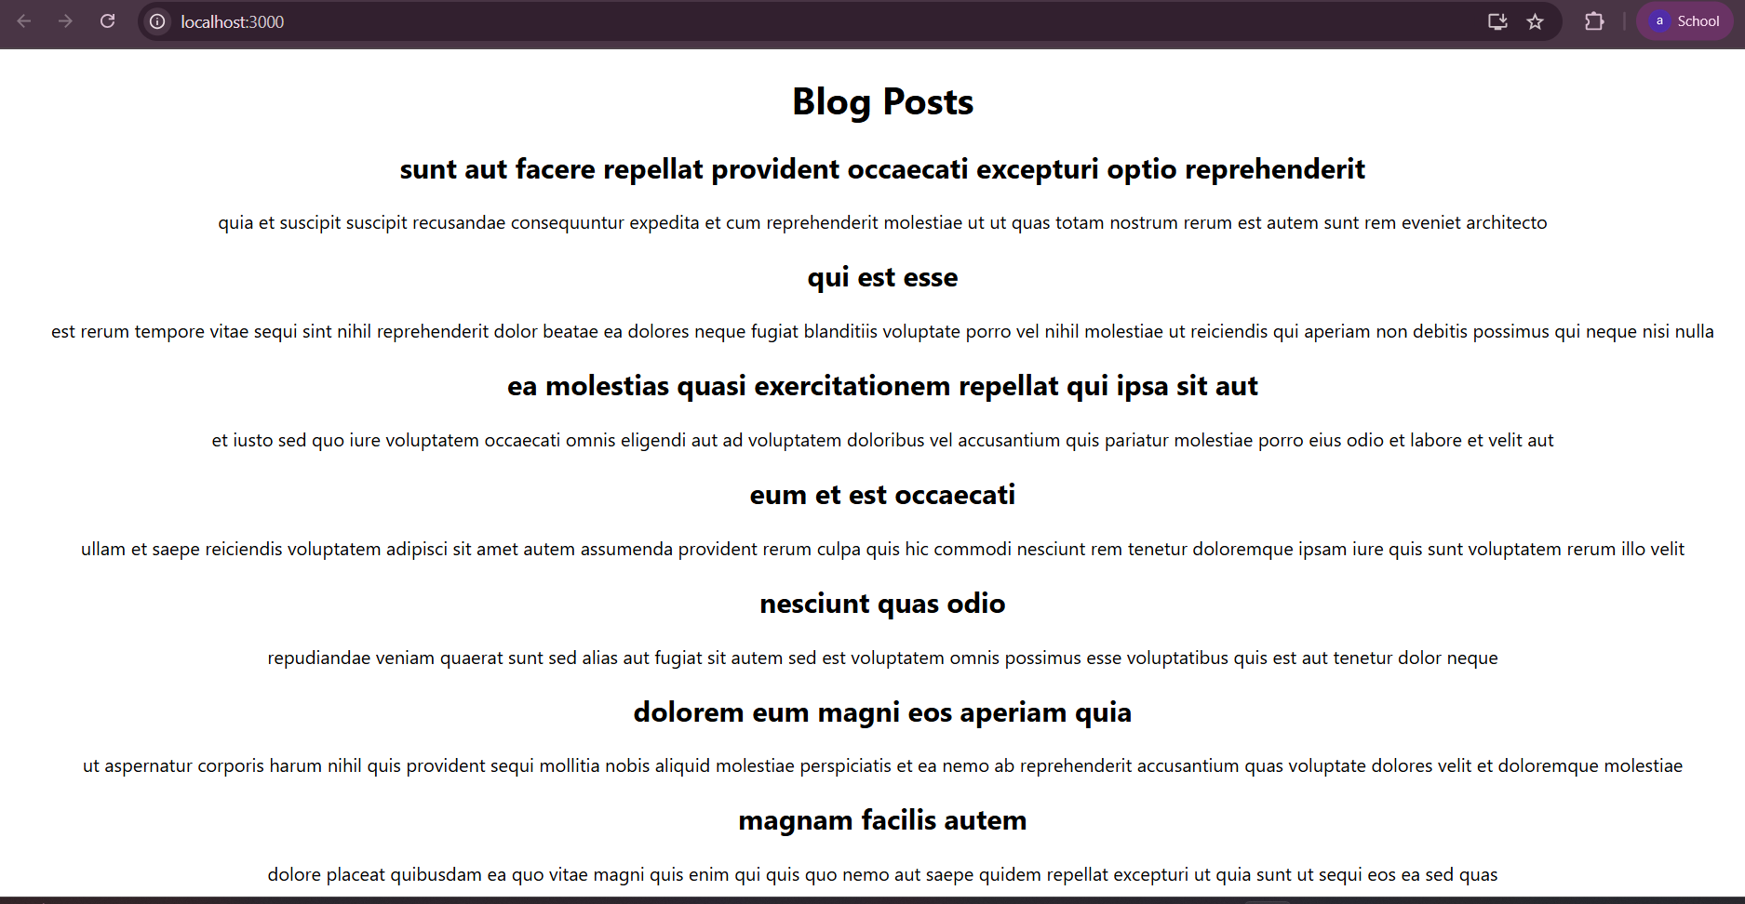

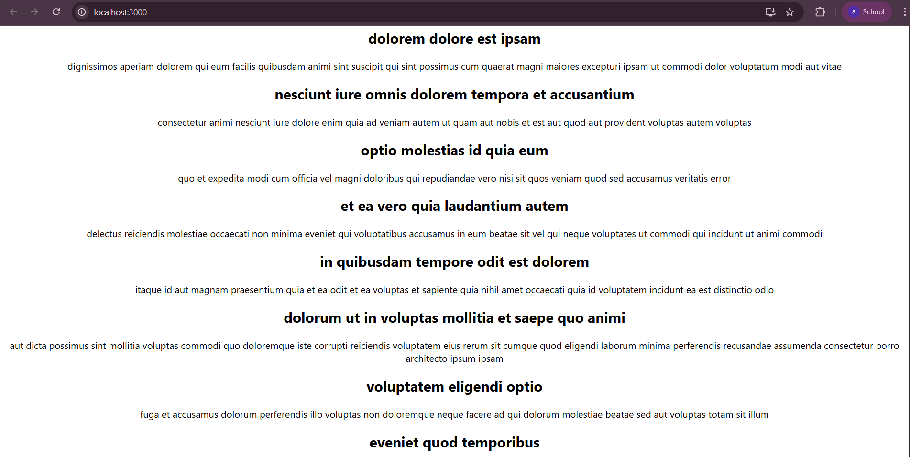

**5.ReactJS-HOL**

**src/App.js**

import logo from './logo.svg';

import './App.css';

import { CohortsData} from './Cohort'

import CohortDetails from './CohortDetails';

function App() {

  return (

  <div>

    <h1>Cohorts Details</h1>

    {CohortsData.map(cohort => <CohortDetails cohort={cohort}/>)}

  </div>

  );

}

export default App;

**src/** **CohortDetails.js**

import styles from './CohortDetails.module.css';

function CohortDetails(props) {

  return (

    <div className={styles.box}>

      <h3 style={{ color: props.cohort.currentStatus === 'Ongoing' ? 'green' : 'blue' }}>

        {props.cohort.cohortCode} -

        <span>{props.cohort.technology}</span>

      </h3>

      <dl>

        <dt>Started On</dt>

        <dd>{props.cohort.startDate}</dd>

        <dt>Current Status</dt>

        <dd>{props.cohort.currentStatus}</dd>

        <dt>Coach</dt>

        <dd>{props.cohort.coachName}</dd>

        <dt>Trainer</dt>

        <dd>{props.cohort.trainerName}</dd>

      </dl>

    </div>

  );

}

export default CohortDetails;

**src/CohortDetails.module.css**

.box {

  width: 300px;

  display: inline-block;

  margin: 10px;

  padding: 10px 20px;

  border: 1px solid black;

  border-radius: 10px;

}

dt {

  font-weight: 500;

}

**Src/Cohort.js**

class Cohort {

    constructor(cohortCode,

        startDate,

        technology,

        trainerName,

        coachName,

        currentStatus) {

        this.cohortCode = cohortCode;

        this.coachName = coachName;

        this.trainerName = trainerName;

        this.technology = technology;

        this.startDate = startDate;

        this.currentStatus = currentStatus;

    }

}

const CohortsData =[

    new Cohort('INTADMDF10','22-Feb-2022', '.NET FSD', 'Jojo Jose','Aathma', 'Scheduled'),

    new Cohort('ADM21JF014','10-Sep-2021', 'Java FSD', 'Elisa Smith','Apoorv', 'Ongoing'),

    new Cohort('CDBJF21025','24-Dec-2021', 'Java FSD', 'John Doe','Aathma', 'Ongoing'),

    new Cohort('INTADMJF12','22-Feb-2022', 'Java FSD', 'To Be Assigned','Ibrahim', 'Scheduled'),

    new Cohort('CDE22JF011','24-Dec-2021', 'Java FSD', 'Emma Swan','Apoorv', 'Ongoing'),

    new Cohort('INTADMDF09','22-Feb-2022', 'Dataware Housing', 'Babjee Rao','Aathma', 'Scheduled'),

    new Cohort('ADM22DF001','10-Sep-2021', '.NET FSD', 'Marie Curie','Ibrahim', 'Ongoing'),

];

export {Cohort, CohortsData};

**Run the React App:**

npm start

**Output:**

